Supplementary material

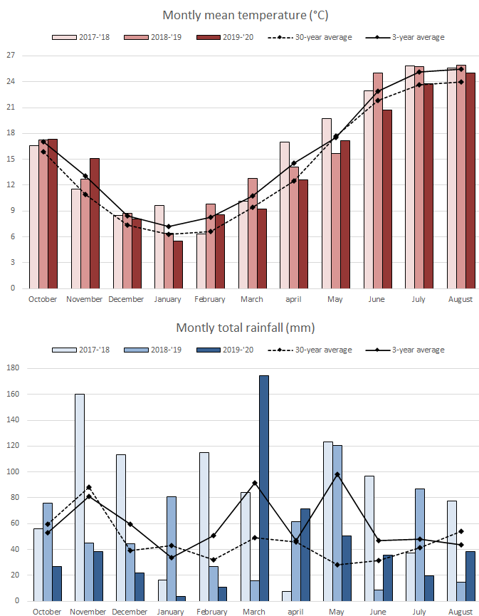

Fig. S1. Monthly mean temperatures and total rainfall occurred during the three experimental years compared to the climatic data over the 30 last years.

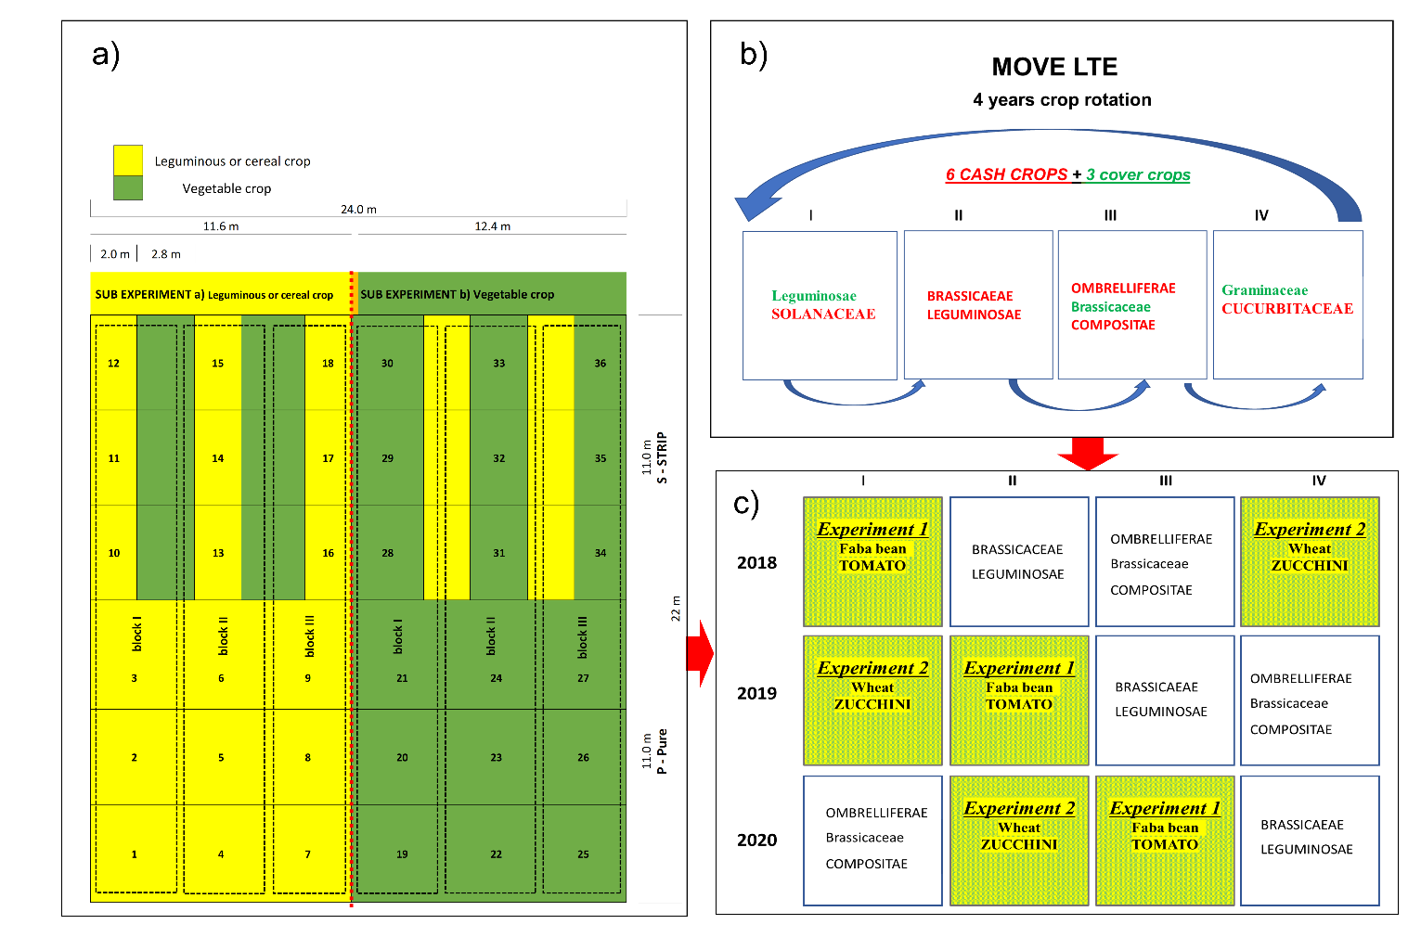
Fig. S2. Layout of the two experiments (a: Experiment 1.faba bean- tomato; Experiment 2. wheat-zucchini) embedded within the rotation of MOVE-LTE (b) during the three experimental years (c)

Table S1. Main agronomic management practices adopted during the experimental years for the crops in both the experiments

Experiment 1
 | 2018 |  | 2019 |  | 2020
 | faba bean | tomato | faba bean | tomato | faba bean | tomato
Fertilization | not  fertilized | Superstallaticoª (Choncimer srl)  4 Mg ha⁻¹ (NPK applied kg ha⁻¹: 120-0-0) applied in two split doses | not  fertilized | Superstallatico (Choncimer srl)  4 Mg ha⁻¹ (NPK applied kg ha⁻¹: 120-0-0) applied in two split doses | not  fertilized | Superstallatico (Choncimer srl)  4 Mg ha⁻¹ (NPK applied kg ha⁻¹: 120-0-0) applied in two split doses
Plant protection | 2 treatments with copper hydroxide^{c} (Cu applied kg ha⁻¹: 0.8) | 3 treatments with copper hydroxide and oxychloride^{d}  (Cu applied kg ha⁻¹: 1.2) | no need for treatments | 4 treatments with copper sulphate^{e}, copper oxychloride and sulfur^{f}, and spinosad^{h}  (Cu applied kg ha⁻¹: 1.4) | no need for treatments | 5 treatments with copper sulphate, copper oxychloride and sulfur, spinosad and pyrethrin^{i}  (Cu applied kg ha⁻¹: 2.5)
Irrigation | not  irrigated | 300 L m⁻² | not  irrigated | 300 L m⁻² | not irrigated | 300 L m⁻²
Weeding | 2 mechanical weeding with cultivator | 2 manual weeding  and 1 mechanical weeding with mowing blade | 2 mechanical weeding with cultivator | 2 manual weeding and 2 mechanical weeding with mowing blade | 1 mechanical weeding with cultivator | 2 manual weeding and 2 mechanical weeding with mowing blade

Experiment 2
 | 2018 |  | 2019 |  | 2020
 | wheat | zucchini | wheat | zucchini | wheat | zucchini
Fertilization | Prodigy^{b} Plus  (CBC srl)  0.48Mg ha⁻¹ (NPK applied kg ha⁻¹: 34-5-6) | Superstallatico  (Choncimer srl)  3.3 Mg ha⁻¹  (NPK applied kg ha⁻¹: 100-0-0) applied in two split doses | Prodigy Plus  (CBC srl)  0.48 Mg ha⁻¹  (NPK applied kg ha⁻¹: 34-5-6) | Superstallatico (Choncimer srl)  3.3 Mg ha⁻¹  (NPK applied kg ha⁻¹: 100-0-0) applied in two split doses | Prodigy Plus  (CBC srl)  0.48 Mg ha⁻¹  (NPK applied kg ha⁻¹: 34-5-6) | Superstallatico (Choncimer srl)  3.3 Mg ha⁻¹  (NPK applied kg ha⁻¹: 100-0-0) applied in two split doses
Plant protection | no need for treatments | 2 treatments with copper hydroxide + oxychloride and sulfur  (Cu applied kg ha⁻¹: 0.4) | no need for treatments | 2 treatments with sulfur^{g} and pyrethrin | no need for treatments | 1 treatment with sulfur
Irrigation | not irrigated | 110 L m⁻² | not irrigated | 250 L m⁻² | not irrigated | 200 L m⁻²
Weeding | not weeded | 2 manual weeding and 1 mechanical weeding with mowing blade | not weeded | 2 manual weeding and 2 mechanical weeding with mowing blade | not weeded | 2 manual weeding and 2 mechanical weeding with mowing blade
Brand name, company name, and company address for each input:
a) Organic pellets: Superstallatico, Choncimer srl, frazione Rocchetta 63 San Severino Marche (MC) Italy;
b) Organic pellets: PRODIGY PLUS, CBC srl (BIOGARD division), via Zanica 25 Grassobbio (BG) Italy;
c) Copper hydroxide: Coprantol Hi Bio, Syngenta Italia spa, via Gallarate 139 Milano Italy;
d) Copper hydroxide and oxychloride: AIRONE, Gowan Italia srl, via Morgagni 68 Faenza (RA) Italy;
e) Copper sulphate: Cuproxat SDI, SIPCAM Italia, via Sempione 195 Pero (Milano) Italy;
f) Copper oxychloride and sulfur: CUTHIOL, Mormino, via Lungomolo 16 Termini Imerese (PA) Italy;
g) Sulfur: THIOVIT JET, Syngenta Italia spa, via Gallarate 139 Milano Italy;
h) Spinosad: LASER, Dow Agro Sciences Italia, via Francesco Albani 65 Milano Italy
i) Pyrethrin: BIOPIREN PLUS, CBC srl (BIOGARD division), via Zanica 25 Grassobbio (BG) Italy

Table S2. Mean annual amount of inputs over the three years and unit costs for a) 1 ha cultivated in pure in a proportion of 42% of faba bean for dry grain and 58% of faba bean for fresh pod production + tomato and b) 1 ha of faba bean and zucchini cultivated in strips with the same widths and management described in the experiments
 | a) Faba bean for grain in pure (0.42 ha) + Faba bean for freash pods /Tomato (0.58 ha) in pure | b) Faba bean- Tomato in strips | Unit cost
Workforce employee (n hours) | 1800.0 | 1868.4 | 14 € h⁻¹
Subcontractor for faba bean harvest + transport (whole-job fixed price) | - | - | 170 € ha⁻¹ in pure; 195 € ha⁻¹ in strip
Faba bean seeds(kg) | 150.0 | 150.0 | 4.4 € kg⁻¹
Tomato seeds (n) | 20300.0 | 20300.0 | 0.05 € n⁻¹
Solid organic fertilizer in tomato (kg) | 2320.0 | 2320.0 | 0.192 € kg⁻¹
Liquid organic fertilizer in tomato (l) | 8.5 | 8.5 | 8.91 € l⁻¹
Fungicides in faba bean (kg) | 1.3 | 1.3 | 8 € l⁻¹
Fungicides in tomato (kg) | 5.4 | 5.4 | 9.62 € kg⁻¹
Insecticides in tomato (kg) | 0.46 | 0.46 | 347.2 € kg⁻¹
Diesel fuel (l) | 148.1 | 148.1 | 0.95 € l⁻¹
Lubricants (l) | 4.4 | 4.4 | 6 € l⁻¹
Bamboo sticks (n) | 16570.6 | 16570.6 | 0.2 € n⁻¹
Water (mc) | 1740.0 | 1740.0 | 0.20 € mc⁻¹
Drip line (n) | 8285.3 | 8285.3 | 0.15 € n⁻¹
Electricity (kwh) | 840.6 | 840.6 | 0.276 € kwh⁻¹

Table S3. Mean annual amount of inputs over the three years and unit costs for a) 1 ha cultivated in pure in a proportion of 42% of wheat for dry grain and 58% of wheat as cover crop + zucchini and b) 1 ha of wheat and zucchini cultivated in strips with the same widths and management described in the experiments

 | a) Wheat in pure (0.42 ha) + Cover crop/Zucchini (0.58 ha) in pure | b) Wheat- Zucchini in strips (1 ha) | Unit cost
Workforce employee (n hours) | 792.3 | 836.9 | 14 € h⁻¹
Subcontractor for wheat harvest+ transport (whole-job fixed price) | - | - | 100 € ha⁻¹ in pure; 115 € ha⁻¹ in strip
Wheat seeds (kg) | 200.0 | 200.0 | 1.5 € kg⁻¹
Zucchini seeds (n) | 8000.0 | 8000.0 | 0.14 € n⁻¹
Solid organic fertilizer in wheat (kg) | 480.0 | 480.0 | 1.456 € kg⁻¹
Solid organic fertilizer in zucchini (kg) | 1914.0 | 1914.0 | 0.192 € kg⁻¹
Liquid organic fertilizer in zucchini (l) | 37.1 | 37.1 | 7.8 € l⁻¹
Plant Protection from snails (kg) | 5.8 | 5.8 | 7 € l⁻¹
Fungicides (kg) | 3.5 | 3.5 | 14.56 € kg⁻¹
Diesel fuel (l) | 112.6 | 116.6 | 0.95 € l⁻¹
Lubricants (l) | 3.4 | 3.5 | 6 € l⁻¹
Water (mc) | 1082.7 | 1082.7 | 0.20 € mc⁻¹
Drip line (n) | 4640.0 | 4640.0 | 0.15 € n⁻¹
Electricity (kwh) | 526.6 | 526.6 | 0.276 € kwh⁻¹

Table S4. Annual costs, gross saleable production, and gross margin in the three experimental years (2018, 2019, 2020) for pure (1 ha cultivated in pure in a proportion of 42% of legume or cereal crop for dry grain and 58% of legume or cereal as cover crop + vegetable crop) and strip (1 ha of legume or cereal crop and vegetable crop cultivated in strips with the same widths and management described in the experiments) of faba bean - tomato and wheat- zucchini systems
Faba bean – Tomato
 |  | Pure (1 ha) | Strip (1 ha)
Costs (€) | 2018 | 32477.9 | 33756.7
 | 2019 | 33046.6 | 33933.3
 | 2020 | 33391.1 | 34376.0
Gross saleable production (€) | 2018 | 40077.7 | 67075.7
 | 2019 | 71948.4 | 63621.2
 | 2020 | 86699.5 | 92498.2
Gross margin (€) | 2018 | 7599.8 | 33319.0
 | 2019 | 38901.8 | 29687.9
 | 2020 | 53308.4 | 58122.2
Wheat - Zucchini
 |  | Pure (1 ha) | Strip (1 ha)
Costs (€) | 2018 | 15029.9 | 15865.0
 | 2019 | 15272.5 | 15656.3
 | 2020 | 15207.8 | 15834.3
Gross saleable production (€) | 2018 | 22225.7 | 33288.7
 | 2019 | 16448.8 | 20859.9
 | 2020 | 14854.4 | 26787.2
Gross margin (€) | 2018 | 7195.8 | 17423.6
 | 2019 | 1176.3 | 5203.6
 | 2020 | -353.4 | 10952.9

