Supplementary Material

Interview Guide

Today, I’ll ask questions to learn more about your hemp products and the ways that you sell them.
Responses are voluntary and you may skip any questions you prefer not to answer. Are you willing to talk with me about your hemp products?

Background Questions:

1. Confirm farm/brand name, city/state, website, contact person, contact’s preferred phone & email as needed.
Production questions:

2. How long have you been farming? What else do you grow? How long have you been growing hemp?

3. How many acres of hemp did you grow in 2020 and how many are planned for 2021?

4. Have your markets influenced your genetic selection? Has any particular product or channel directed that selection?
Product & Processing Questions:

5. What hemp products do you sell? Examples include flower (smokable/consumable), tinctures (CBD/CBG oils), topicals (salves/lotions), and bulk oil (called crude).

6. Can you describe how each product is made? Which steps do you do and are you using a custom/third-party processor for some of it? They might do some in-house (flower, for example) and have some products made, so try to get a clear understanding of what parts they do for each product.

7. Do you make products differently for the different sales channels that you use? Another way to ask it: Is the production process the same for a product, regardless of which sales channel you plan to sell it in?

8. Can you describe the shelf life/perishability of your products?
Channel Utilization Questions:

9. What market channels are you selling the products in? (Examples are farmers market, their own farm store, online, wholesale to other stores, etc..) They might use particular channels for some but not all products, so try to get a clear understanding of the channels that are being used for each product.

10. If selling at farmers markets, how do they determine if an individual market is “worth it?”

11. What metrics/factors do you consider when evaluating a channel? (Examples are daily gross sales, price received, perception of profitability.)

12. Were you already participating in these channels with other products or is this all new with hemp products? Clarify, were you already conducting direct-to-consumer sales before you began marketing hemp products? If yes, ask how long have you been marketing in direct-to-consumer channels?

13. In what channel do you most enjoy selling and why?

14. On a similar note, do you enjoy customer interaction, do you find it energizing or draining?

15. What channel do you think is most profitable for your hemp business and why?

16. If you have a limited amount of product, what channel would you reserve it for and why?

17. If you had to drop one channel, which one would it be and why?
Marketing & Sales Questions:

18. In 2021, would you estimate the demand for hemp products like yours is greater than the supply? How has that changed through your years of experience marketing hemp products?

19. What are your marketing and advertising efforts? OR How do you find new customers and get the word out about your products?

20. Have regulations impacted your sales, your channels, or anything about your marketing in general?

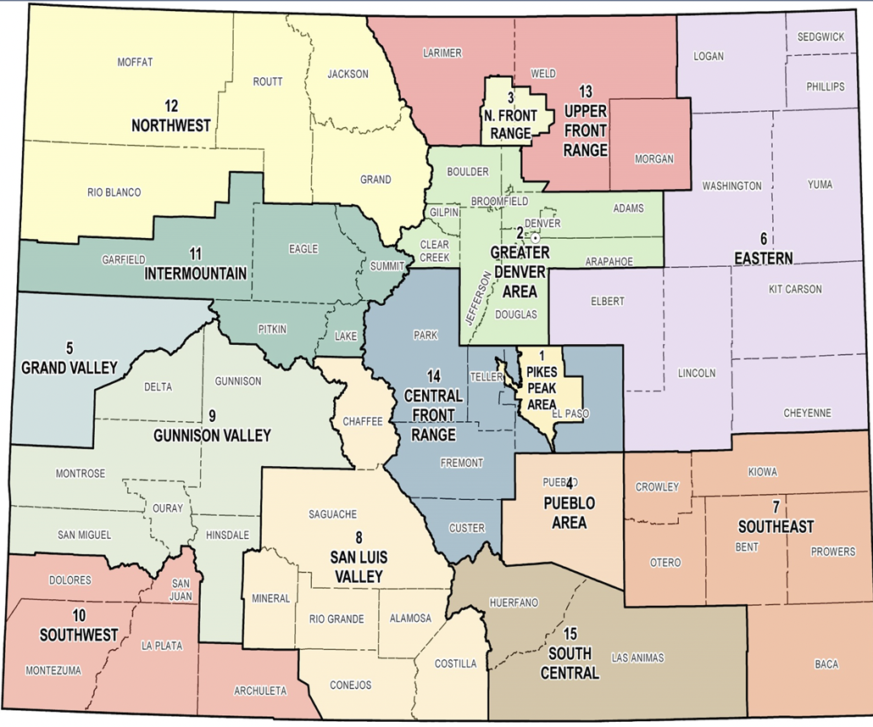
Figure S1. Map of Colorado regions. 12 total producers were interviewed in Colorado. Four of the hemp operations were based in the greater Denver area, three in the Pikes Peak (Colorado Springs) area, and one each in the upper front range, Northwest, intermountain, Gunnison Valley, and Grand valley regions.

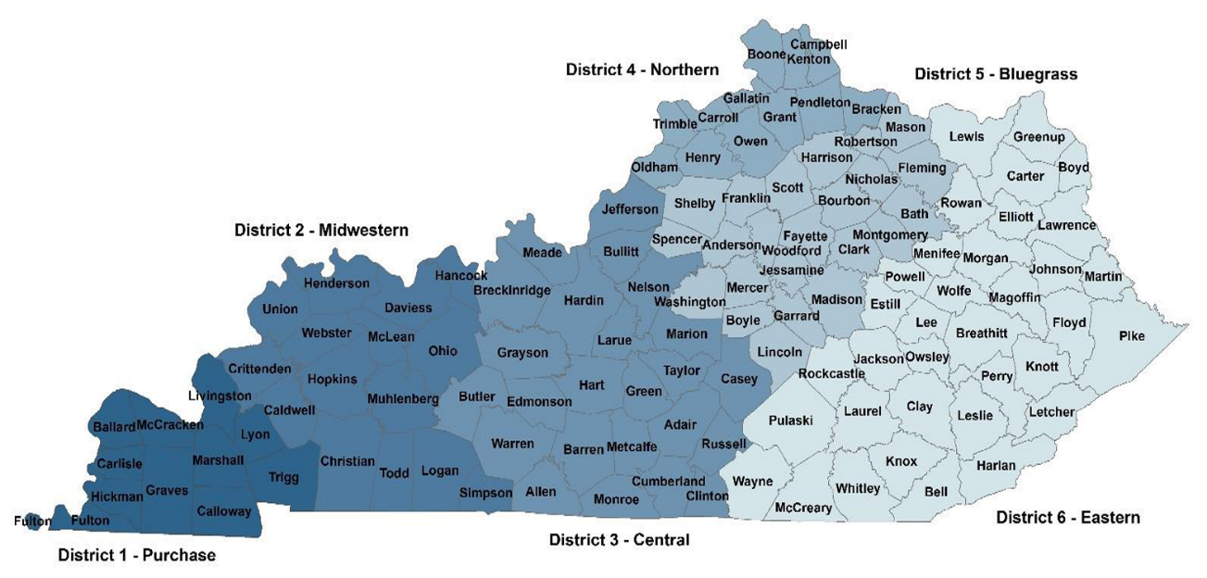
Figure S2. Map of Kentucky regions. 10 total producers were interviewed in Kentucky. Three of the hemp operations were based in each the Bluegrass and Northern Districts, two in the Central, Purchase Districts.

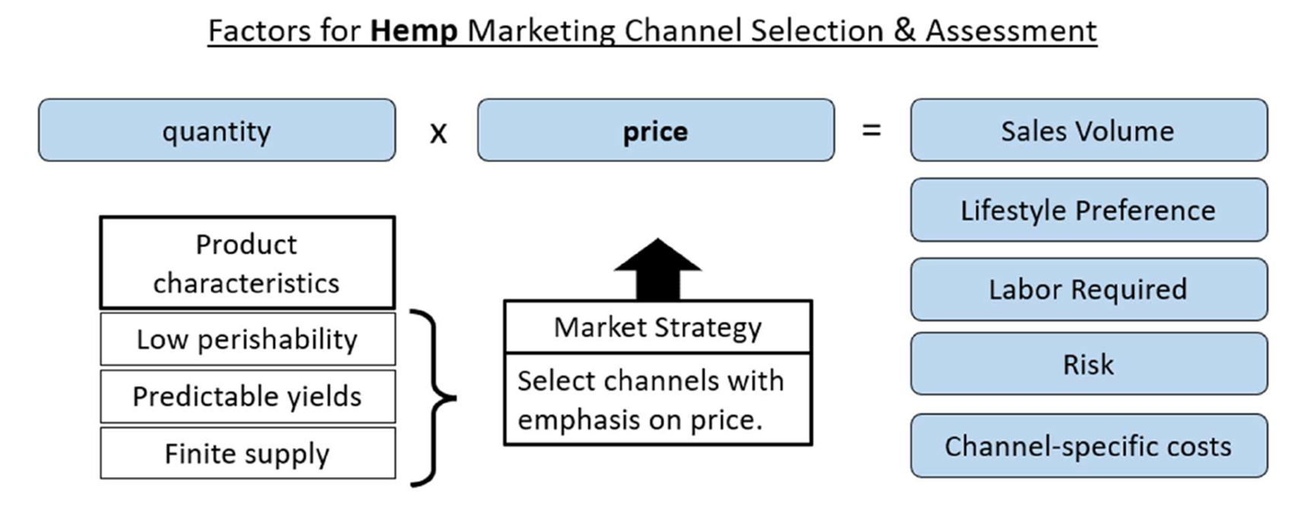
Figure S3. As hemp for processing has a long shelf life, the operation can hold inventory while seeking the best price, thus putting more weight on the price component of sales volume in the market channel assessment.

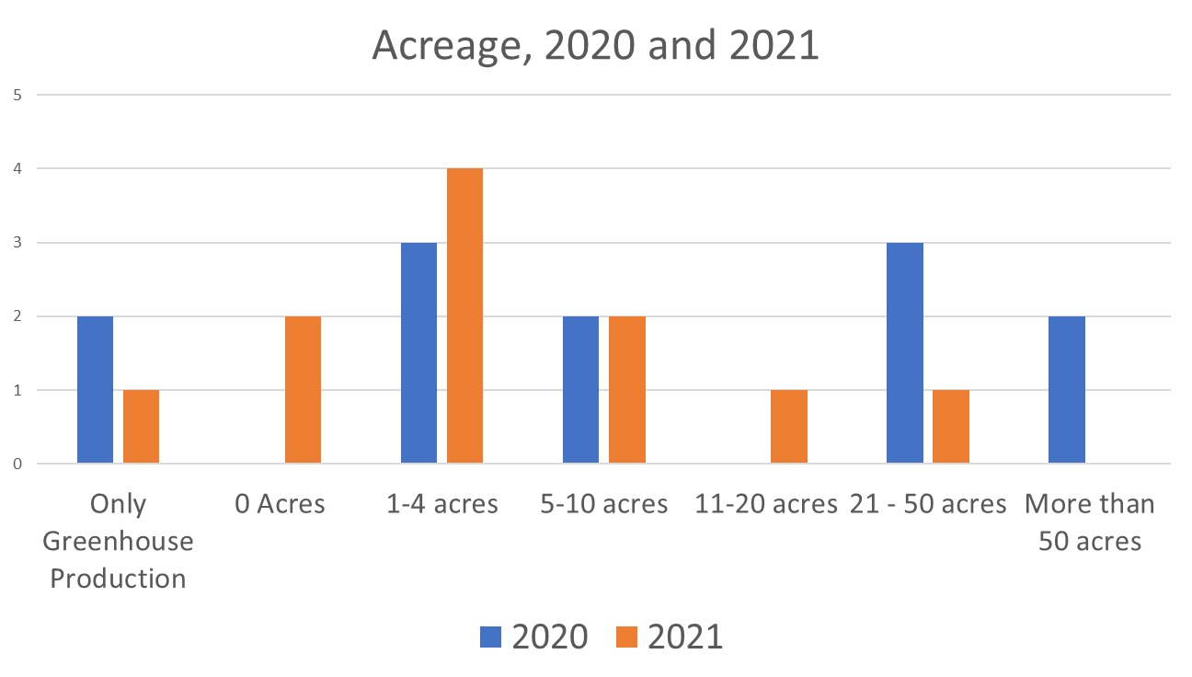
Figure S4. Colorado producers interviewed by acreage planted

(a) Direct:
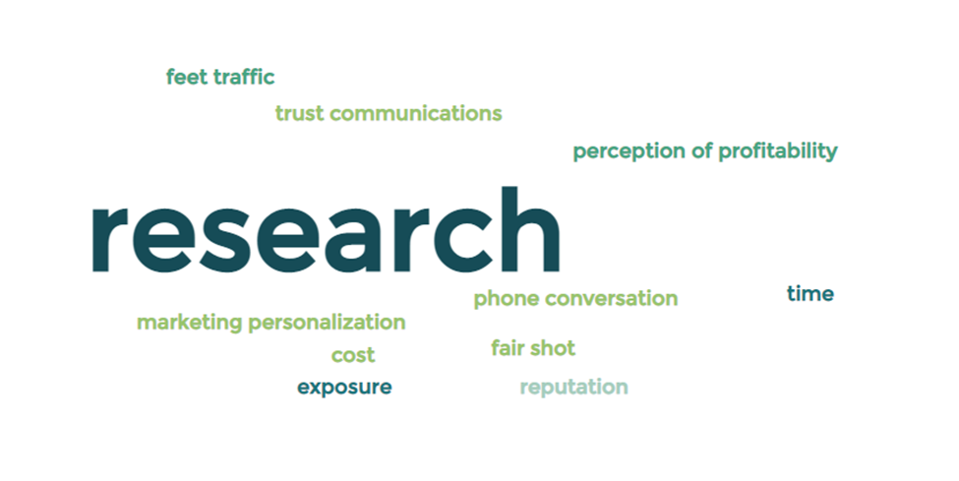
(b) Intermediated:
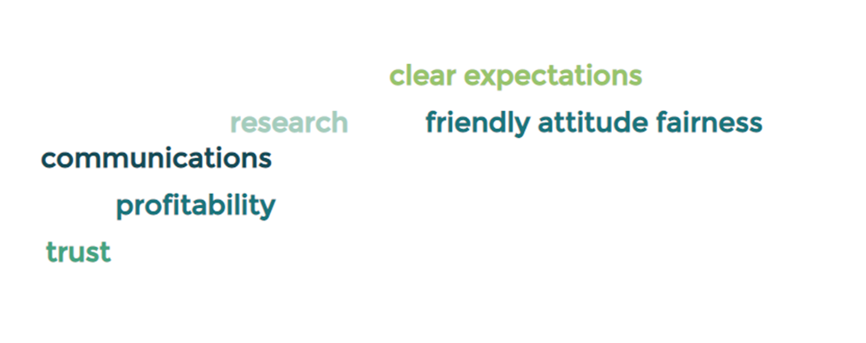
(c) Both:
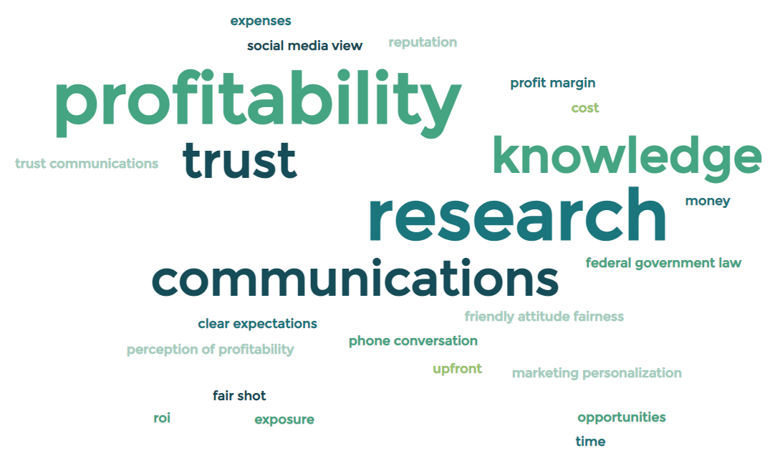

Figure S5. Word cloud of the open-ended responses across all market channels to the question: “What metrics/factors do you consider when evaluating a channel?”

Summary Statistics

 | Colorado | Kentucky
Total number of producers interviewed | 12 | 10
CBD | 10 | 6
Fiber | 1 | 4
Grain/Seed | 1 | 0
Average acres planted - 2020 | 26 | 38
Average acres planted - 2021 | 8 | 47
% Using hand cultivation | 83% | 43%
Average number of products sold | 4.2 | 2
% Selling more than one product | 82% | 40%
% Who reported farming previously | 50% | 78%

