

**Figure 1:** Experimental designs of melon (*Cucumis melo*) in 2018 and 2019

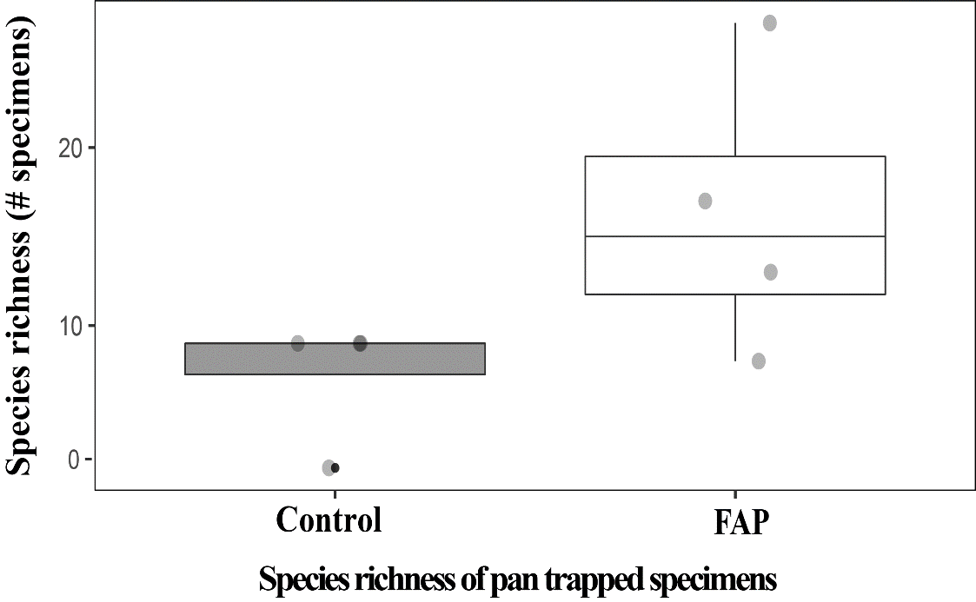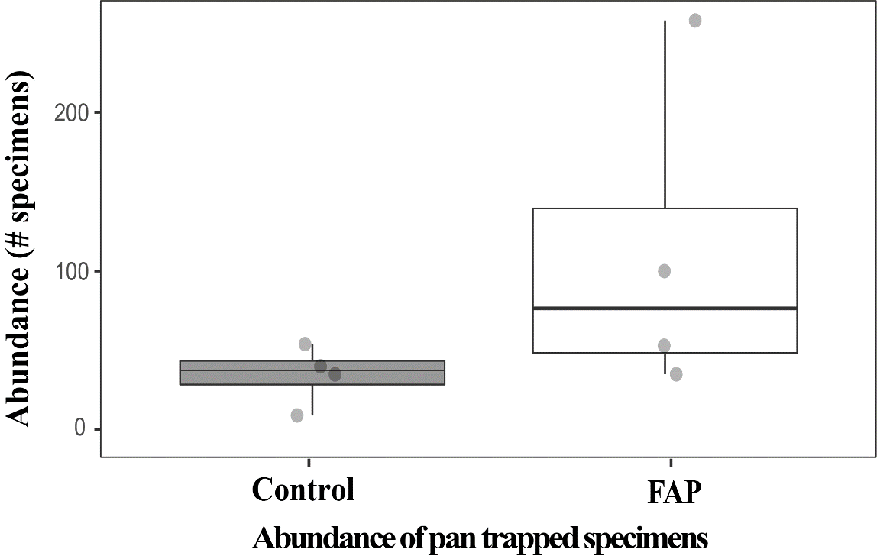

**Figure 2:** Boxplots showing the total mean abundance of pan trapped specimens (right, **Fig. 2a**) and species richness (left, **Fig. 2b**) FAP (75% zone main crop & 25% zone MHEP) and control (100% zone main crop) fields. Significant differences are shown in species richness by the statistical test (Kruskal-Wallis), instead of that there is no significant difference in the abundance by the statistical test (ANOVA Test).

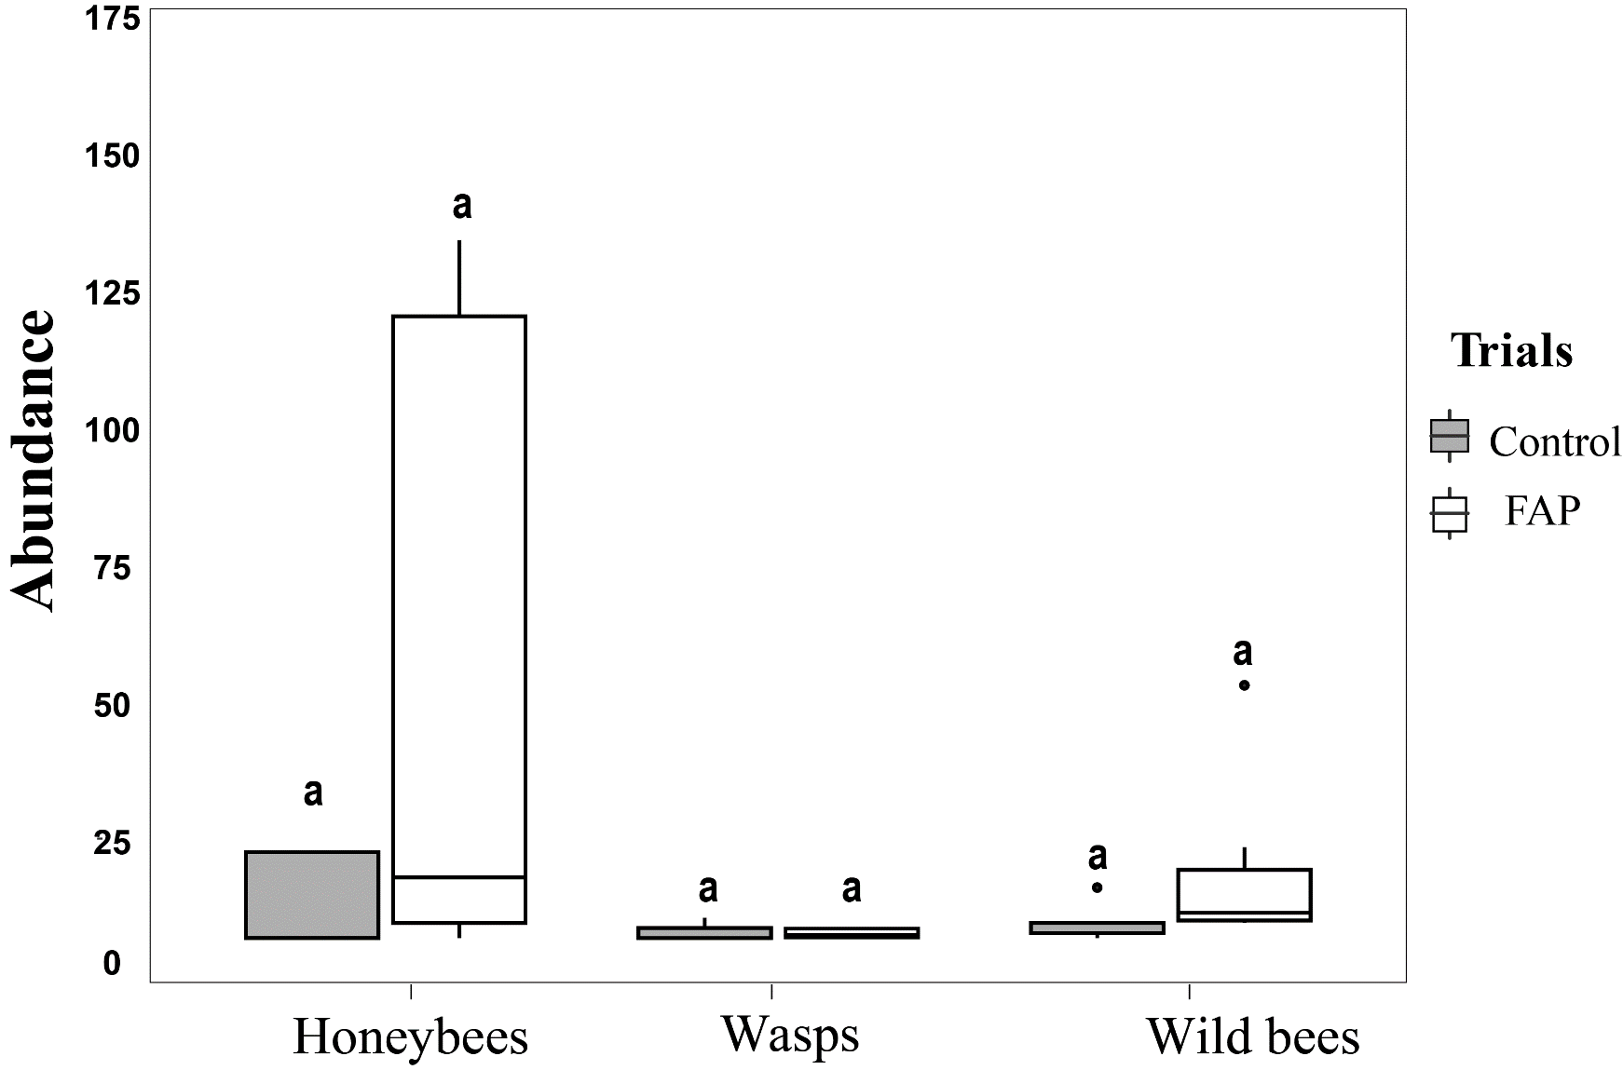 **Figure 3**: Boxplotsencompass the difference of mean abundance offour floral visitor groups between two type of sites FAP fields (75% zone main crop) and control fields (75% zone main crop). Significant differences are shown by the statistical test (Kruskal-Wallis).

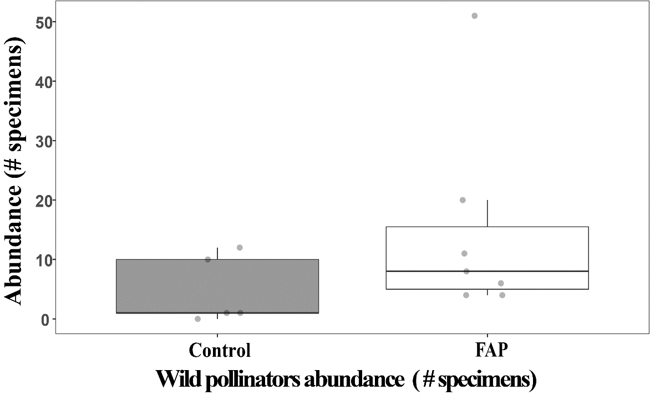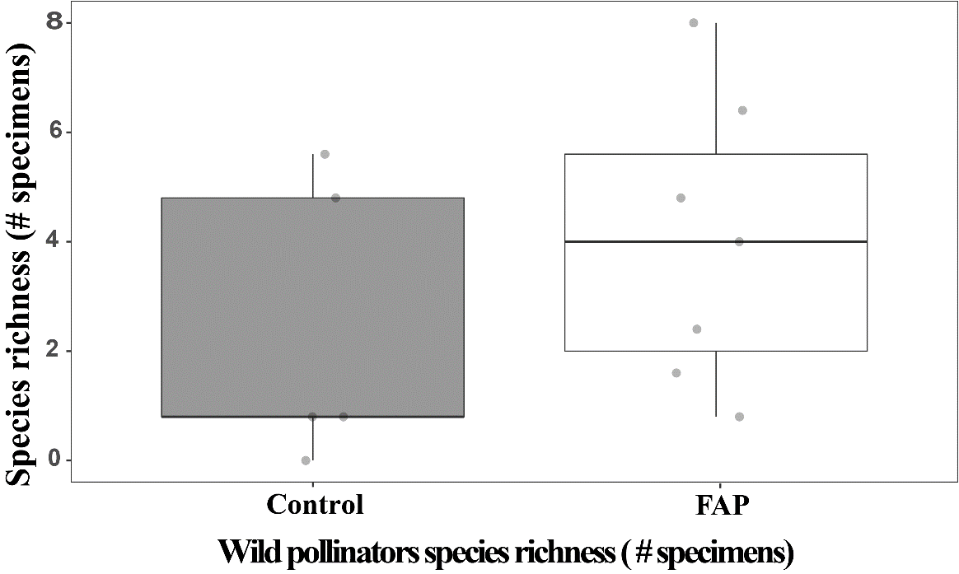

**Figure 4:** Boxplots showing the total mean abundance of wild pollinators (left, **Fig. 4a**) and species richness (right, **Fig. 4b**) in FAP (75% zone main crop) and control (75% zone main crop) fields. Significant differences are shown by the statistical test. (Kruskal-Wallis and ANOVA Test).

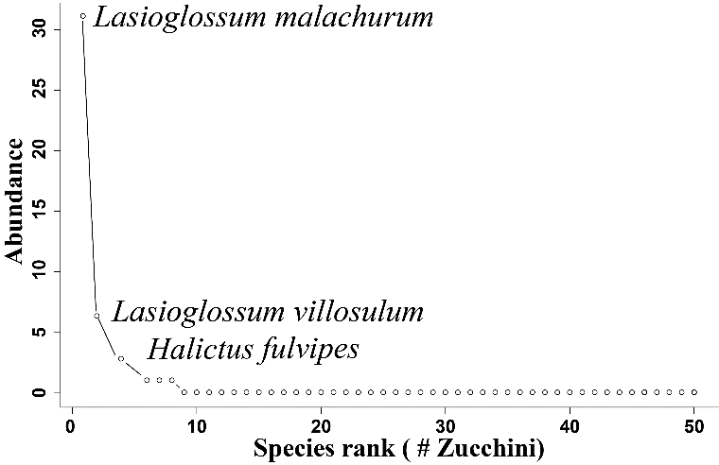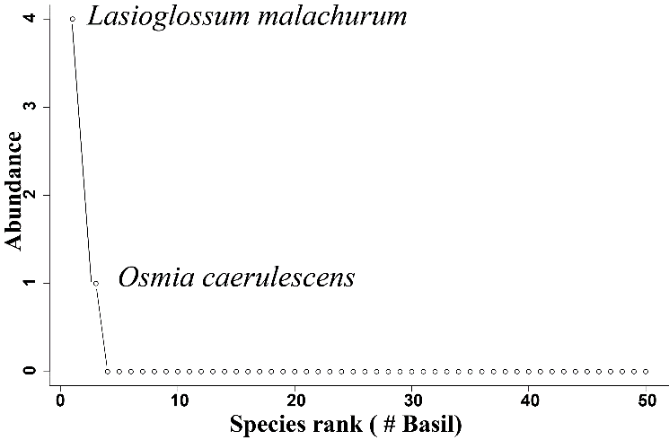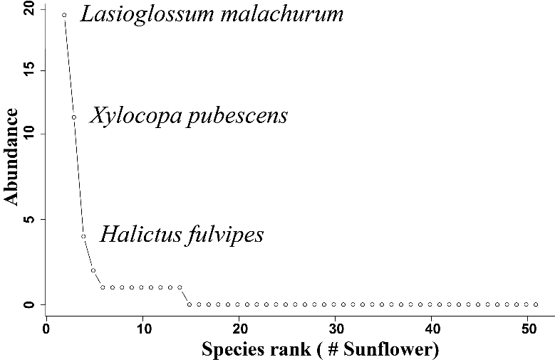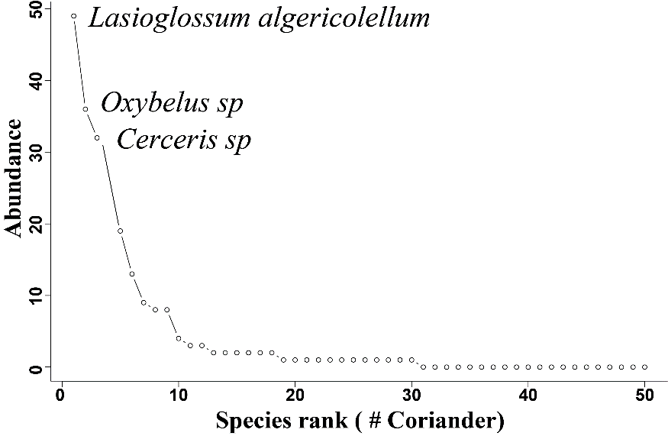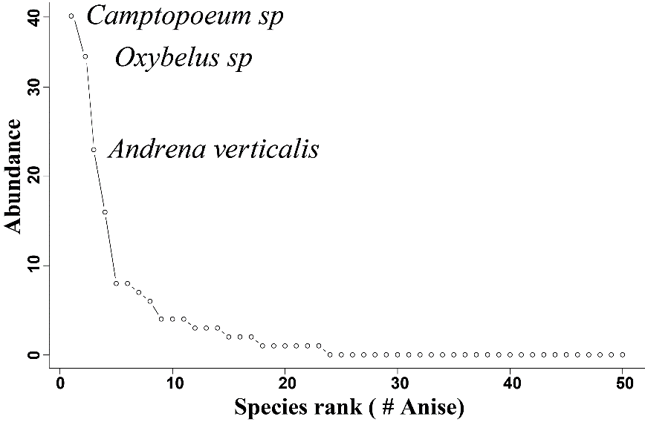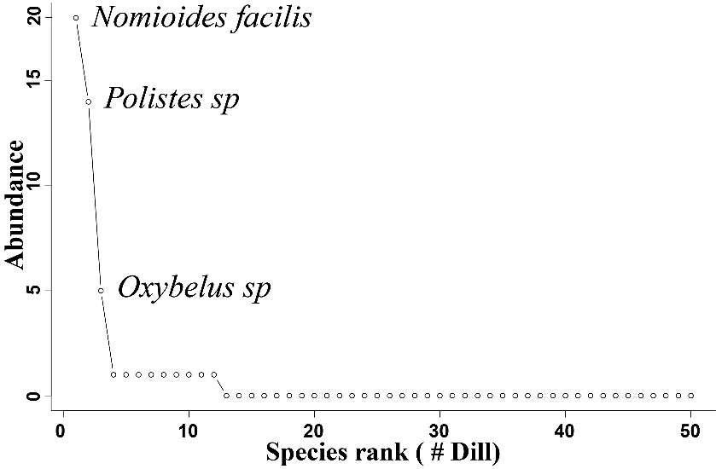

**Figure 5:** Rank abundance curves illustrating the dominant species in different MHEP in FAP fields (Zucchini, sunflower, basil, coriander, anise, and dill

**Table 1**: Rank abundance of visits to flowers of melon and MHEP over two years

|  |  |  |  |  |  |
| --- | --- | --- | --- | --- | --- |
|  | Family | *Species* | Abundance | Species percentage (%) | Family percentage (%) |
| Bee Family | Andrenidae | Camptopoeum sp. | 51 | 3.83 | 9.10 |
| Andrena spp | 8 | 0.60 |
| *Andrena fulvicornis* | 7 | 0.53 |
| *Andrena flavipes* | 4 | 0.30 |
| *Andrena impunctate* | 4 | 0.30 |
| *Andrena labialis* | 3 | 0.23 |
| *Andrena verticalis* | 44 | 3.31 |
| Apidae | *Apis mellifera* | 560 | 42.11 | 44.21 |
| *Xylocopa pubescens* | 12 | 0.90 |
| *Amegilla savignyi* | 4 | 0.30 |
| *Eucera obliterata* | 4 | 0.30 |
| *Schmiedeknechtia oraniensis* | 3 | 0.23 |
| *Bombus terrestris* | 2 | 0.15 |
| Ceratina spp | 1 | 0.08 |
| Eucera sp | 1 | 0.08 |
| Nomada sp1 | 1 | 0.08 |
| Colletidae | *Hylaeus taeniolatus* | 9 | 0.68 | 2.18 |
| *Hylaeus absolutus* | 8 | 0.60 |
| *Hylaeus sulphuripes* | 5 | 0.38 |
| Hylaeus sp | 3 | 0.23 |
| *Hylaeus euryscapus* | 2 | 0.15 |
| *Colletes nigricans* | 1 | 0.08 |
| *Hylaeus cornutus* | 1 | 0.08 |
| Halictidae | *Lasioglossum malachurum* | 114 | 8.57 | 28.87 |
| *Lasioglossum algericolellum* | 62 | 4.66 |
| *Lasioglossum interruptum* | 48 | 3.61 |
| *Nomioides facilis* | 35 | 2.63 |
| Halictini sp | 31 | 2.33 |
| *Lasioglossum subhirtum* | 14 | 1.05 |
| *Lasioglossum villosulum* | 12 | 0.90 |
| *Halictus fulvipes* | 11 | 0.83 |
| *Seladonia smaragdula* | 10 | 0.75 |
| Sphecodes sp. | 8 | 0.60 |
| *Vestitohalictus pollinosus* | 10 | 0.75 |
| *Seladonia gemmella* | 6 | 0.45 |
| *Lasioglossum glabriusculum* | 5 | 0.38 |
| *Lasioglossum minutissimum* | 5 | 0.38 |
| *Nomiapis bispinosa* | 3 | 0.23 |
| *Nomioidini* | 2 | 0.15 |
| *Seladonia gemmea* | 2 | 0.15 |
| *Halictus constantinensis* | 1 | 0.08 |
| *Lasioglossum callizonium* | 1 | 0.08 |
| *Lasioglossum griseolum* | 1 | 0.08 |
| *Lasioglossum lucidulum* | 1 | 0.08 |
| *Lasioglossum pallens* | 1 | 0.08 |
| *Nomioides bluethgeni* | 1 | 0.08 |
| Megachilidae | Megachile spp | 8 | 0.60 | 0.75 |
| *Osmia caerulescens* | 2 | 0.15 |
| Wasp Family | Crabronidae | Oxybelus spp | 80 | 6.02 | 11.35 |
| Cerceris spp | 43 | 3.23 |
| Crabronidae sp. | 28 | 2.11 |
| Pompilidae | Pompilidae sp. | 20 | 1.50 | 1.50 |
| Scoliidae | *Scolia hortorum* | 3 | 0.23 | 0.23 |
| Tiphiidae | Tiphia spp | 1 | 0.08 | 0.08 |
| Vespidae | Polistes spp | 18 | 1.35 | 1.65 |
| Eumenes spp | 3 | 0.23 |
| Euodynerus spp | 1 | 0.08 |
| Chrysididae | Chrysididae sp. | 1 | 0.08 | 0.08 |
|  |  | **Total** | 1330 |  |  |

**Table 2**: Abundance of visits to flowers of melon and the MHEP

|  |  |  |
| --- | --- | --- |
| **Floral visitors** | **Main crop & MHEP's** | **Frequency of visits** |
| *Nomioides facilis* | *Anethum graveolens* | 18 |
| Oxybelus spp. | *Anethum graveolens* | 5 |
| Polistes spp. | *Anethum graveolens* | 14 |
| *Andrena verticalis* | *Coriandrum sativum* | 19 |
| Camptopoeum sp. | *Coriandrum sativum* | 13 |
| Cerceris spp. | *Coriandrum sativum* | 32 |
| *Lasioglossum algericolellum* | *Coriandrum sativum* | 49 |
| *Lasioglossum interruptum* | *Coriandrum sativum* | 32 |
| *Lasioglossum malachurum* | *Coriandrum sativum* | 9 |
| Oxybelus spp. | *Coriandrum sativum* | 36 |
| *Seladonia gemmella* | *Coriandrum sativum* | 4 |
| *Seladonia smaragdula* | *Coriandrum sativum* | 8 |
| Sphecodes sp. | *Coriandrum sativum* | 8 |
| *Apis mellifera* | *Cucumis melo* | 402 |
| *Eucera obliterata* | *Cucumis melo* | 4 |
| *Halictus fulvipes* | *Cucumis melo* | 5 |
| *Lasioglossum algericolellum* | *Cucumis melo* | 4 |
| *Lasioglossum malachurum* | *Cucumis melo* | 39 |
| *Lasioglossum subhirtum* | *Cucumis melo* | 11 |
| *Lasioglossum villosulum* | *Cucumis melo* | 4 |
| *Vestitohalictus pollinosus* | *Cucumis melo* | 6 |
| *Apis mellifera* | *Cucurbita pepo* | 37 |
| *Lasioglossum malachurum* | *Cucurbita pepo* | 31 |
| *Lasioglossum villosulum* | *Cucurbita pepo* | 4 |
| *Apis mellifera* | *Helianthus annuus* | 71 |
| *Halictus fulvipes* | *Helianthus annuus* | 4 |
| *Lasioglossum malachurum* | *Helianthus annuus* | 17 |
| *Xylocopa pubescens* | *Helianthus annuus* | 11 |
| *Lasioglossum malachurum* | *Ocimum basilicum* | 4 |
| *Andrena fulvicornis* | *Pimpinella anisum* | 4 |
| Andrena spp. | *Pimpinella anisum* | 6 |
| *Andrena verticalis* | *Pimpinella anisum* | 23 |
| Camptopoeum sp. | *Pimpinella anisum* | 38 |
| Cerceris spp | *Pimpinella anisum* | 8 |
| *Hylaeus absolutus* | *Pimpinella anisum* | 7 |
| *Hylaeus sulphuripes* | *Pimpinella anisum* | 4 |
| *Hylaeus taeniolatus* | *Pimpinella anisum* | 8 |
| *Lasioglossum malachurum* | *Pimpinella anisum* | 4 |
| *Nomioides facilis* | *Pimpinella anisum* | 16 |
| Oxybelus spp. | *Pimpinella anisum* | 37 |