Appendix A

Below is the survey instrument implemented for this study and administered through Qualtrics.

USDA-UConn Growers Survey

Survey Flow
Standard: Welcome Page (1 Question)
Block: Screening Question (3 Questions)
Standard: Section 1: Your Greenhouse Operation (16 Questions)
Standard: Section 2: General Water Questions (Knowledge & Perceptions) (2 Questions)
Standard: Section 3: Using Recycled Water in Greenhouse Operation (4 Questions)
Standard: Section 4: Grower Profile (6 Questions)
Standard: THANK YOU! (4 Questions)
Page Break

Start of Block: Welcome Page

Q1
Welcome to the Greenhouse Water Use Survey a collaborative effort between Department of Civil and Environmental Engineering and Department of Plant Science and Landscape Architecture at the University of Connecticut funded by the US Department of Agriculture.

This 10 minute survey focuses on water use in greenhouse operations. Results from this research will help improve understanding of water for agriculture and tailor educational materials for agricultural extension.

We appreciate your time. As a thank you for participating, you will be offered a chance to enter a drawing to win one of ten $50 Amazon gift cards when you complete the survey.

Your answers are confidential. Any identifying information will be removed before the results are shared.

By clicking the arrow below you consent to participate in the survey.

End of Block: Welcome Page

Start of Block: Screening Question

Q2
SCREENING QUESTION

Q3 For this survey, if you have owned or worked in different greenhouse projects in the past, please think about your current (or most recent) greenhouse project as you respond to the questions.

Q4 Are you involved in a greenhouse growing operation in some capacity?
- Yes (1)
- No, take me to the end of survey (2)

Skip To: End of Survey If Are you involved in a greenhouse growing operation in some capacity? = No, take me to the end of survey
Skip To: End of Block If Are you involved in a greenhouse growing operation in some capacity? = Yes
End of Block: Screening Question

Start of Block: Section 1: Your Greenhouse Operation

Q5 SECTION 1: YOUR GREENHOUSE OPERATION

Q6 What is your primary role regarding your greenhouse operation?
- Employee (with decision power) (1)
- Employee (with no decision power) (2)
- Owner (involved w/ daily decisions) (3)
- Owner (not involved w/ daily decisions) (4)
- Other, please specify: (5) ________________________________________________

Q7 What plants have you grown in your greenhouse(s) over the last 5 years? (Check all that apply)
- Leafy- and micro-greens (e.g., lettuce, spinach, persian cress, mustards, pac choi, radish, beet, orach) (1)
- Vegetables (e.g., cucumbers, tomatoes, peppers) (2)
- Herbs (e.g., basil, water cress, cilantro) (3)
- Berries (e.g., raspberries, strawberries) (4)
- Ornamentals, Perennials (5)
- Pharmaceutical / medicinal crops (6)
- Other(s), please specify: (7) ________________________________________________

Q8 Who are your primary customers for your greenhouse products?
- Restaurants (1)
- Wholesale / distributor (2)
- Retail (3)
- Farmers' markets (4)
- Other, please specify: (5) ________________________________________________

Q9 What is your primary source of water for your greenhouse operation?
- Purchased public or private water (1)
- Purchased treated wastewater (2)
- Surface water on my property (e.g. ponds, river, lake) (3)
- Drilled well on my property (4)
- Other, please specify: (5) ________________________________________________

Q10 Have you experienced any water shortage(s) where you operate your greenhouses over the last 5 years?
- Yes (1)
- No (2)

Q11 Before you use water in your greenhouse operation, do you treat the water to improve its quality?
- Yes (1)
- No (2)

Display This Question:
If Before you use water in your greenhouse operation, do you treat the water to improve its quality? = Yes

Q12 Could you please specify how do you treat your water?
________________________________________________________________

Q13 What do you use water for in your greenhouse operation? (Check all that apply)
- Irrigation (1)
- Environmental control (2)
- Washing vegetables (3)
- Cleaning facilities (4)
- Other(s), please specify: (5) ________________________________________________

Q14 What is the primary irrigation system used in your greenhouse operation?
- Overhead sprinkler system (1)
- In-pot drip system (2)
- Boom system (3)
- Ebb and flood benches (4)
- Flooded floors (5)
- Deep-water culture (6)
- Hand-watering with a hose (7)
- Other, please specify: (8) ________________________________________________

Q15 Do you use recycled water in your greenhouse operation?
- Yes (1)
- No (4)

Display This Question:
If Do you use recycled water in your greenhouse operation? = Yes

Q16 Please explain what recycled water you use and how you use it in your greenhouse operation?
________________________________________________________________
________________________________________________________________
________________________________________________________________
________________________________________________________________
________________________________________________________________

Display This Question:
If Do you use recycled water in your greenhouse operation? = No

Q17 You indicated 'no' you do not use recycled water in your greenhouse operation. What does "recycled water" mean to you?
________________________________________________________________
________________________________________________________________
________________________________________________________________
________________________________________________________________
________________________________________________________________

Q18 The following questions ask about use of recycled water for irrigation of crops.
 | Yes (1) | No (2)
Are you willing to use recycled water to irrigate non-edible plants? (1)
Do you have experience using recycled water to irrigate non-edible plants? (2)
Are you willing to irrigate food crops using recycled water if that water is not in direct contact with the food crop? (3)
Do you have experience using recycled water to irrigate food crops not in direct contact with the recycled water? (4)
Are you willing to use recycled water to irrigate food crops if that water is in direct contact with the food crop? (5)
Do you have experience using recycled water to irrigate food crops in direct contact with recycled water? (6)

Q19 How much water do you use each month on average for your greenhouse operation?
- Approximate average water use in gallons per month: (1) ________________________________________________
- Don't know (2)

Q20 Approximately how much floor area do you have in your greenhouse operation?
- Approximate floor area in square feet: (1) ________________________________________________
- Don't know (2)

End of Block: Section 1: Your Greenhouse Operation

Start of Block: Section 2: General Water Questions (Knowledge & Perceptions)

Q21 SECTION 2: GENERAL WATER QUESTIONS

Q22 Six descriptive statements appear below. For each statement, indicate "Yes" if you think it describes the type of water in each column or "No" if you think it does not.
 | Recycled Water |  | Tap Water |  | Treated Wastewater
 | Yes (1) | No (2) | Yes (1) | No (2) | Yes (1) | No (2)
Contains chemicals, such as chlorine (1)
Contains bacteria or viruses (2)
Is purified sewage (3)
Is drinkable (4)
Is disgusting (5)
I trust the provider that the quality is suitable for the intended usage (6)

End of Block: Section 2: General Water Questions (Knowledge & Perceptions)

Start of Block: Section 3: Using Recycled Water in Greenhouse Operation

Q23 SECTION 3: USING MUNICIPAL RECYCLED WATER IN GREENHOUSE OPERATION

Q24 We define municipal recycled water as highly treated wastewater effluent. This treatment process (shown in Figure 1) removes or neutralizes impurities to a higher quality than most irrigation water, making the water safe for use.
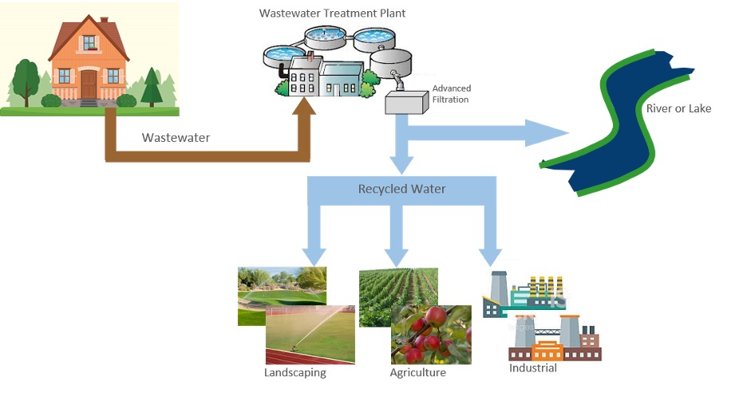Figure 1. Process of using advanced treatment to turn wastewater into municipal recycled water.

Q25 The following questions ask about use of municipal recycled water for irrigation of crops.
 | Yes (1) | No (2)
Are you willing to use municipal recycled water to irrigate non-edible plants? (1)
Do you have experience using municipal recycled water to irrigate non-edible plants? (2)
Are you willing to irrigate food crops using municipal recycled water if that water is not in direct contact with the food crop? (3)
Do you have experience using municipal recycled water to irrigate food crops not in direct contact with the recycled water? (4)
Are you willing to use municipal recycled water to irrigate food crops if that water is in direct contact with the food crop? (5)
Do you have experience using municipal recycled water to irrigate food crops in direct contact with recycled water? (6)

Q26 Below are statements about using municipal recycled water. Assuming municipal recycled water was available to you, please indicate if each statement motivates use, limits use, or neither motivates nor limits use of municipal recycled water to grow food crops.
 | Limits Use (1) | Motivates Use (4) | Neither Motivates nor Limits Use (2)
a. Health effects to greenhouse staff due to contact with municipal recycled water (1)
b. Health effects to customers who consume crops grown with municipal recycled water (2)
c. Customers' perceptions regarding the use of municipal recycled water (3)
d. Business partners' perceptions regarding the use of municipal recycled water (4)
e. Crop productivity compared to irrigation with conventional water (5)
f. Environmental impact (6)
g. Effect on water security (7)
h. Capital investments to allow use of municipal recycled water (8)
i. Operational costs (9)
j. Monetary incentives for use of municipal recycled water (10)
k. Prior experience with use of municipal recycled water (11)
l. Experience of other greenhouse growers in the United States of using municipal recycled water (12)
m. Experience of other greenhouse growers worldwide of using municipal recycled water (13)
n. Water quality of municipal recycled water (14)
o. Trustworthiness of laboratory test results about quality of municipal recycled water (15)
p. Regulatory oversight over quality of municipal recycled water (16)

End of Block: Section 3: Using Recycled Water in Greenhouse Operation

Start of Block: Section 4: Grower Profile

Q27 SECTION 4: GROWER PROFILE

Q28 Please provide the primary zipcode for the physical location of the greenhouses, which you own and/or manage:
________________________________________________________________

Q29 On average, what is your approximate annual total greenhouse operation net income?
- Less than $100,000 (1)
- $100,000 - $499,999 (2)
- $500,000 - $999,999 (3)
- $1 million - $4.99 million (7)
- $5 million - $14.99 million (6)
- $15 million or greater (5)

Q30 Approximately how many years have you been in the greenhouse growing industry?
________________________________________________________________

Q31 Age:
- 25 or younger (1)
- 26 - 35 (2)
- 36 - 45 (3)
- 46 - 55 (4)
- 56 - 65 (5)
- 66 - 75 (6)
- 76 or older (7)

Q32 Education:
- Some school education, no degree (1)
- High School graduate (2)
- Associate degree (3)
- Bachelor’s degree (4)
- Master’s degree (5)
- PhD or greater (6)
- Other, please specify: (7) ________________________________________________

End of Block: Section 4: Grower Profile

Start of Block: THANK YOU!

Q33 We value your participation in this survey. Thank you!

Q34 Please enter your preferred email address below, if you would like to participate in the drawing to win one of ten $50 Amazon gift cards or if you would like to receive a summary of the research results. Email addresses will be kept confidential and will not be shared or used for any other purpose.
________________________________________________________________

Display This Question:
If If Please enter your preferred email address below, if you would like to participate in the drawing to win one of ten $50 Amazon gift cards or if you would like to receive a summary of the resear... Text Response Is Not Empty

Q35 You have entered your email above. Would you like to:
 | My preferences:
 | Yes (1) | No (2)
Participate in the Amazon gift card drawing (1)
Receive a summary of the research results (2)

Q36 If there is any additional information you would like to add or feedback you wish to provide, please enter those notes in the textbox. Thank you.
________________________________________________________________
________________________________________________________________
________________________________________________________________
________________________________________________________________
________________________________________________________________

End of Block: THANK YOU!

