Supplementary materials

Improved nutrition and yield resilience will make Conservation Agriculture more attractive for Zambian smallholders

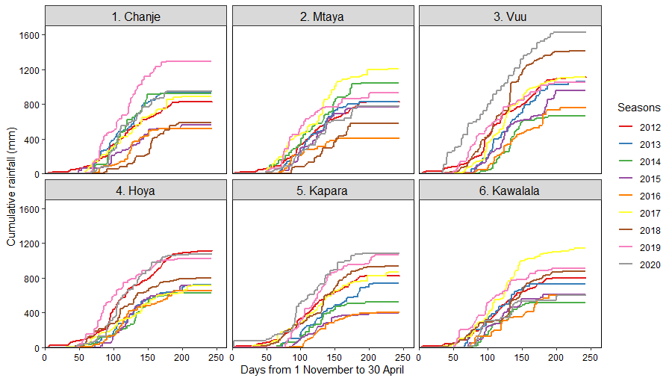
Fig . S1. Cumulative rainfall for the study communities recorded from 1 November to 30 April of the following year in the seasons 2012 to 2020
S2. Materials and methods
S2.1 Study area
Most farming systems are mixed crop-livestock systems (Dixon et al., 2001) with maize being the predominant crop besides extensive cattle (Bos taurus L.) rearing as the predominant ruminant farming (FAOSTAT, 2020). Besides maize, farmers grow a range of legumes such as common bean (Phaseolus vulgaris L.), cowpea, soybean and groundnut (Arachis hypogaea L.) and occasionally pigeonpea (Cajanus cajan (L.) Millsp.). Farmers also grow cotton (Gossypium hirsutum L), sunflower (Helianthus annuus L.) and tobacco (Nicotiana tabacum L.). Farmers have been exposed to different types of agro-forestry diversification with Winterthorn trees (Faidherbia albida Delile) and Gliricidia (Gliricidia sepium (Jacq.) Kunth ex Walp) which are occasionally growing in farmers’ fields.

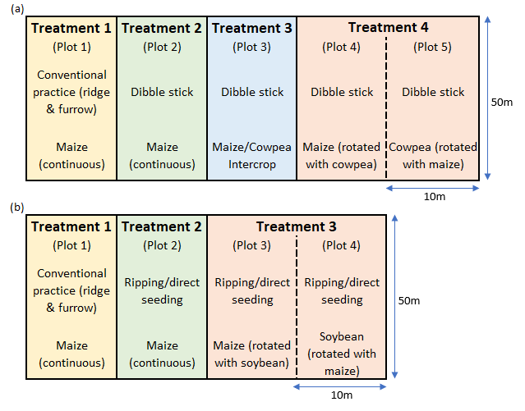
Fig. S2. Experimental layout at each farmer field for (a) manual-based and (b) animal traction-based experiments. Each farmer field was regarded as a replicate with either four or three treatments. The dashed line between plots signify that they are rotation plots and crops are alternated each season.

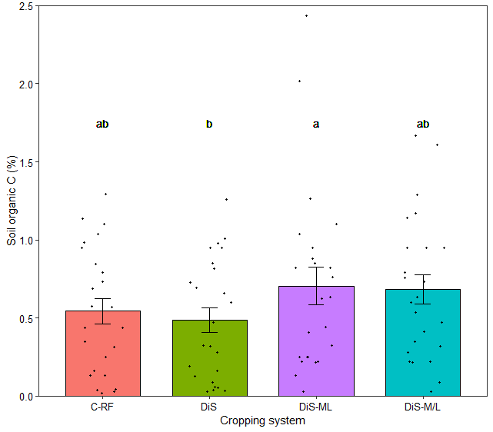

Fig. S3. Effects of different cropping systems on percentage soil organic carbon (C) as an average for
the 0-40 cm depth after eight seasons across communities that practiced manual systems. Columns
with different letters above them are significantly different from each other at 0.05 probability level.
The error bars represent standard error and the jittered points represent the individual observations.
Cropping systems descriptions: C-RF = ridge and furrow; Dis = dibble stick planting; DiS-ML = dibble stick planting plus maize-legume rotation; and DiS-M/L = dibble stick planting plus maize-legume intercropping

