Supplemental tables and figures for:

Root traits of cover crops and carbon inputs in an organic grain rotation

Joseph Pierre Amsili^{a,b}, Jason P. Kayeª

ª Department of Ecosystem Science and Management, Pennsylvania State University, 116 ASI,
University Park, PA, 16802, USA.
^{b} Section of Crop and Soil Sciences, School of Integrative Plant Science, Cornell University, 1001 Bradfield Hall, Ithaca, NY, 14853, USA.

*Corresponding author
Email address: jpa28@cornell.edu (Joseph Pierre Amsili)
Phone number: 607 592-1646
Fax number: 607 255-2644

Table S1 Mean cover crop root biomass carbon (kg C ha⁻¹) at each depth interval (0-5 cm, 5-20 cm, 20-40 cm) in fall 2016 and spring 2017. Mean root C results represent the average of in-row and between-row roots. Superscript letters indicate significance differences in root C among cover crop treatments at different depth intervals for fall 2016 and spring 2017 (P<0.05). Values in parentheses are 1 standard error of the mean.
Depth interval | Fall 2016
 | 5 spp. mix | Canola | Crimson Clover | Triticale
0-5 cm roots | 203^{b} (18) | 274^{ab} (41) | 104^{c} (5) | 333ª (13)
5-20 cm roots | 204 (58) | 301 (73) | 176 (12) | 316 (39)
20-40 cm roots | 93 (28) | 76 (16) | 93 (8) | 136 (23)
 | Spring 2017
 | 5 spp. mix | Canola | Crimson Clover | Triticale
0-5 cm roots | 373ª (19) | 362ª (65) | 140^{b} (17) | 441ª (26)
5-20 cm roots | 278^{b} (30) | 220^{b} (48) | 218^{b} (24) | 436ª (10)
20-40 cm roots | 86^{b} (7) | 112^{b} (10) | 101^{b} (15) | 201ª (25)

Table S2 Repeated measures mixed model analysis of cover crop R:S ratio. Fixed effects were cover crop, season, and cover crop by season interactions. Block was a random effect.
Effect | Sum Sq | Mean Sq | df | F | Pr(>F)
Cover crop | 0.847 | 0.282 | 3,18 | 30.42 | <.0001
Season | 0.060 | 0.060 | 1,3 | 7.40 | 0.0726
Cover crop ^{x} Season | 0.178 | 0.059 | 3,18 | 6.41 | 0.0038

Table S3 Between-row root carbon (kg C ha⁻¹) at each depth interval (0-5 cm, 5-20 cm, 20-40 cm) in fall 2016 and spring 2017. Superscript letters indicate significance differences in between-row root biomass C at different depth intervals for fall 2016 and spring 2017 (P<0.05). Values in parentheses are 1 standard error of the mean.
Depth interval | Fall 2016
 | 5 spp. mix | Canola | Crimson Clover | Triticale
0-5 cm roots | 63^{b} (12) | 51^{b} (2) | 38^{b} (3) | 238ª (49)
5-20 cm roots | 97^{b} (17) | 140^{b} (31) | 105^{b} (28) | 316^{s} (52)
20-40 cm roots | 76^{ab} (28) | 50^{b} (8) | 92^{ab} (18) | 137ª (25)
 | Spring 2017
 | 5 spp. mix | Canola | Crimson Clover | Triticale
0-5 cm roots | 373ª (19) | 362ª (65) | 140^{b} (17) | 441ª (26)
5-20 cm roots | 278^{b} (30) | 220^{b} (48) | 218^{b} (24) | 436ª (10)
20-40 cm roots | 86^{b} (7) | 112^{b} (10) | 101^{b} (15) | 201ª (25)

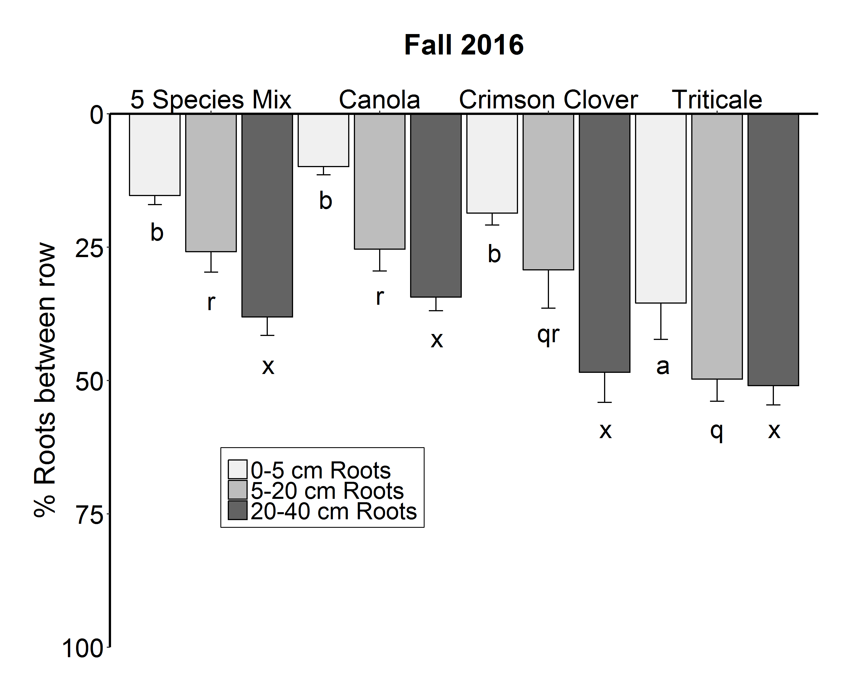
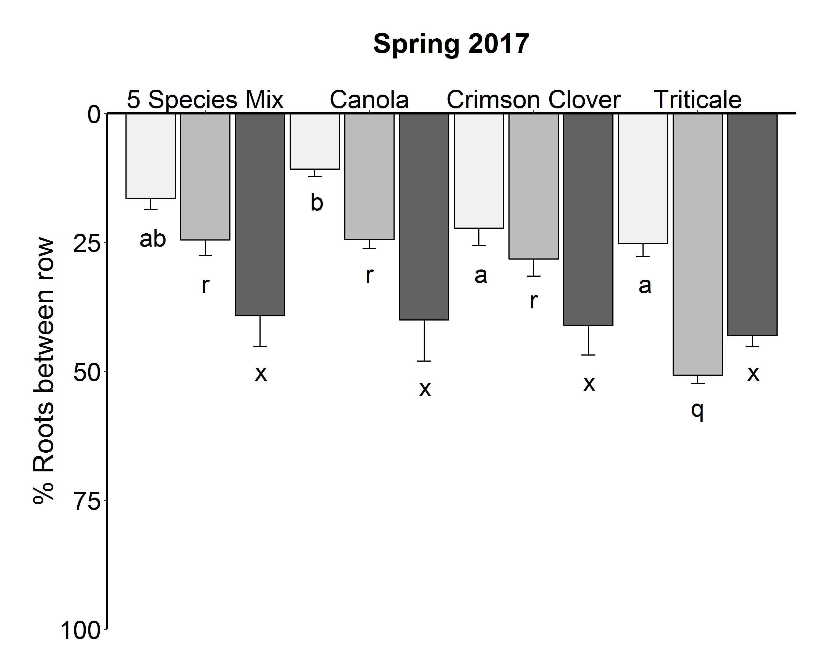

Fig. S1 The percent of total root carbon that was found in the between-row space at each depth interval (0-5 cm, 5-20 cm, 20-40 cm) in fall 2016 and spring 2017. Superscript letters indicate significance differences in the % of root carbon in the between-row space at different depth intervals for fall 2016 and spring 2017 (P<0.05).
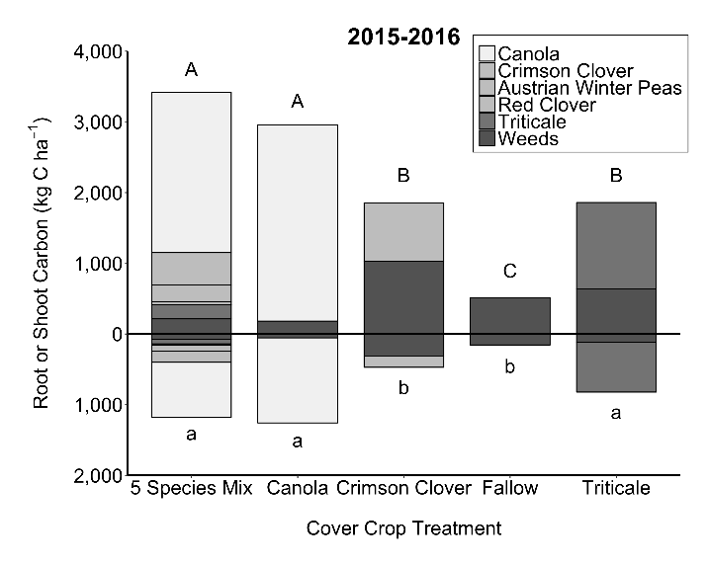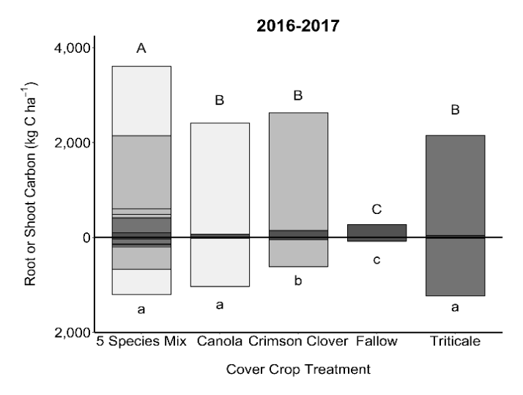
Fig. S2 Cover crop carbon inputs for the 2015-2016, 2016-2017 winter annual cover cropping windows. Carbon inputs were partitioned into shoot and root inputs.

Table S4 Species composition of 5 spp. mix sampling quadrats for root study and field scale aboveground biomass determination.
Cover crop | Fall 2016 |  | Spring 2017
 | Root quadrats | Field scale quadrats | Root quadrats | Field scale quadrats
CC | 46 % | 41 % | 48 % | 45 %
CA | 45 % | 44 % | 38 % | 42 %
TR | 5 % | 6 % | 13 % | 11 %
Pea | 4 % | 7 % | 1 % | 1 %

Table S5 Aboveground shoot carbon residues (kg C ha⁻¹) at different sampling dates. On 5/1/17, living tissues and dead residues were separated. All other dates show living and dead residues combined.
Treatment | Sampling date
 | 11/1/16 | 2/22/17 | 4/10/17 | 5/1/17 living | 5/1/17 residues
5spp Mix | 1,282 | 1,512 | 1,264 | 2,183 | 106
Canola | 990 | 599 | 644 | 1,379 | 36
Crimson  clover | 1,295 | 1,813 | 1,059 | 1,155 | 241
Triticale | 751 | 982 | 1,142 | 1,323 | 212

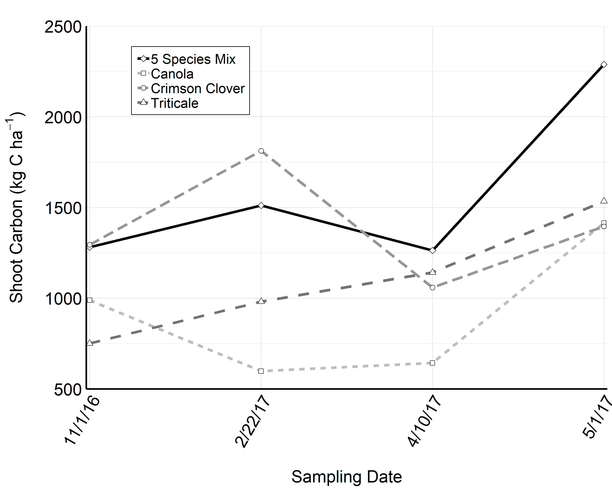Fig. S3 Total shoot carbon (kg C ha⁻¹) at different sampling dates. Samples include living biomass and residues.

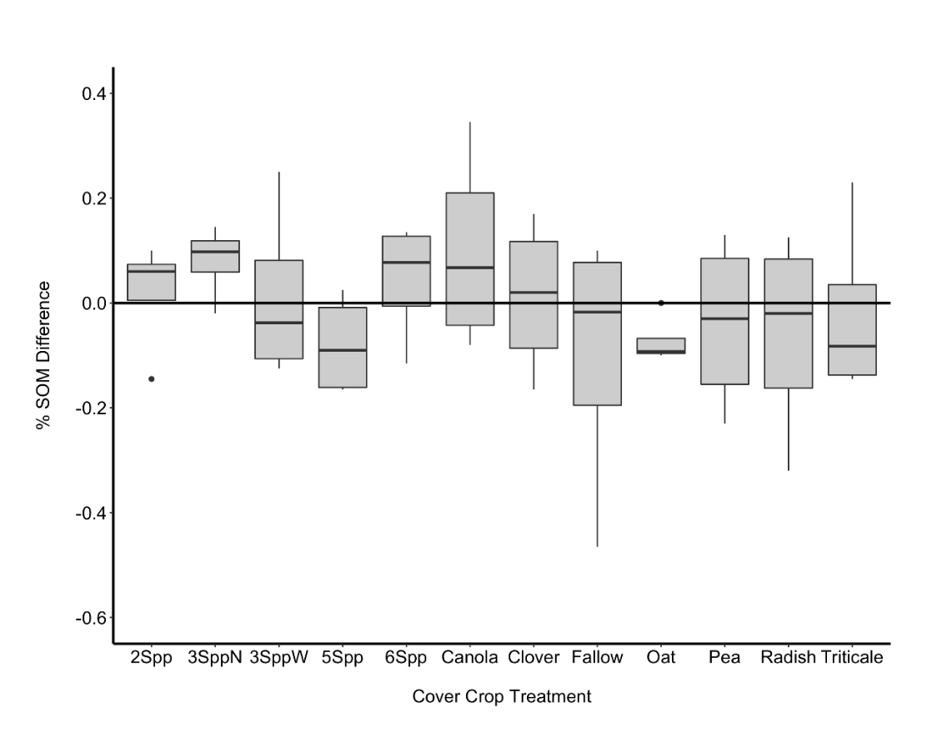
Fig. S4 % SOM differences between the beginning and end of a full three-year crop rotation. Sampling time was right at cover crop termination in early May for both beginning and end sampling dates.

