Table S.1. Field operations and sampling dates by each entry of the crop rotation.
Cropping Year | 2011 |  |  |  |  |  | 2012 |  |  |  | 2013
Winter Cover Crop ª | Hairy Vetch and Triticale (HVT) ^{b} |  |  |  |  |  | Cereal Rye ^{b} |  |  |  | Wheat
Cover Crop Termination Date | Early |  | Middle | Late |  |  | Early | Middle | Late
Planted winter crop | 3-Sep |  | 3-Sep | 3-Sep |  |  | 18-Oct | 18-Oct | 18-Oct |  | 24-Oct
First cover crop rolling | 31-May |  | 8-Jun | 15-Jun |  |  | 11-May | 21-May | 1-Jun
Planted cash crop | 1-Jun |  | 9-Jun | 16-Jun |  |  | 25-May | 6-Jun | 11-Jun
Second cover crop rolling |  |  |  |  |  |  | 25-May | 6-Jun | 11-Jun
Pitfall trapping | 27-Jun |  | 1-Jul | 11-Jul |  |  | 11-Jun | 25-Jun | 2-Jul |  | 17-Jun
First high residue cultivation | 5-Jul |  | 14-Jul | 20-Jul |  |  | 28-Jun | 5-Jul | 11-Jul
Second high residue cultivation |  |  |  |  |  |  | 5-Jul | 11-Jul | 18-Jul
Harvested cash crop | 7-Oct |  | 7-Oct | 7-Oct |  |  | 11-Oct | 11-Oct | 11-Oct |  | 16-Jul
Winter Cover Crop | Wheat |  |  |  |  |  | Hairy Vetch and Triticale (HVT) |  |  |  | Cereal Rye
Cover Crop Termination Date |  |  |  |  |  |  | Early | Middle | Late |  | Early | Middle |  | Late
Planted winter crop | 24-Oct |  |  |  |  |  | 1-Sep | 1-Sep | 1-Sep |  | 15-Oct | 15-Oct |  | 15-Oct
First cover crop rolling |  |  |  |  |  |  | 25-May | 7-Jun | 15-Jun |  | 24-May | 29-May |  | 4-Jun
Planted cash crop |  |  |  |  |  |  | 31-May | 7-Jun | 15-Jun |  | 31-May | 3-Jun |  | 17-Jun
Second cover crop rolling |  |  |  |  |  |  | 11-Jun | 14-Jun | 22-Jun |  | 31-May | 3-Jun |  | 17-Jun
Pitfall trapping | 20-Jun |  |  |  |  |  | 25-Jun | 25-Jun | 2-Jul |  | 24-Jun | 24-Jun |  | 9-Jul
First high residue cultivation |  |  |  |  |  |  | 28-Jun | 5-Jul | 11-Jul |  | 16-Jul | 16-Jul |  | 22-Jul
Second high residue cultivation |  |  |  |  |  |  | 5-Jul | 11-Jul | 18-Jul |  | 18-Jul | 18-Jul |  | 25-Jul
Harvested cash crop | 7-Jul |  |  |  |  |  | 1-Oct | 1-Oct | 1-Oct |  | 5-Oct | 5-Oct |  | 5-Oct
Winter Cover Crop | Cereal Rye |  |  |  |  |  | Wheat |  |  |  | Hairy Vetch and Triticale (HVT)
Cover Crop Termination Date | Early | Middle |  |  | Late |  |  |  |  |  | Early |  | Middle |  | Late
Planted winter crop | 22/23-Sep | 22/23-Sep |  |  | 22/23-Sep |  | 25-Oct |  |  |  | 30-Aug |  | 30-Aug |  | 30-Aug
First cover crop rolling | 25-May | 2-Jun |  |  | 13-Jun |  |  |  |  |  | 1-Jun |  | 6-Jun |  | 18-Jun
Planted cash crop | 26-May | 3-Jun |  |  | 14-Jun |  |  |  |  |  | 1-Jun |  | 6-Jun |  | 18-Jun
Second cover crop rolling |  |  |  |  |  |  |  |  |  |  | 12-Jun |  | 13-Jun |  | 26-Jun
Pitfall trapping | 13-Jun | 27-Jun |  |  | 11-Jul |  | 18-Jun |  |  |  | 24-Jun |  | 1-Jul |  | 5-Jul
First high residue cultivation | 5-Jul | 14-Jul |  |  | 20-Jul |  |  |  |  |  | 8-Jul |  | 16-Jul |  | 17-Jul
Second high residue cultivation | 14-Jul | 20-Jul |  |  | 28-Jul |  |  |  |  |  | 12-Jul |  | 18-Jul |  | 19-Jul
Harvested cash crop | 18-Oct | 18-Oct |  |  | 18-Oct |  | 9-Jul |  |  |  | 23-Sep |  | 23-Sep |  | 23-Sep
ª In this full-entry design, we planted every crop in every year, with a full rotation as follows: hairy vetch and triticale – corn – cereal rye – soybean – wheat.
^{b} The corn cash crop followed hairy vetch and triticale; the soybean cash crop followed cereal rye.
Table S.2. Total activity-density in each crop for species representing more than 1% of total activity-density, across the three years of the experiment, and after cover crop management.
 | Trophic Group^{b} |  | HVTª | Ryeª | Wheat
 |  | % of Total | n = 144 | n = 144 | n = 144
Bembidion quadrimaculatum oppositum (Say) | O | 49.05 | 429 | 113 | 334
Chlaenius tricolor tricolor (Dejean) | C | 11.42 | 153 | 36 | 15
Poecilus chalcites (Say) | C | 7.39 | 87 | 20 | 25
Poecilus lucublandus (Say) | C | 3.47 | 44 | 14 | 4
Pterostichus melanarius (Illiger) | O | 3.30 | 9 | 26 | 24
Bembidion rapidum (LeConte) | C | 2.86 | 33 | 16 | 2
Amara impuncticollis group | G | 2.63 | 27 | 15 | 5
Clivina bipustulata (Fabricius) | O | 2.02 | 34 | 2 | -
Pterostichus mutus (Say) | C | 1.96 | 29 | 4 | 2
Cicindela sexguttata (Fabricius) | C | 1.90 | 0 | 2 | 32
Agonum punctiforme (Say) | O | 1.68 | 29 | 0 | 1
Harpalus affinis (Shrank) | G | 1.40 | 3 | 6 | 16
Bembidion mimus (Hayward) | C | 1.23 | 16 | 5 | 1
Other Carabidae |  | 9.69 | 78 | 30 | 65
Total Number of Individuals |  |  | 971 | 289 | 526
Number of Species |  |  | 34 | 33 | 34
ª HVT = Rolled hairy vetch and triticale mixture; Rye = Cereal rye
^{b} Trophic Groups: C = Mostly carnivorous; G = Mostly granivorous; O = Mostly omnivorous

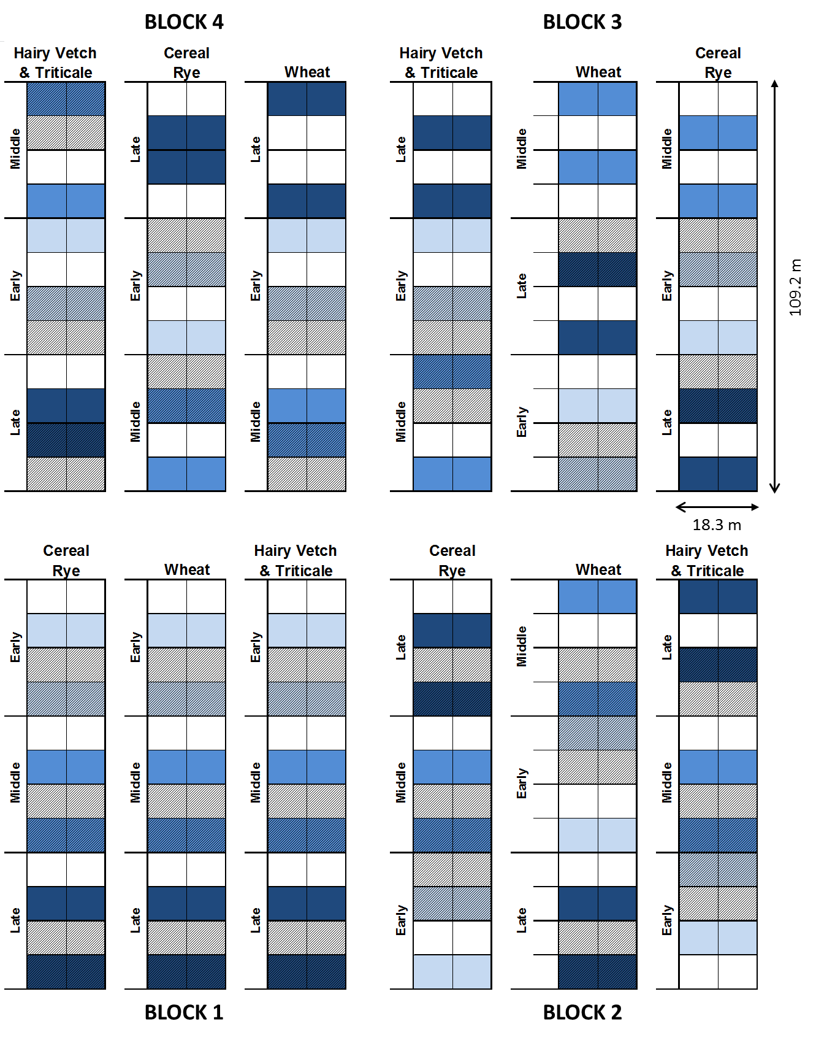
Figure S.1. Example plot map of the Reduced Tillage Organic Systems Experiment (ROSE), implemented in Central Pennsylvania in 2011-2013. The experiment was designed as part of a larger initiative to investigate multiple aspects of a cover crop approach to pest management, including two different tillage treatments, three different cover crop termination dates, and multiple cash crops and cash crop varieties. In the full entry design, meaning every crop was planted in every year, each block contained three full strips (2006 m² per strip) of a single crop. Within each crop, plots were initially split vertically for an expressive weed management treatment (employing a tine weeder). Then each strip was split in three to evaluate a cover crop termination date to allow for cash crop planting relative to standard planting dates in the region (early, middle, or late). These were then again split in two to evaluate crop varieties (not applicable to our experiment). The final split divided the plots to allow for the evaluation of two cultivation strategies: high residue cultivation compared to a no-high residue cultivation control in corn; and high residue cultivation compared to an alternative row spacing in soybean without high residue cultivation. The plots utilized for the experiment discussed herein are indicated in various shades of blue to distinguish between cover crop termination dates, and plots with shading received high residue cultivation. Each individual plot measured 9.1 by 9.1 m.

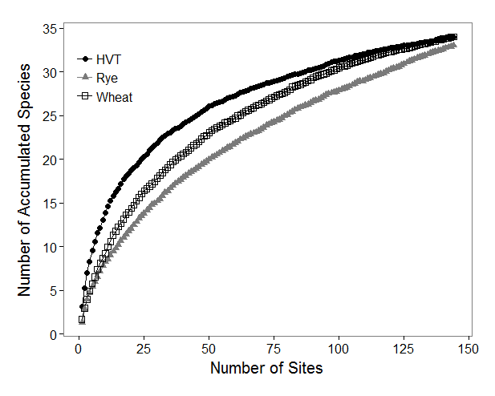
Figure S.2. Rarefaction curve by crop treatment. Overlapping 95% confidence intervals (not shown) indicate the total number of species captured in each crop are not significantly different. HVT = Rolled hairy vetch and triticale, Rye = Cereal rye.

