Supplemental data

Supplemental Figure 1. Effects of TN-C on P7 RGCs neurites. P7 retinal ganglion cells were purified by immunopanning and were cultured on different concentrations of Tnc under defined conditions. Neurites were tentatively measured after 36 hrs in less dense regions of the culture. Neurites were labelled with either ßIII-Tubulin (1:300) or with Neurofilament (1:300, NF) antibodies, followed by appropriate secondary antibodies coupled with Cy3 or Cy2. Arrowheads points at neurites from the RGCs. Mean average length of 10 longest fibers from each group was measured by tracing the entire length of the neurites from the edge of the explant: Means are ± S.D.. Note that Tnc reduced the promoting effect of LN in combined substrates. Significant differences were estimated with the Kruskall-Wallis test with risk 0,001. Post hoc differences were revealed with the Mann-Whitney U-test (n=12). ***p<0.001 from the PDL control; ⁺⁺p<0.001 as compared to LN. Scale bar, 50 µm.

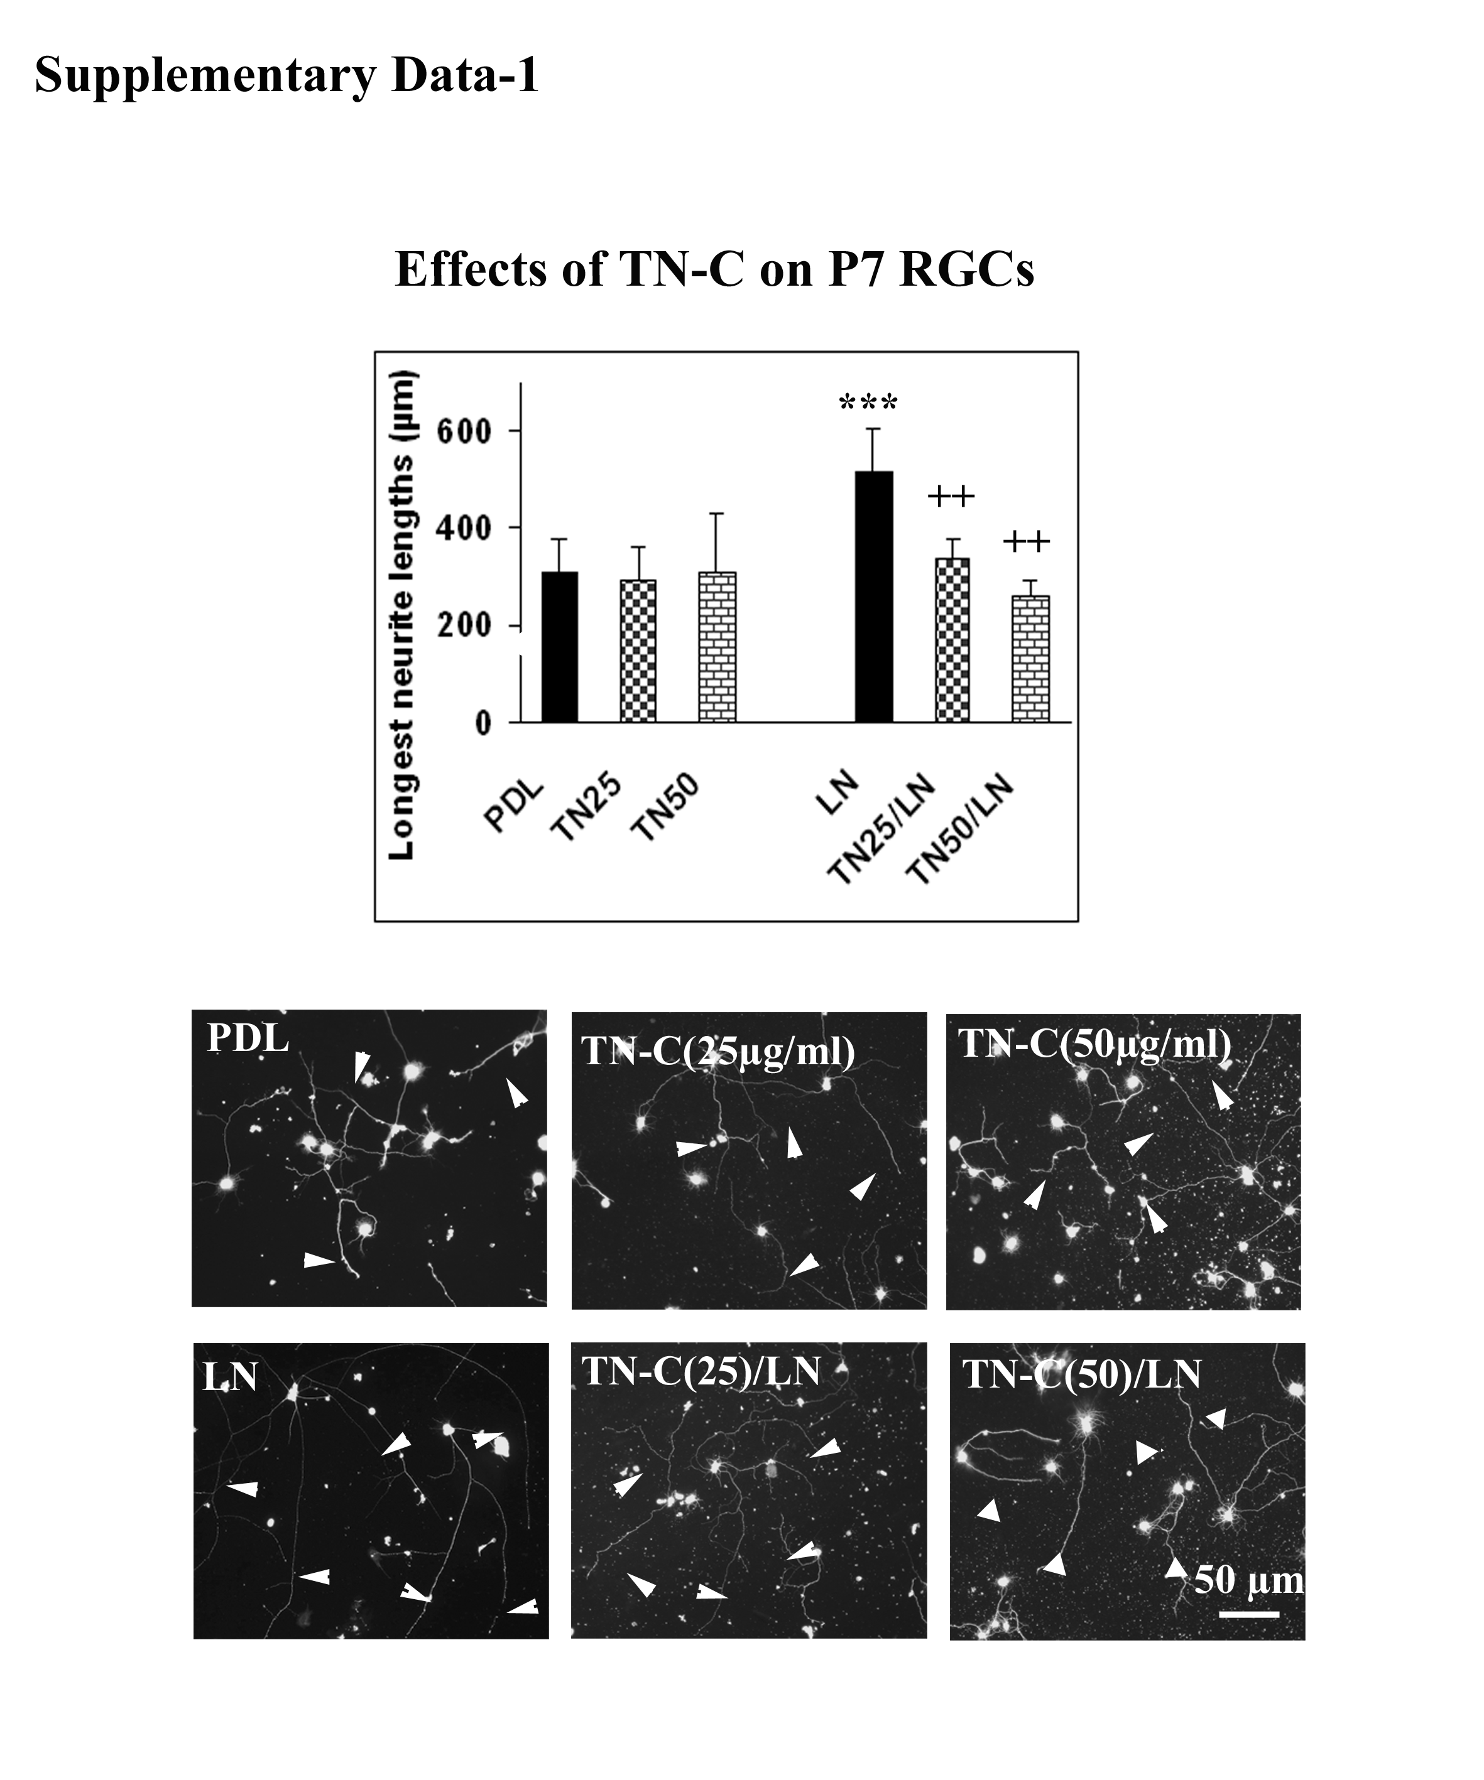

Supplemental Figure 2: Effects of TN-C Fc-recombinant proteins on P7 RGCs neurites. P7 retinal ganglion cells purified by immunopanning were cultured on different FNIII domains (15000 cells/ condition). Neurites were measured after 36 hrs of culture. All Neurites were labelled with either ßIII-Tubulin (1:300) or with Neurofilament (1:300, NF) antibodies, followed by appropriate secondary antibodies coupled with Cy3 or Cy2. Length of the longest neurite: TNfnA₁D significantly increased the average length of the 10 longest neurites, whereas TNfnA₁A₂-Fc remained neutral with regard to both neurite outgrowth parameters. In the presence of LN all TNfn-Fc recombinant proteins significantly decreased the neurite length. Arrowheads indicate neurites from the RGCs. Means are ± S.D. Significant differences were revealed by Kruskall-Wallis test with risk 0,001. Post-hoc differences were tested with the Mann-Whitney U-test. ⁺⁺⁺p<0.0001, ⁺⁺p<0.001 and ⁺p<0.01 from the Laminin control; ##p<0.01 and #p<0.02 compared to Fc-controls. Scale bar, 50 µm.
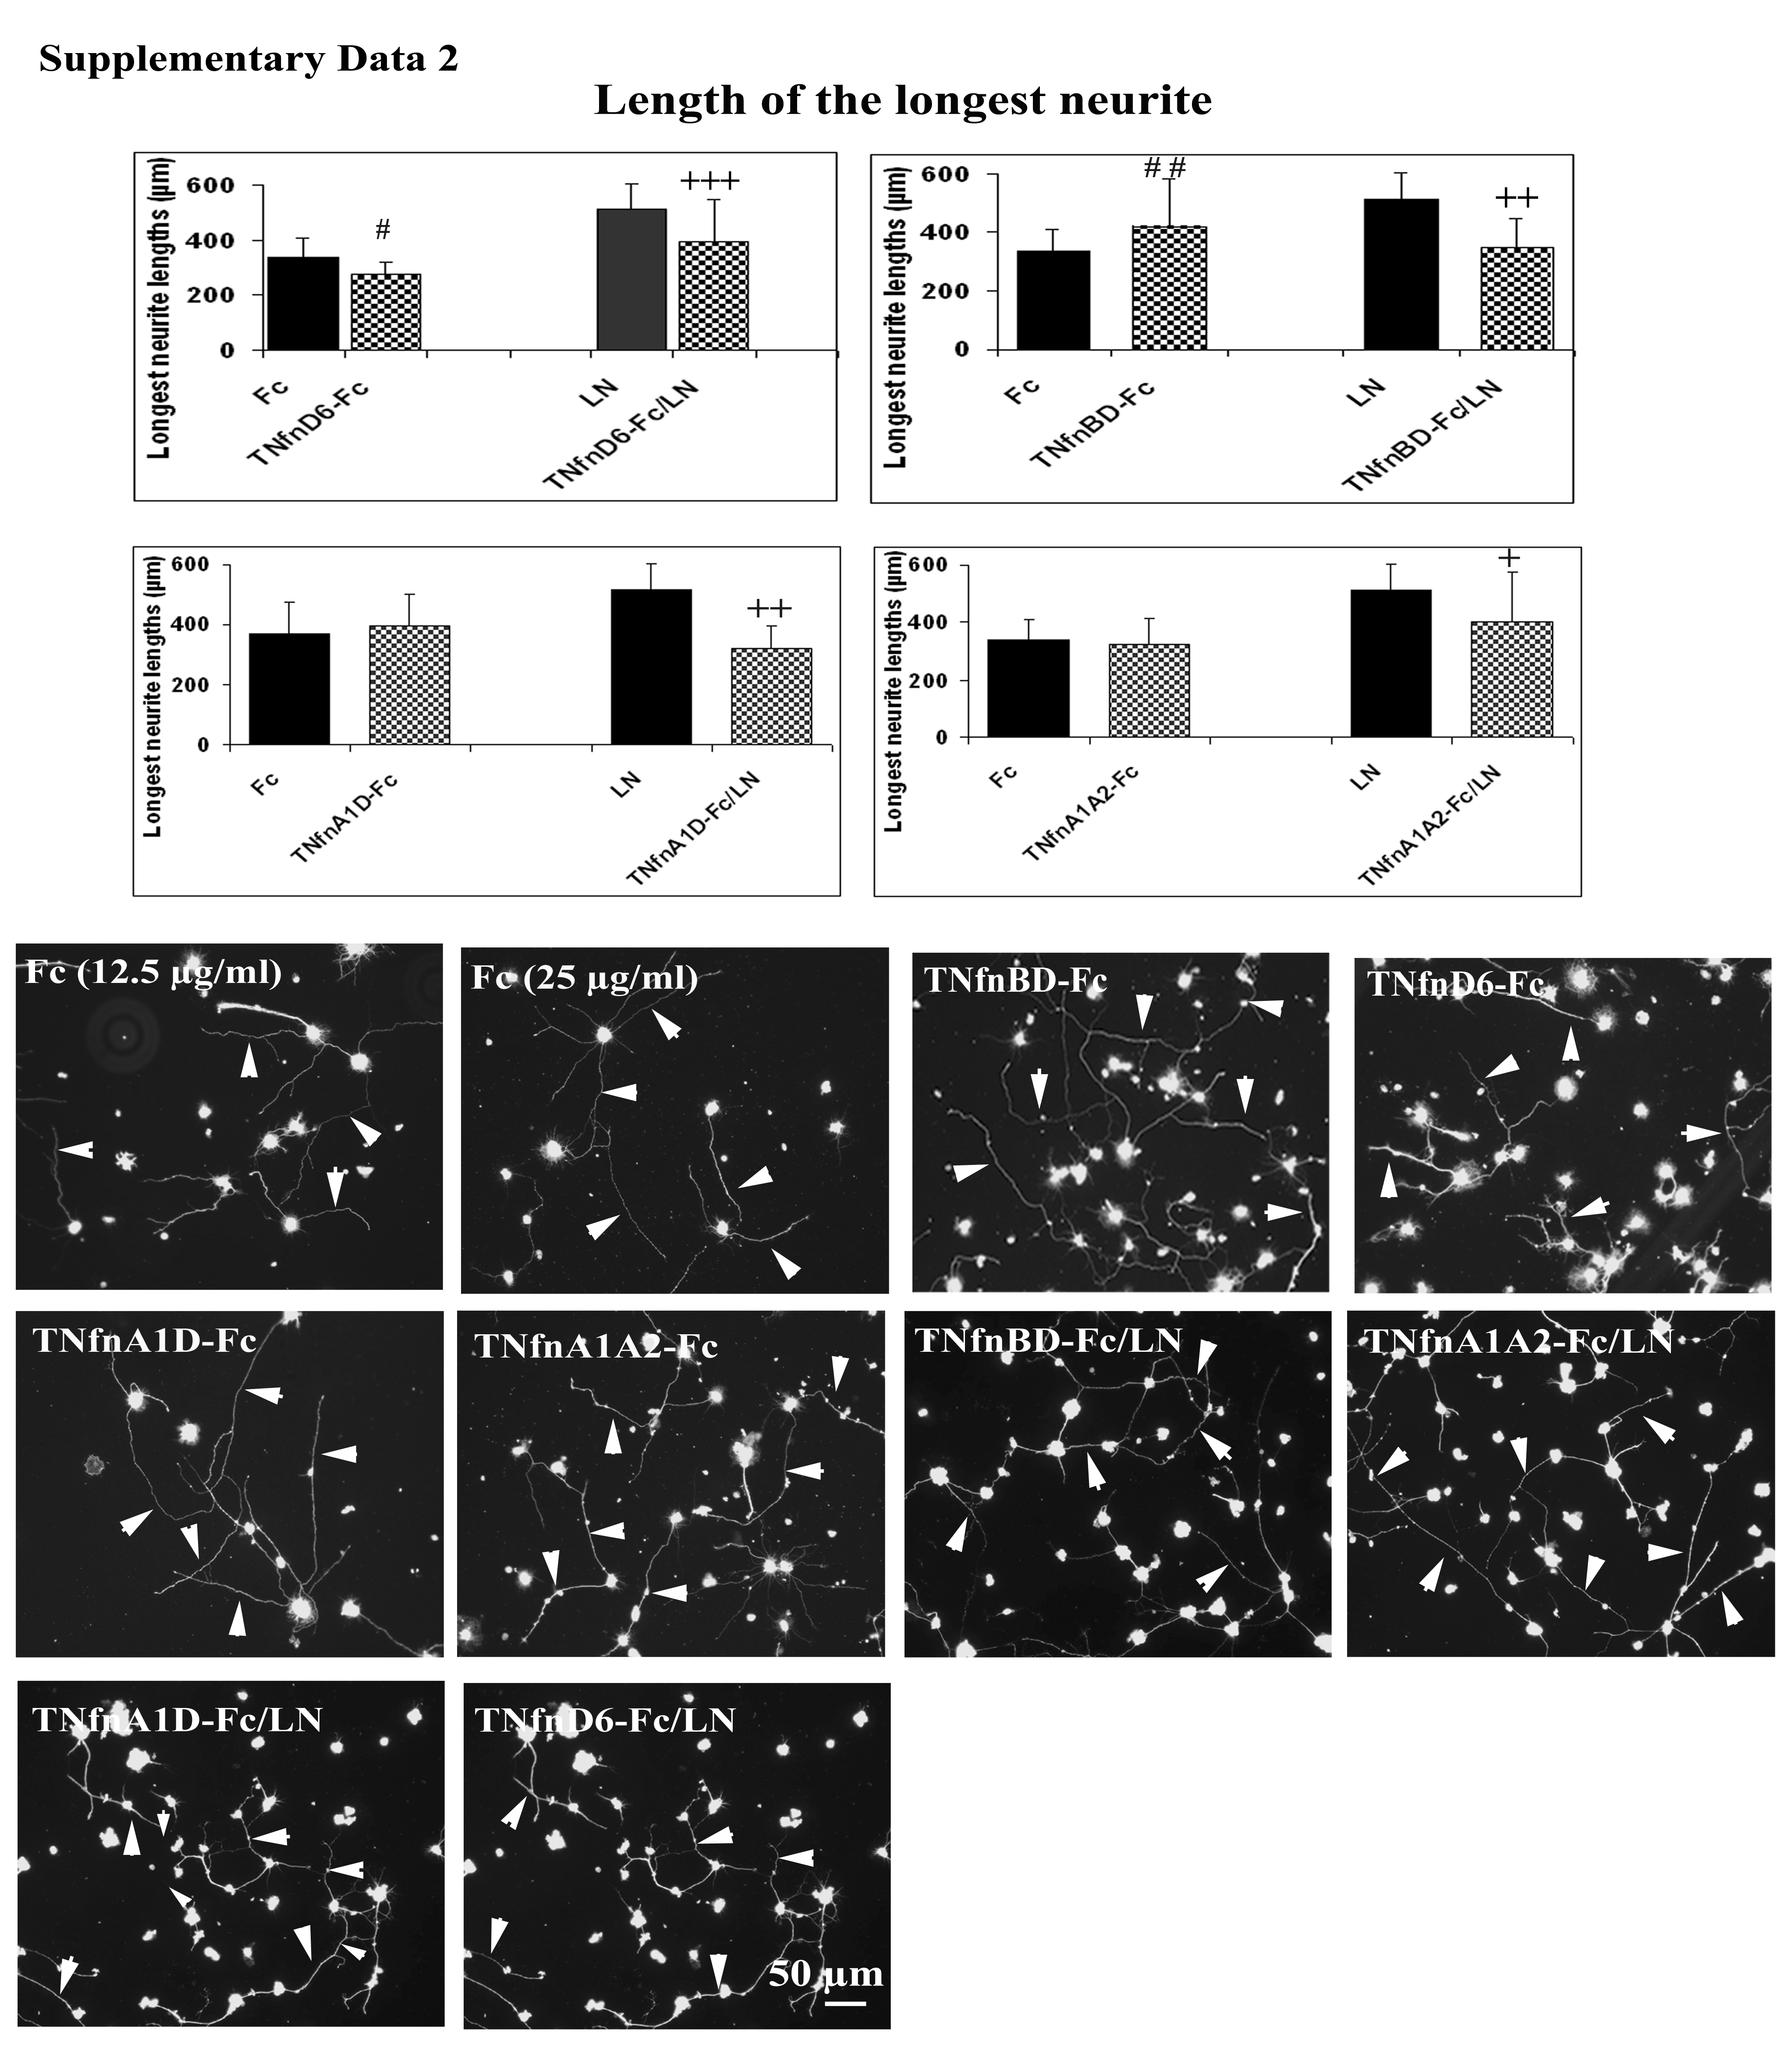

Supplemental Figure 3

