APPENDIX I
Research Context
We examined our hypotheses using data from knowledge-intensive manufacturing sectors, where scientific knowledge is embedded in firms’ product and processes (Cavaliere et al., 2015). In such sectors, high level of technical knowledge is required across the entire value chain functions, including manufacturing, sales and marketing (Bell, Crick, & Young, 2004; Lööf & Heshmati, 2002). Firms in knowledge-intensive manufacturing sector produce technologically sophisticated products such as electronic equipment, control systems, telecom equipment, industrial equipment, electric transformers, and electric machineries, and share 35 and 36 as two-digit Standard Industrial Classification (SIC) codes (Bell et al., 2004; Lööf & Heshmati, 2002). We have taken sample firms from these two-digit SIC codes. These two sectors are appropriate empirical context for this study as the high-valued knowledge embedded in people, product and processes of firms from these sectors emphasize the importance of learning. Knowledge accumulation and utilization is crucial for sustaining competitive advantage in these sectors (Cavaliere et al., 2015).

Data collection. We gathered data from several sources: Prowess, Thomson Reuters Eikon, India Business Insight, and Indian patent office. We identified publicly listed firms from the above-mentioned two sectors from the Prowess database, which is an established source of financial data for Indian firms (Chittoor & Aulakh, 2015). Financial data on variables such as market capitalization, total assets, net income, revenue, R&D investments, employee compensation, sales and general administration expenses (SG&A), debt, common equity, share prices, business and geographic segment names and other information were drawn from this database. We referred to the news data from Thomson Reuters Eikon and India Business Insight database (IBID) to extract information on diversification moves. Both Thomson Reuters Eikon and IBID provide summary of news related to the various corporate activities, including diversification, international expansion, alliances, and acquisitions, of publicly listed firms (Gertler & Horvath, 2018; Shukla, Mital, Qureshi, & Wang, 2020). The firms included in the sample engaged in a total of 1772 distinct diversification events during the period of 1998–2018, out of which 654 were related to product diversification whereas 1162 were related to international diversification. Detail of the coding the diversification events is presented in the next sub-section.
Further, to measure knowledge stock and absorptive capacity, patent data were collected from the Indian Patent Office (Haley & Haley, 2012), which publishes a weekly journal with information on filed patents and provides an interface to search patents based on various criteria.[1] We gathered information about all the patents granted to the focal firm until the end of 2018. Finally, we referred to Securities Data Company (SDC) Platinum database to cross-check that the diversification (product or international) events where mode of diversification was alliance, joint-venture, or acquisition, were also reported in this database. All the acquisition (389) and joint-venture (352) events and around ninety percent of the non-equity alliance events (80 out of 88) were also captured by the SDC Platinum database.[2]

Coding of diversification events. We found a total of 16182 news summaries related to distinct corporate events by the sample firms, for the period 1993–2018, from the Thomson Reuters Eikon and IBID databases. Two coders separately screened these news items and selected and coded diversification events. In the first step, coders excluded all futuristic news summaries which implied that a decision is to be taken in future. Next, other corporate events, such as corporate borrowing, plant restructuring, patenting, ecology and environment, and corporate social responsibilities, which did not relate to product or international diversification, were excluded. Further, coders excluded all events which were related to domestic expansion by the firm in their primary business lines (based on the four-digit standard industrial classification codes). The initial round of screening resulted in a total of 1962 product/international diversification events for the period 1993–2018. In the first iteration, the two coders agreed on around 98% of the 1962 events (i.e., 1920 out of 1962) that these events relate to either product or international diversification. Later, they discussed and resolved the cases of disagreement. Finally, the two coders classified events as product or international diversification based on the standard criteria: if an even involved venturing or expansion into a business segment different that the primary business segment of the focal firm it is classified as product diversification; if an event involved new or repeated investments in a country different than India, it is considered international diversification; if an event involved both moving into a new country and in the non-primary business segment, it is considered as both product and international diversification. Cohen's (1960) kappa statistics indicated that the inter-rater reliability of the coding process was 0.960 (p < 0.000). The coders resolved the cases of disagreement through discussion. In sum, out of the 1962 diversification events for the period 1993–2018, 719 events were classified as product diversification, 1199 events were classified as international diversification; and 44 were classified as both product and international diversification. Since, we considered the prior 10-year window to measure product and international diversification experiences, we have reported the information for the period 1998–2018 (i.e., 1772 diversification events) in the main text.

APPENDIX II
Description of Absorptive Capacity Measurement
Absorptive capacity refers to firms’ abilities to value, acquire, and utilize external knowledge and is reflected in firms’ extant knowledge stock and intellectual assets (Cohen & Levinthal, 1990; Dushnitsky & Lenox, 2005; Nieto & Quevedo, 2005). There have been several approaches to operationalize this construct, which include R&D intensity, patent-based measures, intellectual capital, and survey instruments (Cohen & Levinthal, 1990; Dushnitsky & Lenox, 2005; Nieto & Quevedo, 2005). However, extant literature emphasizes that a single measure may not be able to capture this construct comprehensively, as it reflects two dimensions: a.) firms’ abilities to identify and acquire external knowledge; b.) firms’ abilities to transform and utilize its knowledge into value (Nieto & Quevedo, 2005; Zahra & George, 2002). Hence, to better capture the multidimensionality of this construct, we considered two measures: i.) using patent data (e.g., Dushnitsky & Lenox, 2005); ii.) using the efficiency of value created through human, structural, and relational assets of the firm (Pulic, 2000).
Patent-based measures of absorptive capacity such as accumulated patent stock and diversity of patent classes reflects depth and diversity of a firm’s knowledge stock and capture its abilities to value and acquire external knowledge (Dushnitsky & Lenox, 2005; Nieto & Quevedo, 2005; Quintana-García & Benavides-Velasco, 2011). Compared to R&D intensity, which is the most widely used measure of absorptive capacity (Nieto & Quevedo, 2005; Tsai, 2001), patent-based measures are apparently more attractive proxies for absorptive capacity as they capture a firm’s learning potential based on the outcomes of the prior R&D investments (Dushnitsky & Lenox, 2005). In particular, we considered patent stock diversity as the primary measure of absorptive capacity, as it captures a firm’s abilities to process and absorb diverse knowledge (Quintana-García & Benavides-Velasco, 2011). We measured patent stock diversity using the Herfindahl index of diversification (Berry, 1975; Quintana-García & Benavides-Velasco, 2011). The expression for the Herfindahl index of diversification is as below:
Patent stock diversity = $1-{\sum_{i}{P}}_{i}^{2}$
Where P_{i} is the proportion of a firm’s accumulated patents (i.e. all granted patents till a time t) in technical field (i.e. patent class) i. The minimum value of the diversity is zero when all the accumulated patents are in a single technical field, whereas it can attain maximum value (closer to 1) when a firm has a highly diversified knowledge base across several technical fields. The international patent classifications (IPC) was used to measure diversity, where each four-digit IPC was considered a unique technical field and patents are classified into different technical fields accordingly (Huang & Chen, 2010; Lettl, Rost, & von Wartburg, 2009).
Additionally, a firm’s absorptive capacity can also be inferred from its intellectual assets (i.e., human, structural, and relational assets (Bontis, 1998)). Human assets, such as engineers, scientists, and managers, help firms identify, acquire, and utilize novel and diverse technological and market knowledge. Structural assets such as appropriate organizational structure, incentives, and information technology and knowledge management systems help firms absorb and manage knowledge from diverse businesses and geographies. Moreover, firms’ partnerships with buyers, suppliers, and complementors across diverse business segments and countries are useful in processing and acquiring external knowledge from these partners. Hence, in addition to patent-based measures, we measured absorptive capacity as intellectual capital efficiency, which captures a firm’s ability to utilize and transform knowledge that reside in its intellectual assets (e.g., human, structural, and relational assets) into value (Edvinsson & Sullivan, 1996; Pulic, 2000; Zahra & George, 2002). Whereas patent-based measures, such as patent stock diversity, capture firms’ abilities to identify and acquire external knowledge from diverse businesses and geographies, intellectual assets-based measures, such as intellectual capital efficiency, capture firms’ abilities to transform and utilize its knowledge acquired from diverse businesses and geographies.
We measured intellectual capital efficiency using the ‘intellectual capital efficiency’ component of the value added intellectual coefficient (VAICTM) model suggested by (Pulic, 2000). VAICTM is widely used model to measure focal firm’s overall value creation efficiency, i.e., value created by both tangible and intangible assets. (Lu, Wang, & Kweh, 2014; Pulic, 2000). This efficiency model comprises three factors: capital employed efficiency, human capital efficiency, and structural capital efficiency. Firm’s intellectual capital efficiency is derived by adding human capital efficiency and structural capital efficiency. The intellectual capital efficiency component of the VAICTM model appropriately measures a firm’s ability to convert its knowledge and intellectual assets into value.
Following prior studies (Lu et al., 2014; Pulic, 2000), we calculate intellectual capital efficiency in following steps. First, we calculated value added as sum of net income, compensation to employees, interest expenses, corporate taxes, depreciation, and amortisation. Second, we calculated structural capital by subtracting human capital, i.e., compensation to employees, from value added. Third, we calculated human capital efficiency by dividing value added by human capital. We calculated structural capital efficiency by dividing structural capital by value added. Finally, intellectual capital efficiency is calculated by adding human capital efficiency and structural capital efficiency.

APPENDIX III
Table A1. Measurement of variables used in this study
Variables | Measurement | References
Dependent Variables
Tobin’s Q | Ratio of market to book value of a firm’s assets, where market value is calculated as market value of common equity plus book value of assets minus book value of common equity. | Chang & Wang (2007)
ROA | Ratio of net profit to total assets | Delios and Beamish, (1999); Richard et al., (2009)
Independent Variables
Product diversification experience | The number of diversifications made by a firm in the product-market domain in last ten years | Haleblian & Finkelstein (1999); Nguyen & Cai (2016)
International diversification experience | The number of countries in which a firm diversified in last ten years. | Delios & Beamish (1999); Tallman & Li, (1996)
Product diversification experience unrelatedness | The ratio of the number of diversification moves made by a firm in the unrelated industries to the total number of diversification moves made the firm in last ten years | Haleblian & Finkelstein (1999); Nguyen & Cai (2016)
International diversification experience unrelatedness | The ratio of number of unique countries in which a firm has diversified to the total number of international diversification moves taken by a firm in last ten years. | Delios & Beamish (1999); Vachani (1991)
Patent stock diversity | Measured using the Herfindahl index of diversification of accumulated patents in different classes | Berry (1975); Quintana-García & Benavides-Velasco (2011); Dushnitsky & Lenox (2005)
Intellectual capital efficiency | Intellectual capital efficiency component of VAICTM model | Pulic (2000); Lu et al., (2014)
Control Variables
Firm size | Natural logarithm of firm’s total assets | Zahavi & Lavie ( 2013)
Firm age | Natural logarithm of the number of years since a firm was incorporated | Chakrabarti et al., (2007)
Leverage | Debt-to-equity ratio | Delios & Beamish (1999); Chakrabarti et al., (2007)
Current ratio | Ratio of current assets to current liabilities | Chakrabarti et al. (2007)
Business group affiliation | A dummy variable which captures whether a firm is affiliated to a business group or not | Khanna & Palepu, (2000); Kim et al., (2014)
R&D intensity | Ratio of a firm’s R&D investments to total sales | Zahavi & Lavie (2013)
Knowledge stock | The cumulative number of patents that a firm holds till the beginning of the focal year | Yamakawa et al., (2011)
Product diversity | Measured as the as entropy index of sales in different industries defined based on 4-digit SICs | Palepu (1985)
International diversity | Measured as the number of countries where a firm has operating subsidiaries. Log transformed to reduce skewness. | Delios & Beamish (1999); Tallman & Li, (1996)
Industry and Year dummies | Dummy variables for industries using two-digit SIC codes; and dummies for year | Su & Tsang, (2014)

APPENDIX IV
Results of the Heckman First Stage Probit Panel Models
For the first stage probit model, we created two separate binary dependent variables for product and international diversification decisions and regressed them on predictor variables in two separate models. Common regressors for both the models were firm size, firm age, leverage, operating margin (measured as the ratio of profit before interest and tax to sales), and ROA (Dastidar, 2009; Zahavi & Lavie, 2013), which can affect a firm’s diversification decisions in the product or international domain (Ahuja & Novelli, 2017; Dastidar, 2009; Hitt et al., 2006; Zahavi & Lavie, 2013). Additionally, we included two separate regressors for the product and international diversification models respectively: PDIVPCT (fraction of all firms in an industry (four-digit SIC) that were diversified in product market); IDIVPCT (fraction of all firms in an industry (four-digit SIC) that were diversified in international market) (Dastidar, 2009). These two variables indicate industry pressure to diversify and can affect a firm’s diversification decision but are less likely to be related with the firm performance; and thus serve as exclusion restrictions for the Heckman models (Dastidar, 2009). All the regressors were lagged by a year with respect to the dependent variables in the respective models.
Table B1. Heckman first stage probit panel model for product and international diversification
 | Probability of product diversification | Probability of international diversification
Firm size_{t-1} | 1.480*** | 2.591***
 | (0.177) | (0.250)
Firm age_{t-1} | 2.586*** | 0.495
 | (0.696) | (0.929)
Leverage_{t-1} | 0.017 | 0.004
 | (0.018) | (0.017)
Operating margin_{t-1} | -0.062 | 0.087
 | (0.075) | (0.310)
ROA_{t-1} | 0.127 | -0.900
 | (1.494) | (2.511)
PDIVPCT_{t-1} | 4.702*
 | (2.399)
IDIVPCT _{t-1} |  | -1.592
 |  | (2.611)
Year dummies | Yes | Yes
Industry dummies | Yes | Yes
Intercept | -24.206*** | -25.038***
 | (2.665) | (3.183)
n/N | 232/1282 | 232/1282
Log likelihood | -314.08 | -279.160
Notes: Unstandardized regression coefficients are reported with standard error in parenthesis. n=firm-year observations; N=firms. ROA = Return on Assets. PDIVPCT= fraction of all firms in an industry (four-digit standard industrial classification code) that were diversified in product market; IDIVPCT = fraction of all firms in an industry (four-digit standard industrial classification code) that were diversified in international market.
⁺ p < 0.1, * p < 0.05, ** p < 0.01, *** p < 0.001

The first model in the above table predicts the probability that a firm will diversify in product-market, and the second model predicts the probability that a firm will diversify in international market. Findings suggest that firm size (β = 1.480, p < 0.001), firm age (β = 2.586, p < 0.001) and PDIVPCT (β = 4.702, p < 0.05) are significant predictors of probability of product diversification. On the other hand, only firm size (β = 2.591, p < 0.001) is a significant predictor of probability of international diversification.
APPENDIX V
Robustness Checks and Additional Analysis
We used alternative estimation technique and variable measures to examine the robustness of our main findings. Hausman (1978) test suggested fixed-effect was not superior to random effects (Greene, 2003). Thus, we used random effect models, with robust standard errors, as an alternative estimation technique in the second stage of the Heckman. Our findings remained broadly consistent.^{[3]} Results of the random-effect models are presented in Tables C1–C4. Using this alternative estimation technique, we found support for the positive moderation effect of intellectual capital efficiency on the performance outcomes of both product diversification experience (Model B4: β = 0.107, p < 0.1; Model B9: β = 0.008, p < 0.02) and international diversification experience (Model B14: β = 0.287, p < 0.05; Model B19: β = 0.023, p < 0.000) for both measures of firm performance. The moderation effect of intellectual capital efficiency persists in full models (Models B5, B10, B15, B20) as well. Thus, both H1a and H1b are supported with this alternative estimation technique as well. However, the moderation effect of intellectual capital efficiency on the performance consequence of product diversification experience unrelatedness was not significant, though the coefficient of respective interaction terms were positive as expected (Models B23 and B27). The moderation effect of intellectual capital efficiency on the outcomes of international diversification experience unrelatedness was positive and significant for the Tobin’s Q model (Model B31: β = 0.042, p < 0.1). Thus, H2b was supported.
However, the moderation effects of patent stock diversity on performance effects of product and international diversification experience were not found significant with this alternative estimation technique in the second stage. Similarly, we did not observe significant moderation effect of patent stock diversity on the outcomes of unrelatedness in product and international diversification experiences. Considering that random-effect models with robust standard errors do not correct for the autocorrelated standard errors (Cuervo-Cazurra, 2008; Greene, 2003), we believe that one potential reason of this unexpected finding could be the presence of autocorrelation in the error terms of our models. FGLS, on the other hand, accounts for both heteroscedastic and autocorrelated error terms and allows modelling panel-specific autocorrelations as well. Nonetheless, the results of random-effect models suggest that findings related to the moderating effects of intellectual capital efficiency are robust to alternative estimation technique; thus, broadly supporting our arguments regarding positive moderation effect of absorptive capacity.
Additionally, we checked robustness of our findings using multiple alternative measures for the absorptive capacity. First, we considered patent stock (i.e. number of all granted patents till the beginning of the focal year) as an alternative measure of absorptive capacity (Dushnitsky & Lenox, 2005; McCann & Folta, 2011). Our findings remained similar to those with patent stock diversity. Next, following prior studies (Cohen & Levinthal, 1990; Nieto & Quevedo, 2005; Tsai, 2001), we measured absorptive capacity as the as average R&D intensity during last five years and reconducted the analysis. We found support for H2a (β_{Tobin’s Q} = 0.044, p < 0.05; β_{ROA} = 0.003, p < 0.01), but not for other hypotheses. In sum, our findings were broadly robust to both alternative estimation technique and alternative measures of absorptive capacity.
Finally, to check sensitivity of our findings with respect to the time frame (i.e., ten-year window) used to measure diversification experiences, we re-examined our hypotheses after considering five-year and fifteen-year time window to measure product and international diversification experiences and their unrelatedness. Our findings remained similar with the alternative operationalization of experience.

Table C1. Second stage random-effect models (with robust standard errors) for firm performance (Product diversification experience)
 | Dependent Variable = Tobin’s Q_{t+1} |  |  |  |  | Dependent Variable = ROA_{t+1}
Variable | Model B1 | Model B2 | Model B3 | Model B4 | Model B5 | Model B6 | Model B7 | Model B8 | Model B9 | Model B10
Firm size | -0.362* | -0.305* | -0.297** | -0.315* | -0.306** | 0.007 | 0.010 | 0.009 | 0.010 | 0.010
 | (0.141) | (0.127) | (0.111) | (0.129) | (0.114) | (0.006) | (0.007) | (0.007) | (0.007) | (0.007)
Firm age | -0.538⁺ | -0.471 | -0.444⁺ | -0.473 | -0.445⁺ | 0.013 | 0.016 | 0.015 | 0.016 | 0.015
 | (0.307) | (0.288) | (0.249) | (0.289) | (0.250) | (0.012) | (0.013) | (0.013) | (0.013) | (0.014)
Leverage | -0.002 | -0.002 | -0.002 | -0.001 | -0.002 | -0.000 | -0.000 | -0.000 | -0.000 | -0.000
 | (0.001) | (0.001) | (0.001) | (0.001) | (0.001) | (0.000) | (0.000) | (0.000) | (0.000) | (0.000)
Knowledge stock | 0.266* | 0.303* | 0.332 | 0.308* | 0.338⁺ | 0.004 | 0.006* | 0.003 | 0.006* | 0.003
 | (0.131) | (0.138) | (0.205) | (0.139) | (0.205) | (0.003) | (0.003) | (0.005) | (0.003) | (0.006)
Current ratio | 0.210⁺ | 0.229* | 0.231* | 0.228* | 0.230* | 0.066** | 0.067** | 0.067** | 0.067** | 0.067**
 | (0.114) | (0.109) | (0.104) | (0.109) | (0.104) | (0.023) | (0.023) | (0.023) | (0.023) | (0.023)
R&D intensity | 1.637 | 2.416 | 2.282 | 2.764 | 2.637 | 0.494 | 0.676* | 0.654* | 0.719* | 0.695*
 | (3.817) | (4.015) | (4.002) | (4.115) | (4.109) | (0.334) | (0.328) | (0.324) | (0.341) | (0.338)
Business group affiliation | -0.195 | -0.218 | -0.220 | -0.214 | -0.217 | 0.003 | 0.003 | 0.003 | 0.003 | 0.004
 | (0.197) | (0.202) | (0.217) | (0.202) | (0.216) | (0.011) | (0.011) | (0.012) | (0.011) | (0.012)
Product diversity | -0.032 | 0.018 | 0.006 | 0.016 | 0.004 | -0.008 | -0.005 | -0.004 | -0.007 | -0.006
 | (0.108) | (0.109) | (0.112) | (0.107) | (0.111) | (0.009) | (0.009) | (0.011) | (0.009) | (0.011)
IMR_PD | -0.287* | -0.264* | -0.256* | -0.267* | -0.259* | 0.008 | 0.010 | 0.010 | 0.010 | 0.010
 | (0.127) | (0.120) | (0.115) | (0.121) | (0.116) | (0.007) | (0.007) | (0.007) | (0.007) | (0.008)
Year dummies included | Yes | Yes | Yes | Yes | Yes | Yes | Yes | Yes | Yes | Yes
Industry dummy included | Yes | Yes | Yes | Yes | Yes | Yes | Yes | Yes | Yes | Yes
Product diversification experience |  | -0.235** | -0.193⁺ | -0.228** | -0.188⁺ |  | -0.008* | -0.008 | -0.009** | -0.008
 |  | (0.087) | (0.108) | (0.084) | (0.108) |  | (0.003) | (0.007) | (0.003) | (0.007)
Patent stock diversity |  |  | -0.055 |  | -0.058 |  |  | 0.006 |  | 0.005
 |  |  | (0.195) |  | (0.195) |  |  | (0.007) |  | (0.007)
Product diversification experience × Patent stock diversity (H1a) |  |  | -0.032  (0.044) |  | -0.030  (0.043) |  |  | (0.004) |  | -0.000  (0.004)
Intellectual capital efficiency |  |  |  | 0.054 | 0.054 |  |  |  | -0.006 | -0.006
 |  |  |  | (0.033) | (0.034) |  |  |  | (0.007) | (0.007)
Product diversification experience × Intellectual capital efficiency (H1a) |  |  |  | 0.107⁺  (0.064) | 0.109  (0.068) |  |  |  | 0.009*  (0.004) | 0.008*  (0.004)
Mean VIF | 2.78 | 2.84 | 3.18 | 2.79 | 3.15 |  | 2.84 | 3.18 | 2.80 | 3.15
n/N | 1005/190 | 1005/190 | 1005/190 | 1005/190 | 1005/190 | 1007/190 | 1007/190 | 1007/190 | 1007/190 | 1007/190
R² | 0.134 | 0.135 | 0.133 | 0.139 | 0.137 | 0.213 | 0.236 | 0.238 | 0.224 | 0.225
Wald χ² (p) | 0.000 | 0.000 | 0.000 | 0.000 | 0.000 | 0.000 | 0.000 | 0.000 | 0.000 | 0.000
Notes: Unstandardized regression coefficients are reported with robust standard errors in parenthesis. R² (between) is reported. Intercept terms are included but not shown. n=firm-year observations; N=firms. ROA = Return on Assets. R&D = research and development; IMR_PD = Inverse Mills Ratio (Product Diversification); H = Hypothesis; VIF = variance inflation factor.
+ p < 0.1, * p < 0.05, ** p < 0.01, *** p < 0.001

Table C2. Second stage random-effect models (with robust standard errors) for firm performance (International diversification experience)
 | Dependent Variable = Tobin’s Q_{t+1} |  |  |  |  | Dependent Variable = ROA_{t+1}
Variable | Model B11 | Model B12 | Model B13 | Model B14 | Model B15 | Model B16 | Model B17 | Model B18 | Model B19 | Model B20
Firm size | -0.349* | -0.333* | -0.332* | -0.363* | -0.360* | 0.005 | 0.005 | 0.005 | 0.004 | 0.004
 | (0.151) | (0.162) | (0.149) | (0.168) | (0.155) | (0.004) | (0.004) | (0.004) | (0.004) | (0.004)
Firm age | -0.017 | -0.016 | 0.007 | 0.014 | 0.034 | -0.001 | -0.001 | -0.002 | -0.001 | -0.002
 | (0.114) | (0.114) | (0.096) | (0.112) | (0.097) | (0.007) | (0.007) | (0.007) | (0.007) | (0.007)
Leverage | -0.001 | -0.001 | -0.002 | -0.001 | -0.001 | -0.000 | -0.000 | -0.000 | -0.000 | -0.000
 | (0.001) | (0.001) | (0.001) | (0.001) | (0.001) | (0.000) | (0.000) | (0.000) | (0.000) | (0.000)
Knowledge stock | 0.227* | 0.232* | 0.287 | 0.259* | 0.308 | 0.005* | 0.005* | 0.002 | 0.007** | 0.003
 | (0.115) | (0.114) | (0.191) | (0.117) | (0.192) | (0.002) | (0.002) | (0.005) | (0.002) | (0.005)
Current ratio | 0.198⁺ | 0.200⁺ | 0.209⁺ | 0.210⁺ | 0.218* | 0.066** | 0.066** | 0.067** | 0.069** | 0.069**
 | (0.116) | (0.116) | (0.109) | (0.113) | (0.107) | (0.023) | (0.023) | (0.024) | (0.023) | (0.024)
R&D intensity | 0.938 | 1.321 | 0.592 | 2.335 | 1.638 | 0.457 | 0.505 | 0.445 | 0.665⁺ | 0.623⁺
 | (3.565) | (3.825) | (3.751) | (3.973) | (3.869) | (0.344) | (0.362) | (0.350) | (0.370) | (0.366)
Business group affiliation | -0.251 | -0.259 | -0.286 | -0.263 | -0.286 | 0.002 | 0.002 | 0.003 | 0.002 | 0.003
 | (0.230) | (0.229) | (0.250) | (0.229) | (0.250) | (0.010) | (0.011) | (0.011) | (0.011) | (0.011)
International diversity | 0.004 | 0.009 | -0.004 | 0.044 | 0.031 | 0.001 | 0.002 | -0.000 | 0.003 | 0.002
 | (0.085) | (0.084) | (0.078) | (0.085) | (0.077) | (0.007) | (0.007) | (0.007) | (0.006) | (0.006)
IMR_ID | -0.232* | -0.228⁺ | -0.218⁺ | -0.243* | -0.234* | 0.005⁺ | 0.005⁺ | 0.006⁺ | 0.004 | 0.004
 | (0.117) | (0.119) | (0.113) | (0.123) | (0.117) | (0.003) | (0.003) | (0.003) | (0.003) | (0.003)
Year dummies included | Yes | Yes | Yes | Yes | Yes | Yes | Yes | Yes | Yes | Yes
Industry dummy included | Yes | Yes | Yes | Yes | Yes | Yes | Yes | Yes | Yes | Yes
International diversification experience |  | -0.054 | 0.080 | -0.104 | 0.014 |  | -0.001 | 0.003 | -0.007⁺ | -0.003
 |  | (0.116) | (0.138) | (0.101) | (0.126) |  | (0.004) | (0.007) | (0.004) | (0.006)
Patent stock diversity |  |  | -0.049 |  | -0.052 |  |  | 0.009 |  | 0.010
 |  |  | (0.195) |  | (0.192) |  |  | (0.006) |  | (0.006)
International diversification experience × Patent stock diversity (H1b) |  |  | -0.138  (0.090) |  | -0.118  (0.081) |  |  | -0.005  (0.004) |  | -0.003  (0.004)
Intellectual capital efficiency |  |  |  | 0.172* | 0.163* |  |  |  | 0.003 | 0.003
 |  |  |  | (0.074) | (0.077) |  |  |  | (0.005) | (0.005)
International diversification experience × Intellectual capital efficiency (H1b) |  |  |  | 0.288*  (0.129) | 0.270*  (0.137) |  |  |  | 0.023***  (0.006) | 0.022***  (0.006)
Mean VIF | 2.53 | 2.58 | 2.68 | 2.57 | 2.68 | 2.53 | 2.58 | 2.68 | 2.57 | 2.68
n/N | 999/189 | 999/189 | 999/189 | 999/189 | 999/189 | 1001/189 | 1001/189 | 1001/189 | 1001/189 | 1001/189
R² | 0.117 | 0.116 | 0.125 | 0.124 | 0.130 | 0.205 | 0.207 | 0.213 | 0.209 | 0.216
Wald χ² (p) | 0.000 | 0.000 | 0.000 | 0.000 | 0.000 | 0.000 | 0.000 | 0.000 | 0.000 | 0.000
Notes: Unstandardized regression coefficients are reported with robust standard errors in parenthesis. R² (between) is reported. Intercept terms are included but not shown. n=firm-year observations; N=firms. ROA = Return on Assets. R&D = research and development; IMR_ID = Inverse Mills Ratio (International Diversification); H = Hypothesis; VIF = variance inflation factor.
+ p < 0.1, * p < 0.05, ** p < 0.01, *** p < 0.001

Table C3. Second stage random-effect models (with robust standard errors) for firm performance (Product diversification experience unrelatedness)
Variable | Dependent Variable = Tobin’s Q_{t+1} |  |  |  | Dependent Variable = ROA_{t+1}
 | Model B21 | Model B22 | Model B23 | Model B24 | Model B25 | Model B26 | Model B27 | Model B28
Firm size | -0.353* | -0.349** | -0.364** | -0.361** | 0.007 | 0.006 | 0.004 | 0.003
 | (0.138) | (0.121) | (0.140) | (0.123) | (0.006) | (0.006) | (0.006) | (0.006)
Firm age | -0.514⁺ | -0.502⁺ | -0.489⁺ | -0.481⁺ | 0.013 | 0.012 | 0.015 | 0.013
 | (0.300) | (0.257) | (0.295) | (0.254) | (0.012) | (0.012) | (0.013) | (0.012)
Leverage | -0.001 | -0.001 | -0.001 | -0.001 | -0.000 | -0.000 | -0.000 | -0.000
 | (0.001) | (0.001) | (0.001) | (0.001) | (0.000) | (0.000) | (0.000) | (0.000)
Knowledge stock | 0.272* | 0.297 | 0.272* | 0.292 | 0.004 | -0.000 | 0.006* | 0.001
 | (0.132) | (0.199) | (0.131) | (0.198) | (0.003) | (0.005) | (0.002) | (0.005)
Current ratio | 0.197⁺ | 0.197⁺ | 0.192⁺ | 0.191⁺ | 0.066** | 0.066** | 0.066** | 0.066**
 | (0.116) | (0.109) | (0.115) | (0.109) | (0.023) | (0.023) | (0.024) | (0.024)
R&D intensity | 1.081 | 0.856 | 1.293 | 1.054 | 0.488 | 0.522 | 0.557⁺ | 0.588⁺
 | (3.617) | (3.565) | (3.617) | (3.556) | (0.338) | (0.338) | (0.331) | (0.329)
Business group affiliation | -0.169 | -0.167 | -0.153 | -0.151 | 0.002 | 0.002 | 0.005 | 0.005
 | (0.190) | (0.208) | (0.189) | (0.207) | (0.011) | (0.011) | (0.011) | (0.011)
Product diversity | -0.024 | -0.027 | -0.012 | -0.013 | -0.009 | -0.007 | -0.008 | -0.007
 | (0.110) | (0.114) | (0.110) | (0.114) | (0.010) | (0.010) | (0.010) | (0.010)
IMR_PD | -0.288* | -0.284* | -0.294* | -0.291* | 0.008 | 0.008 | 0.007 | 0.006
 | (0.127) | (0.121) | (0.128) | (0.122) | (0.007) | (0.007) | (0.006) | (0.006)
Year dummies included | Yes | Yes | Yes | Yes | Yes | Yes | Yes | Yes
Industry dummy included | Yes | Yes | Yes | Yes | Yes | Yes | Yes | Yes
Product diversification experience unrelatedness | -0.094⁺ | -0.083⁺ | -0.084⁺ | -0.074 | 0.001 | -0.000 | 0.002 | 0.001
 | (0.049) | (0.048) | (0.050) | (0.049) | (0.004) | (0.004) | (0.004) | (0.004)
 | (0.187) | (0.207) | (0.183) | (0.203) | (0.012) | (0.013) | (0.012) | (0.013)
Patent stock diversity |  | -0.045 |  | -0.032 |  | 0.006 |  | 0.008
 |  | (0.205) |  | (0.204) |  | (0.006) |  | (0.006)
Product diversification experience unrelatedness × Patent stock diversity (H2a) |  | -0.030  (0.033) |  | -0.032  (0.033) |  | 0.003  (0.002) |  | 0.003  (0.003)
Intellectual capital efficiency |  |  | 0.089** | 0.088*** |  |  | 0.012** | 0.012**
 |  |  | (0.027) | (0.025) |  |  | (0.005) | (0.005)
Product diversification experience unrelatedness × Intellectual capital efficiency (H2a) |  |  | 0.015  (0.022) | 0.012  (0.022) |  |  | 0.004  (0.004) | 0.004  (0.004)
Mean VIF | 2.84 | 2.80 | 2.73 | 2.71 | 2.84 | 2.80 | 2.73 | 2.71
n/N | 1005/190 | 1005/190 | 1005/190 | 1005/190 | 1007/190 | 1007/190 | 1007/190 | 1007/190
R² | 0.131 | 0.132 | 0.133 | 0.133 | 0.213 | 0.222 | 0.220 | 0.300
Wald χ² (p) | 0.000 | 0.000 | 0.000 | 0.000 | 0.000 | 0.000 | 0.000 | 0.000
Notes: Unstandardized regression coefficients are reported with robust standard errors in parenthesis. R² (between) is reported. Intercept terms are included but not shown. n=firm-year observations; N=firms. ROA = Return on Assets. R&D = research and development; IMR_PD = Inverse Mills Ratio (Product Diversification); H = Hypothesis; VIF = variance inflation factor.
+ p < 0.1, * p < 0.05, ** p < 0.01, *** p < 0.001

Table C4. Second stage random-effect models (with robust standard errors) for firm performance (International diversification experience unrelatedness)
Variable | Dependent Variable = Tobin’s Q_{t+1} |  |  |  | Dependent Variable = ROA_{t+1}
 | Model B29 | Model B30 | Model B31 | Model B32 | Model B33 | Model B34 | Model B35 | Model B36
Firm size | -0.359* | -0.346* | -0.367* | -0.355* | 0.005 | 0.004 | 0.002 | 0.001
 | (0.156) | (0.145) | (0.158) | (0.147) | (0.004) | (0.004) | (0.003) | (0.003)
Firm age | -0.031 | -0.012 | 0.009 | 0.025 | -0.002 | -0.003 | 0.003 | 0.002
 | (0.120) | (0.102) | (0.117) | (0.101) | (0.007) | (0.007) | (0.007) | (0.007)
Leverage | -0.002 | -0.002 | -0.001 | -0.001 | -0.000 | -0.000 | -0.000 | -0.000
 | (0.001) | (0.001) | (0.001) | (0.001) | (0.000) | (0.000) | (0.000) | (0.000)
Knowledge stock | 0.226* | 0.261 | 0.226* | 0.255 | 0.004⁺ | -0.000 | 0.006** | 0.001
 | (0.115) | (0.183) | (0.115) | (0.182) | (0.002) | (0.005) | (0.002) | (0.004)
Current ratio | 0.182 | 0.187 | 0.180 | 0.184 | 0.066** | 0.065** | 0.066** | 0.065**
 | (0.122) | (0.115) | (0.120) | (0.113) | (0.023) | (0.023) | (0.023) | (0.023)
R&D intensity | 0.839 | 0.867 | 0.979 | 1.001 | 0.356 | 0.349 | 0.395 | 0.389
 | (3.602) | (3.610) | (3.591) | (3.595) | (0.344) | (0.341) | (0.332) | (0.329)
Business group affiliation | -0.236 | -0.243 | -0.222 | -0.228 | 0.003 | 0.003 | 0.005 | 0.005
 | (0.221) | (0.239) | (0.220) | (0.238) | (0.011) | (0.011) | (0.011) | (0.011)
International diversity | -0.007 | -0.006 | 0.002 | 0.003 | -0.000 | -0.000 | 0.001 | 0.001
 | (0.082) | (0.082) | (0.083) | (0.083) | (0.006) | (0.006) | (0.006) | (0.006)
IMR_ID | -0.219* | -0.217* | -0.223* | -0.221* | 0.006⁺ | 0.006⁺ | 0.005 | 0.005
 | (0.108) | (0.105) | (0.110) | (0.106) | (0.004) | (0.004) | (0.003) | (0.003)
Year dummies included | Yes | Yes | Yes | Yes | Yes | Yes | Yes | Yes
Industry dummy included | Yes | Yes | Yes | Yes | Yes | Yes | Yes | Yes
International diversification experience unrelatedness | 0.118 | 0.122 | 0.115 | 0.118 | 0.007 | 0.006 | 0.007 | 0.005
 | (0.083) | (0.085) | (0.082) | (0.084) | (0.005) | (0.005) | (0.005) | (0.005)
Patent stock diversity |  | -0.114 |  | -0.102 |  | 0.012⁺ |  | 0.014*
 |  | (0.184) |  | (0.182) |  | (0.007) |  | (0.006)
International diversification experience unrelatedness × Patent stock diversity (H2b) |  | 0.038  (0.059) |  | 0.040  (0.057) |  | -0.005  (0.004) |  | -0.007  (0.004)
Intellectual capital efficiency |  |  | 0.083** | 0.080*** |  |  | 0.013** | 0.014**
 |  |  | (0.025) | (0.024) |  |  | (0.005) | (0.005)
International diversification experience unrelatedness × Intellectual capital efficiency (H2b) |  |  | 0.042⁺  (0.025) | 0.044⁺  (0.025) |  |  | -0.004  (0.004) | -0.004  (0.004)
Mean VIF | 2.48 | 2.52 | 2.59 | 2.62 | 2.48 | 2.52 | 2.59 | 2.62
n/N | 999/189 | 999/189 | 999/189 | 999/189 | 1001/189 | 1001/189 | 1001/189 | 1001/189
R² | 0.121 | 0.121 | 0.122 | 0.121 | 0.198 | 0.207 | 0.207 | 0.220
Wald χ² (p) | 0.000 | 0.000 | 0.000 | 0.000 | 0.000 | 0.000 | 0.000 | 0.000
Notes: Unstandardized regression coefficients are reported with robust standard errors in parenthesis. R² (between) is reported. Intercept terms are included but not shown. n=firm-year observations; N=firms. ROA = Return on Assets. R&D = research and development; IMR_ID = Inverse Mills Ratio (International Diversification); H = Hypothesis; VIF = variance inflation factor.
⁺ p < 0.1, * p < 0.05, ** p < 0.01, *** p < 0.001

APPENDIX VI
Figures Depicting the Moderation Effects

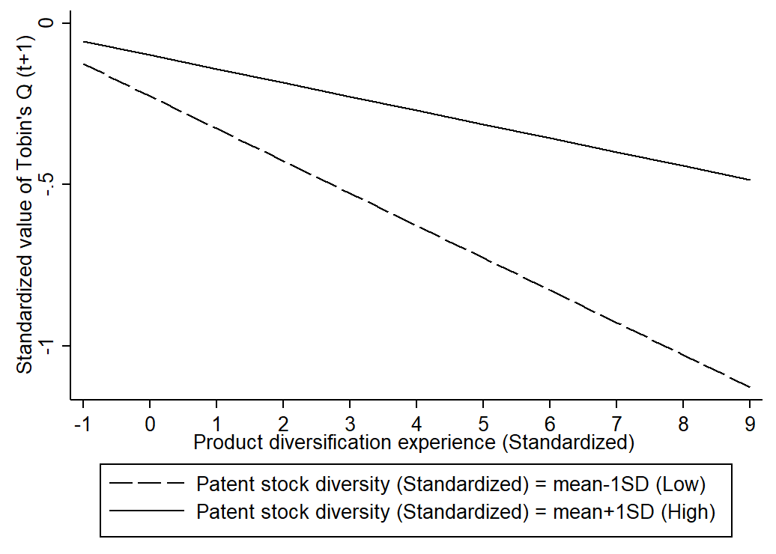

Figure A1. The moderation effect of patent stock diversity on the performance impacts of product diversification experience (Model 3)

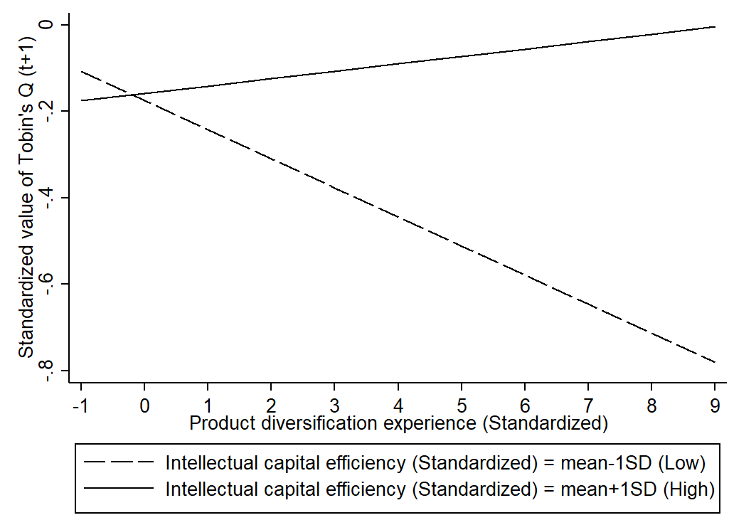
Figure A2. The moderation effect of intellectual capital efficiency on the performance impacts of product diversification experience (Model 4)

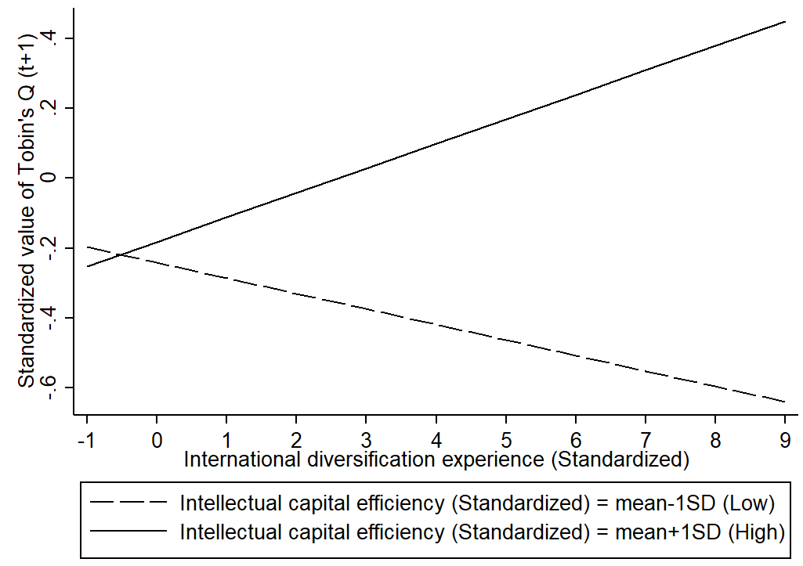

Figure A3. The moderation effect of intellectual capital efficiency on the performance impacts of international diversification experience (Model 14)

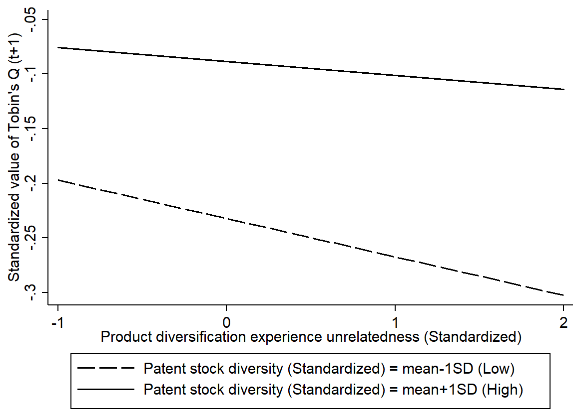

Figure A4. The moderation effect of patent stock diversity on the performance impacts of product diversification experience unrelatedness (Model 22)

Note: SD = Standard deviation; All figures are plotted over the entire range of the explanatory variables (i.e., X-axis)

NOTES
[1] Indian Patent Search interface can be accessed at http://ipindiaservices.gov.in/publicsearch. Indian Patent Data have now also been available through the PATENTSCOPE search engine of the World Intellectual Property Organization (WIPO) since March 2018.

[2] Please note that modes of international diversification such as exports and greenfield operating subsidiaries are not reported in SDC Platinum database.

[3] Results of RE and FGLS are consistent when absorptive capacity was measured using intellectual capital efficiency, but not when using patent stock diversity. We believe the presence of heteroscedastic and autocorrelated error terms in our model might be one of the reasons why results of RE models vary from those of FGLS, as unlike FGLS, RE does not model both heteroscedastic and autocorrelated error terms simultaneously. In an additional analysis, we used generalized estimating equation (GEE) for the second stage analysis, which allows addressing these two concerns together (xtgee with first order correlation and robust standard errors in Stata) (Ballinger, 2004). We found that results of GEE were similar those of FGLS models, as the coefficient of interaction term between product diversification experience and patent stock diversity (DV = Tobin’s Q: β = 0.03, p < 0.01) and that of the product diversification experience unrelatedness and patent stock diversity were positive and significant (DV = Tobin’s Q: β = 0.01, p < 0.05). Additionally, the moderation effects of patent stock diversity on the outcomes of international diversification experience and unrelatedness therein also remained similar to those of the FGLS models. Results of the GEE models could be obtained from the authors on request. This additional analysis enhanced our confidence in the findings of the FGLS model.

REFERENCES (used in online supplementary material)
Ahuja, G., & Novelli, E. 2017. Redirecting research efforts on the diversification–performance linkage: The search for synergy. Academy of Management Annals, 11(1): 342–390.
Ballinger, G. A. 2004. Using generalized estimating equations for longitudinal data analysis. Organizational Research Methods, 7(2): 127–150.
Bell, J., Crick, D., & Young, S. 2004. Small firm internationalization and business strategy: An exploratory study of ‘knowledge-intensive’ and ‘traditional’ manufacturing firms in the UK. International Small Business Journal, 22(1): 23–56.
Berry, C. 1975. Corporate growth and diversification. Princeton, NJ: Princetown University Press.
Bontis, N. 2001. Assessing knowledge assets: A review of the models used to measure intellectual capital. International Journal of Management Reviews, 3(1): 41–60.
Cavaliere, V., Lombardi, S., & Giustiniano, L. 2015. Knowledge sharing in knowledge-intensive manufacturing firms. An empirical study of its enablers. Journal of Knowledge Management, 19(6): 1124–1145.
Chakrabarti, A., Singh, K., & Mahmood, I. 2007. Diversification and performance: Evidence from East Asian firms. Strategic Management Journal, 28(2): 101–120.
Chang, S.-C., & Wang, C.-F. 2007. The effect of product diversification strategies on the relationship between international diversification and firm performance. Journal of World Business, 42(1): 61–79.
Chittoor, R. (R.), & Aulakh, P. S. 2015. Organizational landscape in India: Historical development, multiplicity of forms and implications for practice and research. Long Range Planning, 48(5): 291–300.
Cohen, J. 1960. A coefficient of agreement for nominal scales. Educational and Psychological Measurement, 20(1): 37–46.
Cohen, W. M., & Levinthal, D. A. 1990. Absorptive capacity: A new perspective on learning and innovation. Administrative Science Quarterly, 35(1): 128–152.
Cuervo-Cazurra, A. 2008. The effectiveness of laws against bribery abroad. Journal of International Business Studies, 39(4): 634–651.
Dastidar, P. 2009. International corporate diversification and performance: Does firm self-selection matter? Journal of International Business Studies, 40(1): 71–85.
Delios, A., & Beamish, P. W. 1999. Geographic scope, product diversification, and the corporate performance of Japanese firms. Strategic Management Journal, 20(8): 711–727.
Dushnitsky, G., & Lenox, M. J. 2005. When do firms undertake R&D by investing in new ventures? Strategic Management Journal, 26(10): 947–965.
Edvinsson, L., & Sullivan, P. 1996. Developing a model for managing intellectual capital. European Management Journal, 14(4): 356–364.
Gertler, P., & Horvath, R. 2018. Central bank communication and financial markets: New high-frequency evidence. Journal of Financial Stability, 36: 336–345.
Greene, W. H. 2003. Econometric analysis. Dehli, India: Pearson Education India.
Haleblian, J., & Finkelstein, S. 1999. The influence of organizational acquisition experience on acquisition performance: A behavioral learning perspective. Administrative Science Quarterly, 44(1): 29–56.
Haley, G. T., & Haley, U. C. V. 2012. The effects of patent-law changes on innovation: The case of India’s pharmaceutical industry. Technological Forecasting and Social Change, 79(4): 607–619.
Hausman, J. A. 1978. Specification tests in econometrics. Econometrica, 46(6): 1251–1271.
Hitt, M. A., Tihanyi, L., Miller, T., & Connelly, B. 2006. International diversification: Antecedents, outcomes, and moderators. Journal of Management, 32(6): 831–867.
Huang, Y.-F., & Chen, C.-J. 2010. The impact of technological diversity and organizational slack on innovation. Technovation, 30(7): 420–428.
Khanna, T., & Palepu, K. 2000. Is group affiliation profitable in emerging markets? An analysis of diversified Indian business groups. The Journal of Finance, 55(2): 867–891.
Kim, H., Hoskisson, R. E., & Lee, S.-H. 2015. Why strategic factor markets matter: “New” multinationals’ geographic diversification and firm profitability. Strategic Management Journal, 36(4): 518–536.
Lettl, C., Rost, K., & von Wartburg, I. 2009. Why are some independent inventors ‘heroes’ and others ‘hobbyists’? The moderating role of technological diversity and specialization. Research Policy, 38(2): 243–254.
Lööf, H., & Heshmati, A. 2002. Knowledge capital and performance heterogeneity: A firm-level innovation study. International Journal of Production Economics, 76(1): 61–85.
Lu, W.-M., Wang, W.-K., & Kweh, Q. L. 2014. Intellectual capital and performance in the Chinese life insurance industry. Omega, 42(1): 65–74.
McCann, B. T., & Folta, T. B. 2011. Performance differentials within geographic clusters. Journal of Business Venturing, 26(1): 104–123.
Nguyen, T., & Cai, C. X. 2016. Value-enhancing learning from industry-wide diversification experience. British Journal of Management, 27(2): 323–337.
Nieto, M., & Quevedo, P. 2005. Absorptive capacity, technological opportunity, knowledge spillovers, and innovative effort. Technovation, 25(10): 1141–1157.
Palepu, K. 1985. Diversification strategy, profit performance and the entropy measure. Strategic Management Journal, 6(3): 239–255.
Pulic, A. 2000. VAICTM–an accounting tool for IC management. International Journal of Technology Management, 20(5): 702–714.
Quintana-García, C., & Benavides-Velasco, C. A. 2011. Knowledge organisation in R&D alliances: Its impact on product innovation. Technology Analysis & Strategic Management, 23(10): 1047–1061.
Richard, P. J., Devinney, T. M., Yip, G. S., & Johnson, G. 2009. Measuring organizational performance: Towards methodological best practice. Journal of Management, 35(3): 718–804.
Shukla, D. M., Mital, A., Qureshi, I., & Wang, T. 2020. Valuation effects of alliance portfolio expansion speed and strength: Evidence from high-tech firms. Journal of Business Research, 113: 370–383.
Su, W., & Tsang, E. W. K. 2014. Product diversification and financial performance: The moderating role of secondary stakeholders. Academy of Management Journal, 58(4): 1128–1148.
Tallman, S., & Li, J. 1996. Effects of international diversity and product diversity on the performance of multinational firms. The Academy of Management Journal, 39(1): 179–196.
Tsai, W. 2001. Knowledge transfer in intraorganizational networks: Effects of network position and absorptive capacity on business unit innovation and performance. The Academy of Management Journal, 44(5): 996–1004.
Vachani, S. 1991. Distinguishing between related and unrelated international geographic diversification: A comprehensive measure of global diversification. Journal of International Business Studies, 22(2): 307–322.
Yamakawa, Y., Yang, H., & Lin, Z. (J.). 2011. Exploration versus exploitation in alliance portfolio: Performance implications of organizational, strategic, and environmental fit. Research Policy, 40(2): 287–296.
Zahavi, T., & Lavie, D. 2013. Intra-industry diversification and firm performance. Strategic Management Journal, 34(8): 978–998.
Zahra, S. A., & George, G. 2002. Absorptive capacity: A review, reconceptualization, and extension. The Academy of Management Review, 27(2): 185–203.

