APPENDIX Ⅰ
Development of Factor Markets
We quantified the development of factor markets using the average of three NERI indices. They are the marketization of the financial industry and technical achievements and the supply of human capital.
1. Marketization of the financial industry | 1. Market competition in the financial industry, measured by the proportion of non-state-owned financial assets in a region’s total financial assets.  2. Marketization of the credit allocation, measured by the fraction of loans to non-state-owned regional entities.
2. Supply of human capital | 1. Supply of technicians in a region based on a nationwide survey of firms.  2. Supply of managers in a region based on a nationwide survey of firms.  3. Supply of skilled labor in a region based on a nationwide survey of firms.
3. Marketization of the technical achievements | 1. It is measured by the value of technology transactions in the local market scaled by the number of local technicians.

APPENDIX Ⅱ
Development of Legal Institutions
We quantified the legal institution development using the average of two NERI indices: protection of market transactions and protection of IPR. The detailed measures are as follows.

1. Protection of market transactions is quantified using managers’ evaluations of law enforcement by the local public security organs, procuratorial organs, and courts in a country-wide survey of firms.
2. Protection of IPR is measured using the number of patents granted to local inventors scaled by the number of local technicians.

APPENDIX Ⅲ
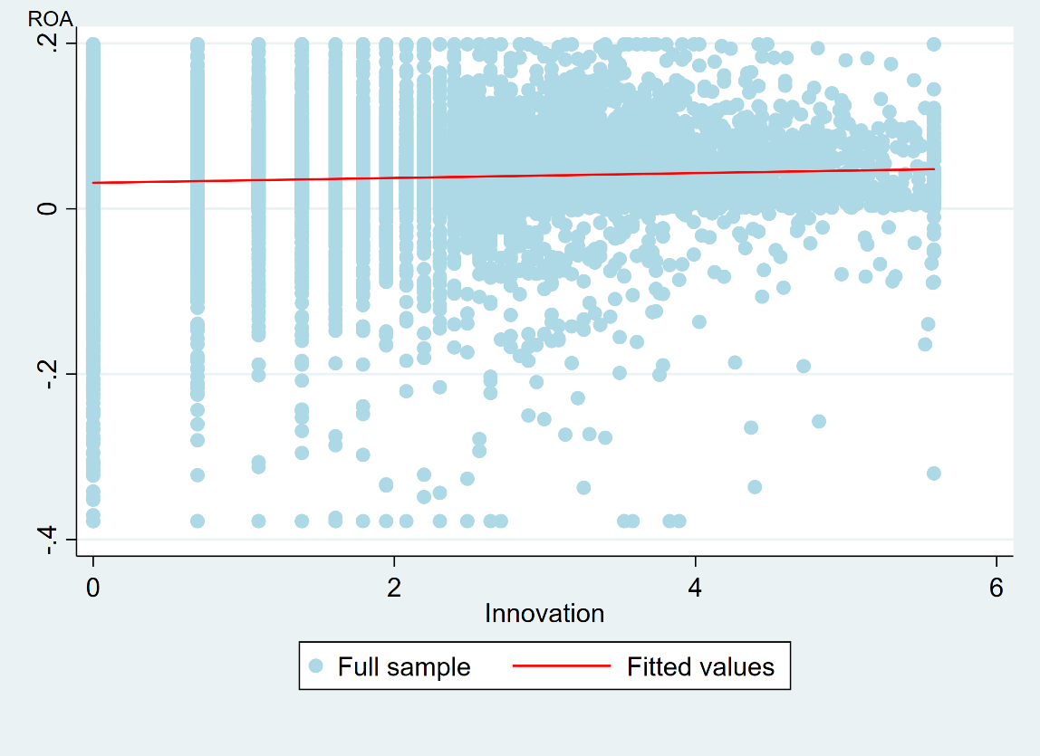
The Relationship Between Patents and ROA

APPENDIX Ⅳ
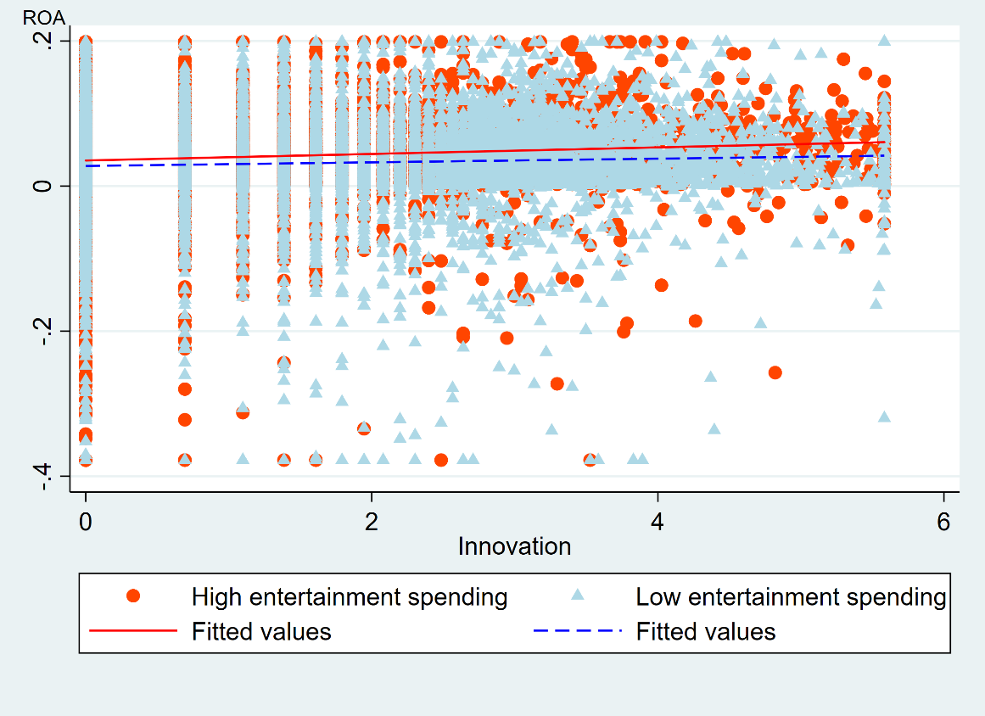
The Moderating Role of Entertainment Spending on the Relationship Between Patents and ROA
APPENDIX Ⅴa
The Moderating Role of Entertainment Spending on the Relationship Between Patents and ROA with Well-Developed Factor Markets
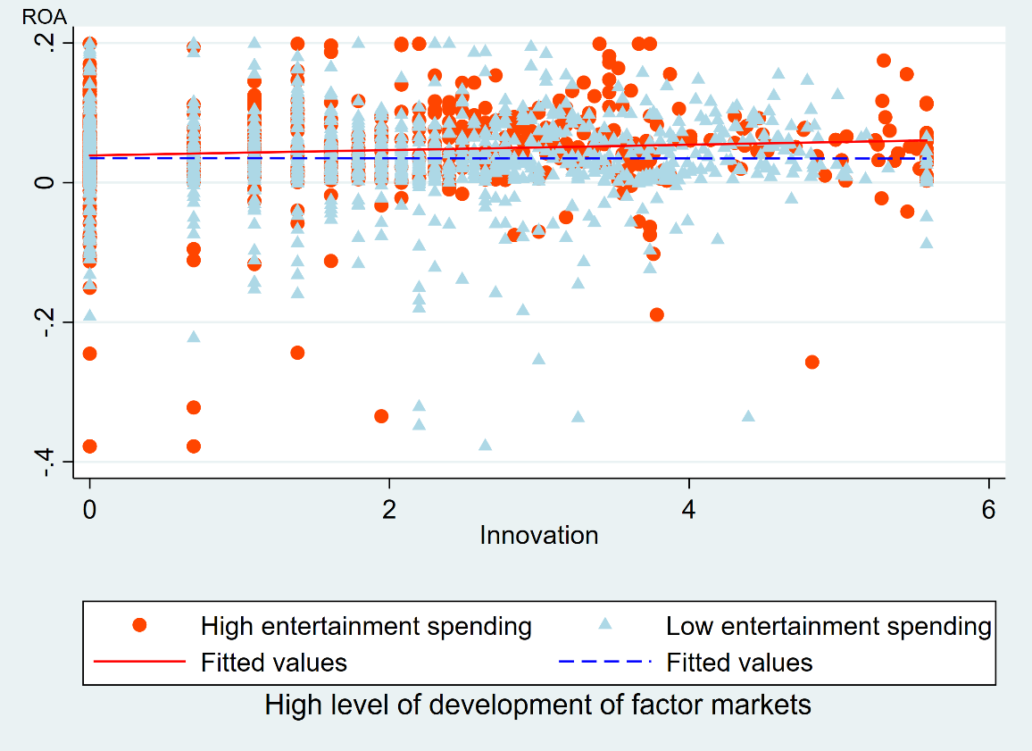

APPENDIX Ⅴb
The Moderating Role of Entertainment Spending on the Relationship Between Patents and ROA with Poorly-Developed Factor Markets
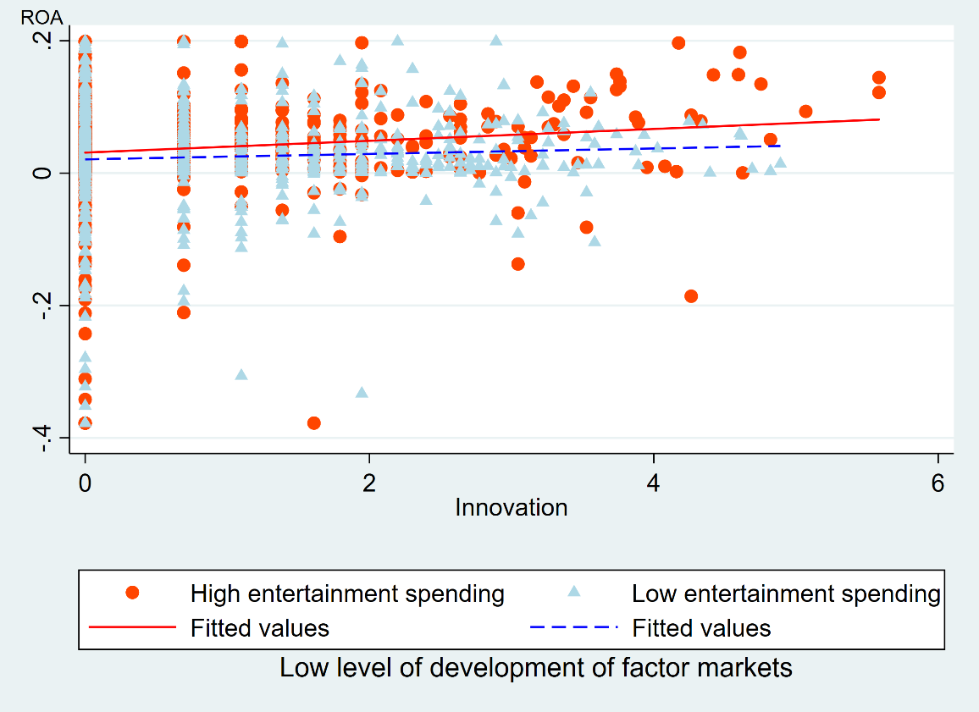

APPENDIX Ⅵa
The Moderating Role of Entertainment Spending on the Relationship Between Patents and ROA with Well-Developed Legal Institutions
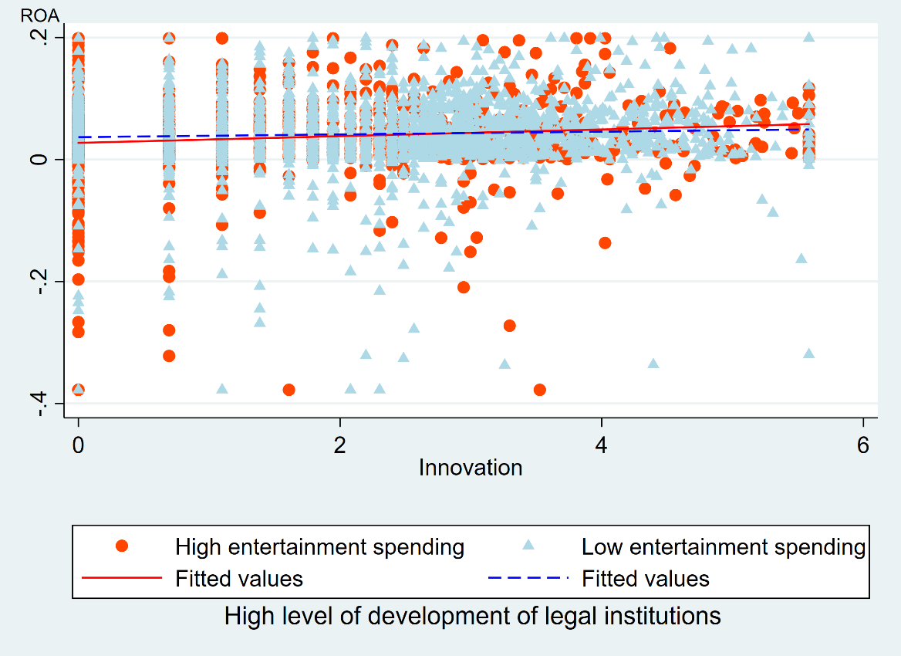

APPENDIX Ⅵb
The Moderating Role of Entertainment Spending on the Relationship Between Patents and ROA with Weak Legal Institutions
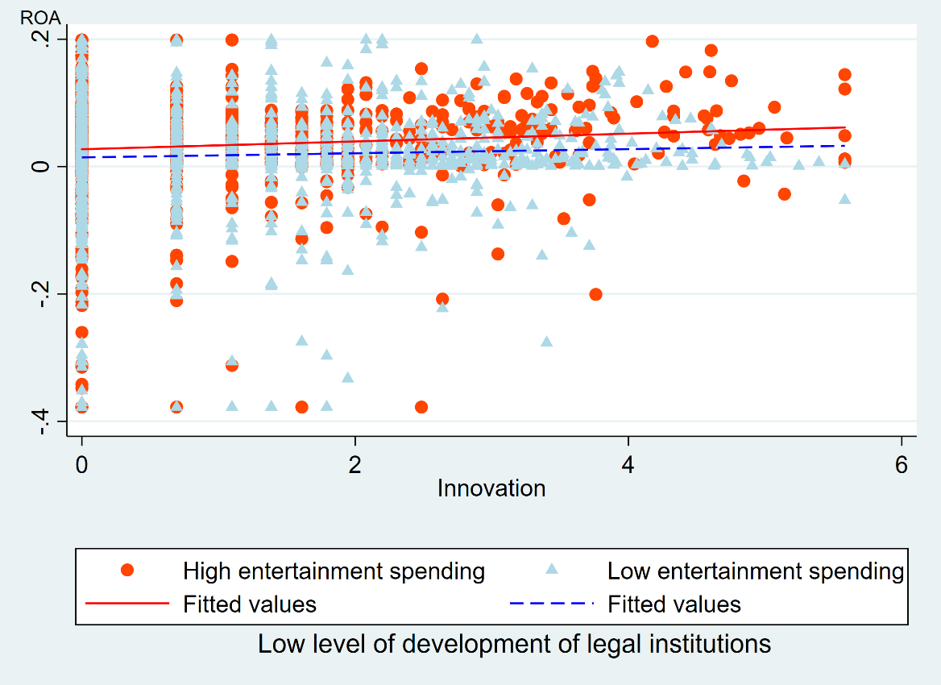

APPENDIX Ⅶ
Coefficients of Second-Stage Firm Fixed Effects Models Predicting ROA After Adding Market Share and Region Dummies
 | A1 | A2 | A3 | A4
Firm size | -0.015*** | -0.015*** | -0.016*** | -0.016***
 | (0.002) | (0.002) | (0.002) | (0.002)
Firm age | -0.038 | -0.041 | -0.050† | -0.044*
 | (0.026) | (0.026) | (0.027) | (0.022)
Financial leverage | -0.003 | -0.004 | -0.006 | -0.004
 | (0.008) | (0.008) | (0.008) | (0.007)
Financial slack | 0.026*** | 0.027*** | 0.028*** | 0.027***
 | (0.006) | (0.006) | (0.006) | (0.006)
Market share | 0.342*** | 0.341*** | 0.348*** | 0.339***
 | (0.068) | (0.068) | (0.069) | (0.068)
CEO duality | 0.000 | 0.000 | 0.000 | 0.000
 | (0.002) | (0.002) | (0.002) | (0.002)
Blockholder ownership | 0.070*** | 0.070*** | 0.073*** | 0.072***
 | (0.012) | (0.012) | (0.012) | (0.011)
Internationalization | -0.011 | -0.012 | -0.014 | -0.012
 | (0.009) | (0.009) | (0.009) | (0.008)
R&D intensity | -0.103** | -0.107** | -0.106** | -0.102**
 | (0.039) | (0.039) | (0.039) | (0.039)
State ownership | -0.008† | -0.008† | -0.008† | -0.008†
 | (0.004) | (0.004) | (0.005) | (0.005)
Development of factor markets | -0.000 | -0.000 | -0.001 | -0.000
 | (0.001) | (0.001) | (0.001) | (0.001)
Development of legal institutions | -0.000 | -0.000 | -0.000 | 0.000
 | (0.000) | (0.000) | (0.000) | (0.000)
Entertainment spending | 0.770*** | 0.680*** | 0.996*** | 0.775***
 | (0.188) | (0.191) | (0.272) | (0.221)
Firm innovation | 0.015 | 0.018 | 0.023 | 0.020
 | (0.016) | (0.016) | (0.017) | (0.013)
Firm innovation*Entertainment spending (H1) |  | 0.584** | 0.292 | 0.517†
 |  | (0.227) | (0.424) | (0.267)
 |  | [p = 0.010]
Firm innovation*Entertainment spending*Development of factor markets (H2) |  |  | -0.222*
 |  |  | (0.090)
 |  |  | [p = 0.014]
Entertainment spending*Development of factor markets |  |  | 0.120
 |  |  | (0.144)
Firm innovation*Development of factor markets |  |  | 0.001
 |  |  | (0.001)
Firm innovation*Entertainment spending* Development of legal institutions (H3) |  |  |  | -0.077*
 |  |  |  | (0.034)
 |  |  |  | [p = 0.025]
Entertainment spending*Development of legal institutions |  |  |  | 0.006
 |  |  |  | (0.037)
Firm innovation*Development of legal institutions |  |  |  | 0.000
 |  |  |  | (0.000)
Regional dummies | Yes | Yes | Yes | Yes
Year dummies | Yes | Yes | Yes | Yes
Industry dummies | Yes | Yes | Yes | Yes
R² | 0.5256 | 0.5262 | 0.5267 | 0.5266
Notes: N = 9,214. Standard errors are reported in parentheses and p values in brackets
* indicates a coefficient significant at the p ≤ 0.05 († p < 0.1, **p ≤ 0.01, ***p ≤ 0.001) confidence level.

APPENDIX Ⅷ
Coefficients of Models with the World Bank Data After Adding CEO Tenure and Customized Products
 | (1) | (2)
 | Long-term collaboration with clients | Long-term collaboration with suppliers
Entertainment spending | 0.112*** | 0.120***
 | (0.010) | (0.009)
Financial performance | 0.027*** | 0.021***
 | (0.001) | (0.001)
Firm age | 0.148*** | 0.157***
 | (0.012) | (0.012)
Firm size | -0.032* | -0.006
 | (0.014) | (0.014)
State ownership | -0.122* | -0.077
 | (0.056) | (0.056)
CEO tenure | 0.112*** | 0.121***
 | (0.009)  [p = 0.000] | (0.009)  [p = 0.000]
CEO tenure² | -0.003*** | -0.003***
 | (0.000)  [p = 0.000] | (0.000)  [p = 0.000]
Customized products | 0.001***
(0.000)
[p = 0.001]
Constant | 2.948*** | 2.846***
 | (0.057) | (0.055)
N | 12384 | 12385
R² | 0.165 | 0.165
F | 347.989 | 402.451
Notes: Standard errors in parentheses and p values in brackets. * p ≤ 0.05, *** p ≤ 0.001

