External Threats and Public Opinion:
The East Asian Security Environment and Japanese Views on the Nuclear Option

Online Appendix

A1. Survey Question Wordings

Instrument
In this study, we ask you to read a hypothetical newspaper editorial. We will then ask you to give us your views on the subject addressed in the editorial, and we will ask you questions about the contents of the editorial. Therefore, please read the editorial carefully and please answer the questions that follow it.

1. Hiroshima and Nagasaki Reminder
Hiroshima and Nagasaki at the Dawn of the Reiwa Era
Japan is the only country that has experienced nuclear attacks—in August 1945, against Hiroshima and Nagasaki. For several decades, Japanese policy has been based on a policy of three non-nuclear principles, that is, Japan should neither possess nor build nuclear weapons, nor should it permit another country to bring nuclear weapons into Japanese territory. Japan’s three non-nuclear principles should be remembered as we enter the new Reiwa era after Showa and Heisei.

2. Foreign Policy Placebo
International Environment at the Dawn of the Reiwa Era
In this time of transition to Reiwa from Heisei, it is important to consider the international environment that is facing Japan. Foreign policy experts suggest that the following three international circumstances affecting Japan must be closely watched:
- The problem of global climate change remains acute.
- The problem of economic development remains a serious challenge for many poorer countries.
- The problem of global trade protectionism is becoming increasingly important.
[1-3 must be randomly shown]

3. Status-Quo
Japanese Security Environment at the Dawn of the Reiwa Era
In this time of transition to Reiwa from Heisei, it is important to consider the international security environment that is facing Japan. Foreign policy experts suggest that the following three circumstances affecting Japan’s security must be closely watched:
- The U.S. security commitment to Japan remains highly reliable. Most important, if Japan were threatened by a foreign power with military force, including nuclear weapons, we can be certain that the United States would intervene and defend Japan with all necessary means.
- North Korea’s recent stance toward Japan remains less hostile compared to the past. Most important, North Korea has put a hold on its development program for nuclear weapons and it has largely stopped testing its ballistic missiles, including the missile types that would be especially threatening to Japan.
- South Korea is Japan’s nearest neighbor and largely faces the same international environment in East Asia as does Japan. Most important, South Korea remains publicly committed to a policy not to acquire nuclear weapons, and is taking no action to develop such weapons.
[1-3 must be randomly shown]
4. Worst-Case
Japanese Security Environment at the Dawn of the Reiwa Era
In this time of transition to Reiwa from Heisei, it is important to consider the international security environment that is facing Japan. Foreign policy experts suggest that the following three circumstances affecting Japan’s security must be closely watched:
- The U.S. security commitment to Japan has become less reliable. Most important, if Japan were threatened by a foreign power with military force, including nuclear weapons, we cannot be certain that the United States would intervene and defend Japan.
- North Korea’s recent stance toward Japan is as highly hostile as in the past. Most important, North Korea has not put a meaningful hold on its development program for nuclear weapons and it has largely continued testing its ballistic missiles, including the missile types that would be especially threatening to Japan.
- South Korea is Japan’s nearest neighbor and largely faces the same international environment in East Asia as does Japan. Most important, South Korea is no longer publicly committed to a policy not to acquire nuclear weapons, and could be taking action to develop such weapons.
[1-3 must be randomly shown]

5. High US-Security Commitment
Japanese Security Environment at the Dawn of the Reiwa Era
In this time of transition to Reiwa from Heisei, it is important to consider the international security environment that is facing Japan. Foreign policy experts suggest that the following three circumstances affecting Japan’s security must be closely watched:
- The U.S. security commitment to Japan remains highly reliable. Most important, if Japan were threatened by a foreign power with military force, including nuclear weapons, we can be certain that the United States would intervene and defend Japan with all necessary means.
- North Korea’s stance toward Japan in recent years is as highly hostile as in the past. Most important, North Korea has not put a meaningful hold on its development program for nuclear weapons and it has largely continued testing its ballistic missiles, including the missile types that would be especially threatening to Japan.
- South Korea is Japan’s nearest neighbor and largely faces the same international environment in East Asia as does Japan. Most important, South Korea is no longer publicly committed to a policy not to acquire nuclear weapons, and could be taking action to develop such weapons.
[1-3 must be randomly shown]

6. Low US-Security Commitment
Japanese Security Environment at the Dawn of the Reiwa Era
In this time of transition to Reiwa from Heisei, it is important to consider the international security environment that is facing Japan. Foreign policy experts suggest that the following three circumstances affecting Japan’s security must be closely watched:
- The U.S. security commitment to Japan has become less reliable. Most important, if Japan were threatened by a foreign power with military force, including nuclear weapons, we cannot be certain that the United States would intervene and defend Japan.
- North Korea’s recent stance toward Japan remains less hostile compared to the past. Most important, North Korea has put a hold on its development program for nuclear weapons and it has largely stopped testing its ballistic missiles, including the missile types that would be especially threatening to Japan.
- South Korea is Japan’s nearest neighbor and largely faces the same international environment in East Asia as does Japan. Most important, South Korea remains publicly committed to a policy not to acquire nuclear weapons, and is taking no action to develop such weapons.
[1-3 must be randomly shown]

7. High North Korea’s Nuclear Threats
Japanese Security Environment at the Dawn of the Reiwa Era
In this time of transition to Reiwa from Heisei, it is important to consider the international security environment that is facing Japan. Foreign policy experts suggest that the following three circumstances affecting Japan’s security must be closely watched:
- The U.S. security commitment to Japan remains highly reliable. Most important, if Japan were threatened by a foreign power with military force, including nuclear weapons, we can be certain that the United States would intervene and defend Japan with all necessary means.
- North Korea’s stance toward Japan in recent years is as highly hostile as in the past. Most important, North Korea has not put a meaningful hold on its development program for nuclear weapons and it has largely continued testing its ballistic missiles, including the missile types that would be especially threatening to Japan.
- South Korea is Japan’s nearest neighbor and largely faces the same international environment in East Asia as does Japan. Most important, South Korea remains publicly committed to a policy not to acquire nuclear weapons, and is taking no action to develop such weapons.
[1-3 must be randomly shown]

8. High South Korea’s Nuclear Motivation
Japanese Security Environment at the Dawn of the Reiwa Era
In this time of transition to Reiwa from Heisei, it is important to consider the international security environment that is facing Japan. Foreign policy experts suggest that the following three circumstances affecting Japan’s security must be closely watched:
- The U.S. security commitment to Japan remains highly reliable. Most important, if Japan were threatened by a foreign power with military force, including nuclear weapons, we can be certain that the United States would intervene and defend Japan with all necessary means.
- North Korea’s recent stance toward Japan remains less hostile compared to the past. Most important, North Korea has put a hold on its development program for nuclear weapons and it has largely stopped testing its ballistic missiles, including the missile types that would be especially threatening to Japan.
- South Korea is Japan’s nearest neighbor and largely faces the same international environment in East Asia as does Japan. Most important, South Korea is no longer publicly committed to a policy not to acquire nuclear weapons, and could be taking action to develop such weapons.
[1-3 must be randomly shown]

Dependent Variables
Keeping in mind what you have read in the news editorial, do you support or oppose Japan’s acquisition of nuclear weapons?
1.strongly support 2.support 3.somewhat support 4.somewhat oppose 5.oppose 6.strongly oppose 7.prefer not to answer

We ask you once again, if you only have two choices, to support or to oppose Japan’s acquisition of nuclear weapons, what would be your position?
1. support 2. oppose 3. prefer not to answer

If you think Japan should acquire nuclear weapons, how many nuclear weapons do you think Japan should possess? If you think Japan should never possess nuclear weapons, please answer 0.

Do you support oppose Japan’s acquisition of small-sized nuclear weapons?
1.strongly support 2. support 3.somewhat support 4.somewhat oppose 5.oppose 6.strongly oppose 7.prefer not to answer

Do you support or oppose the stationing by the US of nuclear weapons in Guam for the purpose of defending Japan?
1.strongly support 2. support 3.somewhat support 4.somewhat oppose 5.oppose 6.strongly oppose 7.prefer not to answer

Would you support or oppose a US threat to use nuclear weapons against a country that threatens to attack Japan with nuclear weapons?
1.strongly support 2. support 3.somewhat support 4.somewhat oppose 5.oppose 6.strongly oppose 7.prefer not to answer

Would you support or oppose the US use of nuclear weapons against a country that attacked Japan with nuclear weapons?
1.strongly support 2. support 3.somewhat support 4.somewhat oppose 5.oppose 6.strongly oppose 7.prefer not to answer

Do you support or oppose the strengthening by Japan of its conventional defense capabilities, that is, capabilities other than nuclear weapons?
1.strongly support 2. support 3.somewhat support 4.somewhat oppose 5.oppose 6.strongly oppose 7.prefer not to answer
A2. Summary Statistics
 | N | Mean | S.D. | Min. | Max.
Support for Japan’s acquisition of nuclear weapons | 1878 | 2.55 | 1.49 | 1 | 6
Support for Japan’s acquisition of nuclear weapons, binary | 1834 | 0.26 | 0.44 | 0 | 1
Support for US deployment of nuclear arsenal | 1837 | 3.01 | 1.54 | 1 | 6
Support for US use of nuclear weapons | 1839 | 3.17 | 1.71 | 1 | 6
Male | 1952 | 0.51 | 0.50 | 0 | 1
Age | 1967 | 46 | 14 | 20 | 70
College Education | 1921 | 0.62 | 0.49 | 0 | 1
Income Level | 1750 | 2.30 | 1.42 | 1 | 6
LDP Supporter | 1546 | 0.27 | 0.45 | 0 | 1
Non-Partisan | 1546 | 0.44 | 0.50 | 0 | 1
Pro-Use of Military Force | 1967 | 0.36 | 0.48 | 0 | 1
Social Dominance Orientation | 1967 | 3.47 | 0.92 | 1 | 7

A3. Mean Scores of Variables by Treatment Groups
 | 1 | 2 | 3 | 4 | 5 | 6 | 7 | 8
 | Hiroshima/ Nagasaki | Placebo | Status-Quo | Worst  Case | US-  High | US-  Low | North Korea | South Korea
Male | 0.51 | 0.47 | 0.46 | 0.53 | 0.50 | 0.53 | 0.53 | 0.53
Age | 48 | 44 | 47 | 48 | 48 | 48 | 48 | 47
College Education | 0.61 | 0.61 | 0.61 | 0.64 | 0.62 | 0.65 | 0.58 | 0.61
Income Level | 2.23 | 2.26 | 2.11 | 2.35 | 2.29 | 2.49 | 2.27 | 2.39
LDP Supporter | 0.29 | 0.29 | 0.20 | 0.30 | 0.27 | 0.29 | 0.32 | 0.22
Pro-Use of Military Force | 0.35 | 0.34 | 0.39 | 0.38 | 0.36 | 0.35 | 0.38 | 0.36
Social Dominance Orientation | 3.44 | 3.48 | 3.50 | 3.37 | 3.51 | 3.45 | 3.49 | 3.51
N | 241 | 256 | 245 | 247 | 240 | 242 | 242 | 254

A4. Security Environment, Demographic Characteristics, and Support for Nuclear Weapons, Logit Analysis, with using only subjects who passed the manipulation check

 | 1
Hiroshima Nagasaki Reminder | 1.14**
 | (0.50)
Foreign Policy Placebo | 0.47
 | (0.54)
Worst-Case | 0.82*
 | (0.48)
US-High Commitment | 1.04*
 | (0.53)
US-Low Commitment | 0.83
 | (0.55)
NK High Threat | 0.42
 | (0.51)
SK Nuclear Movement | 0.36
 | (0.52)
Male | 0.81***
 | (0.26)
Age | 0.01
 | (0.01)
Pro-Use of Force | 0.78***
 | (0.14)
SDO | 0.44***
 | (0.13)
LDP Supporter | 0.07***
 | (0.26)
College Education | 0.53**
 | (0.26)
Constant | 6.21***
 | (0.87)
N | 518
Log Likelihood | 219.74
AIC | 467.47
Note: Standard errors in parentheses * p < 0.10, ** p < 0.05, *** p < 0.01

A5. Support for Japan’s Acquisition of Nuclear Weapons
by Respondents’ Demographic Attributes

By Preference of Use of Military Force
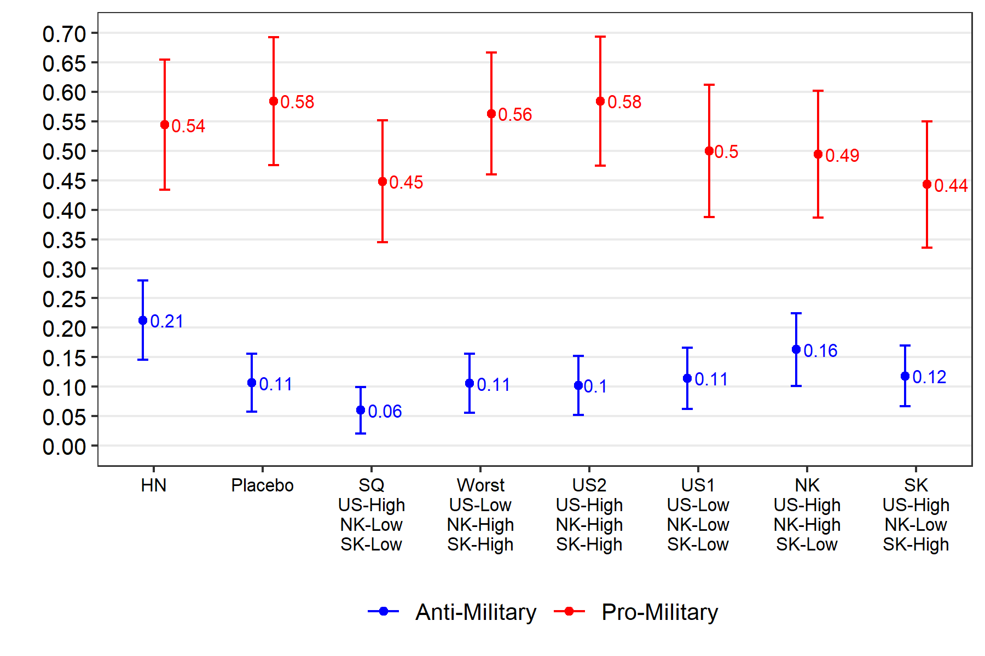
By Support for the Liberal Democratic Party (LDP)
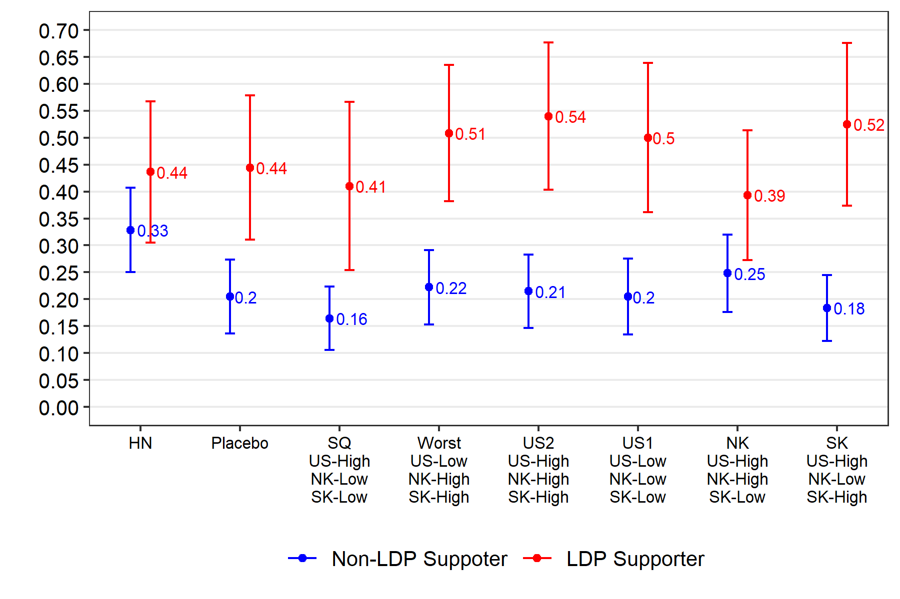

By Social Dominance Orientation (SDO)
