SUPPLEMENTARY INFORMATION
Ethnic and Religious Sentiments in Indonesian Politics: Evidence from the 2017 Jakarta Gubernatorial Election

A1. Survey Design ………………………………………………………………….... | 2
A2. Muslim Voters Less Likely to Support Ahok …………………………………… | 4
A3. Covariate Balance ……………………………………………………………….. | 5
A4. Basic Regression Model from the Survey Experiment (Figure 1 in the Main Text) …………………………………………………………………………….. | 6
A5. Regression Models from the Survey Experiment with Interaction Terms  (Figure 3 in the Main Text) ……………………………...………………………. | 7
A6. Feeling Thermometer Models (Figure 2 in the Main Text) ……………………... | 9
A7. Feeling Thermometer Models with Interaction Terms (Figure 4 in the Main Text) ……………………………………………………………………………. | 10
A8. Probability of Being in the Effective Sample across Experimental Groups …….. | 12
A9. Interactions between Experimental Treatments and Political Knowledge or Income ………………………………………………………………………….. | 13

A1. Survey Design
The survey was done through a random sampling. Jakarta as a province is divided into five municipalities. These municipalities are further divided into districts (kecamatan), which are further divided into urban wards (kelurahan). Respondents were proportionally drawn from the five municipalities using a 2013 report from data.jakarta.go.id, a government-run website, as reference. Two districts were randomly drawn from each municipality and three wards were drawn from each district, resulting in six wards for each municipality. These wards are our primary sampling unit. The number of respondents assigned to each municipality was then equally distributed to each ward.
A list of neighborhoods (RT / rukun tetangga) in each chosen ward was obtained and nine were randomly selected. The number of respondents assigned to each ward were then equally spread across the nine neighborhoods. The interviewers were instructed to draw a rude map of their corresponding neighborhoods with the house of the neighborhood head (Ketua RT) as the center. They then needed to number the houses surrounding the neighborhood head’s and randomly select as many houses as assigned to that neighborhood to be interviewed. Odd-numbered houses mean that a female household occupant should be interviewed, whereas even-numbered houses mean that the respondent should be a male occupant of the house.

Table A1. Sample and Population Characteristics
Indicator | Sample | Population
Gender
Male | 50.46% | 50.25%
Female | 49.54% | 49.75%
Religion
Islam | 87.62% | 85.36%
Protestant | 5.77% | 7.54%
Catholic | 4.35% | 3.16%
Buddha | 1.92% | 3.3%
Hindu | 0.25% | 0.21%
Age Categories
15-19 | 6.65% | 9.23%
20-29 | 20.37% | 25.26%
30-39 | 24.75% | 25.75%
40-49 | 25.17% | 18.80%
50-59 | 15.07% | 12.34%
> 60 | 8.00% | 8.62%
Education
No schooling | 0.59% | 1.28%
Not completing Elementary School | 2.76% | 5.22%
Completing Elementary School | 10.04% | 11.77%
Completing Middle School | 21.61% | 19.70%
Completing High School | 48.58% | 42.49%
Diploma | 5.53% | 5.20%
College or above | 10.88% | 14.33%

A2. Testing Hypothesis 1 (Muslim Voters Less Likely to Support Ahok)

 | Vote Ahok
Muslim | -1.643***
 | (0.40)
Female | 0.238
 | (0.22)
Age | -0.002
 | (0.01)
Education | 0.080
 | (0.09)
Income | -0.012
 | (0.06)
Ethnic: Sunda | -0.130
 | (0.35)
Ethnic: Betawi | -0.246
 | (0.28)
Ethnic: Others | -0.181
 | (0.37)
Political Knowledge | 0.011
 | (0.26)
Satisfaction with Incumbent | 2.055***
 | (0.23)
Intercept | -5.276***
 | (0.97)
N | 544
*** p <. 01 ** p < .05 * p < .10

A3. Covariate Balance
I check for covariate balance by using ANOVA or cross-tabulation (for ethnicity variable), both on the original sample and the effective sample. As can be seen, the ANOVAs suggest that the covariates are reasonably balanced across experimental groups, both in the original and the effective samples. The cross-tabulation also suggests that the respondents’ ethnic affiliations are evenly spread across the experimental groups ($χ_{(12)}^{2}=8.907,n.s.$ for the original sample and $χ_{(12)}^{2}=10.70,n.s.$ for the effective sample).
ANOVA of Covariates (Original Sample)
Variable | F-Statistic | P-Value
Female | $$F_{4,1042}=.54$$ | n.s. (p>.10)
Age | $$F_{4,1035}=.71$$ | n.s. (p>.10)
Education | $$F_{4,1041}=1.35$$ | n.s. (p>.10)
Income | $$F_{4,1033}=.93$$ | n.s. (p>.10)
Political Knowledge | $$F_{4,1042}=.98$$ | n.s. (p>.10)
Satisfaction | $$F_{4,989}=2.15$$ | p<.10
Feeling toward Christians | $$F_{4,1033}=.67$$ | n.s. (p>.10)
Feeling toward Ethnic Chinese | $$F_{4,1026}=1.75$$ | n.s. (p>.10)
Frequency of Shalat | $$F_{4,1037}=.40$$ | n.s. (p>.10)
Religious Tolerance | $$F_{4,975}=1.16$$ | n.s. (p>.10)
Support for Sharia | $$F_{4,973}=.87$$ | n.s. (p>.10)

ANOVA of Covariates (Effective Sample)
Variable | F-Statistic | P-Value
Female | $$F_{4,679}=.51$$ | n.s. (p>.10)
Age | $$F_{4,677}=1.28$$ | n.s. (p>.10)
Education | $$F_{4,678}=.71$$ | n.s. (p>.10)
Income | $$F_{4,677}=.42$$ | n.s. (p>.10)
Political Knowledge | $$F_{4,679}=.13$$ | n.s. (p>.10)
Satisfaction | $$F_{4,668}=1.33$$ | n.s. (p>.10)
Feeling toward Christians | $$F_{4,675}=.64$$ | n.s. (p>.10)
Feeling toward Ethnic Chinese | $$F_{4,675}=1.68$$ | n.s. (p>.10)
Frequency of Shalat | $$F_{4,678}=.69$$ | n.s. (p>.10)
Religious Tolerance | $$F_{4,647}=.92$$ | n.s. (p>.10)
Support for Sharia | $$F_{4,657}=1.78$$ | n.s. (p>.10)
A4. Basic Regression Model from the Survey Experiment
(Figure 1 in the Main Text)

 | Vote Ahok
Ethnicity Priming | -0.508*
 | (0.28)
Religion Priming | 0.288
 | (0.26)
Ethnicity-Religion Priming | -0.422
 | (0.29)
Religion-Ulema Priming | -0.069
 | (0.26)
Intercept | -0.825***
 | (0.19)
N | 684

A5. Regression Models from the Survey Experiment with Interaction Terms
(Figure 3 in the Main Text)

 | Vote Ahok  Model 1 | Vote Ahok  Model 2 | Vote Ahok  Model 3 | Vote Ahok  Model 4
Ethnicity Priming | -7.236** | -1.166 | -1.495 | 0.037
 | (3.46) | (1.30) | (1.64) | (1.12)
Religion Priming | -2.936 | -0.047 | 0.661 | 1.831*
 | (2.32) | (1.14) | (1.36) | (1.10)
Ethnicity-Religion Priming | -4.118 | -0.174 | -2.985 | -0.198
 | (2.71) | (1.25) | (1.83) | (1.25)
Religion-Ulema Priming | 0.594 | -1.167 | -0.355 | 1.560
 | (1.85) | (1.14) | (1.40) | (1.09)
Satisfaction | 1.826***
 | (0.48)
Ethnicity X Satisfaction | 2.211*
 | (1.14)
Religion X Satisfaction | 1.053
 | (0.77)
Ethnic-Religion X Satisfaction | 1.222
 | (0.89)
Ulema X Satisfaction | -0.199
 | (0.62)
Religiosity |  | -0.374*
 |  | (0.20)
Ethnicity X Religiosity |  | 0.152
 |  | (0.30)
Religion X Religiosity |  | 0.070
 |  | (0.26)
Ethnic-Religion X Religiosity |  | -0.068
 |  | (0.29)
Ulema X Religiosity |  | 0.248
 |  | (0.26)
Tolerance |  |  | 1.819***
 |  |  | (0.39)
Ethnicity X Tolerance |  |  | 0.209
 |  |  | (0.60)
Religion X Tolerance |  |  | -0.220
 |  |  | (0.53)
Ethnic-Religion X Tolerance |  |  | 0.937
 |  |  | (0.68)
Ulema X Tolerance |  |  | 0.067
 |  |  | (0.54)
Sharia |  |  |  | -0.143
 |  |  |  | (0.30)
Ethnicity X Sharia |  |  |  | -0.213
 |  |  |  | (0.41)
Religion X Sharia |  |  |  | -0.557
 |  |  |  | (0.40)
Ethnic-Religion X Sharia |  |  |  | -0.068
 |  |  |  | (0.44)
Ulema X Sharia |  |  |  | -0.576
 |  |  |  | (0.40)
Intercept | -6.125*** | 0.772 | -5.067*** | -0.461
 | (1.46) | (0.89) | (1.02) | (0.83)
N | 673 | 683 | 652 | 662
*** p <. 01 ** p < .05 * p < .10

A6. Feeling Thermometer Models (Figure 2 in the Main Text)

 | Pr(Vote Ahok)  Model 1 | Pr(Vote Ahok)  Model 2 | Pr(Vote Ahok)  Model 3
Female | 0.248 | 0.277 | 0.289
 | (0.25) | (0.25) | (0.25)
Age | -0.003 | -0.003 | -0.004
 | (0.01) | (0.01) | (0.01)
Education | -0.015 | -0.004 | -0.009
 | (0.10) | (0.10) | (0.10)
Income | -0.050 | -0.049 | -0.044
 | (0.07) | (0.07) | (0.07)
Ethnic: Sunda | -0.175 | -0.190 | -0.233
 | (0.36) | (0.36) | (0.36)
Ethnic: Betawi | -0.240 | -0.249 | -0.245
 | (0.29) | (0.29) | (0.29)
Ethnic: Others | 0.338 | 0.298 | 0.300
 | (0.42) | (0.42) | (0.42)
Political Knowledge | 0.073 | -0.040 | -0.007
 | (0.29) | (0.29) | (0.29)
Satisfaction with Incumbent | 2.029*** | 1.995*** | 1.994***
 | (0.24) | (0.25) | (0.25)
Feeling: Christians | 0.592*** |  | 0.005
 | (0.21) |  | (0.31)
Feeling: Ethnic Chinese |  | 0.772*** | 0.753**
 |  | (0.20) | (0.30)
Intercept | -8.124*** | -8.525*** | -8.490***
 | (1.12) | (1.12) | (1.15)
N | 439 | 440 | 439
*** p <. 01 ** p < .05 * p < .10

A7. Feeling Thermometer Models with Interaction Terms (Figure 4 in the Main Text)

 | Vote Ahok  Model 1 | Vote Ahok  Model 2 | Vote Ahok  Model 3 | Vote Ahok  Model 4
Female | 0.310 | 0.347 | 0.225 | 0.496*
 | (0.25) | (0.26) | (0.26) | (0.26)
Age | -0.003 | 0.003 | -0.004 | -0.002
 | (0.01) | (0.01) | (0.01) | (0.01)
Education | -0.010 | 0.034 | -0.038 | -0.015
 | (0.10) | (0.10) | (0.11) | (0.10)
Income | -0.041 | -0.034 | -0.066 | -0.074
 | (0.07) | (0.07) | (0.07) | (0.07)
Ethnic: Sunda | -0.233 | -0.313 | -0.128 | -0.317
 | (0.37) | (0.37) | (0.38) | (0.38)
Ethnic: Betawi | -0.245 | -0.263 | -0.214 | -0.220
 | (0.29) | (0.30) | (0.31) | (0.30)
Ethnic: Others | 0.273 | 0.296 | 0.204 | 0.240
 | (0.43) | (0.43) | (0.44) | (0.43)
Political Knowledge | 0.022 | 0.048 | 0.059 | 0.048
 | (0.29) | (0.30) | (0.31) | (0.30)
Satisfaction with Incumbent | 3.731** | 1.979*** | 1.589*** | 1.966***
 | (1.48) | (0.25) | (0.26) | (0.25)
Feeling: Christians | 5.549** | 2.149* | 0.613 | -1.827
 | (2.23) | (1.19) | (1.22) | (1.39)
Feeling: Ethnic Chinese | -3.207* | 0.432 | -0.381 | 2.016
 | (1.79) | (1.12) | (1.13) | (1.41)
Christians X Satisfaction | -1.920**
 | (0.77)
Chinese X Satisfaction | 1.393**
 | (0.63)
Shalat |  | 1.057
 |  | (0.77)
Christian X Shalat |  | -0.526*
 |  | (0.29)
Chinese X Shalat |  | 0.102
 |  | (0.28)
Tolerance |  |  | 0.746
 |  |  | (1.19)
Christians X Tolerance |  |  | -0.298
 |  |  | (0.48)
Chinese X Tolerance |  |  | 0.428
 |  |  | (0.44)
Support Sharia |  |  |  | -1.136
 |  |  |  | (0.94)
Christian X Support Sharia |  |  |  | 0.634
 |  |  |  | (0.48)
Chinese X Support Sharia |  |  |  | -0.422
 |  |  |  | (0.47)
Intercept | -13.772*** | -13.599*** | -8.289*** | -5.423*
 | (4.55) | (3.58) | (3.16) | (2.91)
N | 439 | 439 | 420 | 431
*** p <. 01 ** p < .05 * p < .10

A8. Probability of Being in the Effective Sample across Experimental Groups

I examine whether there are systematic differences across the experimental groups related to the probability of respondents being included in the analysis. In general, I find no such differences. The only difference being the ulama group, which has higher inclusion rate than the control group. This difference, however, should not jeopardize the conclusion of the study’s findings as support for Ahok among respondents in the ulama group is not statistically different from the control or the religion groups and this group does not feature prominently in our analysis.

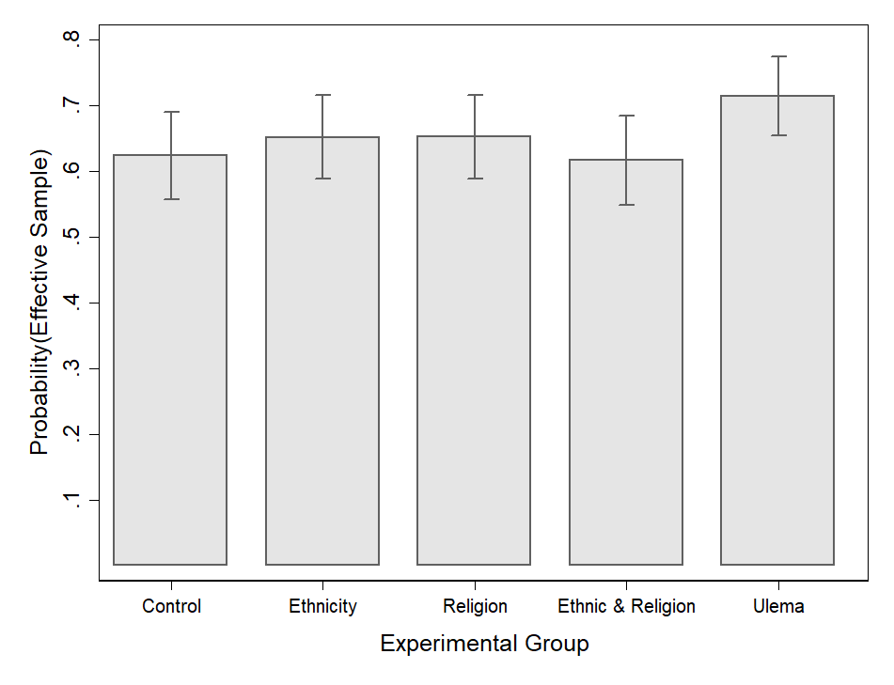

Logistic Regression of Being in the Effective Sample

 | Being in Effective Sample
Ethnicity Priming | 0.122
 | (0.20)
Religion Priming | 0.123
 | (0.20)
Ethnicity-Religion Priming | -0.030
 | (0.21)
Religion-Ulema Priming | 0.408*
 | (0.21)
Intercept | 0.508***
 | (0.14)
N | 1047
*** p <. 01 ** p < .05 * p < .10
A9. Interactions between Experimental Treatments and Political Knowledge or Income

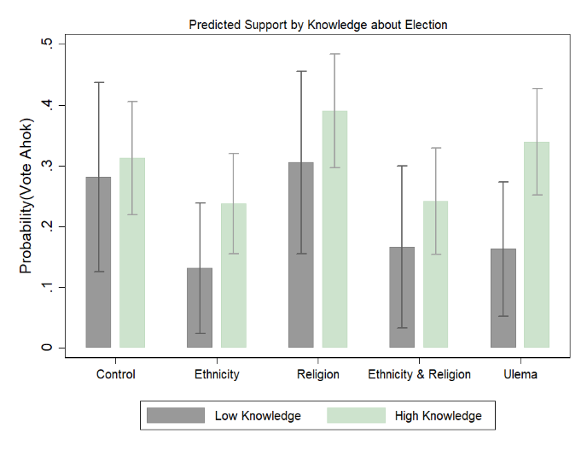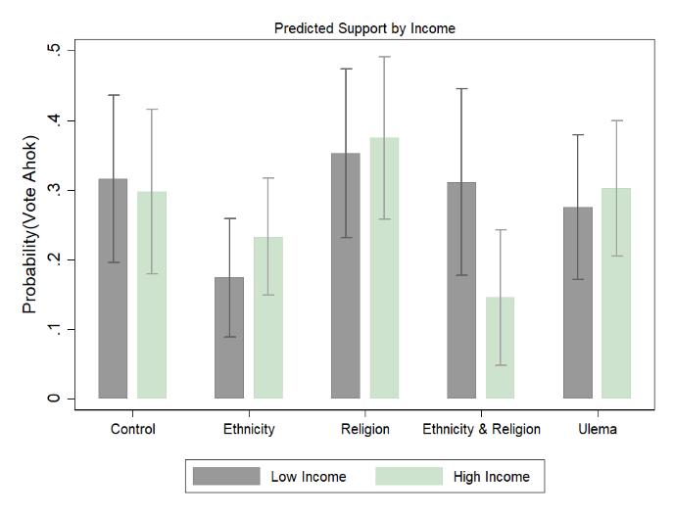

 | Vote Ahok Model 1 | Vote Ahok Model 2
Ethnicity Priming | -0.949 | -0.937*
 | (0.62) | (0.56)
Religion Priming | 0.117 | 0.103
 | (0.53) | (0.55)
Ethnicity-Religion Priming | -0.671 | 0.271
 | (0.63) | (0.62)
Religion-Ulema Priming | -0.699 | -0.268
 | (0.57) | (0.54)
Political Knowledge | 0.150
 | (0.45)
Ethnicity X Knowledge | 0.572
 | (0.70)
Religion X Knowledge | 0.226
 | (0.61)
Ethnic-Religion X Knowledge | 0.317
 | (0.71)
Ulema X Knowledge | 0.821
 | (0.64)
Income |  | -0.019
 |  | (0.09)
Ethnicity X Income |  | 0.096
 |  | (0.12)
Religion X Income |  | 0.039
 |  | (0.12)
Ethnic-Religion X Income |  | -0.189
 |  | (0.15)
Ulema X Income |  | 0.046
 |  | (0.12)
Intercept | -0.938** | -0.742*
 | (0.39) | (0.40)
N | 684 | 682
*** p <. 01 ** p < .05 * p < .10

