Online Appendix

Launch Site | Geographical Location
Chiha-ri | ‘38d37m00sN','126d41m00sE'
Chunggang-up | '41d46m00sN','126d53m00sE'
Kanggamchan | '40d24m00sN','125d12m00sE'
Kanggye | '40d07m00sN','126d35m00sE'
Man'gyongdae-ri | '38d59m00sN','125d40m00sE'
Wonsan | '39d09m15sN','127d26m44sE'
Namgung-ni | '39d08m00sN','125d46m00sE'
No-dong | '40d50m00sN','129d40m00sE'
Ok'pyong | '39d17m00sN','127d18m00sE'
Paegun | '39d58m00sN','124d35m00sE'
Pyongyang | '39d00m00sN','125d45m00sE'
Sangwon | '38d50m00sN','126d05m00sE'
Sunchon | '39d25m00sN','125d55m00sE'
Tokch'on | '39d45m00sN','126d15m00sE'
Tokson | '40d25m00sN','128d10m00sE'
Yongo-dong | '41d59m00sN','129d58m00sE'
Table 3: North Korean Launch Site Geographical Information

Target Site | Geographical Location
Seoul | '37d31m58sN','127d01m29sE'
Pusan | '35d06m10sN','129d02m25sE'
Inchon | '37d27m23sN','126d42m19sE'
Chinhae | '35d08m53sN','128d38m01sE'
Osan AFB | '37d05m16sN','127d01m28sE'
Kunsan | '35d54m08sN','126d36m34sE'
Tokyo | '35d39m10sN','139d45m12sE'
Yokosuka | '35d17m01sN','139d40m02sE'
Sasebo | '33d09m33sN','129d43m22sE'
Okinawa | '26d12m44sN','127d40m45sE'
Misawa | '40d41m13sN','141d23m23sE'
Atsugi | '35d26m20sN','139d21m35sE'
Andersen AFB | '13d34m31sN','144d55m17sE'
Table 4: Geographical Information for Target Sites in the Asia-Pacific Region

Interceptor | Properties
PATRIOT Interceptor | Maximum Altitude = 5 km  Minimum Altitude = 25 km  Burn-out Velocity = 1.5 km/s  Maximum Intercept Distance = 30 km
THAAD interceptor | Minimum Altitude = 20 km  Maximum Altitude = 150 km  Burn-out Velocity = 2.8 km/s  Maximum Intercept Distance = 250 km
SM-3 IA/B  interceptor | Minimum Altitude = 100 km  Maximum Altitude = 500 km  Burn-out Velocity:  SM-3 IA = 3.0 km/s  SM-3 IB = 3.5 km/s  Maximum Intercept Distance = 700 km
Table 5: Interceptor Data

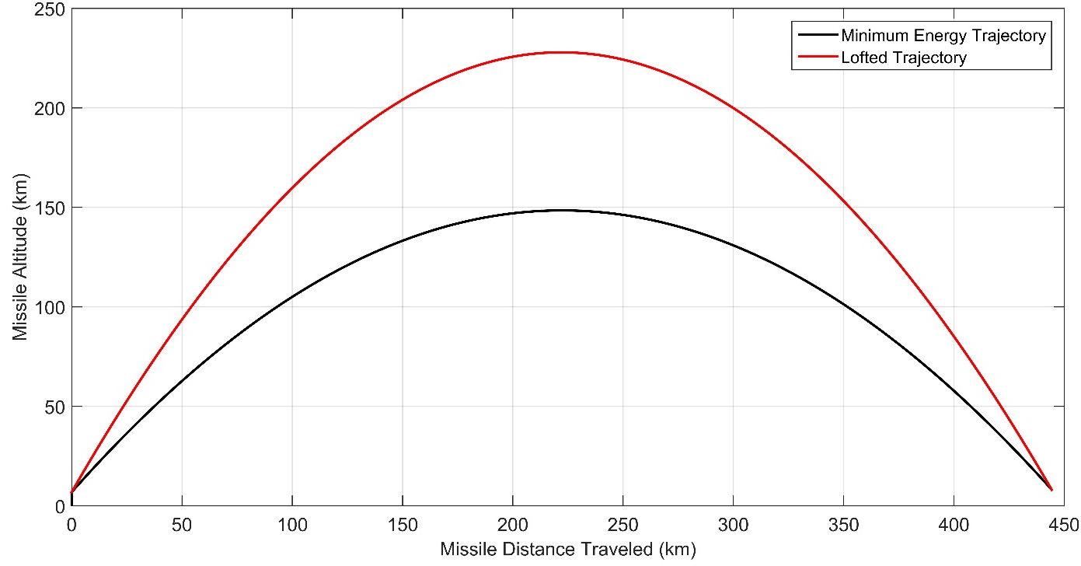Figure A: Missile Trajectory (Chiha-ri, North Korea to Pusan Naval Base, South Korea)

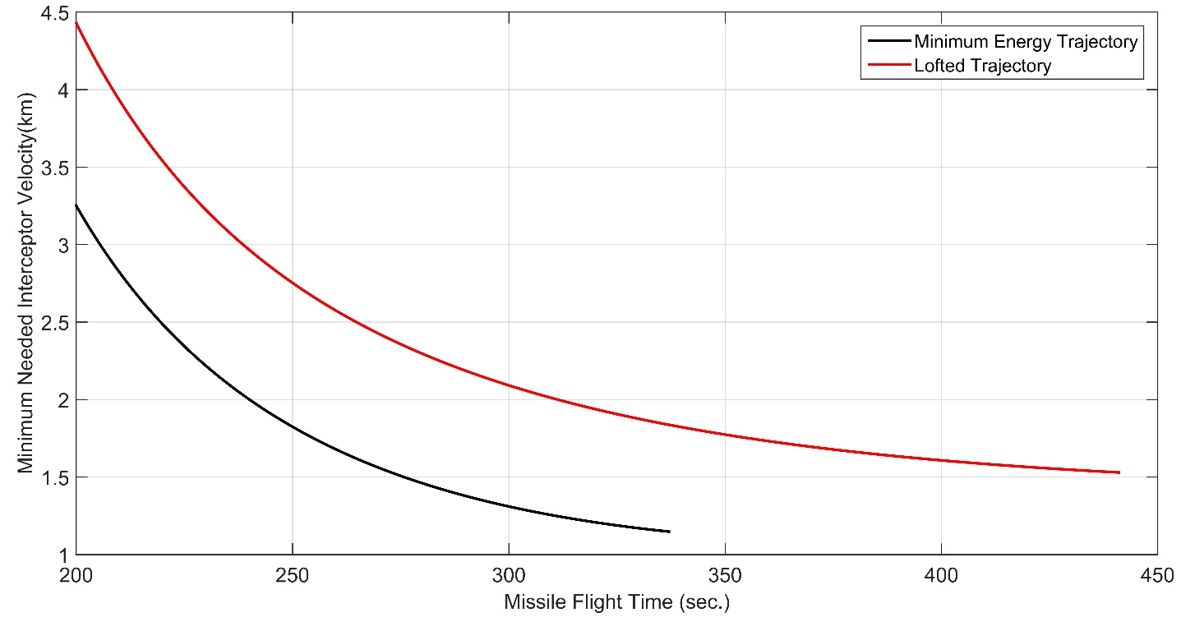
Figure B: Burn-Out Velocity to Intercept Missile Trajectory (Chiha-ri, North Korea to Pusan Naval Base, South Korea)

