The Influence of Pinochet on the Chilean Miracle
Edwar E. Escalante
Appendix.
A. Robustness Checks
A.1 Alternative Donor Units
The execution of the method considers two alternative group of donors for the GDP per capita with different data sets. I focus on the first experiment only to run additional robustness checks. A first counterfactual was built with a restricted sample and the second one with an expanded sample. Table 5 presents the weights for each country. The RSMPE between Chile and its synthetic counterfactual was 0.096, which is smaller than 0.109, which is the RMSPE using the expanded sample. Table 6 includes the fit of the predictors for each case. The first alternative synthetic counterfactual includes only Latin American countries and two former European colonizers (Spain and Portugal). It also contains three noticeable copper producers, Peru, Brazil, and Mexico. The second alternative dataset adds nine countries. They are the most relevant copper producers with adequate data during the period of examination. Only Zambia, which had GDP per capita information but lacked information on openness indicators, has been removed from those potential countries. With the change in donor countries, the pre-treatment fit is worse, as a considerable weight is now assigned to China, which is a very poor match for Chile’s initial GDP per capita.

Table 5. Estimated synthetic control weights, change in donors.

 | Restricted | Expanded
Argentina | 3.20 | 31.8
Australia | – | 0.00
Bolivia | 0.00 | 0.00
Brazil | 0.00 | 0.00
Canada | – | 0.00
China | – | 10.6
Colombia | 0.00 | 0.00
Congo De. Rep. | – | 0.00
Costa Rica | 0.00 | 0.00
Dominican Rep. | 0.00 | 0.00
Ecuador | 0.00 | 0.00
Guatemala | 0.00 | 0.00
Honduras | 0.00 | 0.00
Indonesia | – | 0.00
Mexico | 0.00 | 0.00
Nicaragua | 0.00 | 0.00
Panama | 53.2 | 1.80
Peru | 0.00 | 44.0
Philippines | – | 0.00
Portugal | 0.00 | 0.00
South Africa | – | 0.00
Spain | 0.00 | 0.00
United States | – | 0.00
Uruguay | 43.6 | 11.8
Venezuela | 0.00 | 0.00
Model ﬁt pre-intervention
RMSPE | 0.096 | 0.109
Note: Columns show the weight assigned to each country in the synthetic controls for Chile
for both, the restricted and expanded sample. A dash (–) specifies that the donor is not available
in the dataset. Weights are in percentage points. Rounding errors may prevent columns from
summing to 100. Data World Bank 2010 US$. The RMSPE reports the error of the unit of
comparison for each case.

Table 6. Indicator fits, GDP per capita, change in donors.

Variables | Actual Chile | Restricted | Expanded
 |  | Synth. Chile | Synth. Chile
Avg. GDP per capita | 4037.13 | 4218.48 | 4238.68
Pop. growth rate | 2.10 | 1.97 | 2.10
Openness, 1960 | 29.17 | 67.91 | 29.2
Openness, 1972 | 23.06 | 74.87 | 23.10
Total ed., 15+, 1960 | 5.22 | 4.75 | 4.12
Primary ed., 15+, 1960 | 3.98 | 3.83 | 3.30
Total ed., 15+, 1970 | 6.09 | 5.46 | 5.07
Primary ed., 15+, 1970 | 4.46 | 4.12 | 3.84

Note: Table shows the results of indicator variables and the average pre-Pinochet outcome variable for
actual and synthetic Chile for both, the restricted and expanded sample. Average GDP is an average over
the pre-Pinochet period, 1960–1973. GDP per capita is measured in 2010 dollars. Population growth is in
percentage points. Openness is a share fraction of GDP, in percentage points. The education variables are
measured in years.

A.2 Autocracy
A potential objection to the synthetic control is that the regime had spillovers representing an autocratic trend in the region. To see the relevance of this claim, I have elaborated a synthetic control with similar countries that did not go through an autocracy during this period: Colombia, Costa Rica, Dominican Republic, Mexico, and Venezuela. Predictably there is a poorer lack of fit in the pre-treatment period due to the restriction. However, the results are similar. The real Chile underperformed the synthetic “democratic” Chile during the Pinochet’s regime. Figure 5 shows the trends and table 7 and 8, the weights and the indicator fits, respectively.
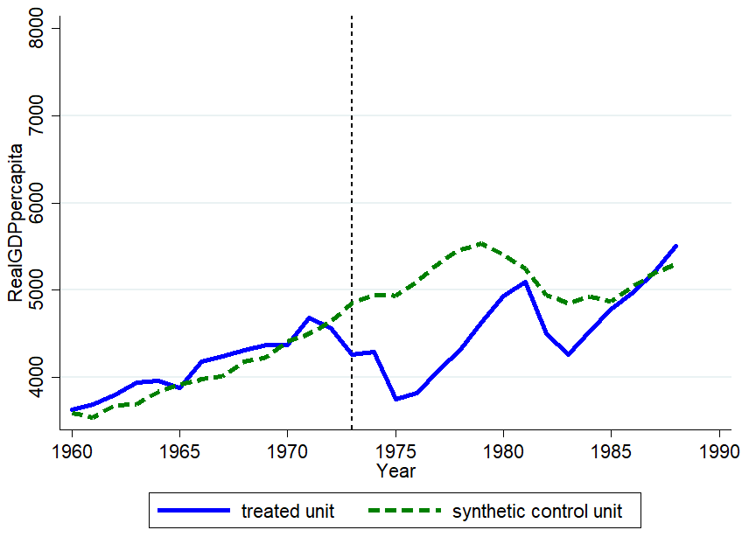

Figure 5. GDP per capita.
Note: The solid line represents observed per capita income in Chile, 1960–88; the dashed line represents the synthetic control for the same period. World Bank Data are in constant 2010 U.S. Dollars.

A.3 Jackknife Resampling
I consider the baseline model for GDP per capita while dropping each donor that received a weight in the synthetic counterfactual. Table 7 presents the results of these models, which exclude, Argentina, Panama, and Uruguay. Excluding Panama and Uruguay produce new members for the compositions of the synthetic controls such as Bolivia and Ecuador. However, none of these different controls produces a better fit pre-intervention than the initial construction. Their RMSPE is 0.144 and 0.155, respectively. The counterfactual that drops Argentina is a close approximation to the opening results but still maintains a higher root square error. Table 8 reports the indicators of these versions of the model and compare them to those of actual Chile.

Table 7. Synthetic Control Weights, Jackknife Resampling
 | Drop Argentina | Drop Panama | Drop Uruguay | Drop Autocracies
Argentina | --* | 37.10 | 45.7 | --*
Bolivia | 0.00 | 5.20 | 6.00 | --*
Brazil | 0.00 | 0.00 | 0.00 | --*
Colombia | 0.00 | 0.00 | 0.00 | 70.4
Costa Rica | 0.00 | 0.00 | 0.00 | 0.00
Dominican Republic | 0.00 | 0.00 | 0.00 | 0.00
Ecuador | 0.00 | 47.00 | 48.3 | --*
Guatemala | 0.00 | 0.00 | 0.00 | --*
Honduras | 0.00 | 0.00 | 0.00 | --*
Mexico | 0.00 | 0.00 | 0.00 | 18.5
Nicaragua | 0.00 | 0.00 | 0.00 | --*
Panama | 52.30 | ---* | 0.00 | --*
Peru | 0.00 | 0.00 | 0.00 | --*
Portugal | 0.00 | 0.00 | 0.00 | --*
Spain | 0.00 | 0.00 | 0.00 | --*
Uruguay | 47.70 | 10.80 | ---* | --*
Venezuela | 0.00 | 0.00 | 0.00 | 11.1
Model ﬁt pre-intervention
RMSPE
 | 0.099 | 0.144 | 0.155 | 0.0.98
Note: Columns present the weights assigned to each country in the synthetic controls for Chile. Each column includes a synthetic control for a different outcome variable. A dash (–) indicates that the country is not available in the dataset for the given comparison. Weights are in percentage points. Rounding errors may prevent columns from summing to 100. The root square error (RMSPE) indicates the average pre-intervention prediction error.
* These donors have been excluded in order to show the effect on the weights and ﬁt of the model

Table 8. Indicator ﬁts, Jackknife Resampling
 |  | Drop Argentina | Drop Panama | Drop Uruguay | Drop Autocracies
Variables | Actual Chile | Synth. Chile | Synth. Chile | Synth. Chile
avg. GDP per capita | 4037.13 | 4207.55 | 4294.78 | 4307.84 | 4264.40
Pop. Growth Rate | 2.10 | 1.93 | 2.12 | 2.22 | 2.93
Openness 1960 | 29.17 | 67.85 | 27.92 | 26.46 | 29.91
Openness 1972 | 23.06 | 74.62 | 23.97 | 22.62 | 27.76
Total ed. 15+, 1960 | 5.22 | 4.72 | 4.30 | 4.33 | 2.88
Primary ed. 15+, 1960 | 3.98 | 3.80 | 3.60 | 3.64 | 2.29
Total ed. 15+, 1970 | 6.09 | 5.44 | 5.24 | 5.26 | 3.74
Primary ed. 15+, 1970 | 4.46 | 4.10 | 4.23 | 4.27 | 2.76
Note: Table shows the values of indicator variables and the average pre-Pinochet outcome variable for real and synthetic Chile. Average GDP
is an average over the pre-Pinochet years chosen for the control. GDP per capita is measured in 2010 dollars. Population growth is in percentage
points. Government share is a fraction of GDP, in percentage points. Polity and Executive Constraints follow the polity scores scale. The measure
of durability and the education variables is years.

A.4 Change in Indicators
Here, I consider three different sets of predictors. They provide a good fit for the covariates used to distribute the weights for each control and the pre-Pinochet observations on GDP per capita according to the root mean squared error. Table 9 presents the results of the three-alternative set of covariates. The alternative model 1 considers average population growth 1960-72, and education variables of the primary synthetic control, but removes the indicators on openness for both 1960 and 1972 and adds average GDP per capita from the four years chosen for the original control, and measures of government and investment shares of GDP from 1960 and 1972. Alternative model 2 includes the same indicators than Alternative 1 and adds openness indicators and indicators from Polity IV. However, it removes the four educational variables. Alternative model 3 includes the same indicators than alternative 2, but it adds three more covariates from Polity IV which refer to 1960. The results of the alternative models 2 and 3 show that the removal of the educational variables and the inclusion of the polity V has a positive influence on the pre-Pinochet fit. Alternative model 1 has a pre-Pinochet fit almost as good as the baseline model, the algorithm does not change the distribution of weights of the countries that compose the control. Table 10 reports the indicators of the alternative models and compare them to those of actual Chile. As we can see lower errors for alternative models come at the cost of not having traditional predictors of the GDP per capita.
Table 9. Synthetic Control Weights, Alternative Models
 | Alt. 1 | Alt. 2 | Alt. 3
Argentina | 3.20 | 0.00 | 0.00
Bolivia | 0.00 | 0.00 | 0.00
Brazil | 0.00 | 0.00 | 0.00
Colombia | 0.00 | 0.00 | 0.00
Costa Rica | 0.00 | 45.00 | 45.00
Dominican Republic | 0.00 | 0.00 | 0.00
Ecuador | 0.00 | 0.00 | 0.00
Guatemala | 0.00 | 0.00 | 0.00
Honduras | 0.00 | 0.00 | 0.00
Mexico | 0.00 | 0.00 | 0.00
Nicaragua | 0.00 | 0.00 | 0.00
Panama | 53.20 | 38.10 | 0.00
Peru | 0.00 | 0.00 | 38.10
Portugal | 0.00 | 0.00 | 0.00
Spain | 0.00 | 9.38 | 0.00
Uruguay | 43.60 | 10.60 | 10.70
Venezuela | 0.00 | 6.30 | 6.30
Model ﬁt pre-intervention
RMSPE | 0.097 | 0.079 | 0.079
Note: Columns present the weights assigned to each country in the synthetic controls for Chile. Each column includes a synthetic control for a different outcome variable. A dash (–) indicates that the country is not available in the dataset for the given comparison. Weights are in percentage points. Rounding errors may prevent columns from summing to 100. The root square error (RMSPE) indicates the average pre-intervention prediction error for the unit of comparison specific to each control.

Table 10. Indicator ﬁts, alternative models.

 |  | Alt. 1 |  | Alt. 2 |  | Alt. 3
Variables | Actual Chile | Synth. Chile |  | Synth. Chile |  | Synth. Chile
Avg. GDP per capita | 4037.13 | 4218.48 |  | 4248.00 |  | 4253.54
Pop. Growth Rate | 2.10 | 1.97 |  | 2.78 |  | 2.78
Openness, 1960 | 29.17 | – |  | 43.00 |  | 43.03
Openness, 1972 | 23.06 | – |  | 46.83 |  | 46.86
Total ed., 15+, 1960 | 5.22 | 4.75 |  | – |  | –
Primary ed., 15+, 1960 | 3.98 | 3.83 |  | – |  | –
Total ed., 15+, 1970 | 6.09 | 5.46 |  | – |  | –
Primary ed., 15+, 1970 | 4.46 | 4.12 |  | – |  | –
GDP per capita Growth Rate | 2.26 | 1.75 |  | 1.16 |  | 1.16
Inv. Share 1960 | 0.12 | 0.17 |  | 0.14 |  | 0.14
Inv. Share 1972 | 0.10 | 0.22 |  | 0.12 |  | 0.12
Gov. Share 1960 | 0.18 | 0.13 |  | 0.15 |  | 0.15
Gov. Share 1972 | 0.21 | 0.18 |  | 0.20 |  | 0.20
Polity II, 1972 | 6 | – |  | 2.08 |  | 2.08
Durability, 1972 | 17 | – |  | 25.56 |  | 25.56
Exec. Constraints, 1972 | 5 | – |  | 4.23 |  | 4.23
Polity II,1960 | 9 | – |  | – |  | 7.64
Durability, 1960 | 1 | – |  | – |  | 20.96
Exec. Constraints, 1960 | 6 | – |  | – |  | 5.90
Note: Table presents the values of indicator variables and the average pre-Pinochet outcome variable for real and synthetic Chile.
Average GDP is an average over the pre-Pinochet period, 1960–72. GDP per capita is measured in 2010 dollars. Population growth
is in percentage points. Government share is a fraction of GDP, in percentage points. Polity and Executive Constraints follow the
polity scores scale. The measure of durability and the education variables is years.

Appendix B:
B.1 Results in Life Expectancy
Another vital dimension on which to evaluate the effect of Pinochet on the Chilean economy is life expectancy, which should provide a good overall indicator of social well-being. The effect of Pinochet’s regime on health outcomes is given by annual observations from the period 1960–88. Again, countries with more reliable data are considered as well as countries with similar institutional conditions. Consequently, the eighteen control countries for life expectancy are basically the same as those for the income per capita control. The configuration of the synthetic control on life expectancy is shown in table 11.

Table 11. Indicator fits, life expectancy

Variables | Actual Chile | Synth. Chile
Log GDP per capita | 3.5599 | 3.6704
Inv. share 1960 | 0.1224 | 0.2289
Inv. share 1972 | 0.1041 | 0.2307
Gov. share 1960 | 0.1818 | 0.1814
Gov. share 1972 | 0.2102 | 0.2232
Polity II 1972 | 6 | 5.653
Exec. constraints, 1972 | 5 | 5.019
Durability, 1972 | 17 | 17.738
Polity II, 1960 | 5 | 2.988
Exec. constraints, 1960 | 4 | 4.583
Durability, 1960 | 5 | 13.204
Adol. fert. rate, 1970 | 87.888 | 110.639
Crude birth rate, 1970 | 29.6 | 36.817

Note: Table shows the values of indicator variables and the
average pre-Pinochet outcome variable for actual Chile and
synthetic Chile.

Figure 6 shows that the synthetic counterfactual captures the pre-Pinochet performance almost precisely, and the post-Pinochet period presents a notable effect of Pinochet’s regime on life expectancy. The graph shows that both the actual and the synthetic trajectories of Chile’s life expectancy are quite similar. After applying the algorithm, the synthetic control consists of Costa Rica (23.2 percent), Guatemala (21.8 percent), Paraguay (5.40 percent), Spain (5.60 percent), Uruguay (0.10 percent), and Venezuela (43.8 percent). The error for the pre-intervention fit (RMSPE) is 0.037.
The divergence starts at the year of the treatment, and although it is not dramatic, there is a discernible but small effect of Pinochet’s regime on life expectancy, the gap becomes wider over the following years. Chile’s life expectancy roughly increases at a greater rate than the control. By the end of the period under study, Chilean life expectancy is almost four years higher than what is predicted by the synthetic counterfactual.

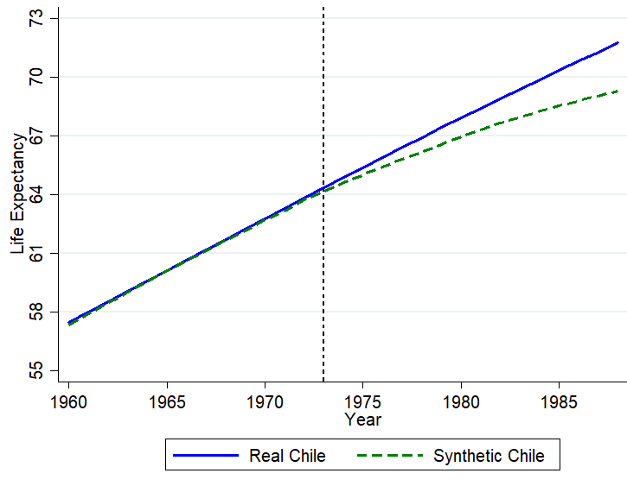
Figure 6. Life expectancy. Note: The solid line represents observed life expectancy in Chile, 1960–2010; the dashed line represents the synthetic control.

B.2 Inference Test
Regarding the social outcomes, synthetic Chile consistently obtains higher life expectancy throughout the post-intervention period. However, the divergence is not extensive, even though the improvement is almost immediately noticeable. These results are expected considering the nature of the variable. The changes in life expectancy tend to be relatively small since the period under analysis is short. Figure 7 shows the placebo tests with all the eighteen countries for the results on life expectancy. Just like the tests on income per capita, the placebo tests use all countries. Compared to other donor’ synthetic controls, the control for Chile is reasonably accurate during the pre-Pinochet period.

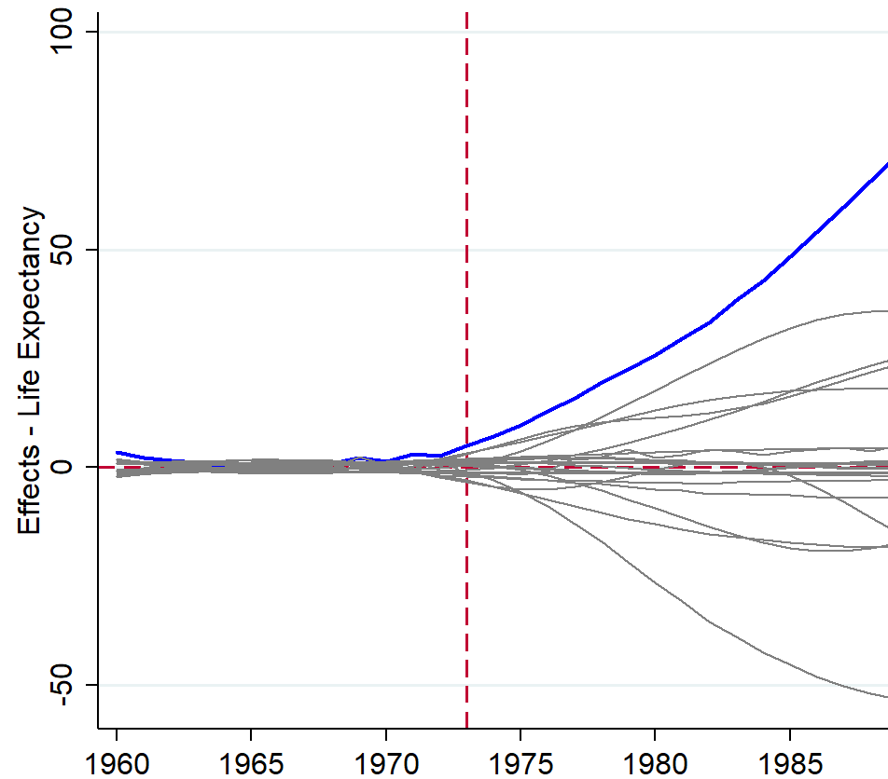
Figure 7. Life-expectancy placebo tests. The blue line characterizes the difference between the observed life expectancy in Chile, 1960–88, and the synthetic control; the synthetic control is normalized to zero. Gray lines represent placebo tests—i.e., deviations from the synthetic control for the other countries in the dataset.

The calculation of the p-values for the synthetic-control results in life expectancy follows the same process as that for income per capita. There are eighteen donors in this case, and there is one single event: Pinochet’s autocracy. Likewise, the algorithm calculates eighteen placebo averages to compute each p-value. The results are shown in figure 8. They confirm the results obtained with the synthetic control presented in figure 6 by providing a significant statistical increase in life expectancy for every year after the introduction of Pinochet’s autocracy.

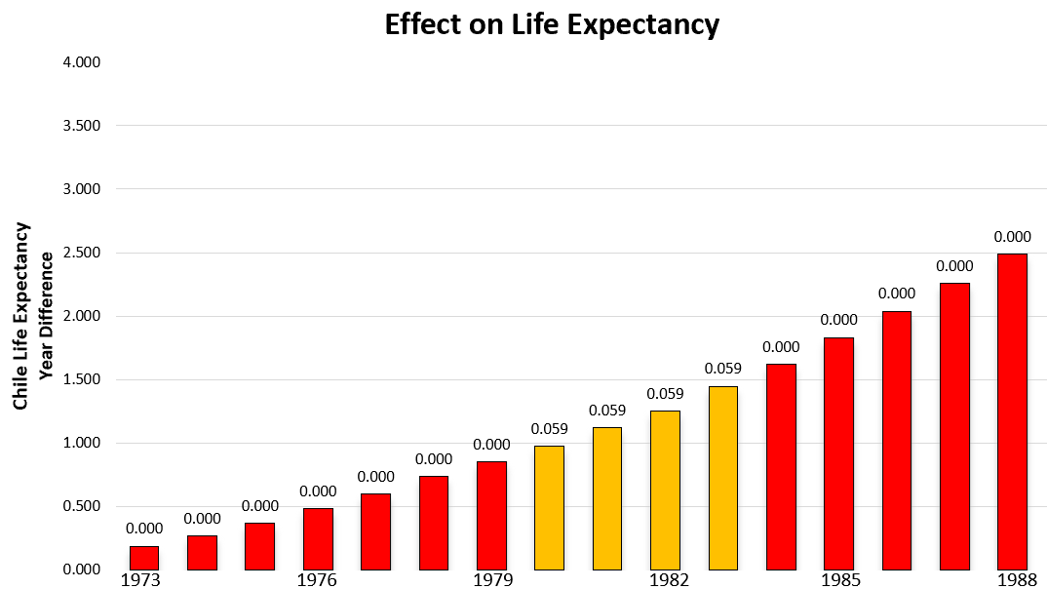

Figure 8: This figure shows the estimated treatment effects upon life expectancy for each period following the Pinochet treatment. The y-axis shows the difference in years between the synthetic control and the real Chile. Numbers above each bar display the p-value for each period. Effects in red are significant at the < .0001 level, effects in yellow are significant at the .06 level.

The results on life expectancy showed a positive influence of the autocracy. A small divergence expanded progressively from 1973 through the post-treatment period. My results coincide with Tapia Granados (2010), who found that longevity increased faster under right-wing autocracies in southern Europe than under social democracies in the Nordic countries. In contrast, Besley and Kudamatsu (2006) find a robust correlation between democratic institutions and higher life expectancy. This prevailing thesis argues that democratic regimes allocate health-conducive resources more widely than their autocratic counterparts do. My article does not attempt to challenge this thesis. Instead, it may serve to contribute to a broader explanation of the health effects of regime type.

This expanded sample includes the same countries of the second experiment in section 4 but it uses the World Bank data set of the first experiment. The World Bank data ser covers a shorter pre-treatment period 1960-73.
URSS and Poland had been removed because of the lack of information on GDP per capita in data of the World Bank. Unlike the initial experiment, I have considered Indonesia in this data set because of its conditions as copper producer and data availability in the shorter pre-treatment period I analyze in this section.

