Online Appendix A: Sample Descriptive Features

Table A1 shows the demographics of our sample after reweighting to approximate the 2018 American Community Survey proportions for gender, age, race/ethnicity, educational attainment, urbanicity, and region. We find, in general, that our weights suffice for the other variables in the weighted sample to likewise reflect demographic patterns in the US adult population. PureSpectrum draws upon a variety of commercial panels including MFour, some of which recruit volunteers and others which incentivize their respondents through loyalty points, rewards in computer games, or cash.

Table A1: Sample demographics.
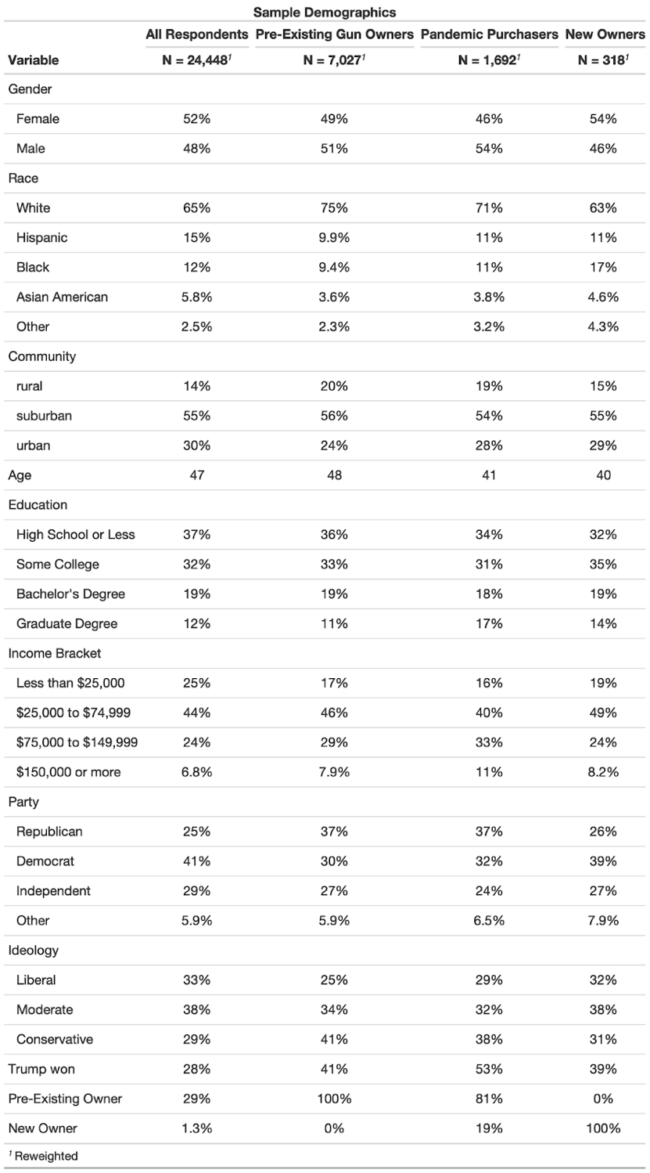

Online Appendix B: Question Wording for Key Variables

Gun Ownership
Gun owner Do you or a member of your household own a gun?
▢ Yes
▢ No

Gun purchase Did you or a member of your household buy a gun during the COVID-19 pandemic (in the past 12 months)?
▢ Yes
▢ No

Pre-existing owner Did you or a member of your household own a gun before the COVID-19 pandemic (over 12 months ago)?
▢ Yes
▢ No

Reasons for Gun Buying

What were the reasons you or a member of your household decided to get a gun? (Please select all that apply)
▢ Hunting
▢ Target shooting
▢ Protection against crime
▢ Protection against the government
▢ Because of COVID-19
▢ Because of the lockdown and restrictions
▢ Because of the election
▢ Protection against someone I know personally
▢ Other

Conspiracy Beliefs
Respondents received a “1” for saying accurate and a “0” for saying inaccurate or not sure, except for the clinical trials item which was reverse coded (1 for inaccurate, 0 for accurate or not sure). The vaccine conspiracy index is the average of these scores.

Below are some statements about the COVID-19 vaccines that are currently being distributed. To the best of your knowledge, are those statements accurate or inaccurate?
 | Accurate | Inaccurate | Not sure
The COVID-19 vaccines will alter people’s DNA. | ▢ | ▢ | ▢
The COVID-19 vaccines contain microchips that could track people. | ▢ | ▢ | ▢
The COVID-19 vaccines contain the lung tissue of aborted fetuses. | ▢ | ▢ | ▢
The COVID-19 vaccines can cause infertility, making it more difficult to get pregnant. | ▢ | ▢ | ▢
The COVID-19 vaccines were tested on thousands of people in clinical trials. | ▢ | ▢ | ▢

Institutional Trust

The trust health officials variable is an average of the following three items. These items were originally embedded in a longer list.

How much do you trust the following people and organizations to do the right thing to best handle the current coronavirus (COVID-19) outbreak?
 | A lot | Some | Not too much | Not at all
The FDA (Food and Drug Administration) | ▢ | ▢ | ▢ | ▢
The CDC (Centers for Disease Control and Prevention) | ▢ | ▢ | ▢ | ▢
Dr. Anthony Fauci of the National Institutes of Health | ▢ | ▢ | ▢ | ▢

The trust scientists and trust news media variables appeared in the following matrix, which originally contained more items.

How much do you trust the following people and organizations to do the right thing to best handle the current coronavirus (COVID-19) outbreak?

 | A lot | Some | Not too much | Not at all
Scientists and researchers | ▢ | ▢ | ▢ | ▢
The news media | ▢ | ▢ | ▢ | ▢

COVID-19 Variables
The following two questions were used to construct the COVID-19 House variable. Respondents who answered “Yes” to the first question or any answer aside from “None” on the second question were coded as 1. All others were coded as 0.

Have you ever been diagnosed with coronavirus (COVID-19)?
▢ Yes, I was diagnosed by a medical professional
▢ No, I was not diagnosed but I think I may have it now
▢ No, I was not diagnosed but I think I had it previously and recovered
▢ No, I was not diagnosed and I do not think I ever had it
▢ I am not sure

How many members of your household (other than yourself) have been diagnosed with coronavirus (COVID-19)?
▢ None
▢ One
▢ Two
▢ Three
▢ Four
▢ Five or more

The economic hardship index was constructed from the number of items a respondent checked in the following list.

Are you or someone in your household currently experiencing any of the following as a result of the coronavirus (COVID-19) outbreak? (Please select all that apply)
▢ Had to start working from home
▢ Had their school or university closed
▢ Had to stop or scale back work to take care of their children
▢ Had to stop or scale back work to take care of someone who had COVID-19
▢ Had to take a cut in pay due to reduced hours or demand for their work
▢ Was unable to make rent or mortgage payments
▢ Was evicted from their home
▢ Was laid off or lost a job
▢ Was unable to make rent or mortgage payments
▢ None of the above

Online Appendix C: Logit and Full Models

