Supporting Information
The Supporting Information contains the following:
Survey Information

Sample Quality
Table : Comparison of ELTS sample and known population characteristics
Figures SI1 and SI2: Sample composition over time
Question Wording
Figure SI3: Paired conjoint experiment prompt

Additional Analysis

Figure SI4: Perceptions of 2020 election outcome (unweighted data)
Figure SI5: Perceptions of 2020 election outcome by partisanship (unweighted data)
Figure SI6: Perceptions of 2020 election outcome by partisanship and demographics
(unweighted data)
Figure SI7: Perceptions of 2020 election outcome (acceptance index)
Figure SI8: Perceptions of 2020 election outcome by partisanship (acceptance index)
Figure SI9: Support for political violence
Figure SI10: Support for political violence by partisanship (unweighted data)
Figure SI11: Willingness to participate in violent protest by partisanship
Figure SI12: Willingness to attack police forces by partisanship
Figure SI13: Willingness to encourage other to join violent illegal protests by partisanship
Figure SI14: Willingness to war to protect rights of group by partisanship
Figure SI15: Willingness to retaliate against members of other group by partisanship
Figure SI16: Results of conjoint experiment (unweighted data)
Sample Quality
Probability-based samples, such as those generated through random-digit dialing, have been the gold standard for survey research. Nonetheless, weighted opt-in national surveys like ours have increasingly become a common way to gauge public opinion and voting behavior. Empirical evidence suggests they fare just as well at predicting election outcomes as more traditional methods Kennedy et al. (2018).
Qualtrics is an established, respected survey research firm that, similar to firms like YouGov, maintains a large verified online panel of potential survey respondents. It compensates panelists who opt to participate in studies with money-based incentives. It generates diverse samples through quotas that balance the sample with respect to preset demographic targets (e.g., 51% women). We instituted a quota for partisanship, which we tied to the distribution of Democrats, Independents, and Republicans according to the 2016 American National Election Study and gender, which we tied to the distribution of men and women among registered voters. To ensure that our daily samples were comparable, we asked Qualtrics to use a two-step method for study recruitment. First, it drew up a list of panelists necessary to generate a 20,000-person study. Second, it randomly sample participants from this list each day the survey was placed into the field and stopped once it reached 500 completed, quota-balanced observations.
Of course, whether our sample is nationally representative is an open question. To gauge the quality of our sample Table SI1 compare its demographic composition to known benchmarks. Our sample closely matches the population of registered voters in terms of: turnout, gender, identifying as White as well as Latino, education, and identifying as Republican. However, there are some discrepancies. The ELTS over-represents those who identify as Black, those younger than 50, the northeast and the south, and those identifying as Democrat. We address these departures from the population through applying sample weights. The figures below show that the results are essentially the same in the weighted and unweighted data.

Table SI1: Comparing ELTS Sample Characteristics to Population Estimates
Variable | ELTS Sample | Population Estimate
Turnout | 87.7% | 86.8%
Female | 51.9% | 51%
Black | 15.1% | 9%
Hispanic/Latino | 6.2% | 8%
White | 72.8% | 75%
Age 18-29 | 24.4% | 11%
Age 30-49 | 48.4% | 30%
Age 50-64 | 16.5% | 29%
Age 65+ | 10.6% | 31%
High School Degree or Less | 22.1% | 25%
Northeast | 22.3% | 17.2%
Midwest | 18.4% | 21%
South | 43.2% | 38%
West | 15.4% | 23.8%
Democrat | 43.7% | 35%
Republican 33.1% 31%
Note: Table compares the unweighted ELTS sample to estimates of the population of registered voters. Turnout among registered voters comes from the US Census Current Population Survey from 2016 (2020 not yet available). Population estimates for demographic variables and party identification come from Pew’s Validated Voter data from 2018(https://www.pewresearch.org/fact-tank/2020/10/30/a-voterdata-resource-detailed-demographic-tables-about-verified-votersin-2016-2018/).
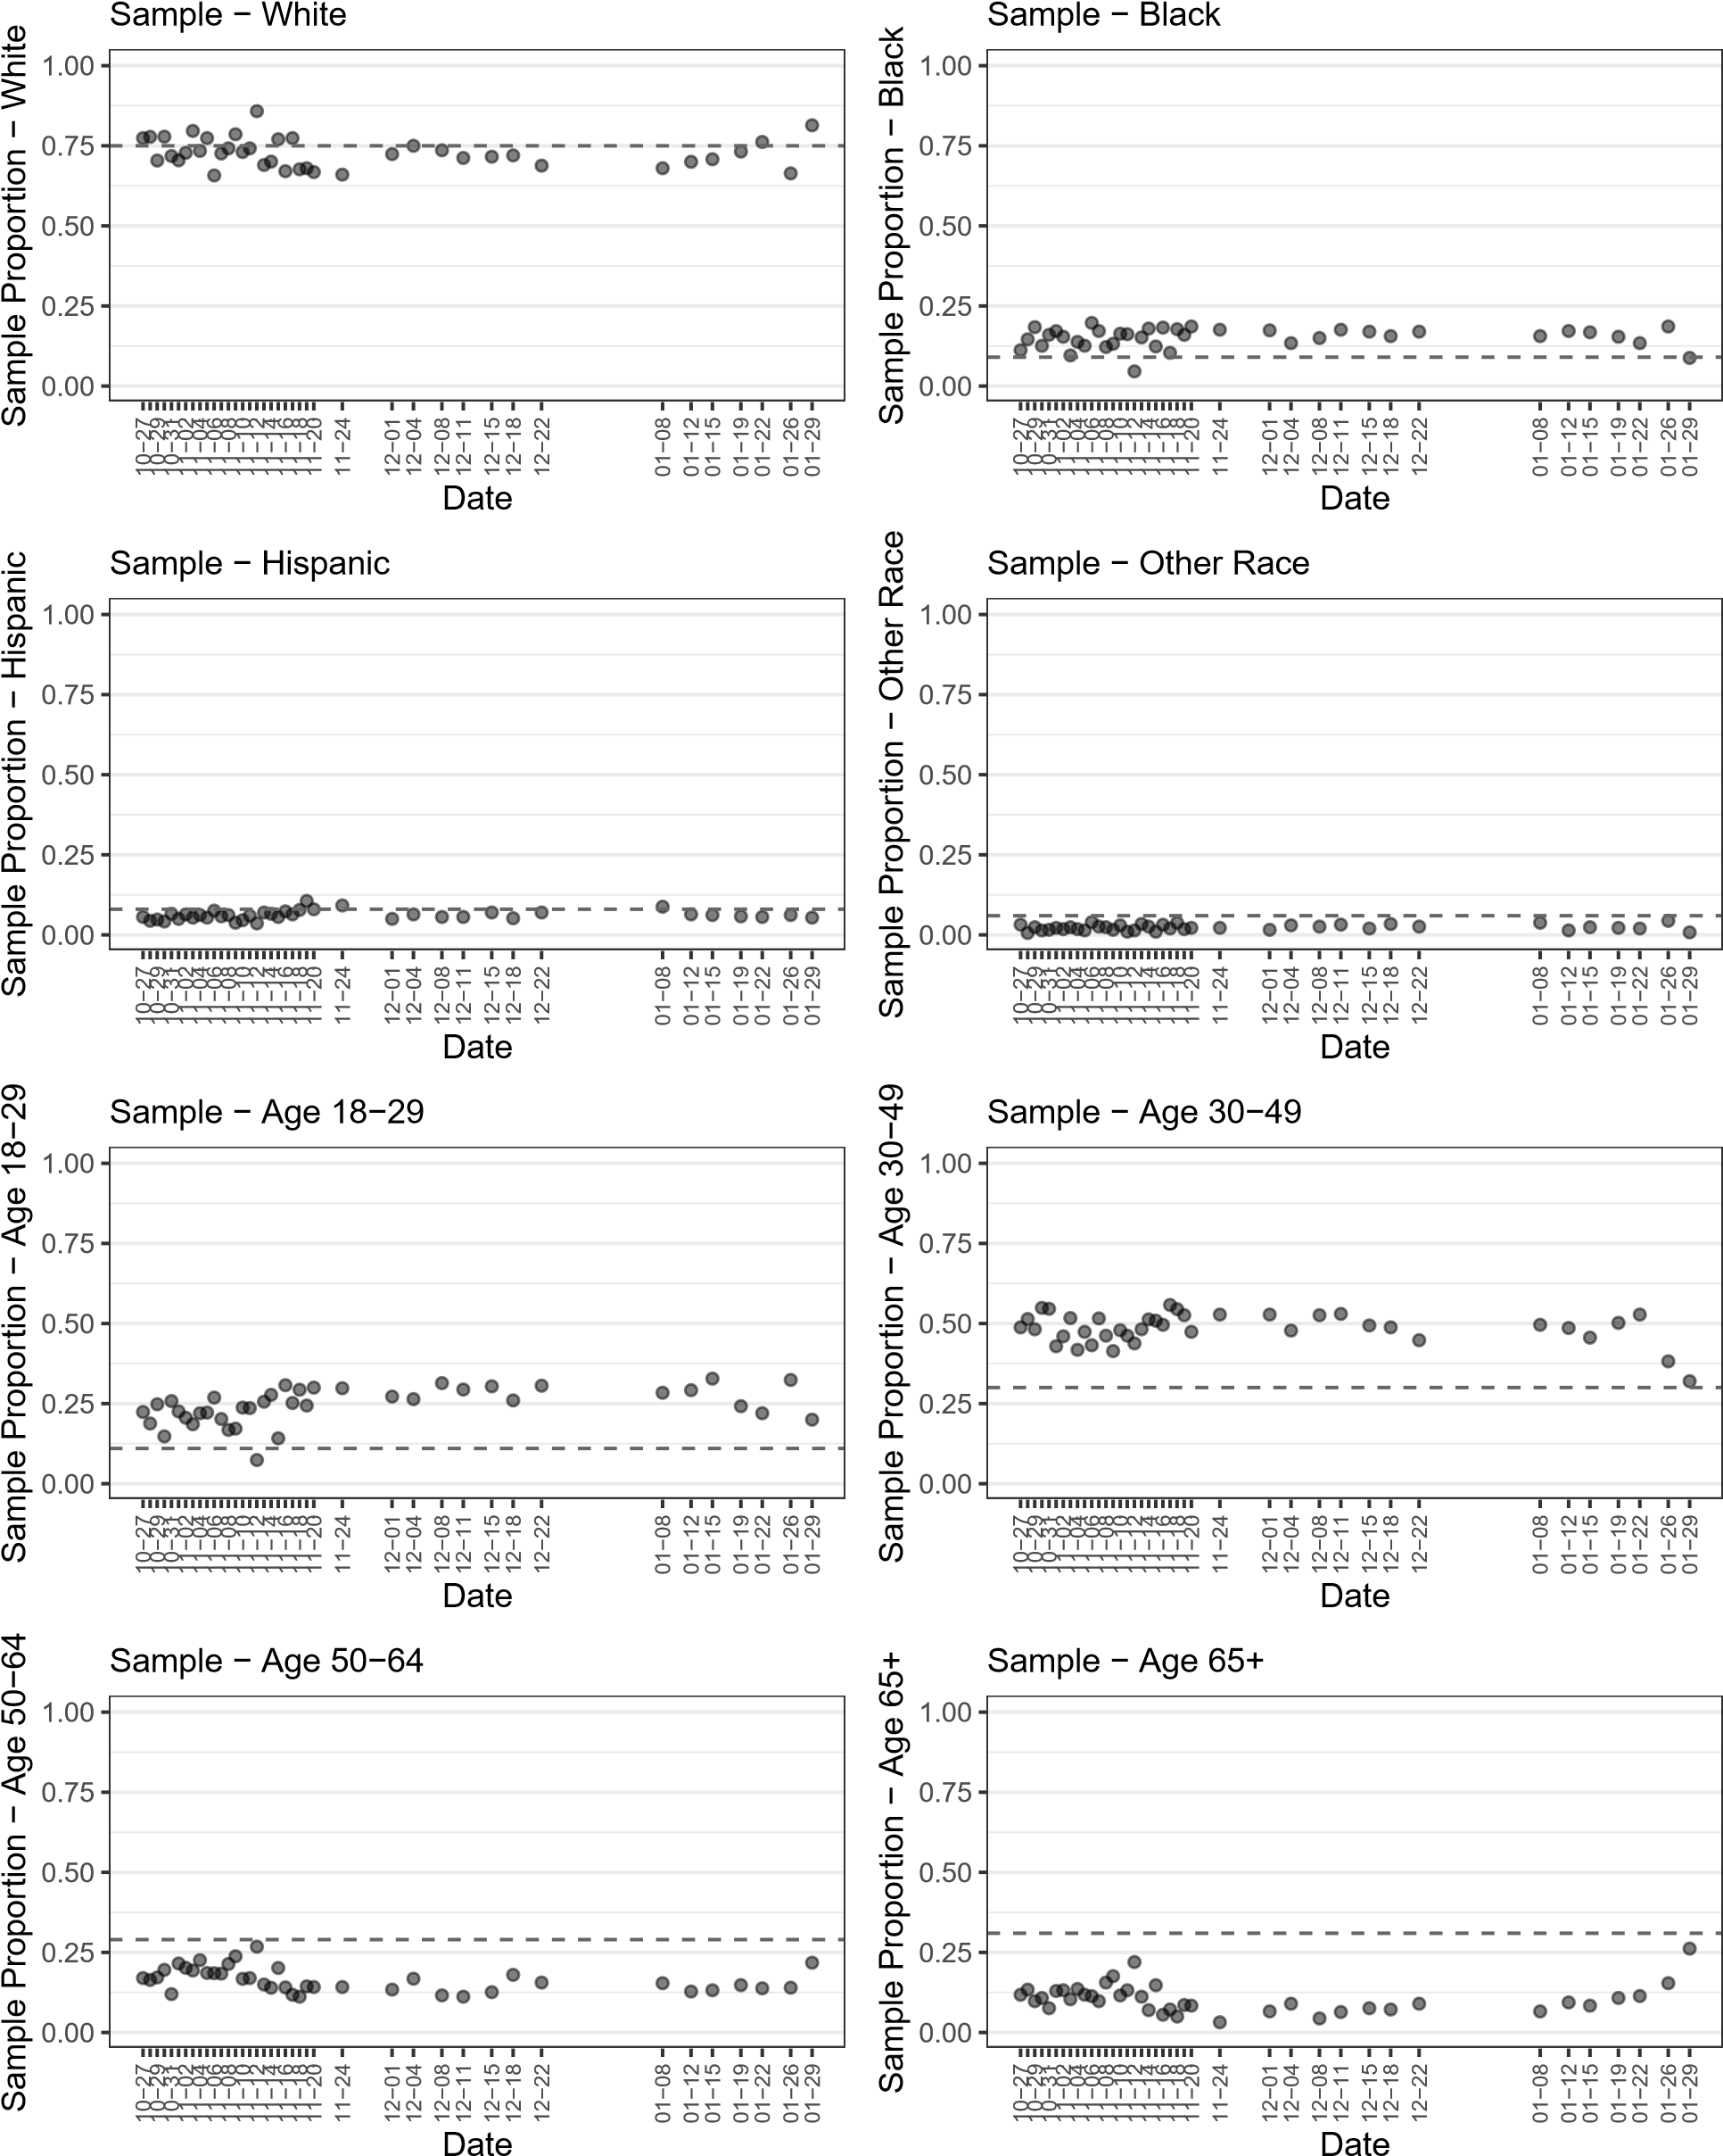
Figure SI1: Sample composition over time (1/2). The figure shows different the share of respondents falling into different demographic categories in each daily sample. The dotted line represents the group’s share of registered voters. Categories where the points consistently fall above the dotted line are over-represented in the unweighted survey data. Categories where the points fall below are under-represented. All data drawn from Election Legitimacy Tracking Survey (ELTS).
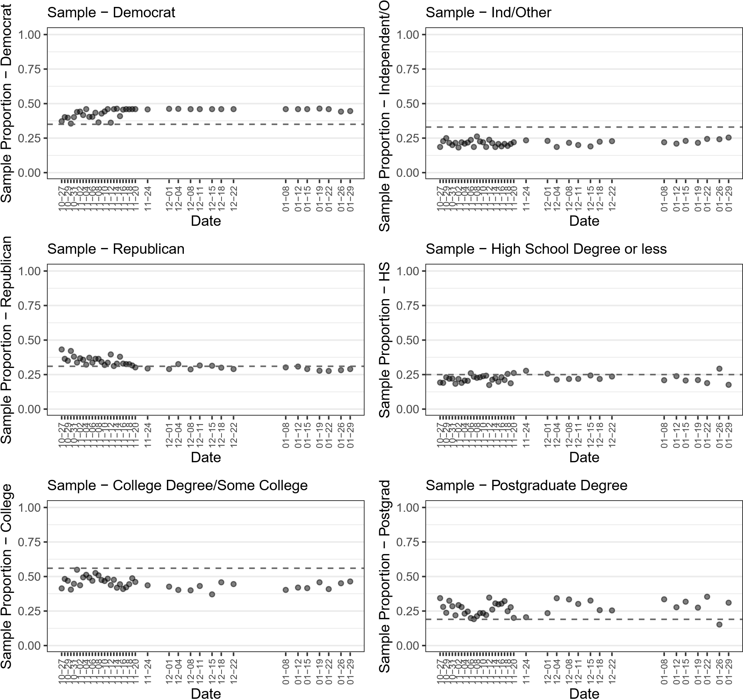
Figure SI2: Sample composition over time (2/2). The figure shows different the share of respondents falling into different demographic categories in each daily sample. The dotted line represents the group’s share of registered voters. Categories where the points consistently fall above the dotted line are over-represented in the unweighted survey data. Categories where the points fall below are under-represented. All data drawn from Election Legitimacy Tracking Survey (ELTS).

Question Wording
Module: Radicalism Intention Scale (RIS) Moskalenko and McCauley (2009)
In this section, you will be presented with a series of possible actions that you can carry out to promote your group’s political rights and interests. By “your group,” we mean the political, religious, or social group that you identify with the most. To what extent do you disagree or agree with the following statements?
V1. I would participate in a public protest against oppression of my group even if I thought the protest might turn violent.
- - Strongly agree
- - Agree
- - Neither agree or disagree
- - Disagree
- - Strongly disagree
99 - No answer
V2. I would attack police or security forces if I saw them beating members of my group.
- - Strongly agree
- - Agree
- - Neither agree or disagree
- - Disagree
- - Strongly disagree
99 - No answer
V3. I would encourage others to join violent protests against oppression of my group, even if I knew it was illegal.
- - Strongly agree
- - Agree
- - Neither agree or disagree
- - Disagree
- - Strongly disagree
99 - No answer
V4. I would go to war to protect the rights of my group.
- - Strongly agree
- - Agree
- - Neither agree or disagree
- - Disagree
- - Strongly disagree
99 - No answer
V5. I would retaliate against members of a group that had attacked my group, even if I couldn’t be sure I was retaliating against the guilty party.
- - Strongly agree
- - Agree
- - Neither agree or disagree
- - Disagree
- - Strongly disagree
99 - No answer
Module: Election Outcomes
E1. Who do you think is most likely to win the presidential election? [administered preelection]
- - Definitely Joe Biden
- - Probably Joe Biden
- - Both Joe Biden and Donald Trump are equally likely to win
- - Probably Donald Trump
- - Definitely Donald Trump
99 - No answer
E2. Who do you think won the presidential election? [administered postelection]
- - Joe Biden
- - Donald Trump
99 - No answer
E3. Major news networks have announced that Joe Biden is the winner of the 2020 presidential election. Do you accept the election results as legitimate?[administered postelection]
- - Yes
- - No
99 - No answer
Module: Candidate Identification
P5b. In the 2020 general election, who did you vote for?
- - Donald Trump
- - Joe Biden
- - Someone else
- - I am not sure
- - No answer
P4. On each of the next several pages you will be presented with a statement. Please rate how much you agree or disagree with the statement on each page.
P4b. When people criticize [P5b piped text], it feels like a personal insult.
- - Strongly agree
- - Agree
- - Neither agree or disagree
- - Disagree
- - Strongly disagree
99 - No answer
P4f. When people praise the [P5b piped text], it makes me feel good.
- - Strongly agree
- - Agree
- - Neither agree or disagree
- - Disagree
- - Strongly disagree
99 - No answer

Figure SI3: Paired conjoint experiment prompt. The figure shows how the conjoint experiment appeared to respondents in the Electoral Legitimacy Tracking Survey (ELTS).

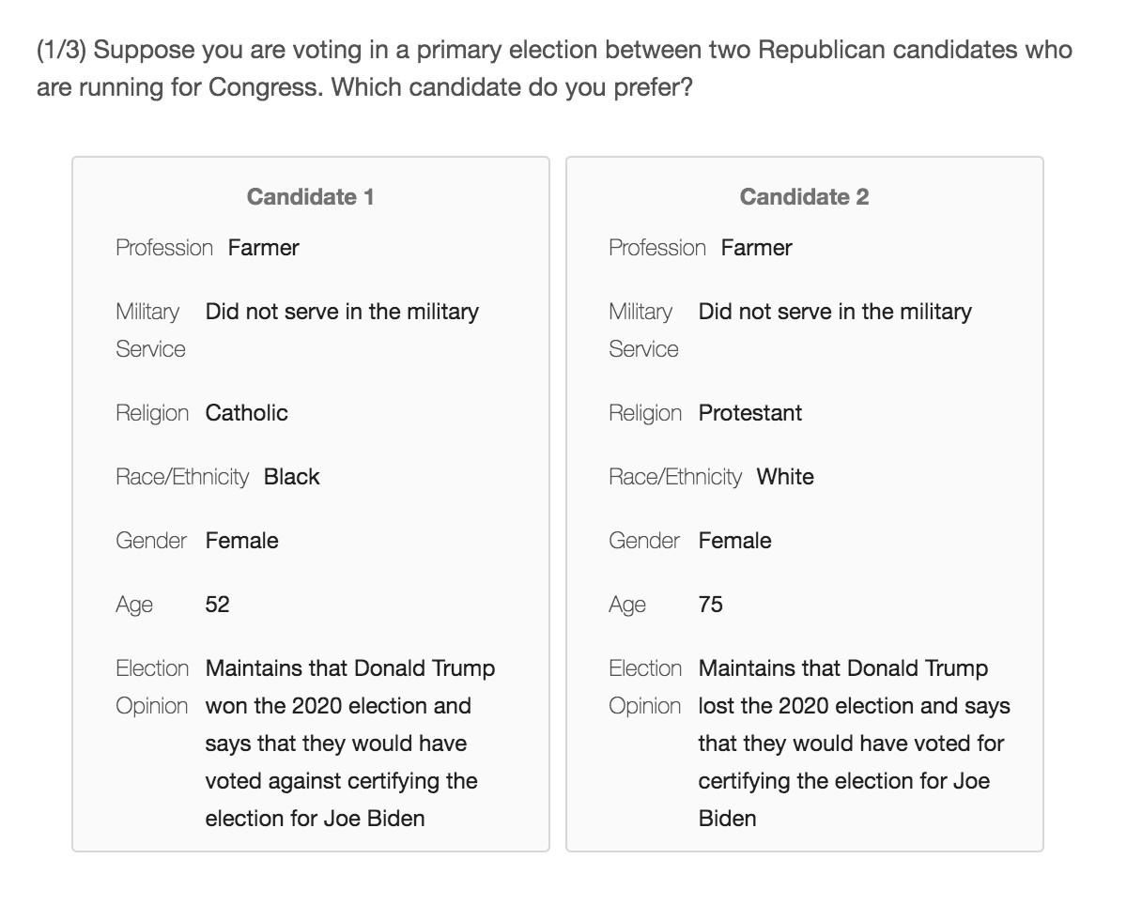

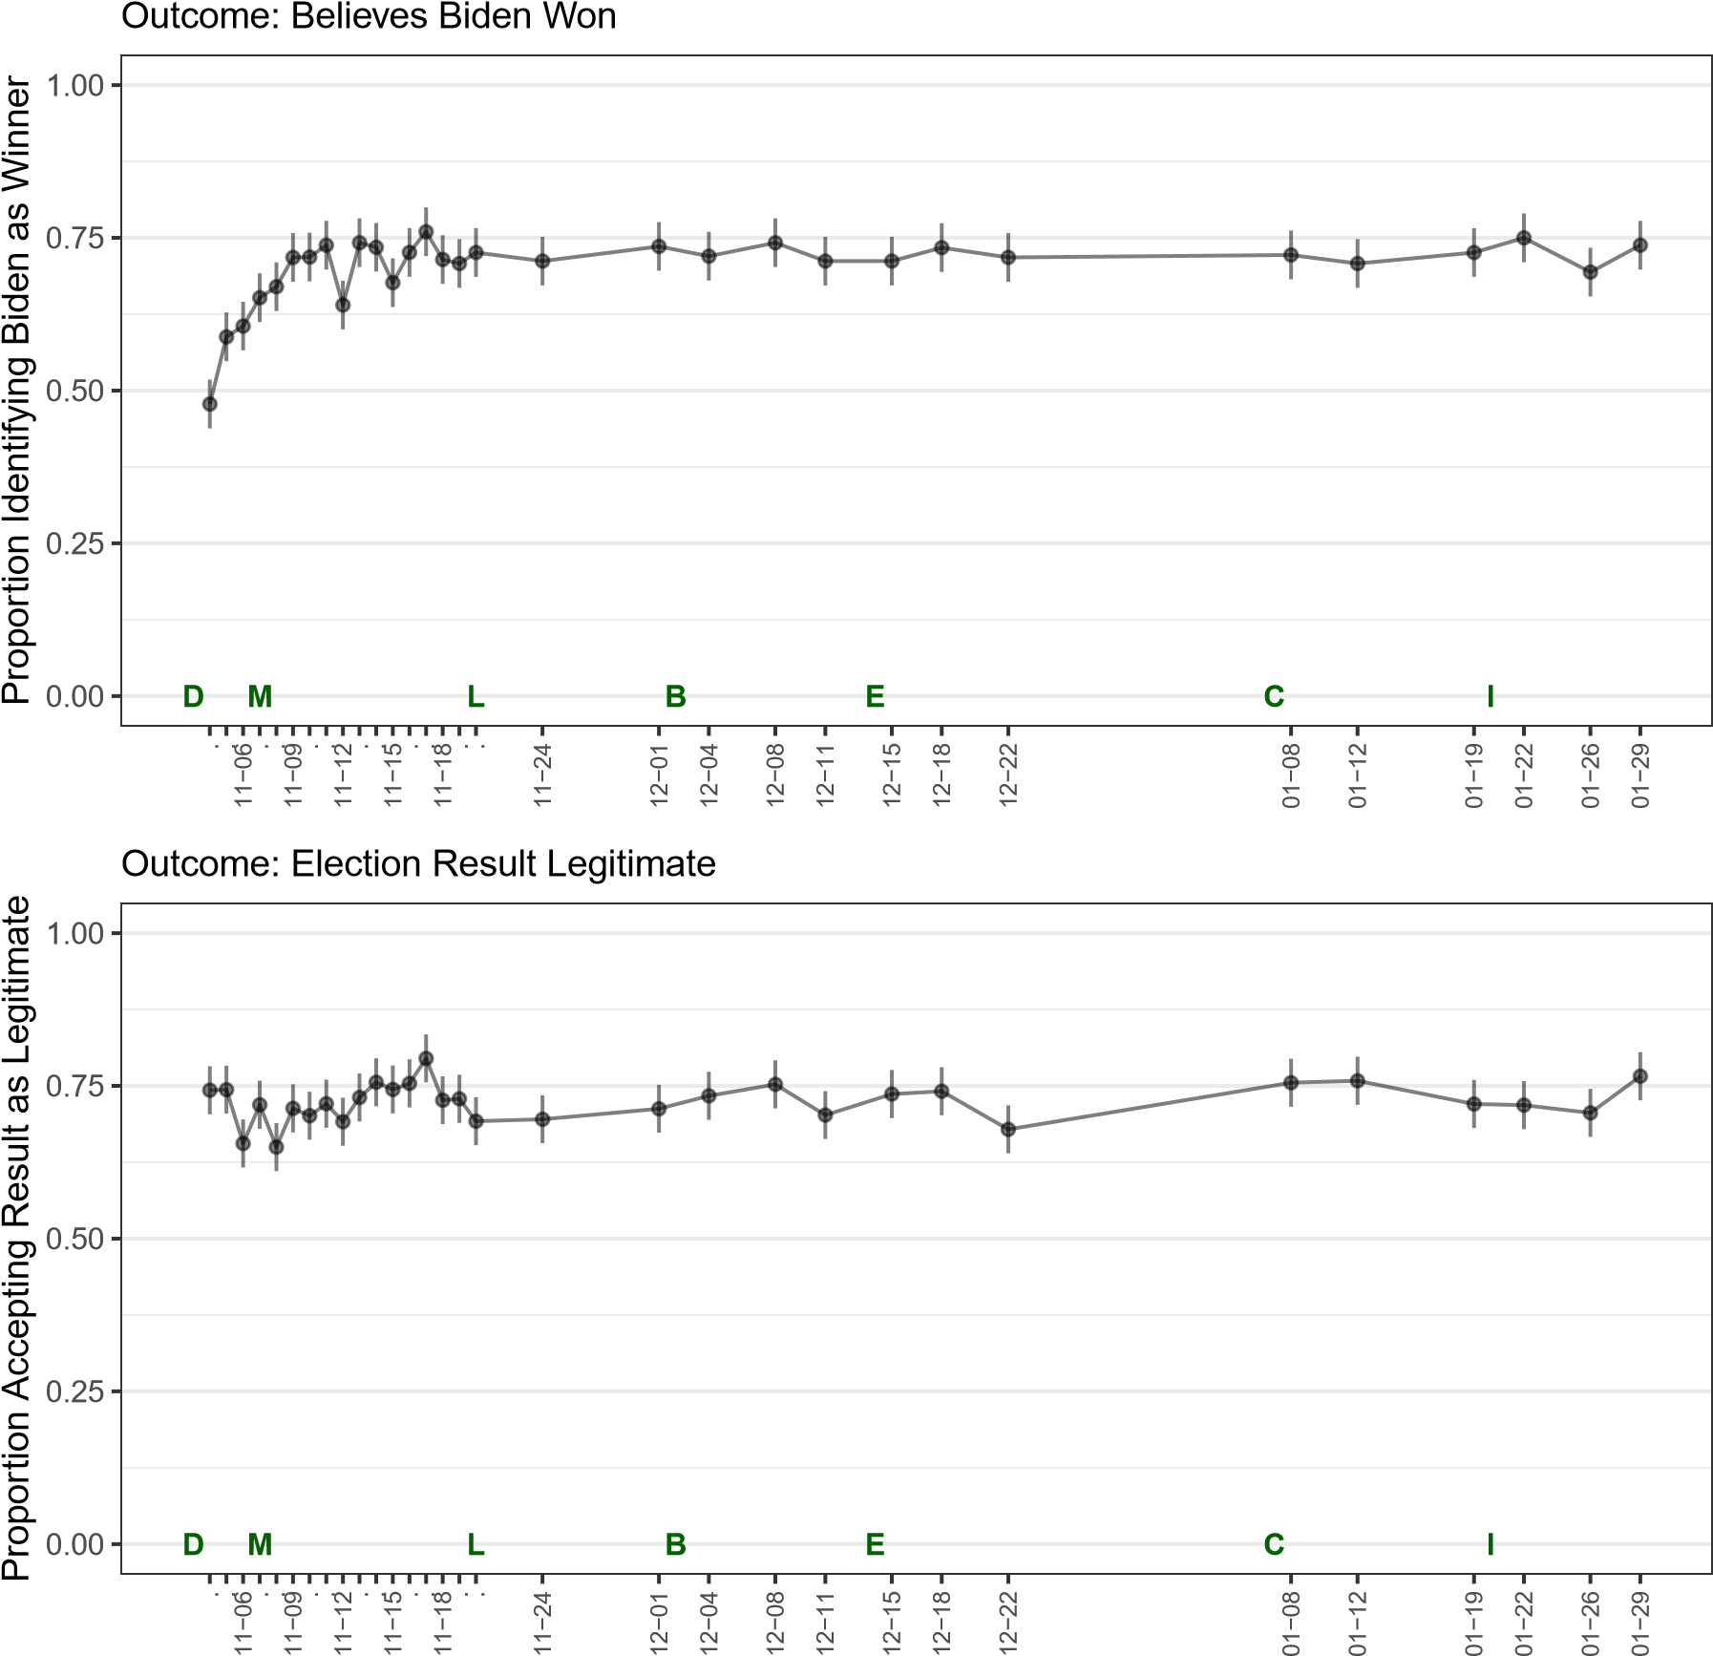
Figure SI4: Perceptions of 2020 election outcome (unweighted data). The top panel shows the proportion of respondents that answered “Joe Biden” to the question, “Who do you think won the 2020 presidential election?” The bottom panel shows the proportion that responded “Yes” to the question, “Do you accept the election results as legitimate?” Starting on November 8th, the legitimacy question was preceded by the sentence, “Major news networks have announced that Joe Biden is the winner of the 2020 presidential election.” Letters mark significant political events: D = Election Day, Nov 3; M = Race called by news networks, Nov 7; L = Trump invites Michigan legislators to White House, Nov 24 ; B = Barr says no evidence of fraud, Dec 2; E = Electoral College certifies Biden, Dec 15; C = Capitol insurrection, Jan 7; I = Inauguration Day, Jan 20. Line segments represent 95% confidence intervals. All data drawn from Election Legitimacy Tracking Survey (ELTS).
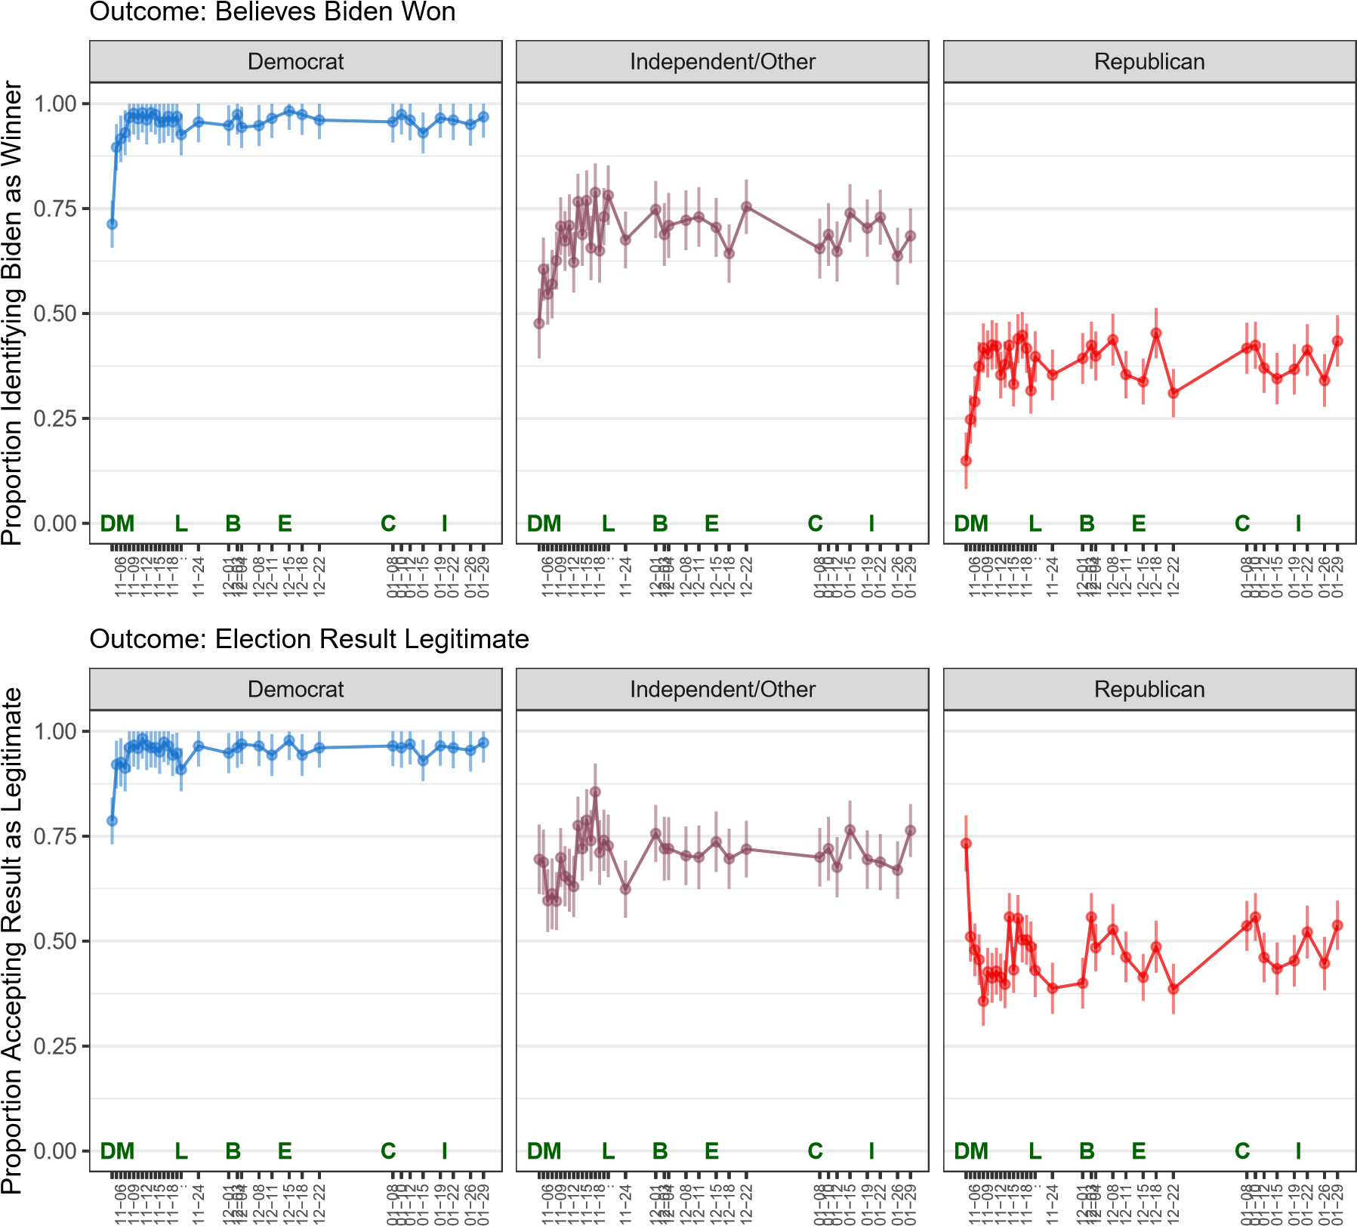
Figure SI5: Perceptions of 2020 election outcome by partisanship (unweighted data). The top panel shows the proportion of respondents that answered “Joe Biden” to the question, “Who do you think won the 2020 presidential election?” The bottom panel shows the proportion that responded “Yes” to the question, “Do you accept the election results as legitimate?” Starting on November 8th, the legitimacy question was preceded by the sentence, “Major news networks have announced that Joe Biden is the winner of the 2020 presidential election.” Letters mark significant political events: D = Election Day, Nov 3; M = Race called by news networks, Nov 7; L = Trump invites Michigan legislators to White House, Nov 24 ; B = Barr says no evidence of fraud, Dec 2; E = Electoral College certifies Biden, Dec 15; C = Capitol insurrection, Jan 7; I = Inauguration Day, Jan 20. Line segments represent 95% confidence intervals. All data drawn from Election Legitimacy Tracking Survey (ELTS).

Outcome: Election Result Legitimate

Republican
Independent/Other
Gender
evel(age.group, ref = "65
el(ed.group, ref = "
Social Status
−0.2
0.0
0.2
−0.2
0.0
0.2
Female
Male
65+
50−64
30−49
18−29
HS
College
Postgrad
High
Medium
Low
Coefficient Estimate
Figure SI6: Perceptions of 2020 election outcome by partisanship and demographics (unweighted data). The figure shows the coefficient estimates from a linear probability model where the binary legitimate variable was regressed on demographic covariates of interest. Starting on November 8th, the legitimacy question was preceded by the sentence, “Major news networks have announced that Joe Biden is the winner of the 2020 presidential election”– the estimates in this figure reflect data collected after that date. Line segments represent 95% confidence intervals. All data drawn from Electoral Legitimacy Tracking Survey (ELTS).

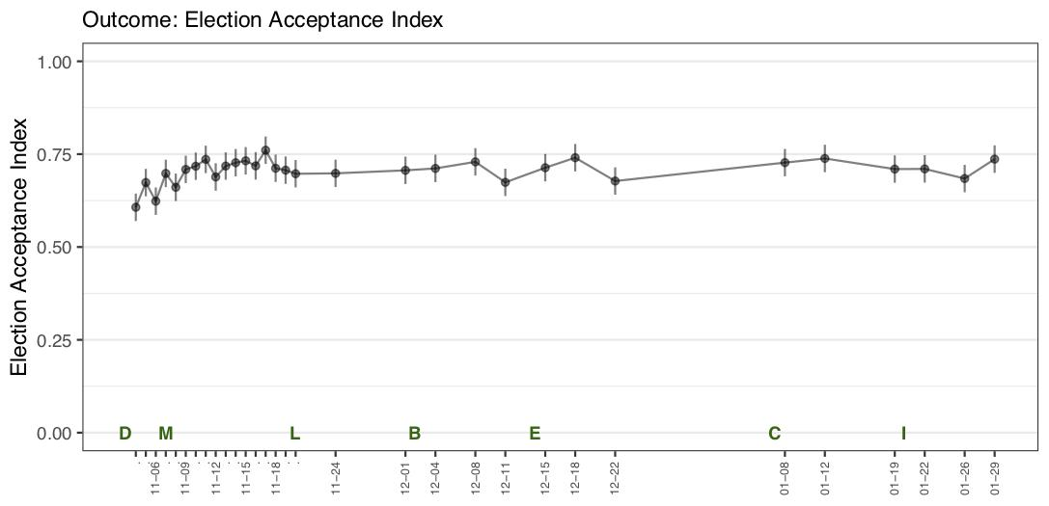
Figure SI7: Perceptions of 2020 election outcome (acceptance index). Letters mark significant political events: D = Election Day, Nov 3; M = Race called by news networks, Nov 7; L = Trump invites Michigan legislators to White House, Nov 24 ; B = Barr says no evidence of fraud, Dec 2; E = Electoral College certifies Biden, Dec 15; C = Capitol insurrection, Jan 7; I = Inauguration Day, Jan 20. Line segments represent 95% confidence intervals. All data drawn from Election Legitimacy Tracking Survey (ELTS).

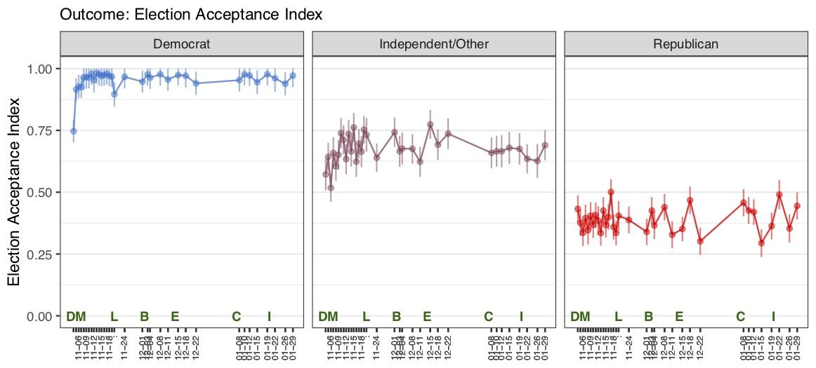
Figure SI8: Perceptions of 2020 election outcome by partisanship (acceptance index). Letters mark significant political events: D = Election Day, Nov 3; M = Race called by news networks, Nov 7; L = Trump invites Michigan legislators to White House, Nov 24 ; B = Barr says no evidence of fraud, Dec 2; E = Electoral College certifies Biden, Dec 15; C = Capitol insurrection, Jan 7; I = Inauguration Day, Jan 20. Line segments represent 95% confidence intervals. All data drawn from Election Legitimacy Tracking Survey (ELTS).

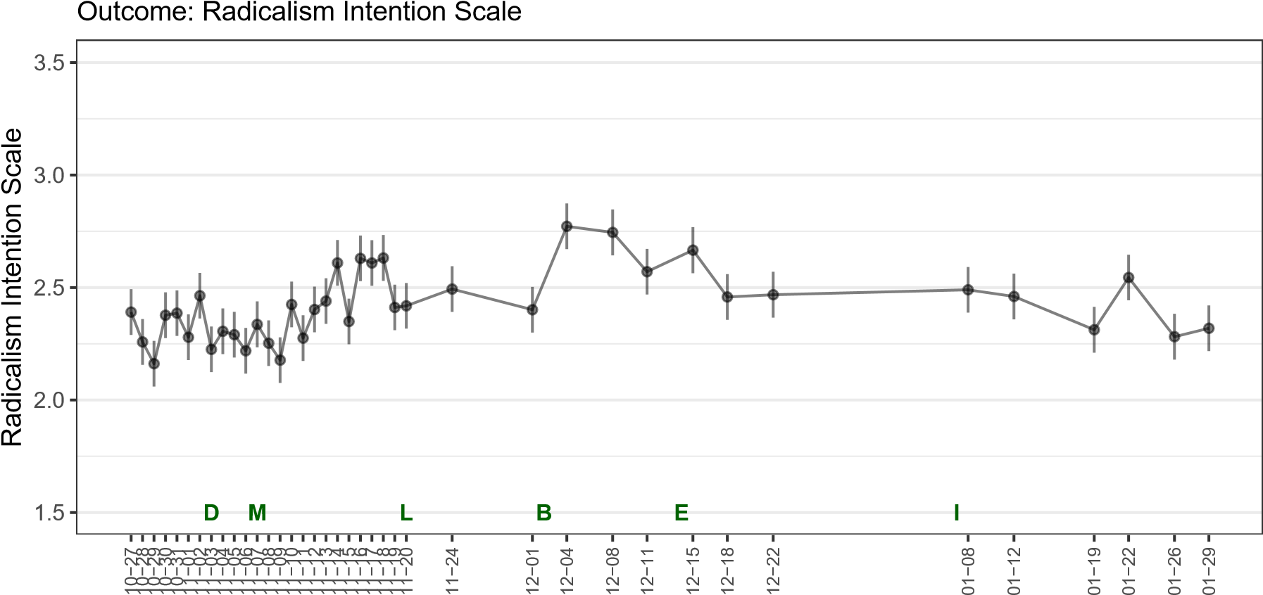
Figure SI9: Support for political violence. Letters mark significant political events: D = Election Day, Nov 3; M = Race called by news networks, Nov 7; L = Trump invites Michigan legislators to White House, Nov 24 ; B = Barr says no evidence of fraud, Dec 2; E = Electoral College certifies Biden, Dec 15; I = Capitol insurrection, Jan 7. Line segments represent 95% confidence intervals. All data drawn from Election Legitimacy Tracking Survey (ELTS).
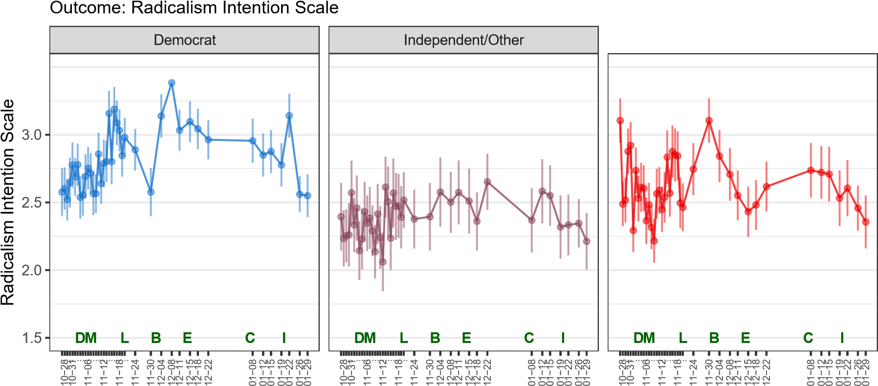
Figure SI10: Support for political violence by partisanship (unweighted data). Letters mark significant political events: D = Election Day, Nov 3; M = Race called by news networks, Nov 7; L = Trump invites Michigan legislators to White House, Nov 24 ; B = Barr says no evidence of fraud, Dec 2; E = Electoral College certifies Biden, Dec 15; C = Capitol insurrection, Jan 7; I = Inauguration Day, Jan 20. Line segments represent 95% confidence intervals. All data drawn from Election Legitimacy Tracking Survey (ELTS).

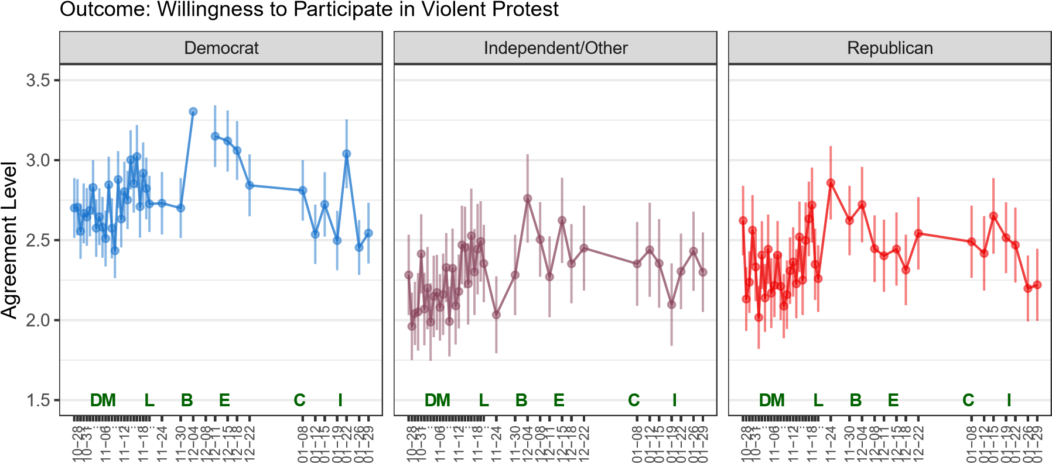
Figure SI11: Willingness to participate in violent protest by partisanship. Letters mark significant political events: D = Election Day, Nov 3; M = Race called by news networks, Nov 7; L = Trump invites Michigan legislators to White House, Nov 24 ; B = Barr says no evidence of fraud, Dec 2; E = Electoral College certifies Biden, Dec 15; C = Capitol insurrection, Jan 7; I = Inauguration Day, Jan 20. Line segments represent 95% confidence intervals. All data drawn from Election Legitimacy Tracking Survey (ELTS).

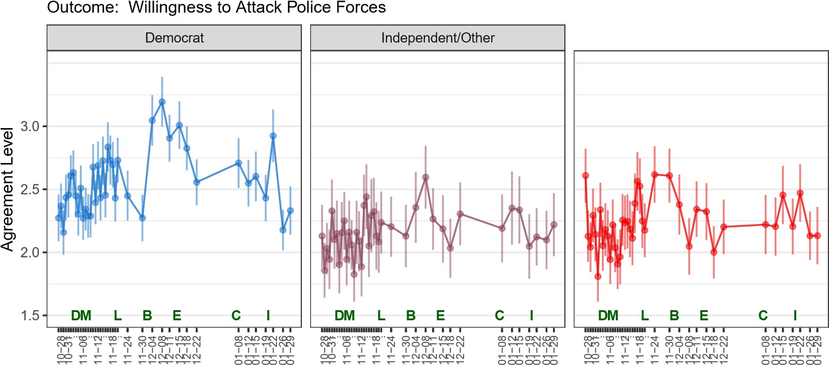
Figure SI12: Willingness to attack police forces by partisanship. Letters mark significant political events: D = Election Day, Nov 3; M = Race called by news networks, Nov 7; L = Trump invites Michigan legislators to White House, Nov 24 ; B = Barr says no evidence of fraud, Dec 2; E = Electoral College certifies Biden, Dec 15; C = Capitol insurrection, Jan 7; I = Inauguration Day, Jan 20. Line segments represent 95% confidence intervals. All data drawn from Election Legitimacy Tracking Survey (ELTS).

Outcome: Willingness to Encourage Others to Join Violent Illegal Protests
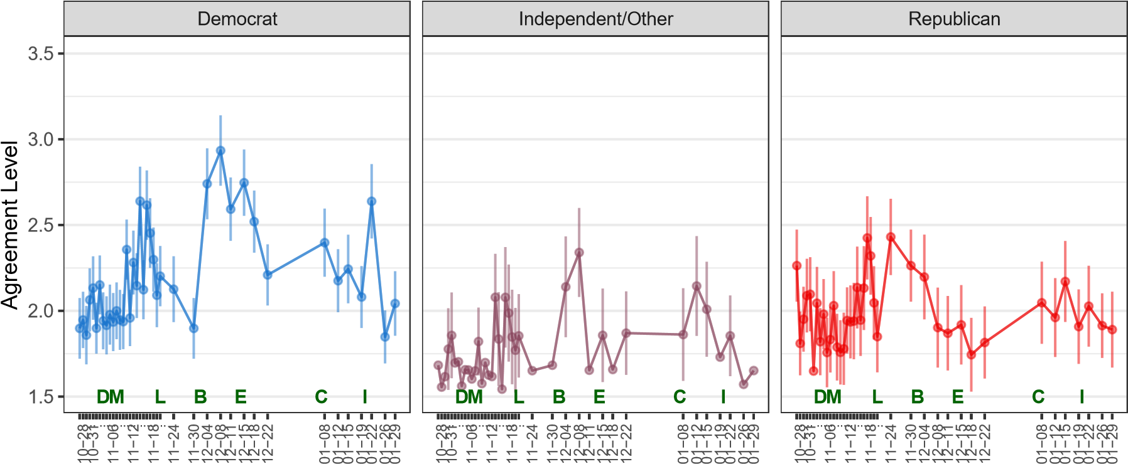
Figure SI13: Willingness to encourage other to join violent illegal protests by partisanship. Letters mark significant political events: D = Election Day, Nov 3; M = Race called by news networks, Nov 7; L = Trump invites Michigan legislators to White House, Nov 24 ; B = Barr says no evidence of fraud, Dec 2; E = Electoral College certifies Biden, Dec 15; C = Capitol insurrection, Jan 7; I = Inauguration Day, Jan 20. Line segments represent 95% confidence intervals. All data drawn from Election Legitimacy Tracking Survey (ELTS).

Outcome: Willingness to Go to War to Protect Rights of Group
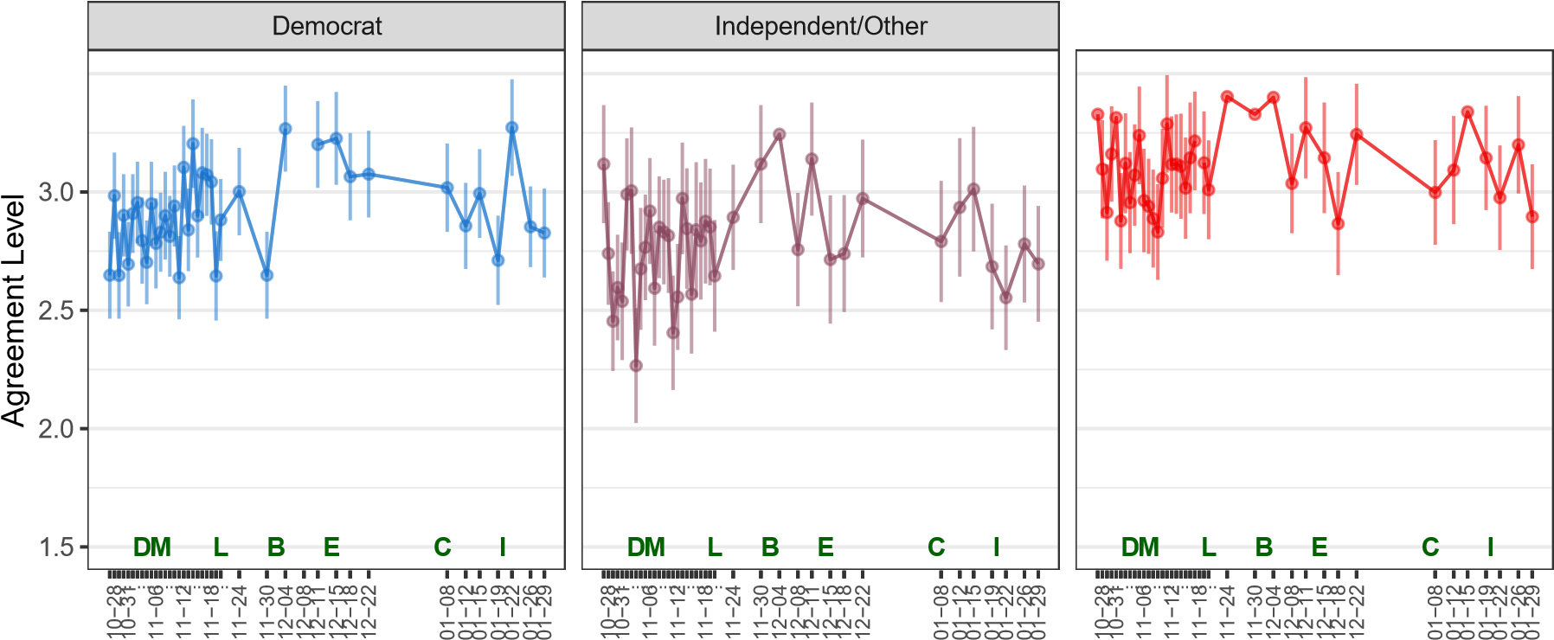
Figure SI14: Willingness to go to war to protect rights of group by partisanship. Letters mark significant political events: D = Election Day, Nov 3; M = Race called by news networks, Nov 7; L = Trump invites Michigan legislators to White House, Nov 24 ; B = Barr says no evidence of fraud, Dec 2; E = Electoral College certifies Biden, Dec 15; C = Capitol insurrection, Jan 7; I = Inauguration Day, Jan 20. Line segments represent 95% confidence intervals. All data drawn from Election Legitimacy Tracking Survey (ELTS).

Outcome: Willingness to Retaliate Against Members of Other Group
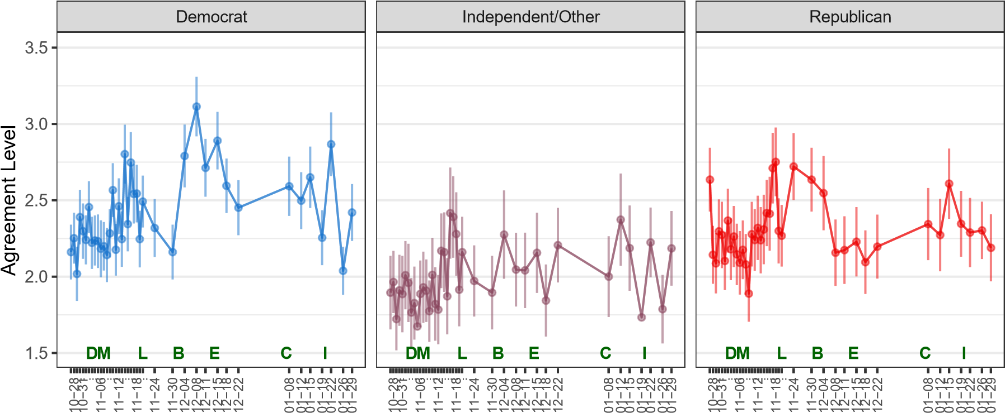
Figure SI15: Willingness to retaliate against members of other group by partisanship. Letters mark significant political events: D = Election Day, Nov 3; M = Race called by news networks, Nov 7; L = Trump invites Michigan legislators to White House, Nov 24 ; B = Barr says no evidence of fraud, Dec 2; E = Electoral College certifies Biden, Dec 15; C = Capitol insurrection, Jan 7; I = Inauguration Day, Jan 20. Line segments represent 95% confidence intervals. All data drawn from Election Legitimacy Tracking Survey (ELTS).
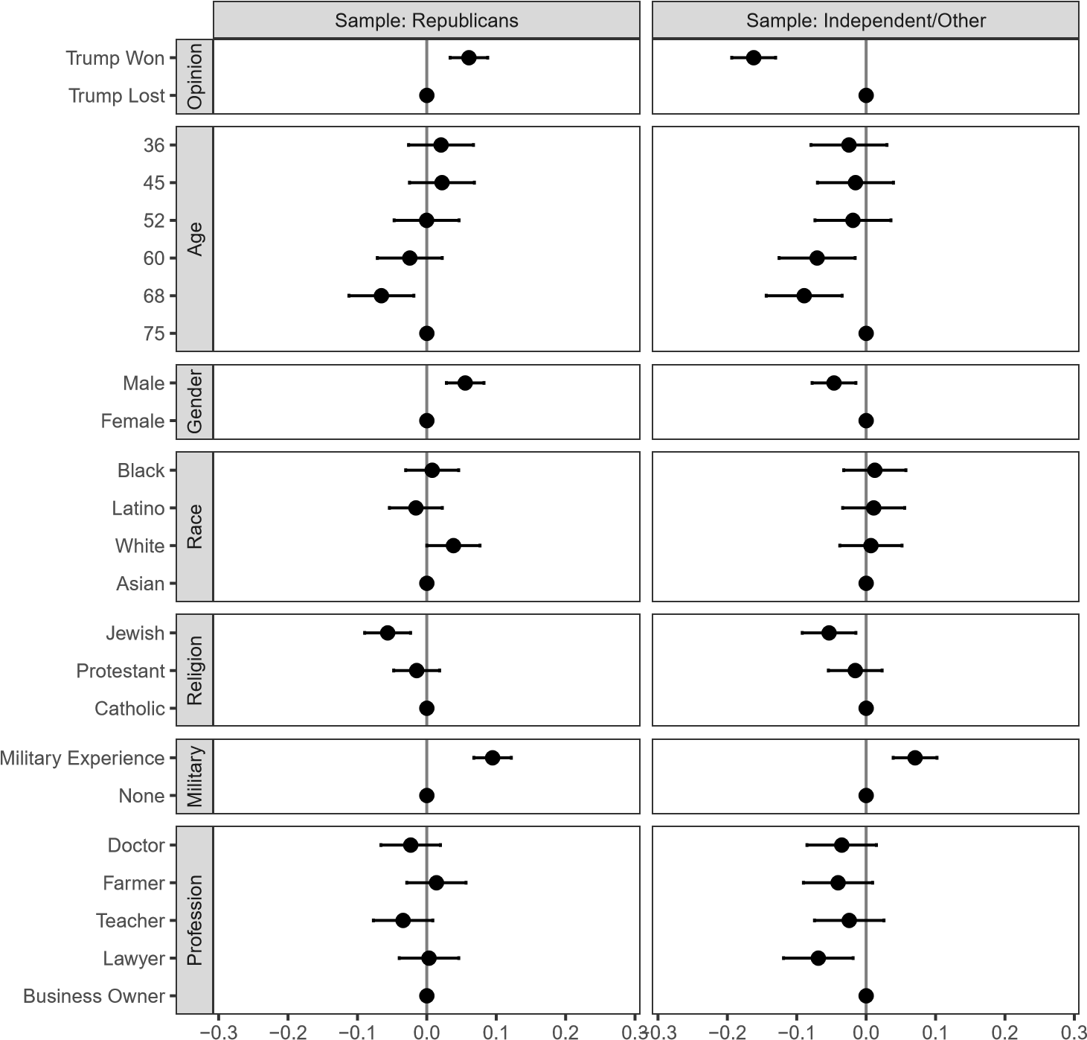

Candidate Attribute
Change in the Probability of Winning
Figure SI16: Results of conjoint experiment (unweighted data). The figure shows the coefficient estimates from a linear model where the candidate choice outcome was regressed on the randomly assigned candidate attributes in the conjoint experiment. The estimates in this figure reflect data collected after January 12th. Line segments represent 95% confidence intervals, which reflect standard errors clustered at the respondent level. All data drawn from Electoral Legitimacy Tracking Survey (ELTS).

