*Data replication sets are available in Harvard Dataverse at:
https://doi.org/10.7910/DVN/EOQDGM

Centralization and Subnational Capacity:
The Struggle to Make Federalism Work Equitably in Public Education

Vast disparities between and within American states’ responses to the COVID-19 pandemic have evoked renewed attention to whether greater centralization might enhance investments in subnational capacity and remedy subnational inequalities, or instead erode subnational organizational capacity. Developments in American public education (1997-2015) offer perspective on this puzzle, which we examine by applying Interrupted Time Series Analysis to a novel dataset to assess the implications of centralization on subnational investments in administrative and technical capacity: two dimensions of organizational capacity. We find simultaneous subnational erosion in administrative capacity and growth in technical capacity following centralization, both of which appear concentrated in low poverty areas despite centralization’s explicit anti-poverty purposes. Public education reforms highlight both the challenge of dismantling subnational inequality through centralization and the need for future research on policy designs that enable centralization to yield subnational capacity able to remedy inequality.

1.0 Introduction
Among the many factors that fuel inequalities in American social welfare policies, American federalism looms large (Campbell 2014; Kettl 2020; Mettler 1998; Michener 2018; Soss, Fording and Schram 2008). This is not unique to the United States: global critiques of federalism document their ineffective and unequal service delivery (Beramendi, Rogers and Diaz-Cayeros 2017). Centralization offers a potential antidote to subnational inequalities endemic in federalism, notably when it strives to bolster public bureaucracies’ capacities to address social problems. Centralization, however, also poses risks: keeping the central government in check constitutes a key purpose of federalism’s structural safeguards (Bednar 2009) and has been a durable part of debates in the U.S. over the balance of power (Kettl 2020). Centralization, moreover, risks eroding subnational organizational capacity, which combines resources, reach, technical expertise, and administrative coherence (Centeno, Kohli and Yashar 2017, 10). Subnational organizational capacity is important both to the formation of federalist systems (Ziblatt 2004) and to their operation (Manna 2006). Expanding the reach of the central government to remedy subnational inequalities continues to fuel debate over whether such expansion is zero-sum: whether or not centralization augments or erodes subnational organizational capacity (Cohen 1982).

We put this enduring puzzle of whether centralization erodes or augments subnational organizational capacity to a novel empirical test and offer three contributions to this ongoing debate. First, we focus our analysis on the implications of centralization for the “quality of bureaucracy” (Centeno, Kohli and Yashar 2017, 5-6), with particular emphasis on investments in public bureaucracy. To do so, we distinguish between two key forms of organizational capacity: technical capacity and administrative capacity (Moffitt et al. 2018). Technical capacity includes the knowledge and know-how to perform core tasks. Administrative capacity entails coordination and oversight mechanisms. While these two forms of organizational capacity are integral to state-building (Skowronek 1982), assessing them separately allows us to discern whether and how the implications of centralization depend on prior investments in subnational capacity.

Second, we examine the implications of centralization on high-resourced and under-resourced areas to assess the persistence of subnational inequalities. Remedying subnational inequalities constitutes a chief justification for greater centralization. Yet, some centralizing policies can exacerbate underlying resource disparities (Howell and Magazinnik 2020). Third, we assess the durability of centralization on subnational capacity by considering the implications of the 2008 recession’s economic shock and the potential for serious economic upheaval to undermine capacity. Examining both geographic variation and the post-recession period reveal the extent of the central government’s reach and offer insights on disruptions posed by COVID-19 and the 2020 economic recession.

We argue that the implications of centralization depend on two aspects of path dependence. One aspect of path dependence focuses on the prior development of subnational organizational capacity. If centralization is zero-sum, we expect it to manifest in dimensions of organizational capacity that subnational entities had previously developed. We find that greater centralization coincided with disruptions to established subnational capacity (administrative capacity). A second aspect of path dependence focuses on prior privilege. If centralization augments subnational capacity, better resourced areas might be better positioned to capitalize on new capacity. We find that centralization does augment capacity in areas of prior subnational weakness (technical capacity). Centralization, however, continues path dependent processes of privilege: the development of new subnational capacity appears concentrated in low poverty counties, even in the context of a major U.S. federal policy that was designed with explicit anti-poverty purposes.

We assess this argument through the lens of the No Child Left Behind Act (NCLB), well-known for extending the reach of the federal government into U.S. public schools; and we consider its implications for investments in subnational organizational capacity and inequality in public education. We begin with historical analysis that draws on archival material from the Department of Education in the State of New York. We then use Interrupted Time Series Analysis (ITSA), which is commonly used to explore temporal discontinuities when randomization is not possible, to assess the implications of centralization on investments in subnational administrative and technical bureaucratic capacity following NCLB. Since durability is essential to federalist systems’ operations, this approach allows us to test the fragility of subnational capacity in the wake of national volatility arising from the recession of 2008. We marshal a novel dataset drawn from the Common Core of Data’s Local Education Agency Universe Survey Data from 1997 to 2015 for all 50 states. For each of our models, we compare high and low poverty counties to explore variation in capacity across socioeconomic status.

We examine our argument on centralization and investments in subnational bureaucracy in federalist systems in the context of NCLB for several reasons. We focus on public education, in part, because education is an enduring and central component of the American welfare state (Katznelson and Weir 1985). Public education stands as a prime example of an unenumerated power in the constitution—thus under states’ jurisdictions—and was one of the first areas in which states’ power began to develop in the U.S. It constitutes a significant sector for states’ and localities’ expenditures, and its experiences are salient to a broad array of social policies, including health and income support. We focus on NCLB as a form of centralization, both because it inserted the U.S. federal government into public schooling in forceful ways and because it followed earlier reforms, which allow us to examine whether implications of centralization depend on prior investments. While prior scholarship attends to NCLB’s problems improving student achievement, we focus on its implications for organizational capacity. Examining investment in subnational bureaucracy in U.S. public education provides perspective on the challenges that federalist systems face from shocks like COVID-19 and economic recession, given long standing neglect of subnational public infrastructure and enduring structural inequality. Greater centralization offers one path forward, but lessons from NCLB underscore the importance of policy design to overcome path dependent privilege.

2.0 Organizational Capacity: Doing the Work of Federalism
At the heart of Federalist Paper No. 45 resides an argument over the allocation of power and Madison’s assertion that states’ power would not be subsumed by the federal government’s:
The powers delegated by the proposed Constitution to the federal government are few and defined. Those which are to remain in the State governments are numerous and infinite (Madison, Federalist Paper No. 45).

Concerns about central government over-reach and the balance of power between governments are as old as the structure of federalism, and remain active across federalist systems and policy domains. Underlying these debates reside concerns about different levels of government engaging in strategic behavior to exceed their authority or to shift cost burdens onto other levels of government, shirk responsibilities, or engage in other forms of intergovernmental opportunism (Bednar; 2009; Derthick 1975; Filippov, Ordeshook and Shvetsova 2004; Luigjes and Vandenbroucke 2020; Posner 1998). Opportunism can arise both from the central government and from subnational governments.

Opportunism clearly matters. Yet, focusing exclusively on opportunism risks obscuring the importance of capacity. Rather than opportunism, fundamental problems of bureaucratic overload – insufficient capacity to perform core tasks – impair subnational governments’ abilities to deliver services (Dasgupta and Kapur 2020). The absence of bureaucratic capacity, moreover, can interfere with efforts to engage in effective oversight (Huber and McCarty 2004). Lacking basic bureaucratic capacity reduces the likely effectiveness of laws and procedures designed to mitigate opportunism.

Capacity problems loom large in federalist systems. While geographically prevalent and celebrated for their normative potential (Levy 2007), federalist systems struggle to deliver on their promise of greater efficiency and democratic responsiveness (Beramendi 2007). Not only do subnational governments struggle to deliver services to citizens and to do so equitably (Beramendi, Rogers and Diaz-Cayeros 2017), but subnational fiscal ineptitude can yield reverberating consequences that threaten a country’s financial health. Subnational over-spending and reliance on the central government for bail outs form key considerations in fiscal federalism (Rodden 2005; Wibbels 2012). Capacity problems can also emerge through the economic and administrative burdens that central governments impose on subnational governments through unfunded mandates (Imazeki and Reschovsky 2004; Posner 1998).

Centralization manifests as a common proposal to discourage subnational over-spending (Rodden 2005; Wibbels 2012) and to redress inequalities in subnational service delivery (Campbell 2014; Kettl 2020; Mettler 1998; Michener 2018; Soss, Fording and Schram 2008). Yet, centralization evokes debate over when such expansion is zero-sum—when the growth of the central government diminishes subnational capacity (Derthick 2015; Leach 1970, 2)—and when central government growth can, instead, be positive-sum and expand capacity in multiple venues and levels of government simultaneously (Cohen 1982, 477).

Calls for greater centralization typically assume that it will yield “infrastructural power,” meaning “the capacity of the state to actually penetrate civil society, and to implement logistically political decisions throughout the realm” (Mann 1984, 189). Yet, infrastructural power is not just a matter of a strong central government: infrastructural capacity is also about doing the work of governance. In federations, the central government depends on the capacity of subnational governments. As Ziblatt (2004) reminds us, “the key challenge to creating federalism is not simply constraining the power of a political center; instead, what’s important is the task of building up infrastructural capacity of subunits to do the work of governance in a federation” (96).

What does it take for subunits to have the capacity to do the work of governance in a federation? We focus here on organizational capacity, with its roots in classic public bureaucracy (Weber 1946, 196). In particular, we focus on two aspects of organizational capacity: technical capacity and administrative capacity. Technical capacity includes the knowledge and know-how along with responsibility to put ideas into practice. To do the work of governance, component parts need technical know-how, such as the scientific knowledge to understand how infectious disease spreads through communities. Administrative capacity includes connections and oversight between constituent and collaborative units to put ideas into practice, such as distributing relief funds to eligible organizations. To do the work of governance, component parts in a federation need ways to coordinate, collaborate, and oversee governance operations. We focus on investments in these two forms of capacity both because of their distinct conceptual contribution to organizational capacity and because they have the potential to develop on separate trajectories.

What are the implications of centralization for subnational capacity to do the work of governance? The implications of centralization, we argue, depend on what was in place before. Conditional on prior development, centralization dynamics could be zero-sum, redistributive positive-sum, or path dependent positive-sum, each of which yields different expected implications for subnational organizational capacity. When centralization is zero-sum, it would erode previously established capacity, particularly in areas where subnational capacity is strong. Centralization, however, could yield positive-sum returns for subnational capacity and could do so in at least two ways (López-Santana 2015). For one, the central government might expand in domains where subnational capacity has not developed or is under-developed. Proponents of expanding the U.S. federal government in the 1960s in policy domains such as health (through Medicaid) or early childhood development (through Head Start), for instance, sought to remedy weak subnational capacity (Cohen et al. 2015; Karch 2013). This form of positive-sum centralization could, thus, be redistributive: building subnational capacity in domains where it did not previously exist, especially in under resourced areas.

A second form of positive-sum centralization, however, could build on underlying path dependence. Instead of a strong central government redressing the weaknesses of subnational units, a weak central government can “borrow” the strength of subnational units to accomplish national goals (Manna 2006). Thus, also consistent with increasing returns, an expanding central government could further augment previously established subnational capacity. Table 1 summarizes our expectations of the implications that centralization might have on subnational capacity, depending on the extent of previously established subnational organizational capacity.
Table 1: Implications of Centralization
Centralization Process | Subnational Organizational Capacity
Zero-Sum | Erode: centralization diminishes subnational organizational capacity, especially previously established capacity.
Redistributive Positive-Sum | Build up: centralization augments subnational organizational capacity, especially previously weak or absent capacity.
Path-Dependent Positive-Sum | Build on: centralization augments previously established subnational organizational capacity.

Our approach flips the conventional inquiry from models of decentralization (Falleti 2005; Hooghe and Marks 2003) to a model of centralization, though we expect a core insight from theories of decentralization to extend to our analysis of centralization: centralization in federalist systems is neither unidimensional nor linear (López-Santana 2015). The implications of centralization depend on prior development in organizational capacity. Moreover, centralizing policy designs can yield both zero-sum and positive-sum implications for organizational capacity.

We examine the implications of centralization for organizational capacity and investments in subnational bureaucracy in the context of early 21st century American public education. U.S. public education resides solidly within states’ jurisdictions and vividly embodies decentralization. However, 21st century U.S. public education also reflects prior efforts to expand the federal role in education; and it provides variation in previously developed and weakly developed subnational capacity. The experiences from public education offer lessons for other components of the welfare state, especially in the COVID-19 era as the U.S. and other countries take stock of how to strengthen subnational organizational capacity across unequal contexts.

3.0 U.S. Public Education, Subnational Organizational Capacity, and Centralization
Decentralization has long defined American public education. American schooling was highly decentralized throughout the 19th century, and built on prior private schools and local initiatives (Kaestle 1983). This decentralization manifested clearly in systems of financing public education. At the end of the 19th century and beginning of the 20th century, local sources such as property taxes accounted for fully 80 percent of public school revenues with states providing the remaining 20 percent. As public schooling expanded throughout the 19th and 20th centuries, its decentralized form persisted both through ideas and organizational structures (Timar 1997). States had formal authority over local school operations, but states typically delegated operational decisions to districts. Even states like New York, which were more hierarchical and oversaw districts more closely than other states, embodied organizational decentralization:
It is not believed that the good of the school system is to be promoted by too much inspection; on the other hand, it is felt that local officers and teachers will grow in capacity for school work by doing it independently. It is believed that substantial improvement must come through freedom of local initiative and administration, rather than through too much direction on the part of the state (State of New York 1905, 36).

While American states and localities have, for centuries, held formal authority over public education, subnational capacity to deliver public instruction has followed distinct trajectories. Notably, administrative capacity (procedural oversight) developed separately from technical capacity (profession-based know-how) to support instruction. As American public education expanded during the early 20th century, it accumulated layers of school administration and new responsibilities, including requirements for student attendance (Steffes 2012). These administrative developments focused primarily on taxation, revenue disbursement, school construction, expanding access to students, and setting required courses of study. They attended much less to the practice of teaching, learning, teacher education, the assessment of students’ learning (Rice 1893), or overseeing the quality of classroom teaching and learning (Murphy 1974).

The New York State Department of Education from the early 20th century helps illuminate how the administrative capacity for public education (i.e. collecting and distributing taxes, building schools, etc.) developed separately from the technical capacity of public education (i.e. ensuring teachers learned the content they were expected to teach and learned how to teach that content well). New York State had one of the most developed state departments of education in this era of American public schools. If state-level technical capacity to support instruction appeared in any state, it would have likely appeared in New York.
Table 2. State of New York Department of Education Staff, 1904, 1911, 1924, 1934
 | Number of Staff  1904 | Number of Staff  1911 | Number of Staff  1924 | Number of Staff  1934
Commissioner’s Office | 23 | 15 | 11 | 8
Higher Education Division |  |  | 51 | 75
Secondary Education Division |  |  | 5 | 6
Elementary Education Division |  |  | 35 | 8
Vocational and Extension Education Division |  |  | 46 | 89
Educational Extension |  | 16
Vocational Schools |  | 4
Finance Division |  |  | 10 | 39
Administrative Division |  | 20 | 147 | 158
Accounts Division | 4
Records Division | 2
Statistics Division | 6 | 6
Archives and History Division |  | 7 | 6 | 6
Attendance and Child Accounting Division | 3 | 4 | 10 | 10
Educational Research Division |  |  |  | 9
Examinations | 54 | 67
Inspections | 14 | 15
Examination and Inspection Division |  |  | 62 | 77
Health and Physical Education Division |  |  |  | 20
Law Division | 2 | 2 | 3 | 6
State Library | 78 | 75 | 91 | 86
Library Extension Division |  | 3 | 18 | 22
Motion Picture Division |  |  |  | 20
State Museum | 21 | 24 | 23 | 24
Professional Licensure Division |  |  |  | 8
Rural Education Division |  |  |  | 8
School Buildings and Grounds Division |  |  | 4 | 8
Teacher Education and Certification Division |  |  |  | 17
Visual Instruction Division |  | 8 | 14 | 15
Total | 207 | 266 | 536 | 719

Our archival material depicted in table 2 illustrates the impressive growth of subnational government agencies in the early part of the 1900s. Overall, the New York State agency grew from 207 staff members to 719 over the course of 30 years. A significant proportion of this growth focused on the development of administrative capacity. We estimate that, in 1934, over one quarter of the staff of New York State’s Department of Education focused on administration and finance. However, New York funded only 17 positions during this time period that supported instructional matters such as teacher education and certification: approximately 2 percent of its staff. While American subnational education agencies looked little like the Weberian ideal, administrative capacity developed more fully than and separately from technical capacity related to teaching and learning.

While subnational control over public education has persisted, the passage of the 1965 Elementary and Secondary Education Act (ESEA) signaled a notable expansion of federal government involvement in American public education (Bailey and Mosher 1968; Cohen and Moffitt 2009; Derthick 2015; Peterson, Rabe and Wong 1986). The U.S. federal government’s expansion into public education appeared alongside a suite of federal programs aimed at redressing perceived weaknesses and inequity in state and local service delivery during the decade between 1965 and 1975, including health (Cohen et al. 2015), early childhood education (Karch 2013), housing (Peterson, Rabe and Wong 1986), and community development (Derthick 1972). The policies of the Great Society bundled together fiscal inducements with administrative procedures to promote national policy objectives.

In the domain of public education, Title I of the ESEA ushered in new financial resources, imposed a host of requirements on how those resources could be spent, and helped put the disparities in educational resources in American public schools on the national agenda. As one part of the Great Society’s suite of policies, ESEA Title I’s anti-poverty purposes helped justify the extension of the federal government into local-state controlled schooling. The 1965 law, however, explicitly prohibited the federal government from specifying curriculum or guiding instruction. The federal, state, and local administrative architecture that developed around ESEA focused on disbursing federal funds and monitoring that they were being used in accordance with federal policy.

Throughout the last half of the 20th century, however, the ideas guiding the federal role began to move beyond distributing financial resources and toward eliminating the achievement gap that manifests in the U.S. along socioeconomic, racial, and ethnic lines (McDonnell 2005). Part of this shift emerged from backlash to rigid fiscal accounting procedures developed in the early days of the program (Peterson, Rabe and Wong 1986). These fiscal procedures yielded instructional implications, including pulling students out of conventional classrooms to receive supplemental instruction to create a clean audit trail (Kimbrough and Hill 1981; Peterson, Rabe and Wong 1986, 141-143). Changes to fiscal compliance procedures to help districts both satisfy auditors and have more pedagogical flexibility began in the 1970s and continued during reauthorizations in the 1980s (Cohen and Moffitt 2009, 77-78, 118-121).

Underlying these programmatic shifts were different ideas about connections between fiscal resources, effective instruction, and school improvement. These ideas pivoted away from expecting federal fiscal transfers to yield achievement gains and toward expectations that different arrangements in instructional practices would be necessary to reduce inequality in student achievement (Purkey and Smith 1983). With this shift in goals, federal policy began to move toward reaching more deeply into school operations, and closer to instructional content (McDonnell 2005). To this end, the 1994 Improving America’s Schools Act (IASA) began to press state and local education agencies to measure and hold schools accountable for students’ performance, to take steps to improve student achievement, and to reduce inequality between subgroups of students. This included requiring states and localities to establish academic standards, conduct student assessments consistent with standards, and use the results from those assessments to hold schools accountable for students’ performance (Manna 2006; Moffitt and Cohen 2015). IASA, however, lacked meaningful incentives, consequences, and supports yielding few substantive changes in frontlines educational practice. The regulatory infrastructure, financed through federal funds but conducted by state and district administrators, remained focused on compliance with fiscal protocols.

Substantive inducements for change emerged in the 2002 No Child Left Behind Act (NCLB), President George W. Bush’s reform bill. For this reason, NCLB (and not IASA) is typically portrayed as the watershed federal policy, expanding federal reach into subnational terrains in new ways (Manna 2010), with different implications for the core technology of teaching and learning. As McGuinn (2005) argues, “No Child Left Behind signaled the beginning of a new era of federal education policy and significantly transformed and expanded the national role in our country’s schools” (66). More than its predecessors, it focused more explicitly on holding schools accountable for reducing inequality between subgroups of students.

NCLB was able to push in these new directions at least partly because of its prior investments in subnational capacity, and because of states’ prior investments in elements of standards-based reforms (McDonnell 2005; 2015). Federal categorical grants played notable roles in augmenting the administrative capacities of state departments of education as well as augmenting the capacities of non-profit organizations to provide technical assistance to school districts (Bulkley and Burch 2011). The federal government’s expanded reach into public education had been underway for fifty years, and those prior investments mattered to states’ and districts’ responses to NCLB. The implications of centralization on organizational capacities, this suggests, depend on the terrain in which centralization occurs.

Yet, this “new era” of American public education provoked a chorus of critics who portrayed it as usurping state and local control over schools (Derthick 2015; Ravitch 2010) and others who documented subnational resistance (Shelly 2008). Despite its subsequent critics, NCLB enjoyed impressive bipartisan support in Congress during an era marked with increasing partisan acrimony and polarization (Manna 2010). Indeed, many states had been moving toward elements of NCLB’s standards-based reform approach during the decade that preceded NCLB. Federal policy expansion was possible, in part, because it “borrowed strength” from the states thanks to policy entrepreneurs who capitalized on subnational capacity and legitimacy (Manna 2006). Despite its conceptual shift – toward more regulation of instruction – NCLB did not embody a significant shift in its fiscal design: it remained a categorical grant, with a formula that distributed funds widely across congressional districts. Thus, NCLB did not reflect significant shift in politics or finances. It did, however, represent a significant shift in organization, albeit one that built on previous investments.

While other scholars have attended to NCLB’s problems improving student achievement, we attend to its implications for the “quality of bureaucracy”: whether and where the expansion of federal government through NCLB yielded zero-sum, redistributive positive-sum, and/or path dependent positive-sum implications for subnational technical and administrative capacity, depending on prior development, depicted in table 3. Considering American public education in terms of organizational capacity, administrative capacity embodies a subnational domain that had been well-developed before the passage of NCLB. In contrast, subnational governments had not developed technical capacity for instructional support. Moreover, NCLB’s proponents argued centralization was crucial to remedy inequalities that local and state-controlled schooling had created, allowed, and perpetuated. We thus examine the development of capacity in high and low poverty counties following NCLB.

Since durability is a fundamental feature of a robust federation (Bednar 2009), we also examine the implications of the 2008 recession on organizational capacity, since economic instability threatened the ambitious education goals accompanying NCLB and other standards-based education reforms. Even if capacity augmented after NCLB, that capacity might be vulnerable to economic volatility.
Table 3: Implications of Centralization for Subnational Education Capacity
Centralization Process | Subnational Education Capacity
Zero-Sum | Erode: subnational administrative capacity would diminish following NCLB (since administrative capacity had been previously established).
Redistributive Positive-Sum | Build up: subnational technical capacity for instructional support would expand following NCLB (since technical capacity had been relatively weak or absent), especially in high poverty areas.
Path-Dependent Positive-Sum | Build on: subnational administrative capacity would expand following NCLB (since administrative capacity had been previously established).

4.0 Empirical Strategy and Measures
What are the implications of centralization for investments in and durability of subnational organizational capacity? To address these questions, we leverage a dataset of subnational administrative and technical capacity for all counties in the U.S. from 1997-2015. We examine the implications of centralization—the rollout of NCLB—and the implications of volatility from the 2008 recession.

4.1 Measures. We measure organizational capacity in two primary ways: subnational administrative capacity and subnational technical capacity for instructional support. Because these two forms of capacity experienced different historical trajectories and different degrees of prior development, centralization through NCLB may bear on them differently.

Both technical and administrative capacity require individuals (i.e. staff) to do the work of governance. Therefore, we operationalize capacity using measures of staffing levels for both administrative capacity and technical capacity, as reported by schools and Local Education Agencies (LEAs). Organizational capacity is partly a matter of connective tissue (administration), partly a matter of know-how (technical capacity), and partly a matter of resources. Staff, as a reflection of resource investment, allows us to assess relative investment in administration and/or the technical core of agency work by providing a common unit of measurement across the two categories. It also provides a way of mitigating the risk of conflating organizational capacity (infrastructure) with implementation or outcomes (Centeno, Kohli and Yashar 2017, 4-6). To contribute to debates over whether and when centralization remedies and/or exacerbates subnational inequalities, we also assess variation in subnational capacity development and erosion across high and low poverty counties. Our source of data for both forms of organizational capacity comes from the Common Core of Data Local Education Agency Universe Staff Survey Data.

Our measure of subnational administrative capacity includes the following classifications: school administrative support staff, LEA administrative support staff, school administrators, and LEA administrators. These positions align with fiscal and oversight roles and responsibilities, consistent with administrative capacity. The variable measures staff members responsible for coordinating finances within districts and within states – critical components of inter- and intra-institutional oversight. Moreover, our measure of subnational administrative capacity includes the staff responsible for enforcing and overseeing implementation of federal policy and adherence to federal mandates within and across schools. Administrative capacity, thus, connects component parts both vertically and horizontally.

Our measure of subnational technical capacity includes instructional coordinators and supervisors. These positions are typically connected to classroom teaching and learning and provide the technical expertise required for supporting teachers’ instructional practice. This includes support for teachers’ professional learning opportunities, support with materials selection and use, and support with instructional strategies. Each measure is aggregated to the county level and weighted by the number of students, yielding the total number of administrative and instructional employees per 100 students by county.

Organizational capacity and effective governance depend on more than staff: they also depend on bureaucratic competence (Centeno, Kohli and Yashar 2017; Evans and Rauch 1999). While publicly available data do not allow us to measure the competence of the public bureaucrats who hold administrative and technical positions, investments in those positions constitute first-order conditions for organizational capacity. Administrative and technical investments reflect core components of bureaucratic development, crucial for subnational units to do the work of governance.

4.2 Models. We analyze two discontinuities—NCLB and the 2008 recession—to assess the implications of centralization on subnational capacity and the durability of subnational capacity in the context of economic volatility. To do so, we use Interrupted Time Series Analysis (ITSA). ITSA is commonly used to explore temporal discontinuities when randomization is not possible in the social and medical sciences (Bloom 2003; Dee and Jacob 2011; Goldstein and Pevehouse 1997; Kontopantelis et al. 2015; Penfold and Zhang 2013). Because of this, we use ITSA to model subnational capacity before and after NCLB and the 2008 recession. ITSA performs interrupted time-series analysis using two ordinary least-squares regressions, estimating the effect of an intervention when the outcome variable is ordered as a time series. The basic equation (for one “interruption”) is as follows:

$$Y_{t}= β_{0} + β_{1}\left(T\right)+ β_{2}\left(X_{t}\right)+ β_{3}({TX}_{t})$$

Where $Y_{t}$ is the aggregated outcome variable measured at year (t), $\left(T\right)$ is the time since the intervention, $\left(X_{t}\right)$ is a dummy (indicator) variable representing the intervention (pre-NCLB or pre-Recession periods 0, otherwise 1), and $({TX}_{t})$ is an interaction between the intervention and time. $β_{0}$ represents the intercept, and $β_{1}$ is the slope or trajectory of the outcome variable until the introduction of the intervention (NCLB or the 2008 recession). $β_{2}$represents the change in the level of the outcome that occurs in the period immediately following the introduction of the intervention. $β_{3}$ represents the difference between pre-intervention and post-intervention. In sum, significant p-values for $β_{2}$indicates an immediate treatment effect, and in $β_{3}$indicates a treatment effect over time (Linden and Adams 2011).

First, we examine national trends over time where the unit of analysis is the weighted average of administrative and technical capacity by year. Next, we examine variation in capacity in high poverty and low poverty counties, where the unit of analysis is county-average by year. The ITSA design aggregates our large N data into a weighted annual average. ITSA allows us to estimate separate linear regression lines for multiple periods, to examine the effect of multiple interventions on the outcome variable of interest. In the subsequent analysis highlighted in figures 1 through 6 and summarized in tables 4 through 6, the model estimates three OLS regression lines for each intervention period: pre-NCLB (the 1997 to 2002 school year), post-NCLB (the 2003 to 2009 school year), and post-Recession (the 2010 to 2015 school year).

5.0 Results
Our results reveal the importance of distinguishing between administrative and technical capacity, the importance of distinguishing between high and low poverty counties, as well as the importance of both discerning the impact of initial shocks and longer-term trends. The results suggest evidence that subnational capacity both erodes and expands following NCLB, depending on prior development. The results also suggest limits to centralization’s ability to remedy fundamental aspects of structural inequality.
5.1 Implications of Centralization for Subnational Capacity. Our results suggest that the implications of the landmark No Child Left Behind Act depend on the type of subnational organizational capacity: administrative or technical. Administrative capacity, Model (1), reflects the more developed form of organizational capacity in American public education (collection, allocation, and oversight of funds; oversight of school operations). Should significant zero-sum erosion occur, administrative capacity is where we would expect such erosion to manifest.

Table 4: Administrative and Technical Capacity ITSA, 1997-2015
 | Model 1 | Model 2
 | Administrative | Technical
VARIABLES | Capacity | Capacity
Year | 0.047*** | 0.006***
 | (0.005) | (0.001)
NCLB (1 = NCLB) | -0.061 | -0.017**
 | (0.030) | (0.007)
NCLB * Year | -0.044*** | 0.005
 | (0.007) | (0.003)
Recession (1 = Recession) | 0.047 | -0.030
 | (0.028) | (0.017)
Recession * Year | -0.017* | -0.010**
 | (0.006) | (0.003)
Constant | 1.031*** | 0.065***
 | (0.016) | (0.001)
Post-NCLB Linear Trend | 0.003 | 0.011**
 | (0.006) | (0.003)
Post-Recession Linear Trend | -0.014*** | 0.002***
 | (0.002) | (0.000)
Observations | 19 | 19
Standard errors in parentheses
*** p<0.001, ** p<0.01, * p<0.05

Results from Model (1) in table 4 show evidence of zero-sum erosion. While the initial, negative impact of NCLB does not obtain conventional levels of statistical significance (p= 0.06), the negative impact of NCLB on administrative capacity is significant over time. After NCLB, there is a significant decrease in the number of administrators per 100 students, relative to the pre-NCLB trend of -0.04 per year. In other words, subnational administrative capacity decreases in the wake of NCLB, compared to the period of rapid growth pre-NCLB.

Figure 1 helps discern this trend. The period of 1997 to 2002 is marked by a steep slope, indicating consistent growth in administrative capacity during this time period. We then observe the NCLB disruption, followed by a slower rate of growth after NCLB, though administrative capacity continues to grow in absolute terms. This portrait implies zero-sum implications of centralization in the most developed domain of subnational capacity.

Figure 1. Administrative Capacity ITSA, 1997-2015
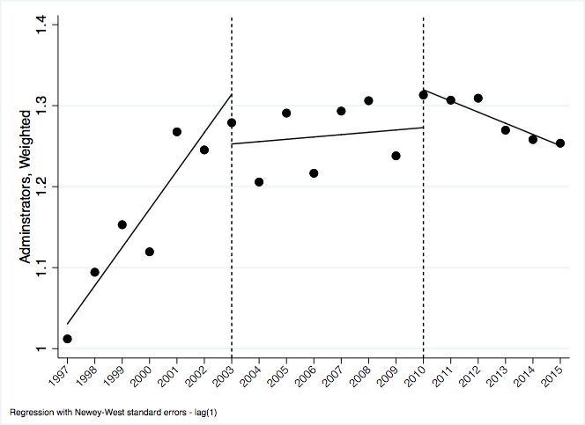

A different portrait appears for technical capacity. Recall that NCLB ushered in significant new demands for American public schools’ teaching and learning—the heart of classroom practice—to help remedy gaps in achievement that persist across socioeconomic, racial, and ethnic lines. These demands move beyond administrative capacity (overseeing fund-use) to include technical demands: expecting teachers to teach more ambitious content to more students than before. Historically, subnational investment in the technical capacity of American public educators has been notably weak. The results from Model (2) in table 4 above suggest an initial dip in subnational technical capacity immediately following NCLB, followed by an increase in the growth rate for subnational technical capacity post-NCLB. The post-NCLB linear trend estimate shows a statistically significant and positive linear trend in the years following the expansion of federal capacity: the number of technical coordinators and supervisors grew at a rate of 0.01 per 100 students.

Figure 2: Technical Capacity ITSA, 1997-2015
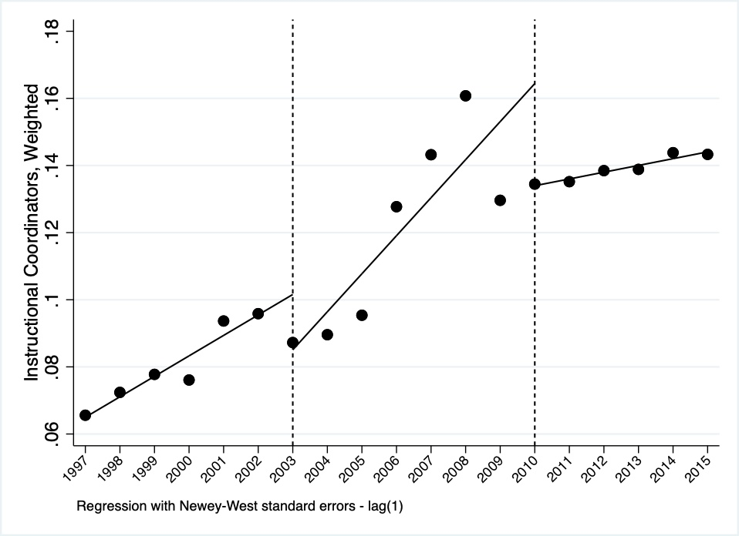

Figure 2 renders these results more vivid. This trend is consistent with positive-sum implications: federal policy “building up” subnational capacity, in a domain that had previously been weak and was essential to “do the work of governance in a federation'' (Ziblatt 2004, 96).

5.2 Durability of Subnational Capacity. Durability is a key element of a robust federation (Bednar 2009). Considering capacity as an important structural safeguard to federations invites us to assess the durability of both embedded capacity (administrative capacity, in the case of public education) and nascent capacity (technical capacity, in the case of public education). The 2008 recession provides us with an opportunity to assess the durability of NCLB’s positive-sum and zero-sum implications in the wake of state fiscal constraints and changing fiscal federal relations.

Returning to table 4 above, the negative association between the 2008 recession and either administrative capacity or technical capacity does not obtain conventional levels of statistical significance in the school year immediately following the recession. This is not surprising in the case of American public education. Given union contracts, public education positions are difficult to eliminate abruptly. Over time, however, administrative and technical capacity, measured by the weighted number of instructional support and administrative support staff, declines after the 2008 recession: the number of administrators per 100 students declines by 0.02 per year, and the number of technical coordinators and supervisors per 100 students declines by 0.01, relative to the positive pre-recession time trend.

Scholarship on decentralization reminds us that administrative decentralization without sufficient funds to support those administrative efforts does not reflect a shift of power from the center to the subnational units (Faletti 2005). Considering NCLB as centralizing (rather than decentralizing), a parallel logic might cast doubt on whether NCLB did, indeed, shift power to the central state if its finger print on organizational capacity proved ephemeral. Our results do not suggest that federalism is the chief contributor to unstable organizational capacity. Rather, they suggest that centralization alone may be insufficient to combat declining subnational budgets in the wake of the 2008 recession. We consider this point and its implications for policy design further below.

While one justification for centralization points to its potential to help manage crises (like economic recessions), another justification points to its potential to remedy subnational inequalities. Looking at administrative and technical capacity overall can mask the subnational inequalities that are hallmarks of federated systems. In what ways have the implications of centralization coupled with the 2008 recession varied by poverty level? We focus on variation in poverty level in the analysis that follows, given its historic and enduring importance in American public education (Owens, Reardon and Jencks 2016).

5.3 Subnational Capacity by Poverty Rate. Given NCLB’s ostensible anti-poverty ambitions, we assess centralization and economic fragility’s implications for county-level capacity, looking specifically at variation in high and low poverty counties. To measure variation by poverty level, we match the dataset to county-level Small Area Income and Poverty Estimates (SAIPE) from 1997 to 2015. We then divide counties into quintiles by childhood poverty levels (percent of the population aged 5-17 living in poverty). The average poverty level for low poverty counties is 9.3 percent and the average poverty level for high poverty counties is 32.8 percent. Focusing on administrative capacity, table 5 suggests NCLB is associated with a decline in administrative capacity in the lowest poverty counties both immediately following the passage of the legislation and over time. This suggests that the extent to which erosion manifested, it did so in low poverty counties.

Table 5: Administrative Capacity in Low Poverty and High Poverty Counties ITSA, 1997-2015
 | Administrative Capacity
VARIABLES | Low Poverty | High Poverty
Year | 0.053*** | 0.054***
 | (0.005) | (0.011)
NCLB (1 = NCLB) | -0.112** | -0.162
 | (0.031) | (0.098)
NCLB * Year | -0.047*** | -0.017
 | (0.009) | (0.023)
Recession (1 = Recession) | 0.102 | -0.030
 | (0.050) | (0.055)
Recession * Year | -0.021* | -0.058*
 | (0.009) | (0.021)
Constant | 1.016*** | 1.005***
 | (0.022) | (0.034)
Post-NCLB Linear Trend | 0.007 | 0.036
 | (0.007) | (0.019)
Post-Recession Linear Trend | -0.014 | -0.022*
 | (0.007) | (0.008)
Observations | 19 | 19
Standard errors in parentheses
*** p<0.001, **p<0.01, * p<0.05

Results from table 5 and from figure 3 suggest evidence that centralization can be zero-sum. In low poverty counties, NCLB depresses the growth of administrative capacity, significant at conventional levels. NCLB does not yield discernible implications for administrative capacity in high poverty counties. Low poverty counties have more administrative support staff on average than high poverty counties, suggesting differences in baseline administrative capacity by income. Administrative capacity in both high and low poverty counties, however, appears to diminish in the wake of the 2008 recession at a rate of administrators per students at -0.02 and -0.06 per year in low poverty and high poverty counties, respectively.

Figure 3: Administrative Capacity Figure 4: Administrative Capacity
ITSA in Low Poverty Counties ITSA in High Poverty Counties

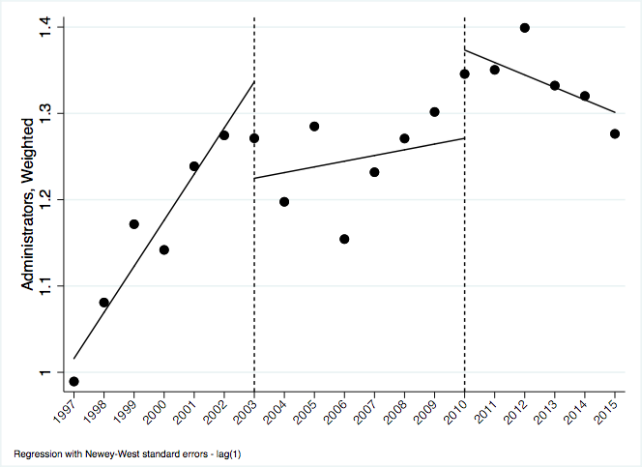

Similar to administrative capacity, the implications of NCLB for technical capacity appear in low poverty counties, albeit in the opposite direction. The portrait for technical capacity suggests some positive-sum implications of centralization, but in ways that continue path dependent processes of privilege rather than in ways that mitigate the structural inequalities that often manifest in federalism.

Table 6: Technical Capacity in Low Poverty and High Poverty Counties ITSA, 1997-2015
 | Technical Capacity
VARIABLES | Low Poverty | High Poverty
Year | 0.008*** | 0.004***
 | (0.001) | (0.001)
NCLB (1 = NCLB) | -0.0237* | -0.005
 | (0.0104) | (0.008)
NCLB * Year | 0.0103*** | 0.005
 | (0.002) | (0.003)
Recession (1 = Recession) | -0.045 | -0.029*
 | (0.025) | (0.014)
Recession * Year | -0.026*** | -0.007**
 | (0.006) | (0.002)
Constant | 0.065*** | 0.074***
 | (0.002) | (0.002)
Post-NCLB Linear Trend | 0.018*** | 0.009**
 | (0.002) | (0.003)
Post-Recession Linear Trend | -0.008 | 0.020**
 | (0.006) | (0.008)
Observations | 19 | 19
Standard errors in parentheses
*** p<0.001, ** p<0.01, * p<0.05

Disparities between schools in terms of whether or not they faced punitive measures resulting from NCLB shed some additional light on these results. Investing in instructional support staff members represents an asset-building approach to school improvement, in contrast to more punitive approaches to intervention like school takeovers or school restructuring. Scholarship finds that the racial composition of districts, along with poverty rates, significantly predicts whether districts would face either more punitive or more lenient NCLB interventions (Manna and Moffitt 2021; Morel 2018). The growth of technical capacity (an asset-building, less punitive approach) in low poverty areas is consistent with these findings.

Figure 5: Technical Capacity Figure 6: Technical Capacity
ITSA in Low Poverty Counties ITSA in High Poverty Counties

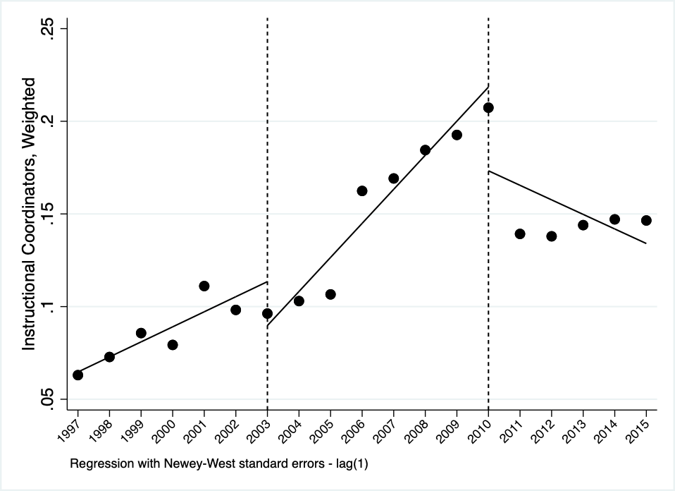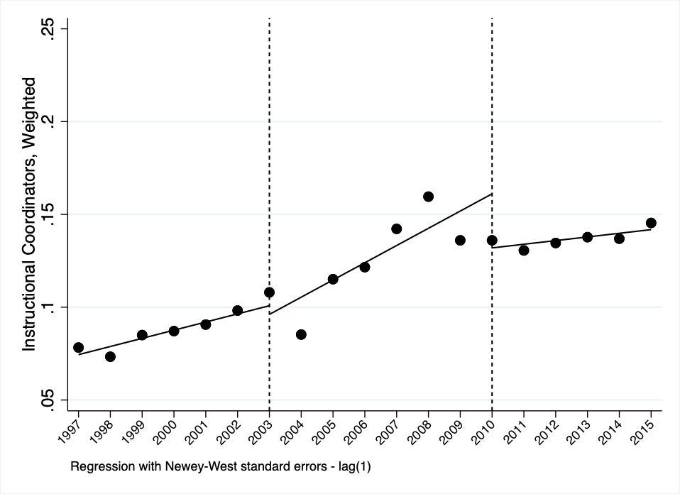

5.4 Robustness Checks and Puzzles for Future Research. Are our results model dependent? To assess this possibility, we deploy an alternative source of measuring administrative capacity, leveraging data from the U.S. Census Annual Survey of Public Employees and Payroll Tables, which measures education employees staffing levels from 1997 to 2015. We combined these data with the Common Core of Data Local Education Survey to create a measure of state administrative capacity weighted by state student population. The results, highlighted in figure 7, are similar to our county-level administrative capacity models. There is a small, immediate decline in capacity following NCLB. After the recession, there is continued decrease in capacity, which is both statistically and substantively significant. These results suggest that our findings on administrative capacity measured at the Local Education Agency level (aggregated to the county level) manifest at the State Education Agency level as well. Our state level and district level administrative results both reveal post-NCLB declines. Yet, future research on policy design could help discern ways in which centralization yields similar and/or different organizational implications for different levels of subnational capacity (state, county, local).

Figure 7: State Administrative Capacity ITSA, 1997-2015

As a second robustness check, we examine the development of nongovernmental capacity throughout this time period. Organizational capacity is not restricted to governmental agencies, but can include nongovernmental agencies that help do the work of governance (Cammett and MacLean 2014; Cohen 1982). One possibility, thus, is that centralization leads to significant expansion of nongovernmental capacity, instead of subnational governmental capacity. Alternatively, increasing reliance on markets instead of governments through private or non-profit service providers has been a hallmark of decentralized welfare reforms. Expanded reliance on nongovernmental sources of capacity could suggest decentralization, rather than centralization. Though nongovernmental education service providers have always been part of the Title I landscape, encouraging school districts to use their Title I funds to purchase their services, NCLB’s call for optional supplemental education services ushered in an additional provision amenable to nongovernmental agency services (Hughes and Hughes 1972; Manna 2010, 75-80).

To measure nongovernmental capacity, we used a subset of organizations from the National Center for Charitable Statistics (NCSS) Core Trend Public Charities 1989 – 2015, which relies on information from both the IRS Business Master File and the IRS Return Transaction Files. Our analysis includes 8,118 education service organizations from 1997 – 2015, yielding 69,761 observations.

Figure 8: Nongovernmental Capacity ITSA, 1997-2015
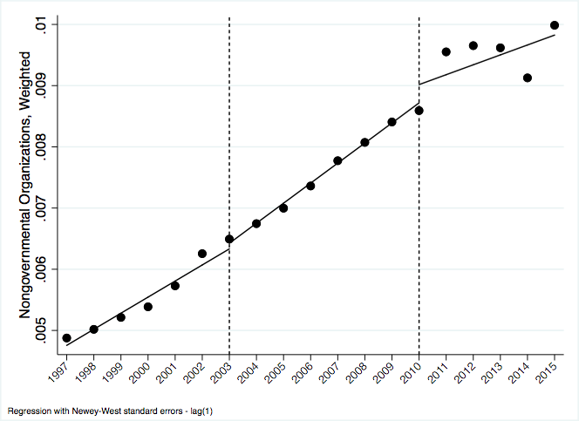

Figure 8 presents our results for nongovernmental capacity, measured by the weighted number of education service organizations over time. Results suggest that nongovernmental capacity expands throughout this period, but does not appear related to NCLB in a systematic way. Results from figure 3 below depict the rapid growth in nonprofit education service provision during this time period, irrespective of policy shocks like NCLB. The stark contrast between subnational governmental agencies and nongovernmental agencies marks another potentially promising venue for future research, since the U.S. system depends heavily upon nongovernmental organizations to do the work of governance.

6.0 Discussion and Conclusion
The COVID-19 pandemic together with a global recession invite renewed attention to centralization: its processes for building capacity and its implications for inequality. Lessons from policies like U.S. Social Security highlight opportunities for greater centralization to protect vulnerable populations from economic volatility and to remedy aspects of inequality that manifest in subnational policies. As we draw lessons from the past to inform paths forward to respond to COVID-19, the bumpy history of expanding the federal government’s role in American public education encourages careful consideration of how the details of centralizing policies bear on bureaucratic quality and underlying inequality.

Assessing the implications of centralization on subnational capacity to “do the work of governance” requires, in part, distinguishing components of organizational capacity – including administrative and technical capacities – and their prior development. Experiences from the No Child Left Behind Act suggest simultaneous subnational erosion in administrative capacity and growth in technical capacity following centralization. To the extent that centralization in the case of NCLB had zero-sum implications, those dynamics appear most vividly for the aspect of subnational capacity that was previously more developed: administrative capacity. Positive-sum implications appeared for the aspect of subnational capacity that had been previously weak: technical capacity. The implications of centralization in our education case, this suggests, depend on a context populated with prior investments: NCLB came nearly fifty years after the original Elementary and Secondary Education Act of 1965. Our story, thus, picks up midstream.

Looking back over a longer expanse of time, the expansion of the U.S. federal government into American public schools since 1965 put the education of children from under-resourced communities on national and state agendas. It helped augment the size and responsibility of state departments of education. By some accounts, it has yielded increases in educational achievement, high school completion rates, and a range of other adulthood benefits, especially for children experiencing poverty (Johnson 2015). Yet, NCLB’s version of centralization reflects a policy design unable to build organizational capacity to remedy underlying inequalities. The growth in subnational technical capacity following NCLB appeared concentrated in low poverty counties, even though the federal policy was designed with explicit anti-poverty purposes. Moreover, the erosion of previously developed capacity (administrative) also appears in low poverty counties. Taken together, this suggests that while centralization has the potential to remedy structural inequalities through investments in subnational capacity, more resourced subnational units may be better positioned to make use of those investments both to dismantle old capacities and to build new ones.

Yet, this discouraging portrait should also be interpreted cautiously and within the context of NCLB’s design. NCLB embodied a particularly punitive form of federal-level policy toward public schools, not one that emphasized building the technical expertise of teachers and administrators. Given NCLB’s accountability-focused design, any growth in subnational technical expertise during this era could seem remarkable. Considering subnational investments in public education’s organizational capacity over time, Title I’s complicated history does not impugn centralization. Instead, the ways in which centralization has fallen short of remedying underlying inequalities, even for policies with anti-poverty purposes, invite greater attentiveness to all four elements of organizational capacity— resources, administration, technical know-how, and reach—both in research and in policy design.

We offer this case to researchers and policymakers in the COVID-19 era to underscore the importance of organizational capacities and investments in public bureaucracy. One lesson from this case study is the importance of context, consistent with established work on the ways federalist systems and their evolving dynamics vary significantly across time and across place (Triesman 2007). A second lesson is the importance of policy design. Policy designs activate different kinds of professions, they activate different kinds of subnational politics (Manna and Moffitt 2021), and they matter to the durability of subnational coalitions willing to support and implement central government policies (Karch and Rose 2019). Considering the limitations of our case, future scholarship would benefit from systematically assessing how the implications of centralization for organizational capacities vary by key aspects of policy design. Key aspects of policy design include whether centralization reaches directly to local governments or passes through state or provincial governments (Hooghe and Marks 2003), whether states have the fiscal capacity to make use of federal-level grants (Howell and Magazinnik 2020), and whether the interests of different types of under-resourced geographic spaces (urban, suburban, and rural) are represented in state-level decisions that bear on the development of subnational organizational capacity.

While we emphasize the importance of organizational capacities, future scholarship would benefit from moving beyond investments in bureaucracy to assessing whether and how those capacities affect policy implementation. Capacity is ultimately relative to the state’s goals (Enriquez and Centeno 2012; Katzenstein 1978; Sikkink 1991; Skocpol 1985; Skowronek 1982). Technical capacity (the needed knowledge) and administrative capacity (the connective tissue and oversight) depend on the tasks that practitioners are expected to accomplish. To remedy subnational inequalities through centralization, future analysis might discern the “capacity gap”: the gap between the amount of technical and administrative capacity that subnational units have and the amount that is needed to accomplish tasks.

Lessons from U.S. education policy invite caution in the current political and policy terrain, reeling from the reverberating effects of COVID-19 and the 2020 recession. Early work on COVID-19 explicitly implicated federalism in exacerbating the inequities that manifest in both the burden and response to COVID-19, with good reason (Huberfeld, Gordon and Jones 2020). The operation of federalism can, indeed, perpetuate inequality (Kettl 2020). Yet, efforts to centralize through policies like NCLB underscore potential risks. The organizational capacity of subnational governments depends on policy designs and operates on unequal terrains. While centralization can help remedy underlying subnational inequalities, such expansion also risks diminishing aspects of subnational capacity and reinforcing inequalities. It bears emphasizing that centralization is not, in and of itself, a panacea for subnational inequalities: its potential depends on the quality of the bureaucracy that it produces.

References
Bailey, Stephen and Edith Mosher. 1968. ESEA: The Office of Education Administers a Law: Syracuse, NY: Syracuse University Press.

Beramendi, Pablo. 2007. “Federalism.” In Oxford Handbook of Comparative Politics, edited by Carles Boix and Susan Stokes. Oxford, Oxford University Press: 752-782.

Beramendi, Pablo, Melissa Rogers, and Alberto Diaz-Cayeros. 2017. “Barriers to Egalitarianism: Distributive Tensions in Latin American Federations.” Latin American Research Review 52 (4): 529-551.

Bardach, Eugene. 1977. The Implementation Game. Cambridge, MA: MIT Press.

Bednar, Jenna. 2009. The Robust Federation: Principles of Design. New York: Cambridge University Press.

Bloom, Howard S. 2003. “Using “Short” Interrupted Time-Series Analysis To Measure The Impacts Of Whole-School Reforms: With Applications to a Study of Accelerated Schools.” Evaluation Review, 27(1):3–49.

Bulkley, Katrina E. and Patricia Burch. 2011. "The Changing Nature of Private Engagement in Public Education: For-Profit and Nonprofit Organizations and Educational Reform." Peabody Journal of Education 86 (3): 236-251.

Cammett, Melani and Lauren M. MacLean. 2014. The Politics of Non-state Social Welfare. Ithaca, NY: Cornell University Press.

Campbell, Andrea Louise. 2014. Trapped in America’s Safety Net: One Family’s Struggle. Chicago: University of Chicago Press.

Centeno, Miguel, Atul Kohli, and Deborah J. Yashar. 2017. States in the Developing World. Cambridge University Press.

Cohen, Alan B., David C. Colby, Keith A. Walloo, and Julian E. Zelizar. 2015. Medicare and Medicaid at 50: America’s Entitlement Programs in the Age of Affordable Care. Oxford University Press.

Cohen, David K. 1982. “Policy and Organization: The Impact of State and Federal Education Policy on School Governance.” Harvard Educational Review 52 (4): 474-499.

Cohen, David K. and Susan L. Moffitt 2009. Ordeal of Equality. Cambridge, MA: Harvard University Press.

Dasgupta, Aditya and Devesh Kapur. 2020. “The Political Economy of Bureaucratic Overload: Evidence from Rural Development Officials in India.” American Political Science Review 114 (4): 1316-1334.

Dee, Thomas S. and Brian Jacob. 2011. “The Impact of No Child Left Behind on Student Achievement.” Journal of Policy Analysis and Management, 30(3), 418-446.

Derthick, Martha. 1972. New Towns in Town. Washington, D.C.: Urban Institute.

Derthick, Martha. 1975. Uncontrollable Spending for Social Services Grants. Washington, D.C.: Brookings Institution.

Derthick, Martha. 2015. On the Mutability of American Laws. In What Would Madison Do? Benjamin Wittes and Pietro S. Nivola (eds.). Washington, D.C.: Brookings Institution Press.

Enriquez, Elaine and Miguel Angel Centeno. 2012. “State Capacity: Utilization, Durability and the Role of Wealth v. History.” International and Multidisciplinary Journal of Social Sciences 1(2): 130-162.

Evans, Peter, and James E. Rauch. 1999. “Bureaucracy and Growth: A Cross-National Analysis of the Effects of "Weberian" State Structures on Economic Growth.” American Sociological Review: 748-765.

Falleti, Tulia. 2005. “A Sequential Theory of Decentralization: Latin American Cases in Comparative Perspective.” The American Political Science Review 99(3): 327-346.

Filippov, M., Peter Ordeshook, and Olga Shvetsova. 2004. Designing Federalism: A Theory of Self-Sustaining Federal Institutions. Cambridge UK: Cambridge University Press.

Goldstein, Joshua S. and Jon C. Pevehouse. 1997. “Reciprocity, Bullying, and International Cooperation: Time-series Analysis of the Bosnia Conflict.” American Political Science Review, 91(3): 515-529.

Hooghe, Liesbet and Gary Marks. 2003. “Unraveling the Central State, but How? Types of Multi-level Governance.” American Political Science Review 97 (2): 233-243.

Howell, William G. and Asya Magazinnik. 2020. “Financial Incentives in Vertical Diffusion: The Variable Effects of Obama’s Race to the Top Initiative on State Policy Making.” State Politics and Policy Quarterly 20 (2): 185-212.

Huber, John and Nolan McCarty. 2004. “Bureaucratic Capacity, Delegation, and Political Reform.” American Political Science Review 9 (3): 481-494.

Huberfeld, Nicole, Sarah H. Gordon, and David K. Jones. 2020. “Federalism Complicates the Response to the COVID-19 Health and Economic Crisis: What Can Be Done?” Journal of Health Politics, Policy and Law 45 (6): 951-965.

Hughes, John F. and Ann O. Hughes. 1972. Equal Education: A New National Strategy. Bloomington, IN: Indiana University Press.

Imazeki, Jennifer and Andrew Reschovsky. 2004. “Is No Child Left Behind an Un (or Under) funded Federal Mandate? Evidence from Texas.” National Tax Journal 57 (3): 571-588.

Johnson, Rucker C. 2015. “Follow the Money: School Spending from Title I to Adult Earnings.” RSF: The Russell Sage Foundation Journal of the Social Sciences 1 (3): 50-76.

Kaestle, Carl. 1983. Pillars of the Republic: Common Schools and American Society 1780-1860. Hill and Wang.

Karch, Andrew. 2013. Early Start: Preschool Politics in the United States. Ann Arbor: University of Michigan Press.

Karch, Andrew and Shanna Rose. 2019. Responsive States: Federalism and American Public Policy. Cambridge University Press.

Katzenstein, Peter J. 1978. Between Power and Plenty: Foreign Economic Policies of Advanced Industrial States. Madison, WI: University of Wisconsin Press.

Katznelson, Ira and Margaret Weir. 1985. Schooling for All: Class, Race, and the Decline of the American Ideal. New York: Basic Books.

Kettl, Donald F. 2020. The Divided States of America: Why Federalism Doesn’t Work. Princeton, NJ: Princeton University Press.

Kimbrough, Jackie and Paul Hill. 1981. The Aggregate Effects of Federal Education Programs. Santa Monica, CA: RAND.

Kirst, Michael and R. Jung. 1980. “The Utility of a Longitudinal Approach in Assessing Implementation: A Thirteen year View of Title I, ESEA.” Educational Evaluation and Policy Analysis 2(5): 17-34.

Kontopantelis, Evangelos, Tim Doran, David A. Springate, Iain Buchan, and David Reeves. 2015. “Regression Based Quasi-Experimental Approach When Randomisation is Not an Option: Interrupted Time Series Analysis.” British Medical Journal, 350: h2750.

Leach, Richard. 1970. American Federalism. New York: Norton.

Levy, Jacob. 2007. “Federalism, Liberalism and the Separation of Loyalties.” American Political Science Review 101(3): 459-477.

Linden, Ariel and John L. Adams. 2011. “Applying a Propensity Score-Based Weighting Model to Interrupted Time Series Data: Improving Causal Inference in Programme Evaluation.” Journal of Evaluation in Clinical Practice 17(6):1231-8.

López-Santana, Mariely. 2015. The New Governance of Welfare States in the United States and Europe. Albany, NY: SUNY Press.

Luigjes, Chris and Frank Vandenbroucke. 2020. “Unemployment Benefits and Activation in Federal Welfare States: An Institutional Moral Hazard Perspective.” Regional & Federal Studies https://doi.org/10.1080/13597566.2020.1751127.

Madison, James. Federalist No. 45: “The Alleged Danger from the Power of the Union to the State Governments Considered.”

Mann, Michael. 1984. “The Autonomous Power of the State: its Origins, Mechanisms and Results.” European Journal of Sociology 25(02): 185–213.

Mann, Michael. 2008. “Infrastructural Power Revised.” Studies in Comparative International Development 43: 355-365.

Manna, Paul. 2006. School’s In: Federalism and the National Education Agenda. Washington, D.C.: Georgetown University Press.

Manna, Paul. 2010. Collision Course: Federal Education Policy Meets State and Local Reality. Washington, D.C.: CQ Press.

Manna, Paul and Susan Moffitt. 2021. “Traceable Tasks and Complex Policies: When Politics Matter for Policy Implementation.” Policy Studies Journal 49(1): 190-218.

McDonnell, Lorraine M. 2005. “No Child Left Behind and the Federal Role in Education: Evolution or Revolution?” Peabody Journal of Education 80 (2): 19-38.

McDonnell, Lorraine M. 2015. “Stability and Change in Title I Testing Policy.” RSF: The Russell Sage Foundation Journal of the Social Sciences 1 (3) 170-186.

McGuinn, Patrick. 2005. “The National Schoolmarm: No Child Left Behind and the New Educational Federalism.” Publius 35 (1): 41-68.

McGuinn, Patrick. 2006. No Child Left Behind and the Transformation of Federal Education Policy, 1965-2005. Lawrence, KS: University of Kansas Press.

Mettler, Suzanne. 1998. Dividing Citizens: Gender and Federalism in New Deal Public Policy. Ithaca, NY: Cornell University Press.

Michener, Jamila. 2018. Fragmented Democracy: Medicaid, Federalism, and Unequal Politics. New York: Cambridge University Press.

Moffitt, Susan L. and David K. Cohen. 2015. “The State of Title I: Developing the Capability to Support Instructional Improvement.” Russell Sage Foundation Journal of the Social Sciences 1(3): 187-202.

Moffitt, Susan L., Matthew J. Lyddon, Domingo Morel, Michaela Krug O’Neill, Kelly B. Smith, Cadence Willse, and David K. Cohen. 2018. State Structures for Instructional Support in California. Technical Report, Getting Down to Facts II: Current Conditions and Paths Forward for California Schools.

Morel, Domingo. Takeover: Raced, Education, and American Democracy. Oxford University Press.

Murphy, Jerome T. 1974. State Education Agencies and Discretionary Funds: Grease the Squeaky Wheel. Lexington, MA: Lexington Books.

National Center for Education Statistics (NCES). 1993. 120 Year of American Education: A Statistical Portrait. Washington, D.C.: U.S. Department of Education.

National Center for Education Statistics (NCES). 2015. Condition of Education. Washington, D.C.: U.S. Department of Education.

National Center for Education Statistics (NCES). 2020. Condition of Education. Washington, D.C.: U.S. Department of Education.

Owens, Ann, Sean F. Reardon and Christopher Jencks. 2016. “Income Segregation between Schools and Districts.” American Education Research Journal 53 (4): 1159-1197.

Penfold, Robert B. and Fang Zhang. 2013. “Use of Interrupted Time Series Analysis in Evaluating Health Care Quality Improvements.” Academic Pediatrics, 13(6 Supplement): S38-S44.

Peterson, Paul E., Barry G. Rabe, Kenneth K. Wong. 1986. When Federalism Works. Washington, D.C.: Brookings Institute Press.

Pierson, Paul. 2000. “Increasing Returns, Path Dependence, and the Study of Politics.” American Political Science Review 94 (2): 251-267.

Posner, Paul L. 1998. The Politics of Unfunded Mandates: Whither Federalism? Washington, D.C.: Georgetown University Press.

Pressman, Jeffrey L. and Aaron Wildavsky. 1984. Implementation 3rd ed. Berkeley, CA: University of California Press.

Purkey, Stewart C. and Marshall S. Smith. 1983. “Effective Schools: A Review.” Elementary School Journal 83 (4): 427-452.

Ravitch, Diane. 2011. The Death and Life of the Great American School System. Basic Books.

Rice, Joseph M. 1893. The Public School System Of The United States. New York: The Century Co.

Riker, William. 1987. The Invention of Centralized Federalism, in The Development of American Federalism. Boston, MA: Kluwer Academic Publishers, pp.17-41.

Rodden, Jonathan A. 2004. “Comparative Federalism and Decentralization: On Meaning and Measurement.” Comparative Politics 36, 4: 481-500.

Rodden, Jonathan A. 2005. Hamilton's Paradox: The Promise and Peril of Fiscal Federalism. New York: Cambridge University Press.

Sanders, Crystal R. 2016. A Chance for Change: Head Start and Mississippi’s Black Freedom Struggle. Chapel Hill, NC: University of North Carolina Press.

Shelly, Bryan. 2008. “Rebels and Their Causes: State Resistance to No Child Left Behind.” Publius 38 (3): 444-468.

Sikkink, Kathryn. 1991. Ideas and Institutions: Developmentalism in Brazil and Argentina. Ithaca: Cornell University Press.

Skocpol, Theda. 1985. Bringing the State Back In: Strategies of Analysis in Current Research. In Bringing the State Back In, edited by Peter B. Evans, Dietrich Rueschemeyer and Theda Skocpol, 3-37. Cambridge: Cambridge University Press.

Skowronek, Stephen. 1982. Building A New American State: The Expansion of National Administrative Capacities 1877-1920. New York: Cambridge University Press.

Soss, Joe, Richard C. Fording and Sanford F. Schram. 2008. “The Color of Devolution: Race, Federalism, and the Politics of Social Control.” American Journal of Political Science. 52(3): 536-553.

Steffes, Tracy L. 2012. School, Society and State: A New Education to Govern Modern America, 1890-1940. Chicago, IL: University of Chicago Press.

Strach, Patricia, Kathleen Sullivan and Elizabeth Pérez-Chiqués. 2019. “The Garbage Problem: Corruption, Innovation, and Capacity in Four American Cities, 1890–1940.” Studies in American Political Development (25): 209-233.

Strach, Patricia, Katie Zuber and Elizabeth Pérez-Chiqués. 2020. “Why Policies Fail: The Illusion of Services in the Opioid Epidemic.” Journal of Health Politics, Policy and Law 25 (2): 341-364.

State of New York. 1905. First Annual Report of the Education Department for the School Year Ending July 31, 1904. Albany, NY: New York State Education Department.

State of New York. 1916. Eleventh Annual Report of the Education Department for the School Year Ending July 31, 1914. Albany, NY: University of the State of New York.

Timar, Thomas B. 1997. “The Institutional Role of State Education Departments: A Historical Perspective.” American Journal of Education 105 (May 1997): 231-260.

Triesman, Daniel. 2007. The Architecture of Government: Rethinking Political Decentralization. New York: Cambridge University Press.

University of the State of New York State Department of Education. 1912. Annual Report of the Education Department for the School Year Ending 1911. Albany, NY: The University of the State of New York.

University of the State of New York State Department of Education. 1924. Twentieth Annual Report of the Education Department. Albany, NY: The University of the State of New York.

University of the State of New York State Department of Education. 1925. Twenty-First Annual Report of the Education Department for the School Year Ending July 31, 1924. Albany, NY: The University of the State of New York.

University of the State of New York State Department of Education. 1936. Thirty-First Annual Report of the Education Department for the School Year Ending June 30, 1934, volume 1. Albany, NY: The University of the State of New York.

Wallner, Jennifer. 2014. Learning to School: Federalism and Public Schooling in Canada. Toronto: University of Toronto Press.

Weber, Max. 1946. From Max Weber: Essays in Sociology, translated by H. H. Gerth and C. Wright Mills. New York: Oxford University Press.

Wibbels, Erik. 2012. Intergovernmental Conflict and Economic Reform in the Developing World. Cambridge University Press.

Ziblatt, Daniel. 2004. “Rethinking the Origins of Federalism: Puzzle, Theory, and Evidence from Nineteenth Century Europe.” World Politics 57: 70-98.

With its roots in Weberian bureaucracy, organizational capacity reflects and embodies power, and manifests through four key indicators: resources, presence of the state, mandarins, and coherence (Centeno, Kohli and Yashar 2017, 9-10).
We use the term “central state” as the most inclusive structure of authority: states as systems of laws, bureaucracy, and coercion that structure relationships within society and between society and governments (Skocpol 1985). We use the term “central government” as a general term for a nation’s highest level governmental entity. We use the term “federal government” to refer to the central government in the United States. We use the term “states” to refer to the subnational governmental unit in the United States. By the term “centralization,” we mean the expansion of the central state, but this expansion does not necessarily mean that power has shifted from subunits to the central government.
For analysis on the importance of the central state to 18th century proponents of federalism in the U.S., see Riker (1987). For current analysis on the struggle and arguments on the balance of power in the U.S., see Kettl (2020).
Expanding on Mann’s framework, Ziblatt (2004) argues that infrastructural capacity is a key condition in the formation of federalism. Without infrastructural capacity, subunits are more likely to be absorbed into a unitary state system.
Technical capacity is akin to the Centeno, Kohli and Yashar (2017, 10) term “Mandarins” which includes the expertise, training, and “appropriate responsibilities” of street-level bureaucrats.
Our concept of administrative capacity is akin to the Centeno, Kohli and Yashar (2017, 10) term “coherence” which includes “inter- and intra-institutional communication and oversight.”
Our decision to focus on investments also incorporates another element of organizational capacity: resources (Centeno, Kohli and Yashar 2017, 10).
In this case, centralization would disrupt increasing returns from path dependence which typically render established capacity difficult to erode (Pierson 2000).
Building on existing capacity can also manifest as helping existing subnational capacity work effectively or efficiently by improving coordination across subunits, for instance.
When centralization mirrors processes of decentralization, centralization could manifest politically through electoral reforms, fiscally through changes in funding authority, and administratively though shifts in responsibility for public service design and delivery (Falleti 2005). Given our focus on organizational capacity, we draw specifically on insights arising from administrative decentralization, recognizing the interdependence between administration and finance. We are grateful to our reviewers for helping us clarify these points.
Complex policies can contain components that are zero-sum (reflecting a layered version of federalism) and positive-sum (reflecting a marbled version of federalism). Even when centralization expands organizational capacity at multiple levels of government, it can abet shifts in the distribution of power, as reflected in the original form of the Head Start program (Sanders 2016).
By focusing on investment in bureaucracy, or the “quality of bureaucracy,” we depart from classic works on the quality of implementation (Derthick 1972; Pressman and Wildavsky 1984).
Though the U.S. has experienced various phases or stages in the life of its federalism, reflecting the importance of the 14th amendment and the suite of civil rights laws passed in the 1960s and 1970s, decentralization pervades American public education.
State-level contributions to public education rose after World War II, expanding to about 35 percent of public school revenue by 1965. By the 21st century, state and local sources of public school revenue became roughly equivalent. Federal government contributions to public schools did not emerge until post-World War II, and have contributed between 6 to 12 percent of public school revenue since 1965 (NCES 1993, 2020).
This quotation appears in Moffitt and Cohen (2015), along with discussion of the New York’s Department of Education’s development.
Our claim that if technical capacity at the subnational level were to manifest, we would expect it in New York is based on the archival work that we conducted for 4 states—New York, Minnesota, North Carolina and Washington—selected on the basis of their regional diversity. For each state, we reviewed annual reports of the state superintendent of public instruction (or its equivalent) from 1890-1935, housed in the Gutman Library’s Special Collections at Harvard University. Among these 4 states, New York reported state-level investments along with descriptions of agency work that allowed us to discern between administrative and technical capacity. The other states presented different kinds of evidence including narrative reports, organization charts, and financial statements that led us to conclude that the portrait that emerged from New York generalizes to other states.
Data for this table come from the University of the State of New York State Department of Education 1912, 311-312; University of the State of New York State Department of Education 1925, 327; University of the State of New York State Department of Education 1936, 170-171. The Administrative Division in 1914 was responsible for “finances, publications and printing, and general supervision of the Department staff” (State of New York, 1916 17). For a summary of the responsibilities of the Examinations Division and discussion of teacher examinations, see: State of New York 1905, 35, 56-57. For a summary of the work of the Inspections Division at the beginning of the 20th century, see: State of New York, 1905, 36; State of New York 1916, 21.
Though poverty rates formed one part of ESEA Title I’s formula, those funds were distributed widely and thinly (Cohen and Moffitt 2009).
McDonnell (2005), however, makes clear that NCLB would not have been possible without prior investments from earlier reauthorizations of Title I of the Elementary and Secondary Education Act and without prior state-level investments in standards-based reforms.
On the quality of bureaucracy, see Centeno, Kohli and Yashar (2017, 5-6).
Weak subnational technical capacity has been particularly pronounced in teachers’ professional learning opportunities and having instructional materials aligned with those professional learning opportunities.
We rely on data from 1997-2015 from The National Center for Education Statistics (NCES), the federal entity responsible for collecting and reporting data in public school districts and states. We employ data from 1997 onwards due to issues of missing data in prior years of the variables of interest, specifically instructional and administrative support. Future research would benefit from a longer time trend.
We supplement this with measures of staff training to provide a robustness check which appear in our online Technical Appendix.
Following scholarship estimating the effect of NCLB (Dee and Jacobs 2011), we categorize the 2002-2003 academic year as the post-NCLB period. Similarly, we categorize the 2009-2010 school year as the post-recession period. We select these years as the “post-intervention” period for two reasons: first, staffing data is collected in the spring of the academic year. Second, due to the nature of school contracts, subnational units are unlikely to hire administrative and technical support positions in the middle of the school year. Therefore, we expect changes in subnational capacity to occur in the academic year after federal policy expansion or economic recession.
Additional robustness checks on state expenditures and capacity during economic recession in another policy domain, policing, can be found in the online Technical Appendix. More information on state and local spending for public education in this time period is available through NCES (2015, 120-126).
We use full time equivalent employment from the “Other Education” category: (https://www.census.gov/topics/public-sector/about/classification-manual.html last accessed on July 28, 2020).
Only organizations required to file Form 990, and thus have annual operating budgets of more than $25,000, are included in the dataset. The analysis included organizations classified as: 1) special education, 2) libraries, 3) student services, 4) educational services, and 5) remedial reading and encouragement. Other analyses using these data appear in Moffitt et al. (2018).
The finding that administrative capacity erosion appears in low poverty counties is, on the one hand, surprising: low poverty are areas where we would expect administrative capacity to be deeply entrenched. On the other hand, when coupled with the findings on technical capacity, these results might provide another window into privilege. Low poverty counties might be better positioned to dismantle one form of capacity to create room for another, signaling another promising area for future research.
Other federalist systems demonstrate how provincial level coordination can manifest without central state expansion (Wallner 2014).
While we focus on investment in bureaucracy as an end in and of itself, future work on organizational capacity may help explain problems in subsequent implementation, including corruption or a policy’s inability to address underlying problems (Strach, Sullivan and Pérez-Chiquès 2019; Strach, Zuber and Pérez-Chiquès 2020).

