Appendix materials:

Appendix A1: Party ownership question wording (Table 1) 2
Appendix A2: Survey Experiment (Figure 2) 3
Appendix A3: Survey Data Compilation (Figure 3) 10
Appendix A4: MeToo and Party Affect (Figure 4) 17
Appendix A5: Candidate MeToo Stance and vote intention (Figure 5) 22

Appendix A1: Party ownership question wording (Table 1)
NBC 1991/2017: “When it comes to... dealing with the issue of sexual harassment... which party do you think would do a better job--the Democratic party, the Republican party, both about the same, or neither?”
Quinnipiac 2017: “Which political party do you think can do a better job of handling sexual harassment, the Democratic party or the Republican party? Democratic Party, Republican Party, No Difference.”
CNN 2018: “Do you think the (Republicans in Congress) or the (Democrats in Congress) would do a better job of dealing with each of the following issues and problems?” Sexual misconduct

Appendix A2: Survey Experiment (Figure 2)

The experiment was approved by the [Redacted for Peer review] Institutional Review Board (#XXX) and was pre-registered on OSF (#[Redacted for Peer review]).

We fielded the experiment to 1,724 participants provided by Lucid’s Fulcrum Exchange, “an automated marketplace that connects researchers with willing online research participants” (LUCID, 2018). on Sept. 19, 2018. Per our pre-registration decisions, we exclude 106 participants for “speeding,” by completing the survey in less than 1/3 the median survey time; inclusion of these respondents does not alter the results.

Table A2.1: Sample demographics
Female | 51%
White | 70%
Hispanic | 11%
Col graduate | 40%
Income | Median: $45,000 to $49,999
Party ID:
Strong Dem | 24%
Dem | 13%
Lean Dem | 8%
Independent | 14%
Lean Rep | 9%
Rep | 12%
Strong Rep | 21%

Appendix A2.2: Treatments:

Controls:

We’d like to ask you some questions about your attitudes in politics today. Please be as honest as possible.

Basic information treatment:

Supreme Court nominee faces sexual assault allegation
Associated Press, September 17, 2018
WASHINGTON — President Trump’s bid to confirm Judge Brett M. Kavanaugh to the Supreme Court was thrown into uncertainty on Sunday as a woman came forward with explosive allegations that Mr. Kavanaugh sexually assaulted her when they were teenagers more than three decades ago.
The woman, Christine Blasey Ford, 51, a research psychologist at Palo Alto University in Northern California, said the alleged incident happened the summer before Ford's junior year in high school at a small party.
Ford, in an interview, said “I thought he might inadvertently kill me. He was trying to attack me and remove my clothing.” Ms. Ford is willing to testify before Congress, if asked.
Denying the allegations, Supreme Court nominee Kavanaugh said Monday he would be willing to testify to Congress about Ford’s account.

Party Information Treatment:

Republicans and Democrats scramble to respond to sexual assault allegations against Supreme Court nominee
Associated Press, September 17, 2018
WASHINGTON — President Trump’s bid to confirm Judge Brett M. Kavanaugh to the Supreme Court was thrown into uncertainty on Sunday as a woman came forward with explosive allegations that Mr. Kavanaugh sexually assaulted her when they were teenagers more than three decades ago.
Senate Republican leaders said they intend to move forward with voting on Kavanaugh. Unless more information comes to light, they see no reason to delay the vote, according to a person involved in the discussions.
Senator Dianne Feinstein, the top Democrat on the Judiciary Committee, called the accusations “extremely serious” and said they “bear heavily on Judge Kavanaugh’s character.” Other Democrats have called for a delay in the hearings until a full investigation can be completed.
The woman, Christine Blasey Ford, 51, a research psychologist at Palo Alto University in Northern California, said the alleged incident happened the summer before Ford's junior year in high school at a small party.
Ford, in an interview, said “I thought he might inadvertently kill me. He was trying to attack me and remove my clothing.” Ms. Ford is willing to testify before Congress if asked.
Denying the allegations, Supreme Court nominee Kavanaugh said Monday he would be willing to testify to Congress about Ford’s account.

Table A2.3: Balance checks
 | (1) | (2)
 | All Conditions | All Conditions
Control
Party Id - 7 pt | -0.0451^ | -0.0389
 | (0.0273) | (0.0289)
Women |  | 0.138
 |  | (0.130)
White |  | -0.125
 |  | (0.173)
Hispanic |  | 0.0598
 |  | (0.250)
College Graduate |  | -0.0196
 |  | (0.140)
Household Income |  | 0.0218*
 |  | (0.0104)
Constant | 0.146 | -0.0635
 | (0.125) | (0.202)
Basic treatment
Party Id - 7 pt | -0.0498^ | -0.0436
 | (0.0272) | (0.0287)
Women |  | 0.0387
 |  | (0.129)
White |  | -0.108
 |  | (0.173)
Hispanic |  | 0.213
 |  | (0.244)
College Graduate |  | 0.0596
 |  | (0.139)
Household Income |  | 0.0151
 |  | (0.0103)
Constant | 0.180 | 0.0282
 | (0.124) | (0.201)
Multinomial logit. Standard errors in parentheses. ^ p<.10, * p<.05, ** p<.01, *** p<.001. Baseline category is the party information condition.

A2.4: Examining prior knowledge of events among the experimental group

Views in Control Group of Party Ownership among those who had and had not heard of the Kavanaugh hearings

 | Republicans Own | Neither | Democrats Own
Had not heard | 20% | 62% | 18%
Heard | 16% | 51% | 33%

A2.5: Effect of treatments among those who had not heard of Kavanaugh hearings
 |  | Republicans better at policy |  |  | Democrats better at policy |  | Republicans better at punishing leaders |  | Democrats better at punishing leaders
Control |  |  | 0.147*** | 0.195*** |  | 0.184*** |  | 0.174***
 |  |  | (0.0328) | (0.0360) |  | (0.0350) |  | (0.0338)
Basic treatment |  |  | 0.112*** | 0.235*** |  | 0.161*** |  | 0.210***
 |  |  | (0.0211) | (0.0274) |  | (0.0232) |  | (0.0262)
Party cues treatment |  |  | 0.0832*** | 0.278*** |  | 0.139*** |  | 0.250***
 |  |  | (0.0228) | (0.0419) |  | (0.0297) |  | (0.0400)
Observations |  |  | 408 | 408 |  | 408 |  | 408
Post-hoc predicted probabilities from multinomial logit models, restricting the sample to those who had not heard of the Kavanaugh hearings.

A2.6: Effect of party cues (vs control) by partisanship
 | Republicans better at policy | Democrats better at policy | N
Strong Democrats | -0.00753* | 0.0538^ | 234
 | (0.00365) | (0.0304)
Democrats | -0.0159* | 0.0694^ | 128
 | (0.00746) | (0.0377)
Lean Dem | -0.0290* | 0.0761^ | 88
 | (0.0138) | (0.0394)
Independent | -0.0454* | 0.0689* | 125
 | (0.0227) | (0.0339)
Lean Rep | -0.0605^ | 0.0516* | 91
 | (0.0327) | (0.0242)
Republican | -0.0699^ | 0.0325* | 119
 | (0.0407) | (0.0149)
Strong Republican | -0.0710 | 0.0178* | 221
 | (0.0438) | (0.00811)
Observations | 1003 | 1003

Appendix A2.7: Unexpected event during survey design:

We use an “unexpected event during survey design” quasi-experiment (Muñoz, Falcó-Gimeno, and Hernández 2020) by taking advantage of the fact that the CCES survey was in the field before and after the Kavanaugh hearings. We identify those individuals who took the survey before and after the Kavanaugh hearings. We dropped those respondents that took the survey during the Kavanaugh hearings. This produced a pre-Kavanaugh group (N=362), which is our control group (as they were not exposed to the party’s handling of the hearing before answering the survey) and a post-Kavanaugh group (N=184), which is our treatment group (as they were “treated” by the hearing prior to answering the questions). We use traditional balancing tests and find that the two groups are balanced on partisanship, income, and education but that gender is unevenly distributed across the two groups, so we control for gender in our models. The data is from a 1000-person sub-sample of the Cooperative Congressional Elections Study, purchased by [redacted for peer review]
To examine how the party’s actions might shape issue ownership, we use this as the survey timing variable in a multinomial logistical regression model predicting both Republican Party ownership of sexual harassment policy and whether the Republican Party is better at punishing its members. Because the control group took the survey before the Kavanaugh hearings (and the parties’ handling of the issue), they are the baseline, compared with the treatment group (those who took the survey after the hearings). To ease interpretation, we present the post-hoc predicted probabilities of the share of respondents who selected Republicans or Democrats as better at handling the issue, by whether they took the survey before or after the Kavanaugh hearings (see Figure 2).
The Kavanaugh hearings reduced the proportion of respondents who favored the Republican Party on sexual misconduct, both as a policy domain and in how they handle misconduct by their own leaders. As a consequence, Democrats extended their pre-Kavanaugh ownership advantage over Republicans on policy, from 21 to 28 points. The same pattern recurs for handling accusations against party leaders, growing the Democratic advantage from 22 point to 33 points.

Kavanaugh Hearings and Party Ownership (Unexpected Event)

Note: Post-hoc predicted probabilities from a multi-nominal logistic regression model.

Table A2.7: Pre-post Kavanaugh Hearings & views of party ownership
 | (1) | (2) | (3) | (4)
 | Which party is better at policy | Which party is better at punishing members | Which party is better at policy | Which party is better at punishing members
-1 (Democrats better)
Post Kavanaugh | -0.369^ | -0.168
 | (0.220) | (0.239)
Independent | -2.569*** | -2.999*** | -2.931*** | -3.157***
 | (0.314) | (0.353) | (0.438) | (0.478)
Republican | -1.339*** | -1.712*** | -1.470*** | -2.014***
 | (0.238) | (0.260) | (0.310) | (0.339)
Gender | -0.0696 | -0.1000 | -0.0670 | -0.104
 | (0.216) | (0.235) | (0.216) | (0.235)
Post Kavanaugh=1 |  |  | -0.690^ | -0.628
 |  |  | (0.366) | (0.410)
Post Kavanaugh=1 # Independent |  |  | 0.807 | 0.434
 |  |  | (0.632) | (0.710)
Post Kavanaugh=1 # Republican |  |  | 0.338 | 0.766
 |  |  | (0.481) | (0.526)
Constant | 1.467*** | 1.804*** | 1.589*** | 1.979***
 | (0.237) | (0.262) | (0.268) | (0.302)
1 (Republicans better)
Post Kavanaugh | -0.729** | -0.531*
 | (0.256) | (0.248)
Independent | 1.820*** | 2.138*** | 1.489** | 1.893***
 | (0.448) | (0.485) | (0.514) | (0.566)
Republican | 1.029* | 1.316** | 0.798 | 0.916
 | (0.454) | (0.484) | (0.520) | (0.559)
Gender | -0.573* | -0.909*** | -0.568* | -0.915***
 | (0.253) | (0.249) | (0.253) | (0.249)
Post Kavanaugh=1 |  |  | -1.667 | -1.533
 |  |  | (1.127) | (1.159)
Post Kavanaugh=1 # Independent |  |  | 1.139 | 0.922
 |  |  | (1.178) | (1.210)
Post Kavanaugh=1 # Republican |  |  | 0.923 | 1.288
 |  |  | (1.195) | (1.213)
Constant | -1.249** | -1.010* | -1.015* | -0.724
 | (0.439) | (0.473) | (0.480) | (0.527)
Observations | 563 | 564 | 563 | 564
Multinomial Logistic Regression. Standard errors in parentheses. ^ p<.10, * p<.05, ** p<.01, *** p<.001. Baseline party ID is Democrat. Baseline analysis category is “Both Parties”

Appendix A3: Survey Data Compilation (Figure 3)

Table A3.1: Survey data used in compiled analysis:

Year | Survey | Question
1986 | Time Magazine | How much of a problem is sexual harassment?
1991 | Minnesota Crime and Sexual Offenders Poll | How serious is sexual assault of an issue?  Women are to blame for rape
1991 | Newsweek Sexual harassment Poll | Is it harassment when:  boss asks for sex  boss asks on date  boss fondles employee  boss makes sexual jokes  displays sexual pictures at work  sexual remarks on street
1997 | TimeCNNYankelovich Partners Poll | How much of a problem is sexual harassment?
1998 | TimeCNN 1998 | How much of a problem is sexual harassment?
1998 | Yankelovich-Time-CNN Poll Iraq & Sexual harassment | Is sexual harassment of women in the workplace a problem?  Is it harassment when:  boss asks for sex  boss makes sexual remarks boss flirts  boss makes sexual jokes  boss puts arms around woman
1998 | Yankelovich-Time-CNN Feminism Poll | Is sexual harassment of women a problem?
2013 | Pew 2013 | How important is the issue of sexual assault in the military?
2015 | Post-Kaiser Feminism Survey | Gov't priority: sexual harassment  Gov't priority: domestic vio. & sexual assault
2015 | PRRI Millennials, Sexuality, and Reproductive Health Survey | How common is sexual harassment in:  Middle school  High school  College  Workplace  Do middle schools/high schools/college/workplaces do enough to address sexual assault?
2017 | CNN 2017 | How much of a problem is sexual harassment?
2017 | Associate Press 2017 | How important are each of the following issues to you personally? (sexual misconduct)  Do you think news organizations are giving too much coverage, too little coverage or about the right amount of coverage to each of the following?  - A. The accusations of sexual misconduct against people in Hollywood and media organizations  B. The accusations of sexual misconduct against politicians  How serious a problem would you say sexual misconduct is at each of the following places?  A. Hollywood and the entertainment industry  B. The federal government  C. Your state government  Do you think the following are doing too much, too little or the right amount to address the problem of sexual misconduct?  A. Hollywood and the entertainment industry  B. The federal government  C. Your state government
2018 | CNN 2018 | How much of a problem is sexual harassment?
2018 | PRRI Abortion and 2018 | Bigger problem - sexual harassment or false reports
2018 | ABC 2018 | How much of a problem is sexual harassment?
All answers are scaled on a 0-1 scale and coded so that higher values indicate a stronger support for victims of sexual harassment or a view that sexual harassment is a more serious problem.

Table A3.2: Partisanship and gender in views sexual harassment
 | Party x Year | Gender x Year
Democrat | 0.028
 | (0.023)
Democrat |  | 0.194***
 |  | (0.004)
year 1991 | -0.015 | 0.004
 | (0.156) | (0.157)
year 1997 | 0.047 | 0.054
 | (0.181) | (0.182)
year 1998 | 0.025 | 0.011
 | (0.147) | (0.148)
year 2013 | 0.225 | 0.177
 | (0.181) | (0.182)
year 2015 | 0.152 | 0.111
 | (0.180) | (0.181)
year 2016 | 0.037 | 0.181
 | (0.180) | (0.181)
year 2017 | 0.103 | 0.179
 | (0.157) | (0.157)
year 2018 | -0.007 | 0.157
 | (0.143) | (0.144)
Democrat # year 1991 | -0.008
 | (0.029)
Democrat # year 1997 | 0.017
 | (0.033)
Democrat # year 1998 | -0.006
 | (0.026)
Democrat # year 2013 | 0.031
 | (0.034)
Democrat # year 2015 | -0.016
 | (0.027)
Democrat # year 2016 | 0.231***
 | (0.025)
Democrat # year 2017 | 0.159***
 | (0.029)
Democrat # year 2018 | 0.377***
 | (0.025)
Gender | 0.047***
 | (0.005)
Gender |  | 0.009
 |  | (0.024)
Gender # year 1991 |  | -0.026
 |  | (0.030)
Gender # year 1997 |  | 0.002
 |  | (0.034)
Gender # year 1998 |  | 0.033
 |  | (0.027)
Gender # year 2013 |  | 0.104**
 |  | (0.034)
Gender # year 2015 |  | 0.021
 |  | (0.027)
Gender # year 2016 |  | 0.000
 |  | (.)
Gender # year 2017 |  | 0.019
 |  | (0.030)
Gender # year 2018 |  | 0.073**
 |  | (0.026)
Constant | 0.472*** | 0.402**
 | (0.128) | (0.129)
lns1_1_1
Constant | -2.067*** | -2.061***
 | (0.178) | (0.178)
lnsig_e
Constant | -1.286*** | -1.251***
 | (0.005) | (0.005)
Observations | 17522 | 17522
Standard errors in parentheses. ^ p<.10, * p<.05, ** p<.01, *** p<.001. Multilevel model with clustered standard errors at the survey level.

Figure A3.1: Republican and Democrat views of Sexual Misconduct:

Note: Post-hoc predicted probabilities of values for Democrats and Republicans from above Appendix table.

Figure A3.2: Difference between women’s and men’s views of Sexual Misconduct
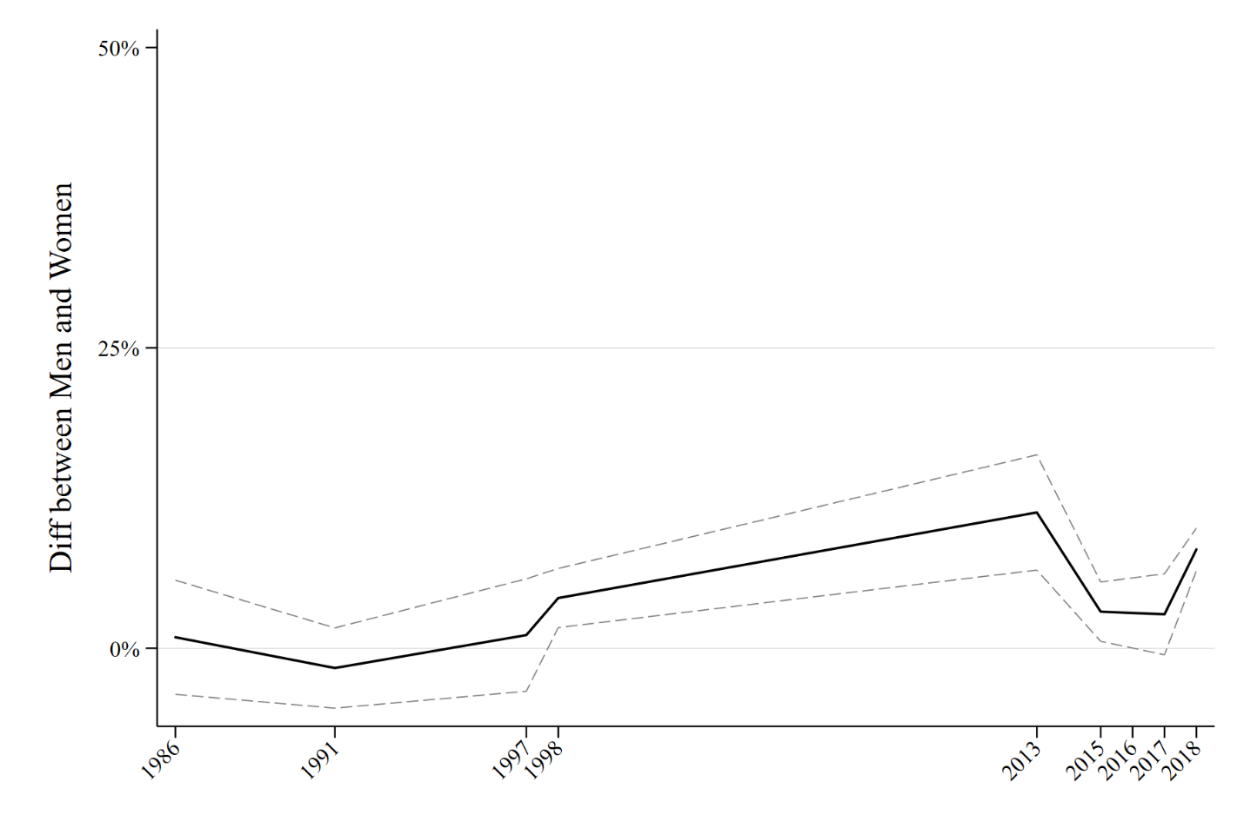

Figure A3.3: Republican and Democrat views of Sexual Misconduct within Genders
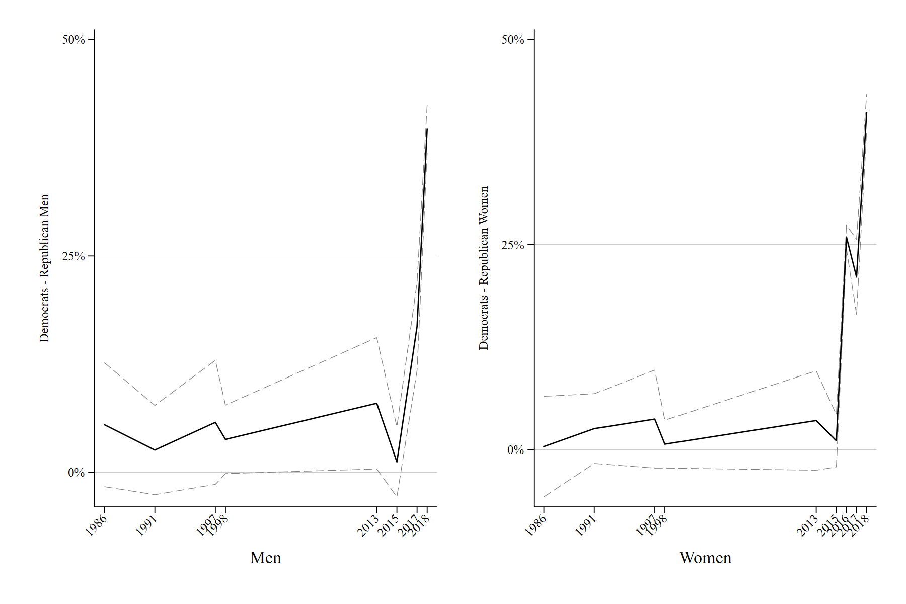

Figure A3.4: Men’s and Women’s views of Sexual Misconduct within Parties
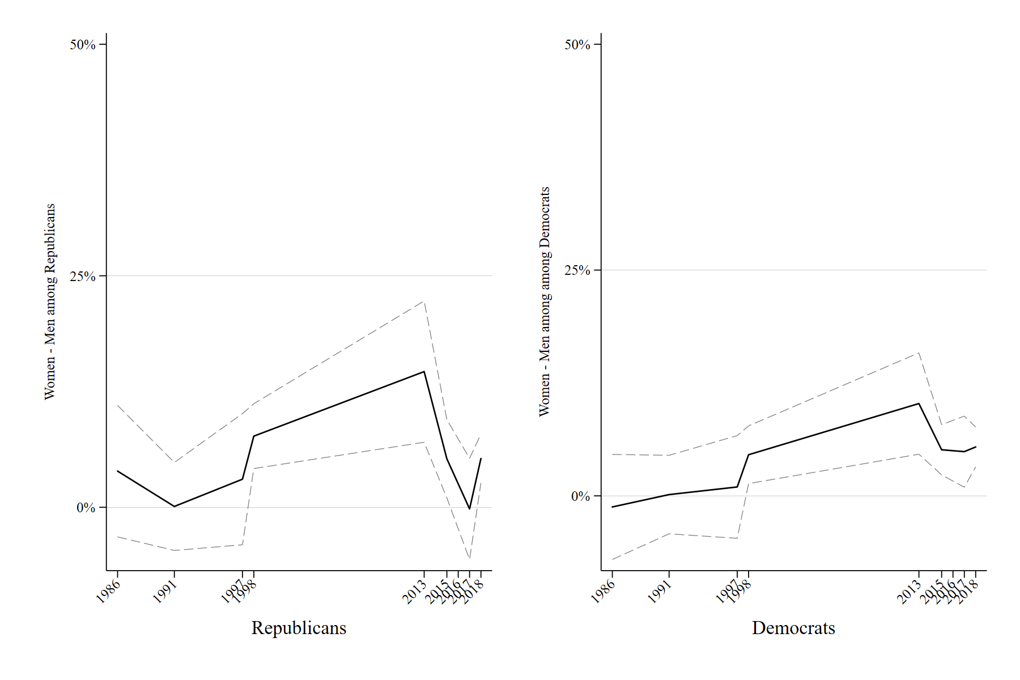

Appendix A4: MeToo and Party Affect (Figure 4)
Figure A4.1: Affect towards the parties and views of MeToo
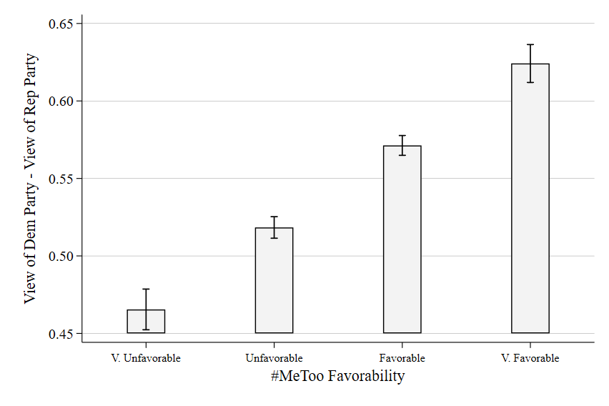
Post-hoc predicted probabilities from ordinary least squares regression models predicting affect towards Democratic Party minus affect towards Republican Party on a 0-1 scale with controls for party ID, gender, race, education, age, whether someone has children and is married, their employment status, income, sexism, racial resentment, and views of the country headed in the right or wrong direction.

Table A4.1: Favorability of MeToo & Parties
 | Favorability of Dems - Reps
Favorability of #MeToo | 0.32***
 | (0.02)
Gender=1 | -0.03
 | (0.04)
pid7 | -0.43***
 | (0.01)
race | -0.01
 | (0.01)
educ4 | -0.01
 | (0.02)
age5 | 0.03
 | (0.02)
child18 | 0.06
 | (0.05)
Married | 0.02
 | (0.04)
Employed part or full time | 0.03
 | (0.04)
Income | -0.01
 | (0.01)
Direction of country | -0.60***
 | (0.03)
racism | -0.19***
 | (0.02)
Constant | 2.54***
 | (0.17)
Observations | 2535
R² | 0.85
Standard errors in parentheses
Dependent variable: Views towards parties (Dem-Rep)
^ p<.10, * p<.05, ** p<.01, *** p<.001

Table A4.2: Favorability of MeToo & Dem and Rep Party favorability
 | Favorability of Democratic Party | Favorability of Republican Party
Favorability of #MeToo | 0.29*** | -0.10***
 | (0.02) | (0.02)
Gender=1 | 0.02 | 0.10***
 | (0.03) | (0.02)
Party ID=2 | -0.74*** | 0.23***
 | (0.03) | (0.03)
Party ID=3 | -0.98*** | 0.86***
 | (0.04) | (0.04)
race | 0.01 | 0.01
 | (0.01) | (0.01)
educ4 | -0.03* | -0.01
 | (0.01) | (0.01)
age5 | 0.01 | -0.02
 | (0.01) | (0.01)
child18 | -0.03 | -0.09*
 | (0.04) | (0.03)
Married | -0.04 | -0.05^
 | (0.03) | (0.03)
Employed part or full time | -0.01 | -0.05^
 | (0.03) | (0.03)
Income | -0.01* | -0.00
 | (0.00) | (0.00)
Direction of country | -0.28*** | 0.45***
 | (0.02) | (0.02)
racism | -0.11*** | 0.16***
 | (0.02) | (0.02)
Constant | 3.02*** | 0.92***
 | (0.12) | (0.12)
Observations | 2408 | 2399
R² | 0.75 | 0.74
Standard errors in parentheses
Dependent variable: favorability of Dems and Reps
^ p<.10, * p<.05, ** p<.01, *** p<.001

Figure A4.2: Affect towards Dems and Reps individually

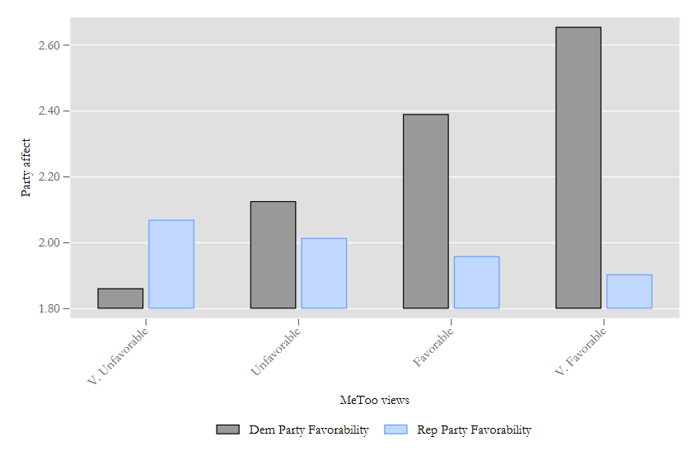

A4.3: C&S view of MeToo
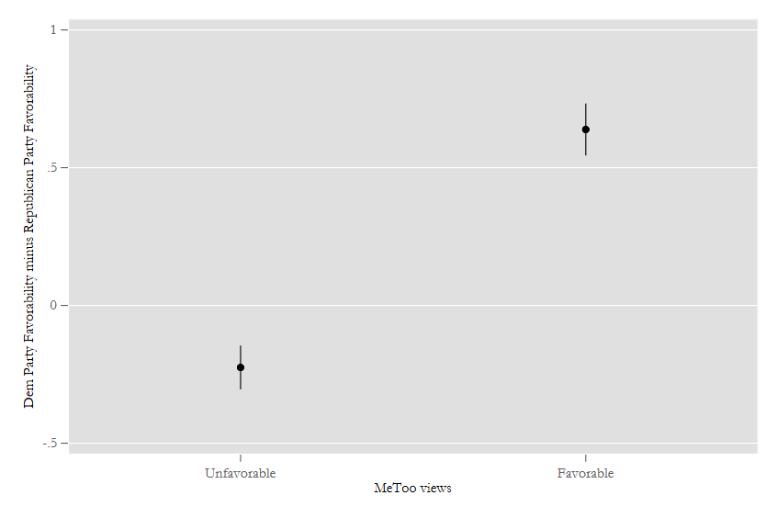
Like Carmine and Stimpson, we create a ‘net affect’ measure, which looks at those with strong positive and negative views of the issue (i.e., splitting the subject population into those who view the issue as important and those who do not) and examining the gaps in views of each party (without regard to the issue) in between these two groups

Appendix A5: Candidate MeToo Stance and vote intention (Figure 5)

Data from Kaiser Family Foundation Poll: June 2018 Kaiser Health Tracking Poll
Survey organization: Social Science Research Solutions
June 11-20, 2018
Sample: 1492 national adult telephone
Downloaded from the Roper Center for Public Opinion Research

Table A5.1: Vote for MeToo Candidate by party identification

Candidate MeToo and vote
 | Vote based on candidate MeToo stance
Party ID=2 | -0.467*
 | (0.218)
Party ID=3 | -1.981***
 | (0.301)
Party ID=4 | -2.155***
 | (0.245)
Party ID=5 | -2.416***
 | (0.197)
Gender=1 | 0.365*
 | (0.150)
Married | -0.0453
 | (0.161)
Employed | -0.280^
 | (0.158)
Education | 0.149
 | (0.0923)
Race - White | 0.190
 | (0.190)
Income | -0.0149
 | (0.0367)
Constant | 0.635^
 | (0.345)
Observations | 1000
Standard errors in parentheses. Dependent variable: Vote based on candidate MeToo stance.
^ p<.10, * p<.05, ** p<.01, *** p<.001

Figure A5.1: Vote for MeToo Candidate by party identification, 3 point measure

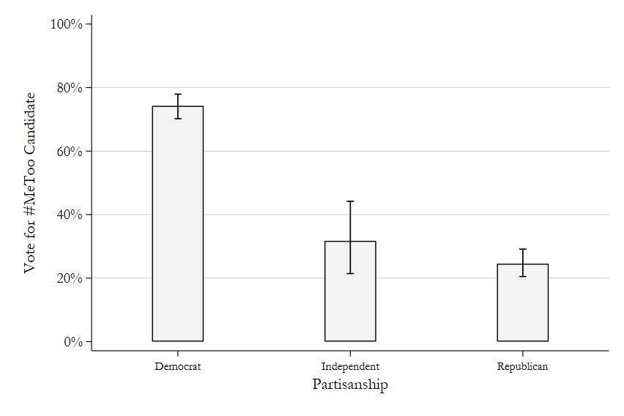

Appendix A6: Party Switching; Data for Progress survey data (Figure 6)

Table A6.1 Favorability of MeToo & Party Switching by Party
 | People who have switched to the Democratic Party | People who have switched to the Republican Party
Favorability of #MeToo | 0.205* | -0.422***
 | (0.103) | (0.0874)
Gender=1 | -0.361* | 0.0553
 | (0.140) | (0.131)
pid7 | 0.177*** | 0.0669
 | (0.0484) | (0.0458)
race | -0.146* | 0.0513
 | (0.0703) | (0.0510)
Education | 0.125 | -0.200**
 | (0.0808) | (0.0754)
Age | 0.0324 | 0.216**
 | (0.0685) | (0.0787)
Child under 18 | -0.157 | -0.222
 | (0.194) | (0.189)
Married | 0.0884 | -0.0860
 | (0.160) | (0.151)
Employed part or full time | 0.0895 | 0.0248
 | (0.155) | (0.141)
Income | 0.0378 | 0.0324
 | (0.0248) | (0.0227)
Direction of country | -1.539*** | 0.815***
 | (0.186) | (0.106)
Racial resentment | -0.265** | 0.184*
 | (0.0984) | (0.0907)
Constant | -0.703 | -3.778***
 | (0.707) | (0.648)
Observations | 2558 | 2558
Pseudo R² | 0.1590 | 0.2470
Standard errors in parentheses
^ p<.10, * p<.05, ** p<.01, *** p<.001

