Throwing Away the Key:
The Unintended Consequences of “Tough-on-Crime” Laws

Appendix

Frank R. Baumgartner
Tamira Daniely
Kalley Huang
Sydney Johnson
Alexander Love
Lyle May
Patrice McGloin
Allison Swagert
Niharika Vattikonda
Kamryn Washington

Perspectives on Politics
Forthcoming, 2021

This document contains supplemental material associated with our article.
Table A-1. The Rapid Diffusion of LWOP and Three-strikes Laws
Year | States Adopting LWOP | Cumulative Number of States with LWOP | States Adopting 3-Strikes Law | Cumulative Number of States with 3-Strikes
Before 1970 | ME MS PA MI MA WV NV | 7 | NY TX | 2
1970s | NH AR CA HI IL SD RI | 14 | DE | 3
1980s | AL DC WY MO OR CT MD VT OK | 23 |  | 3
1992 | MN UT | 25
1993 | AZ GA WA | 28 | WA | 4
1994 | FL IN LA NC VA WI | 34 | MD GA IN LA NC VA WI TN NM CO KS | 15
1995 | MT NJ NY OH SC TN | 40 | PA NV AR SD VT UT FL MT NJ SC ND | 26
1997 | IA NM ND | 43
1998 | KY | 44
2002 | CO NE | 46
2003 | DE | 47
2004 | ID KS | 49
2005 | TX | 50 | AZ | 27
2012 |  |  | MA | 28
Non-  Adopters | AK |  | ME MS MI WV NH HI IL RI AL DC WY MO OR OK MN OH IA KY NE ID AK
Source: 3 strikes: https://www.legalmatch.com/law-library/article/three-strikes-laws-in-different-states.html. LWOP: https://deathpenaltyinfo.org/stories/year-that-states-adopted-life-without-parole-lwop-sentencing

Table A-2. Keywords used for Nexis-Uni Search of Media Coverage.
Frames | Search String | Articles  (Pct of Total)
Overall | “life without parole” AND (“policy” OR “legislation” OR “penal code” OR “provision”) AND NOT ("convicted of" OR "charged with" OR "sentenced to” OR "arrested" OR “commuted”) | 1,772  (100.00)
Human Rights | AND ((humane OR Draconian OR moral OR excessive OR violation OR revoke OR retribution OR ethic* OR reentry OR detention OR second chance w/50 life without parole)) | 156  (8.80)
Costs | AND ((cost analysis OR high* cost OR added cost OR expensive OR costly OR expense OR fiscal benefits OR unsustainable w/50 life without parole)) | 113  (6.38)
Overcrowding | AND (“overcrowding” OR (overcrowded w/5 prison) OR (overcrowded w/5 jail) OR “overcrowded conditions” OR “crowded prisons” OR “Building prisons” OR “prison-building” OR “prison building” OR "new cells" OR “prison beds” OR “more prisons”) | 88  (4.97)
Aging | New String: (“older prisoner” OR “old-age homes” OR “old folks home” OR "elderly inmates" OR “aging prisoners” OR “nursing homes" OR "older prisoners" OR “aging inmates” OR “aging facility” OR “ aging offenders” OR “older inmates” OR "aging criminals" OR “geriatric ward” OR “geriatric wards”) | 47  (2.65)
Irredeemability | (“Killer” OR “rapist” OR “horrendous” OR “severity” OR “recidivists” OR “molesters” OR “repeat offenders” OR “heinous” OR “No second chance” OR “savage” OR “predators” OR “brutal” OR “violent felons” OR “pervert” OR “bad guys” OR “rotten” OR “murderers" OR "vicious” OR “hoodlums” OR “violent offender” OR "violent criminal" OR "violent criminals" OR " career criminals” OR "worst offenders" OR "cop killer" OR "dangerous offenders" OR "rehabilitation doesn’t work” ) | 996  (56.21)
Tough on Crime | (“tough on crime” OR “get-tough” OR “streets” OR “war on crime” OR “throw away the key” OR “Throw away the key” OR “Law and order” OR (should w/3 punish) OR "soft on crime" OR “truth in sentencing”) | 372  (20.99)
Note: Our Nexis-Uni search included all articles from New York, Georgia, Pennsylvania, California, Illinois, Oklahoma, Maryland, and Missouri, because these states had substantial life without parole populations and the highest number of relevant articles. The keywords listed in Table A-2 are the result of an iterated process in which we reviewed the stories that were retrieved by various search terms and validated that they were relevant to the topic of life without parole and that they related to public policy concerns rather than to individual criminal trials or cases. We continued to refine each set of key-words until a random selection of 20 cases in each decade generated fewer than 10 percent false hits. For each frame, we searched for the “overall” frame AND the words associated with the specific frame, as indicated in the table. The same article could therefore be counted more than once, if it contained more than one frame.

Every frame showed a spike in 1994 except for the human rights and cost frames, which emerged in later years. Tough frames were predominant throughout the entire period studied.

Table A-3. Stimulated Prison Populations with Parole after 20 Years, or No Parole.
 | Parole at 20 Years |  | No Parole
Age Groups | N | Percent | N | Percent
< 18 | 14 | 0.05 | 13 | 0.03
20 - 29 | 4,484 | 16.37 | 4,565 | 9.33
30 - 39 | 9,793 | 35.75 | 9,749 | 19.93
40 - 49 | 8,254 | 30.13 | 9,559 | 19.54
50 - 59 | 3,494 | 12.76 | 8,942 | 18.28
60 - 69 | 1,045 | 3.82 | 7,818 | 15.98
70 - 79 | 265 | 0.97 | 5,559 | 11.37
80 - 89 | 40 | 0.15 | 2,319 | 4.74
90 + | 3 | 0.01 | 388 | 0.79
Total Population | 27,392 |  | 48,912
Median Age | 39.4 |  | 50.6

Figure A-1. Changes in Simulated Prison Demographics with and without Parole.
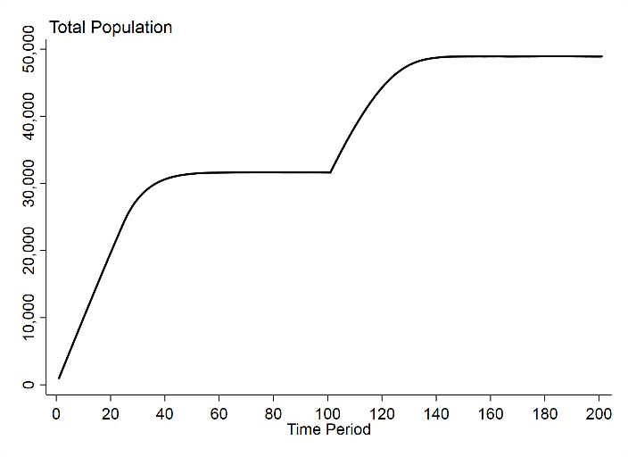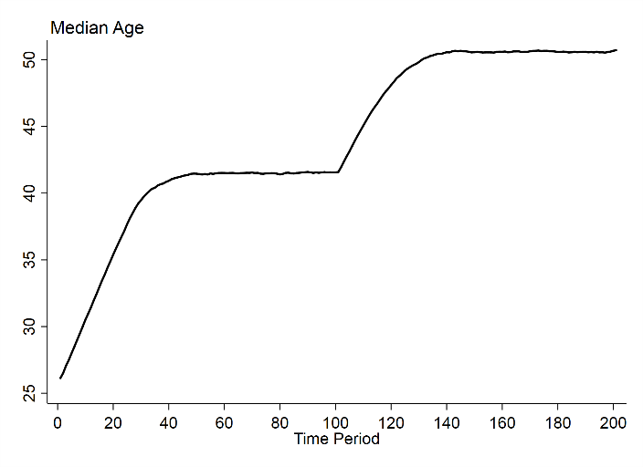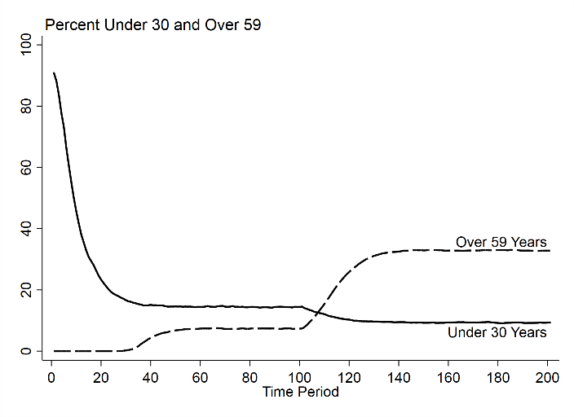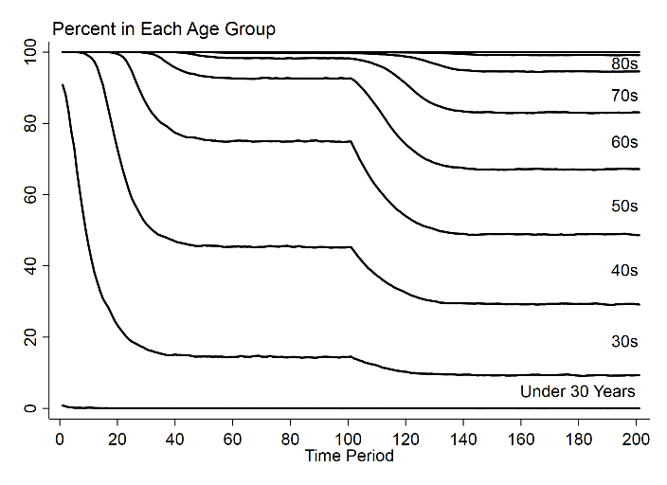
Note: Figure A-1 shows the results of a simulation as described in the text. For the first 100 time periods, it operates with individuals becoming eligible for parole after 25 years, and 10 percent receiving parole annually. Parole is then eliminated in time period 101. The system takes about 40 time periods to reach equilibrium, and each part of the figure shows a different outcome: larger total population, higher median age, more over the age of 59 than under 30, and a systematic aging of the population.

Note: See a link to our interactive simulation tool allowing a user to choose any parameters of interest and see the results in a simulated prison population. A link is available at Frank Baumgartner’s UNC web page associated with this article, available here: http://fbaum.unc.edu/articles.htm.

Construction of the North Carolina Prison Population Dataset

We generate annual files based on the prison population on December 31 of each year from 1975 through 2019, and for the last date available in 2020. The file consists of a total of 458,976 individuals, of whom 31,749 were active as of August 7, 2020, when we last retrieved the data.

The DPS Offender Public Information website, https://webapps.doc.state.nc.us/opi/downloads, provides a wealth of information about North Carolina prisoners. We use the “Inmate Profile (INMT4AA1)” set of files. This large database contains information on all individuals having served in North Carolina prisons for many decades, including those who have since been released. By filtering on the variable showing whether the person is currently “active” in the system, we can limit our analysis to those currently incarcerated. By using the “date received” and the “date released” variables, we can generate statistics for any given day in history.

Our numbers generally correspond with, but are not identical to, those of the NC DPS through the “Offender Search” query system (https://webapps.doc.state.nc.us/opi/offendersearch.do?method=view), allowing such things as searches for all individuals in the prison system who are of a certain age range. We are not aware of the reason for these disparities.

