Appendix

Table A1: Effect of political conditions on difference between internal and public data

 | Dependent variable:
 | Per Capita Difference
 | (1) | (2)
Share of opposition councilors | -3,424.930**
 | (1,374.553)
CCM majority |  | 1,868.956**
 |  | (918.290)
Observations | 173 | 179
R² | 0.258 | 0.232
Adjusted R² | 0.236 | 0.209
Residual Std. Error | 4,206.238) | 4,242.385
F Statistic | 11.620*** | 10.433***
 | *p<0.1; **p<0.05; ***p<0.01
Note: Models include controls for population, administrative status.

Table A2: Effect of political conditions on difference between internal and public data

 | Dependent variable:
 | Log(Per Capita Difference)
 | (1) | (2)
Share of opposition councilors | -1.158
 | (0.735)
CCM majority |  | 0.885*
 |  | (0.478)
Observations | 173 | 179
R² | 0.044 | 0.048
Adjusted R² | 0.015 | 0.020
Residual Std. Error | 2.250 | 2.210
F Statistic | 1.526 | 1.736
 | *p<0.1; **p<0.05; ***p<0.0
Note: Models include controls for population, administrative status.
Coefficient in model 1 has a p-value of 0.11

Table A3: Effect of political conditions on negative underestimates
 | Dependent variable:
 | Significant per capita underestimates
 | (1) | (2) | (3) | (4)
Share of opposition councilors | 1.632** |  | 1.893***
 | (0.640) |  | (0.672)
CCM majority |  | -0.793** |  | -1.030**
 |  | (0.401) |  | (0.432)
Controls | N | N | Y | Y
Observations | 173 | 179 | 173 | 179
Log Likelihood | -114.393 | -119.728 | -107.939 | -112.670
Akaike Inf. Crit. | 232.786 | 243.456 | 221.878 | 231.339
 | *p<0.1; **p<0.05; ***p<0.0
Note: Models include controls for population as indicated. Models 1-3 are also robust to controlling for administrative type. Significant underestimates are those greater than a standard deviation of the per capita differences. I do not estimate the effect of these variables on underestimates of total tax because all underestimates greater than a standard deviation are LGAs under opposition control.

Table A4: Effect of administrative type on revenue raising
 | Dependent variable:
 | Internal Data |  | Public Data
 | log(Local Tax Revenue)
 | (1) | (2) | (3) | (4)
Rural council | -1.445*** | -1.173*** | -1.816*** | -1.538**
 | (0.277) | (0.285) | (0.567) | (0.597)
Municipal council | -0.792*** | -0.617** | -1.179* | -1.000
 | (0.303) | (0.301) | (0.622) | (0.632)
Town council | -1.156*** | -0.904*** | -1.570** | -1.313**
 | (0.302) | (0.306) | (0.619) | (0.642)
Region fixed effects | Y | Y | Y | Y
LGA majority controls | N | Y | N | Y
Observations | 179 | 179 | 179 | 179
R² | 0.656 | 0.675 | 0.402 | 0.410
Adjusted R² | 0.588 | 0.609 | 0.285 | 0.291
Residual Std. Error | 0.440 | 0.429 | 0.902 | 0.899
F Statistic | 9.777*** | 10.241*** | 3.452*** | 3.431***
 | *p<0.1; **p<0.05; ***p<0.01
Note: Models include controls for population, region and CCM control of the LGAas indicated

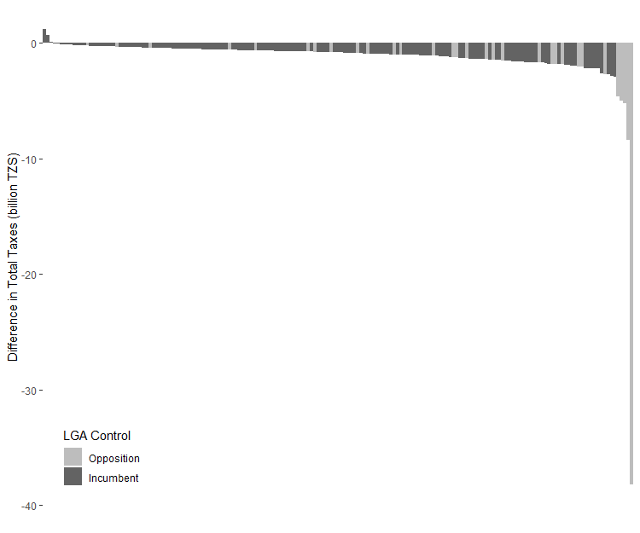
Figure A1: Difference between total revenue reported in internal and public data by LGA including Kinondoni

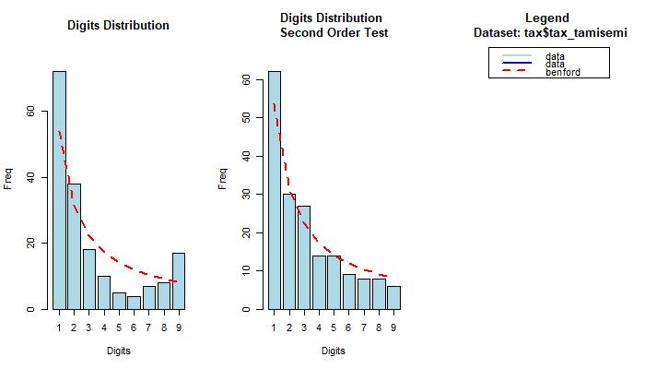(a) Benford’s Law analysis of internal data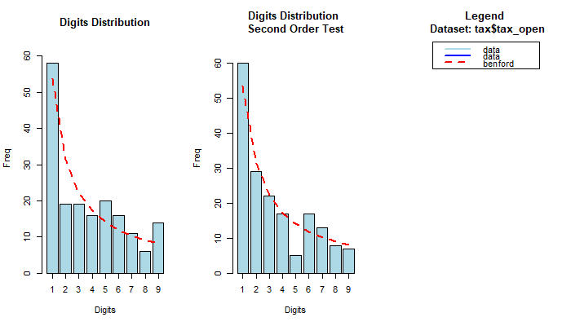
(b) Benford’s Law analysis of public data
Figure A2: Digit analysis of first digits of tax data. Benford’s law states that the distribution of first digits should conform to the red line show
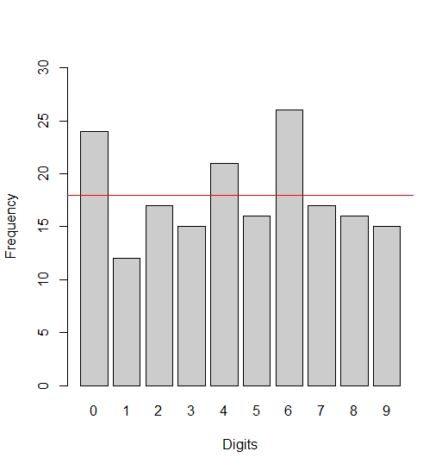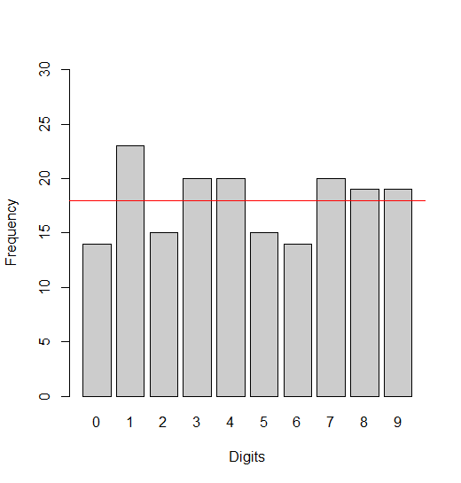
- Internal data (b) Public data

Figure A3: Digit analysis of last digits of tax data. If the data reported is the true data, we would expect broadly consistent frequencies across all digits.

Figure A4: Selection of newspaper headlines reporting on local tax performance

