**Appendices for online publication only**

**Appendix 1: Comparison of Survey Sample with Demographic Targets in Current Population Survey (2017-2018 data) and CCES (2016)**

|  |  |  |  |
| --- | --- | --- | --- |
| **Characteristic** | **Survey %** | **Weighted Survey %** | **CPS %** |
| Female | 58% | 52% | 52% |
| Hispanic | 12% | 14% | 14% |
| 18-29 | 19% | 21% | 21% |
| 30-41 | 27% | 20% | 20% |
| 42-53 | 22% | 20% | 20% |
| 54-64 | 18% | 19% | 19% |
| 65+ | 13% | 21% | 21% |
| White | 82% | 82% | 82% |
| Black | 11% | 10% | 10% |
| Am. Indian | 3% | 3% | 3% |
| Asian | 4% | 3% | 3% |
| HS or Less | 37% | 40% | 40% |
| Some College | 31% | 29% | 29% |
| College | 20% | 20% | 20% |
| More than BA | 11% | 10% | 10% |
| AZ | 21% | 21% | 21% |
| CO | 17% | 18% | 17% |
| KY | 13% | 13% | 13% |
| NC | 31% | 30% | 31% |
| OK | 12% | 12% | 12% |
| WV | 6% | 6% | 6% |

|  |  |  |  |
| --- | --- | --- | --- |
| **Characteristic** | **Survey %** | **Weighted Survey %** | **2016 CCES %** |
| Strong Republican | 18% | 19% | 19% |
| Not strong Republican | 11% | 10% | 13% |
| Independent, lean Republican | 10% | 10% | 11% |
| Independent | 25% | 24% | 18% |
| Independent, lean Democrat | 11% | 11% | 9% |
| Not strong Democrat | 9% | 10% | 11% |
| Strong Democrat | 16% | 17% | 19% |
| Republican | 39% | 39% | 43% |
| Independent | 25% | 24% | 18% |
| Democrat | 36% | 37% | 39% |
| Attended political meeting | 9% | 9% | 10% |
| Put up a political sign | 14% | 13% | 18% |
| Worked for a candidate or campaign | 4% | 4% | 5% |

**Appendix 2: Complete Survey Instrument**

The complete survey instrument is available at this link:

https://www.dropbox.com/s/65302whwirqeq86/2018\_Teacher\_Walkout\_Survey\_Blinded.pdf

**Appendix 3: Free Response Items**

*Were the Walkouts Top of Mind for Respondents When Thinking About Unions?* Before we administered items about the walkouts, we asked respondents “In just a few words, what do you remember a union doing recently?” Respondents could then provide a short answer in a text box. Although the most common bi-grams involved variants on “don’t know”, a significant proportion of respondents indicated that they were thinking about the teacher strikes in LA or in their state in the previous year as shown below. Some respondents also pointed to the government shutdown and labor actions by federal employees, including TSA security officers and air traffic controllers. We interpret these responses as indicating that for a large number of respondents in the walkout states, the strikes remained highly salient and top of mind as they were thinking about unions and the labor movement. 96% of respondents provided answers of at least seven characters.

**Data/RememBigramFreqs.pdf**

**Appendix 4: Correlations Between Main Outcome Variables**

|  |  |  |  |  |  |  |
| --- | --- | --- | --- | --- | --- | --- |
|  | **(1)** | **(2)** | **(3)** | **(4)** | **(5)** | **(6)** |
| **(1) Support 2018 Walkouts** | 1 |  |  |  |  |  |
| **(2) Participate in Walkouts** | 0.13 | 1 |  |  |  |  |
| **(3) Support for Teachers Union Rights** | 0.69 | 0.15 | 1 |  |  |  |
| **(4) Support for Future Teachers Strike** | 0.81 | 0.14 | 0.74 | 1 |  |  |
| **(5) Donate to LA Teachers** | 0.45 | 0.12 | 0.54 | 0.49 | 1 |  |
| **(6) Donate to Unions** | 0.22 | 0.17 | 0.24 | 0.24 | 0.19 | 1 |

**Appendix 5: AFL-CIO Polling Consortium Analysis**

Below we summarize the difference in means in union thermometer ratings with and without individual survey respondent demographic controls and state and survey wave fixed effects in the AFL-CIO Polling Consortium data. Individual controls include gender, age and age squared, binary indicators for white, black and Hispanic, binary indicator for a union household, binary indicator for children, binary indicators for liberal and conservative ideological orientations, binary indicators for Democratic and Republican affiliation, binary indicators for some college education or college or more education, and household income (in seven bins). The smaller N in Model 3 reflects observations with missing values on demographic characteristics.

|  |  |  |  |
| --- | --- | --- | --- |
|  | **Model 1** | **Model 2** | **Model 3** |
| Indicator for strike/walkout in state | 3.85\*  (4.17) | 9.22  (1.55) | 10.33\*  (2.15) |
| Individual controls | N | N | Y |
| Survey wave fixed effects | N | Y | Y |
| State fixed effects | N | Y | Y |
| N | 5,996 | 5, 996 | 5,375 |

*Notes*: OLS regressions. *t* statistics in parentheses. \* *p* < 0.05. Robust standard errors and survey weights applied.

When we subset our analysis to parents and non-parents, we see that the strike/walkout difference is especially large for parents, which is suggestive of a “strike effect”. Model 4 includes only parents, while Model 5 includes only non-parents. Parents are those with children 18 or younger living with them (28% of the strike state sample).

|  |  |  |
| --- | --- | --- |
|  | **Model 4**  **Parents** | **Model 5**  **Non-Parents** |
| Indicator for strike/walkout in state | 17.11  (1.80) | 4.78  (1.00) |
| Individual controls | Y | Y |
| Survey wave fixed effects | Y | Y |
| State fixed effects | Y | Y |
| N | 1,479 | 3,896 |

*Notes*: OLS regressions. *t* statistics in parentheses. \* *p* < 0.05. Robust standard errors and survey weights applied.

**Appendix 6: Control Variable Specification**

* Partisan identification (on a three-point scale)
  + *Generally speaking, do you usually think of yourself as a Republican, Democrat, Independent, or what?*
* Political ideology (on a seven-point scale)
  + *Below is a seven-point scale on which the political views that people might hold are arranged from very liberal to very conservative. Where would you place yourself on this scale?*
* Index of economic liberalism (average on a one through five scale)
  + Average of following three items:
    - *Would you support or oppose raising the national minimum wage to $15 an hour?* (1-5 response)
    - *How strongly do you agree or disagree with the following statement: The government should reduce income differences in the United States?* (1-5 response)
    - *How strongly do you agree or disagree with the following statement: Differences in income in America are too large?* (1-5 response)
* Children
  + Binary indicator for having children
* Gender
  + Binary indicator for female (as opposed to male or other)
* Age
  + In years
* Race and ethnicity
  + Binary indicators for white and Hispanic
* Logged family income
  + Item provided 12 options, ranging from $10,000 or less to $200,000 or more
* Education
  + Up to some high school
  + High school or equivalent (GED)
  + Some college
  + Associates degree
  + College
  + Graduate or professional school
* Current union member
  + Binary indicator for member
* Reporting friend or family member as union member
  + Binary indicator
  + *Do you have a friend or family member who has ever been a member of a union or a teachers association?*
* Religious attendance (six-point scale)
  + *Aside from weddings and funerals, how often do you attend religious services?*

**Appendix 7: Balance on Demographics Between**

**Parents with and without Just-School-Aged Children**

**Replication%20Materials/placebo_window_combined.pdf**

*Notes*: OLS regressions. Each marker indicates a coefficient on having a just-school-aged child and an outcome variable, using either the 4-6 and 16-18 child age window or the 2-8 and 14-20 child age window. The outcome variables are standardized to have a mean of zero and a standard deviation of one to ease comparisons across models. 95% confidence intervals shown and robust standard errors applied. State fixed effects included. The figure shows that there are few significant differences between parents with and without a just-school-aged-child in either window.

**Appendix 8: First Stage Results of Just-School-Aged Children**

**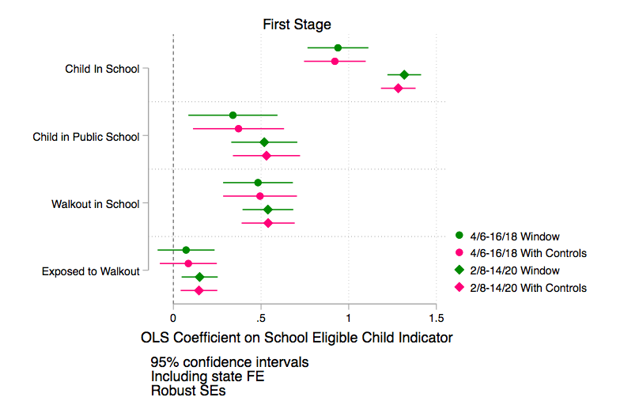**

*Notes:* OLS regressions. Each marker indicates a coefficient on having a just-school-aged child and an outcome variable, using either the 4-6 and 16-18 child age window or the 2-8 and 14-20 child age window and with or without demographic controls. The outcome variables are standardized to have a mean of zero and a standard deviation of one to ease comparisons across models. 95% confidence intervals shown and robust standard errors applied. State fixed effects included. The figure shows that parents of just-school-aged children are very likely to have children in school, in public school, and to have reported walkouts in their local schools.

**Appendix 9: Additional Reduced Form Analysis**

**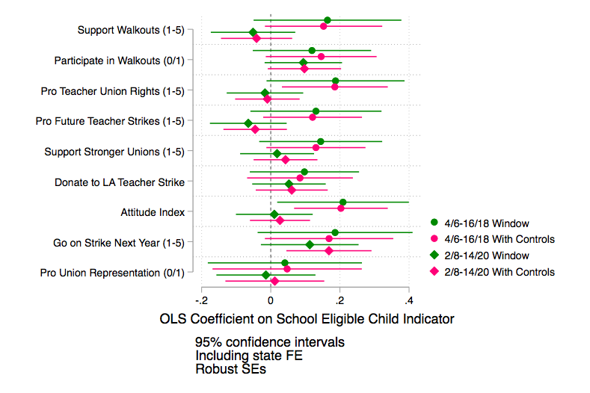**

*Notes*: OLS regression results. Each marker indicates a coefficient on having a just-school-aged child experience and an outcome variable, with or without demographic controls for child age windows of varying size. All models include state fixed effects. The outcome variables are standardized to have a mean of zero and a standard deviation of one to ease comparisons across models. 95% confidence intervals shown and robust standard errors applied. “Go on strike next year and “pro union representation” models restricted to employed respondents only; “pro union representation” further restricted to non-union members.

**Appendix 10: Additional Instrumental Variables Analysis**

**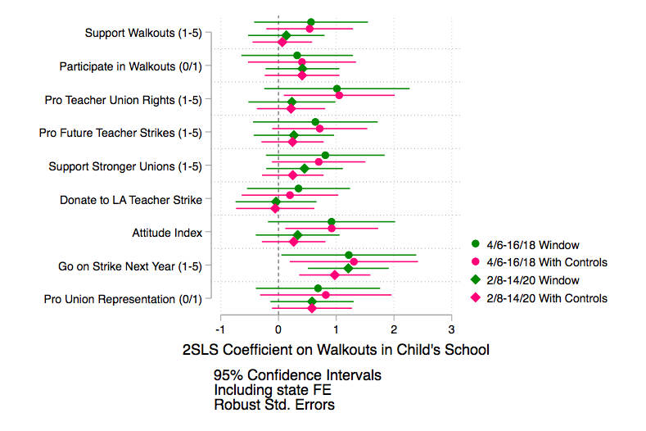**

*Notes*: 2SLS regression results. Each marker indicates a coefficient on firsthand school walkout experience (as instrumented by having a just-school-aged child) and an outcome variable, with or without demographic controls for child age windows of varying size. All models include state fixed effects. The outcome variables are standardized to have a mean of zero and a standard deviation of one to ease comparisons across models. 95% confidence intervals shown and robust standard errors applied. “Go on strike next year and “pro union representation” models restricted to employed respondents only; “pro union representation” further restricted to non-union members.

**Appendix 11: Free Response Analysis – “What do you remember a union doing recently?”**

|  |  |  |  |  |  |  |  |  |  |  |  |
| --- | --- | --- | --- | --- | --- | --- | --- | --- | --- | --- | --- |
|  | | *Reduced Form Estimates - 4-6, 16-18 child window* | | | | | | | | | |
|  | Text: Don't Know | | Text: Don't Know | Text: Strike or Walkout | Text: Strike or Walkout | Text: Schools or Teachers | Text: Schools or Teachers | Text: Unions | Text: Unions | Text: Public Goods | Text: Public Goods |
| Just School Aged Child | -0.0124 | | -0.0272 | 0.0155 | 0.0157 | -0.00969 | -0.00268 | 0.0308 | 0.0470 | 0.0355\* | 0.0435\* |
| (-0.31) | | (-0.65) | (0.55) | (0.55) | (-0.39) | (-0.11) | (1.17) | (1.71) | (2.16) | (2.46) |
| State FE | Y | | Y | Y | Y | Y | Y | Y | Y | Y | Y |
| Controls | N | | Y | N | Y | N | Y | N | Y | N | Y |
| N | 1022 | | 1006 | 1022 | 1006 | 1022 | 1006 | 1022 | 1006 | 1022 | 1006 |

*Notes*: OLS regressions. *t* statistics in parentheses; \* *p*<0.05.

**Appendix 12: Perceptions of School Quality**

|  |  |  |  |  |
| --- | --- | --- | --- | --- |
|  | *Reduced Form Estimates - 4-6, 16-18 child window* | | | |
|  | (1) | (2) | (3) | (4) |
|  | School Grade (1-5) | School Grade (1-5) | Has Opinion on School (0/1) | Has Opinion on School (0/1) |
| Just School Aged Child | 0.0418 | 0.0471 | 0.00892 | 0.0155 |
|  | (0.44) | (0.50) | (0.42) | (0.71) |
| State FE | Y | Y | Y | Y |
| Controls | N | Y | N | Y |
| N | 971 | 956 | 1022 | 1006 |

*Notes*: OLS regressions. *t* statistics in parentheses; \* *p*<0.05.

**Appendix 13: Hearing from Teachers/Unions Firsthand**

|  |  |  |
| --- | --- | --- |
|  | *Reduced Form Estimates - 4-6, 16-18 child window* | |
|  | (1) | (2) |
|  | Heard from Teacher/Union (0/1) | Heard from Teacher/Union (0/1) |
| Just School Aged Child | -0.00138 | -0.0120 |
|  | (-0.03) | (-0.24) |
| State FE | Y | Y |
| Controls | N | Y |
| N | 852 | 843 |

*Notes*: OLS regressions. *t* statistics in parentheses; \* *p*<0.05.