Online Appendix for
“The White Working Class and the 2016 Election”

I. Additional Analyses

Table A1. Measuring Working Class Using Occupation
Measure | WWC as proportion of Trump voters | Proportion of WWC who voted for Trump | WWC proportion of switchers to Trump | WWC proportion of switchers to Clinton
Income and education | 31.2 | 61.6 | 39.7 | 18.5
 | N=1,119 | N=554 | N=321 | N=229
Occupation | 39.1 | 60.2 | 42.6 | 21.1
 | N=744 | N=463 | N=233 | N=188
Notes: Values indicate proportions using different measures of white working class. The income and education measure identifies the white working class as non-Hispanic white respondents with no college degree and annual household incomes below the median. The occupation measure identifies them as holding manual and service-industry occupations. Sample sizes are reported below each proportion.
Sources: ANES 2016.

Table A2. Validated Votes
Sample |  | WWC as proportion of Trump voters | Proportion of WWC who voted for Trump | WWC proportion of switchers to Trump | WWC proportion of switchers to Clinton
ANES
 | All self-reported voters | 31.2 | 61.6 | 39.8 | 18.5
 |  | N=1,119 | N=554 | N=319 | N=229
 | Validated voters only | 30.0 | 63.1 | 39.8 | 15.1
 |  | N=939 | N=447 | N=119 | N=50
CCES
 | All self-reported voters | 31.3 | 59.5 | 38.4 | 18.9
 |  | N=16,398 | N=11,453 | N=3,588 | N=2,631
 | Validated voters only | 34.7 | 59.0 | 42.9 | 20.8
 |  | N=12,827 | N=9,565 | N=2,558 | N=1,914
Notes: For proportions of switchers in the ANES, we include only respondents who were validated voters in both 2012 and 2016. Sample sizes are provided below each estimate.
Sources: ANES 2016; CCES 2016.

Figure A1. Replicating Figures 2 and 3 with ANES Subjective Class Identification 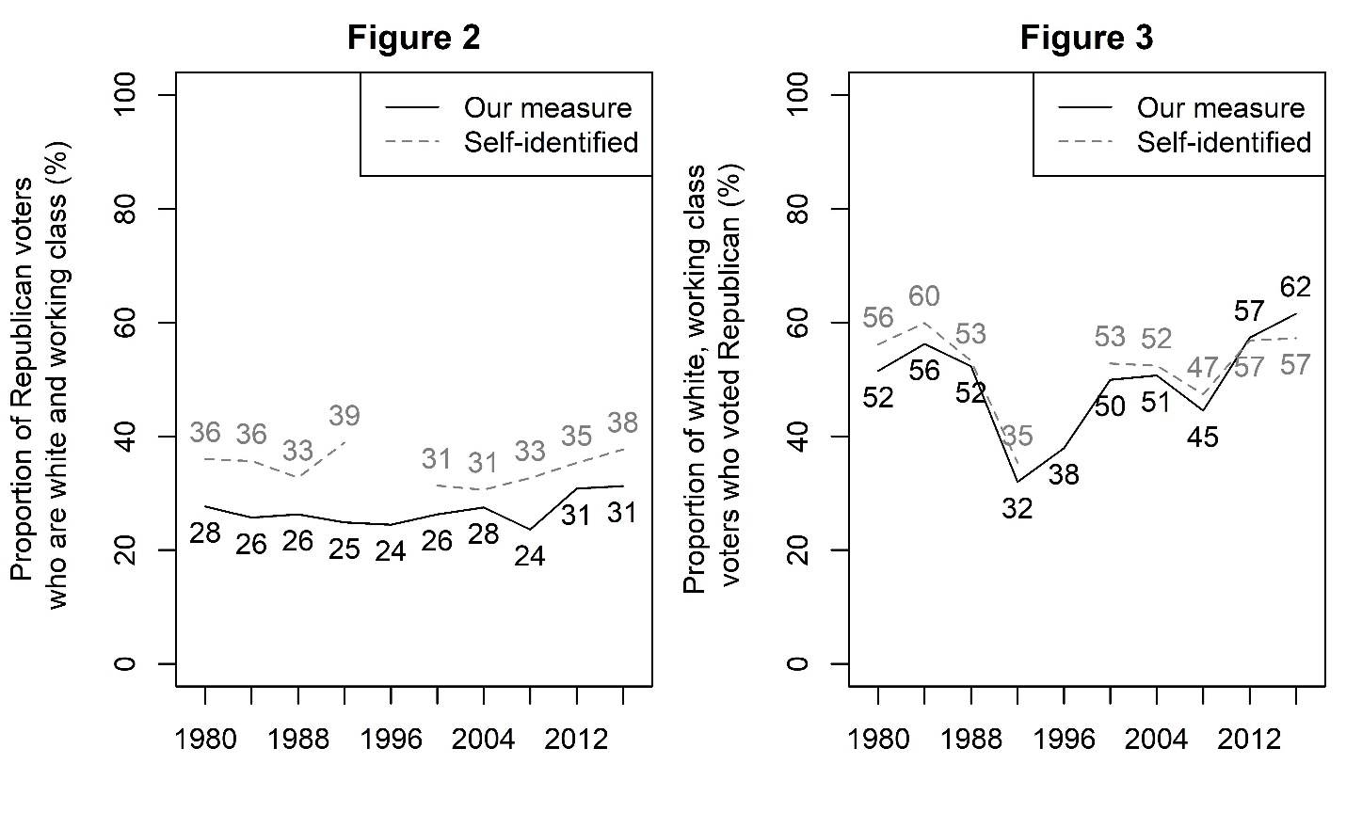
Notes: Values indicate the white working-class share of Republican presidential voters in each election (left panel) and the Republican share of white working-class voters (right panel) using our measure of social class and the ANES subjective social class measure.
Sources: ANES 1980-2016.

There is a subtle difference that is worth noting. Whereas we find no change between Trump and Romney in the percent of Republican voters who were workers (black line, left panel) and an increase in the percent of workers who were Republican voters (black line, right panel), when we switch to subjective social class, we find the reverse: a slight increase in the share of Republican voters who were workers (grey line, left panel) and no change in the share of workers who were Republican voters (grey line, right panel). What we do not see using either measure to test either claim is a sharp increase in 2016. In each combination of measure and hypothesis, Trump seemed to either continue a gradual trend favoring Republicans or seemed about the same as Mitt Romney.
Table A3. Item Nonresponse Rates
Survey | Year | Household income | Education | Race | Occupation | Subjective class
ANES | 1980 | 11.77 | 0.25 | 0.19 |  | 1.86
 | 1984 | 10.41 | 0.62 | 0.75 |  | N/A
 | 1988 | 8.73 | 1.82 | 0.63 |  | N/A
 | 1992 | 8.09 | 2.45 | 0.08 |  | N/A
 | 1996 | 8.75 | 0.18 | 0.58
 | 2000 | 12.12 | 0.39 | 1.05 |  | 2.16
 | 2004 | 9.74 | 0.08 | 0.66 |  | 2.72
 | 2008 | 5.85 | 0.6 | 0.47 |  | 2.50
 | 2012 | 6.07 | 0.14 | 0.49 |  | 0.08
 | 2016 | 4.45 | 0.35 | N/A | 0.33 | 1.18
CCES | 2008 | 6.18 | 0.00 | 0.00
 | 2012 | 11.82 | 0.00 | 0.00
 | 2016 | 10.06 | 0.00 | 0.00
VOTER | 2016 | 13.31 | 0.00 | 0.00

Notes: Values indicate item nonresponse rates (including Don’t Know, No Answer, and Refused to Answer) for each indicator. When these responses cannot be disaggregated from others (e.g., data omitted due to researcher error), we list them as N/A.
Figure A2. ANES Representativeness of Demographic Groups
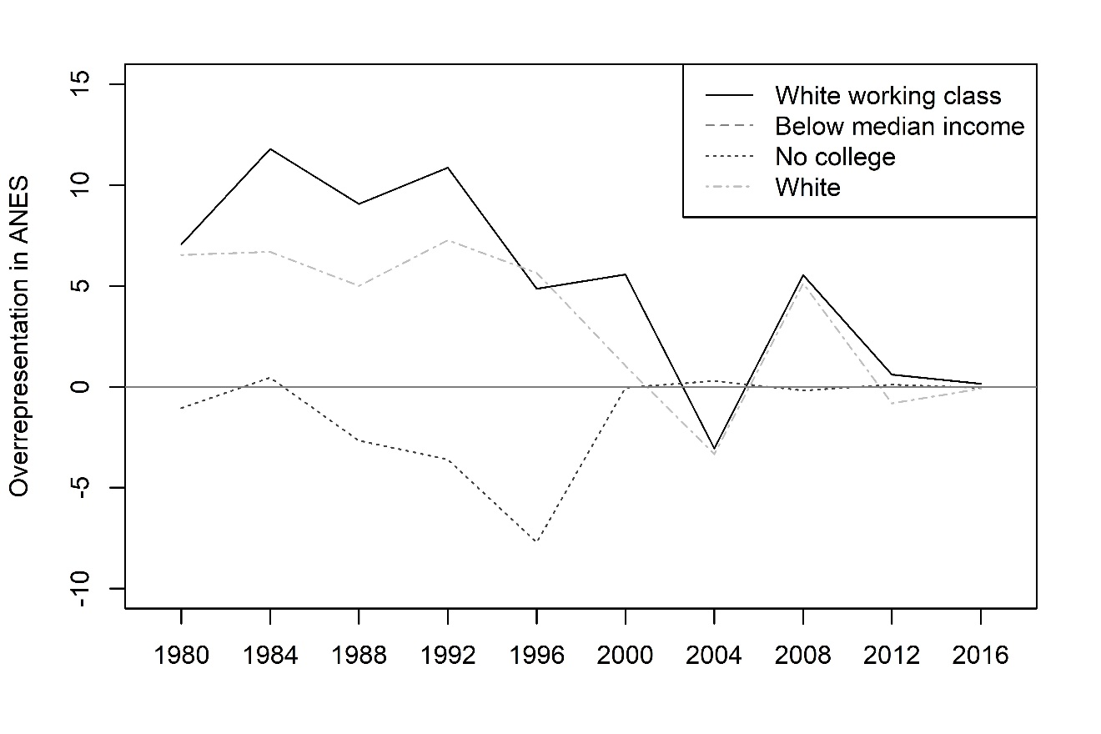
Notes: Values represent the percentage of respondents of a given demographic group in the ANES minus the percentage in the CPS, that is, the percentage-point difference by which the group is numerically overrepresented (positive values) or underrepresented (negative values) in the ANES. Here we define the white working class as non-Hispanic white respondents who report not having college degrees and who report below-median household incomes.
Sources: ANES 1980-2016, CPS 1980-2016.

Table A4. Regression Models Relating White Working Class and Vote Switching to Republicans
Variable | 2016 |  |  | 2012 |  |  | 2004
 | ANES | CCES | VOTER (panel) | ANES | CCES | VOTER | ANES (panel)
White working class | 0.078* | 0.066* | 0.011 | 0.029* | 0.035* | 0.001 | -0.009
 | (0.017) | (0.006) | (0.009) | (0.011) | (0.005) | (0.007) | (0.018)
Age | -0.000 | -0.002* | -0.000 | -0.001* | -0.001* | -0.000 | 0.000
 | (0.000) | (0.000) | (0.000) | (0.000) | (0.000) | (0.000) | (0.001)
Female | -0.005 | -0.020* | 0.013 | 0.002 | -0.003 | -0.003 | -0.012
 | (0.013) | (0.005) | (0.009) | (0.009) | (0.004) | (0.008) | (0.018)
Constant | 0.101* | 0.150* | 0.029 | 0.085* | 0.095* | 0.019 | 0.036
 | (0.023) | (0.010) | (0.017) | (0.016) | (0.008) | (0.018) | (0.038)
Observations | 3,415 | 47,395 | 6,935 | 5,351 | 47,918 | 6,935 | 837
R² | 0.013 | 0.019 | 0.002 | 0.004 | 0.008 | 0.001 | 0.002
Notes: OLS regression estimates with standard errors in parentheses. Switchers are those who reported voting for the Republican candidate in the study year and either voted for the Democratic candidate or did not vote in the prior election. The white working class are non-Hispanic white respondents with no college degree and annual household incomes below the median. * p < 0.05
Sources: ANES 2000-04, 2012, 2016; CCES 2012, 2016; VOTER.

Table A5. Partisanship of Vote Switchers in Panel Surveys
Source | Partisanship | D-R | R-D | Nonvoter-R | Nonvoter-D
VOTER 2012-16 | Democrat | 62.9 | 26.6 | -- | --
 | Independent | 7.9 | 23.3 | -- | --
 | Republican | 29.1 | 46.9 | -- | --
 | Sample size | 228 | 126
ANES 2000-04 | Democrat | 69.5 | 15.5 | 34.4 | 52.1
 | Independent | 11.3 | 26.5 | 17.8 | 10.0
 | Republican | 19.2 | 58.0 | 46.4 | 36.8
 | Sample size | 39 | 20 | 27 | 27
Notes: Values indicate the share of switchers who previously identified as Democrats, Independents, or Republicans, by survey.
Sources: ANES 2000-04; VOTER.

II. What about the Education Gap in 2016?
Our analyses differ sharply from reports that have used education alone as a measure of social class. Many popular commentaries identify working-class survey respondents as those who do not hold a college degree, and go on to point out that the share of non-college-educated people who voted Republican diverged sharply form the share of college-educated people who voted Republican in 2016 (as scholars have also noted; Sides, Tesler, and Vavreck 2018).
The problem with using educational data to make claims about the working class, however, is that many Americans without college degrees are actually quite affluent. If we thought that working-class Americans were driving Trump’s support, we would expect Americans without college degrees to be divided internally, with the least affluent supporting Trump at higher rates. As we have shown elsewhere (Carnes and Lupu 2016b; 2017), however, in 2016, Trump support was actually higher among affluent people without college degrees than among lower-income people without college degrees.
Although the “education gap” reached historic levels in 2016, this phenomenon was driven largely by more affluent Americans. Figure A3 plots the gap in support for Republican presidential candidates in 2008, 2012, and 2016 between voters with and without college degrees, dividing citizens by their household income quintile. For most income groups, the education gap widened in 2016. But the education gap was higher among the top three quintiles than the bottom two, and the education gap actually declined in the bottom quintile. That is, most of the people who contributed to the education gap in 2016 were in fact people with high incomes, not the working class imagined in popular media narratives.
Something is truly “going on with education”—college attainment is becoming more and more of a dividing line in presidential elections—but simply conflating not having a college degree with being “working class” obscures the important reality that many people without college degrees are quite well off, and those affluent people are increasingly important to the Republican electoral coalition.
Figure A3. Education Gap in Republican Presidential Support, by Income Quintile
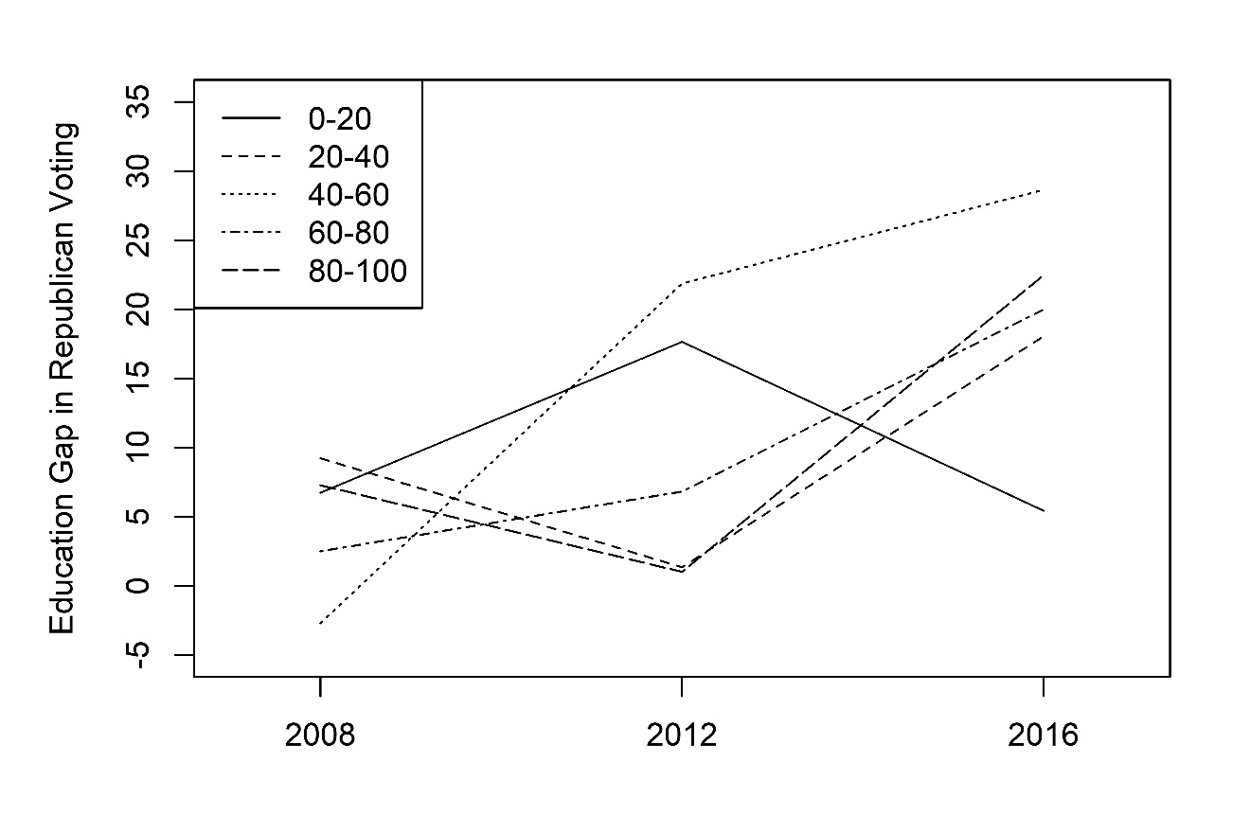
Notes: Values indicate the difference between the shares of non-college-educated and college-educated whites who voted for the Republican presidential candidate in each election, by household income quintile.
Sources: ANES 2008, 2012, 2016.

III. Weighting to Account for Overrepresentation of the White Working Class in Surveys
Even after applying the weights provided by survey houses, the share of white working-class respondents in our surveys sometimes differed dramatically from the shares in the general public as Figure 1 illustrates. As such, we developed alternative weights that essentially re-weighted each survey’s weighted sample; we did so by creating inverse proportion weights using the weighted sample, then multiplying them by existing weights.
To check that this approach did not distort our findings, we also ran relevant analyses using both the weights provided by the survey house and inverse proportion weights that re-weighted each survey’s unweighted sample. All three approaches yielded similar results.
Figure A4 below repeats the analysis in Figure 2 using all three approaches. Regardless of which approach we used, white working-class Respondents made up a minority of Trump voters, their share was not substantially larger than in 2012, and there was a steady increase in their share in preceding election cycles. Because white working-class people were over-represented in the early waves of the ANES and in all of the CCES surveys, the middle panel in Figure A4 naturally shows higher rates of white working-class Republican voters in those surveys, but even if we accepted those estimates as genuine (which we do not—the Census data we analyze suggest that white working-class people are substantially over-represented in these surveys), it would not change our substantive claims. If anything, the high shares of white-working class people among Republican respondents in the 1980s and 1990s would cast further doubt on the idea that Trump uniquely appealed to the white working class.
We do not replicate Figure 3 in a similar fashion here because it is not necessary to do so—Figure 3 focuses only on white working-class respondents, so it is not necessary to adjust for the fact that they are over- or under-represented in the surveys we analyze. Tables A6 and A7 replicate the analysis in Table 1 using only the survey house weights and using only our weight for the white working class. Tables A8 and A9 do the same, replicating the analysis in Table 2. Unsurprisingly, none of these changes in the weight structure substantially change our findings.

Figure A4. The White Working Class’s Share of the Republican Presidential Vote
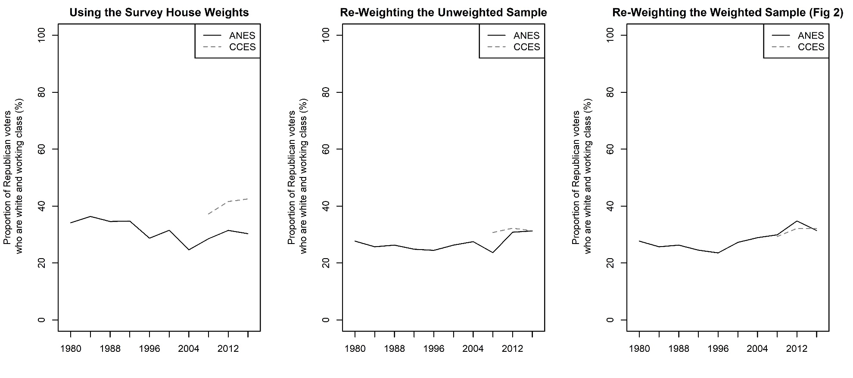
Notes: Values indicate the white working-class share of Republican presidential voters in each election. The white working class are non-Hispanic white respondents with no college degree and annual household incomes below the median.
Sources: ANES 1980-2016; CCES 2008-2016.

Table A6. Vote Switching in 2016, 2012, and 2004 – only survey house weights
Election | Source | D-R switchers as share of R voters | R-D switchers as share of D voters | Nonvoter-R switchers as share of R voters | Nonvoter-D switchers as share of  D voters
2016 | ANES | 13.6 | 3.8 | 18.0 | 18.0
 |  | (40.1) | (14.3) | (40.0) | (19.5)
 |  | N=1,175 | N=1,283 | N=1,175 | N=1,283
 | CCES | 10.6 | 4.1 | 14.4 | 14.4
 |  | (39.5) | (28.0) | (58.2) | (27.3)
 |  | N=18,755 | N=22,136 | N=18,755 | N=22,136
 | VOTER (panel) | 9.2 | 4.7 | -- | --
 |  | (41.0) | (34.1) | -- | --
 |  | N=3,467 | N=3,543
2012 | ANES | 9.9 | 4.8 | 9.7 | 12.2
 |  | (28.4) | (29.5) | (45.1) | (16.6)
 |  | N=1,686 | N=2,493 | N=1,686 | N=2,493
 | CCES | 9.0 | 3.8 | 10.4 | 13.6
 |  | (40.2) | (44.0) | (56.0) | (38.1)
 |  | N=19,132 | N=18,777 | N=18,777 | N=19,132
 | VOTER | 7.9 | 4.7 | -- | --
 |  | (35.9) | (41.5) | -- | --
 |  | N=3,369 | N=3,724
2004 | ANES (panel) | 9.9 | 6.6 | 11.0 | 9.9
 |  | (21.2) | (13.2) | (47.4) | (12.1)
 |  | N=389 | N=337 | N=389 | N=337
Notes: Values indicate the share of respondents who were switchers, by survey. Values in parentheses are the proportion of each type of switcher who were white and working-class. The white working class are non-Hispanic white respondents with no college degree and annual household incomes below the median.
Sources: ANES 2000-04, 2012, 2016; CCES 2016; VOTER.
Table A7. Vote Switching in 2016, 2012, and 2004 – only WWC weights
Election | Source | D-R switchers as share of R voters | R-D switchers as share of D voters | Nonvoter-R switchers as share of R voters | Nonvoter-D switchers as share of  D voters
2016 | ANES | 12.9 | 4.2 | 15.9 | 14.4
 |  | (35.9) | (15.7) | (41.2) | (17.3)
 |  | N=1,117 | N=1,230 | N=1,117 | N=1,230
 | CCES | 12.1 | 3.9 | 9.5 | 14.2
 |  | (32.0) | (22.1) | (46.1) | (22.5)
 |  | N=16,398 | N=20,174 | N=16,398 | N=20,174
 | VOTER (panel) | 7.0 | 3.8 | -- | --
 |  | (26.2) | (17.2) | -- | --
 |  | N=2,969 | N=3,119
2012 | ANES | 11.0 | 4.0 | 8.1 | 10.2
 |  | (33.9) | (33.6) | (51.8) | (16.3)
 |  | N=1,593 | N=2,268 | N=1,593 | N=2,268
 | CCES | 7.8 | 3.5 | 5.8 | 8.3
 |  | (31.5) | (37.9) | (47.7) | (31.4)
 |  | N=15,894 | N=17,239 | N=15,894 | N=17,239
 | VOTER | 7.8 | 4.1 | -- | --
 |  | (18.3) | (20.3) | -- | --
 |  | N=2,860 | N=3,276
2004 | ANES (panel) | 10.1 | 6.0 | 7.5 | 8.0
 |  | (26.2) | (28.3) | (47.0) | (17.1)
 |  | N=389 | N=337 | N=389 | N=337
Notes: Values indicate the share of respondents who were switchers, by survey. Values in parentheses are the proportion of each type of switcher who were white and working-class. The white working class are non-Hispanic white respondents with no college degree and annual household incomes below the median.
Sources: ANES 2000-04, 2012, 2016; CCES 2016; VOTER.
Table A8. Class and Trump Support in Swing States – only survey house weights
Variable | Trump vote | Trump vote | Trump switch | Trump switch
White working class | 0.204* | 0.197* | 0.060* | 0.062*
 | (0.011) | (0.010) | (0.007) | (0.006)
Swing state | 0.032* |  | 0.006
 | (0.011) |  | (0.006)
WWC × Swing state | -0.027 |  | 0.019
 | (0.019) |  | (0.013)
“Blue wall” state |  | 0.021 |  | 0.012
 |  | (0.015) |  | (0.009)
WWC × “Blue wall” state |  | -0.001 |  | 0.025
 |  | (0.025) |  | (0.019)
Age | 0.005* | 0.005* | -0.002* | -0.002*
 | (0.000) | (0.000) | (0.000) | (0.000)
Female | -0.078* | -0.078* | -0.019* | -0.019*
 | (0.008) | (0.008) | (0.005) | (0.005)
Constant | 0.191* | 0.195* | 0.150* | 0.150*
 | (0.015) | (0.015) | (0.010) | (0.010)
Observations | 40,212 | 40,212 | 47,395 | 47,395
R² | 0.072 | 0.072 | 0.020 | 0.020
Notes: OLS regression estimates with standard errors in parentheses. The white working class are non-Hispanic white respondents with no college degree and annual household incomes below the median. Swing states are Florida, Iowa, Michigan, Ohio, Pennsylvania, and Wisconsin. “Blue wall” states are Michigan, Pennsylvania, and Wisconsin. * p < 0.05
Source: CCES 2016.
Table A9. Class and Trump Support in Swing States – only WWC weights
Variable | Trump vote | Trump vote | Trump switch | Trump switch
White working class | 0.173* | 0.163* | 0.039* | 0.040*
 | (0.006) | (0.006) | (0.003) | (0.003)
Swing state | 0.037* |  | 0.008*
 | (0.007) |  | (0.003)
WWC × Swing state | -0.050* |  | 0.010
 | (0.012) |  | (0.006)
“Blue wall” state |  | 0.032* |  | 0.009*
 |  | (0.009) |  | (0.004)
WWC × “Blue wall” state |  | -0.028 |  | 0.012
 |  | (0.016) |  | (0.008)
Age | 0.004* | 0.004* | -0.000* | -0.000*
 | (0.000) | (0.000) | (0.000) | (0.000)
Female | -0.081* | -0.081* | 0.002 | 0.002
 | (0.005) | (0.005) | (0.002) | (0.002)
Constant | 0.171* | 0.176* | 0.061* | 0.062*
 | (0.009) | (0.008) | (0.003) | (0.003)
Observations | 40,212 | 40,212 | 58,079 | 58,079
R² | 0.055 | 0.054 | 0.007 | 0.007
Notes: OLS regression estimates with standard errors in parentheses. The white working class are non-Hispanic white respondents with no college degree and annual household incomes below the median. Swing states are Florida, Iowa, Michigan, Ohio, Pennsylvania, and Wisconsin. “Blue wall” states are Michigan, Pennsylvania, and Wisconsin. * p < 0.05
Source: CCES 2016.

