Figure A.1: Partisan Gender Gap in Preference for Democrats, 1948 – 2016

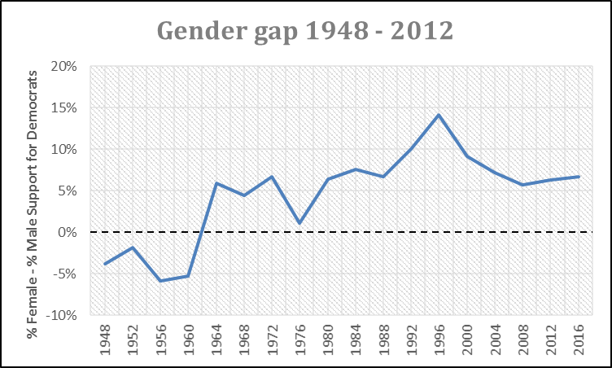
Source: American National Election Study, 1948 – 2016

