Figure A.2: Percent of Men and Women Voting Democratic, 1948 – 2016

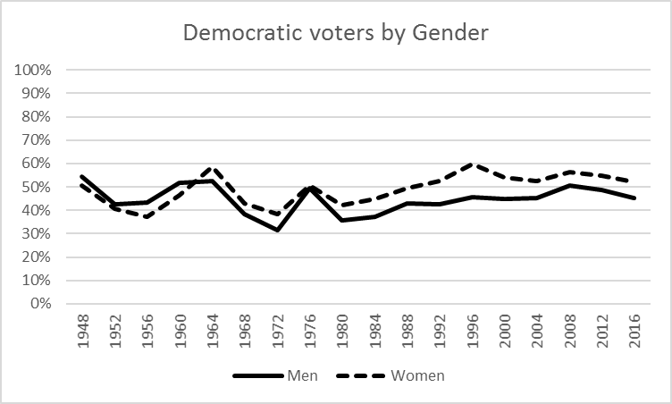
Source: American National Election Study, 1948 – 2016

