Appendix

*Question Wording and Descriptions, Spending Questions*

For the next questions, please say whether there should be more or less public expenditure in each of the following areas. Remember if you say "more" it could require a tax increase, and if you say "less" it could require a reduction in those services.

Q: Thinking about public expenditure on HEALTH, should there be much more than now, somewhat more than now, the same as now, somewhat less than now, or much less than now?

HELP: The word "health" is intended to refer to public expenditure related to health care, i.e., public health care programs, public hospitals, clinics, etc.

Q: Thinking about public expenditure on OLD-AGE PENSIONS, should there be much more than now, somewhat more than now, the same as now, somewhat less than now, or much less than now?

HELP: The phrase "old-age pensions" is intended to refer to public expenditure on old age pensions, NOT other spending on programs directed at the elderly.

Q: Thinking about public expenditure on WELFARE BENEFITS, should there be much more than now, somewhat more than now, the same as now, somewhat less than now, or much less than now?

HELP: The phrase "welfare benefits" is intended to refer to public expenditure on welfare programs or social benefit programs

*Question Wording and Descriptions, Improving Standard of Living*

Q: Over the next ten years or so, how likely or unlikely is it that you will improve your standard of living? Very likely, somewhat likely, somewhat unlikely, or very unlikely?

*Question Wording and Descriptions, Government Action Differences in Income*

Q: Please say to what extent you agree or disagree with the following statement: "The government should take measures to reduce differences in income levels."

Do you strongly agree, somewhat agree, neither agree nor disagree, somewhat disagree, or strongly disagree?

*Question Wording and Descriptions, Ideology*

Q: Where would you place yourself on this scale? 0 – 10 where 0 means the left and 10 means the right.

This question follows a set of similar questions with the prompt: In politics people sometimes talk of left and right. Where would you place [PARTY A] on a scale from 0 to 10 where 0 means the left and 10 means the right?

*Measures of Press Limits*

Our measure of *Press Limits* based on the V-Dem data is based on an equally-weighted combination of the following variables: Government censorship effort, Print/broadcast media critical of government, Print/broadcast media perspectives, Female journalists, Media self-censorship, Media bias, and Media corruption. We use the relative scale version of the variables, described in detail at <https://www.v-dem.net/media/filer_public/e0/7f/e07f672b-b91e-4e98-b9a3-78f8cd4de696/v-dem_codebook_v8.pdf>.

Appendix Figures 1 and 2 show the relationship between the Freedom House measure and the other two measures of *Press Limits*. Countries in black are OECD countries for which we do not have complete data; countries in blue are those for which we have complete data, i.e., data on welfare spending, media systems, and survey data from the CSES. Note that there are two outlying blue data points in Appendix Figure 1 (and Appendix Figure 2), between 60 and 80 in Freedom House and 40 and 60 in the RSF. These are Mexico and Turkey, the two countries in our sample with markedly less “free” media systems. We consider the impact that these (and all other countries) have on our estimations in the Robustness Checks section of the paper.

*Robustness*

The robustness checks section of the paper refers to several different sets of results, included in. Appendix Tables 1-3.

*Descriptives*

Appendix Table 4 includes descriptive data for each of the 24 countries we include in our analyses.

Appendix Figure 1. Measures of Press Freedom: Freedom House and RSF

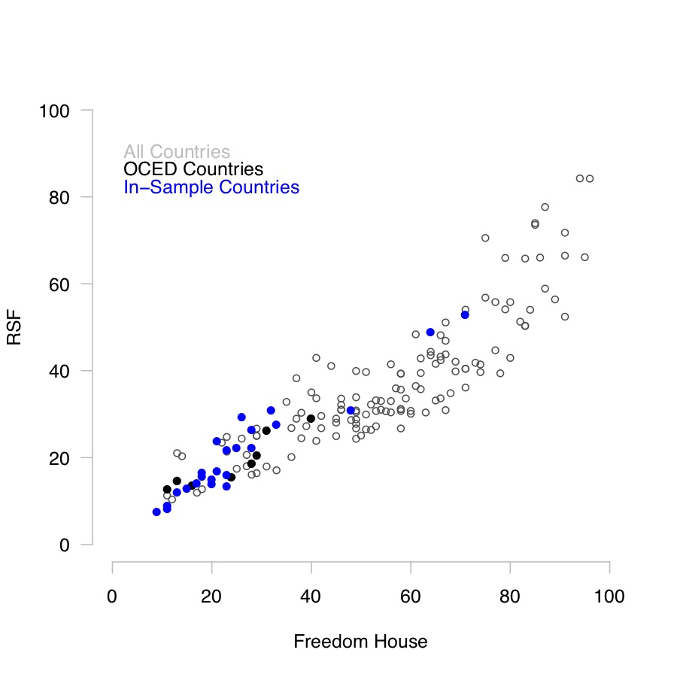

Appendix Figure 2. Measures of Press Freedom: Freedom House and V-Dem



Appendix Table 1. Modeling Relative Preferences for Spending,

using non-Domain Spending

|  |  |  |  |
| --- | --- | --- | --- |
|  | Welfare | Health | Pensions |
| Spending | 0.013 | -0.009 | -0.085*** |
|  | (0.034) | (0.021) | (0.023) |
| Female | 0.040* | 0.100*** | 0.078*** |
|  | (0.016) | (0.020) | (0.016) |
| Age | 0.001 | -0.000 | 0.004*** |
|  | (0.002) | (0.001) | (0.001) |
| Education | -0.211*** | -0.121 | -0.245*** |
|  | (0.070) | (0.093) | (0.067) |
| Std of Living | -0.073 | 0.045 | -0.044 |
|  | (0.088) | (0.080) | (0.057) |
| Mean Spending | -0.035 | 0.002 | 0.042* |
|  | (0.029) | (0.019) | (0.019) |
| Gov Reduce | 0.884*** | 0.367*** | 0.385*** |
|  | (0.123) | (0.104) | (0.058) |
| Ideology | -0.045*** | -0.028*** | -0.006 |
|  | (0.012) | (0.008) | (0.006) |
| Constant | 0.395 | 0.872*** | 1.121*** |
|  | (0.311) | (0.262) | (0.247) |
| Observations | 27300 | 28651 | 28539 |
| R2 | 0.114 | 0.032 | 0.090 |

* p < .05; ** p < .01; *** p < .001. Cells contain OLS regression coefficients with clustered standard errors (by country).

Appendix Table 2. Modeling Relative Preferences for Spending,

Using Political and Civil Liberty Measures

|  |  |  |  |  |  |  |
| --- | --- | --- | --- | --- | --- | --- |
|  | Welfare | | Health | | Pensions | |
|  | Model 1 | Model 2 | Model 1 | Model 2 | Model 1 | Model 2 |
| Spending | 2.113 | 4.069 | -0.180 | -0.322 | 0.113* | 0.201* |
|  | (1.480) | (3.201) | (0.211) | (0.394) | (0.050) | (0.080) |
| Political Freedom | -1.415*** |  | 0.067 |  | -0.355 |  |
|  | (0.487) |  | (1.004) |  | (0.465) |  |
| *interaction* | -2.633a |  | -0.034 |  | -0.137a |  |
|  | (1.503) |  | (0.239) |  | (0.067) |  |
| Civil Liberty |  | -1.536* |  | -0.516 |  | -0.305 |
|  |  | (0.724) |  | (1.676) |  | (0.544) |
| *interaction* |  | -4.803 |  | 0.123 |  | -0.228* |
|  |  | (3.232) |  | (0.446) |  | (0.103) |
| Female | 0.047*** | 0.042*** | 0.103*** | 0.102*** | 0.076*** | 0.075*** |
|  | (0.012) | (0.014) | (0.019) | (0.019) | (0.016) | (0.016) |
| Age | 0.003a | 0.003a | 0.001 | 0.001 | 0.004*** | 0.004*** |
|  | (0.001) | (0.001) | (0.001) | (0.001) | (0.001) | (0.001) |
| Education | -0.148*** | -0.132* | -0.079 | -0.082 | -0.248*** | -0.245*** |
|  | (0.047) | (0.052) | (0.083) | (0.079) | (0.056) | (0.054) |
| Std Living | -0.005 | -0.019 | 0.064 | 0.060 | -0.049 | -0.055 |
|  | (0.069) | (0.077) | (0.055) | (0.058) | (0.056) | (0.053) |
| Mean Spending | 0.412a | 0.620* | 0.139 | 0.132 | 0.006 | 0.005 |
|  | (0.221) | (0.242) | (0.082) | (0.090) | (0.048) | (0.048) |
| Gov Reduce | 0.755*** | 0.797*** | 0.300*** | 0.304*** | 0.405*** | 0.425*** |
|  | (0.103) | (0.109) | (0.072) | (0.072) | (0.055) | (0.061) |
| Ideology | -0.046*** | -0.046*** | -0.030*** | -0.030*** | -0.005 | -0.004 |
|  | (0.011) | (0.012) | (0.006) | (0.006) | (0.006) | (0.007) |
| Constant | 1.256*** | 1.375* | 1.268 | 1.812 | 0.845* | 0.817a |
|  | (0.403) | (0.619) | (0.798) | (1.463) | (0.342) | (0.416) |
| Observations | 28893 | 28893 | 30254 | 30254 | 30149 | 30149 |
| R2 | 0.152 | 0.144 | 0.059 | 0.059 | 0.083 | 0.080 |

a p < .1; * p < .05; ** p < .01; *** p < .001. Cells contain OLS regression coefficients with clustered standard errors (by country).

Appendix Table 3. Modeling Relative Preferences for Spending,

Alternative Specifications

*Excluding all Controls …*

|  |  |  |  |
| --- | --- | --- | --- |
|  | Welfare | Health | Pensions |
| Spending | -0.420 | -0.233* | 0.002 |
|  | (0.329) | (0.090) | (0.028) |
| Press Limits | 1.488*** | -2.146a | 1.040* |
|  | (0.402) | (1.181) | (0.493) |
| *interaction* | 2.050 | 0.558a | 0.032 |
|  | (1.348) | (0.304) | (0.077) |
| Constant | -0.021 | 2.068*** | 0.493* |
|  | (0.212) | (0.494) | (0.225) |
| Observations | 29136 | 30495 | 30388 |
| R2 | 0.061 | 0.032 | 0.031 |

*Including Macroeconomic Variables…*

|  |  |  |  |
| --- | --- | --- | --- |
|  | Welfare | Health | Pensions |
| Spending | -0.823* | -0.342*** | -0.048 |
|  | (0.368) | (0.111) | (0.038) |
| Press Limits | 1.024 | -1.602 | 0.078 |
|  | (0.674) | (1.120) | (0.646) |
| *interaction* | 1.234 | 0.468 | 0.101 |
|  | (1.379) | (0.304) | (0.075) |
| Female | 0.044*** | 0.107*** | 0.073*** |
|  | (0.013) | (0.021) | (0.017) |
| Age | 0.002a | 0.002 | 0.004*** |
|  | (0.001) | (0.001) | (0.001) |
| Education | -0.127* | -0.065 | -0.228*** |
|  | (0.047) | (0.066) | (0.043) |
| Std Living | 0.004 | 0.089 | -0.042 |
|  | (0.071) | (0.055) | (0.052) |
| Mean Spending | 0.538* | 0.169* | 0.016 |
|  | (0.235) | (0.078) | (0.043) |
| Gov Reduce | 0.805*** | 0.294*** | 0.411*** |
|  | (0.090) | (0.057) | (0.054) |
| Ideology | -0.041*** | -0.029*** | -0.004 |
|  | (0.010) | (0.006) | (0.006) |
| GDP per capita (PPP) | -0.000 | -0.000 | -0.000 |
|  | (0.000) | (0.000) | (0.000) |
| Unemployment Rate | 0.024 | 0.008 | 0.005 |
|  | (0.017) | (0.010) | (0.017) |
| Constant | -0.455 | 1.646*** | 0.689 |
|  | (0.597) | (0.480) | (0.476) |
| Observations | 28893 | 30254 | 30149 |
| R2 | 0.154 | 0.072 | 0.090 |

* p < .05; ** p < .01; *** p < .001. Cells contain OLS regression coefficients with clustered standard errors (by country). GDP per capita (PPP) and unemployment are from the World Bank, as included in the CSES dataset.

Appendix Table 4. Modeling Relative Preferences for Spending

Ordered Logit Estimations

|  |  |  |  |
| --- | --- | --- | --- |
|  | Welfare | Health | Pensions |
| Spending | -1.822* | -0.812*** | -0.098 |
|  | (0.786) | (0.202) | (0.095) |
| Press Limits | 2.150* | -4.575* | 1.112 |
|  | (0.972) | (1.948) | (1.004) |
| *interaction* | 4.579a | 1.397*** | 0.295* |
|  | (2.764) | (0.521) | (0.149) |
| Female | 0.081*** | 0.231*** | 0.165*** |
|  | (0.027) | (0.046) | (0.035) |
| Age | 0.003 | 0.003 | 0.008*** |
|  | (0.002) | (0.002) | (0.003) |
| Education | -0.297*** | -0.183 | -0.592*** |
|  | (0.101) | (0.144) | (0.111) |
| Std Living | -0.036 | 0.196 | -0.107 |
|  | (0.140) | (0.121) | (0.133) |
| Mean Spending | 0.939* | 0.347* | 0.006 |
|  | (0.419) | (0.173) | (0.110) |
| Gov Reduce | 1.519*** | 0.601*** | 0.981*** |
|  | (0.190) | (0.119) | (0.132) |
| Ideology | -0.080*** | -0.064*** | -0.008 |
|  | (0.022) | (0.014) | (0.016) |
| Cut 1 | -1.966*** | -6.456*** | -3.992*** |
|  | (0.459) | (0.814) | (0.574) |
| Cut 2 | -0.515 | -4.941*** | -2.396*** |
|  | (0.435) | (0.805) | (0.540) |
| Cut 3 | 1.449*** | -2.984*** | 0.224 |
|  | (0.414) | (0.791) | (0.546) |
| Cut 4 | 3.117*** | -1.070 | 2.138*** |
|  | (0.409) | (0.771) | (0.523) |
| Observations | 28893 | 30254 | 30149 |

* p < .05; ** p < .01; *** p < .001. Cells contain ordered logit regression coefficients with clustered standard errors (by country).

Appendix Table 5. Descriptives

|  |  |  |  |  |  |  |  |  |
| --- | --- | --- | --- | --- | --- | --- | --- | --- |
| Country | Sample Size | Year | Means – Demographics and Attitudes | | | | | |
|  |  |  | Female | Education | Income | Std. Living | Gov. Reduce | Ideology |
| AUS | 3953 | 2013 | 0.52 | 0.87 | 1.88 | 0.54 | 0.59 | 5.15 |
| AUT | 1000 | 2013 | 0.49 | 0.34 | 2.03 | 0.42 | 0.69 | 4.68 |
| CAN | 3458 | 2010 | 0.56 | 0.52 | 1.99 | 0.53 | 0.57 | 5.02 |
| CHE | 4391 | 2011 | 0.52 | 0.90 | 1.83 | 0.44 | 0.68 | 5.11 |
| CZE | 1653 | 2013 | 0.51 | 0.16 | 1.88 | 0.35 | 0.61 | 4.97 |
| DEU | 1889 | 2013 | 0.51 | 0.31 | 2.06 | 0.33 | 0.81 | 4.37 |
| FIN | 1587 | 2015 | 0.50 | 0.30 | 2.06 | 0.45 | 0.75 | 5.59 |
| FRA | 2014 | 2011 | 0.55 | 0.31 | 1.70 | 0.44 | 0.81 | 4.65 |
| GBR | 1567 | 2015 | 0.56 | 0.48 | 1.97 | 0.43 | 0.64 | 4.96 |
| GRC | 1029 | 2012 | 0.40 | 0.55 | 1.82 | 0.45 | 0.46 | 4.90 |
| IRL | 1853 | 2010 | 0.50 | 0.42 | 1.78 | 0.55 | 0.57 | 6.00 |
| ISL | 1479 | 2012 | 0.49 | 0.58 | 2.01 | 0.61 | 0.62 | 5.48 |
| ISR | 1017 | 2012 | 0.51 | 0.44 | 1.89 | 0.58 | 0.78 | 5.99 |
| JPN | 1937 | 2013 | 0.53 | 0.40 | 2.11 | 0.35 | 0.75 | 5.61 |
| KOR | 1000 | 2011 | 0.50 | 0.61 |  | 0.50 | 0.83 | 5.40 |
| MEX | 2400 | 2012 | 0.58 | 0.12 | 1.92 | 0.55 | 0.68 | 6.63 |
| NOR | 1727 | 2013 | 0.49 | 0.50 | 1.96 | 0.57 | 0.62 | 5.65 |
| NZL | 1374 | 2011 | 0.54 | 0.59 | 1.97 | 0.52 | 0.63 | 5.54 |
| POL | 1919 | 2011 | 0.55 | 0.16 | 1.97 | 0.38 | 0.81 | 6.01 |
| PRT | 1499 | 2015 | 0.57 | 0.11 | 1.49 | 0.45 | 0.79 | 4.94 |
| SVN | 1031 | 2011 | 0.54 | 0.33 | 1.90 | 0.37 | 0.81 | 4.72 |
| SWE | 832 | 2014 | 0.49 | 0.43 | 2.00 | 0.53 | 0.70 | 5.15 |
| TUR | 1086 | 2015 | 0.49 | 0.13 | 2.06 | 0.46 | 0.88 | 5.94 |
| USA | 1929 | 2012 | 0.57 | 0.37 | 1.93 | 0.69 | 0.48 | 6.27 |

|  |  |  |  |  |  |  |  |  |  |
| --- | --- | --- | --- | --- | --- | --- | --- | --- | --- |
|  | Spending | | | Mean Spending | | | Media Freedom | | |
| Country | Welfare | Health | Pensions | Welfare | Health | Pensions | FH | RSF | V-Dem |
| AUS | 0.25 | 6.27 | 4.88 | 0.20 | 4.91 | 4.46 | 23.0 | 16.0 | 15.9 |
| AUT | 0.37 | 6.49 | 12.19 | 0.32 | 5.75 | 9.90 | 23.0 | 13.5 | 18.0 |
| CAN | 2.28 | 7.29 | 3.92 | 2.82 | 6.15 | 3.96 | 18.0 | 16.5 | 18.1 |
| CHE | 0.58 | 6.09 | 5.99 | 0.50 | 4.51 | 5.68 | 13.0 | 12.1 | 8.3 |
| CZE | 0.21 | 5.93 | 8.21 | 0.42 | 5.00 | 5.86 | 21.0 | 16.9 | 23.3 |
| DEU | 0.18 | 7.94 | 8.22 | 0.16 | 7.25 | 7.90 | 20.0 | 15.0 | 10.0 |
| FIN | 0.85 | 5.79 | 11.44 | 0.57 | 4.86 | 7.97 | 11.0 | 8.9 | 11.4 |
| FRA | 0.62 | 8.40 | 12.07 | 0.28 | 7.33 | 10.12 | 28.0 | 22.2 | 6.5 |
| GBR | 0.38 | 7.15 | 6.55 | 0.19 | 5.24 | 5.21 | 25.0 | 22.3 | 18.7 |
| GRC | 0.45 | 6.27 | 15.06 | 0.21 | 4.32 | 9.39 | 48.0 | 30.9 | 19.2 |
| IRL | 0.31 | 5.84 | 4.99 | 0.32 | 4.59 | 3.17 | 17.0 | 14.1 | 15.6 |
| ISL | 0.56 | 5.29 | 2.49 | 0.46 | 5.76 | 3.56 | 15.0 | 13.0 | 19.5 |
| ISR | 0.57 | 5.03 | 4.75 | 1.14 | 5.24 | 4.56 | 32.0 | 31.0 | 33.7 |
| JPN | 0.28 | 7.84 | 10.70 | 0.14 | 5.55 | 6.05 | 26.0 | 29.4 | 28.5 |
| KOR | 0.49 | 3.74 | 1.93 | 0.26 | 1.86 | 1.10 | 33.0 | 27.6 | 31.9 |
| MEX | 0.00 | 3.00 | 0.00 | 0.46 | 2.20 | 0.60 | 64.0 | 49.0 | 37.5 |
| NOR | 0.68 | 5.55 | 7.60 | 0.73 | 4.49 | 6.84 | 9.0 | 7.6 | 12.5 |
| NZL | 0.19 | 7.69 | 4.60 | 0.11 | 5.76 | 5.30 | 20.0 | 14.0 | 19.9 |
| POL | 0.15 | 4.42 | 8.76 | 0.27 | 3.92 | 7.85 | 28.0 | 26.5 | 15.3 |
| PRT | 0.20 | 6.05 | 12.15 | 0.15 | 5.05 | 6.22 | 18.0 | 15.8 | 18.8 |
| SVN | 0.56 | 6.26 | 9.64 | 0.47 | 5.85 | 9.91 | 23.0 | 21.7 | 23.3 |
| SWE | 0.71 | 6.55 | 9.56 | 0.74 | 5.98 | 9.12 | 11.0 | 8.3 | 16.1 |
| TUR | 0.20 | 3.98 | 6.70 | 0.16 | 2.56 | 3.08 | 71.0 | 53.0 | 50.1 |
| USA | 0.89 | 7.97 | 6.09 | 0.52 | 5.80 | 5.07 | 21.0 | 23.9 | 11.6 |

Appendix Figure 3. Preferences and Spending, Moderated by Press Freedom

