**The Dynamics of Racial Resentment Across the 50 U.S. States**

Appendix for Reflection

**Appendix A: Detailed Figures Referenced in Text**

**A1. Racial Resentment in Individual States, Over Time**



**

**A2. Racial Resentment by Region, Over Time**



**A3. Mapping Annual Racial Resentment in the States, Relative to Other States**

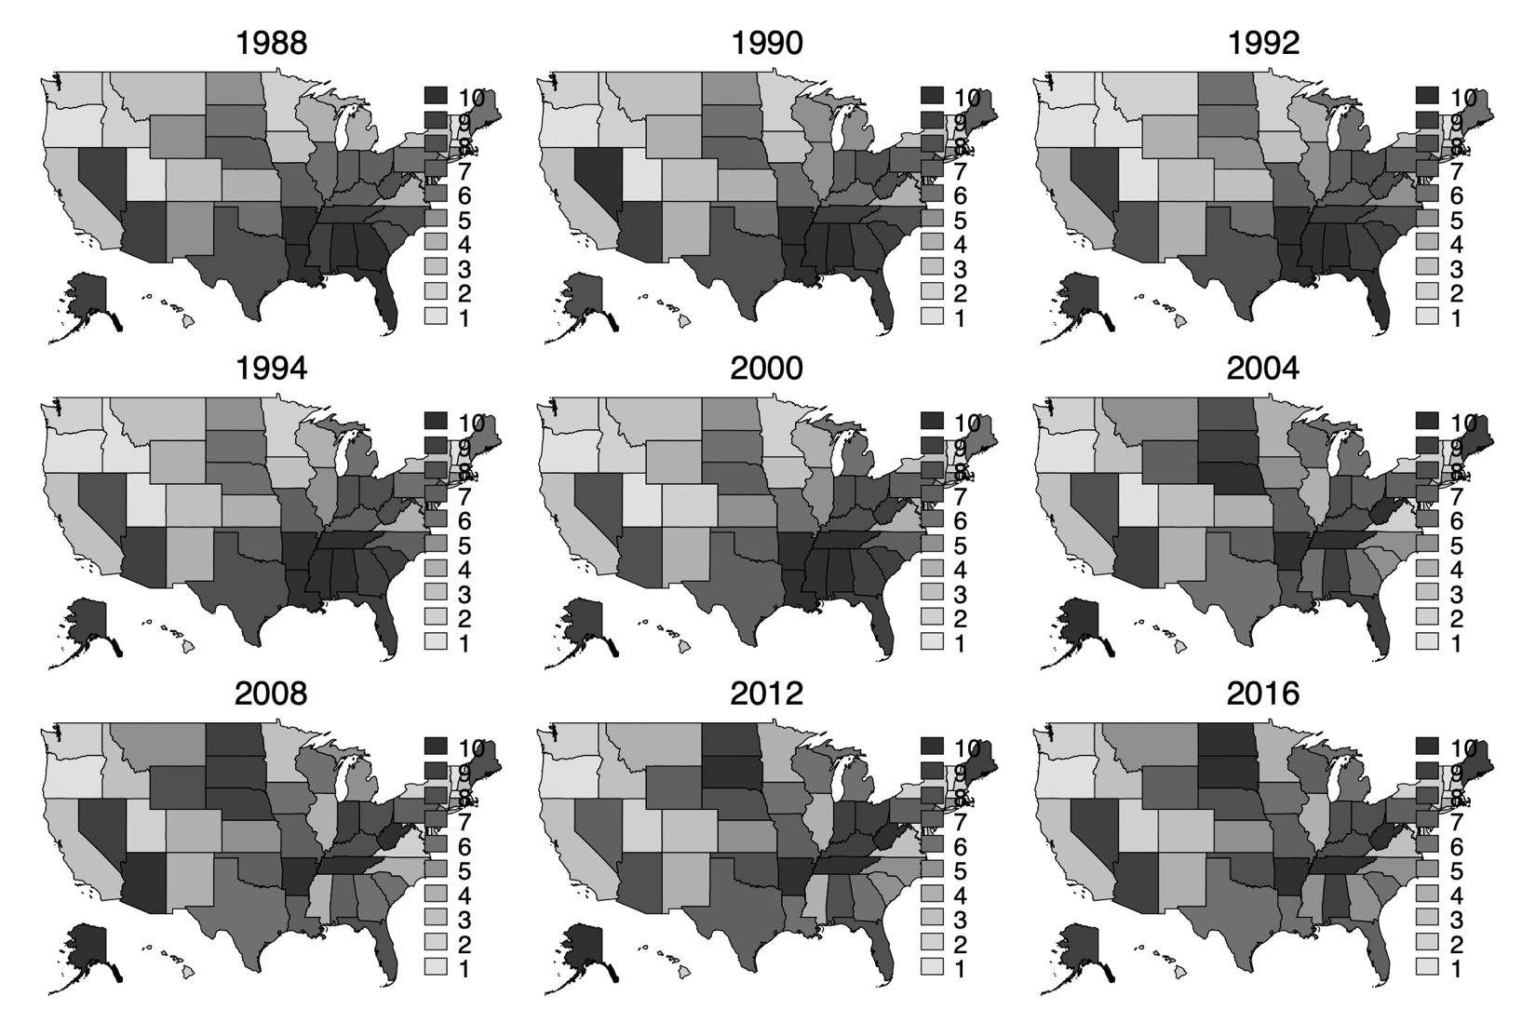

*Note: This is similar to Figure 3, but with deciles in lieu of quintiles. Quintiles for each map are calculated using data from that year only. As such, the individual maps should not be directly compared to each other. However, it is appropriate to compare to maps to observe patterns in which states have racial resentment scores in the higher and low quintiles of the data.*

**A4. Changes in Estimated Racial Resentment in Over Time, Sort by Racial Resentment in 2016**



*Note: This is similar to Figure 4, but instead sorted by estimated racial resentment in 2016.*

**A5. Mapping Annual Racial Resentment in the States, Relative to Other States**

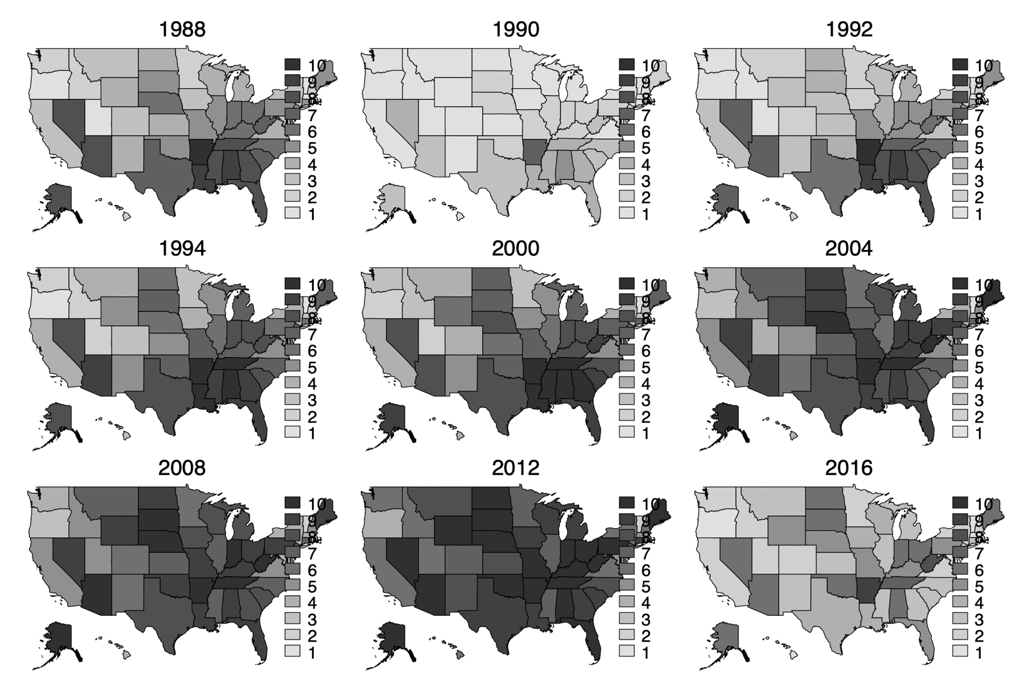

*Note: This is similar to Figure 5, but with deciles in lieu of quintiles. Quintiles for each map are calculated using data from that year only. As such, the individual maps should not be directly compared to each other. However, it is appropriate to compare to maps to observe patterns in which states have racial resentment scores in the higher and low quintiles of the data.*

**Appendix B: The Use of MRP to Create Subnational Estimates of Public Opinion**

Multilevel regression with post-stratification weighting (MRP) is an approach to estimating public opinion that brings together three pieces of information: census data, survey data containing a measure of the attitude one is interested in measuring, and data on state-level variables that may have an impact on those attitudes. Public opinion is modeled as a function of demographic characteristics and state-level variables, and the responses are weighted using frequencies of demographic types from the census.

The method has been vigorously tested and validated across a range of data, and several groups of scholars have created useful sets of guidelines and cautions to those using MRP (Lax and Phillips 2013, Buttice and Highton 2013). MRP can be used to create state level estimates with a single national survey of at least 1,400 or so respondents (Lax and Phillips 2009b, Park, Gelman, and Bafumi 2004, Pacheco 2011) and congressional districts with just a few thousand respondents (Warshaw and Rodden 2012). MRP produces more robust and precise estimates than simple survey disaggregation, particularly when sample sizes are relatively small (Raudenbush and Bryk 2002, Snijders 2011, Steenbergen and Jones 2002, Lax and Phillips 2009b, Park, Gelman, and Bafumi 2004). Park, Gelman and Bafumi (2006) compare MRP estimates of opinion to older approaches to modeling state opinion and show that MRP substantially outperforms approaches that do not partially pool information across respondents. The subsequent process of post-stratification corrects for over-sampling or under-sampling of demographic categories (Voss, Gelman, and King 1995). The pooling of information across states and years also allows for accurate estimation of opinion for smaller states, which are often excluded from national surveys or have a small state sample (Lax and Phillips 2009b, Pacheco 2011). In general, MRP yields smaller errors, higher correlations, and more reliable estimates than disaggregation (Lax and Phillips 2009b).

Because one doesn’t need as many survey responses to produce reliable state estimates compared to disaggregation, scholars have used MRP to create measures of sub-national and sub-state attitudes on a range of issues, including same-sex marriage (Lax and Phillips 2009a, Lewis and Jacobsmeier 2017), ideology and partisanship (Enns and Koch 2015, 2013, Pacheco 2011), immigration (Butz and Kehrberg 2016), gender mood (Koch and Thomsen 2017), Supreme Court nominees and decisions (Kastellec, Lax, and Phillips 2010, Franko 2017, Caldarone, Canes-Wrone, and Clark 2009), income inequality (Franko 2017), roll call voting (Kastellec et al. 2015, Kastellec, Lax, and Phillips 2010, Krimmel, Lax, and Phillips 2016), the Affordable Health Care act (Pacheco and Maltby 2017), smoking bans (Pacheco 2012), abortion (Pacheco 2014), death penalty (Pacheco 2014), and welfare spending (Pacheco 2014), to name a few. Indeed, MRP is “emerging as a widely used gold standard for estimating preferences from national surveys” (Selb and Munzert 2011, 456).

***Implementing MRP to Measure Racial Resentment***

Racial resentment is most frequently measured with a battery of four questions, and combined into an additive scale (Kinder and Sanders 1996). Scholars typically use this battery to create a measure of an individual’s level of racial resentment, and then in turn, may use that measure as an independent variable when assessing someone’s opinion on racialized policy (DeSante 2013, Feldman and Huddy 2005, Filindra and Kaplan , Tuch and Hughes 2011). Here, we use a multilevel model to create individualized scores of racial resentment based on demographic and geographic markers, and weight the occurrence of those factors appropriately to create a state level measure. That measure represents the level of racial resentment in each state in a particular year.

In order to implement MRP, we collected public opinion survey data on racial resentment over time using the American National Election Survey (ANES) and pooled that data into a single dataset. The ANES uses a cluster sampling design. Some scholars have articulated concerns about the use of clustered data to create estimates of state opinion because of the non-representativeness of clustered data (Brace et al. 2002). The problem of clustered sampling can be mitigated by including state level variables in MRP, and the final step of post-stratification in particular corrects for this bias (Lax and Phillips 2009b). Many other scholars have effectively used clustered data to create state estimates of opinion using MRP (for instance (Stollwerk 2013, Koch and Thomsen 2017, Butz and Kehrberg 2016).

The ANES asked the standard battery of four questions to gauge racial resentment in 1988, 1990, 1992, 1994, 2000, 2004, 2008, 2012, and 2016. Specifically, respondents were asked if they agree strongly, agree somewhat, neither agree nor disagree, disagree somewhat or disagree strongly with the following four statements: 1) Irish, Italians, Jewish and many other minorities overcame prejudice and worked their way up. Blacks should do the same without any special favors. 2) Generations of slavery and discrimination have created conditions that make it difficult for blacks to work their way out of the lower class. 3)Over the past few years, blacks have gotten less than they deserve. 4)It’s really a matter of some people not trying hard enough, if blacks would only try harder they could be just as well off as whites.

We follow conventions established by both scholars of MRP and racial resentment in our treatment of these questions in our analysis. We code each of the four racial resentment questions such that agreement with the prompts are coded on a five-point scale, with higher scores indicating a higher level of racial resentment. We then combined responses to the four prompts and divided that number by 16, so that an individual’s racial resentment score ranges from 0 to 1, with 1 representing the highest possible level of racial resentment.

Next, we use a multilevel linear regression model to predict the level of racial resentment using a series of demographic and state-level factors used in the extant MRP literature. This includes measures of a series of binary categorical measures for age (18-29, 30-44, 45-64, or 65+), education (less than high school graduate, high school graduate, some college, or college graduate), and state of residence (each of the 50 states). Rather than include a race-gender interaction, we follow scholars who have sought to take seriously the intersectionality literature in quantitative data analysis; specifically, we include indicators of each race-gender combination of respondents (non-Hispanic white man, non-Hispanic white woman, non-Hispanic black man, non-Hispanic black woman, men of “other” race, women of “other” race) (Hancock 2007, Masuoka and Junn 2013, Reingold and Smith 2012).[1][2]

Scholars often exclude public opinion data from non-whites in their analysis of racial resentment. While blacks and other people of color may not exhibit the same levels of anti-Black animus, they are neither immune from relying on individual rather than structural explanations of racial inequality (Smith 2014, Nunnally and Carter 2012) nor impervious to a reliance on the dominant racial logic of the time (Bonilla-Silva 2014 [2003]). Henry and Sears (2002) show that the racial resentment measure is reliable for Blacks, and Kam and Burge (2018) find that white and Black Americans relate to the four questions of the measurement in similar ways. Finally, we include a state-level variable representing state ideology (Berry et al. 1998) and an indicator variable for the year of the survey.

The results of the model are used to predict the level of racial resentment for each of “types” of individuals based on combinations of the demographic and geographic identifiers. By “type” we are referring to the 4,800 permutations of individuals (3 race groups x 2 genders x 4 age groups x 4 education groups x 50 states) that we are able to ascertain within the constraints of the U.S. Census data. For instance, we predict the level of racial resentment for the average non-Hispanic white, male, between the ages of 18-29, with less than a high school education in Alabama, as well as the level of racial resentment of a non-Hispanic black, woman, older than 65, with a college education in Wyoming.

We are interested in estimating racial resentment in the states over time. Previous work with dynamic MRP takes two different approaches to incorporating an over-time element to the analysis. One approach to incorporating time is to run the analysis iteratively with small windows of time. For instance, Pacheco (2011) pools survey data in three and five year floating blocks to create an annual estimate of opinion. On the one hand, this approach may have the benefit of incorporating information from neighboring years to mitigate potential effects of outlier survey years. On the other hand, this approach is relatively inefficient and may ignore as significant amounts of data (Gelman et al. 2016). Not all scholars using this iterative approach create short “windows” of time. For example, in their creation of state level partisanship and ideology, Enns and Koch (2013) create annual estimates by only using data for a single given year. By using only information from a single year, this approach makes use of an even smaller percent of the total data. The other approach to dynamic MRP pools all of the survey data into one analysis and includes indicator variables for years (Gelman et al. 2016, Franko 2017). This approach generates comparable estimates to those generated in this first method, but because it incorporates the complete set of information, is a more efficient model with tighter standard errors (Gelman et al. 2016). We take the latter approach here, pooling all survey data and including indicator variables for specific years.

The results in the model reflect our expectations and the broad literature on predicting racial resentment. In brief, we find that age has a positive relationship with racial resentment, meaning that older people are more racially resentful (Nteta and Greenlee 2013). We find that higher education is associated with lower racial resentment. Finally, the results corroborate studies that show that white men tend to have higher levels of racial animus than other race-gendered groups (e.g. (Smith, Senter, and Strachan 2013). The state-level ideology variable is also significant.

**Table B1. Predicting Racial Resentment**

|  |  |  |  |  |
| --- | --- | --- | --- | --- |
|  | Coeff |  |  |  |
|  | Std. Err. |  |  |  |
| Age (30-44) | 0.43885 | *** |  |  |
|  | 0.06361 |  |  |  |
| Age (45-64) | 0.57282 | *** |  |  |
|  | 0.06307 |  |  |  |
| Age (65+) | 0.46422 | *** |  |  |
|  | 0.0719 |  |  |  |
| Educ (HS grad) | 0.25779 | * |  |  |
|  | 0.10734 |  |  |  |
| Educ (some college) | -0.05844 |  |  |  |
|  | 0.1116 |  |  |  |
| Educ (college grad) | -1.55261 | *** |  |  |
|  | 0.11268 |  |  |  |
| Race - Black | -3.82843 | *** |  |  |
|  | 0.09855 |  |  |  |
| Race - Other | -0.82888 | *** |  |  |
|  | 0.8933 |  |  |  |
| Female | -5.85958 | *** |  |  |
|  | 1.38478 |  |  |  |
| Female*Black | |  |  |  |
|  |  |  |  |  |
| Female*Other | |  |  |  |
|  |  |  |  |  |
| Ideology | -0.01383 | * |  |  |
|  | 0.00537 |  |  |  |
| Intercept | 13.1919 | *** |  |  |
|  | 1.4161 |  |  |  |
| 0 '***' 0.001 '**' 0.01 '*' 0.05 |  |  |  |  |
| N: 25138 (787 obs missing due to missingness) | | | | |
| Multiple R-squared:  0.1616, Adjusted R-squared:  0.1592 | | | | |
| State indicator variables omitted from table for brevity | | | | |
|  | | | | |

After estimating the multilevel linear regression model, we predicted the level of racial resentment for each of the 4800 “types” of people using the full slate of independent variables in the model. We then weight these person types by the frequency of those person types by each state, incorporating this information from the U.S. Census. By combining the predicted level of racial resentment for each “type” of person by how many of those “types” of people there are in each state, we are able to construct a measure of the state-level racial resentment. The estimates of state racial resentment are reported in Table B2.

**Table B2. Racial Resentment Scores in the US States, 1988-2016**

|  |  |  |  |  |  |  |  |  |  |
| --- | --- | --- | --- | --- | --- | --- | --- | --- | --- |
| **State** | **1988** | **1990** | **1992** | **1994** | **2000** | **2004** | **2008** | **2012** | **2016** |
| **AK** | 0.6793 | 0.6263 | 0.6684 | 0.6892 | 0.7032 | 0.7145 | 0.7125 | 0.7271 | 0.6589 |
| **AL** | 0.6968 | 0.6551 | 0.6910 | 0.7072 | 0.7169 | 0.7005 | 0.6934 | 0.7158 | 0.6597 |
| **AR** | 0.7138 | 0.6668 | 0.7078 | 0.7310 | 0.7361 | 0.7293 | 0.7416 | 0.7598 | 0.7045 |
| **AZ** | 0.6800 | 0.6311 | 0.6673 | 0.6912 | 0.6883 | 0.7027 | 0.7147 | 0.7163 | 0.6609 |
| **CA** | 0.6283 | 0.5822 | 0.6240 | 0.6449 | 0.6446 | 0.6466 | 0.6558 | 0.6661 | 0.6082 |
| **CO** | 0.6250 | 0.5750 | 0.6150 | 0.6340 | 0.6351 | 0.6524 | 0.6628 | 0.6705 | 0.6131 |
| **CT** | 0.6478 | 0.5948 | 0.6391 | 0.6634 | 0.6676 | 0.6743 | 0.6742 | 0.6922 | 0.6216 |
| **DE** | 0.6650 | 0.5990 | 0.6335 | 0.6596 | 0.6713 | 0.6572 | 0.6570 | 0.6679 | 0.6117 |
| **FL** | 0.6891 | 0.6381 | 0.6786 | 0.6947 | 0.6981 | 0.7034 | 0.7036 | 0.7129 | 0.6554 |
| **GA** | 0.6890 | 0.6373 | 0.6780 | 0.7010 | 0.7048 | 0.6825 | 0.6868 | 0.6991 | 0.6296 |
| **HI** | 0.6174 | 0.5705 | 0.6135 | 0.6252 | 0.6362 | 0.6375 | 0.6454 | 0.6579 | 0.5943 |
| **IA** | 0.6252 | 0.5753 | 0.6182 | 0.6393 | 0.6506 | 0.6774 | 0.6836 | 0.6961 | 0.6370 |
| **ID** | 0.6066 | 0.5580 | 0.5893 | 0.6127 | 0.6233 | 0.6555 | 0.6555 | 0.6636 | 0.6105 |
| **IL** | 0.6499 | 0.5986 | 0.6361 | 0.6599 | 0.6604 | 0.6633 | 0.6686 | 0.6769 | 0.6267 |
| **IN** | 0.6604 | 0.6140 | 0.6547 | 0.6800 | 0.6833 | 0.6994 | 0.7063 | 0.7194 | 0.6571 |
| **KS** | 0.6359 | 0.5828 | 0.6219 | 0.6488 | 0.6587 | 0.6709 | 0.6764 | 0.6832 | 0.6297 |
| **KY** | 0.6577 | 0.6018 | 0.6461 | 0.6716 | 0.6876 | 0.6964 | 0.6997 | 0.7167 | 0.6560 |
| **LA** | 0.7019 | 0.6427 | 0.6912 | 0.7084 | 0.7178 | 0.6933 | 0.6967 | 0.6957 | 0.6436 |
| **MA** | 0.5950 | 0.5471 | 0.5934 | 0.6245 | 0.6209 | 0.6402 | 0.6421 | 0.6553 | 0.5926 |
| **MD** | 0.6322 | 0.5887 | 0.6312 | 0.6567 | 0.6543 | 0.6353 | 0.6410 | 0.6532 | 0.5906 |
| **ME** | 0.6499 | 0.6080 | 0.6458 | 0.6668 | 0.6758 | 0.7054 | 0.7007 | 0.7188 | 0.6589 |
| **MI** | 0.6425 | 0.5961 | 0.6424 | 0.6665 | 0.6678 | 0.6782 | 0.6776 | 0.6938 | 0.6334 |
| **MN** | 0.6077 | 0.5652 | 0.6020 | 0.6305 | 0.6331 | 0.6638 | 0.6599 | 0.6757 | 0.6144 |
| **MO** | 0.6545 | 0.6047 | 0.6466 | 0.6691 | 0.6745 | 0.6921 | 0.6953 | 0.7053 | 0.6484 |
| **MS** | 0.6877 | 0.6414 | 0.6870 | 0.7020 | 0.7089 | 0.6805 | 0.6734 | 0.6759 | 0.6288 |
| **MT** | 0.6309 | 0.5787 | 0.6130 | 0.6396 | 0.6404 | 0.6763 | 0.6753 | 0.6806 | 0.6295 |
| **NC** | 0.6659 | 0.6198 | 0.6591 | 0.6751 | 0.6820 | 0.6756 | 0.6716 | 0.6887 | 0.6329 |
| **ND** | 0.6445 | 0.5943 | 0.6414 | 0.6618 | 0.6669 | 0.6980 | 0.7040 | 0.7184 | 0.6622 |
| **NE** | 0.6646 | 0.6081 | 0.6344 | 0.6663 | 0.6797 | 0.7055 | 0.7074 | 0.7148 | 0.6560 |
| **NH** | 0.6123 | 0.5594 | 0.5990 | 0.6168 | 0.6208 | 0.6469 | 0.6524 | 0.6621 | 0.6024 |
| **NJ** | 0.6475 | 0.6057 | 0.6487 | 0.6711 | 0.6678 | 0.6657 | 0.6776 | 0.6902 | 0.6260 |
| **NM** | 0.6439 | 0.5865 | 0.6313 | 0.6541 | 0.6562 | 0.6607 | 0.6630 | 0.6781 | 0.6200 |
| **NV** | 0.6847 | 0.6387 | 0.6734 | 0.6875 | 0.6849 | 0.6988 | 0.7037 | 0.7119 | 0.6584 |
| **NY** | 0.6270 | 0.5750 | 0.6142 | 0.6394 | 0.6444 | 0.6409 | 0.6454 | 0.6617 | 0.5971 |
| **OH** | 0.6648 | 0.6147 | 0.6566 | 0.6823 | 0.6828 | 0.6920 | 0.7035 | 0.7167 | 0.6575 |
| **OK** | 0.6504 | 0.6047 | 0.6432 | 0.6736 | 0.6763 | 0.6895 | 0.6990 | 0.7141 | 0.6584 |
| **OR** | 0.5901 | 0.5337 | 0.5711 | 0.5934 | 0.5988 | 0.6240 | 0.6270 | 0.6397 | 0.5834 |
| **PA** | 0.6495 | 0.6054 | 0.6487 | 0.6657 | 0.6763 | 0.6920 | 0.6946 | 0.7104 | 0.6472 |
| **RI** | 0.5865 | 0.5488 | 0.5984 | 0.6164 | 0.6041 | 0.6307 | 0.6337 | 0.6429 | 0.5824 |
| **SC** | 0.6721 | 0.6318 | 0.6729 | 0.6903 | 0.6935 | 0.6716 | 0.6822 | 0.6915 | 0.6344 |
| **SD** | 0.6479 | 0.6052 | 0.6445 | 0.6688 | 0.6740 | 0.7025 | 0.7114 | 0.7210 | 0.6626 |
| **TN** | 0.6841 | 0.6375 | 0.6757 | 0.7098 | 0.7080 | 0.7091 | 0.7268 | 0.7356 | 0.6693 |
| **TX** | 0.6690 | 0.6198 | 0.6577 | 0.6843 | 0.6790 | 0.6828 | 0.6901 | 0.6996 | 0.6406 |
| **UT** | 0.5879 | 0.5375 | 0.5813 | 0.6063 | 0.6054 | 0.6364 | 0.6492 | 0.6620 | 0.6024 |
| **VA** | 0.6374 | 0.5892 | 0.6318 | 0.6557 | 0.6563 | 0.6458 | 0.6491 | 0.6627 | 0.6062 |
| **VT** | 0.5452 | 0.5080 | 0.5481 | 0.5514 | 0.5630 | 0.5897 | 0.6004 | 0.6035 | 0.5436 |
| **WA** | 0.5990 | 0.5552 | 0.5867 | 0.6182 | 0.6266 | 0.6415 | 0.6439 | 0.6585 | 0.5993 |
| **WI** | 0.6379 | 0.5921 | 0.6242 | 0.6509 | 0.6553 | 0.6779 | 0.6870 | 0.6986 | 0.6445 |
| **WV** | 0.6773 | 0.6282 | 0.6616 | 0.6810 | 0.6937 | 0.7219 | 0.7279 | 0.7448 | 0.6894 |
| **WY** | 0.6453 | 0.5916 | 0.6267 | 0.6536 | 0.6585 | 0.6904 | 0.7028 | 0.7115 | 0.6503 |

**Notes on Change Over Time**

The correlation of state racial resentment scores within a state over time is very high, ranging from .80 to .99. This means that the average level of racial resentment in states does not vary substantially, and varies more in some states than others. We also compared the relative ranking of states (from 1 to 50) in terms of level of racial resentment. The rankings of state racial resentment are also high over time, though the correlation is lower than the racial resentment scores themselves. That means that there is some variability in the relative rank ordering of states’ racial resentment, though not a lot. Tables B3 and B4 show correlation for racial resentment scores and rankings, respectively, below.

**Table B3. Correlation within Racial Resentment Scores**

|  |  |  |  |  |  |  |  |  |  |
| --- | --- | --- | --- | --- | --- | --- | --- | --- | --- |
|  | 1988 | 1990 | 1992 | 1994 | 2000 | 2004 | 2008 | 2012 | 2016 |
| 1988 | 1 |  |  |  |  |  |  |  |  |
| 1990 | 0.987 | 1 |  |  |  |  |  |  |  |
| 1992 | 0.975 | 0.99 | 1 |  |  |  |  |  |  |
| 1994 | 0.976 | 0.983 | 0.986 | 1 |  |  |  |  |  |
| 2000 | 0.982 | 0.981 | 0.978 | 0.986 | 1 |  |  |  |  |
| 2004 | 0.84 | 0.839 | 0.813 | 0.84 | 0.864 | 1 |  |  |  |
| 2008 | 0.817 | 0.819 | 0.793 | 0.825 | 0.838 | 0.982 | 1 |  |  |
| 2012 | 0.801 | 0.806 | 0.782 | 0.817 | 0.834 | 0.978 | 0.988 | 1 |  |
| 2016 | 0.814 | 0.817 | 0.788 | 0.818 | 0.836 | 0.981 | 0.986 | 0.988 | 1 |

**Table B4. Correlation within Racial Resentment Ranking**

|  |  |  |  |  |  |  |  |  |  |
| --- | --- | --- | --- | --- | --- | --- | --- | --- | --- |
|  | 1988 | 1990 | 1992 | 1994 | 2000 | 2004 | 2008 | 2012 | 2016 |
| 1988 | 1 |  |  |  |  |  |  |  |  |
| 1990 | 0.981 | 1 |  |  |  |  |  |  |  |
| 1992 | 0.966 | 0.985 | 1 |  |  |  |  |  |  |
| 1994 | 0.968 | 0.982 | 0.987 | 1 |  |  |  |  |  |
| 2000 | 0.977 | 0.978 | 0.975 | 0.981 | 1 |  |  |  |  |
| 2004 | 0.8 | 0.814 | 0.786 | 0.798 | 0.833 | 1 |  |  |  |
| 2008 | 0.756 | 0.771 | 0.746 | 0.764 | 0.789 | 0.972 | 1 |  |  |
| 2012 | 0.737 | 0.754 | 0.74 | 0.757 | 0.783 | 0.966 | 0.979 | 1 |  |
| 2016 | 0.747 | 0.767 | 0.744 | 0.759 | 0.783 | 0.965 | 0.975 | 0.98 | 1 |

It is common in MRP scholarship to assess validity by comparing the newly generated scores with widely accepted measures of the same concept. We are unable to do so here, as there are not other state-level measures of racial animus over time. Instead, we compare the estimated racial resentment to presidential vote (in presidential voting years), and to the Enns and Koch (2013) measures of state partisanship and ideology. These scores are more highly correlated with the Enns and Koch scores of ideology (which ranges from correlated at .33 in 1992 to .65 in 2008) than their measure of state partisanship (which ranges from around 0 in 1992 to .56 in 2008). We hesitate to read too much into these patterns, as previous literature indicates that racial resentment is a concept distinct from partisanship and ideology (Henry & Sears, 2002).

**Works Cited in Appendix**

Berry, William D, Evan J Ringquist, Richard C Fording, and Russell L Hanson. 1998. "Measuring citizen and government ideology in the American states, 1960-93." *American Journal of Political Science*:327-348.

Bonilla-Silva, Eduardo. 2014 [2003]. *Racism without Racists: Color-blind Racism and the Persistence of Racial Inequality in the United States*. 4th ed. Lanham: Rowman and LIttlefield Publishers, Inc.

Brace, Paul, Kellie Sims-Butler, Kevin Arceneaux, and Martin Johnson. 2002. "Public opinion in the American states: New perspectives using national survey data." *American Journal of Political Science*:173-189.

Buttice, Matthew K, and Benjamin Highton. 2013. "How does multilevel regression and poststratification perform with conventional national surveys?" *Political Analysis* 21 (4):449-467.

Butz, Adam M, and Jason E Kehrberg. 2016. "Estimating anti-immigrant sentiment for the American states using multi-level modeling and post-stratification, 2004–2008." *Research & Politics* 3 (2):2053168016645830.

Caldarone, Richard P, Brandice Canes-Wrone, and Tom S Clark. 2009. "Partisan labels and democratic accountability: An analysis of State Supreme Court abortion decisions." *The Journal of Politics* 71 (2):560-573.

DeSante, Christopher D. 2013. "Working Twice as Hard to Get Half as Far: Race, Work Ethic, and America’s Deserving Poor." *American Journal of Political Science* 57 (2):342-356.

Enns, Peter K, and Julianna Koch. 2013. "Public Opinion in the US States: 1956 to 2010." *State Politics & Policy Quarterly* 13 (3):349-372.

Enns, Peter K, and Julianna Koch. 2015. "State policy mood: The importance of over-time dynamics." *State Politics & Policy Quarterly* 15 (4):436-446.

Feldman, Stanley, and Leonie Huddy. 2005. "Racial Resentment and White Opposition to Race‐Conscious Programs: Principles or Prejudice?" *American Journal of Political Science* 49 (1):168-183.

Filindra, Alexandra, and Noah J Kaplan. "Racial Resentment and Whites’ Gun Policy Preferences in Contemporary America." *Political Behavior* 32 (2):255-275.

Franko, William W. 2017. "Understanding public perceptions of growing economic inequality." *State Politics & Policy Quarterly* 17 (3):319-348.

Gelman, Andrew, Jeffrey Lax, Justin Phillips, Jonah Gabry, and Robert Trangucci. 2016.

Hancock, Ange-Marie. 2007. "When Multiplication Doesn't Equal Quick Addition: Examining Intersectionality as a Research Paradigm." *Perspectives on Politics* 5 (1):63-79.

Henry, P.J., and David O. Sears. 2002. "The Symbolic Racism 2000 Scale." *Political Psychology* 23 (2):253-283.

Kam, Cindy D, and Camille D Burge. 2018. "Uncovering Reactions to the Racial Resentment Scale across the Racial Divide." *The Journal of Politics* 80 (1):314-320.

Kastellec, Jonathan P, Jeffrey R Lax, Michael Malecki, and Justin H Phillips. 2015. "Polarizing the electoral connection: partisan representation in Supreme Court confirmation politics." *The Journal of Politics* 77 (3):787-804.

Kastellec, Jonathan P, Jeffrey R Lax, and Justin H Phillips. 2010. "Public opinion and Senate confirmation of Supreme Court nominees." *The Journal of Politics* 72 (3):767-784.

Kinder, Donald R., and Lynn M. Sanders. 1996. *Divided by Color: Racial Politics and Democratic Ideals*. Chicago: The University of Chicago Press.

Koch, Julianna, and Danielle M Thomsen. 2017. "Gender Equality Mood across States and over Time." *State Politics & Policy Quarterly* 17 (4):351-360.

Krimmel, Katherine, Jeffrey R Lax, and Justin H Phillips. 2016. "Gay rights in Congress: Public opinion and (mis) representation." *Public Opinion Quarterly* 80 (4):888-913.

Lax, Jeffrey R, and Justin H Phillips. 2009a. "Gay rights in the states: Public opinion and policy responsiveness." *American Political Science Review* 103 (3):367-386.

Lax, Jeffrey R, and Justin H Phillips. 2009b. "How should we estimate public opinion in the states?" *American Journal of Political Science* 53 (1):107-121.

Lax, Jeffrey R, and Justin H Phillips. 2013. "How should we estimate sub-national opinion using MRP? Preliminary findings and recommendations." annual meeting of the Midwest Political Science Association, Chicago.

Lewis, Daniel C, and Matthew L Jacobsmeier. 2017. "Evaluating Policy Representation with Dynamic MRP Estimates: Direct Democracy and Same-Sex Relationship Policies in the United States." *State Politics & Policy Quarterly* 17 (4):441-464.

Masuoka, Natalie, and Jane Junn. 2013. *The Politics of Belonging: Race, Public Opinion, and Immigration*. Chicago, IL: University of Chicago Press.

Nunnally, Shayla C., and Niambi M. Carter. 2012. "Moving from Victims to Victors: African American Attitudes on the "Culture of Poverty" and Black Blame." *Journal of African American Studies* `16 (3):423-455.

Pacheco, Julianna. 2011. "Using national surveys to measure dynamic US state public opinion: A guideline for scholars and an application." *State Politics & Policy Quarterly* 11 (4):415-439.

Pacheco, Julianna. 2012. "The social contagion model: Exploring the role of public opinion on the diffusion of antismoking legislation across the American states." *The Journal of Politics* 74 (1):187-202.

Pacheco, Julianna. 2014. "Measuring and Evaluating Changes in State Opinion across Eight Issues." *American Politics Research* 42 (6):986-1009.

Pacheco, Julianna, and Elizabeth Maltby. 2017. "The Role of Public Opinion—Does It Influence the Diffusion of ACA Decisions?" *Journal of health politics, policy and law* 42 (2):309-340.

Park, David K, Andrew Gelman, and Joseph Bafumi. 2004. "Bayesian multilevel estimation with poststratification: state-level estimates from national polls." *Political Analysis* 12 (4):375-385.

Raudenbush, Stephen W, and Anthony S Bryk. 2002. *Hierarchical linear models: Applications and data analysis methods*. Vol. 1: Sage.

Reingold, Beth, and Adrienne R Smith. 2012. "Welfare policymaking and intersections of race, ethnicity, and gender in US state legislatures." *American Journal of Political Science* 56 (1):131-147.

Selb, Peter, and Simon Munzert. 2011. "Estimating constituency preferences from sparse survey data using auxiliary geographic information." *Political Analysis* 19 (4):455-470.

Smith, Candis Watts. 2014. "Shifting From Structural to Individual Attributions of Black Disadvantage Age, Period, and Cohort Effects on Black Explanations of Racial Disparities." *Journal of Black Studies* 45 (5):432-452.

Smith, Justin M, Mary Senter, and J Cherie Strachan. 2013. "Gender and white college students' racial attitudes." *Sociological Inquiry* 83 (4):570-590.

Snijders, Tom AB. 2011. "Multilevel analysis." In *International encyclopedia of statistical science*, 879-882. Springer.

Steenbergen, Marco R, and Bradford S Jones. 2002. "Modeling multilevel data structures." *american Journal of political Science*:218-237.

Stollwerk, Alissa. 2013. "The application of multilevel regression with post-stratification to cluster sampled polls: Challenges and suggestions." 71st Annual Meeting of the Midwest Political Science Association, Chicago, IL.

Tuch, Steven A, and Michael Hughes. 2011. "Whites’ racial policy attitudes in the twenty-first century: The continuing significance of racial resentment." *The ANNALS of the American Academy of Political and Social Science* 634 (1):134-152.

Voss, Stephen, Andrew Gelman, and Gary King. 1995. "The polls—A review: Preelection survey methodology: Details from eight polling organizations, 1988 and 1992." *Public Opinion Quarterly* 59 (1):98-132.

Warshaw, Christopher, and Jonathan Rodden. 2012. "How should we measure district-level public opinion on individual issues?" *The Journal of Politics* 74 (1):203-219.

1. MRP research often uses ordinal instead of categorical variables for race, age, gender, etc. However, we believe that it is more precise to treat these as series of indicator variables. The effect for education, for instance, is not constant across the various education categories.
2. It is important to note here that the individual characteristics used to model racial resentment must be ones that can be matched with cross-tabs from the census. Our regression equation is thus necessarily limited to the types of information available in the census cross-tabs.