Statistical Appendix

This section develops the hierarchical (or multilevel) model from section 6. We will begin with an individual level model described as follows:
yij = γ00 + u0j + ij (1)

where γ00 is the grand mean of PdSES across all countries (and the fixed effect), u0j (a random effect) describes the error of country means around the grand mean, and ij (also a random effect) describes the deviation of PdSES from year to year from that country’s mean. The goal of estimating this model is merely to see how much of the variation in the dependent variable comes from variation within the same country and how much of it comes from variation across countries. A good way of thinking about this “null model” is that it serves the purpose of verifying whether a hierarchical model is called for in the first place.
The Interclass Correlation Coefficient of model 1 from Table 2 is 80 % (or the correlation of PdSES across years in the same country is .8), on average. This means that most of the variation is explained by difference between countries. Hence, a hierarchical model is definitely justified (Finch, Bolin & Kelley 2014).
The next model incorporates one explanatory variable. Because all of our measures of transitional justice are measured at the country level, we include here the variable “years after the transition” (yaftr), which is measured at the level of individual country-years. To give a better intuition behind the model’s hierarchical structure, we first write the individual level model:
yij = β0j + β1jyaftrij + ij (2)

The level 2 (country level) model is given by

β0j = γ00 + u0j (3)

β1j = γ10 (4)
The full or “mixed” model is then written by substituting equations (4) and (3) into (2):

yij = γ0j + γ10yaftrij + u0j + ij (5)

This model is called a random intercept model. Its results are presented as Model 2 of Table 2 Adding an error term to equation (4) would produce a random slope model, which is illustrated in Table 2 as model 3. Crucially, none of these models yet contains any of our transitional justice measures. Such a model would have to be written differently, because our measures are at the country level (they do not vary with year) as follows:
yij = β0j + β1jyaftrij + ij (6)

The level 2 (country level) model is given by
β0j = γ00 + γ01LUSj + u0j (7)
β1j = γ10 + u1j (8)
The full or “mixed” model is then written by substituting equations (7) and (8) into (6):

yij = γ00 + γ01LUSj + γ10yaftrj + u1jyaftrj + u0j + ij (9)

GIS Appendix

The following appendix presents a GIS coded version of our dataset with all three measures applied to each of the transitional justice mechanisms. The first map presents GIS coded data on the severity of lustration in countries making up our universe of cases. The second map presents the severity of leadership purges for the same group of countries. The third map presents the severity of thorough purges and the fourth map presents the severity of truth commissions. This order is repeated for volatility and urgency/delay.

Figure 8: World Map of TJ Vetting of unknown collaborators-Severity (Darker represents higher severity)

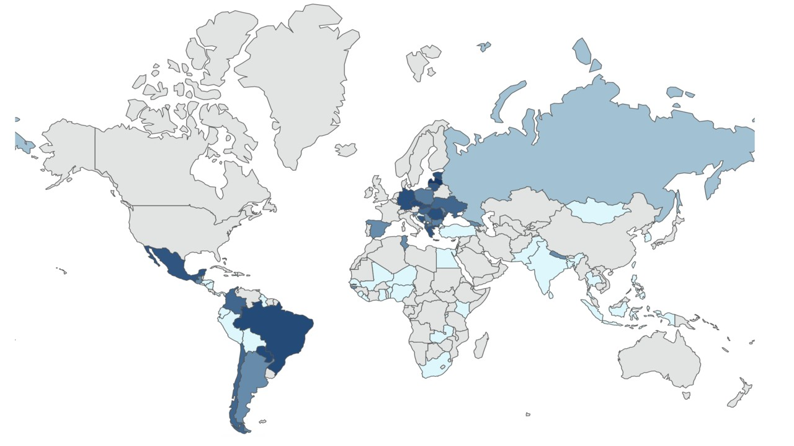

Figure 9: World Map of TJ Vetting of known collaborators-Severity (Darker represents higher severity)

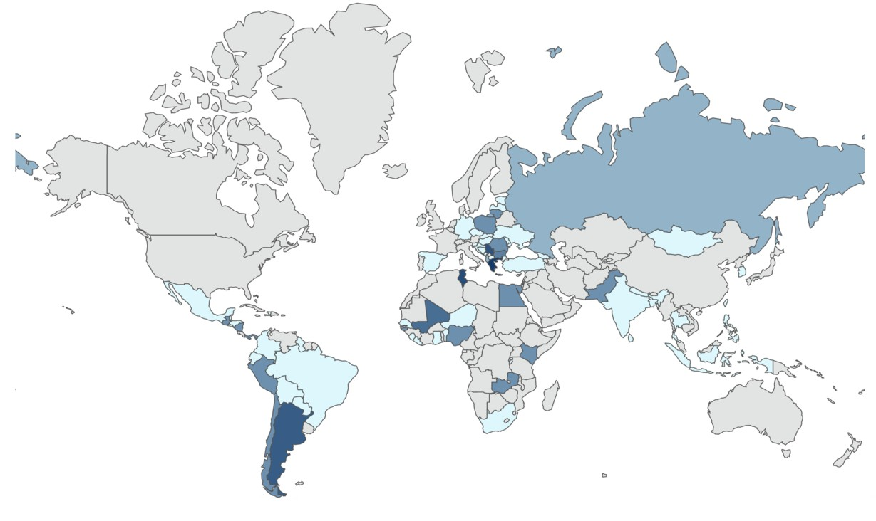

Figure 10: World Map of Purges-Severity (Darker represents higher severity)

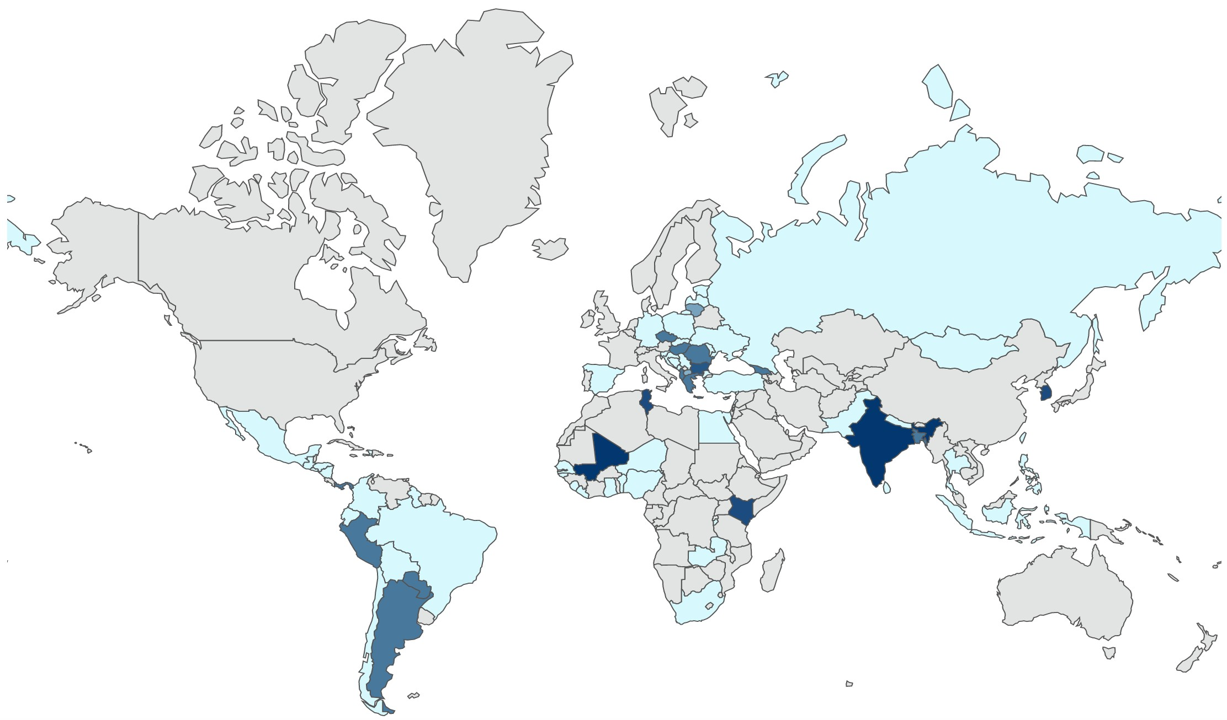

Figure 11: World Map of Truth Commissions-Severity (Darker represents higher severity)

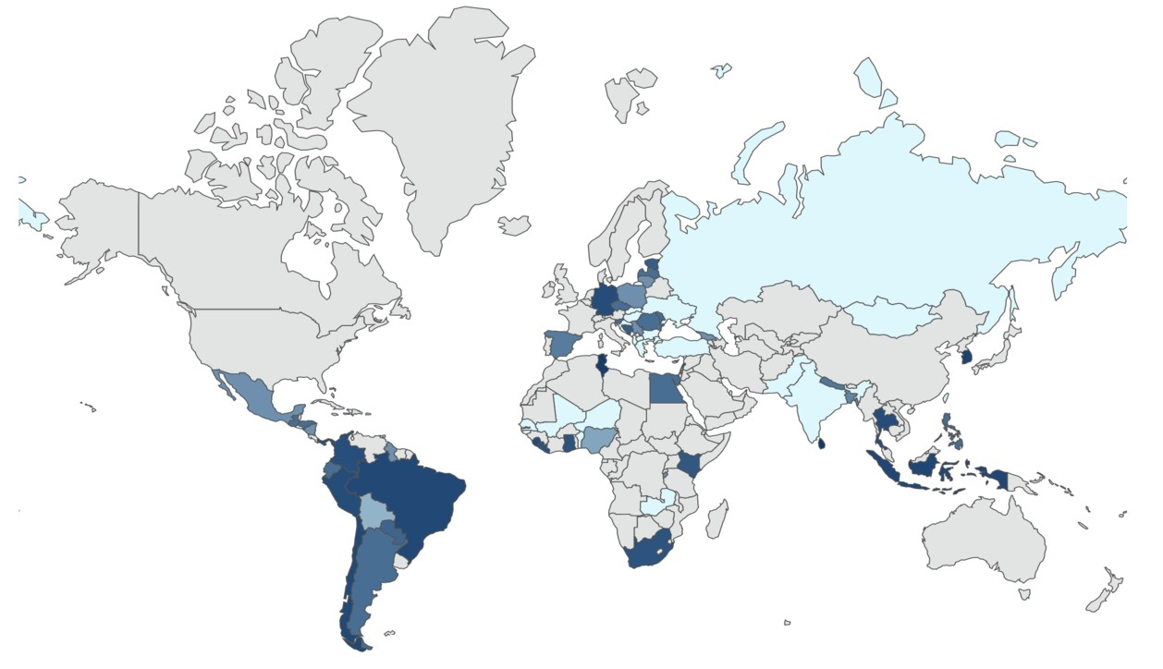

Figure 12: World Map of TJ Vetting of unknown collaborators-Volatility (Darker represents higher volatility)

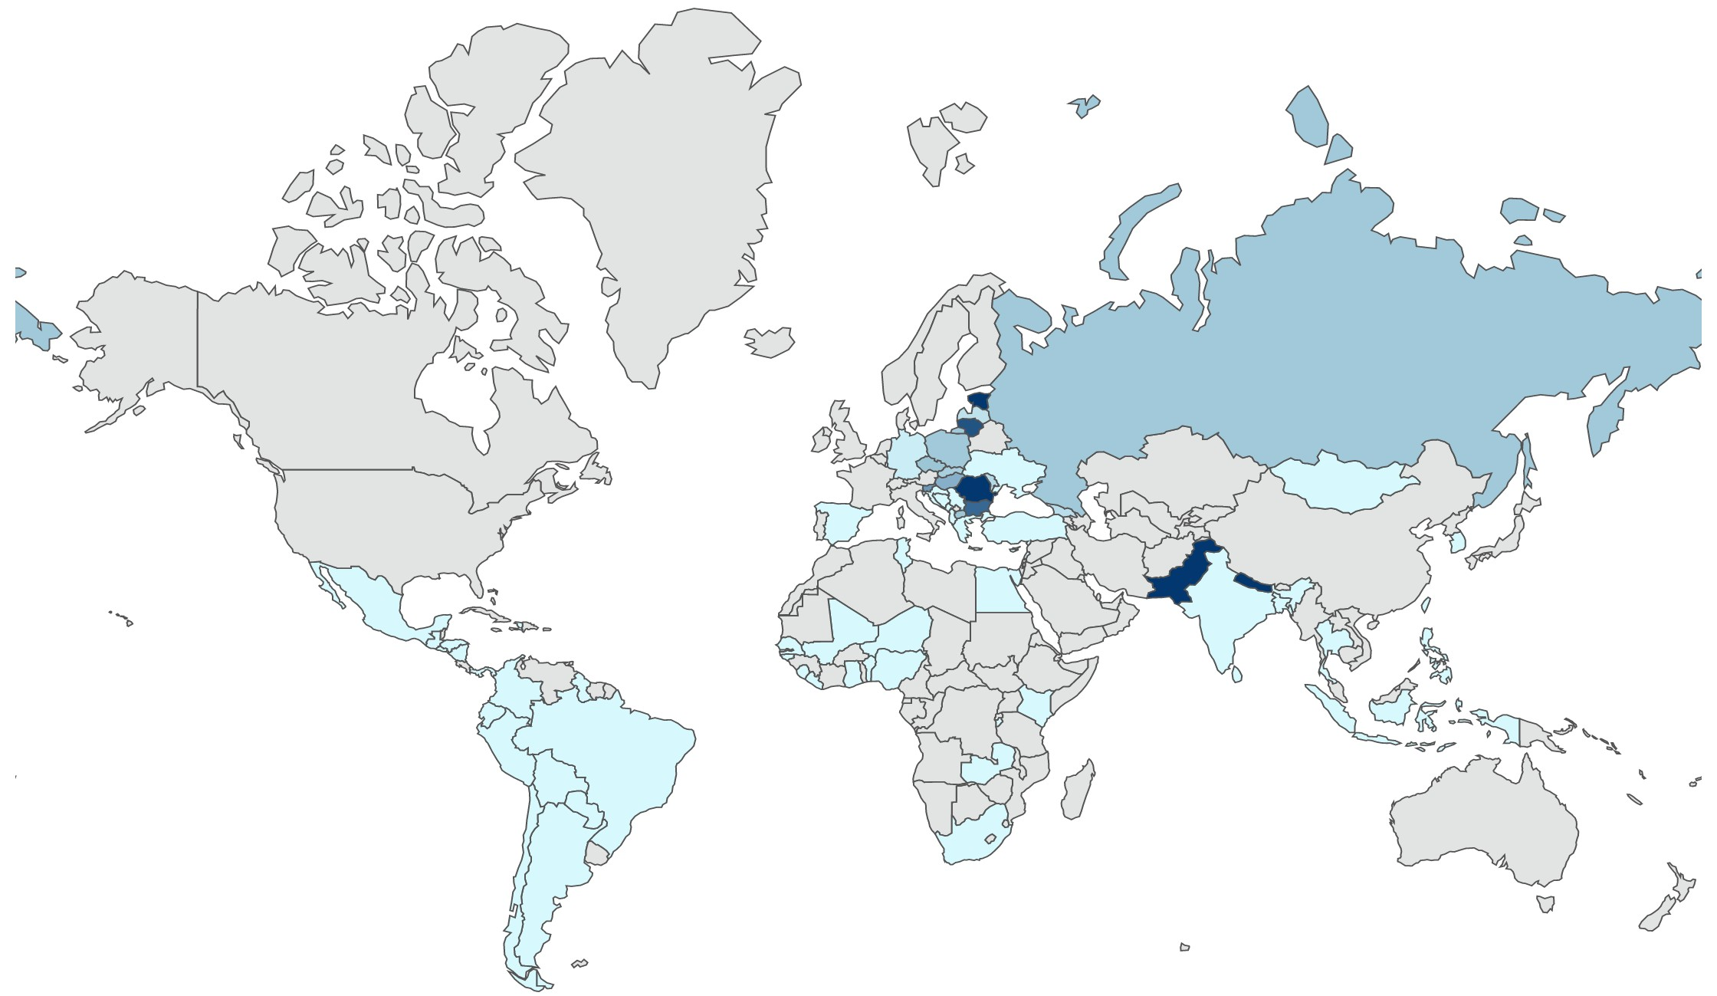

Figure 13: World Map of TJ Vetting of known collaborators-Volatility (Darker represents higher volatility)

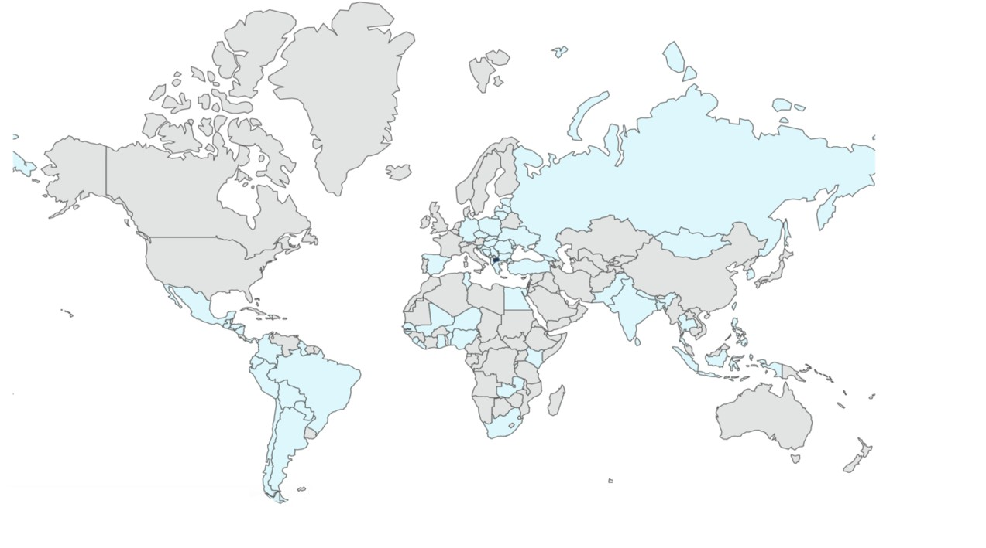

Figure 14: World Map of Purges-Volatility (Darker represents higher volatility)

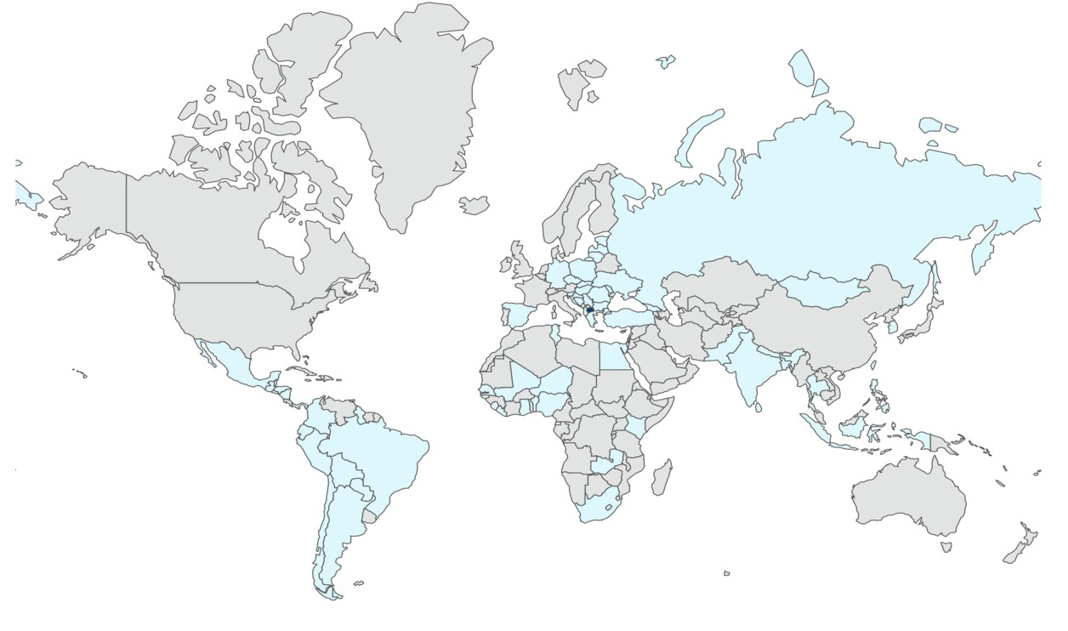

Figure 15: World Map of Truth Commissions-Volatility (Darker represents higher volatility)

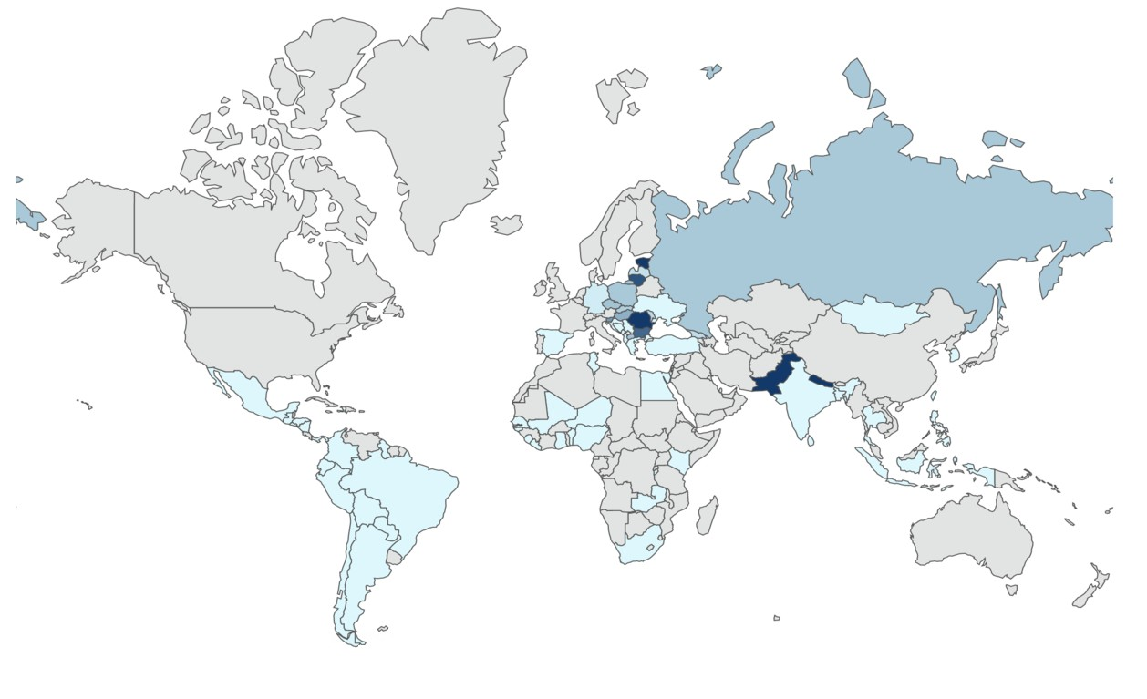

Figure 16: World Map of TJ Vetting of unknown collaborators-Urgency (Darker represents more urgent)

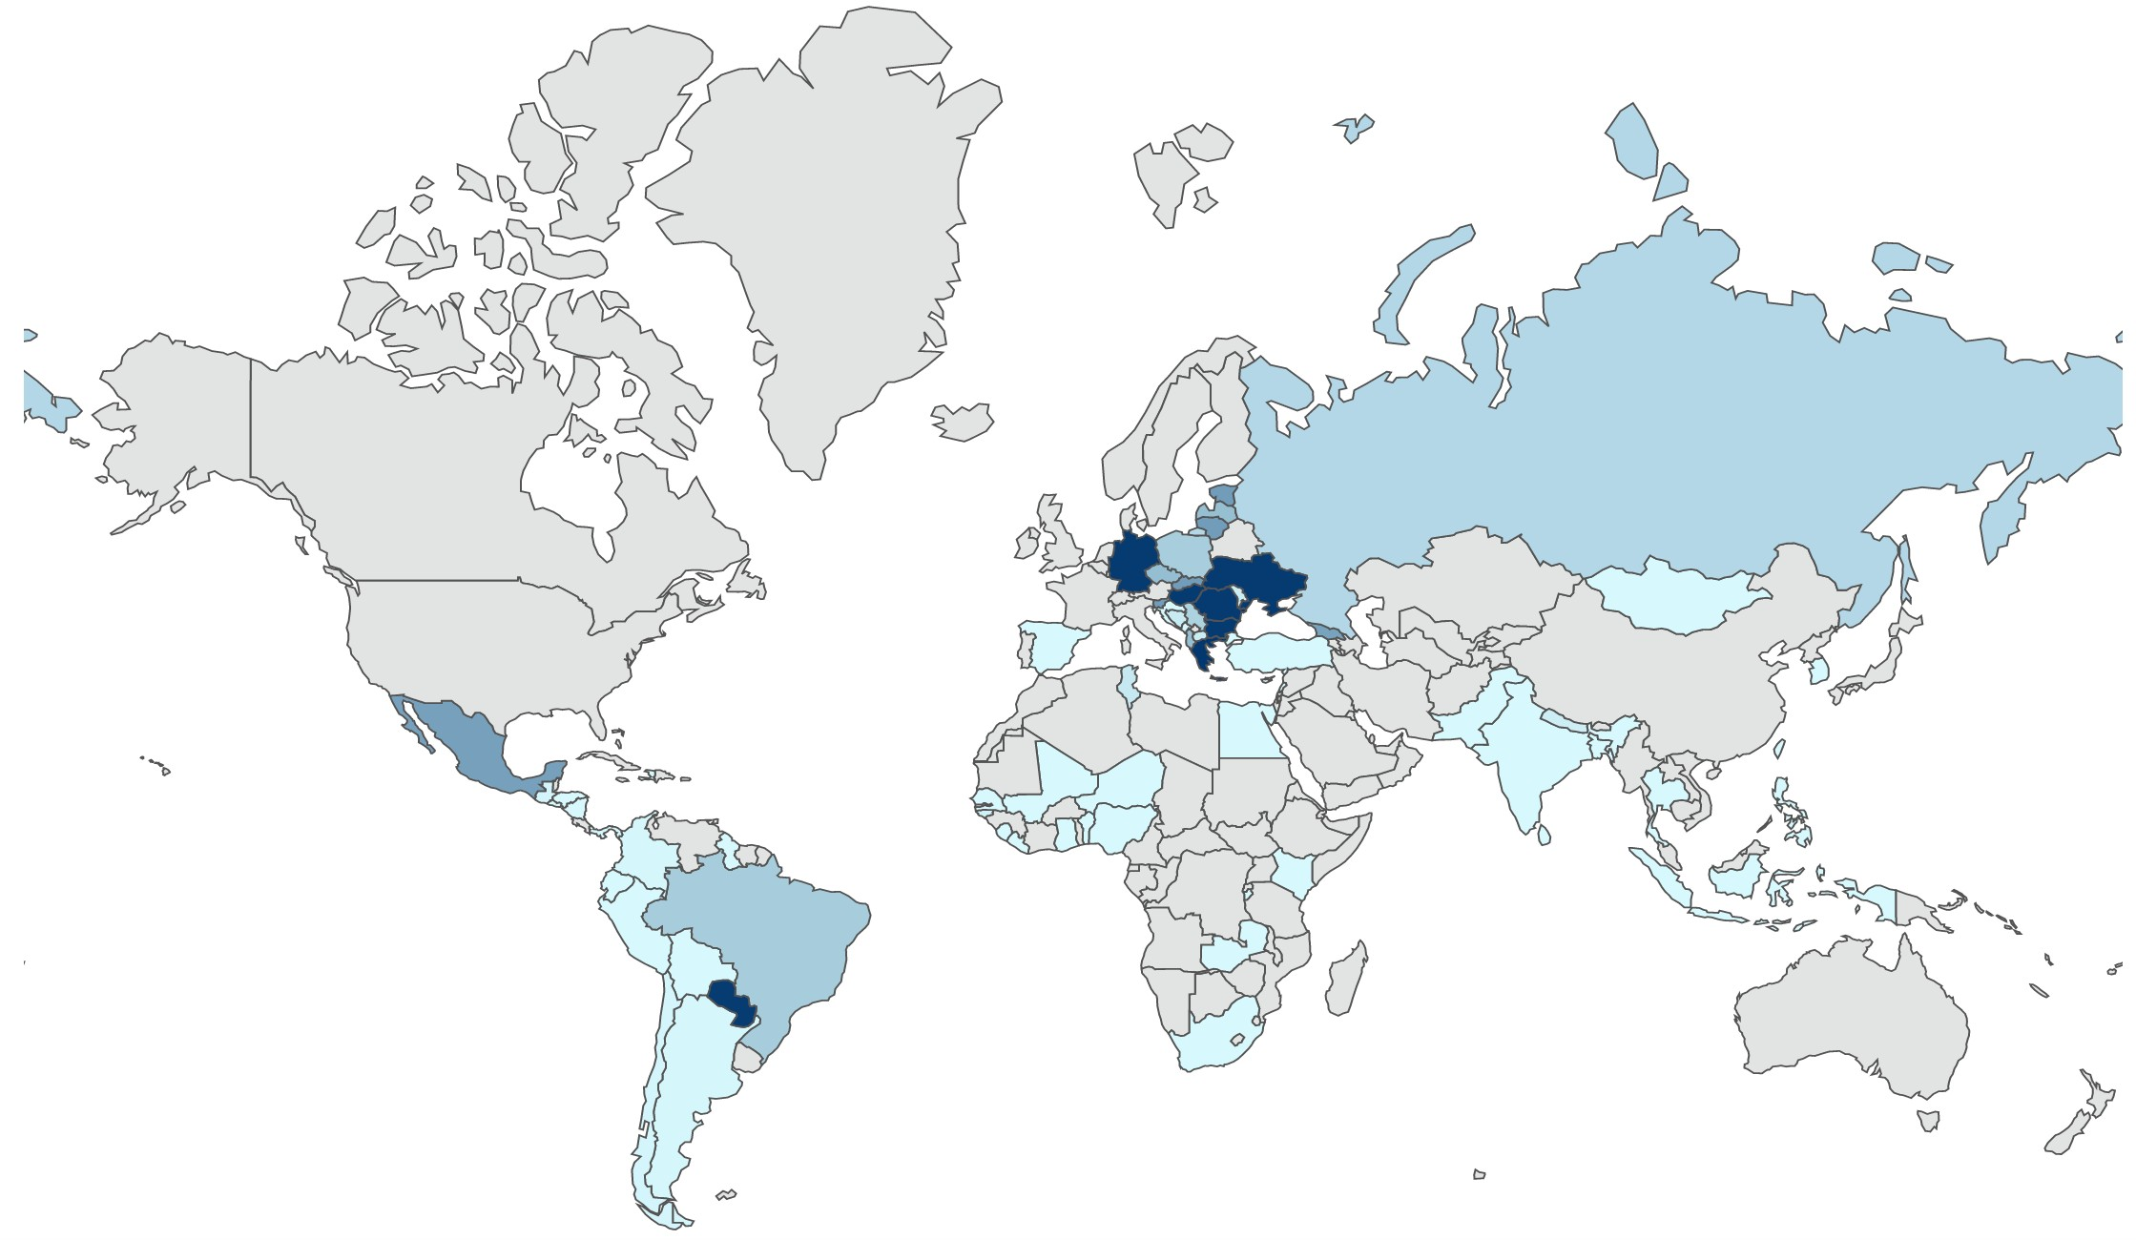

Figure 17: World Map of TJ Vetting of known collaborators-Urgency (Darker represents more urgent)

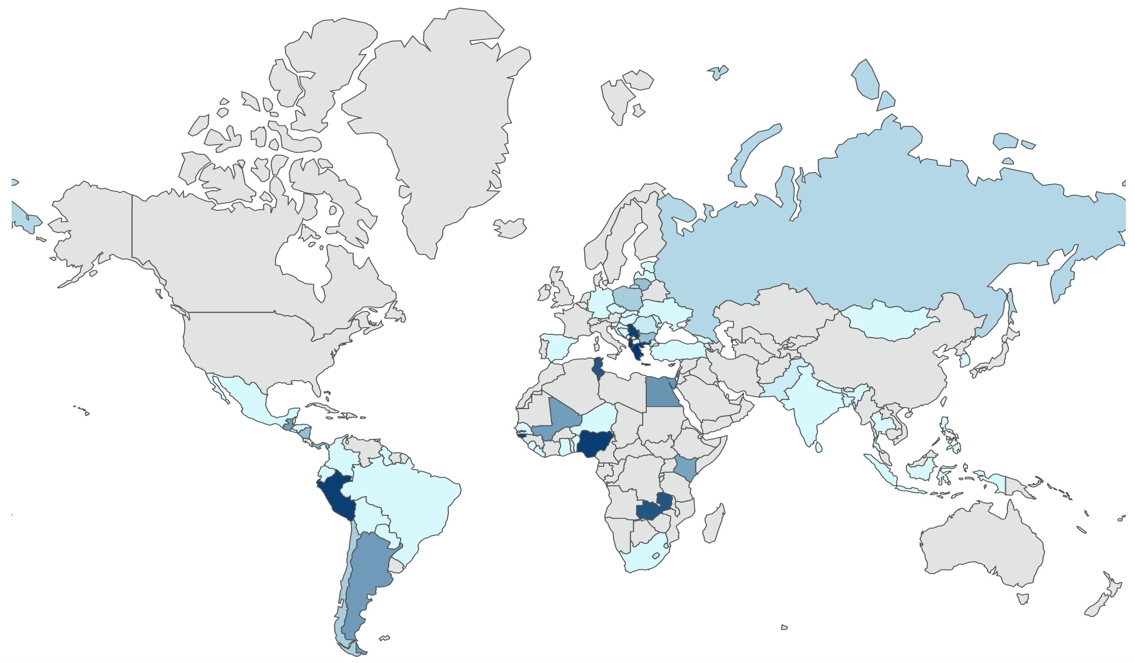

Figure 18: World Map of Purges-Urgency (Darker represents more urgent)

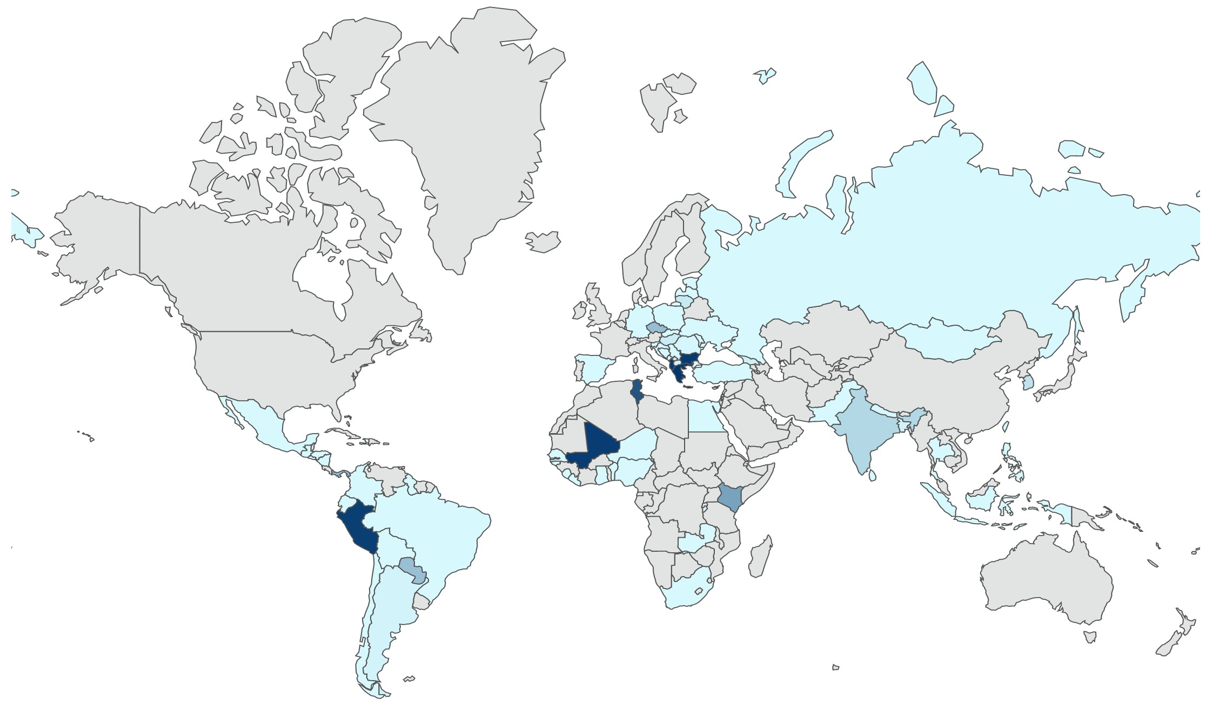

Figure 19: World Map of Truth Commissions-Urgency (Darker represents more urgent)

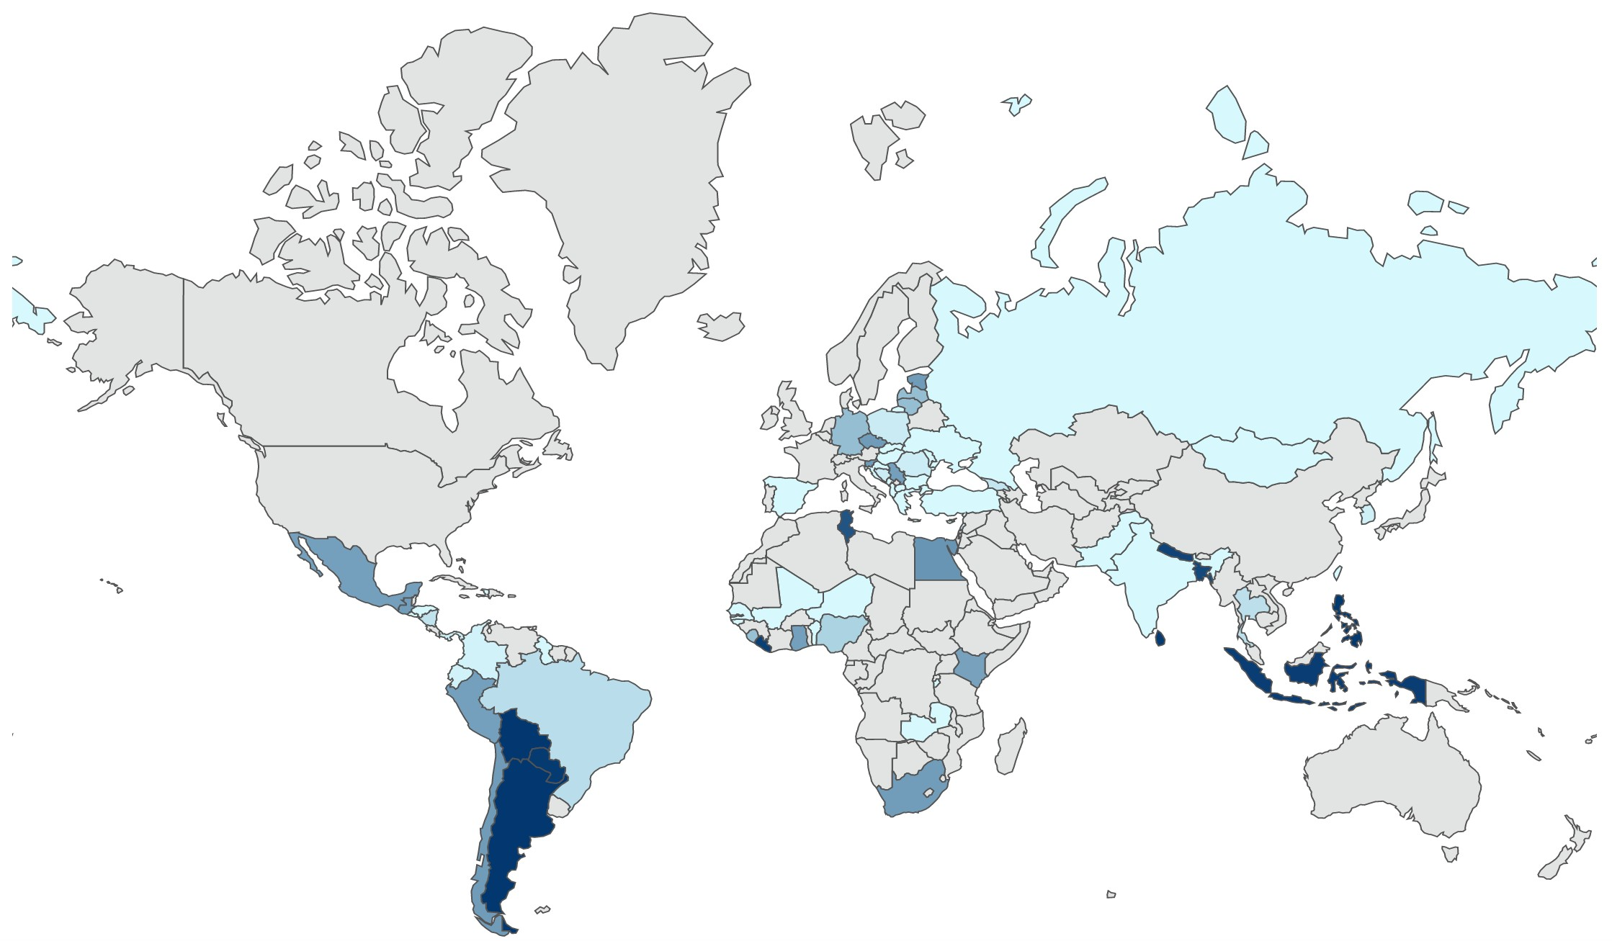

(Coppedge, Gerring, Lindberg, Skaaning, Teorell, Altman, Bernhard, Fish, Glynn, Hicken, Knutsen, Krusell, L uhrmann, Marquardt, McMann, Mechkova, Olin, Paxton, Pemstein, Pernes, Petrarca, von R omer, Saxer, Seim, Sigman, Staton, Stepanova & Wilson 2017), (Coppedge, Gerring, Lindberg, Skaaning, Teorell, David Altman, Fish, Glynn, Hicken, Knutsen, Marquardt, Kelly McMann, Paxton, Pemstein, Saxer, Seim, Sigman & Staton 2017).

