# Appendices

# “A Path out of Patriarchy: Political Agency and Social Identity of Women Fighters”

## Appendix A. Ethnicized Gender Inequality and Women’s Violent Mobilization in Turkey

Figure A. 1 visualizes two dimensions of gender inequality at the provincial level in Turkey: the ratio of teenage mothers (x-axis) and the average marriage age for women (y-axis). Provinces with darker circle have a higher ratio of Kurdish population; provinces represented by larger circles have a higher number of women militants. The figure shows that most Kurdish provinces (with the exception of Tunceli) have higher levels of gender inequality (located in the bottom-right side of the graph). It also suggests significant spatial variation in the number of women joining the insurgency.

Figure A.1. Two Dimensions of Patriarchy and Women’s Violent Mobilization in Turkey

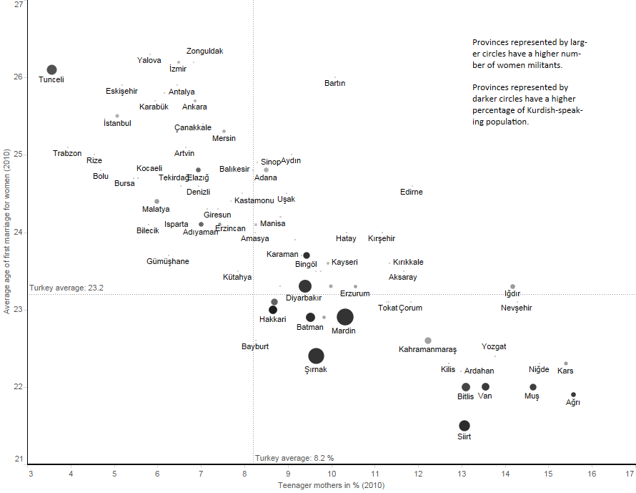

## Appendix B. PKK’s Gender Narrative during its Formative Years

Table B.1. Gender Equality Themed Essays in *Serxwebûn* (1982-1991)

|  |  |  |
| --- | --- | --- |
| Publication Year | Essays on Women’s  Question (Pages) | Contents |
| 1984 | 1 | An article about International Women’s Day |
| 1985 | 0 |  |
| 1986 | 0 |  |
| 1987 | 11 | A very long and multi-issue article titled “Women’s Rights and Freedom Problem” that pays special attention to women’s mobilization for the first time |
| 1988 | 6 | A very long and multi-issue article titled “Family, Women’s Rights and Freedom Problem in Kurdistan” that offers an extensive critique of women’s societal oppression |
| 1989 | 2.5 | An article titled “Family and the Women Question in Kurdistan and the Revolutionary Approach of our Party” addressing the challenges of mixed-gender guerilla army |
| 1990 | 3.5 | Öcalan’s speech that aims to replace the family with the party |
| 1991 | 4 | An article titled “Thoughts on the Women Question” suggesting that the only way out of patriarchy is via women’s active involvement in the struggle |

## Appendix C. In-Depth Interviews

The article utilizes information obtained from face-to-face in-depth interviews conducted during my fieldwork in Turkey (predominantly Kurdish parts and Istanbul) from 2012 to 2013. Four additional face-to-face interviews and a phone interview were conducted in 2016 and 2018. The research had the approval of the Institutional Review Board of XXX (project numbers 942 and SBE-18-13819). Most of the face-to-face interviews were with individuals who had family members involved in the PKK insurgency. These 73 interviews produced information about the life stories of 77 militants (including 20 women). An overwhelming majority of these militants already lost their lives by the time of interview. I have realized that my interviewees were more willing to talk about their deceased relatives. They exhibited more hesitation to talk about individuals who were still active in the insurgent ranks. I conducted most of the interviews in private settings in Turkish and occasionally in Kurmanjî and Zazaki dialects of Kurdish (in times with the help of translator trusted by the interviewee). Most interviews lasted between 45 minutes and 2 hours. In some cases, the conversations extended for much longer periods over a period of several weeks and months. I recruited my interviewees through associations established to help victims of political violence and personal connections to maximize variation in terms of geographical scope and temporal period.

Armed clashes between the Turkish security forces and the PKK continued to take place during the time of the interviews. The IRB approved my request for not obtaining written consent from the participants in the research project. Their consent was obtained orally. None of the interviews was audio recorded or videotaped for security reasons. I took extensive notes during my interviews and put these notes in a narrative format after the interview was completed (typically in the same evening).

The initiation of a series of negotiations between the Turkish government and the insurgency resulted in an extended truce from early 2013 to mid-2015. However, after the June 2015 parliamentary elections, the process collapsed and resulted in the re-intensification of violence in the country. It has become increasingly difficult for the scholars to carry out any type of research on the situation under the prevailing political circumstances. Being affiliated with the PKK is a crime carrying heavy penalties in Turkey. Many individuals were detained and imprisoned on terrorism charges. In fact, some of the individuals I interviewed were later arrested. For this reason, I have decided not to make English translations of my interviews publicly available. Even anonymized translations may contain information that can compromise the confidentiality of the interviewees and unintentionally generate risks for their well-beings.

Most of the interviewees were ethnic Kurds and citizens of Turkey. A majority of them was from lower and lower-middle classes and had limited means and educational capital. Some of them were subject to violent practices by state forces including forced evacuations, extended detentions and physical mistreatment. Almost none of them received any professional help addressing their trauma caused by exposure to political violence. Partially for this reason, they welcomed the opportunity to speak freely about their perceptions of the Kurdish conflict and the effects of this conflict on their family life.

Table C.1 In-Depth Interviews Cited in the Article

|  |  |  |
| --- | --- | --- |
| Interview Code | Interview Subject | Interview Date and Location |
| Interview I | Male | August 20, 2012, Chicago |
| Interview L | Mother of a deceased female militant | November 24, 2012, Istanbul |
| Interview LVII | Father of a deceased female militant | December 6, 2012, Diyarbakır |
| Interview LXII | Sister of a female militant | December 27, 2012, Istanbul |
| Interview LXIII | Parents of a deceased female militant | December 28, 2012, Istanbul |
| Interview LXIV | Parents of a deceased female militant | December 28, 2012, Istanbul |
| Interview LXVII | Sister of a female militant | July 11, 2013, Van |
| Interview LXX | Former male militant | September 13, 2016, phone interview |
| Interview LXXI | Former male militant commander | May 29-30, 2018, Dohuk |
| Interview LXXII | Former female militant | May 29-30, 2018, Dohuk |
| Interview LXXIII | Former female militant commander | May 31, 2018, Erbil |

## Appendix D. The KIM Dataset Supplementary Figures

Figure D.1. Birthplaces of Female PKK Militants

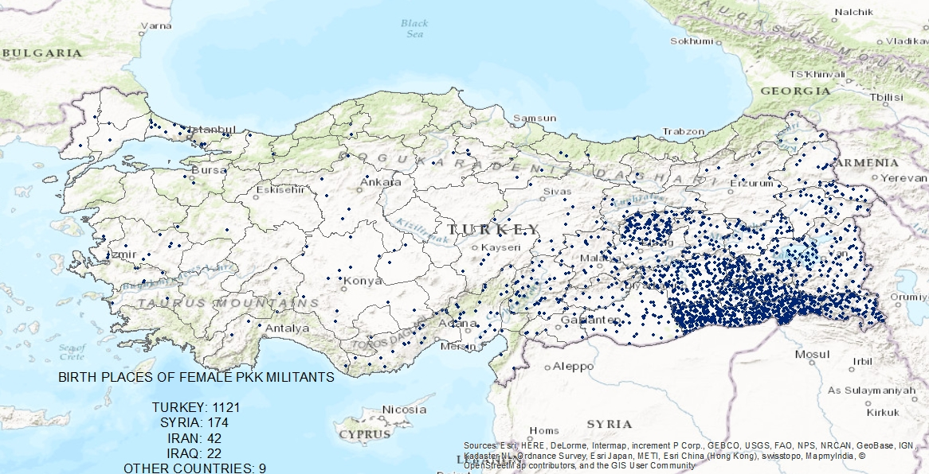

Source: KIM Dataset. Birthplaces of 17 out of 1,385 militants remain unknown. Around 82 percent of all female militants were born in Turkey. Proportionally speaking, more male militants were born in Turkey than females (20.3 and 18.6 percent, respectively), a difference that is not significant at *p* < 0.05.

Figure D.2. Education Levels and Location of Recruitment

Source: KIM Dataset. Numbers represent percentages for each education category in each LOR. Education information is available for 1,472 PKK militants (out of a sample of 9,193). Location of Recruitment information is available for 2,853 of them.

Figure D.3 Box Plots Showing Years Spent in Ranks for Female and Male PKK Militants

 Source: KIM Dataset (sample of 7,365 militants). Difference between years in ranks spent by female and male militants before their death is significant at *p*<0.001 level (one-tailed test). Median years in ranks for females and males are four and three, respectively.

## Appendix E. District Level Analysis

This section offers an investigation of the effect on gender inequality on insurgent recruitment at the aggregate level. The unit of analysis is the Kurdish populated districts of Turkey (n=189) observed at six different periods: 1) 1984-1989, the emergence of the insurgency, 2) 1990-1994, the peak years of the insurgency, 3) 1995-1999, the decline of the insurgency resulting in the capture of its leader, 4) 2000-2004, the ceasefire period with occasional clashes, 5) 2005-2012, the rekindling of the armed conflict, and 6) 2013-2016, the ceasefire period followed by the intensification of clashes by the summer of 2015.[1] Table E.1 provides summary statistics of the variables. The dependent variable, *Female Recruits*, is the number of female PKK militants born in a district in a period.[2]

[Table E.1 about here]

Measuring multiple dimensions of gender inequality including health, education, and political participation presents unique difficulties given data limitations. Two variables measure gender inequality. *Female Literacy Ratio*, the ratio of female to total literacy in a district in a given period, measures educational aspects of gender inequality. *Fertility* measures the dimension of gender inequality associated with classical patriarchy.[3] These variables are related to each other (c= -0.37), but represent two distinct dimensions of gender inequality.

A series of independent variables measuring political, socioeconomic, and historical factors are included in models to account for non-gendered dynamics of recruitment. *Kurdish Vote* measuresthe percentage of votes received by the Kurdish nationalists in the parliamentary elections in a district in a period.[4] *Clashes*, the number of killed insurgents, measures the intensity of armed conflict. *Rural Change* measures changes in the ratio of rural population across periods, as the state forces evacuated thousands of villages as a counterinsurgency strategy. *Previous Recruits* is the number of militants, both female and male, born in the district in the previous period. *Kurdish Population,* a time invariant variable,measures the ratio of Kurdish-speaking population to the general population in a district. Assimilation policies pursued by the Turkish state have been less successful in districts with a concentration of ethnic Kurds. The distinction between Kurdish Population and Kurdish Vote, another variable used to measure support for Kurdish nationalism, builds on the distinction between ethnic structure and practice.[5] *Rebellion* is a dummy variable that indicates whether the district had a repressed rebellion in the 1920s and 1930s.[6] *Rural Population* measures the level of development in a district in a given period due to the unavailability of more precise measurements of socioeconomic development.[7] Individuals from poorer districts would have lower opportunity costs to join the insurgency. In fact, joining the insurgency can be a vehicle of social mobility for these individuals. Finally, *Population* measures the log population of a district in a given period.[8]

Female Recruits takes values that range from 0 to 37. The variable has 871 zero (no recruits) out of 1,134 observations (Figure E.1). It also exhibits over-dispersion, with its variance more than 3 times the mean. These patterns suggest that excess zeros have a separate generation process that could be modeled by a zero-inflated negative binomial (ZINB) regression.[9] There are two types of units of analyses (district-time) with zero observations. Some of these units are likely to have no female recruits at all (structural zeros), while others have zero observations due to sampling issues. It can be plausibly argued that the former units would be the ones that are outside the conflict zone, have no history of militant recruitment, and lack significant levels of Kurdish electoral mobilization. Accordingly, these are the independent variables included in the logit equation (inflate) of a ZINB model.

[Table E.2 about here]

Table E.2 presents results from both ZINB regression (models I and II) and negative binomial regression (model III) for robustness purposes. Model I shows that increases in Female Literacy Ratio lead to a lower number of Female Recruits. When women gain greater educational opportunities, they become less likely to join the insurgency. At the same time, the coefficient of Fertility remains insignificant. Model II extends the ZINB regression to all six periods. Fertility and Rural Change are omitted since they lack observations in period 6 (2013-6). Results of Model II are very similar to Model III. The main variable measuring gender inequality, Female Literacy Ratio, is significant and negative.

[Figure E.2 about here]

A similar result emerges from NB regression (Model III). As visualized in Figure E.2 based on this model (for a figure based on Model I, see Figure E.3), a unit of analysis (district-period) with a Female Literacy Ratio in the 10th percentile (62 percent) has a predicted Female Recruits of 0.85. In contrast, a unit with a very high Female Literacy Ratio (93.5 percent) has predicted Female Recruits of only 0.31, a difference of 2.7 times. These results suggest that female fighter recruitment is shaped by the dynamics of gender inequality also at the aggregate level.

Table E. 1. Summary Statistics of Variables

|  |  |  |  |  |  |  |  |
| --- | --- | --- | --- | --- | --- | --- | --- |
| Variable | Description | N | Mean | SD | Min | Max | Sources |
| Female Recruits | Number of female militants | 1,323 | 0.53 | 1.81 | 0 | 30 | KIM dataset |
| Recruits | Number of militants | 1,323 | 3.7 | 9.9 | 0 | 129 | KIM dataset |
|  |  |  |  |  |  |  |  |
| Female Literacy Ratio | Ratio of female to male literacy | 1,134 | 60 | 19.4 | 5.1 | 93.5 | TUIK |
| Fertility | Average number of children per married women who are 12 years and older | 945 | 4.8 | 0.5 | 2.9 | 6 | TUIK |
| Clashes | Number of insurgents killed | 1,323 | 4.6 | 14.5 | 0 | 236 | KIM dataset |
| Kurdish Vote | % of valid votes received by pro-Kurdish parties and candidates | 1,323 | 23 | 23.4 | 0 | 97 | TUIK |
| Rural Change | Ratio of rural population change since the previous period | 945 | -3.84 | 8.4 | -50.2 | 55.2 | TUIK |
| Rural Population | Ratio of rural population | 1,134 | 61.4 | 19.6 | 2.9 | 94 | TUIK |
| Rebellion | Dummy variable, 1 if the district had rebellion in the 1920s and 1930s | 189 | 0.55 | 0.50 | 0 | 1 | Harp Tarihi Başkanlığı (1992) |
| Kurdish Population | % of residents whose native language is Kurdish | 189 | 47.7 | 22.8 | 11.7 | 81.9 | Mutlu (1996); Kibris (2015) |
|  |  |  |  |  |  |  |  |

Note: Not all variables have values for all 6 periods. Variables from the KIM dataset and Kurdish vote have values also for the pre-insurgency period of 1980-4. TUIK is the Turkish Statistical Institute ([www.tuik.gov.tr](http://www.tuik.gov.tr)).

Figure E.1. Histogram of the Dependent Variable



Note: Seventy-seven percent of observations have a value of 0.

Table E.2 Estimating Female Recruitment (1984-2012)

|  |  |  |  |
| --- | --- | --- | --- |
|  | Model I - ZINB | Model II - ZINB | Model III - NB |
| Previous Recruits | 0.02** (0.00) | 0.02*** (0.00) | 0.03*** (0.00) |
| Clashes | 0.01 (0.01) | 0.01* (0.00) | 0.02* (0.01) |
| Female Literacy Ratio | -0.01* (0.01) | -0.03*** (0.00) | -0.03*** (0.00) |
| Fertility | 0.21 (0.20) |  |  |
| Population (log) | 0.42*** (0.10) | 0.37*** (0.01) | 0.44*** (0.09) |
| Rural Population | 0.00 (0.00) | 0.00 (0.00) | -0.00 (0.00) |
| Rural Change | -0.03** (0.01) |  |  |
| Kurdish Vote | 0.03*** (0.00) | 0.02*** (0.00) | 0.03*** (0.00) |
| Kurdish Population | 0.01 (0.00) | 0.00 (0.00) | 0.01 (0.00) |
| Rebellion | -0.19 (0.19) | -0.14 (0.19) | -0.04 (0.19) |
| *Inflate* |  |  |  |
| Previous Recruits | -0.05 (0.07) | -0.11 (0.10) |  |
| Militant Deaths | -1.92 (2.63) | -1.98 (1.35) |  |
| Rural Change | -0.06 (0.04) |  |  |
| Kurdish Vote | 0.01 (0.02) | 0.91 (0.43) |  |
| Lnalpha | -0.13 (0.23) | 0.35 (0.18) | 0.55 (0.15) |
| Wald chi-square | 234.6 | 224.7 | 386.3 |
| AIC | 1515.8 | 1716.7 | 1784.3 |
| N | 945 | 1,134 | 1,134 |

Robust standard errors clustered around districts in parentheses. Significance level: *0.05; **0.01; ***0.001.

Figure E.2 The Effect of Female Literacy Ratio on Female Insurgent Recruitment (Model II)



Other variables held at mean values. Predictions based on Model II of Table D.2.

Figure E.3 The Effect of Female Literacy Ratio on Female Insurgent Recruitment (Model I)



Other variables held at mean values. Predictions based on Model I of Table E.2.

## Bibliography

Caldwell, John C. 1978. “A Theory of Fertility: From High Plateau to Destabilization.” *Population and Development Review* 4: 553-77.

Chandra, Kanchan, and Steven Wilkinson. 2008. “Measuring the Effect of “Ethnicity.” *Comparative Political Studies* 41(4-5): 515-63.

Harp Tarihi Başkanlığı. 1992. *Genelkurmay Belgelerinde Kürt İsyanları*. 3 Volumes. İstanbul: Kaynak.

Kibris, Arzu, 2015. “The Conflict Trap Revisited: Civil Conflict and Educational Achievement.” *Journal of Conflict Resolution* 5(4): 645-70.

Long, J. Scott and Jeremy Freese. 2006. *Regression Models for Categorical Dependent Variables Using Stata*. 2nd ed. College Station, TX: Stata Press.

Mutlu, Servet. 1996. “Ethnic Kurds in Turkey: A Demographic Study.” *International Journal of Middle East Studies* 28(4): 517-41.

Pecency Mark, and William D. Stanley. 2010. “Counterinsurgency in El Salvador.” *Politics & Society* 38(1): 67-94.

1. Districts (n=957) are the smallest administrative units in Turkey. All districts having more than 10 percent Kurdish population are included in the analysis (covering more than 92% of all female militants born in Turkey in the KIM dataset).
2. An alternate dependent variable could be the ratio of female to male militants in an observation. However, this variable runs into a significant several problem. It is not possible to calculate the ratio for many observations with no recorded militants.
3. Caldwell 1978.
4. For the period 6 (2005-12), the average of the vote received by the Kurdish candidates in the 2007 and 2011 elections is used. For the period 7 (2013-16), the average of the vote received by the HDP in the June and November 2015 elections is used.
5. Chandra and Wilkinson 2008.
6. Memories of past state violence orally transmitted across generations may contribute to contemporary violent mobilization. Pecency and Stanley 2010, 69.
7. Literacy is an alternative measure but very highly correlated with Female Literacy Ratio (c= 0.83).
8. It is log transformed since it has a positively skewed distribution.
9. Long and Freese 2006. A significant z-test (the Vuong test) suggests ZINB over the standard negative binomialmodel, and a significant likelihood ratio test of alpha=0 suggests ZINB over zero-inflated Poisson regression.