**Is There a Trump Effect? An Experiment on Political Polarization and Audience Costs**

*Supplementary Online Appendix*

**Contents**

*Appendix A: Sample Characteristics*

*Appendix B: Balance Across Treatments*

*Appendix C: Robustness Checks*

*Appendix D: Hypothetical Vignette Check*

*Appendix E: Survey*

**Appendix A: Sample Characteristics**

The MTurk sample skews considerably younger, more educated, and liberal consistent with other research on the demographic characteristics of MTurk survey participants.

Table 1: Survey sample characteristics (MTurk)

|  |  |  |
| --- | --- | --- |
|  | **Freq.** | **%** |
| **Gender** |  |  |
| Male | 922 | 46.31 |
| Female | 1069 | 53.69 |
| **Education** |
| High School | 177 | 8.89 |
| Some College | 671 | 33.70 |
| College Degree | 793 | 39.83 |
| Post-graduate Degree | 350 | 17.58 |
| **Age** |
| 19-29 | 598 | 30.04 |
| 30-44 | 827 | 41.54 |
| 44-65 | 483 | 24.26 |
| 65+ | 83 | 4.17 |
| **Race** |
| White | 1533 | 77.15 |
| African American | 163 | 8.20 |
| American Indian | 16 | 0.81 |
| Asian | 123 | 6.19 |
| Hispanic | 88 | 4.43 |
| Mixed Ethnicity | 50 | 2.52 |
| Other | 14 | 0.70 |
| **Voting** |
| Trump | 553 | 27.77 |
| Clinton | 913 | 45.86 |
| Other | 240 | 12.05 |
| Did not Vote | 285 | 14.31 |
| **Party** |
| Strong Republican | 199 | 9.99 |
| Weak Republican | 190 | 9.54 |
| Independent Lean Republican | 230 | 11.55 |
| Independent | 302 | 15.17 |
| Independent Lean Democrat | 372 | 18.68 |
| Weak Democrat | 302 | 15.17 |
| Strong Democrat | 396 | 19.89 |
| **Interest** |
| Not interested | 92 | 4.62 |
| Slightly interested | 481 | 24.16 |
| Moderately interested | 502 | 25.21 |
| Very interested | 324 | 16.27 |
| Extremely interested | 592 | 29.73 |

**Appendix B: Balance across treatments**

The figures below show the composition of respondents within each treatment group for the survey experiment. The randomization achieved a well-balanced sample across treatment conditions

Figure 1: Balance Across Generic President Treatments



Figure 2: Balance Across Obama Treatments



Figure 3: Balance Across Trump Treatments



**Appendix C: Robustness Checks**

A two-way ANOVA was run on participants in who received one of the Trump treatments to examine the effect of the treatments and party on approval toward Trump. There was no significant interaction between the effects of treatment and party on approval, F(2, 492) = 0.27, p = .76. There is also no significant interaction effect for the generic president and Obama treatments.

Table 1 shows the effect of the treatments across only individuals who said they voted for either Hillary Clinton or Donald Trump. The results are nearly identical to the partisan models presented in the body of the text.

Table 2 shows the effect of the treatments with a continuous measure of partisanship that includes independent in the analysis. The results come to the same substantive conclusion as the results presented in the main text. Moreover, Figures 4 and 5 illustrate the interaction effect, demonstrating that there are no heterogeneous effects across party affiliation.

Table 3 shows the effect of the treatments while controlling for non-voters.

Table 4 shows the effect of the treatments on only voters.

Table 5 controls for political awareness.

Table 6 controls for political awareness while limiting the sample to only voters.

Table 7 examines the effect of the treatments on the full sample that doesn’t exclude individuals who failed the manipulation checks.

All these alternative specifications demonstrate that the null interaction with partisanship is robust.

Our surveys included causal mediation questions gauging: (1) perceptions of the president’s competency in foreign policy; (2) perceptions of America’s reputation on the international stage; (3) perceptions that the U.S. follows through on its commitments; and (4) perceptions on the morality of the president’s foreign policy decisions. In addition to our main finding that partisan affiliation does not affect whether citizens impose audience costs, the causal mediation models provide initiation insights on why citizens impose audience costs (Imai et al 2011; Imai and Yamamoto 2013). As with the models presented in the main text, each of the causal mediation models includes controls for *Party ID, Political Awareness, Race, Gender, Age and Education*. In all of the following causal mediation tables, the Average Causal Mediation Effect (ACME) indicates the size of the treatment effect on the dependent variable (*approval*) that specifically flows through the listed mediator (*competence*, *reputation*, *credibility*, or *morals*). The Average Direct Effect (ADE)—which is orthogonal to the ACME—shows the direct effect that the treatment has on the dependent variable (*approval*), or in other words the effect of the treatment that does not flow through the listed mediator.

Figure 6 shows causal mediation results on the extent to which competence, reputation, credibility and morality mediate the effect of the *back down* treatment on *approval* for each leader (“The President”, Barack Obama and Donald Trump).

Figure 7 shows causal mediation results for the *justify* treatment.

Figure 8 shows *moderated* causal mediation results on the extent to which competence, reputation, credibility and morality mediate the effect of the *back down* treatment on *approval* for each leader (“The President”, Barack Obama and Donald Trump). Moderated causal mediation allows us to separate the ADE and ACME according to pre-treatment covariates, and we use this to show that the mediation results do not significantly differ between Democrats and Republicans.

Figure 9 shows the *moderated* causal mediation results for the *justify* treatment.

Figure 10 shows the *moderated* causal mediation results on the extent to which *belligerence costs* mediate the effect of the *back down* treatment on *approval* for each leader. We coded belligerence costs as a dummy variable using respondents’ answers to the following question, asked after measuring the dependent variable: “*Could you please type a few sentences telling us why you approve/disapprove of the way the US president handled the situation?*” Any respondents who based their reasoning on opposition to the issuance of the threat or opposition to U.S. intervention abroad were coded as having imposed belligerence costs. We acknowledge that this method of measuring belligerence costs is far from ideal, as: (1) it is *post hoc*, while Kertzer and Brutger 2016 show that the better way to separate out belligerence costs is to include a separate “Follow Through” treatment condition; and (2) we cannot be certain what number of respondents may have actually imposed belligerence costs, but did not explicitly vocalize this logic in their answers.

When interpreting Figure 5, the Average Causal Mediation Effect (ACME) indicates the size of the *back down* treatment effect that specifically flows through the mediator of *belligerence costs*. The Average Direct Effect (ADE), by contrast, shows the size of the *back down* treatment effect that does not flow through belligerence—as the ADE is orthogonal to the ACME. This means that the ADE represents the size of audience costs with the effect of belligerence subtracted out. Figure 5 gives some preliminary evidence that there is not a partisan division in the imposition of belligerence costs or inconsistency costs (when these effects are disaggregated), and that the size of these costs is not significantly different for Donald Trump, Barack Obama, or the generic leader (“The President”).

**Table 1: Influence of Backing Down and Justification Across Clinton/Trump**

|  |  |  |  |  |  |  |
| --- | --- | --- | --- | --- | --- | --- |
|  | President |  | Obama |  | Trump |  |
|  | *ß* | *SE* | *ß* | *SE* | *ß* | *SE* |
| Back Down | -1.31* | (0.21) | -1.19* | (0.25) | -1.43* | (0.19) |
| Justify | -0.29 | (0.24) | -0.39 | (0.26) | -0.07 | (0.21) |
| Clinton | -0.12 | (0.20) | 0.22 | (0.20) | -0.59* | (0.18) |
| Back Down X Clinton | 0.41 | (0.26) | 0.27 | (0.30) | 0.42 | (0.25) |
| Justify X Clinton | 0.30 | (0.30) | 0.37 | (0.31) | 0.19 | (0.27) |
| Some College | 0.21 | (0.21) | -0.18 | (0.24) | -0.16 | (0.23) |
| College Degree | 0.18 | (0.21) | -0.38 | (0.23) | -0.18 | (0.22) |
| Post-graduate Degree | -0.06 | (0.23) | -0.25 | (0.25) | -0.25 | (0.23) |
| Age | -0.00 | (0.00) | -0.00 | (0.00) | -0.01 | (0.00) |
| Female | 0.12 | (0.11) | 0.14 | (0.11) | -0.04 | (0.11) |
| White | -0.11 | (0.15) | -0.32* | (0.13) | -0.06 | (0.13) |
| Interest in Politics | -0.07 | (0.04) | -0.02 | (0.05) | -0.00 | (0.04) |
| Constant | 3.73* | (0.36) | 3.84* | (0.36) | 4.13* | (0.32) |
| Observations | 416 |  | 414 |  | 421 |  |
| R-Squared | .2 |  | .21 |  | .25 |  |

Robust standard errors in parentheses. * *p* < 0.05

*Note:* Sample only includes individuals who passed reading checks to ensure proper treatment. Results

robust to no controls. Interaction effects demonstrate that the Clinton and Trump Voters do not punish co-partisans differently than Presidents from their own party.

**Table 2: Influence of Backing Down and Justification Across Party Continuous Measure**

|  |  |  |  |  |  |  |
| --- | --- | --- | --- | --- | --- | --- |
|  | President |  | Obama |  | Trump |  |
|  | *ß* | *SE* | *ß* | *SE* | *ß* | *SE* |
| Back Down | -1.33* | (0.22) | -1.00* | (0.27) | -1.36* | (0.21) |
| Justify | -0.23 | (0.26) | -0.19 | (0.28) | -0.23 | (0.24) |
| Party | -0.00 | (0.04) | 0.12* | (0.04) | -0.12* | (0.04) |
| Back Down X Party | 0.06 | (0.05) | 0.00 | (0.06) | 0.07 | (0.06) |
| Justify X Party | 0.05 | (0.06) | 0.03 | (0.06) | 0.08 | (0.06) |
| Some College | 0.04 | (0.18) | -0.11 | (0.18) | -0.18 | (0.18) |
| College Degree | -0.02 | (0.18) | -0.38* | (0.18) | -0.19 | (0.18) |
| Post-graduate Degree | -0.28 | (0.20) | -0.29 | (0.19) | -0.34 | (0.19) |
| Age | -0.00 | (0.00) | -0.00 | (0.00) | -0.01 | (0.00) |
| Female | 0.15 | (0.09) | 0.05 | (0.10) | 0.03 | (0.09) |
| White | -0.10 | (0.12) | -0.22* | (0.11) | -0.05 | (0.11) |
| Interest in Politics | -0.05 | (0.04) | -0.04 | (0.04) | -0.03 | (0.03) |
| Constant | 3.72* | (0.31) | 3.71* | (0.31) | 4.32* | (0.27) |
| Observations | 555 |  | 559 |  | 585 |  |
| R-Squared | .21 |  | .21 |  | .22 |  |

Robust standard errors in parentheses. * *p* < 0.05

*Note:* Sample only includes individuals who passed reading checks to ensure proper treatment. Results

robust to no controls. Party is a continuous variable with ranging from 1 “Strong Republican” to 7 “Strong Democrat”.

**Figure 4: Trump Treatment - Influence of Backing Down and Justification Across Party Continuous**



**Figure 5: Obama Treatment - Influence of Backing Down and Justification Across Party Continuous**



**Table 3: Influence of Backing Down and Justification Across Presidents with Control for Non-Voters**

|  |  |  |  |  |  |  |
| --- | --- | --- | --- | --- | --- | --- |
|  | President |  | Obama |  | Trump |  |
|  | *ß* | *SE* | *ß* | *SE* | *ß* | *SE* |
| Back Down | -1.28* | (0.19) | -1.24* | (0.23) | -1.19* | (0.18) |
| Justify | -0.20 | (0.23) | -0.19 | (0.24) | 0.06 | (0.19) |
| Democrat | -0.05 | (0.18) | 0.40* | (0.18) | -0.36* | (0.16) |
| Back Down X Democrat | 0.26 | (0.23) | 0.33 | (0.26) | 0.18 | (0.23) |
| Justify X Democrat | 0.32 | (0.28) | 0.16 | (0.28) | 0.06 | (0.25) |
| Some College | 0.16 | (0.18) | 0.08 | (0.21) | -0.06 | (0.21) |
| College Degree | 0.02 | (0.18) | -0.14 | (0.20) | -0.05 | (0.20) |
| Post-graduate Degree | -0.19 | (0.20) | -0.16 | (0.21) | -0.18 | (0.21) |
| Age | -0.01 | (0.00) | -0.00 | (0.00) | -0.01 | (0.00) |
| Female | 0.19 | (0.10) | 0.11 | (0.10) | 0.00 | (0.10) |
| White | -0.14 | (0.13) | -0.15 | (0.11) | 0.06 | (0.12) |
| Interest in Politics | -0.03 | (0.04) | -0.05 | (0.04) | -0.01 | (0.04) |
| Did not Vote in 2016 Election | -0.21 | (0.15) | 0.22 | (0.15) | 0.18 | (0.15) |
| Constant | 3.69* | (0.32) | 3.55* | (0.33) | 3.76* | (0.30) |
| Observations | 467 |  | 489 |  | 498 |  |
| R-Squared | .23 |  | .23 |  | .22 |  |

Robust standard errors in parentheses. * *p* < 0.05

*Note:* Sample only includes individuals who passed reading checks to ensure proper treatment. Results

robust to no controls. Interaction effects demonstrate that the Democrats and Republicans do not punish co-partisans differently than Presidents from their own party. Control for non-voters in the 2016 election.

**Table 4: Influence of Backing Down and Justification Across Presidents Limited to Voters Only**

|  |  |  |  |  |  |  |
| --- | --- | --- | --- | --- | --- | --- |
|  | President |  | Obama |  | Trump |  |
|  | *ß* | *SE* | *ß* | *SE* | *ß* | *SE* |
| Back Down | -1.27* | (0.21) | -1.13* | (0.24) | -1.20* | (0.19) |
| Justify | -0.26 | (0.25) | -0.23 | (0.25) | 0.14 | (0.20) |
| Democrat | 0.03 | (0.20) | 0.40* | (0.19) | -0.28 | (0.17) |
| Back Down X Democrat | 0.25 | (0.25) | 0.14 | (0.28) | 0.12 | (0.25) |
| Justify X Democrat | 0.33 | (0.30) | 0.17 | (0.29) | -0.13 | (0.26) |
| Some College | 0.14 | (0.19) | 0.05 | (0.25) | -0.12 | (0.24) |
| College Degree | -0.00 | (0.19) | -0.14 | (0.24) | -0.10 | (0.24) |
| Post-graduate Degree | -0.21 | (0.21) | -0.12 | (0.25) | -0.18 | (0.25) |
| Age | -0.00 | (0.00) | -0.00 | (0.00) | -0.01 | (0.00) |
| Female | 0.11 | (0.11) | 0.11 | (0.11) | -0.08 | (0.11) |
| White | -0.19 | (0.15) | -0.20 | (0.12) | 0.00 | (0.13) |
| Interest in Politics | -0.06 | (0.04) | -0.04 | (0.04) | -0.01 | (0.04) |
| Constant | 3.74* | (0.35) | 3.55* | (0.36) | 3.89* | (0.33) |
| Observations | 415 |  | 433 |  | 442 |  |
| R-Squared | .23 |  | .21 |  | .23 |  |

Robust standard errors in parentheses. * *p* < 0.05

*Note:* Sample only includes individuals who passed reading checks to ensure proper treatment. Results

robust to no controls. Interaction effects demonstrate that the Democrats and Republicans do not punish co-partisans differently than Presidents from their own party. Sample limited to voters in the 2016 Election.

**Table 5: Influence of Backing Down and Justification Across Presidents with Political Awareness Control**

|  |  |  |  |  |  |  |
| --- | --- | --- | --- | --- | --- | --- |
|  | President |  | Obama |  | Trump |  |
|  | *ß* | *SE* | *ß* | *SE* | *ß* | *SE* |
| Back Down | -1.29* | (0.19) | -1.22* | (0.22) | -1.21* | (0.18) |
| Justify | -0.15 | (0.23) | -0.22 | (0.24) | 0.06 | (0.19) |
| Democrat | -0.02 | (0.18) | 0.40* | (0.18) | -0.37* | (0.16) |
| Back Down X Democrat | 0.28 | (0.23) | 0.33 | (0.26) | 0.20 | (0.23) |
| Justify X Democrat | 0.27 | (0.28) | 0.17 | (0.28) | 0.07 | (0.25) |
| Some College | 0.21 | (0.18) | 0.10 | (0.21) | -0.07 | (0.20) |
| College Degree | 0.07 | (0.18) | -0.09 | (0.20) | -0.05 | (0.20) |
| Post-graduate Degree | -0.10 | (0.20) | -0.09 | (0.21) | -0.14 | (0.21) |
| Age | -0.00 | (0.00) | -0.00 | (0.00) | -0.00 | (0.00) |
| Female | 0.13 | (0.11) | 0.04 | (0.10) | -0.03 | (0.10) |
| White | -0.11 | (0.14) | -0.11 | (0.11) | 0.03 | (0.12) |
| Interest in Politics | -0.02 | (0.04) | -0.04 | (0.04) | -0.01 | (0.04) |
| Political Awareness | -0.53* | (0.25) | -0.74* | (0.25) | -0.49 | (0.26) |
| Constant | 3.75* | (0.33) | 3.85* | (0.32) | 4.03* | (0.30) |
| Observations | 467 |  | 489 |  | 498 |  |
| R-Squared | .24 |  | .24 |  | .23 |  |

Robust standard errors in parentheses. * *p* < 0.05

*Note:* Sample only includes individuals who passed reading checks to ensure proper treatment. Results

robust to no controls. Interaction effects demonstrate that the Democrats and Republicans do not punish co-partisans differently than Presidents from their own party. Control for Political Awareness.

**Table 6: Influence of Backing Down and Justification Across Presidents with Political Awareness Control and Limited to Voters**

|  |  |  |  |  |  |  |
| --- | --- | --- | --- | --- | --- | --- |
|  | President |  | Obama |  | Trump |  |
|  | *ß* | *SE* | *ß* | *SE* | *ß* | *SE* |
| Back Down | -1.30* | (0.21) | -1.14* | (0.24) | -1.22* | (0.19) |
| Justify | -0.23 | (0.25) | -0.24 | (0.25) | 0.13 | (0.20) |
| Democrat | 0.04 | (0.20) | 0.40* | (0.19) | -0.27 | (0.17) |
| Back Down X Democrat | 0.28 | (0.25) | 0.15 | (0.28) | 0.13 | (0.25) |
| Justify X Democrat | 0.32 | (0.30) | 0.16 | (0.29) | -0.12 | (0.26) |
| Some College | 0.21 | (0.19) | 0.08 | (0.25) | -0.10 | (0.24) |
| College Degree | 0.07 | (0.19) | -0.08 | (0.24) | -0.07 | (0.24) |
| Post-graduate Degree | -0.11 | (0.21) | -0.04 | (0.25) | -0.12 | (0.25) |
| Age | -0.00 | (0.00) | 0.00 | (0.00) | -0.00 | (0.00) |
| Female | 0.04 | (0.11) | 0.05 | (0.11) | -0.11 | (0.11) |
| White | -0.16 | (0.15) | -0.16 | (0.12) | 0.01 | (0.13) |
| Interest in Politics | -0.05 | (0.04) | -0.03 | (0.04) | -0.00 | (0.04) |
| Political Awareness | -0.55* | (0.27) | -0.70* | (0.27) | -0.44 | (0.28) |
| Constant | 3.88* | (0.36) | 3.78* | (0.38) | 4.02* | (0.34) |
| Observations | 415 |  | 433 |  | 442 |  |
| R-Squared | .24 |  | .22 |  | .23 |  |

Robust standard errors in parentheses. * *p* < 0.05

*Note:* Sample only includes individuals who passed reading checks to ensure proper treatment. Results

robust to no controls. Interaction effects demonstrate that the Democrats and Republicans do not punish co-partisans differently than Presidents from their own party. Sample limited to voters in the 2016 Election and control for political awareness.

**Table 7: Influence of Backing Down and Justification – Full Sample (Including Respondents who Passed & Failed Manipulation Checks)**

|  |  |  |  |  |  |  |
| --- | --- | --- | --- | --- | --- | --- |
|  | President |  | Obama |  | Trump |  |
|  | *ß* | *SE* | *ß* | *SE* | *ß* | *SE* |
| Back Down | -1.18* | (0.18) | -1.17* | (0.20) | -1.06* | (0.17) |
| Justify | -0.02 | (0.20) | -0.18 | (0.22) | 0.06 | (0.18) |
| Democrat | 0.05 | (0.17) | 0.40* | (0.17) | -0.41* | (0.15) |
| Back Down X Democrat | 0.18 | (0.22) | 0.37 | (0.24) | 0.12 | (0.22) |
| Justify X Democrat | 0.17 | (0.25) | 0.17 | (0.25) | 0.08 | (0.23) |
| Some College | 0.15 | (0.18) | 0.03 | (0.18) | 0.05 | (0.19) |
| College Degree | 0.04 | (0.18) | -0.16 | (0.18) | 0.06 | (0.19) |
| Post-graduate Degree | -0.18 | (0.20) | -0.24 | (0.19) | -0.08 | (0.20) |
| Age | -0.00 | (0.00) | -0.00 | (0.00) | -0.01* | (0.00) |
| Female | 0.15 | (0.09) | 0.05 | (0.09) | 0.01 | (0.09) |
| White | -0.15 | (0.12) | -0.12 | (0.11) | 0.05 | (0.11) |
| Interest in Politics | -0.03 | (0.04) | -0.07* | (0.03) | -0.00 | (0.04) |
| Constant | 3.54* | (0.32) | 3.72* | (0.28) | 3.79* | (0.28) |
| Observations | 550 |  | 567 |  | 572 |  |
| R-Squared | .23 |  | .21 |  | .2 |  |

Robust standard errors in parentheses. * *p* < 0.05

*Note:* Sample only includes all individuals including those who failed reading checks Results robust to no controls.

**Figure 6: Causal Mediation Analysis for the Back Down Treatment**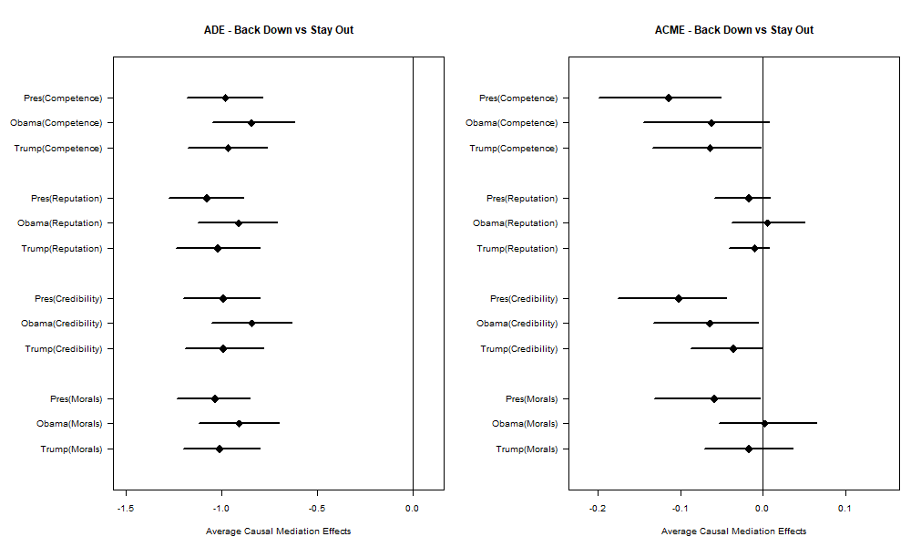

**Figure 7: Causal Mediation Analysis for the Justify Treatment**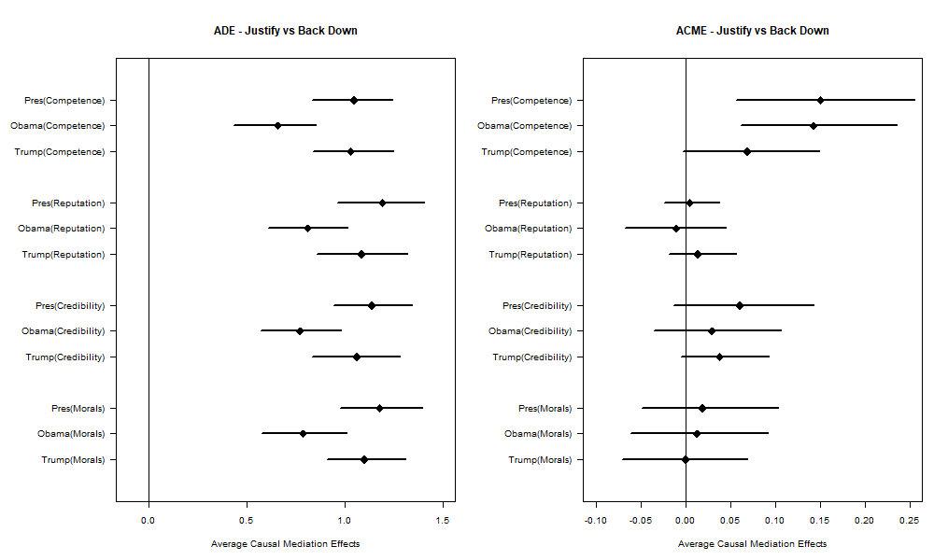

**Figure 8: Moderated Causal Mediation for the Back Down Treatment (By Partisanship)** 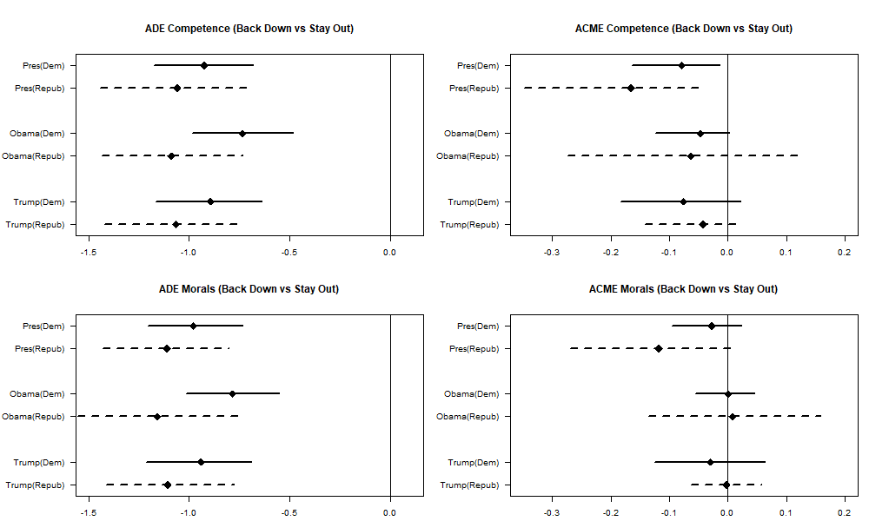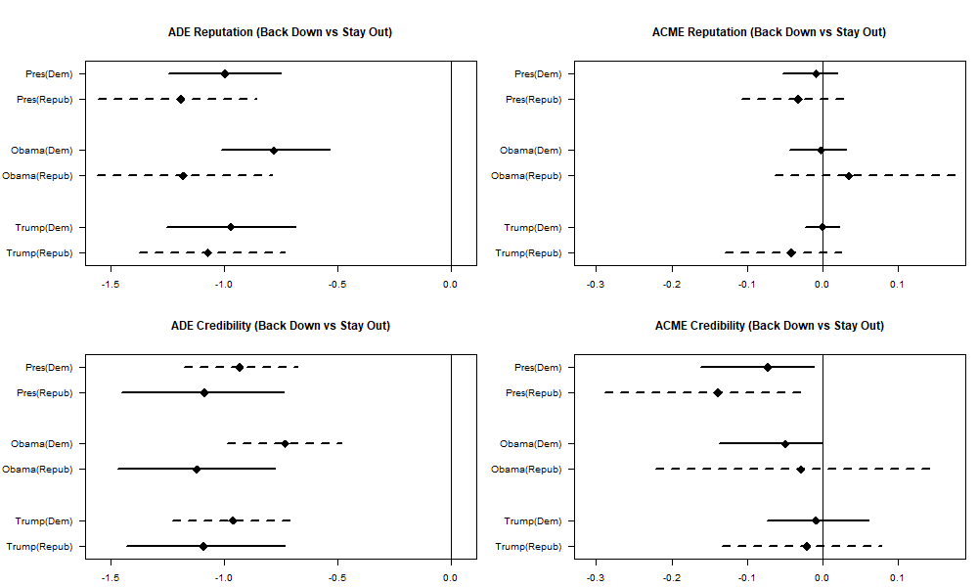

**Figure 9: Moderated Causal Mediation Analysis for the Justify Treatment (By Partisanship)** 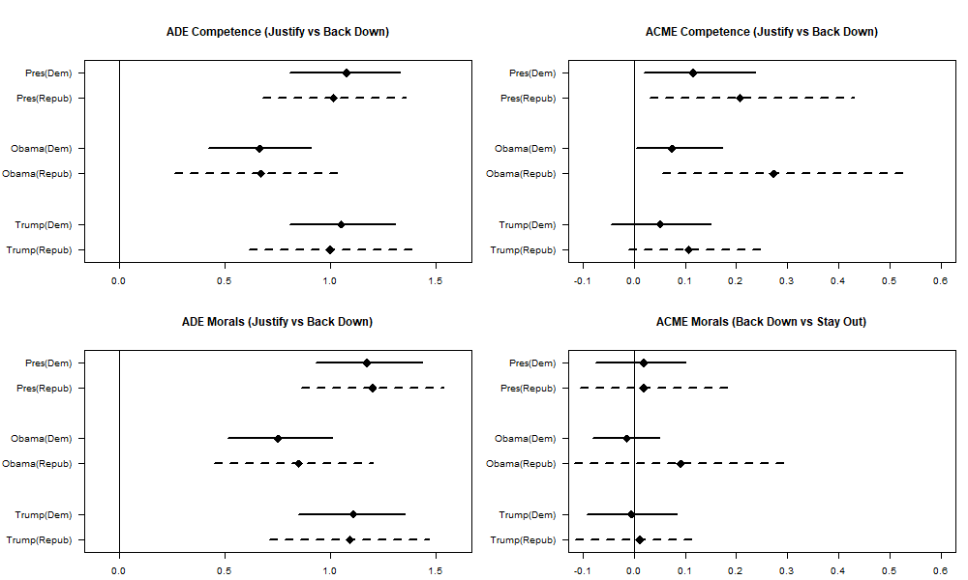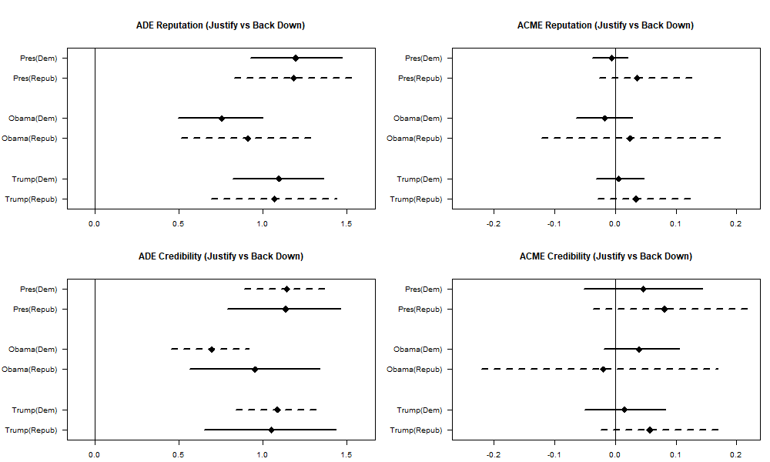

**Figure 10: Moderated Causal Mediation Analysis for Belligerence Costs**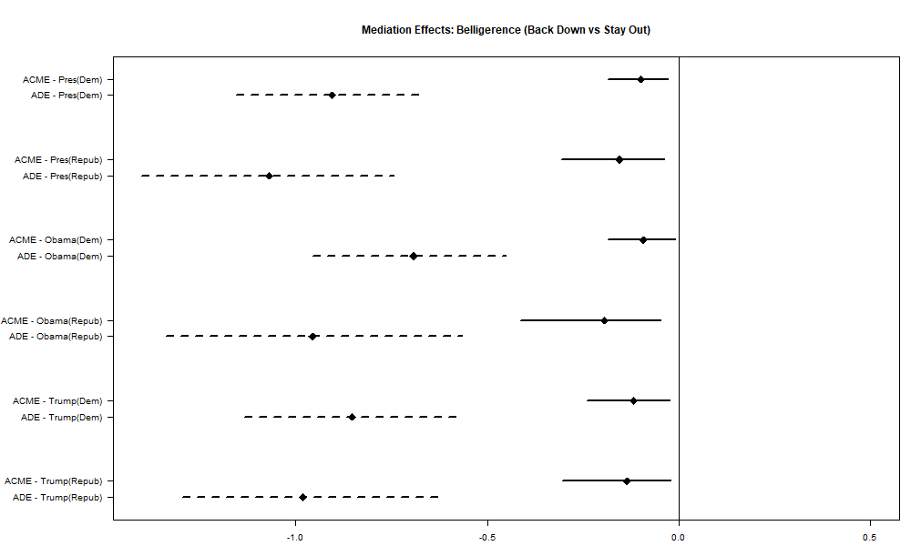

**Appendix D: Who is the Attacking Country?**

In the survey, we asked participants which country they were thinking of when they read the hypothetical vignette. Figure 11 shows that individuals in the Trump treatments were more likely to think about North Korea. Additionally, those with high levels of political awareness were much more likely to think of Russia as the aggressor nation. These results highlight the need to consider how participants interpret hypothetical vignettes. Table 9 shows that the results are nearly identical when we limit the analysis to individuals who think Russia was the attacking country.

**Figure 11: Who do you think was the attacking country?**



**Table 8: Influence of Backing Down and Justification among Individuals who think of Russia/Crimea**

|  |  |  |  |  |  |  |
| --- | --- | --- | --- | --- | --- | --- |
|  | President |  | Obama |  | Trump |  |
|  | *ß* | *SE* | *ß* | *SE* | *ß* | *SE* |
| Back Down | -1.26* | (0.24) | -0.99* | (0.26) | -1.28* | (0.21) |
| Justify | 0.03 | (0.26) | -0.03 | (0.32) | 0.13 | (0.23) |
| Democrat | 0.08 | (0.20) | 0.48* | (0.22) | -0.41* | (0.20) |
| Back Down X Democrat | 0.16 | (0.29) | 0.10 | (0.31) | 0.33 | (0.28) |
| Justify X Democrat | 0.10 | (0.32) | 0.24 | (0.35) | 0.02 | (0.29) |
| Some College | 0.40 | (0.21) | -0.14 | (0.25) | 0.15 | (0.29) |
| College Degree | 0.28 | (0.21) | -0.35 | (0.24) | 0.20 | (0.29) |
| Post-graduate Degree | -0.07 | (0.23) | -0.35 | (0.25) | -0.00 | (0.30) |
| Age | -0.01 | (0.00) | -0.00 | (0.00) | -0.01 | (0.00) |
| Female | 0.28* | (0.12) | 0.17 | (0.12) | -0.06 | (0.11) |
| White | -0.28 | (0.15) | -0.19 | (0.14) | 0.02 | (0.15) |
| Interest in Politics | 0.02 | (0.05) | -0.03 | (0.05) | -0.06 | (0.05) |
| Constant | 3.31* | (0.38) | 3.41* | (0.40) | 3.87* | (0.38) |
| Observations | 294 |  | 338 |  | 343 |  |
| R-Squared | .29 |  | .23 |  | .25 |  |

Robust standard errors in parentheses. * *p* < 0.05

*Note:* Sample only includes individuals who passed reading checks to ensure proper treatment. Result also limited to individuals who thought Russia was the attacking country. Results robust to no controls. Interaction effects demonstrate that the Democrats and Republicans do not punish co-partisans differently than Presidents from their own party

Appendix E: Survey

Late to the Party: Reevaluating Survey Experiments on Audience Costs

Start of Block: Introduction to Survey

Q1 You are invited to participate in a research study from the Department of Political Science at George Washington University (GWU).  Taking part in this research is entirely voluntary. Further information regarding this study may be obtained by contacting Aleksandr Fisher, the student investigator at telephone number 267-337-5263 or Rachel Stein, the principal investigator, at telephone number 303-817-7184.

You are being invited to volunteer to participate in a research study. This summary explains information about this research. The purpose of this study is to examine the connection between a person’s knowledge of international affairs and their position on foreign policy issues.    
You will be asked some questions about: 

1. Your opinion on foreign policy matters (2) Your knowledge of international issues, (3) Your sociodemographic information (e.g. age, education, etc.)

Possible risks or discomforts you could experience during this study include psychological stress in answering questions regarding political issues. You will not benefit directly from your participation in the study. The benefits to social science that might result from this study are greater understanding of public opinion regarding domestic and foreign policy issues.

Every effort will be made to keep your information confidential, however, this cannot be guaranteed. To protect the privacy and confidentiality of the subjects, no personally identifiable information will be used or collected at any point in the study, and the data will be kept on a password protected computer. If results of this research study are reported in journals or at scientific meetings, the people who participated in this study will not be named or identified.

The Office of Human Research of George Washington University, at telephone number (202) 994-2715, can provide further information about your rights as a research participant. Your willingness to participate in this research study is implied if you proceed.

*Please keep a copy of this document in case you want to read it again.

Instructions #1

Q2 You will read about a situation our country has faced many times in the past and will probably face again. Different leaders have handled the situation in different ways. We will describe one approach U.S. leaders have taken, and ask whether you approve or disapprove.

Treatments

**Vignette**

Q3 A country sent its military to take over a neighboring country.  The attacking country invaded to get more power and resources. The attacking country had a strong military, so it would have taken a major effort for the United States to help push them out.

U.S. President/Stay Out

PreOut   
The U.S. president announced that the U.S. military would stay out of the conflict. The attacking country continued to invade and then took over its neighbor.

Obama/Stay Out

ObaOut

President Barack Obama announced that the U.S. military would stay out of the conflict. The attacking country continued to invade and then took over its neighbor.

Trump/Stay Out

TruOut

President Donald Trump announced that the U.S. military would stay out of the conflict. The attacking country continued to invade and then took over its neighbor.

U.S. President/Back Down

PreBack

The President of the United States said that if the attack continued, the U.S. military would push out the invaders. The President sent troops to the region and prepared them for war. The attacking country continued to invade.

He then withdrew U.S. troops without sending them into battle. The attacking country took over its neighbor.

Obama/Back Down

ObaBack

President Barack Obama said that if the attack continued, the U.S. military would push out the invaders. President Obama sent troops to the region and prepared them for war. The attacking country continued to invade.

He then withdrew U.S. troops without sending them into battle. The attacking country took over its neighbor.

Trump/Back Down

TruBack

President Donald Trump said that if the attack continued, the U.S. military would push out the invaders. President Trump sent troops to the region and prepared them for war. The attacking country continued to invade.

He then withdrew U.S. troops without sending them into battle. The attacking country took over its neighbor.

U.S. President/Back-Down/Justification

PreJust

The President of the United States said that if the attack continued, the U.S. military would push out the invaders. The President sent troops to the region and prepared them for war. The attacking country continued to invade.

The U.S. president received new intelligence suggesting involvement is not in America’s interests.  Military experts agreed that the U.S. should not become involved in this crisis. He then withdrew U.S. troops without sending them into battle. The attacking country took over its neighbor.

Obama/Back-Down/Justification

ObaJust

President Barack Obama said that if the attack continued, the U.S. military would push out the invaders. President Obama sent troops to the region and prepared them for war. The attacking country continued to invade.  
President Obama received new intelligence suggesting involvement is not in America’s interests.  Military experts agreed that the U.S. should not become involved in this crisis. He then withdrew U.S. troops without sending them into battle. The attacking country took over its neighbor.

Trump/Back-Down/Justification

TruJust

President Donald Trump said that if the attack continued, the U.S. military would push out the invaders. President Trump sent troops to the region and prepared them for war. The attacking country continued to invade.

President Trump received new intelligence suggesting involvement is not in America’s interests.  Military experts agreed that the U.S. should not become involved in this crisis. He then withdrew U.S. troops without sending them into battle. The attacking country took over its neighbor.

Manipulation Checks

Manipulation 1

In the scenario, how did the United States president respond to the attacking country?

* Stayed out of the conflict (1)
* Threatened to push out the invaders, but ultimately did not intervene (2)
* Deployed US troops and engaged the attacking country (3)

Manipulation 2

In the scenario, did the United States president receive any new intelligence before making his final decision?

* Yes, the President received new intelligence (1)
* Didn't say (2)

Dependent Variables

Approve

Overall, do you approve, disapprove, or neither approve nor disapprove of the way the U.S. president handled the situation that was described to you?

* Strongly approve (1)
* Somewhat approve (2)
* Neither approve nor disapprove (3)
* Somewhat disapprove (4)
* Strongly disapprove (5)

AppWrite

Could you please type a few sentences telling us why you approve/disapprove of the way the US president handled the situation?

________________________________________________________________

Instructions #2

The following questions will ask you about your opinion on a series of statements. Please report the extent to which you agree or disagree with these statements.

Causal Mediation Questions

Comp

The president is competent in foreign policy.

* Strongly agree (1)
* Somewhat agree (2)
* Neither agree nor disagree (3)
* Somewhat disagree (4)
* Strongly disagree (5)

Inter_com

The United States follows through on its international commitments.

* Strongly agree (1)
* Somewhat agree (2)
* Neither agree nor disagree (3)
* Somewhat disagree (4)
* Strongly disagree (5)

Safety

The president cares about the safety and security of U.S. troops.

* Strongly agree (1)
* Somewhat agree (2)
* Neither agree nor disagree (3)
* Somewhat disagree (4)
* Strongly disagree (5)

Reputation

The United States has a good reputation throughout the world.

* Strongly agree (1)
* Somewhat agree (2)
* Neither agree nor disagree (3)
* Somewhat disagree (4)
* Strongly disagree (5)

Morals

The president makes foreign policy decisions that align with good morals.

* Strongly agree (1)
* Somewhat agree (2)
* Neither agree nor disagree (3)
* Somewhat disagree (4)
* Strongly disagree (5)

Inference

PresWho

In the scenario described to you, who do you believe was the president of the United States?

________________________________________________________________

AttWho

Please list some countries, from the real-world, that you think are most likely to be the attacking country in the scenario described to you.

________________________________________________________________

DefWho

Please list some countries, from the real-world, that you think are most likely to be the defending country in the scenario described to you

________________________________________________________________

Partisanship

Feeling We'd like to get your feelings toward a number of groups in the U.S. on a “feeling thermometer.” A rating of zero degrees means you feel as cold and negative as possible. A rating of 100 degrees means you feel as warm and positive as possible. You would rate the group at 50 degrees if you don’t feel particularly positive or negative toward the group.

|  |  |  |  |  |  |  |  |  |  |  |  |
| --- | --- | --- | --- | --- | --- | --- | --- | --- | --- | --- | --- |
|  | 0 | 10 | 20 | 30 | 40 | 50 | 60 | 70 | 80 | 90 | 100 |

|  |  |
| --- | --- |
| Democrats () |  |
| Republicans () |  |
| Elected Officials in Washington () |  |
| The Military () |  |

Party Simple

Generally speaking, do you usually think of yourself as a Republican, a Democrat, an Independent, or what?

* Republican (1)
* Democrat (2)
* Independent (3)
* Other (4) ________________________________________________

Party Full

Generally speaking, I think of myself as (select the most appropriate answer from the list below):

* Strong Democrat (1)
* Weak Democrat (2)
* Independent, Lean Democrat (3)
* Independent (4)
* Independent, Lean Republican (5)
* Weak Republican (6)
* Strong Republican (7)

Ideo

Would you describe yourself as very liberal, somewhat liberal, moderate, somewhat conservative, or very conservative?

* Very liberal (1)
* Somewhat liberal (2)
* Moderate (3)
* Somewhat conservative (4)
* Very conservative (5)

Voteyn16

Did you vote in the 2016 Presidential Election?

* Yes (1)
* No (2)

Vote2016

Who did you vote for in the 2016 Presidential Election?

* Donald Trump (1)
* Hillary Clinton (2)
* Gary Johnson (3)
* Jill Stein (4)
* Other (5)
* Rather not say (6)

Voteyn12

Did you vote in the 2012 Presidential Election?

* Yes (1)
* No (2)

Vote2012

Who did you vote for in the 2012 Presidential Election?

* Mitt Romney (1)
* Barack Obama (2)
* Gary Johnson (3)
* Jill Stein (4)
* Other (5)
* Rather not say (6)

Foreign Countries

Favorable Please tell me if you have a very favorable, somewhat favorable, somewhat unfavorable or very unfavorable opinion of the following countries.

|  |  |  |  |  |  |  |
| --- | --- | --- | --- | --- | --- | --- |
|  | Very favorable (1) | Somewhat favorable (2) | Neither favorable nor unfavorable (3) | Somewhat unfavorable (4) | Very unfavorable (5) | Don't Know (6) |
| United States (1) |  |  |  |  |  |  |
| Russia (2) |  |  |  |  |  |  |
| Ukraine (3) |  |  |  |  |  |  |
| China (4) |  |  |  |  |  |  |
| Iran (5) |  |  |  |  |  |  |
| France (6) |  |  |  |  |  |  |
| Germany (7) |  |  |  |  |  |  |

Who is President

WhoPres

Who is currently the President of the United States?

* Donald Trump (1)
* Barack Obama (2)

Knowledge Instructions

Q34 The following is a set of 12 multiple choice questions testing your knowledge of international relations. Please answer them without using outside material. There are no penalties for wrong answers.

Your test will start when you click “Next.”

Knowledge Questions

|  |
| --- |
|  |

Know1

Who was the U.S. engaged in the Cold War with?

* Soviet Union (1)
* People's Republic of China (2)
* Republic of China (3)
* Federal Republic of Germany (4)
* Democratic People's Republic of Korea (5)

|  |
| --- |
|  |

Know2

From which of the following countries did Russia annex Crimea?

* Ukraine (1)
* Estonia (2)
* Latvia (3)
* Belarus (4)
* Georgia (5)

|  |
| --- |
|  |

Know3

Under which U.S. president did the Cuban Missile Crisis occur?

* John. F. Kennedy (1)
* Lyndon B. Johnson (2)
* Richard Nixon (3)
* Gerald Ford (4)
* Jimmy Carter (5)

|  |
| --- |
|  |

Know4

The League of Nations is the spiritual precursor to which international organization?

* The United Nations (1)
* The European Union (2)
* Commonwealth of Nations (3)
* Association of Southeast Asian Nations (4)
* Organization of Petroleum-Exporting Countries (5)

|  |
| --- |
|  |

Know5

The U.S. is not a member of which of the following international organizations

* Shanghai Cooperation Organization (1)
* International Monetary Fund (2)
* Asia-Pacific Economic Cooperation (3)
* World Bank (4)
* North Atlantic Treaty Organization (5)

Know6

Who was the first U.S. president to visit the People's Republic of China?

* Richard Nixon (1)
* Lyndon B. Johnson (2)
* Gerald Ford (3)
* Jimmy Carter (4)
* Ronald Reagan (5)

Know7

Which of the following countries did not ratify the Kyoto Protocol?

* The United States of America (1)
* Japan (2)
* United Kingdom (3)
* France (4)
* Russia (5)

Know8

Which of the following countries is not a permanent member of the U.N. Security Council?

* Germany (1)
* China (2)
* Russia (3)
* France (4)
* United Kingdom (5)

Know9

What region of the world did the Marshall Plan target?

* Western Europe (1)
* East Asia (2)
* North Africa (3)
* North America (4)
* South America (5)

Know10

What region of the world did the Monroe Doctrine target?

* The Americas (1)
* East Asia (2)
* Central Asia (3)
* The Artic (4)
* Sub-Saharan Africa (5)

|  |
| --- |
|  |

Know11

In March 1996, where did President Clinton send the Seventh Fleet?

* Taiwan Strait (1)
* Sea of Japan (2)
* East China Sea (3)
* South China Sea (4)
* Malacca Strait (5)

Know12

Which U.S. president effectively ended the Bretton Woods system?

* Richard Nixon (1)
* Dwight Eisenhower (2)
* Gerald Ford (3)
* Ronald Reagan (4)
* George H.W. Bush (5)

End of Block: Knowledge Questions

Start of Block: Demographics

Gender

What is your gender?

* Male (1)
* Female (2)
* Other (4) ________________________________________________

Age

What is your age?

________________________________________________________________

Race

How would you describe your race?

* White (1)
* Black or African American (2)
* American Indian or Alaska Native (3)
* Asian (4)
* Hispanic (5)
* Mixed ethnicity (6)
* Other (7) ________________________________________________

Edu

What is the highest educational level that you have attained?

* No high school degree (1)
* High school degree (2)
* Some college (3)
* Four year college degree (4)
* Post-graduate degree (5)