**Supplementary Materials**

**Appendix 1. Experimental Methodology**

To prevent contamination or priming, we used a slightly different question wording to present the male and female candidates, so that the questions appeared distinct. The phrase included “upstanding” to describe the males, while the phrase used a member from the “national party” to describe females. This has the potential drawback of confounding gender with the effect of the “upstanding male” versus a “national party,” but we see no *a priori* reason that being upstanding is preferable to being from a national party. There are many national parties in Tunisia, and being from one says little about the candidate’s party platform. Further, if being upstanding should benefit a candidate, we should expect the religious male to be much more popular—yet, he was the least popular.

Other differences across the photos are worth pointing out. The women have broader smiles, which may raise questions about comparability of the photos. However, as La France, Hecht, and Paluck note, “one of the largest and most reliable findings of behavior research is that men smile less than women.”[1] Moreover, research has shown that viewers respond differently to broad smiles of men and women; thus, even if the smiles were similar, the effect on potential voters would be different.[2] Consequently, we used pictures similar to those in actual campaign posters in Tunisia (see figure A1). Finally, to the extent that the females are disadvantaged at the polls by smiling, this is consistent with a role congruity hypothesis that women do not have the personality traits nor exhibit the behaviors that are required of leaders.

<COMP: FIGURE A1>>

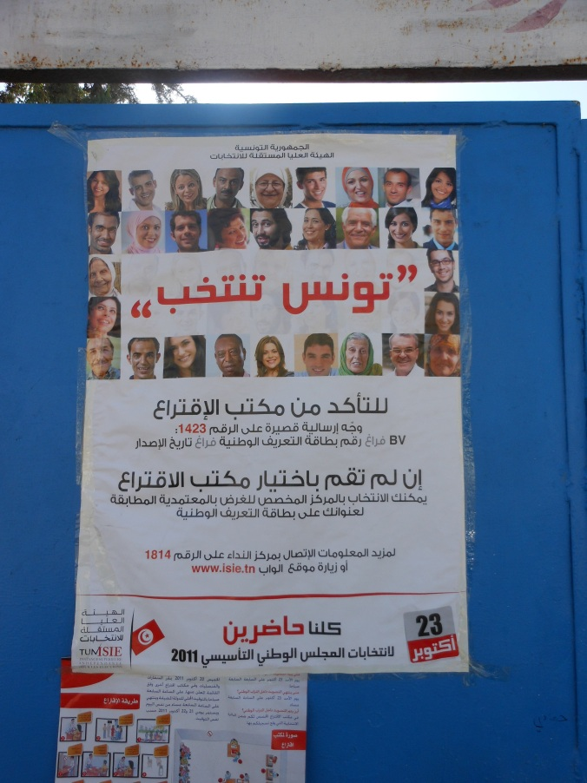

**Figure A1 This get-out-the-vote poster, entitled “Tunisia Votes,” from the October 23, 2011 elections shows females are more likely to smile than males**

The findings presented above also dispel concerns of contamination effects in our experimental design. Each respondent received two secular (male and female) or two religious (male and female) treatments. One might be concerned that presenting the male first affected evaluation of the female; respondents may have attempted to conceal biases against women by simply lending support for females after indicating their support for males. This scenario is plausible, but there is little evidence that it occurred. Respondents who gave a high score to religious males often gave a higher score to religious females, while those who gave a high score to secular males sometimes gave a lower score for secular females. If contamination existed, we would expect consistently high scores for secular women as well.

Finally, attrition did not affect the results. The placement of the questions in the survey instrument maintained coherence in the interview, and it also minimized differences in response rates to the two questions. The response rate was 79.8 percent for those who saw the unreligious male and 80.9 percent for respondents shown the religious male. The response rate increased slightly on the second question to 80.5 percent for those viewing the unreligious female and 81.2 percent for those shown the religious female.

**Appendix 2. Randomization Checks and Question Wording**

<COMP: TABLE A1>

**Table A1 Randomized Block Design**

|  |  |  |  |
| --- | --- | --- | --- |
|  | Secular Treatment | Religious Treatment | Total |
| Ariana | 37 | 41 | 78 |
| Beja | 28 | 27 | 57 |
| Ben Arous | 45 | 47 | 92 |
| Bizerte | 45 | 46 | 91 |
| Gafsa | 29 | 26 | 55 |
| Mahdia | 32 | 31 | 63 |
| Manouba | 32 | 32 | 64 |
| Mednine | 39 | 41 | 80 |
| Nabeul 1 | 32 | 36 | 68 |
| Nabeul 2 | 26 | 29 | 55 |
| Sfax 1 | 34 | 31 | 65 |
| Sfax 2 | 44 | 44 | 88 |
| Sidi Bouzid | 32 | 33 | 65 |
| Sousse | 49 | 48 | 97 |
| Tunis 1 | 51 | 49 | 100 |
| Tunis 2 | 40 | 44 | 84 |
| Total | 595 | 607 | 1202 |

Two-tailed χ2 test show treatments are randomly distributed across communes (*p* < 1.00).

<COMP: TABLE A2>

**Table A2 Randomization of Treatment and Descriptive Statistics for Independent Variables**

|  |  |  |
| --- | --- | --- |
|  | Secular Treatment | Religious Treatment |
| **Education** |  |  |
| No schooling(=1) | 45.71% | 54.29% |
| Primary | 49.79% | 50.21% |
| Secondary | 39.58% | 60.42% |
| High school | 51.25% | 48.75% |
| Technical school | 52.73% | 47.27% |
| University(=6) | 50.00% | 50.00% |
| (N=1197, Mean=3.87, Sd =1.76) | χ2(5)=3.403(p<.638) | |
| **Class** |  | |
| Lower(=1) | 44.90% | 55.10% |
| Lower middle | 52.41% | 47.59% |
| Middle | 50.13% | 49.87% |
| Upper middle | 44.59% | 55.41% |
| Upper(=5) | 56.10% | 43.90% |
| (N=1200, Mean=2.91, Sd =0.86) | χ2(4)=3.583(p<.465) | |
| **Religious observance** |  |  |
| Rarely(=1) | 48.53% | 51.47% |
| 2 | 48.39% | 51.61% |
| 3 | 49.14% | 50.86% |
| 4 | 46.07% | 53.93% |
| Frequently(=5) | 51.79% | 48.21% |
| (N=1142, Mean=3.32, Sd =1.01) | χ2(4)=1.242(p<.871) | |
| **Age** |  |  |
| 18-25 years(=1) | 51.96% | 48.04% |
| 26-35 years | 49.33% | 50.67% |
| 36-45 years | 46.28% | 53.72% |
| 46 years or more(=4) | 52.63% | 47.37% |
| (N=1186, Mean=2.42, Sd =0.93) | χ2(3)=2.41(p<.492) | |
| **Residence** |  |  |
| Rural(=0) | 49.07% | 50.93% |
| Urban(=1) | 49.66% | 50.34% |
| (N=1202, Mean=.73, Sd =.44) | χ2(1)=0.033(p<.856) | |
| **Gender** |  |  |
| Male(=0) | 48.10% | 51.90% |
| Female(=1) | 50.92% | 49.08% |
| (N=1202, Mean=.50, Sd =.50) | χ2(1)=0.957(p<.328) | |
| **Marital status** |  |  |
| Never married(=0) | 51.08% | 48.92% |
| Married, engaged, divorced, or separated(=1) | 48.92% | 51.08% |
| (N=1202, Mean=.73, Sd =.44) | χ2(1)=0.443(p<.506) | |
| **Interviewer gender** |  |  |
| Male(=0) | 50.08% | 49.92% |
| Female(=1) | 48.84% | 51.16% |
| (N=1202, Mean=.47, Sd =.50) | χ2(1)=0.184(p<.668) | |
| **Interviewer dress** |  |  |
| Overtly secular(=1) | 47.61% | 52.39% |
| Overtly religious | 50.67% | 49.33% |
| Overtly very religious(=3) | 48.85% | 51.15% |
| (N=1202, Mean=1.85, Sd =0.65) | χ2(2)=0.907(p<.636) | |
| **Support for political Islam** |  |  |
| Low support(=1) | 51.40% | 48.60% |
| 2 | 45.45% | 54.55% |
| 3 | 51.83% | 48.17% |
| High support(=4) | 43.00% | 57.00% |
| (N=1152, Mean=1.90, Sd =1.00) | χ2(3)=4.847(p<.183) | |
| **Role congruity scale**a |  |  |
| Mean(sd) | 0.595 (0.179) | 0.588 (0.175) |
| (N=1199, Mean=.59, Sd=.18) | χ2(92)=101.149(p<1.000) | |

Two-tailed χ2 test show treatments are randomly distributed across groups.

aItems in the role congruity scale:

* “In general, would you have more confidence in a man or a woman to represent your interests in Parliament or would you say there is no difference?” Man=1/No difference=2/Woman=3.
* “As you may know, there are presently 58 women elected to the Chamber of Deputies (27% of seats). In your opinion, would it be best if this level were to decrease, increase, or stay about the same?” Decrease=1/Stay the same=2/Increase=3.
* “If the party list you would like to vote for has a woman at the head of the list, would you be more likely to vote for that list, a little less likely to vote for that list, or, would it have no influence?” Less likely=1/Not influence=2/More likely=3.
* “Do you agree strongly, agree, disagree, or disagree strongly with the following statements? In general, social and economic problems would improve if there were more women in politics.” Strongly disagree=1/Disagree=2/Agree=3/Strongly agree=4.
* “The government should take care to make sure women accede to top political positions in our country, up to and including Ministers.” Strongly disagree=1/Disagree=2/Agree=3/Strongly agree=4.
* “Would you support a quota to increase the number of women in Parliament?” No=0/Yes=1.

**Appendix 3. Multivariate Checks of Robustness**

To assess the robustness of the results, we modeled support for the four candidates using ordered probit. The findings presented in table A3 are consistent with the results presented above. As shown in figure A2a, support for the secular female increases as the respondent exhibits higher gender role congruity, while support for religious female candidates is unaffected by gender role congruity. As shown in figure A2b, support for religious candidates of both genders increases as the respondent exhibits higher religious role congruity. As social identity moves from the most secular (1) to the most religious (4), support for the religious candidates of both genders increases (refer to figure A2c). That is, religious candidates draw support from members of their in-group. The secular male is unaffected by biases or social identity, voter gender, or any other demographic factor, suggesting he may have advantages at the polls relative to minority candidates.[3]

<COMP: TABLE A3>

**Table A3 Ordered Probit Models of Support for Candidates**

|  |  |  |  |  |
| --- | --- | --- | --- | --- |
| *Independent Variables* | Secular male | Religious male | Secular  Female | Religious female |
|  |  |  |  |  |
| Higher education |  |  |  |  |
| Primary1 | -.16(.39) | -.56(.38) | -.22(.38) | .20(.41) |
| Secondary1 | .21(.74) | -.98(.50)* | .27(.69) | .02(.50) |
| High school1 | -.59(.38) | -.36(.38) | -.45(.37) | -.07(.40) |
| Technical school1 | -.21(.51) | -.73(.60) | .01(.54) | -.17(.53) |
| University1 | -.61(.39)*†* | -.92(.39)* | -.39(.38) | -.18(.43) |
| Higher class |  |  |  |  |
| Lower middle2 | -.08(.53) | .16(.48) | .82(.48) | .31(.42) |
| Middle2 | .19(.48) | .03(.44) | .53(.43) | .25(.39) |
| Upper middle2 | .57(.54) | -.23(.50) | .17(.51) | .01(.45) |
| Upper2 | .13(.80) | -2.19(.78)** | .85(.72) | -2.34(.90)** |
| Higher religious observance |  |  |  |  |
| 23 | .07(.53) | -1.32(.62)* | .09(.53) | -.76(.56) |
| 33 | .10(.34) | .08(.41) | -.09(.39) | .74(.40)*†* |
| 43 | .17(.42) | .41(.47) | -.03(.44) | .76(.47)*†* |
| Frequently3 | .48(.39) | .73(.45)*†* | -.22(.43) | .98(.45)* |
| Higher age | .01(.10) | .11(.10) |  | -.01(.11) |
| Urban residence | -.19(.29) | .67(.29)* | .10(.28) | .48(.26)*†* |
| Female (respondent) | -.06(.21) | .28(.22) | .09(.21) | .50(.22)* |
| Married | -.31(.22) | .04(.22) | -.23(.23) | .17(.23) |
| Female (interviewer) | .06(.29) | -.82(.33)** | -.10(.33) | -.97(.34)** |
| Interviewer religious dress |  |  |  |  |
| Somewhat religious4 | -.01(.24) | .52(.27)* | .07(.25) | .58(.28)* |
| Very religious4 | .88(.34)** | .94(.40)* | .81(.35)* | 1.92(.42)*** |
| Social identity |  |  |  |  |
| 25 | -.01(.26) | -.03(.24) | -.23(.25) | .07(.24) |
| 35 | .09(.25) | .97(.33)** | .46(.25) | .87(.32)** |
| Most Islamist5 | .20(.40) | .51(.33)*†* | .26(.49) | .51(.35) |
| Greater role congruity | .31(.56) | -.68(.64) | 1.84(.57)*** | -.03(.68) |
|  |  |  |  |  |
| N | 428 | 451 | 438 | 453 |
| Wald χ2 | 54.84 | 151.14 | 109.31 | 129.61 |
| Prob. > χ2 | .048* | .000*** | .000*** | .000*** |
| Pseudo R2 | .048 | .124 | .085 | .138 |

Reference groups: 1No schooling. 2Lower class. Strongly disagree (Most religious). 3Rarely. 4Secular dress. 5Most secular.

Cut points and district fixed effects omitted. *† p<.10 * p<.05 ** p<.01 ***p<.001* two-tailed test. Standard errors are in parentheses.

<COMP: FIGURE A2 A-C>>

**Figure A2a Marginal Effect of Gender/Leader Role Congruity on Support for Candidates**



Figure A2a shows the effect of increasing gender role congruity on the predicted probabilty of support for the four candidates. All other variables are held at their mode, where the comparison group is a middle class, never married male with high school education, modal religiosity, support for religious leaders, and gender role congruity, who is, 26-25 years old, living in Tunis, and interviewed by a moderately religious male.

**Figure A2b Marginal Effect of Religious/Leader Role Congruity on Support for Candidates**



Figure A2b shows the effect of increasing religious role congruity on the predicted probability of support for the four candidates.

**Figure A2c Marginal Effect of Islamist-Secular Social Identity on Support for Candidates**



Figure A2c shows the effect of going from secular (1) to religious (4) social identity on the predicted probability of support for the four candidates.

Few of the factors associated with modernization theory—education level, class, urban residence, or religiosity—predict support for candidates. The cultural variant of modernization theory has a hard time accounting for the popularity of the religious female among the more religious, as well as the overall preference of a Muslim society for secular over religious-appearing candidates. More religious respondents are more likely to support both religious candidates; when compared to the least observant, the most observant are more likely to support the religious male (p<.10) and the religious female (p<.05). However, a social identity framework also predicts that respondents will vote for candidates in their in-group.

We find the factor that explains support for the religious male and female is religious role congruity. More educated and wealthy Tunisians are, unsurprisingly, less likely to support religious candidates. Tunisians who are more observant and from urban areas are more likely to support the religious male, consistent with literature showing that support for Islamist parties tends to be concentrated among lower and middle class populations in urban areas.

However, the determinants of support for the religious female differ depending on candidate religiosity. Those who view religiosity and leadership as congruent are as likely to support the religious female as the religious male. Females are significantly more likely to support the religious female (p<.05), but gender is unrelated to support for any of the other candidates.

Finally, no variable—whether the extent of role congruity along a gender or religious dimension or a demographic characteristic—predicts higher or lower support for the secular male, although the model itself is statistically significant (p<.015). This is an important finding. While some segments of society are likely to hold biases against the religious male, the secular male is equally able to attract supporters, regardless of their gender, socioeconomic status, religious views, views about gender or religious roles, or social in-group. This supports programmatic efforts to address biases and stereotype against females, but shows that other categories of disadvantage also exist, including one that is overlooked, though no less present—the religious male.

<end appendix>

<END article>

**Note**

1. La France, Hecht, and Paluck 2003, 306.
2. Deutsch, LeBaron, and Fryer 1987; Otto, Abrosio, and Hoshino 1996.
3. For robustness purposes, we also control for partisan affiliation. To address this concern, we identified two measures of partisanship: (1) 1–9 scale preference for a secular or religious party and (2) whether the individual did not vote 2011, voted for a non-religious party, or voted for the Islamist EnNahda party. In the multivariate models, preference for a religious party predicted support for the religious male candidate, but no other candidate. The 2011 vote choice was not significant. Furthermore, adding these variables to the models did not change the results reported in the paper.