Appendix

Table A-1 presents knowledge questions within the survey. The first column identifies the shorthand label of questions used in Tables A-2 and A-3. The second column indicates if the question was asked before or after the 2018 election. The third column presents the text seen by the respondent. The fourth column indicates possible response options.

Table A.1: Survey Question Wordings
Labels used in Appendix | Pre or Post  Election | Question-Wording | Response Options
Pre – Governor | Pre | Please indicate whether you’ve heard of this person and if so which party he or she is affiliated  with...  - Governor | Never heard of person  Republican  Democrat  Other Party/Independent  Not sure
Pre – U.S. House  Pre – U.S. Senate  Pre – State Senate  Pre – State House | Pre | Which party has a majority of seats in  - U.S. House of Representatives  - U.S. Senate  - State Senate  - State Lower Chamber Name | Republicans  Democrats  Neither  Not Sure
Pre - Relative State GDP  Post - Relative State GDP  Pre - Relative Unemployment  Post - Relative Unemployment | Pre & Post | Which of the following statements do you agree with or believe are true? Check all that apply.  - The [State name] state economy is stronger than state economies in most other states | Check Box to Agree
Gov Veto  Gov Line Item  Gov Executive Orders  Gov Pardons  Gov Term Limits  Gov Courts | Pre | To the best of your knowledge, the Governor of [State name] can  Check all that apply  - Veto legislation passed by the state legislature  - Veto specific amounts or provisions listed in appropriations or spending bills (e.g. through a line-item veto)  - Issue executive orders without legislative approval  - Pardon criminals who violated state law without anyone else’s approval (e.g. the state legislature)  - Only serve two terms as Governor in his or her lifetime  - Make a lifetime appointment to the [State name] [STATE HIGH COURT NAME] with the consent of the state senate | Check Boxes to Agree
State Sen. Term | Pre | For how many years is a [State name] State Senator typically elected? That is, how many years are there in one full term of office for a Senator in the [State Legislature Name]? | Options: 1, 2, 3, 4, 5, 6, 7, 8, 9,10
Pres Veto  Pres Line Item  Pres Executive Orders  Pres Pardons  Pres Term Limits  Pres Courts | Pre | To the best of your knowledge, the President of the United States can  Check all that apply  - Veto legislation passed by the U.S. Congress  - Issue executive orders without legislative approval  - Veto specific amounts or provisions listed in appropriations or spending bills (e.g. through a line-item veto)  - Pardon criminals who violated federal law without anyone else’s approval (e.g. the U.S. Congress)  - Only serve two terms as President in his or her lifetime  - Make a lifetime appointment to the United States Supreme Court with the consent of the U.S. Senate | Check Boxes to Agree
U.S. Sen. Term | Pre | For how many years is a United States Senator elected? That is, how many years are there in one full term of office for a Senator in the U.S. Congress? | Options: 1, 2, 3, 4, 5, 6, 7, 8, 9,10
Background Checks | Pre | Is the below statement True or False?  A background check is required for all fire arm sales in [State name]. | Options: True, False
Abortion | Pre | Is the below statement True or False?  In [State name], a woman may not have an abortion after 20 weeks into the pregnancy except if her health is at risk. | Options: True, False
Voter ID | Pre | Is the below statement True or False?  On Election Day, citizens in [State name] are asked to show a form of identification before being allowed to vote. | Options: True, False
Income Taxes | Pre | Is the below statement True or False?  Since 2016, state income tax rates have risen for most [State name] taxpayers. | Options: True, False
Initiatives | Pre | Is the below statement True or False?  Voters in [State name] can pass state laws using ballot initiatives. | Options: True, False
Term Limits | Pre | Is the below statement True or False?  [State name] state legislators can only run for a certain number of terms due to term limits. | Options: True, False
Revolving Door | Pre | Is the below statement True or False?  When a [State name] state legislator leaves public office, he or she must wait at least one year before registering as a lobbyist. | Options: True, False
State Rep Recall | Pre | Even if you had to guess, who is one of your current representatives in the [State Legislature Lower Chamber Name]? | Open-Ended Text Field
State Unemployment (Within 1) | Pre | The unemployment rate in [State name] has varied between [MIN UNEMPLOYMENT] and [MAX UNEMPLOYMENT] between 1976 and 2017. The average unemployment rate during that time was [AVERAGE UNEMPLOYMENT]. As far as you know what is the current rate of unemployment in [State name]? | Slider Scale, with labels on 0%, 4%, 8%, 12%. 16%, & 20%
U.S. Unemployment (Within 1) | Pre | The unemployment rate in the United States has varied between 3.8% and 10.8% between 1976 and 2017. The average unemployment rate during that time was 6.4%. As far as you know what is the current rate of unemployment in the United States? | Slider Scale, with labels on 0%, 4%, 8%, 12%. 16%, & 20%
Congress – Female Desc. Rep (within 5)  State Leg – Female Desc. Rep (within 5)  Congress – AA Desc. Rep (within 5)  State Leg – AA Desc. Rep (within 5) | Post | Considering those who served for most of 2018 before the election, what percentage of…  - Members of the U.S. Congress were women  - Members of the [State Legislature Name]were women  - Members of the U.S. Congress were African-American  - Members of the [State Legislature Name] were African-American | Slider Scales from 0 – 100%
Post – U.S. House  Post – U.S. Senate  Post – State Senate  Post – State House  Post - Governor | Post | Following the results of the 2018 election, which party will have a majority of seats in the following legislative bodies or will control the Governorship of [State name]  - U.S. House of Representatives  - U.S. Senate  - [State name] State Senate  - [State Legislature Lower Chamber Name]  - Governor of [State name] | Democratic  Republican  Neither  Not sure
Legislator Salary | Post | To the best of your knowledge, which of the following statements are true? Check all that apply.  - The average, government salary of a [State name] state legislator is greater than $50,000. | Check Box to Agree
Medicaid | Post | To the best of your knowledge, which of the following statements are true? Check all that apply.  - [State name] expanded its Medicaid program in accordance with the Affordable Care Act. | Check Box to Agree
Transportation | Post | To the best of your knowledge, which of the following statements are true? Check all that apply.  - In the most recent state budget general fund, spending on highways and roads was the largest expenditure of the [State name] state government. | Check Box to Agree
Closed Primary | Post | To the best of your knowledge, which of the following statements are true? Check all that apply.  - Before election day, [State name] voters need to be registered with the Democratic or Republican party to participate in these parties’ primary elections. | Check Box to Agree
U.S. Budget (Within 5) | Post | In trillions of dollars, what were the total expenditures of the United States federal budget in 2017? | Slider Scale with labels at $0, $1, $2, $3, $4, $5, $6, $7, $8, $9, $10 trillion
State Budget (Within 5) | Post | In billions of dollars, what were the total expenditures of the [State name] state government, general fund budget in 2017?  For this question, do not account for federal matching funds (e.g. Medicaid).  For reference, expenditures in the Vermont state government, general fund budget in 2016 were approximately $1.5 billion when excluding federal matching funds, and in New York, the budget was approximately $68 billion. On average, expenditures in state government budgets are approximately $15 billion. | Slider scale with labels at: $0, $15, $30, $45, $60, $75, $90, $105, $120, $135, $150 Billion

Below identifies the organizations and reports used to identify correct answers to political knowledge questions that vary by state. See replication files and codebook for full citations and descriptions.
- Governor Party Control & Party Control of State Legislatures: National Conference of State Legislatures
- State Legislator Name: Shor and McCarty (2011)
- Descriptive Representation of Women: Center for American Women and Politics
- Descriptive Representation of African Americans: Self-Collected with Research Assistants
- Governor Power – Veto Power: Council of State Governments, Book of States
- Governor Power – Line-Item Veto: National Association of State Budget Officers – Budget Processes in the States 2015, Table 8
- Governor Power – Pardon: Restoration of Rights Project
- Governor Power – Executive Orders: Council of State Government, Book of States
- Governor Term Limits: Book of States
- Governors Power – Judicial Appointments: Brennan Center, Judicial Selection: Significant Figures
- State Senator Term Length: National Conference of State Legislatures, Number of Legislators and Length of Terms in Years
- Voter Identification: Wikipedia. For this question, only strict ID laws were marked as a voter ID law.
- Initiatives: Ballotpedia, States with initiative or referendum
- State Legislative Term Limits: Ballotpedia, State legislatures with term limits
- State Legislator Revolving Door: National Conference of State Legislatures, Revolving Door Prohibitions
- State Legislator Salaries: Bowen and Greene (2014)
- State GDP: Bureau of Economic Analysis
- State Unemployment: Bureau of Labor Statistics
- Background Checks for Guns: Giffords Law Center, Universal Background Checks
- Abortion: Guttmacher Institute, Bans of Specific Abortion Methods Used After the First Trimester
- State Income Tax Increases – Tax Foundation: State Individual Income Tax Rates and Brackets for 2016, Tax Foundation: State Individual Income Tax Rates and Brackets for 2018
- Medicaid Expansion: Kaiser Foundation – Status of State Action on the Medicaid Decision
- Transportation Spending: National Association of State Budget Officers: State Expenditure Report 2016 - 2018; Table 5
- State Budgets: National Association of State Budget Officers: State Expenditure Report 2016 - 2018; Table 1

Table A-2 – Proportion Correct Answers among Voters
 | All Voters
Question | Mean | 95% CI
Pre - Governor | 0.86 | [0.84, 0.88]
Pre - US Senate | 0.79 | [0.76, 0.82]
Pre - US House | 0.79 | [0.76, 0.82]
Pre - State Senate | 0.61 | [0.58, 0.64]
Pre - State House | 0.60 | [0.57, 0.64]
State Rep Recall | 0.10 | [0.08, 0.12]
Congress - Female Desc. Rep (Within 5) | 0.29 | [0.25, 0.32]
State Leg - Female Desc. Rep (Within 5) | 0.27 | [0.24, 0.31]
Congress - AA Desc. Rep (Within 5) | 0.31 | [0.27, 0.34]
State Leg - AA Desc. Rep (Within 5) | 0.26 | [0.23, 0.29]
Post - Governor | 0.83 | [0.80, 0.85]
Post - US Senate | 0.74 | [0.71, 0.77]
Post - US House | 0.74 | [0.71, 0.78]
Post - State Senate | 0.64 | [0.61, 0.68]
Post - State House | 0.63 | [0.59, 0.66]
Gov Veto | 0.57 | [0.54, 0.61]
Gov Line Item | 0.37 | [0.34, 0.40]
Gov Executive Orders | 0.37 | [0.34, 0.40]
Gov Pardons | 0.49 | [0.46, 0.52]
Gov Term Limits | 0.53 | [0.49, 0.56]
Gov Courts | 0.78 | [0.76, 0.81]
State Sen. Term Length | 0.43 | [0.39, 0.46]
Pres Veto | 0.77 | [0.74, 0.80]
Pres Line Item | 0.53 | [0.50, 0.57]
Pres Executive Orders | 0.71 | [0.67, 0.74]
Pres Pardons | 0.79 | [0.76, 0.82]
Pres Term Limits | 0.79 | [0.76, 0.82]
Pres Courts | 0.64 | [0.61, 0.67]
US Sen. Term Length | 0.43 | [0.40, 0.47]
Leg. Term Limits | 0.60 | [0.56, 0.63]
Legislator Salary | 0.56 | [0.52, 0.60]
Revolving Door | 0.56 | [0.52, 0.60]
Voter ID | 0.54 | [0.50, 0.57]
Initiatives | 0.61 | [0.57, 0.64]
Closed Primary | 0.63 | [0.60, 0.67]
Background Checks | 0.47 | [0.44, 0.51]
Abortion | 0.53 | [0.49, 0.56]
Income Taxes | 0.53 | [0.50, 0.57]
Medicaid | 0.64 | [0.61, 0.68]
Transportation | 0.81 | [0.78, 0.84]
US Budget (Within 5) | 0.06 | [0.04, 0.08]
State Budget (Within 5) | 0.03 | [0.02, 0.04]
State Unemployment (Within 1) | 0.36 | [0.33, 0.39]
US Unemployment (Within 1) | 0.45 | [0.40, 0.50]

The average number of correct responses to each question listed in Table A.1 for all respondents to the survey and self-reported registered voters. Means and 95% confidence intervals calculated using survey weights.

Table A-3: State and Federal Individual Item Correlations
 | St. Senate Party | St. House Party | Black Leg | Women Leg | State Sen. Term | Gov Veto | Gov Line Item | Gov Exec. Orders | Gov Pardons | Gov Courts | Gov Term Limits | Unemployment | State Budget Size | US Senate Party | US House Party | Black Cong. | Women Cong. | Pres. Veto | Pres. Line Item | Pres. Exec. Orders | Pres. Pardons | Pres. Term Limits | Pres. Courts | US Sen. Term | Unemployment | Federal Budget Size
St. Senate Party | 1.00 | 0.82 | 0.18 | 0.14 | 0.04 | 0.27 | 0.08 | 0.06 | 0.00 | -0.12 | -0.06 | 0.19 | 0.03 | 0.42 | 0.43 | 0.18 | 0.14 | 0.27 | -0.08 | 0.28 | 0.25 | 0.17 | 0.27 | 0.35 | 0.22 | 0.09
St. House Party | 0.82 | 1.00 | 0.16 | 0.11 | 0.00 | 0.29 | 0.07 | 0.07 | 0.00 | -0.13 | -0.06 | 0.16 | 0.01 | 0.40 | 0.44 | 0.16 | 0.11 | 0.26 | -0.05 | 0.25 | 0.23 | 0.16 | 0.24 | 0.31 | 0.15 | 0.10
Black Leg | 0.18 | 0.16 | 1.00 | 0.21 | -0.01 | 0.21 | 0.02 | 0.09 | 0.04 | -0.03 | -0.04 | 0.08 | 0.03 | 0.19 | 0.20 | 1.00 | 0.21 | 0.15 | 0.01 | 0.17 | 0.17 | 0.14 | 0.15 | 0.20 | 0.16 | 0.03
Women Leg | 0.14 | 0.11 | 0.21 | 1.00 | 0.03 | 0.13 | 0.02 | 0.00 | 0.02 | -0.01 | 0.00 | 0.13 | 0.03 | 0.18 | 0.16 | 0.21 | 1.00 | 0.15 | 0.01 | 0.15 | 0.13 | 0.13 | 0.13 | 0.14 | 0.19 | 0.07
State Sen. Term | 0.04 | 0.00 | -0.01 | 0.03 | 1.00 | 0.06 | 0.05 | 0.08 | -0.02 | -0.01 | 0.03 | 0.09 | -0.07 | 0.02 | 0.04 | -0.01 | 0.03 | 0.04 | 0.05 | 0.04 | 0.05 | 0.08 | 0.07 | -0.01 | 0.12 | 0.02
Gov Veto | 0.27 | 0.29 | 0.21 | 0.13 | 0.06 | 1.00 | 0.26 | 0.21 | 0.01 | -0.23 | -0.07 | 0.22 | 0.03 | 0.35 | 0.32 | 0.21 | 0.13 | 0.45 | -0.14 | 0.37 | 0.34 | 0.28 | 0.40 | 0.31 | 0.20 | 0.09
Gov Line Item | 0.08 | 0.07 | 0.02 | 0.02 | 0.05 | 0.26 | 1.00 | 0.08 | -0.05 | -0.13 | -0.03 | 0.10 | -0.06 | 0.09 | 0.11 | 0.02 | 0.02 | 0.22 | -0.29 | 0.24 | 0.20 | 0.13 | 0.17 | 0.09 | 0.15 | 0.05
Gov Exec. Orders | 0.06 | 0.07 | 0.09 | 0.00 | 0.08 | 0.21 | 0.08 | 1.00 | -0.08 | -0.12 | 0.00 | -0.01 | 0.00 | 0.10 | 0.08 | 0.09 | 0.00 | 0.08 | -0.04 | 0.11 | 0.11 | 0.06 | 0.14 | 0.12 | 0.11 | -0.01
Gov Pardons | 0.00 | 0.00 | 0.04 | 0.02 | -0.02 | 0.01 | -0.05 | -0.08 | 1.00 | 0.01 | 0.02 | 0.00 | 0.02 | 0.05 | 0.05 | 0.04 | 0.02 | 0.02 | 0.03 | -0.03 | 0.00 | 0.02 | -0.01 | 0.01 | 0.01 | 0.06
Gov Courts | -0.12 | -0.13 | -0.03 | -0.01 | -0.01 | -0.23 | -0.13 | -0.12 | 0.01 | 1.00 | 0.03 | -0.09 | -0.06 | -0.10 | -0.14 | -0.03 | -0.01 | -0.09 | 0.08 | -0.13 | -0.10 | -0.07 | -0.17 | -0.12 | -0.14 | -0.02
Gov Term Limits | -0.06 | -0.06 | -0.04 | 0.00 | 0.03 | -0.07 | -0.03 | 0.00 | 0.02 | 0.03 | 1.00 | -0.07 | 0.01 | -0.08 | -0.07 | -0.04 | 0.00 | -0.05 | 0.02 | -0.06 | -0.09 | -0.08 | -0.08 | -0.05 | -0.10 | 0.08
State Unemployment | 0.19 | 0.16 | 0.08 | 0.13 | 0.09 | 0.22 | 0.10 | -0.01 | 0.00 | -0.09 | -0.07 | 1.00 | -0.01 | 0.20 | 0.20 | 0.08 | 0.13 | 0.21 | -0.01 | 0.24 | 0.20 | 0.19 | 0.20 | 0.25 | 0.39 | 0.09
State Budget Size | 0.03 | 0.01 | 0.03 | 0.03 | -0.07 | 0.03 | -0.06 | 0.00 | 0.02 | -0.06 | 0.01 | -0.01 | 1.00 | 0.04 | 0.04 | 0.03 | 0.03 | 0.02 | 0.01 | 0.03 | 0.00 | -0.03 | 0.02 | 0.03 | 0.05 | -0.04
US Senate Party | 0.42 | 0.40 | 0.19 | 0.18 | 0.02 | 0.35 | 0.09 | 0.10 | 0.05 | -0.10 | -0.08 | 0.20 | 0.04 | 1.00 | 0.75 | 0.19 | 0.18 | 0.37 | -0.09 | 0.36 | 0.31 | 0.25 | 0.35 | 0.37 | 0.33 | 0.06
US House Party | 0.43 | 0.44 | 0.20 | 0.16 | 0.04 | 0.32 | 0.11 | 0.08 | 0.05 | -0.14 | -0.07 | 0.20 | 0.04 | 0.75 | 1.00 | 0.20 | 0.16 | 0.35 | -0.10 | 0.34 | 0.35 | 0.28 | 0.33 | 0.34 | 0.35 | 0.06
Black Cong. | 0.18 | 0.16 | 1.00 | 0.21 | -0.01 | 0.21 | 0.02 | 0.09 | 0.04 | -0.03 | -0.04 | 0.08 | 0.03 | 0.19 | 0.20 | 1.00 | 0.21 | 0.15 | 0.01 | 0.17 | 0.17 | 0.14 | 0.15 | 0.20 | 0.16 | 0.03
Women Cong. | 0.14 | 0.11 | 0.21 | 1.00 | 0.03 | 0.13 | 0.02 | 0.00 | 0.02 | -0.01 | 0.00 | 0.13 | 0.03 | 0.18 | 0.16 | 0.21 | 1.00 | 0.15 | 0.01 | 0.15 | 0.13 | 0.13 | 0.13 | 0.14 | 0.19 | 0.07
Pres. Veto | 0.27 | 0.26 | 0.15 | 0.15 | 0.04 | 0.45 | 0.22 | 0.08 | 0.02 | -0.09 | -0.05 | 0.21 | 0.02 | 0.37 | 0.35 | 0.15 | 0.15 | 1.00 | -0.32 | 0.58 | 0.52 | 0.44 | 0.51 | 0.29 | 0.27 | 0.06
Pres. Line Item | -0.08 | -0.05 | 0.01 | 0.01 | 0.05 | -0.14 | -0.29 | -0.04 | 0.03 | 0.08 | 0.02 | -0.01 | 0.01 | -0.09 | -0.10 | 0.01 | 0.01 | -0.32 | 1.00 | -0.26 | -0.32 | -0.19 | -0.18 | 0.10 | -0.04 | -0.04
Pres. Exec. Orders | 0.28 | 0.25 | 0.17 | 0.15 | 0.04 | 0.37 | 0.24 | 0.11 | -0.03 | -0.13 | -0.06 | 0.24 | 0.03 | 0.36 | 0.34 | 0.17 | 0.15 | 0.58 | -0.26 | 1.00 | 0.57 | 0.49 | 0.55 | 0.36 | 0.33 | 0.11
Pres. Pardons | 0.25 | 0.23 | 0.17 | 0.13 | 0.05 | 0.34 | 0.20 | 0.11 | 0.00 | -0.10 | -0.09 | 0.20 | 0.00 | 0.31 | 0.35 | 0.17 | 0.13 | 0.52 | -0.32 | 0.57 | 1.00 | 0.54 | 0.52 | 0.31 | 0.24 | 0.06
Pres. Term Limits | 0.17 | 0.16 | 0.14 | 0.13 | 0.08 | 0.28 | 0.13 | 0.06 | 0.02 | -0.07 | -0.08 | 0.19 | -0.03 | 0.25 | 0.28 | 0.14 | 0.13 | 0.44 | -0.19 | 0.49 | 0.54 | 1.00 | 0.44 | 0.25 | 0.22 | 0.03
Pres. Courts | 0.27 | 0.24 | 0.15 | 0.13 | 0.07 | 0.40 | 0.17 | 0.14 | -0.01 | -0.17 | -0.08 | 0.20 | 0.02 | 0.35 | 0.33 | 0.15 | 0.13 | 0.51 | -0.18 | 0.55 | 0.52 | 0.44 | 1.00 | 0.38 | 0.28 | 0.04
US Sen. Term | 0.35 | 0.31 | 0.20 | 0.14 | -0.01 | 0.31 | 0.09 | 0.12 | 0.01 | -0.12 | -0.05 | 0.25 | 0.03 | 0.37 | 0.34 | 0.20 | 0.14 | 0.29 | 0.10 | 0.36 | 0.31 | 0.25 | 0.38 | 1.00 | 0.28 | 0.09
US Unemployment | 0.22 | 0.15 | 0.16 | 0.19 | 0.12 | 0.20 | 0.15 | 0.11 | 0.01 | -0.14 | -0.10 | 0.39 | 0.05 | 0.33 | 0.35 | 0.16 | 0.19 | 0.27 | -0.04 | 0.33 | 0.24 | 0.22 | 0.28 | 0.28 | 1.00 | 0.01
Federal Budget Size | 0.09 | 0.10 | 0.03 | 0.07 | 0.02 | 0.09 | 0.05 | -0.01 | 0.06 | -0.02 | 0.08 | 0.09 | -0.04 | 0.06 | 0.06 | 0.03 | 0.07 | 0.06 | -0.04 | 0.11 | 0.06 | 0.03 | 0.04 | 0.09 | 0.01 | 1.00

Individual-level question correlations for both state-level and federal, closed-end questions.

Table A-4: Factor Analyses of State Politics Questions
Variable Name | Dimension One | Dimension Two | Dimension Three | Dimension Four | Dimension Five
Gov Party | 0.298 | 0.106 | 0.006 | 0.489 | 0.014
St. Senate Party | 0.976 | -0.050 | -0.071 | 0.085 | 0.001
St. House Party | 1.086 | -0.061 | 0.123 | -0.258 | 0.061
Black Leg | 0.066 | -0.086 | 0.206 | 0.274 | 0.195
Women Leg | 0.012 | 0.090 | 0.021 | 0.334 | 0.020
Leg Term Limits | -0.009 | 0.024 | 0.150 | 0.217 | 0.111
Voter ID | 0.175 | -0.307 | 0.089 | -0.089 | 1.008
Initiatives | -0.182 | 0.443 | 0.046 | 0.276 | -0.168
Rev. Door | -0.012 | 0.047 | 0.097 | -0.067 | -0.024
Leg Salary | 0.087 | -0.013 | -0.014 | 0.101 | -0.114
Closed Primary | -0.067 | -0.016 | -0.076 | 0.301 | -0.049
State Sen. Term | -0.034 | 0.256 | 0.044 | 0.018 | -0.019
Gov Veto | -0.063 | -0.087 | 0.867 | 0.349 | -0.036
Gov Line Item | -0.154 | 0.278 | 0.310 | 0.139 | 0.088
Gov Exec. Orders | -0.006 | 0.025 | 0.413 | -0.005 | -0.010
Gov Pardons | -0.079 | -0.093 | 0.018 | -0.089 | 0.022
Gov Courts | -0.149 | 0.167 | -0.364 | 0.065 | 0.057
Gov Term Limits | -0.025 | -0.033 | -0.053 | 0.027 | 0.067
Guns | 0.152 | 0.323 | -0.139 | 0.016 | 0.130
Abortion | 0.123 | 0.235 | -0.068 | 0.019 | 0.322
Income Taxes | 0.135 | 0.077 | -0.003 | 0.117 | -0.048
Medicaid | 0.076 | -0.105 | 0.083 | 0.231 | -0.026
Trans. Spend | -0.043 | 0.033 | -0.012 | -0.018 | 0.124
Unemployment | 0.102 | 0.018 | 0.170 | 0.165 | 0.121
State Budget Size | -0.182 | -0.983 | 0.083 | 0.560 | 0.029

 | Dimension One | Dimension Two | Dimension Three | Dimension Four | Dimension Five
SS loadings | 2.359 | 1.507 | 1.462 | 1.261 | 1.239
Proportion Var | 0.094 | 0.060 | 0.058 | 0.050 | 0.050
Cumulative Var | 0.094 | 0.155 | 0.213 | 0.264 | 0.313
Proportion Explained | 0.301 | 0.193 | 0.187 | 0.161 | 0.158
Cumulative Proportion | 0.301 | 0.494 | 0.681 | 0.842 | 1.000

The following tables present CITC and IRT estimates when only including the common set of Presidential power and Governor power questions.
Table A-5: Item Performance Statistics for President’s Power Knowledge Questions
Variable | CITC | Discrimination | Difficulty
Pres. Courts | 0.606 | 2.611* (0.240) | -0.355* (0.052)
Pres. Exec. Orders | 0.635 | 3.539* (0.367) | -0.524* (0.051)
Pres. Line Item | -0.319 | -0.843* (0.099) | 0.346* (0.093)
Pres. Pardons | 0.596 | 3.775* (0.460) | -0.782* (0.057)
Pres. Term Limits | 0.554 | 2.314* (0.212) | -0.916* (0.067)
Pres. Veto | 0.556 | 2.945* (0.287) | -0.743* (0.058)

Corrected-Item Correlations, discrimination parameters, and difficulty parameters for closed-ended state politics questions. Standard errors in parentheses. * p < 0.05. Estimations only include questions about the President’s powers.

Table A-6: Item Performance Statistics for Governor’s Power Knowledge Questions
Variable | CITC | Discrimination | Difficulty
Gov Courts | -0.181 | -0.925* (0.153) | 1.682* (0.229)
Gov Exec. Orders | 0.055 | 0.659* (0.112) | 0.960* (0.175)
Gov Line Item | 0.073 | 0.843* (0.131) | 0.699* (0.122)
Gov Pardons | -0.042 | -0.054 (0.086) | 0.591 (1.490)
Gov Term Limits | -0.029 | -0.191* (0.084) | 1.148 (0.602)
Gov Veto | 0.105 | 3.793 (2.081) | -0.095* (0.046)

Corrected-Item Correlations, discrimination parameters, and difficulty parameters for closed-ended state politics questions. Standard errors in parentheses. * p < 0.05. Estimations only include questions about the Governor’s powers.

Table A-7: Item Performance Statistics for Federal Knowledge Questions
 | Difficulty | Discrimination
US House Party | -0.925* (0.071) | 1.891* (0.173)
US Senate Party | -0.889* (0.070) | 1.892* (0.173)
Black Cong. | 1.377* (0.188) | 0.745* (0.110)
Budget Size | 5.526* (1.806) | 0.538* (0.193)
Pres. Courts | -0.377* (0.051) | 2.515* (0.211)
Pres. Exec. Orders | -0.552* (0.049) | 3.342* (0.313)
Pres. Line Item | 0.525* (0.155) | -0.500* (0.080)
Pres. Pardons | -0.821* (0.054) | 3.260* (0.320)
Pres. Term Limits | -0.954* (0.066) | 2.139* (0.190)
Pres. Veto | -0.762* (0.054) | 2.931* (0.271)
Unemployment | 0.404* (0.094) | 1.354* (0.184)
US Sen. Term | 0.351* (0.062) | 1.645* (0.154)
Women Cong. | 1.525* (0.225) | 0.668* (0.106)

Discrimination and difficulty parameters for closed-ended federal politics questions. Standard errors in parentheses. * p < 0.05.

Figure A-1: Americans’ Awareness of State-Level Policies
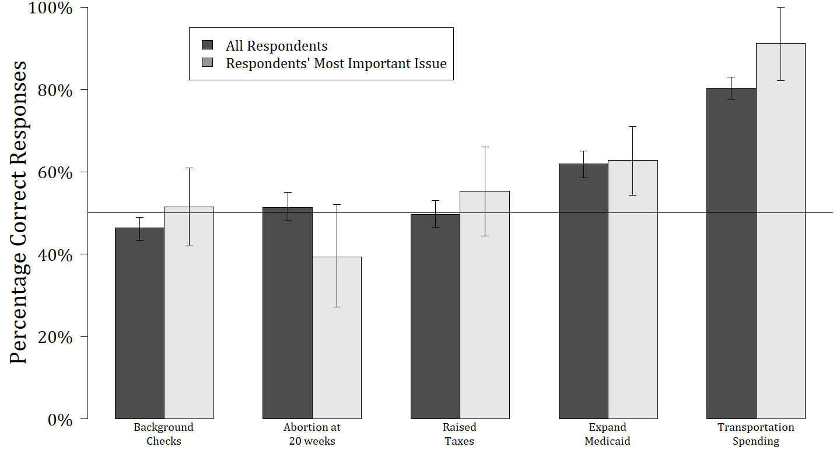
Dark grey bars reflect the proportion of respondents who correctly identified whether a particular policy was enacted in their state. Other bars reflect correct responses among Americans for whom the given policy was the most important to their vote for the state legislature and supporters or opposers of the policy.

Half of the respondents were asked which issue was most important to their vote for the state legislature. Respondents could choose issues of gun control, abortion, taxes, health care, transportation/infrastructure, unemployment, education, immigration, racial equality, budget deficits or delays, and law enforcement. Focusing on issue publics (e.g., Krosnick 1990), I do not find meaningful differences between the full sample and those respondents who indicated that gun control, abortion, taxes, or health care were the most important issues to them when voting for their state representative (Figure A-1, light grey bars).

Item Characteristic Curves
Figures A-2 through A-6 present Item Characteristic Curves (ICC) for survey items to ease the interpretation of difficulty and discrimination parameters (Table 6). An ICC represents the probability that a respondent provides a correct answer (y-axis) as that respondent’s ability differs (x-axis). The 0 point on the x-axis reflects a respondent with an average ability level.

Figure A-2: ICC Curves for all Questions
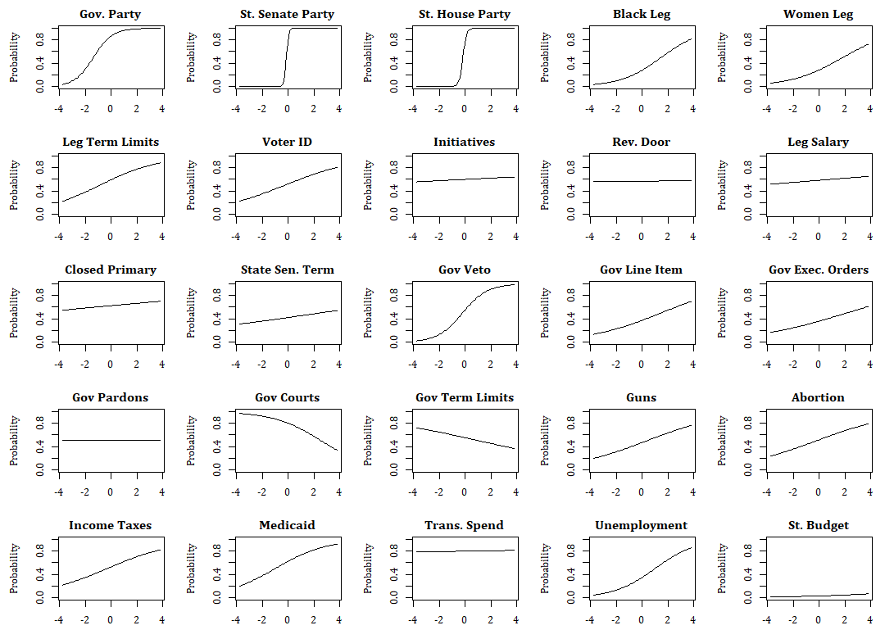
Item characteristics curves for closed-ended state political knowledge questions when pooling all questions in a single estimation.

Figure A-3: ICC Curves for “Parties and People” Questions
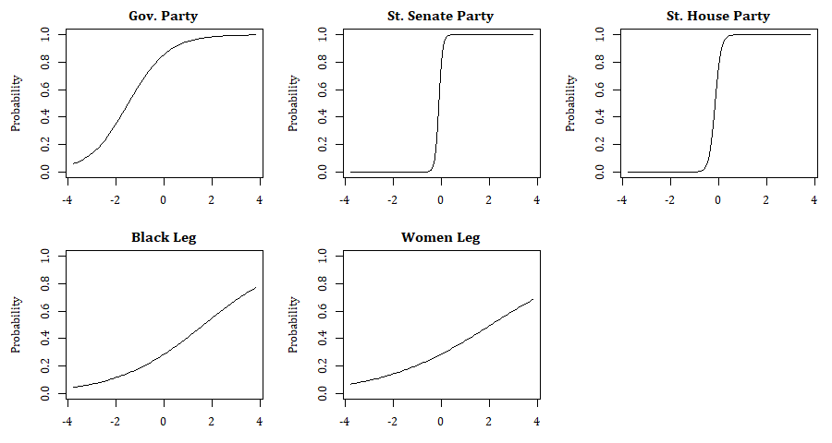
Item characteristics curves for “Parties and People” questions when only considering these questions within the “people” domain.

Figure A-4: ICC Curves for “Rules of the Game” Questions
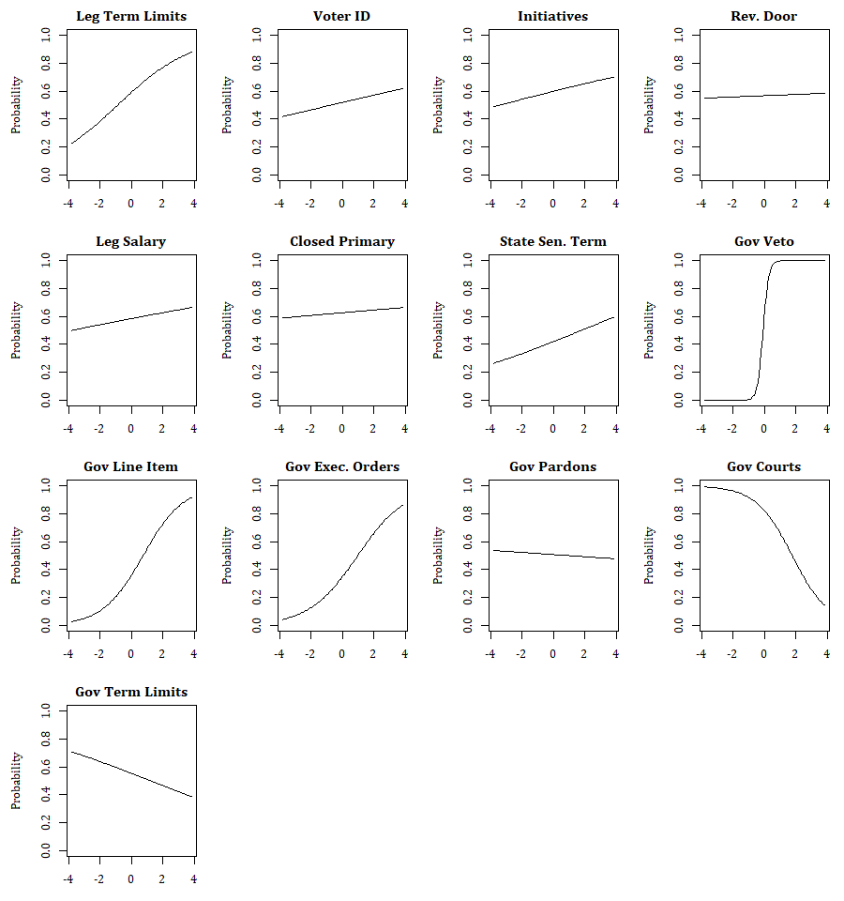
Item characteristics curves for “rules” questions when only considering these questions within the “rules” domain.

Figure A-5: ICC Curves for “Substance of Politics” Questions
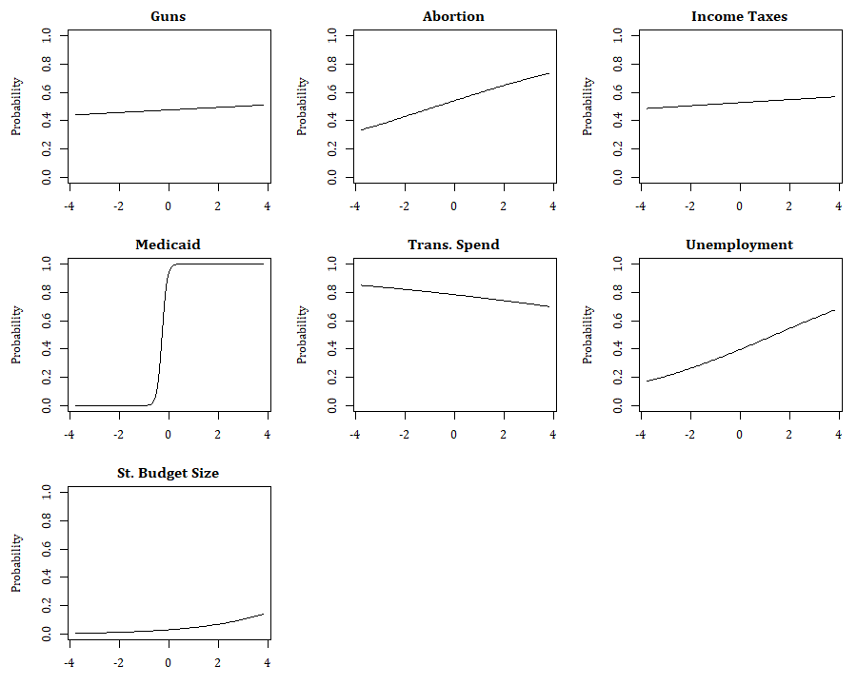
Item characteristics curves for “Substance” questions when only considering these questions within the “Substance” domain.

Figure A-6: ICC Curves for Federal Political Knowledge Questions
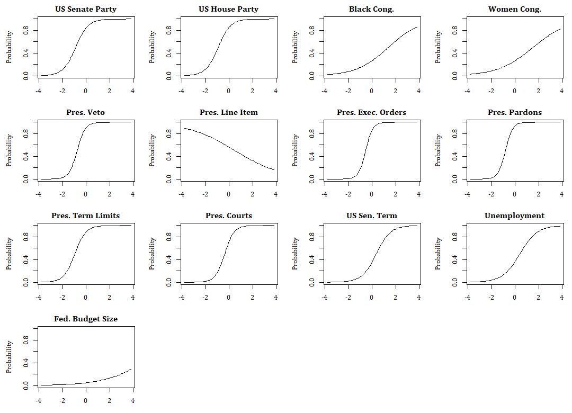
Item characteristics curves for federal politics questions when only considering federal questions.

Figure A-7: Density Plot of Respondents’ Federal and State Knowledge Ability Parameters
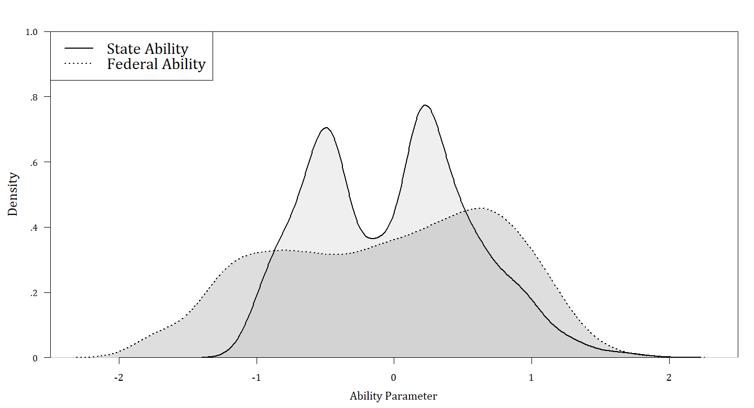
Kernell density plots of respondents’ ability parameters $\left(z_{i}\right)$ from IRT estimations that separately use closed-ended state politics and federal politics questions.

Table A-8: Predicting Americans' Knowledge
 | State  Ability | Federal  Ability | State  Mean Score | Federal  Mean Score
Female | -0.279* | -0.323* | -0.072* | -0.093*
 | (0.041) | (0.053) | (0.013) | (0.016)
Nonwhite | -0.157* | -0.350* | -0.056* | -0.097*
 | (0.048) | (0.065) | (0.016) | (0.020)
Age (Years) | 0.005* | 0.013* | 0.001* | 0.003*
 | (0.001) | (0.002) | (0.000) | (0.001)
Education | 0.100* | 0.153* | 0.023* | 0.043*
 | (0.013) | (0.020) | (0.004) | (0.006)
Income | -0.000 | -0.000 | -0.000 | 0.000
 | (0.001) | (0.001) | (0.000) | (0.000)
Constant | -0.431* | -1.000* | 0.355* | 0.328*
 | (0.089) | (0.115) | (0.030) | (0.036)
Observations | 995 | 995 | 995 | 995

This table reports the results of a linear regression in which the outcome of interest is either a respondent’s estimated ability from the above IRT models or their average score for state or federal political knowledge questions. Independent variables come from the CES Common Content. Standard errors in parentheses. * p < 0.05

Non-Differentiation in Answers

Knowledge questions concerning Governor’s and President’s powers were presented in a format where respondents identified an executive’s powers by selecting checkboxes to agree. Similarly, questions concerning a legislator’s salary, Medicaid expansion, transportation spending, closed primaries, and the relative economy used this check box format. Using such a format can lead to non-differentiation in answers or “straightlining,” where less engaged respondents check all or check none of the boxes, leading to less accurate measures of political knowledge.
To assess how straightlining impacts estimates of Americans’ knowledge, the first column of Table A-9 reports the proportion of correct responses among all respondents for each considered question. Other columns indicate the difference between this proportion of all respondents and the proportion of respondents who did not straightline answers for a particular grid of questions, as indicated by the column heading. Positive numbers in these columns indicate where percentages in the main text are likely to overestimate knowledge due to straightlining. Negative numbers in these columns indicate where percentages in the main text are underestimated.

Table A-9: Proportion Correct Responses when removing Straightliners
Issue | All  Resp.  Means | Diff when  Removing Relative  State Economy  Question  Straightliners | Diff when  Removing Gov. Powers  Question  Straightliners | Diff when  Removing Pres. Power  Question  Straightliners | Diff when  Removing trans. spending, primaries, Medicaid, & salaries  Question  Straightliners
Pre - Governor | 0.79 | 0.00 | -0.01 | 0.03 | 0.01
Pre - State Senate | 0.54 | 0.00 | -0.01 | 0.03 | 0.00
Pre - State House | 0.53 | 0.00 | 0.00 | 0.04 | 0.01
Pre - US Senate | 0.71 | 0.00 | -0.01 | 0.04 | 0.01
Pre - US House | 0.72 | 0.00 | -0.01 | 0.04 | 0.00
Post - Governor | 0.77 | -0.01 | -0.02 | 0.03 | 0.00
Post - State Senate | 0.59 | 0.00 | -0.03 | 0.01 | -0.01
Post - State House | 0.57 | 0.00 | -0.02 | -0.01 | -0.01
Post - US Senate | 0.67 | 0.00 | -0.02 | 0.01 | 0.00
Post - US House | 0.68 | 0.00 | -0.02 | 0.02 | 0.00
State Rep Recall | 0.08 | 0.00 | -0.01 | 0.00 | 0.00
State Leg - AA Desc. Rep (Within 5) | 0.23 | 0.00 | 0.00 | 0.03 | 0.00
Congress - AA Desc. Rep (Within 5) | 0.28 | 0.00 | -0.02 | 0.02 | 0.01
State Leg - Female Desc. Rep (Within 5) | 0.26 | 0.01 | -0.01 | 0.00 | 0.01
Congress - Female Desc. Rep (Within 5) | 0.28 | 0.00 | 0.00 | 0.00 | -0.01
Gov Veto | 0.50 | 0.01 | -0.07 | 0.06 | 0.01
Gov Line Item | 0.36 | 0.01 | -0.02 | 0.06 | 0.01
Gov Executive Orders | 0.35 | 0.01 | -0.01 | 0.01 | 0.01
Gov Pardons | 0.50 | 0.01 | 0.00 | 0.00 | 0.00
Gov Term Limits | 0.53 | 0.00 | 0.04 | 0.00 | 0.00
Gov Courts | 0.80 | 0.00 | 0.00 | -0.02 | 0.00
State Sen. Term Length | 0.42 | 0.01 | 0.01 | 0.00 | 0.01
Pres Veto | 0.73 | 0.00 | -0.03 | 0.03 | 0.01
Pres Line Item | 0.56 | 0.00 | 0.02 | -0.15 | -0.01
Pres Executive Orders | 0.64 | 0.00 | -0.03 | 0.07 | 0.01
Pres Pardons | 0.73 | 0.00 | -0.04 | 0.02 | 0.01
Pres Term Limits | 0.73 | 0.00 | -0.03 | 0.03 | 0.00
Pres Courts | 0.58 | 0.00 | -0.03 | 0.10 | 0.01
US Sen. Term Length | 0.38 | 0.00 | 0.01 | 0.03 | 0.01
Background Checks | 0.46 | 0.00 | -0.03 | -0.02 | 0.00
Abortion | 0.51 | -0.01 | -0.01 | -0.02 | 0.00
Income Taxes | 0.50 | 0.00 | 0.01 | 0.02 | 0.00
Medicaid | 0.62 | 0.01 | 0.00 | 0.01 | 0.01
Transportation | 0.80 | -0.01 | 0.00 | -0.01 | -0.04
State Unemployment (Within 1) | 0.33 | 0.01 | -0.01 | 0.02 | 0.01
US Unemployment (Within 1) | 0.37 | -0.01 | -0.01 | 0.05 | -0.02
State Budget (Within 5) | 0.03 | 0.00 | 0.00 | 0.00 | 0.00
US Budget (Within 5) | 0.05 | 0.00 | 0.00 | 0.01 | 0.00
Pre - Relative State GDP | 0.59 | 0.01 | 0.01 | 0.00 | 0.01
Post - Relative State GDP | 0.57 | 0.00 | 0.01 | -0.01 | 0.00
Pre - Relative Unemployment | 0.58 | 0.00 | -0.01 | -0.01 | 0.00
Post - Relative Unemployment | 0.58 | 0.00 | 0.00 | 0.00 | 0.01
Initiatives | 0.61 | 0.00 | -0.01 | 0.00 | 0.00
Closed Primary | 0.64 | 0.00 | 0.01 | -0.01 | 0.01
Voter ID | 0.52 | 0.00 | 0.00 | 0.00 | 0.01
Leg. Term Limits | 0.59 | 0.01 | 0.00 | 0.00 | 0.00
Revolving Door | 0.55 | 0.00 | 0.01 | 0.00 | -0.01
Legislator Salary | 0.58 | 0.01 | 0.00 | 0.01 | 0.04

All governors have some form of veto power, 44 governors have line-item veto power for budget or appropriations bills, 39 can issue executive orders without legislative approval, 28 can pardon criminals who violated state law without anyone else’s approval, 8 are subject to a lifetime two term limit, and none can make a lifetime appointment to the state supreme court with consent of the state senate. Only in Massachusetts, New Hampshire, and Rhode Island are justices appointed with lifetime tenure. In Massachusetts and New Hampshire, appointment requires approval from “Governor’s Councils,” and in Rhode Island confirmation is required from both state legislative chambers.
Respondents typed their answers in a text form, and research assistants coded responses’ accuracy. The most specific geographic identifiers were a respondent’s zip code and congressional district. I identified what state legislative district fell into “Zip-CD” regions, but multiple state legislative districts at times fell into a “Zip-CD” region. In coding, a voter was identified as providing a “correct” answer if they provided the name of a representative who represented one of these districts. For multi-member districts, I coded a voter’s response as correct if a voter accurately identified at least one of their representatives.
Respondents were asked descriptive representation questions in the post-election module to avoid priming from questions pertaining to racial resentment and feminism on the CES pre-election common content.
Respondents never saw their own state’s budget. To avoid partisan influences, respondents randomly saw different small and large states that were traditionally Republican or Democratic (e.g. Texas and Delaware in addition to New York and South Dakota). In 2017, the mean, median, and largest state government budgets were approximately $16 billion, $9 billion, and $119 billon.

