Appendix

Key Votes from 2009-2020

Year | Bill Number | Bill Name
2009 | HB 1657 | Contractor Worker's Compensation
2009 | HB 1736 | Increasing Wrongful Conviction Compensation
2009 | HB 2962 | Children’s Health Care
2009 | HB 537 | Increase Required Age for Seatbelts
2009 | HB 681 | Warning Signs Regarding Mercury Levels in Fish
2009 | SB 1049 | Increasing Age Restriction on Tobacco Purchases
2009 | SB 175 | Capping Automatic College Admissions
2009 | SB 188 | Authorizes Needle Exchange Programs
2009 | SB 298 | Authorizing Sobriety Checkpoints
2009 | SB 362 | Requiring Proof of Identification to Vote
2009 | SB 855 | Authorizing County Taxes and Fees to Fund Transportation Projects
2009 | SB1 | 2009-2011 Biennium Budget
2011 | HB 1 | 2011-2013 Budget
2011 | HB 12 | Enforcement of State and Federal Laws Governing Immigration
2011 | HB 15 | Requires an Ultrasound Prior to an Abortion
2011 | HB 150 | 2011-2012 Redistricting
2011 | HB 2403 | Internet Sales Tax
2011 | HB 242 | Prohibits Texting While Driving
2011 | HB 359 | Corporal Punishment in Public Schools
2011 | HB 537 | Interstate Health Care Compact
2011 | SB 1 | 2011-2013 Biennium Education Budget
2011 | SB 14 | Voter Identification Requirements
2011 | SB 16 | Abortion Procedures Bill
2011 | SB 181 | Prohibits Smoking in Public Places
2011 | SB 1811 | Reduces Funding for State Agencies
2011 | SB 22 | Establishing the Texas Congressional Redistricting Commission
2011 | SB 23 | Prohibits State Funding of Facilities that Perform Abortions
2011 | SB 29 | Restricts Certain Types of Touching During Searches by Government Officials
2011 | SB 4 | Congressional Redistricting
2011 | SB 420 | Eligibility for Indigent Health Care
2011 | SB 7 | Health Care
2011 | SB 8 | Management of Operation of Public Schools
2011 | SB 9 | Enforcement of State and Federal Laws Governing Immigration
2011 | SJR 1 | Urging Congress to Propose a Balanced Budget Amendment
2013 | HB 1009 | Establishes a "School Marshal" as a New Category of Law Enforcement for Schools
2013 | HB 1076 | Prohibits the Enforcement of Federal Firearm Regulations
2013 | HB 1340 | Authorizes Certain Children to Consent to Immunizations
2013 | HB 148 | Prohibits Multiple Ballots from Being Turned in by 1 Individual
2013 | HB 2 | Increases Abortion Facility Requirements and Prohibits Abortions After 20 Weeks
2013 | HB 318 | Prohibits Employers from Asking for Private Passwords
2013 | HB 489 | Expands Access to Service Dogs for Veterans with PTSD
2013 | HB 500 | Expands Franchise Tax Exemption for Certain Businesses
2013 | HB 63 | Prohibits Texting While Driving
2013 | HB 772 | Requires Individuals to Opt-Out of Immunization Registry
2013 | HB 852 | Rophibit the Sale of Shark Fins
2013 | HB 912 | Limits the Private Use of Unmanned Aircrafts
2013 | HB 928 | Prohibits State Funds from Being Used for the Enforcement of Federal Firearm Regulations
2013 | HB 950 | Requires Equal Pay for Women
2013 | HB 972 | Authorizes Concealed Handguns on Higher Eduction Campuses
2013 | SB 1 | 2013-2015 Biennium Budget
2013 | SB 1247 | Limits Payday Loan Interest Rates
2013 | SB 1467 | Requires Facilitation of Expansion of Firearms Manufacturers
2013 | SB 1907 | Authorizes Firearms in Vehicles on College Campuses
2013 | SB 2 | State Senate Redistricting
2013 | SB 21 | Requires Drug Testing for Unemployment Benefits
2013 | SB 303 | Amends the End-of-Life Care Procedures
2013 | SB 376 | Establishes a Free Breakfast Program for Students
2013 | SB 4 | Congressional Redistricting
2013 | SB 5 | Increases Abortion Facility Requirements
2013 | SB 864 | Reduces Required Hours for Concealed Handgun License Training
2015 | HB 1690 | Requires Texas Rangers to Investigate Public Corruption
2015 | HB 3994 | Amends Requirements for Minors Seeking Abortions
2015 | HB 40 | Specifies that the State will Regulate Oil and Gas Operations
2015 | HB 910 | Authorizes Open Carry of Handguns
2015 | SB 10 | Transfers Public Integrity Unit to Texas Rangers
2015 | SB 11 | Authorizes Concealed Carry of Firearms on College Campuses
2015 | SB 158 | Authorizes Grants for Body-Worn Cameras to Certain Law Enforment Agencies
2015 | SB 1628 | Amends Existing Law Relating to Insurance Claim Lawsuits
2015 | SB 17 | Authorizes Open Carry of Handguns
2015 | SB 1968 | Prohibits Wage Deductions for State Employee Union Dues
2015 | SB 2065 | Authorizes Religious Organizations to Perform Marriage Services
2015 | SB 267 | Prohibits Local Regulations that Prohibit Refusal of Tenants Based on Source of Income
2015 | SB 339 | Authorizes Medical Use of Cannabis
2015 | SB 575 | Prohibits Health Plan Coverage for Abortions
2015 | SB 6 | Establishes a Rating System for Schools
2015 | SB 900 | Amends Texas Windstorm Insurance Association
2017 | HB 214 | Premium Increase for Non-Emergency Abortions
2017 | HB 215 | Requires Additional Reporting for Abortions Performed on Minors
2017 | HB 22 | Amends Education Accountability Standards
2017 | HB 2466 | Expands Healthcare to Cover Postpartum Depression
2017 | HB 25 | Prohibits One-Punch Straight Ticket Voting
2017 | HB 28 | Establishes Standards for Determining Adjusted Franchise Tax Rates
2017 | HB 3859 | Authorizes Child-Placement Agencies to Deny Services Based on Religion
2017 | HB 3994 | Prohibits Cavvination of New Foster Children
2017 | HB 7 | Specifies Tree Removal Regulations Municipalities May Impose
2017 | HB 89 | Prohibits Contracts with Companies Boycotting Israel
2017 | SB 10 | Changes for Abortion Requirements at Health Care Facilities
2017 | SB 13 | Amends Provisions Regarding Payroll Deductions
2017 | SB 16 | Reduce Fee for Firearm Carry Licenses
2017 | SB 2 | Appropriates Funds for Private School Scholarships
2017 | SB 20 | Prohibits Coverage of Abortion by Soe Health Insurance Plans
2017 | SB 25 | Prohibits Wrongful Birth Lawsuits
2017 | SB 258 | Authorizes Burial or Cremation of Fetal Tissue After Abortion or Miscarriage
2017 | SB 260 | Amends Regulations Related to Immigration and Refugee Affairs
2017 | SB 3 | Appropriates State Funds for Education in Non-Rural Areas
2017 | SB 3 | Amends Regulations of Publich and Charter School Facilities
2017 | SB 4 | Prohibits Sanctuary Cities
2017 | SB 457 | Appropriates Funds fo Charter Schools
2017 | SB 463 | Amends High-School Diploma Eligibility
2017 | SB 576 | Establishes Reporting Standards for Sexual Assault on College Campuses
2017 | SB 6 | Requires Individuals to Use Bathrooms According to Gender on Birth Certificate
2017 | SB 75 | Requires Parental Consent for Minors to Join Labor Unions
2019 | HB 1 | Appropriates Fiunds for Fiscal Years 2020-2021
2019 | HB 1143 | Authorizes Storage and Transportation of Firearms in School Parking Areas
2019 | HB 1387 | Authorizes Law Enforcement Officers to Carry on School Property
2019 | HB 1528 | Requires Family Violence Convictions be Reported to the Department of Public Safety
2019 | HB 1576 | Authorizes Medicaid Payments to Ride-Hailing Sites for Appointment Pickup
2019 | HB 1584 | Repeals Step Therapy or "fail First" Protocols for Metastatic Stage 4 Cancer Patients
2019 | HB 16 | Establishes Requirements for Abortions Resulting in Premature Birth
2019 | HB 1631 | Prohibits Use of Red Light Cameras
2019 | HB 1739 | Prohibits Unfair Settlement Practice Regarding Motorist Insurance Coverage
2019 | HB 2271 | Authorizes the Advertisement of "Choose Life Grant" Funds
2019 | HB 2536 | Establishes Drug-Pricing Transparency Requirements
2019 | HB 2911 | Amends Election Law to Determine Voter Eligibility
2019 | HB 3285 | Establishes Services for Substance Use Disorders
2019 | HB 3490 | Classifies Indirect Cybercullying as a Crime
2019 | HB 3557 | Increase Penalties for Pipeline Protesting
2019 | HB 448 | Requires Children Under 2 Ride in Rear-Facing Car Seats
2019 | HB 455 | Establishes Standards for Public School Recess
2019 | HB 63 | Authorizes the Decriminalization of Cannabis Possession
2019 | HB 793 | Prohibits Specific State Contracts with Certain Companies that Boycott Israel
2019 | HB 824 | Prohibits Pharmaceutical Companies from Using "Pay for Delay" Practices
2019 | HB 888 | Increases Penalities for Misrepresenting a Child's Identity at Port of Entry
2019 | SB 1033 | Establishes the "Preborn Nondiscrimination Act"
2019 | SB 1264 | Authorizes Arbitration Processes for Insurers to Stop "Surprise Billings"
2019 | SB 17 | Authorizes Protections for Lawyers that Deny Clients Based on Religious Exemptions
2019 | SB 1978 | Prohibits Government Action Against Businesses that Donate to Religious Organizations
2019 | SB 21 | Prohibits Smoking under the Age of 21
2019 | SB 22 | Prohibits Taxpayer Dollars for Abortions Clinics
2019 | SB 2485 | Prohibits Local Governments from Imposing Regulations on Private Businesses Regarding Employee Benefits
2019 | SB 2487 | Prohibits Local Governments from Imposing Regulations on Private Businesses for Employee Leave
2019 | SB 406 | Amends Conceal Carry Regulations for Local School Marshals
2019 | SB 535 | Authorizes Handguns on the Premises of Places of Worship

Table 1. Cosponsorship Timing by Chamber for All Legislation 1997–2020

Variable | House | Senate
Cumulative Cosponsors | 1.00** | 0.82***
 | (0.00) | (0.01)
Copartisan Cosponsors | 1.07*** | 1.73***
 | (0.00) | (0.03)
Bipartisan Cosponsors | 5.11*** | 5.36***
 | (0.06) | (0.20)
Democrat | 1.18*** | 2.53***
 | (0.02) | (0.10)
Ideologically Extreme Legislator | 1.38*** | 1.34***
 | (0.02) | (0.05)
Conservativism | 1.17*** | 0.95
 | (0.03) | (0.07)
Conservatism of Bill Author | 1.28*** | 1.01
 | (0.01) | (0.01)
Member Ideological Difference | 1.02 | 1.30***
 | (0.01) | (0.04)
Challenger in General Election | 1.10*** | 0.86***
 | (0.01) | (0.02)
Agriculture | 1.16*** | 8.12***
 | (0.05) | (2.60)
Business | 1.16*** | 9.92***
 | (0.03) | (0.51)
Defense | 1.54*** | 18.56***
 | (0.04) | (1.32)
Education | 1.22*** | 11.66***
 | (0.03) | (0.64)
Energy | 1.10
 | (0.05)
Environment | 0.81*** | 7.39***
 | (0.02) | (0.51)
Health | 1.33*** | 10.18***
 | (0.03) | (2.10)
Justice | 1.05* | 9.50***
 | (0.02) | (0.52)
Parks and Recreation | 0.93
 | (0.05)
Revenue & Taxation | 1.25***
 | (0.03)
State and Local Government | 1.20*** | 9.36***
 | (0.02) | (0.47)
Welfare | 1.39*** | 1.32
 | (0.04) | (0.27)
N | 5,669,902 | 754,738
Note: * p<0.05, ** p<0.01, *** p<0.001. We report hazard ratios. Any coefficient greater than one means that a legislator cosponsors early and anything less than one means a legislator delays cosponsoring.

Table 2. Cosponsorship Timing by Chamber for Key Votes, 2009–2020

Variable | House |  | Senate
Cumulative Cosponsors | 0.96*** |  | 0.74***
 | (0.00) |  | (0.05)
Copartisan Cosponsors | 1.04*** |  | 1.44***
 | (0.00) |  | (0.09)
Bipartisan Cosponsors | 1.91*** |  | 1.24
 | (0.25) |  | (0.27)
Democrat | 0.67*** |  | 1.23
 | (0.07) |  | (0.28)
Ideologically Extreme Legislator | 1.35*** |  | 1.75***
 | (0.08) |  | (0.27)
District Conservativism | 1.05 |  | 1.11
 | (0.13) |  | (0.35)
Conservatism of Bill Author | 4.00*** |  | 0.47***
 | (0.35) |  | (0.06)
Member Ideological Difference | 0.96 |  | 1.38**
 | (0.05) |  | (0.15)
Challenger in General Election | 1.05 |  | 0.95
 | (0.06) |  | (0.14)
Agriculture | 20.24***
 | (13.45)
Business | 15.50*** |  | 0.16
 | (5.24) |  | (0.18)
Defense | 5.31*** |  | 3.54***
 | (1.25) |  | (0.89)
Education | 1.49 |  | 2.12***
 | (0.49) |  | (0.47)
Energy | 10.00***
 | (2.53)
Environment |  |  | 4.87*
 |  |  | (3.24)
Health | 1.70 |  | 2.59***
 | (0.62) |  | (0.60)
Justice | 30.85*** |  | 0.38*
 | (7.06) |  | (0.16)
Parks and Recreation | 4.50**
 | (2.42)
Revenue & Taxation | 6.73***
 | (1.69)
State and Local Government | 3.40*** |  | 2.52***
 | (0.74) |  | (0.50)
Welfare | 1650. 51***
 | (520.39)
N | 5,810 |  | 1,913
Note: * p<0.05, ** p<0.01, *** p<0.001. We report hazard ratios. Any coefficient greater than one means that a legislator cosponsors early and anything less than one means a legislator delays cosponsoring.

In the following two figures, Figures 1 and 2, we provide some insight into the data. We randomly selected bills with 10 cosponsors and plot the cosponsorship of those bills. Two patterns are visible in the figures. First, when legislators decide to cosponsor varies by bill. Second, the time a bill actively waits for cosponsors also fluctuates. In Figure 1, we can see that some bills, like HB 262 in the 75th session (1997), slowly gain cosponsors while other bills, like HB 1685 in the 86th session (2019), gain traction for only a month or two. It's also common to see multiple legislators sign on as cosponsors together, such as in HB 288 in the 79th (2005) session, where four cosponsors join on the same day. We see evidence of both bipartisanship cosponsorship and purely partisan (from both parties) cosponsorship.
In Figure 2, we track the same four years in the Senate. One thing to note in comparing the two chambers is that the cosponsorship decision making process in the Senate is much faster than in the House. After a legislator introduces a bill, the remaining legislators who are likely to cosponsor have usually made their decision within the following month. There are some exceptions to this pattern, but it’s usually the result of a legislator introducing a bill before the session officially begins or if a single legislator joins the chamber late. In addition, it is much more likely that legislators will sign on to a bill on the same day. Finally, in this random sample of the cosponsorship patterns, there appears to be a stronger tendency towards bipartisanship in the Senate, despite Republican control for most of the sessions.

Figure 1. House Cosponsorship Timing
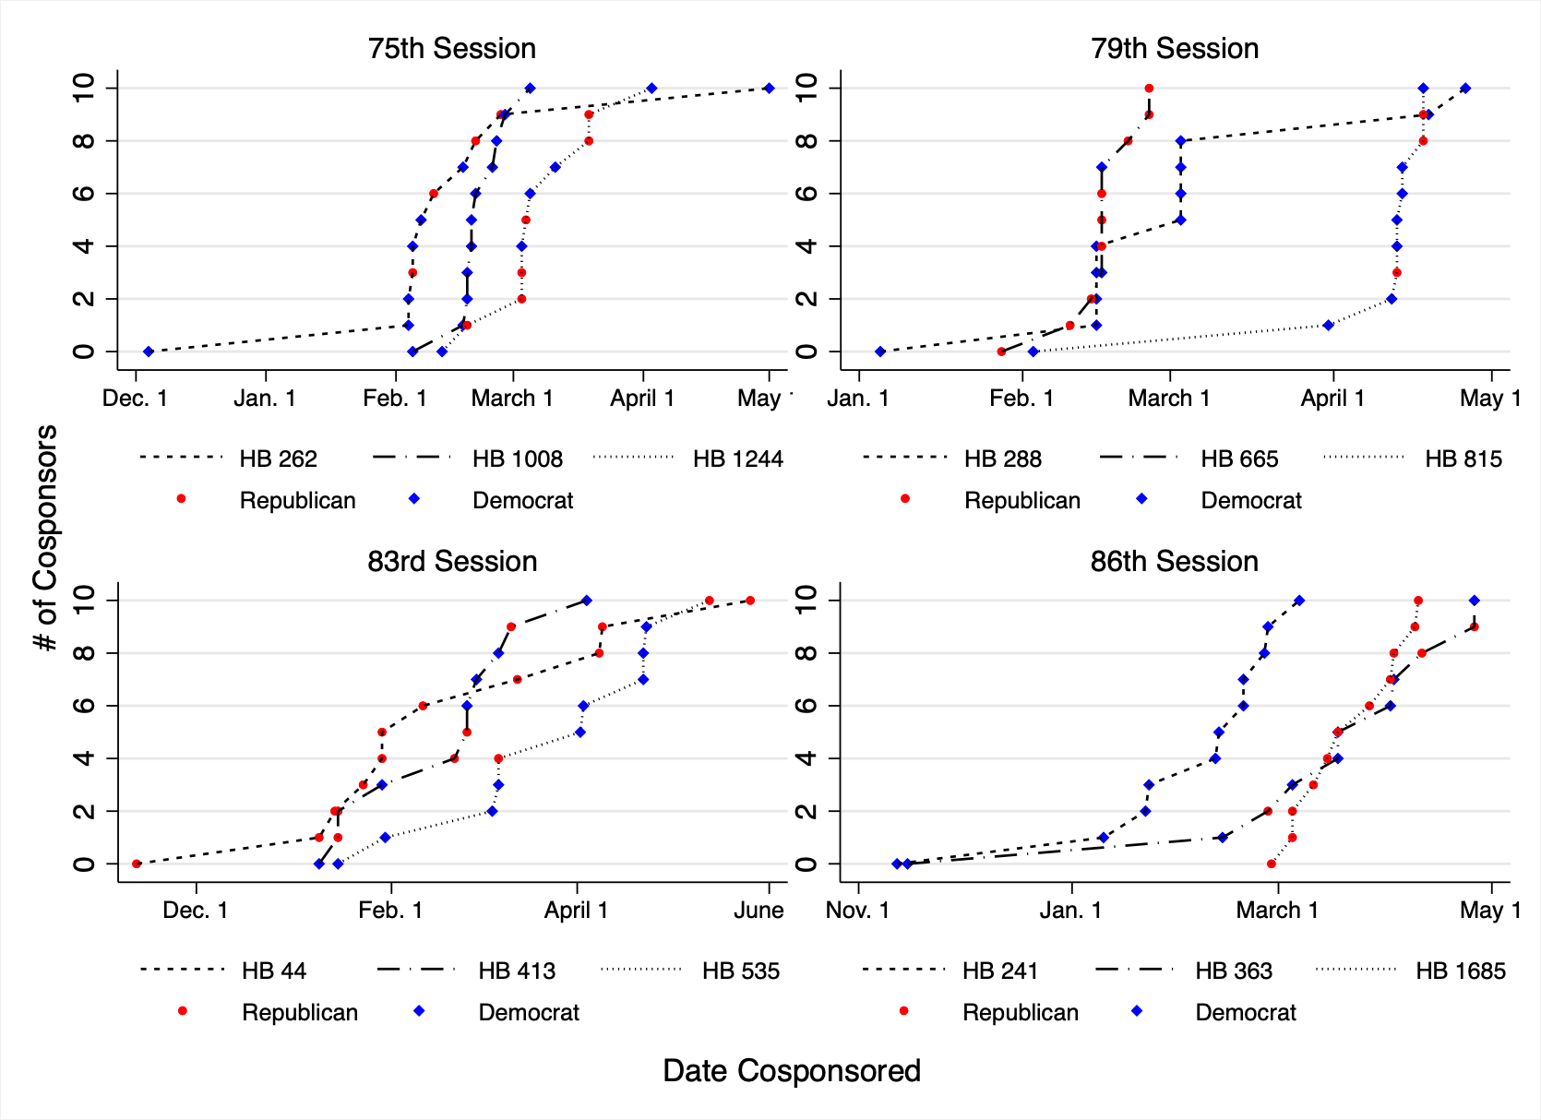

Figure 2. Senate Cosponsorship Timing
