Do Reserved Seats Work?

Evidence from Tribal Representatives in Maine

Online Appendix

Table of Contents
Appendix A: Identifying Tribal-Related Legislation in the Maine State Legislature 1
Appendix B: Bill Cosponsorship Analysis 5
Appendix C: Constituency Effects -- Percent of Native American Constituents 7
Appendix D: Legislator Ideology 10
Appendix E: Negative Binomial Regression 12
Appendix F: Analysis of roll call data and pro-tribal voting 13

Appendix A: Identifying Tribal-Related Legislation in the Maine State Legislature
We rely on multiple sources to construct a dataset of tribal-related legislation in the Maine State Legislature. We began by collecting the title of every bill sponsored or cosponsored by one of the eleven tribal representatives that served from 1995 to 2020. The rule change in the 117th Legislature (H.P. 156) that allowed the tribal representatives to sponsor tribal legislation specified that the representatives could sponsor legislation related to “Indians and Indian land claims.” A subsequent reform allowed the tribal representatives to cosponsor legislation pertaining to other topics. We include every bill that the tribal representatives sponsor in our dataset, but we are more selective about the bills they cosponsor. We include a cosponsored bill if the title or body include one of the keywords related to “Indians and Indian land claims.”
Next, we contacted the research staff at the Maine Law and Legislative Reference Library to obtain a list of tribal bills based on keyword searches. Non-tribal legislators were permitted to introduce tribal-related legislation before and after the rule change that empowered tribal representatives, thus we wanted to identify all such bills that were introduced before and after the reform. We cross-referenced the staff’s list with the National Conference of State Legislatures database of tribal-related bills (Johnson and Witmer 2020). These sources allowed us to extend the dataset back to 1984. We supplemented these three lists with our own keyword searches of the Maine legislature’s web directory of bills. The list of keyword search terms included, but was not limited to, phrases related to Maine’s tribes (e.g., Passamaquoddy, Maliseet, Micmac, Wabanaki) and Native Americans more broadly (e.g., Indian, Native, tribal, Indigenous). Of note, ‘Penobscot’ and ‘Aroostook’ are frequent names in Maine, requiring us to carefully filter out bills unrelated to the tribes.
We then coded the dataset of 394 bills into several categories based on the primary issue that was addressed by each bill. Although these categories do not factor directly into our analysis, it is nonetheless informative to consider the range of tribal-related issues that Maine legislators tend to address. We identified the following 15 categories based on the bills’ titles, text, and transcripts from floor debate (when available): Gaming/Casinos (18% of tribal-related bills), Tribal-State Relations (15%), Courts and Legal Jurisdiction (12%), Hunting/Fishing (11%), Naming and Commemoration (11%), Land Claims and Land Use (10.5%), Health and Housing (4%), Business and Economic Development (3.5%) Culture and Archaeology (4%), Education (2.5%), Taxes (2.5%), Child Welfare (2%), Treaties with the Federal Government (1.5%), Water Resources (1.5%), and Energy (1%).
We provide a list of bills in Table A.1 to illustrate the types of bills in each category. As the bill titles suggest, there is significant overlap between categories – for example, bills related to child welfare are fundamentally related to the tribal courts’ jurisdiction over child custody cases. Land claim bills are inseparable from tribal-state relations. And prohibitions on the misuse of tribal names, such as fraudulent claims about the authenticity of Native-produced art and commercial goods, are simultaneously related to economic interests and cultural identity. Given the fluidity between categories, we provide the following list for descriptive purposes but do not otherwise incorporate the categories into our statistical analysis.
Table A.1: Sample of tribal-related legislation (by category) in the Maine State Legislature:
Bill title | Category | Bill number and session
“An Act Authorizing a Tribally Owned Casino in the City of Calais” | Gaming/Casinos | H.P. 1470; 116th
“An Act to Allow Indian Gaming at Established Commercial Race Tracks” | Gaming/Casinos | H.P. 699; 119th
“An Act to Expand the Number of Authorized High-stakes Beano and High-stakes Bingo Games” | Gaming/Casinos | L.D. 108; 120th
“Requires that 4% of net slot machine income be distributed to four tribal governments” | Gaming/Casinos | S.P. 560; 128th
“An Act to Amend the Act to Implement the Maine Indian Claims Settlement” | Tribal-State Relations | L.D. 2036; 118th
“An Act To Provide Tribal Representation in the Senate” | Tribal-State Relations | H.P. 485; 125th
“An Act To Include a Representative of the Aroostook Band of Micmacs in the House of Representatives” | Tribal-State Relations | H.P. 40; 126th
“Proposes an amendment to the Constitution of Maine to provide the Indian Representatives a vote in the Maine Legislature” | Tribal-State Relations | L.R. 2286; 126th
“An Act to Create the Office of Tribal-State Relations” | Tribal-State Relations | L.R. 956;129th
“Resolve, To Increase Funding for Indigent Legal Aid Provided to Wabanaki Tribal Members” | Courts/Legal Jurisdiction | H.P. 478; 126th
“An Act Regarding the Penobscot Nation’s and Passamaquoddy Tribe’s Authority To Exercise Jurisdiction under the Federal Tribal Law and Order Act of 2010 and the Federal Violence Against Women Reauthorization Act of 2013” | Courts/Legal Jurisdiction | L.D. 268; 127th
“An Act to Ensure the Protection of Tribal Fish Stocks and Other Natural Resources” | Hunting/Fishing | H.P. 63; 117th
“An Act To Provide Native Americans with Lifelong Licenses and Permits to Hunt, Fish and Trap” | Hunting/Fishing | L.D. 51; 123rd
“An Act to Remove State Road Signs with Offensive Names from Interstate Route 95 and the Maine Turnpike” | Naming/ Commemoration | L.D. 618;120th
“An Act To Ban Native American Mascots in All Public Schools” | Naming/ Commemoration | H.P. 699;129th
“An Act to Repeal the Law Providing that State Laws Apply to Indian Lands” | Land Claims/Use | L.D. 956;118th
“An Act To Extend Time Limits for Placing Land in Trust Status under the Maine Indian Claims Settlement” | Land Claims/Use | L.D. 921;128th
“Resolve, To Direct Action on Health Disparities of the Passamaquoddy Tribe and Washington County” | Health/Housing | H.P. 848;124th
“An Act Concerning Radioactive Waste Disposal Facilities on Indian Territory” | Health/Housing | S.P. 416;113th
“Resolve, to Create the Commission to Study the Establishment of a State and Tribal Partnership to Encourage Economic Development | Business/Economic | S.P. 607; 114th
“An Act To Ensure the Authenticity of Items Reported To Have Been Crafted by Native Americans” | Business/Economic | H.P. 100; 126th
“Resolve, to Prevent Tampering with Indian Archeological Sites” | Culture/Archaeology | L.D. 1028;119th
“Resolve, To Authorize State Funding of the Penobscot Nation Museum” | Culture/Archaeology | H.P. 239; 112th
“An Act Concerning Funding of Indian Schools under the Act to Implement the Maine Indian Claims Settlement” | Education | H.P. 1433; 115th
“An Act To Establish the Penobscot Language Preservation Fund in the Department of Education” | Education | H.P. 1247; 122nd
“An Act Regarding Taxation inside the Passamaquoddy Indian Territory” | Taxes | L.D. 1044;121st
“An Act To Provide a Tax Exemption for Tobacco Sold to an Adult Member of a Federally Recognized Indian Tribe for Cultural, Spiritual or Ceremonial Purposes” | Taxes | H.P. 173; 126th
“An Act To Streamline Enforcement of Child Support Orders Issued by the Penobscot Nation” | Child Welfare | ^{H.P. 1211; 126th}
“An Act to Authorize the Trial of Child Welfare Cases Involving the Houlton Band of Maliseet Indians in the Penobscot Tribal Court” | Child Welfare | L.R. 2906; 120th
“An Act To Impose a Penalty for Making False Claims Regarding Affiliation with a Federally Recognized Tribe” | Federal Treaties | H.P. 1201; 125th
“Joint Resolution Memorializing the President of the United States and the Congress of the United States to Provide to the Houlton Band of Maliseet Indians Just and Equitable Compensation Comparable to the Settlement Provided To the Penobscot Nation and the Passamaquoddy Tribe” | Federal Treaties | H.P. 963; 126th
“An Act Providing for Regulation of the Uses of Surface Waters within or Affecting Passamaquoddy Territory” | Water Resources | L.D. 1255; 119th
“An Act to Amend the Charter of the Passamaquoddy Water District” | Water Resources | H.P. 1313; 112th
“An Act To Facilitate the Establishment of Tribal Electric Utility Districts” | Energy | H.P. 200; 123rd
“An Act To Provide Access to Regional Greenhouse Gas Initiative Auction Funds to Maine Indian Tribes” | Energy | L.D. 260, 124th

Appendix B: Bill Cosponsorship Analysis
To what extent did cosponsorship behavior change after the 1995 rule change? In this section, we reproduce our cross-section and time-series analyses using data on pro-tribal bill cosponsorship. Table B.1 presents the results of our cross-section analysis. Again, the tribal representatives played an active role in the legislative process once they were granted the ability to participate. Tribal representatives cosponsored, on average, 8 more pro-tribal bills per session than their non-tribal colleagues. We also find that the presence of a tribe in a given district is positively associated with that legislator cosponsoring pro-tribal bills. These legislators sponsored approximately one more bill per session, on average. In the time series analysis, presented in Table B.2, we also find that non-tribal legislators with tribes in their district did not significantly reduce their cosponsorship behavior after 1995.
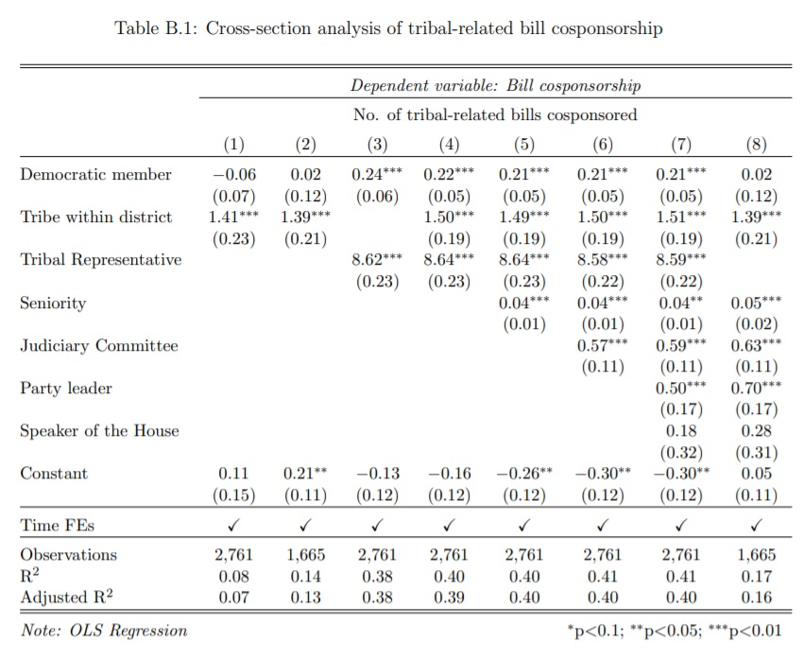
.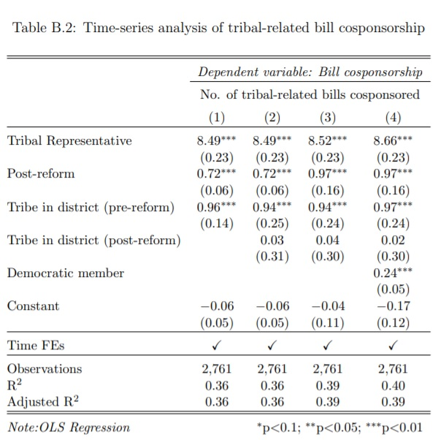

Taken together with the results of the sponsorship data, we can say that there is some evidence to support the substitute hypothesis with regards to non-tribal legislators with tribes in their district. These legislators decreased their output of non-tribal bills once their tribal representative counterparts gained the right to sponsor legislation, but they did not stop cosponsoring other pro-tribal bills, including those offered by the tribal representatives.

Appendix C: Constituency Effects -- Percent of Native American Constituents
The literature on Native American constituency effects uses other measures of Indigenous constituency, in addition to the presence of federally recognized tribes. For example, one might expand the binary measure to include state-recognized tribes that could plausibly exert influence on federal or state legislators without federal recognition. Another popular measure used in the empirical research on descriptive representation is the percentage of constituencies that belong to a certain group (Hansen and Treul 2015).
- Constituency Hypothesis #2: State legislators will be more supportive of tribal legislation as the percentage of their constituents who are Native American increases (Conner 2014; Turner 2005)
Following the work of Turner (2005), we use U.S. Census data to find the percent of residents that self-identify as “Native American” or “American Indian” in each of Maine’s 151 lower house districts. Unfortunately, these data are only readily available from 2009 to 2017, and we are unable to reproduce the difference-in-differences analysis with a continuous measure of Indigenous constituency. Nonetheless, we present here the results of the cross-section analysis for bill sponsorship over the last decade. Tables C.1 and C.2 present the results for the cross-sectional analysis of bill sponsorship and cosponsorship behavior, respectively. Although we find strong evidence that the percent of residents who are Native American is positively correlated with cosponsoring pro-tribal bills, we counterintuitively find that the size of the Indigenous constituency is negatively associated with primary sponsorship of such bills.
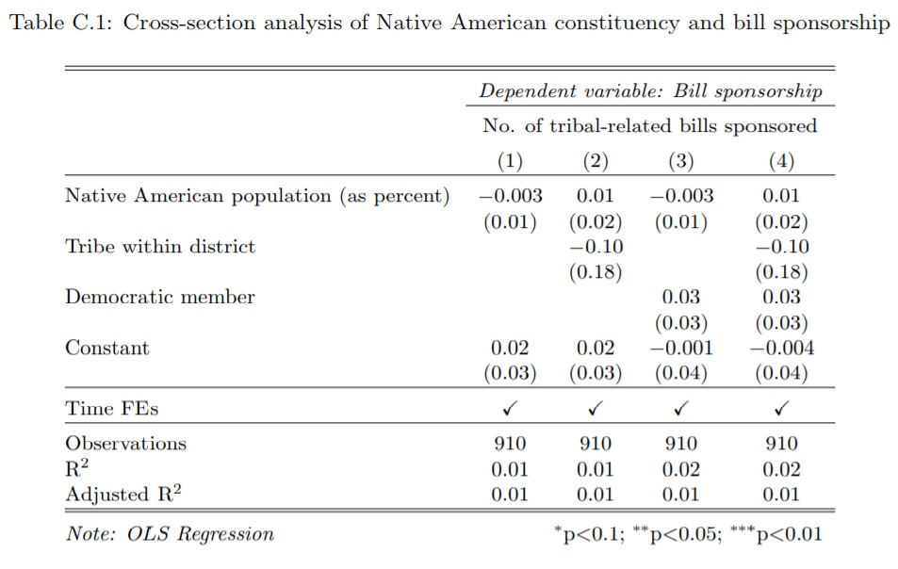
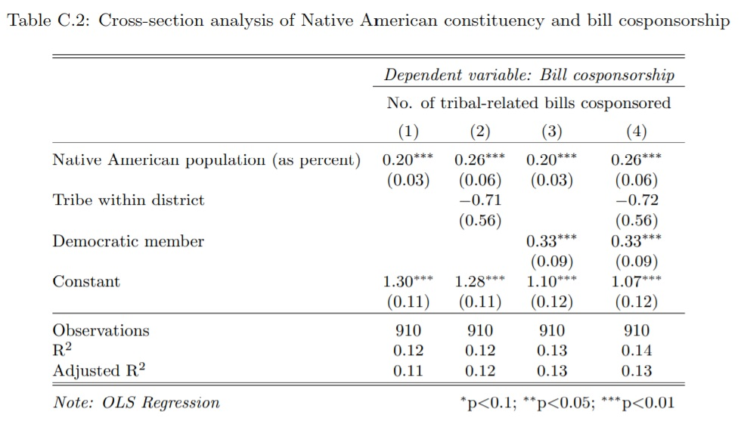

Appendix D: Legislator Ideology
In addition to partisanship, we might also expect that a legislator’s ideology will be associated with their willingness to sponsor or cosponsor pro-tribal bills. We express this hypothesis as follows:
- Ideology Hypothesis #1: Liberal legislators will be more supportive of tribal-related bills than more conservative legislators, conditional on the presence of a tribe in the district.
To test this hypothesis, we draw on the work of Bonica (2014) and identify the DIME scores for most of Maine’s legislators. Unfortunately, the DIME data begin in 1996, one year after the reform in which we are interested, so we are unable to account for ideology in our difference-in-differences analysis. We were also unable to locate DIME data for all 151 members in every session of the Maine House. Nonetheless, these data can be helpful for evaluating our expectations about the relationship between ideology and pro-tribal behavior in the legislature.
Here we present the results of the cross-sectional analyses using the DIME scores from 1996 to 2016. Tables D.1 and D.2 present the results for bill sponsorship and cosponsorship respectively. We find some evidence that a higher CF score is associated with a member sponsoring and cosponsoring fewer pro-tribal bills. We caution that the magnitude of these effects are quite small, and in the case of bill sponsorship, not robust to the inclusion of partisanship and constituency effects. Conversely, we find strong evidence, across multiple specifications, that ideology is predictive of cosponsoring pro-tribal bills.
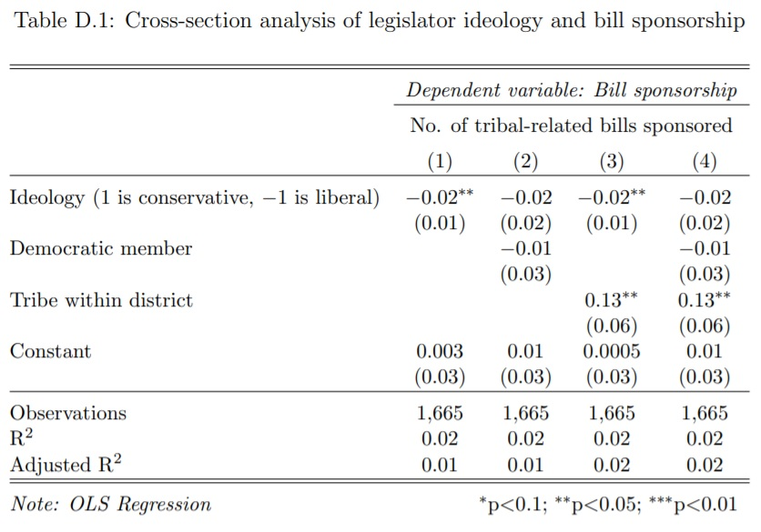

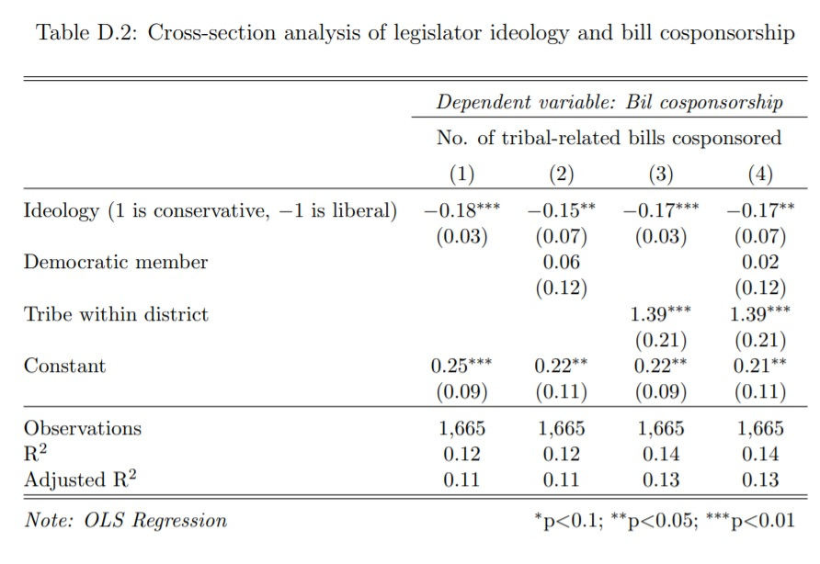

Appendix E: Negative Binomial Regression

In this section, we re-estimate our cross-sectional models with negative binomial regression because of the count-based nature of our dependent variable.

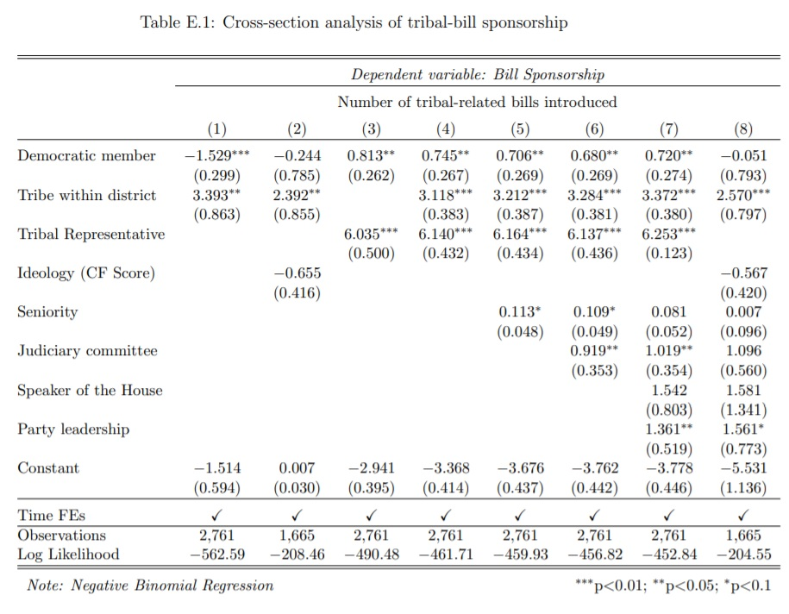

Appendix F: Analysis of Roll Call Data and Pro-Tribal Voting
What follows is an analysis of roll call vote data from 60 pro-tribal bills between 1984 and 2020. We calculate the number of pro-tribal votes taken by each non-tribal legislators in each session and re-estimate our cross-section analysis using this alternate dependent variable.
