Appendix (“The U.S. Political Economy of Climate Change: Impacts of the ``Fracking'' Boom on State-Level Climate Policies”)

Contents
- Figures A1, A2. LEV policy: Common trends for >5% and >0% shale as treatment status. (p. 2-3)
- Figure A3. Mandated renewables: Common trends for >0% shale as treatment status. (p. 4)
- Tables A1, A2, A3. Main regression results from the text, with control variables. (p. 5-7)
- Tables A4, A5. LEV policy diff-in-diff regressions for additional treatment time periods. (p. 8-9)
- Table A6. Mandated renewable electricity policy diff-in-diff regressions for additional treatment time periods. (p. 10)
- Figures A4. Tables A7, A8. Placebo test coefficient plots and regression results. (p. 11-13)
- Tables A9, A10, A11. Two-way fixed effects (i.e., state-time) regressions. (p. 14-15)
- Why not try an instrumented difference-in-difference? (p. 16)

LEV policy: Common trends for >5% and >0% shale as treatment status

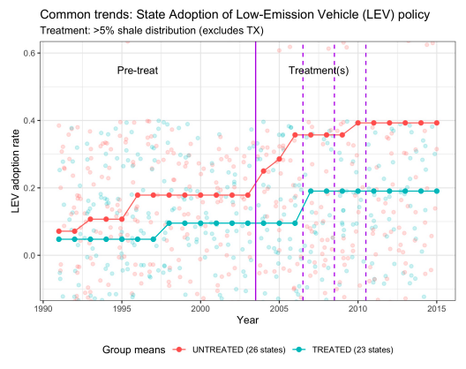
Figure A1. For >5% shale coverage treatment status: Common trends before, during, and after the height of the fracking boom. Vertical lines (2003, 2013) indicate breaks between pre-treatment (1999-2003), treatment (2004-06, 2004-08, or 2004-10), and post-treatment (2007-10, 2009-12, or 2011-14) periods. Raw data is plotted in the background of group means and trends.

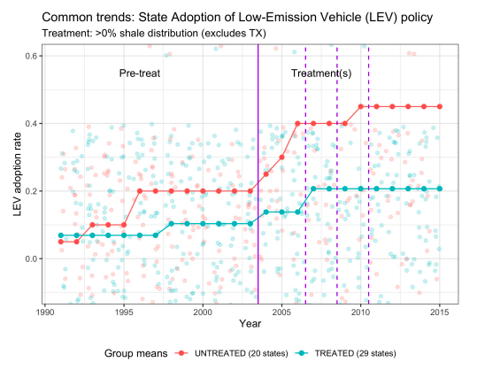
Figure A2. For >0% shale coverage treatment status: Common trends before, during, and after the height of the fracking boom. Vertical lines (2003, 2013) indicate breaks between pre-treatment (1999-2003), treatment (2004-06, 2004-08, or 2004-10), and post-treatment (2007-10, 2009-12, or 2011-14) periods. Raw data is plotted in the background of group means and trends.

Mandated renewables: Common trends for >0% shale as treatment status

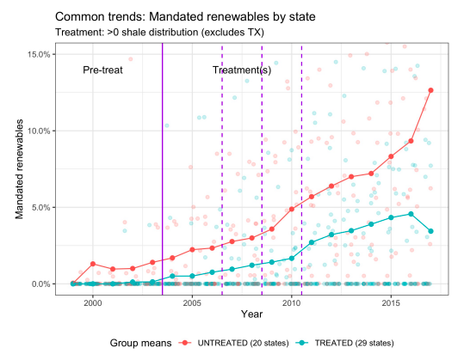
Figure A3. For >0% shale coverage treatment status: Common trends before, during, and after the height of the fracking boom. Vertical lines (2003, 2013) indicate breaks between pre-treatment (1999-2003), treatment (2004-06, 2004-08, or 2004-10), and post-treatment (2007-10, 2009-12, or 2011-14) periods. Raw data is plotted in the background of group means and trends. Multiple vertical dotted lines indicate the multiple treatment timing periods tested.

Main regression results from the text, with control variables.

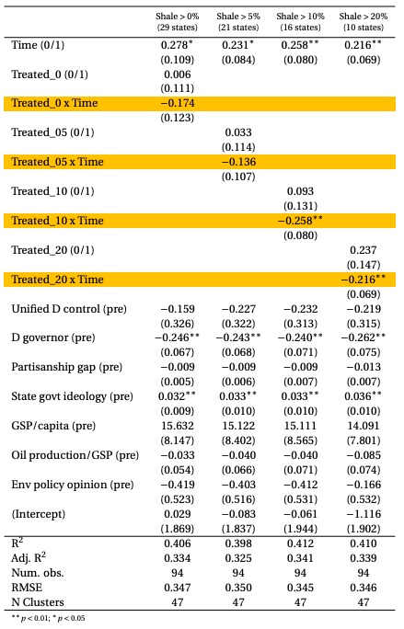
Table A1. Effect of fracking on LEV policy, 2004-06 as treatment period. Estimates produced using OLS difference-in-difference regressions. DV is LEV policy adoption per state. Standard errors are clustered (by state) and robust. The treatment period is 2004-06, so the ``pre'' period is 1999-2003; the ``post'' period is 2007-11. All continuous variables are measured as averages per state, during those five-year spans. ``Treated'' and ``Time'' are binary (0/1). N = 94 because Texas is dropped for theoretical reasons and Alaska and Hawaii are dropped for data availability reasons.

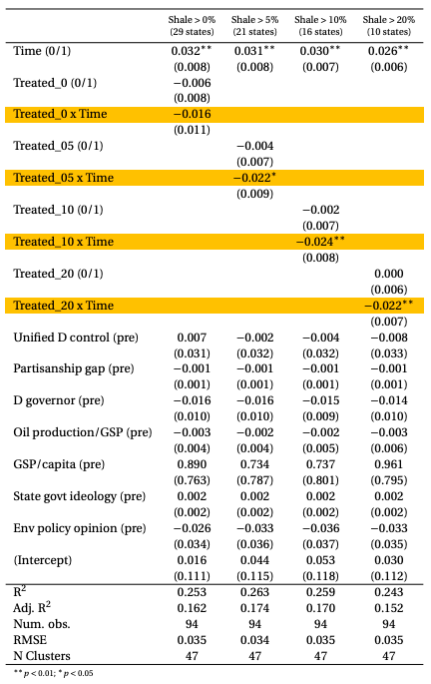
Table A2. Effect of fracking on renewable electricity policy, 2004-06 as treatment period. Estimates produced using OLS difference-in-difference regressions. DV is mandated renewable proportion per state. Standard errors are clustered (by state) and robust. The treatment period is 2004-06, so the ``pre'' period is 1999-2003; the ``post'' period is 2007-11. All continuous variables are measured as averages per state, during those five-year spans. ``Treated'' and ``Time'' are binary (0/1). N = 94 because Texas is dropped for theoretical reasons and Alaska and Hawaii are dropped for data availability reasons.

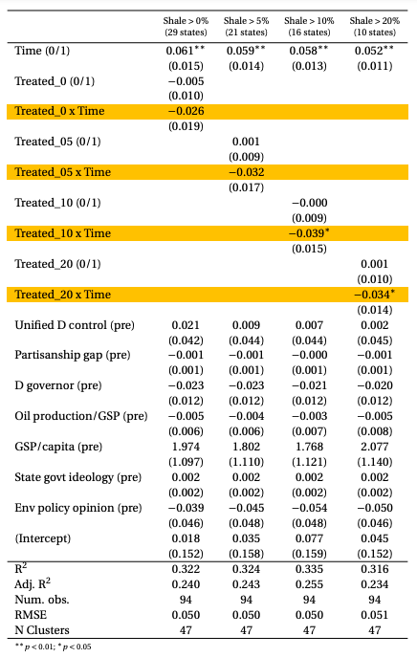
Table A3. Effect of fracking on renewable electricity policy, 2004-10 as treatment period. Estimates produced using OLS difference-in-difference regressions. DV is mandated renewable proportion per state. Standard errors are clustered (by state) and robust. The treatment period is 2004-10, so the ``pre'' period is 1999-2003; the ``post'' period is 2011-15. All continuous variables are measured as averages per state, during those five-year spans. ``Treated'' and ``Time'' are binary (0/1). N = 94 because Texas is dropped for theoretical reasons and Alaska and Hawaii are dropped for data availability reasons.

LEV policy diff-in-diff regressions for additional treatment time periods

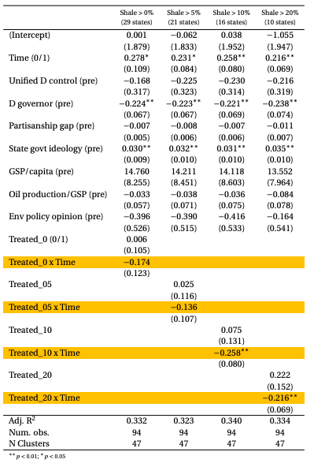
Table A4. Effect of fracking on LEV policy, 2004-08 as treatment period. Estimates produced using OLS difference-in-difference regressions. DV is LEV policy adoption per state. Standard errors are clustered (by state) and robust. The treatment period is 2004-08, so the ``pre'' period is 1999-2003; the ``post'' period is 2009-13. All continuous variables are measured as averages per state, during those five-year spans. ``Treated'' and ``Time'' are binary (0/1). N = 94 because Texas is dropped for theoretical reasons and Alaska and Hawaii are dropped for data availability reasons.

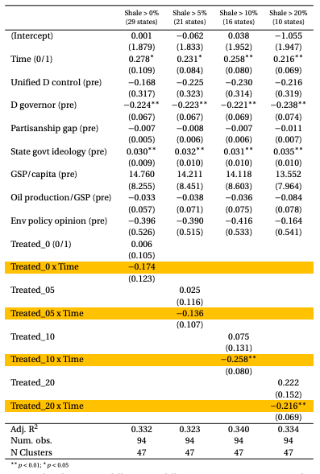
Table A5. Effect of fracking on LEV policy, 2004-10 as treatment period. Estimates produced using OLS difference-in-difference regressions. DV is LEV policy adoption per state. Standard errors are clustered (by state) and robust. The treatment period is 2004-10, so the ``pre'' period is 1999-2003; the ``post'' period is 2011-15. All continuous variables are measured as averages per state, during those five-year spans. ``Treated'' and ``Time'' are binary (0/1). N = 94 because Texas is dropped for theoretical reasons and Alaska and Hawaii are dropped for data availability reasons.

Mandated renewable electricity policy diff-in-diff regressions for additional time periods

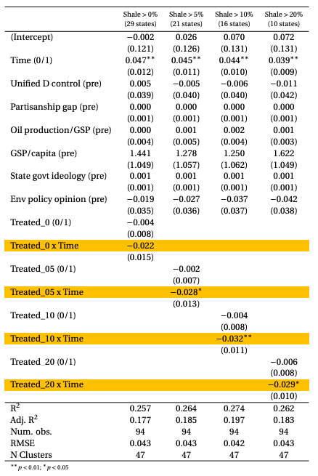
Table A6. Effect of fracking on renewable electricity policy, 2004-08 as treatment period. Estimates produced using OLS difference-in-difference regressions. DV is mandated renewable proportion per state. Standard errors are clustered (by state) and robust. The treatment period is 2004-08, so the ``pre'' period is 1999-2003; the ``post'' period is 2009-13. All continuous variables are measured as averages per state, during those five-year spans. ``Treated'' and ``Time'' are binary (0/1). N = 94 because Texas is dropped for theoretical reasons and Alaska and Hawaii are dropped for data availability reasons.

Placebo test coefficient plots and regression results

When employing the difference-in-difference research design, it is necessary to run similar regressions while using a placebo treatment timing, to check whether treatment may have started before the research design assumes. In this case, the following regression table and coefficient plot shows that there were not significant correlations when we use 2002 as a potential treatment period (really ``2001.5'': pre period is 2000-01, post period is 2002-03). A coefficient placebo plot is shown below for the renewable policy outcome (regression tables follow). These placebo tests show null results (if we pretend that fracking treatment began before 2004).
I do not display a coefficient plot to test the placebo timing effects for the case of LEV policy, as the common trends charts show that outcome variable values for the years 1998-2003 are all constant. Therefore, any placebo test that uses a year in that time window as the treatment timing (e.g., 2001.5, as described above) will produce placebo treatment estimates of 0, with standard errors of 0.

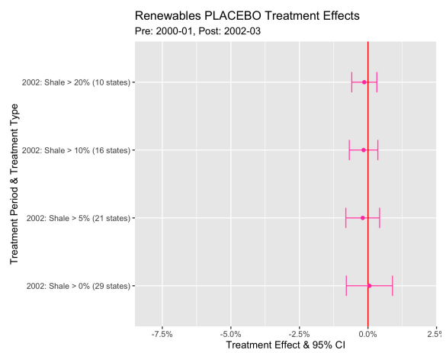
Figure A4.

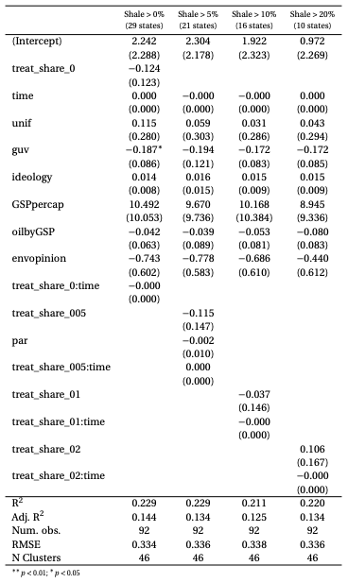
Table A7. LEV placebo regressions: pre as 2000-01, post as 2002-03.

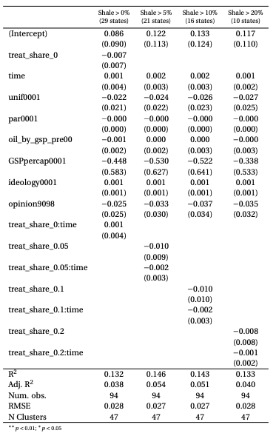
Table A8. Renewables placebo regressions: pre as 2000-01, post as 2002-03.

Two-way fixed effects (i.e., state-time) regressions

Table A9 displays a similar model to the main results in the text (from Tables 2-4) using a two-way fixed effects model. There are still just two periods in these models. The “pre” period is 1999-2003 for each column in Table A9, but the “post” period varies (by column), as in the main results in Tables 2-4. The treatment and outcome values here are the averages of the variable over those five-year spans (for both pre and post periods). The treatment variable in Table A9 is shale share of land per state—measured the same as the main results. For both outcome variable policies (LEV—first three columns—and RPS—fourth through sixth columns), all treatment period possibilities yield statistically significant results for these two-way fixed effects models. The coefficients are slightly larger than main diff-in-diff results from the text. (Unlike in the main text regressions, Hawaii and Alaska are included here, as no covariates are necessary in these two-way fixed effects models; HI and AK were dropped from the main diff-in-diff regressions because data on environmental policy opinion was not available for those states. Texas is still not included here, so 49 states are included in these two-way fixed effects regressions.)

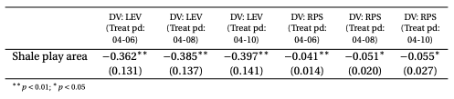
Table A9.

Table A10 displays two-way fixed effects regression results but broadens the units (from state-time) to state-year, increasing the time periods for each state from two to 17 (for the LEV outcome) or 19 (for RPS). Further, the “treatment” here is measured as shale wells (data from Fedaseyeu et al 2015) per state, divided by state GSP to obtain a more economically meaningful measure of shale wells (both oil and gas)—as a proxy for volume of oil or gas extracted. (I am not sure if data on volume of shale oil/gas extracted per state-year exists.) I refer to “treatment” here in quotation marks because the extraction of fracked shale oil or gas is less plausibly exogenous to political forces that are relevant changes in LEV and RPS policies. As explained in a footnote in the paper text, extraction is partially a product of political forces that shape regulation, which in turn makes extraction more or less difficult for corporations in any given state. Therefore, this measure of fracking as extraction is less well-suited to causal inference analysis. However, in the chance that this extraction measure is exogenous enough, Table A10 (and A11) employ this measure of extraction as a treatment in these two-way fixed effects models, still yielding statistically significant results. The coefficients are not intuitively interpretable because of the weighting by state GSP. This treatment variable is specifically calculated as: (well count / state GSP) * 1,000,000.

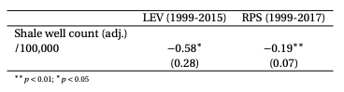
Table A10.

Table A11 displays similar two-way fixed regressions as A9 (using state-time [not year]—two time periods), still yielding statistically significant results. Treatment here is shale well count (adjusted by state GSP, as explained for Table A10). Since A11 measures different treatment time periods, the treatment variable (adjusted well count) is measured as the sum of that (adjusted) quantity over all years of the treatment (e.g., if the treatment period is measured as 2004-06, as it is in the first two columns, then the treatment variable is measured as the sum of all [adjusted] wells in 2004 + 2005 + 2006). Similar to A10, the adjusted nature of the treatment variable makes the coefficients not very intuitive to interpret.

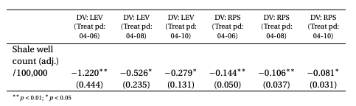
Table A11.

Why not try an instrumented difference-in-difference?
Given that shale distribution is plausibly random but extraction is a treatment of interest, some readers may wonder if I could employ a research design framing shale distribution as an instrument for the endogenous treatment of extraction. This might produce the complier average causal effect (CACE) of extraction (from pre to post time periods). Unfortunately, since one necessary assumption for instrumental variables research designs is “excludability”—that the instrument (here, shale distribution) can only plausibly affect the outcome (here, climate policy) via the endogenous treatment (here, extraction). In this political context, that claim seems unsupported: it is very possible that the pure knowledge that shale resource extraction is on the table could cause state policymakers to change policy to be more favorable to future extraction, independent from actual oil or gas extracted. (I still show a few two-way fixed effects models in the appendix that employ extraction as the treatment variable; results show statistically significant effects, similar to the main results reported in the paper body.)

