Appendix

Table 1.A Betting Odds on the Chances of a Candidate Carrying the State, September 1896
State | Candidate  Predicted to Win | Odds  9/26/1896 | Probability | Market  Predicted Winner | Actual Winner
Alabama | Bryan | 2.5 to 1 | 0.71 | D | D
Arkansas | Bryan | 4 to 1 | 0.8 | D | D
California | McKinley | even | 0.5 | R | R
Colorado | Bryan | 4 to 1 | 0.8 | D | D
Connecticut | McKinley | even | 0.50 | R | R
Delaware | McKinley | 10 to 7 | 0.58 | R | R
Florida | McKinley | 1 to 7 | 0.13 | R | D
Georgia | Bryan | 3 to 1 | 0.75 | D | D
Iowa | McKinley | 10 to 9 | 0.53 | R | R
Idaho | Bryan | 8 to 5 | 0.62 | D | D
Illinois | Bryan | 5 to 4 | 0.56 | D | R
Indiana | McKinley | 10 to 7 | 0.59 | R | R
Kansas | McKinley | even | 0.5 | R | D
Kentucky | McKinley | even | 0.5 | R | R
Louisiana | McKinley | 1 to 2.5 | 0.29 | R | D
Massachusetts | McKinley | 6 to 1 | 0.85 | R | R
Maryland | McKinley | even | 0.5 | R | R
Maine | McKinley | 4 to 1 | 0.8 | R | R
Michigan | McKinley | 10 to 7 | 0.58 | R | R
Minnesota | McKinley | 10 to 9 | 0.53 | R | R
Missouri | McKinley | 7 to 10 | 0.41 | R | D
Mississippi | Bryan | 3 to 1 | 0.75 | D | D
Montana | Bryan | 3 to 1 | 0.75 | D | D
North Carolina | McKinley | 1 to 2.5 | 0.28 | R | D
North Dakota | McKinley | 1 to 3 | 0.25 | R | R
Nebraska | McKinley | 4 to 5 | 0.44 | R | D
New Hampshire | McKinley | 4 to 1 | 0.8 | R | R
New Jersey | McKinley | 2 to 1 | 0.66 | R | R
Nevada | Bryan | 3 to 1 | 0.75 | D | D
New York | McKinley | 6 to 1 | 0.86 | R | R
Ohio | McKinley | 2 to 1 | 0.66 | R | R
Oregon | McKinley | 3 to 5 | 0.38 | R | R
Pennsylvania | McKinley | 10 to 1 | 0.91 | R | R
Rhode Island | McKinley | 2 to 1 | 0.66 | R | R
South Carolina | Bryan | 3 to 1 | 0.75 | D | D
South Dakota | McKinley | 1 to 2 | 0.33 | R | D
Tennessee | McKinley | 1 to 3 | 0.25 | R | D
Texas | Bryan | 3 to 1 | 0.75 | D | D
Virginia | McKinley | 1 to 2 | 0.33 | R | D
Vermont | McKinley | 6 to 1 | 0.85 | R | R
Washington | McKinley | 1 to 3 | 0.25 | R | D
Wisconsin | McKinley | 10 to 7 | 0.59 | R | R
Wyoming | McKinley | 3 to 5 | 0.38 | R | D
Source for betting odds: "'M’Kinley Favorite in the Betting." Chicago Daily Tribune Sept 26 1896.

Figure 1.A Betting Odds Data, September 1896
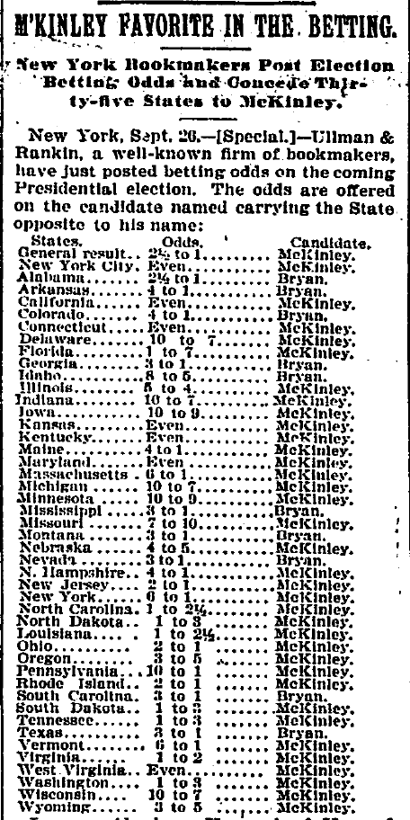

Source: "M’Kinley Favorite in the Betting." Chicago Daily Tribune Sept 26 1896.

Figure 2.A Betting Odds Data, October 1896
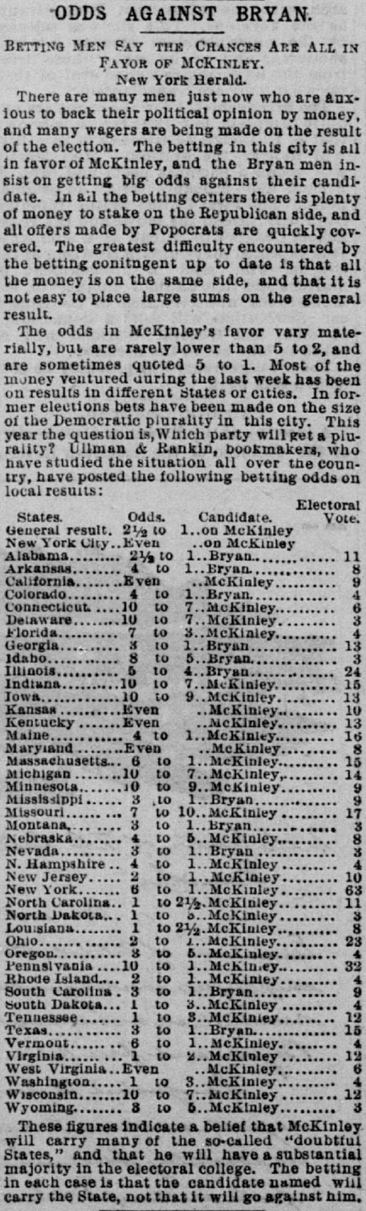
Source: "Odds against Bryan." San Francisco Call Oct 5 1896.
Figure 3.A Example of Betting Odds Data in Newspapers
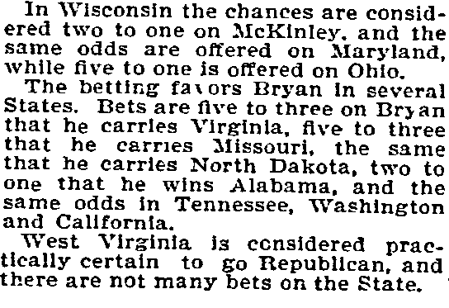
Source: “How the Betting Men are figuring Election Chances” The Philadelphia Inquirer Sept. 20, 1896

Table 2.A The Republican Share of the Two-party Vote as a Function of Betting Market Predictions (Probabilities) 1896
 | (1) | (2)
 | Republican % of 2-Party Vote 1896 | Republican % of 2-Party Vote 1896
Republican Candidate Price 1896 | 0.597***  (0.093) | 0.378***  (0.080)
Republican % of 2-Party Vote 1892 | — | 0.658***  (0.109)
Constant | 0.177** | 0.016
 | (0.051) | (0.044)
Observations | 43 | 43
R² | .531 | .752
Adj. R² | .520 | .740
Standard errors in parentheses
* p < 0.05, ** p < 0.01, *** p < 0.001

Figure 4.A Republican Share of the 2-Party Vote vs. Candidate Prices (Probabilities) 1896
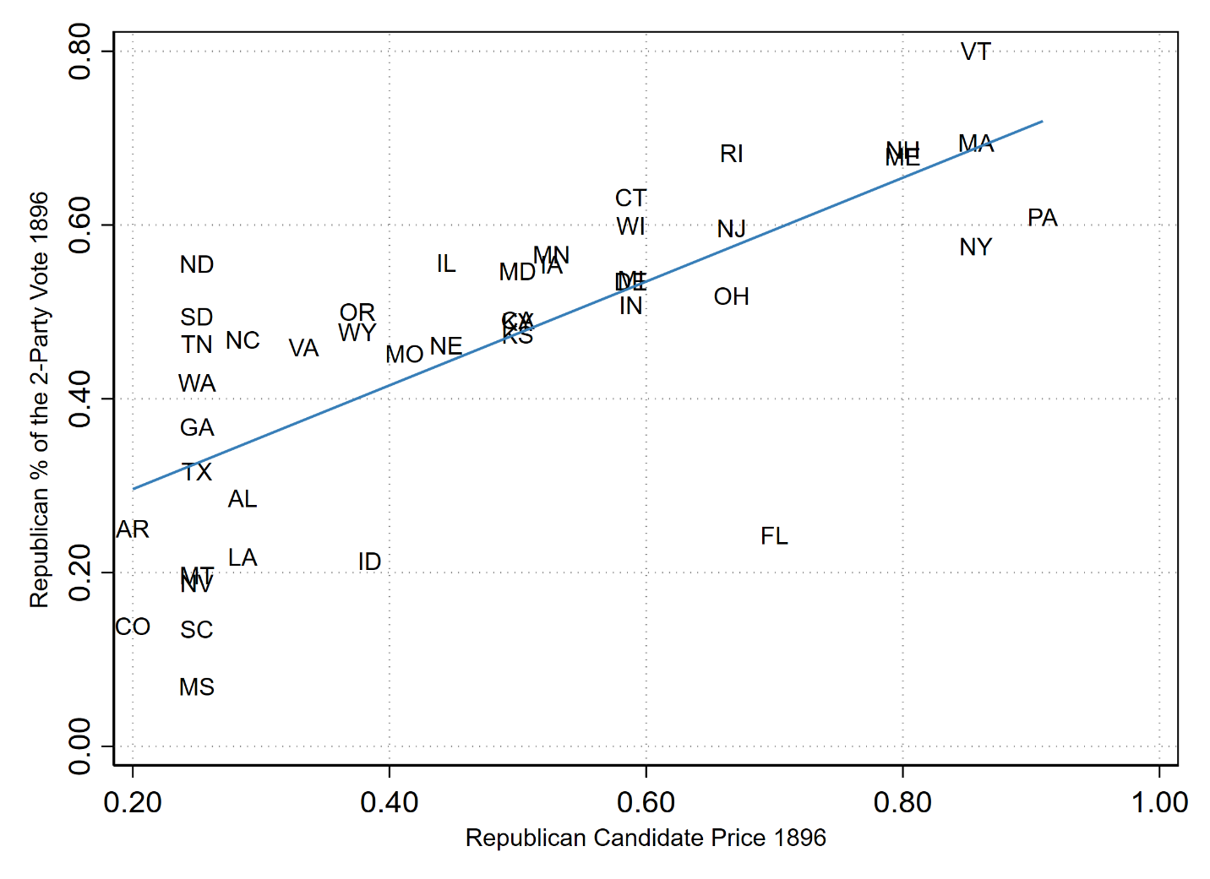
Correlation is .73

Figure 5.A Republican Share of the 2-Party Vote vs. Candidate Prices (Probabilities) in Non-southern States 1896
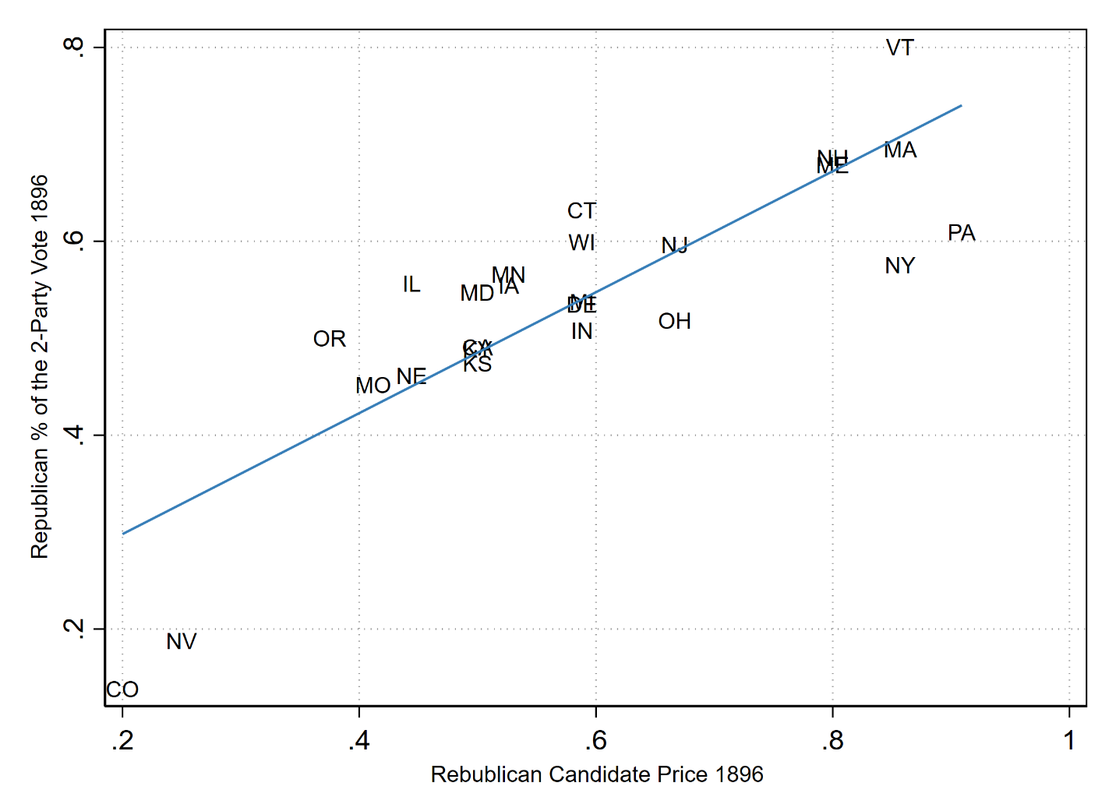
Correlation is .84

