Supplemental Appendix

Supplemental Appendix A
Ballot Scanner Codes, Categorization, and Observation Counts
 |  | Scanner Event Codes | Count | Average Duration (seconds) | Standard Deviation (seconds) | Maximum Duration (seconds)
Event Type | No Error | No Error | 379455 | 2.87 | 0.53 | 11
 | Machine Error | Ballot Jam. Please check the paper path. | 267 | 242.00 | 629.09 | 4782
 |  | System Error - Contact Election Official. | 8 | 11.88 | 0.64 | 13
 |  | Ballot Jam. Please remove ballot and re-insert. | 69 | 8.51 | 4.34 | 13
 |  | Ballot Could Not Be Read. Please remove your ballot and re-insert the opposite end first. | 4167 | 2.79 | 0.66 | 10
 |  | Error scanning ballot. Please remove your ballot and re-insert the opposite end first. Ensure all stubs are removed from the ballot. | 1655 | 2.16 | 0.64 | 11
 |  | Shutdown initiated | 5 | 833.6 | 566.72 | 1771
 |  | Ballot too short Please remove ballot. | 17 | 1.71 | 0.69 | 3
 |  | Voting Machine Not Programmed For Your Ballot | 236 | 2.38 | 0.68 | 8
 | Marking Error | Voter Rejected Overvoted Ballot | 2132 | 27.99 | 31.79 | 594
 |  | Voter Accepted Overvoted Ballot | 3099 | 23.85 | 33.70 | 741
 |  | Voter Rejected Blank Ballot | 636 | 31.07 | 58.02 | 570
 |  | Voter Accepted Blank Ballot | 1896 | 20.00 | 44.61 | 826
 |  | Automatically rejected Ballot with Unreadable mark | 9849 | 2.74 | 0.65 | 10
 | HMI Error | Ballot was not inserted far enough. Please remove your ballot and re-insert it completely. | 664 | 8.87 | 3.52 | 11
 |  | Ballot was removed during scanning. Please re-insert the ballot completely. | 1653 | 1.89 | 1.49 | 11
 |  | Multiple ballots were detected. Please remove ballots and insert them one ballot at a time. Ensure your ballot is not folded or damaged. | 2666 | 1.22 | 0.42 | 3
Supplemental Appendix B
Processed DS200 Log File Data Using BOOTH Voting Package

Duration (mm:ss) | Scan Type | Ballot Cast Status
00:04 | No Error | Successful
02:30 | Ballot Jam. Please check the paper path. | Jam
00:03 | No Error | Successful
00:03 | No Error | Successful
00:03 | No Error | Successful
00:03 | No Error | Successful
00:02 | No Error | Successful
00:05 | Voter Accepted Blank Ballot | Successful
00:03 | No Error | Successful
00:03 | No Error | Successful
00:03 | No Error | Successful
00:03 | No Error | Successful
00:07 | Voter Accepted Overvoted Ballot | Successful
00:04 | No Error | Successful
00:02 | No Error | Successful
00:02 | No Error | Successful
00:02 | No Error | Successful
00:02 | No Error | Successful
00:03 | No Error | Successful
00:03 | No Error | Successful
00:02 | No Error | Successful
00:03 | No Error | Successful
00:03 | No Error | Successful
00:03 | No Error | Successful
00:03 | No Error | Successful
00:03 | No Error | Successful
00:02 | No Error | Successful

Supplemental Appendix C
Sample Ballot from the 2018 Rhode Island Midterm elections
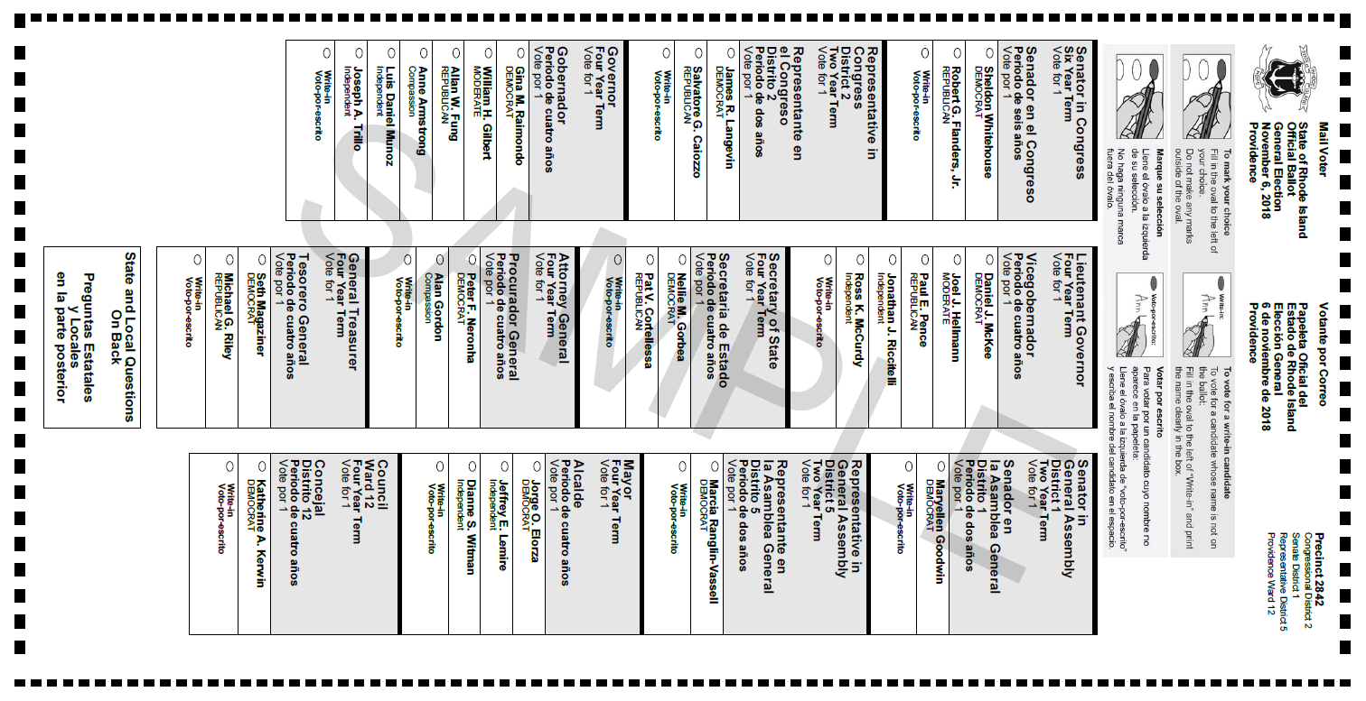

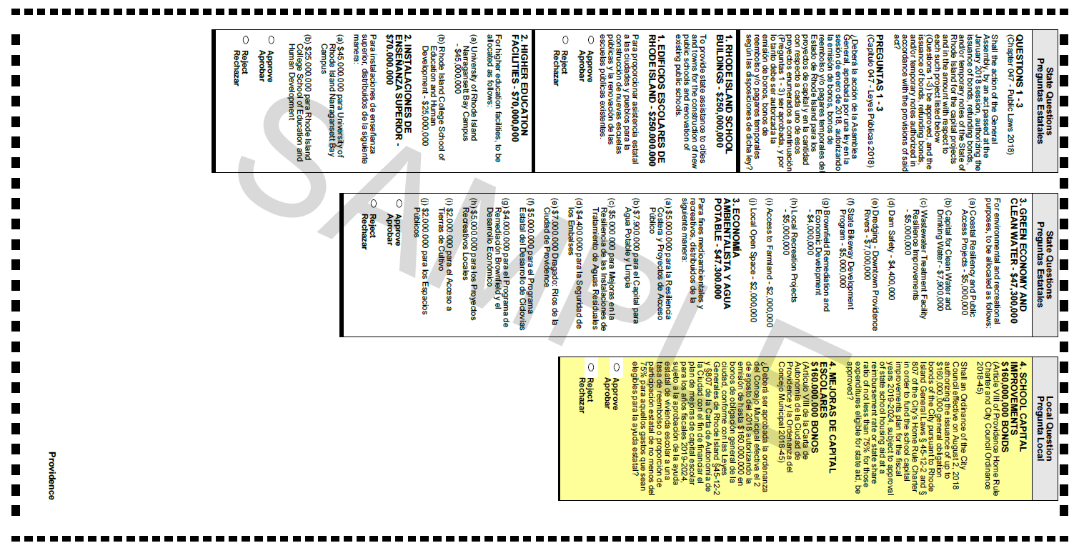

Supplemental Appendix D
Sample Set of Final Data Formatted
Event Description | Pages | Sheets | Office Questions | State Questions | Local Questions | Bilingual | Total Questions | Candidate Select | Total Select | Total Words | Error String | Binary Error
Ballot was not inserted far enough. Please remove your ballot and re-insert it completely. | 2 | 1 | 12 | 3 | 3 | 0 | 18 | 15 | 21 | 729 | HMI | 1
No Error | 2 | 1 | 12 | 3 | 3 | 0 | 18 | 15 | 21 | 729 | No | 0
No Error | 2 | 1 | 12 | 3 | 3 | 0 | 18 | 15 | 21 | 729 | No | 0
No Error | 2 | 1 | 12 | 3 | 3 | 0 | 18 | 15 | 21 | 729 | No | 0
No Error | 2 | 1 | 12 | 3 | 3 | 0 | 18 | 15 | 21 | 729 | No | 0
Ballot was removed during scanning. Please re-insert the ballot completely. | 2 | 1 | 12 | 3 | 3 | 0 | 18 | 15 | 21 | 729 | HMI | 1
Multiple ballots were detected. Please remove ballots and insert them one ballot at a time. Ensure your ballot is not folded or damaged. | 2 | 1 | 12 | 3 | 3 | 0 | 18 | 15 | 21 | 729 | HMI | 1

