Luiz Vilaça and Jacob R. Turner, The new corruption crusaders: Security sector ties as an anti-corruption voting heuristic. Latin American Politics and Society vol. 66, no. 4 (Winter 2024).

Appendix A: Full Questionnaire and Vignette Text (English)

Block: Informed Consent

Informed Consent (Text available upon request)
Q2 Do you agree to participate in this study?
Yes (1)
No (2)

Block: Filter/Demographic I
Q4 What is your age?

Q5 What is your sex?
o Male (1)
o Female (2)
o Non-binary (3)
o Prefer not to say (4)

Q6 In what state do you reside?

Q7 Adding together the monthly incomes of all of the family members you live with, what would be your monthly income?
o Less than 2 minimum wages (less than R$ 2.200) (1)
o 2 to 4 minimum wages (from R$ 2.200 to R$ 4.400) (2)
o 4 to 10 minimum wages (from R$ 4.400 to R$ 11.000) (3)
o 10 to 20 minimum wages (from R$ 11.000 to R$ 22.000) (5)
o Greater than 20 minimum wages (more than R$ 22.000) (6)
o Prefer not to say (7)

Block: Institutional Trust

Q8 To what degree do you trust the following institutions?
 | Completely Distrust (1) | Slightly Distrust (2) | Neither Trust nor Distrust (3) | Slightly Trust (4) | Completely Trust (5)
Civil Police (1) | o | o | o | o | o
Military Police (2) | o | o | o | o | o
Federal Congress (3) | o | o | o | o | o
Attorney General (4) | o | o | o | o | o
Mayor of your city (For DF residents, consider your governor) (5) | o | o | o | o | o
City council of your city (6) | o | o | o | o | o
Armed Forces (7) | o | o | o | o | o

Block: Experiment Intro

Q9 Imagine that municipal elections are about to happen in your city. We are going to present several fictional profiles of mayoral candidates and ask you what you think of each one.

Several candidates might appear to be quite similar. Try to rate each candidate independently, without considering the others.

Block: Candidate 1

[PRESENT FIRST SANTINHO]

Q11 How likely would you be to support this candidate?
o Extremely Likely (1)
o Somewhat Likely (2)
o Neither Likely nor Unlikely (3)
o Somewhat Unlikely (4)
o Extremely Unlikely (5)

Q12 How effective do you believe that this candidate would be for the following issues:
 | Not effective at all (1) | Somewhat effective (2) | Moderately effective (3) | Very effective (4) | Extremely effective (5)
Public Security (1) | o | o | o | o | o
Corruption (2) | o | o | o | o | o
Unemployment (3) | o | o | o | o | o

Block: Candidate 2

[PRESENT SECOND SANTINHO]

Q11 How likely would you be to support this candidate?
o Extremely Likely (1)
o Somewhat Likely (2)
o Neither Likely nor Unlikely (3)
o Somewhat Unlikely (4)
o Extremely Unlikely (5)

Q12 How effective do you believe that this candidate would be for the following issues:
 | Not effective at all (1) | Somewhat effective (2) | Moderately effective (3) | Very effective (4) | Extremely effective (5)
Public Security (1) | o | o | o | o | o
Corruption (2) | o | o | o | o | o
Unemployment (3) | o | o | o | o | o

Block: Candidate 3

[PRESENT THIRD SANTINHO]

Q11 How likely would you be to support this candidate?
o Extremely Likely (1)
o Somewhat Likely (2)
o Neither Likely nor Unlikely (3)
o Somewhat Unlikely (4)
o Extremely Unlikely (5)

Q12 How effective do you believe that this candidate would be for the following issues:
 | Not effective at all (1) | Somewhat effective (2) | Moderately effective (3) | Very effective (4) | Extremely effective (5)
Public Security (1) | o | o | o | o | o
Corruption (2) | o | o | o | o | o
Unemployment (3) | o | o | o | o | o

Block: Police Legitimacy

Q19 Now we would like to ask you several questions about public security. To what degree do you agree with the following statements:

 | Completely Disagree (1) | Somewhat Disagree (2) | Neither Agree nor Disagree (3) | Somewhat Agree (4) | Completely Agree (5)
When the police deal with people, they always behave according to the law (1) | o | o | o | o | o
The police treat citizens with respect (2) | o | o | o | o | o
Crime levels in my neighborhood have changed for the better in the last year (3) | o | o | o | o | o
I feel safe walking in my neighborhood at night (4) | o | o | o | o | o
The police make sure citizens receive the outcomes they deserve under the law (5) | o | o | o | o | o

Q20 In the previous six months, how frequently did you have contact with the following groups:
Nos últimos seis meses, com que frequência você teve contato com os seguintes grupos:
 | Never (1) | Once (2) | Monthly (3) | Weekly (4) | Daily (5)
Civil Police (1) | o | o | o | o | o
Military Police (2) | o | o | o | o | o
Municipal Guard (3) | o | o | o | o | o
Public Health Workers (4) | o | o | o | o | o
Public School Teachers (5) | o | o | o | o | o

Q21 In the previous six months, how many times was something belonging to you or a family member stolen?
o Never (1)
o Once (2)
o Two or three times (3)
o Three to five times (4)
o More than five times (5)

Block: Municipal Finance Experiment

Q22 Now we are going to ask you to read a small text about how municipal governments managed public resources to combat the pandemic. Please read closely, as we will ask questions about the text later.

[PRESENT VIGNETTE]

Q24 What did the TCU investigation and public prosecutor find about the budget of Rosa Branca?
o The mayor had been stealing from the city budget (1)
o The mayor had been managing the city budget honestly (2)

Q25 After the investigation of the finances of Rosa Branca, the city council of that city began to discuss public policies and would like to know your opinion about the following policies:

 | Discordo totalmente (1) | Discordo um pouco (2) | Não concordo nem discordo (3) | Concordo um pouco (4) | Concordo totalmente (5)
Create an anti-corruption task force (1) | o | o | o | o | o
Increase police budgets (2) | o | o | o | o | o
Cut public spending by privatizing parks, public transportation, and healthcare facilities (3) | o | o | o | o | o
Restrict the use of force by the police (4) | o | o | o | o | o
Create an armed municipal police force (5) | o | o | o | o | o
Build military schools (6) | o | o | o | o | o
Create a task force to investigate police abuses (7) | o | o | o | o | o

Block: National Problems

Q26 There are many problems facing the Brazilian people today. Please rate the following issues from most important (1) to least important (5):
______ Corruption (1)
______ Healthcare (2)
______ Public Security (3)
______ Inequality (4)
______ Unemployment (5)

Q27 Are there other national problems that you would include?
________________________________________________________________

Block: Covid Block

Q28 In your opinion, how well have municipal governments managed the Covid-19 pandemic?
o Very badly (1)
o Somewhat badly (2)
o Neither well nor badly (3)
o Somewhat well (4)
o Very well (5)

Q29 How many people do you know who have died or been hospitalized because of a Covid-19 infection?

Block: Ideology/Political Knowledge

Q30 In politics, sometimes people talk in terms of “left” and “right”. Where would you place the following individuals on a scale from 1 to 7, where 1 means left and 7 means right?
You ()
The mayor of your city (for residents of DF, consider the governor) ()
The president of Brazil ()

Q31 If it wasn’t mandatory, how frequently would you vote?
o I would never vote (1)
o I would only vote when there was a candidate that I strongly preferred (2)
o I would always vote (3)

Q32 Which candidate did you vote for in the first round of the last presidential election?
Em qual candidato você votou no primeiro turno da última eleição presidencial?

Q33 What is the party of your city’s mayor?

Q34 With which party do you identify most?

Block: Authoritarian Personality

Q35 Now we would like to ask you some questions about yourself. Wlthough there are a number of qualities that people believe children should have, every person thinks that some qualities are more important than others. Below are four pairs of desirable qualities. Please choose which quality from each pair is more important for a child to have:
 | 1 (1) | 2 (2)
Respect for Elders | o | o | Indepencence
Self-reliance | o | o | Obedience
Good Manners | o | o | Curiosity
Being Considerate | o | o | Being Well-behaved

Block: Demographic II

Q36 What is your religion, if any?
o I do not belong to any religion (1)
o Roman Catholic (2)
o Evangelical Christian (4)
o Jewish (5)
o Spiritist (6)
o Umbanda, candomblé or other Afro-Brazilian religions (7)
o Atheist (8)
o Other (11)

Q37 Which of the following racial groups would you consider yourself a part of?
▢ White (1)
▢ Indigenous (2)
▢ Black (3)
▢ Pardo (4)
▢ Asian (5)
▢ Other (6)

Q38 What municipality do you reside in?
________________________________________________________________

Q39 What is your CEP? Find your CEP
________________________________________________________________

Q40 Would you describe your municipality as primarily...
o Rural (1)
o Urban (2)

Q41 What is the highest level of education you have completed?
o No formal education (1)
o Primary school (2)
o High school (3)
o Technical education (4)
o Bachelor’s degree (5)
o Post-graduate degree (6)

Block: post-survey

[PRESENT SANTINHO 1]

Q46 You responded that it would be [RESPONSE TO Q11] that you would vote for this candidate. Could you explain why you responded this way?

Q47 You responded that this candidate would be [RESPONSE TO Q12_2] at managing corruption in your city. Could you please explain this response?

Q48 Do you have any other comments about the candidate rating activity?

Appendix B: Full Questionnaire and Vignette Text (Portuguese)
Block: Termo de Consentimento

Termo de Consentimento (Text available upon request)
Q2 Você concorda em participar neste estudo?
Sim (1)
Não (2)

Block: Filter/Demographic I
Q4 Qual a sua idade?

Q5 Qual o seu sexo?
o Masculino (1)
o Feminino (2)
o Não-binário (3)
o Prefiro não responder (4)

Q6 Em qual estado você reside?

Q7 Somando toda a renda mensal dos membros da sua família que moram com você, qual seria a sua renda mensal?
o Até 2 salários mínimos (até R$ 2.200) (1)
o De 2 a 4 salários mínimos (de R$ 2.200 a R$ 4.400) (2)
o De 4 a 10 salários mínimos (de R$ 4.400 a R$ 11.000) (3)
o De 10 a 20 salários mínimos (de R$ 11.000 a R$ 22.000) (5)
o Acima de 20 salários mínimos (mais de R$ 22.000) (6)
o Prefiro não responder (7)

Block: Institutional Trust

Q8 Em que medida você confia nas seguintes instituições?
 | Desconfio totalmente (1) | Desconfio um pouco (2) | Não confio nem desconfio (3) | Confio um pouco (4) | Confio totalmente (5)
Polícia Civil (1) | o | o | o | o | o
Polícia Militar (2) | o | o | o | o | o
Congresso Nacional (3) | o | o | o | o | o
Ministério Público (4) | o | o | o | o | o
Prefeito(a) da sua cidade (para moradores do DF, considere o governador) (5) | o | o | o | o | o
Câmara de vereadores da sua cidade (6) | o | o | o | o | o
Forças armadas (7) | o | o | o | o | o

Block: Experiment Intro

Q9 Imagine que as eleições municipais estão chegando na sua cidade. Nós vamos te apresentar alguns perfis de candidatos a prefeito fictícios e perguntar o que você acha de cada um.

Alguns candidatos podem parecer bem semelhantes. Tente classificar cada candidato independentemente, sem considerar sua reação aos outros candidatos.

Block: Candidate 1

[PRESENT FIRST SANTINHO]

Q11 Qual a chance de você apoiar esse(a) candidato(a)?
o Extremamente provável (1)
o Um pouco provável (2)
o Nem provável nem improvável (3)
o Um pouco improvável (4)
o Extremamente improvável (5)

Q12 Quão efetivo você acha que o(a) candidato(a) seria nos seguintes temas:
 | Nada efetivo (1) | Pouco efetivo (2) | Moderamente efetivo (3) | Muito efetivo (4) | Extremamente efetivo (5)
Segurança Pública (1) | o | o | o | o | o
Corrupção (2) | o | o | o | o | o
Desemprego (3) | o | o | o | o | o

Block: Candidate 2

[PRESENT SANTINHO 2]

Q14 Qual a chance de você apoiar esse(a) candidato(a)?
o Extremamente provável (1)
o Um pouco provável (2)
o Nem provável nem improvável (3)
o Um pouco improvável (4)
o Extremamente improvável (5)

Q15 Quão efetivo você acha que o(a) candidato(a) seria nos seguintes temas:
 | Nada efetivo (1) | Pouco efetivo (2) | Moderamente efetivo (3) | Muito efetivo (4) | Extremamente efetivo (5)
Segurança Pública (1) | o | o | o | o | o
Corrupção (2) | o | o | o | o | o
Desemprego (3) | o | o | o | o | o

Block: Candidate 3

[PRESENT SANTINHO 3]

Q17 Qual a chance de você apoiar esse(a) candidato(a)?
o Extremamente provável (1)
o Um pouco provável (2)
o Nem provável nem improvável (3)
o Um pouco improvável (4)
o Extremamente improvável (5)

Q18 Quão efetivo você acha que o(a) candidato(a) seria nos seguintes temas:
 | Nada efetivo (1) | Pouco efetivo (2) | Moderamente efetivo (3) | Muito efetivo (4) | Extremamente efetivo (5)
Segurança Pública (1) | o | o | o | o | o
Corrupção (2) | o | o | o | o | o
Desemprego (3) | o | o | o | o | o

Block: Police Legitimacy

Q19 Agora gostaríamos de fazer alguma perguntas sobre segurança pública. Em que medida você concorda com as seguintes frases:
 | Discordo totalmente (1) | Discordo um pouco (2) | Nem concordo nem discordo (3) | Concordo um pouco (4) | Concordo totalmente (5)
Quando a polícia lida com pessoas, ela sempre se comporta de acordo com a lei (1) | o | o | o | o | o
A polícia trata os cidadãos com respeito (2) | o | o | o | o | o
Os níveis de criminalidade no meu bairro melhoraram no último ano (3) | o | o | o | o | o
Eu me sinto seguro(a) à noite no meu bairro (4) | o | o | o | o | o
A polícia assegura que os cidadãos recebem o que merecem aos olhos da lei (5) | o | o | o | o | o

Q20 Nos últimos seis meses, com que frequência você teve contato com os seguintes grupos:
 | Nunca (1) | Uma vez (2) | Mensalmente (3) | Semanalmente (4) | Diariamente (5)
Polícia Civil (1) | o | o | o | o | o
Polícia Militar (2) | o | o | o | o | o
Guardas Municipais (3) | o | o | o | o | o
Agentes de saúde pública (4) | o | o | o | o | o
Professores de escolas públicas (5) | o | o | o | o | o

Q21 Nos últimos seis meses, com que frequência você ou membro de sua família teve algum pertence roubado?
o Nunca (1)
o Uma vez (2)
o Duas ou três vezes (3)
o De três a cinco vezes (4)
o Mais de cinco vezes (5)

Block: Municipal Finance Experiment

Q22 Agora pedimos que você leia um pequeno texto sobre como prefeituras gastaram recursos públicos no combate à pandemia. Por valor leia com atenção, pois faremos perguntas sobre o texto em seguida.

[PRESENT VIGNETTE]

Q24 O que a investigação do TCU e do Ministério Público encontrou sobre o orçamento de Rosa Branca?
o O prefeito estava desviando recursos públicos (1)
o O prefeito gerenciou o orçamento de maneira honesta (2)

Q25 Após a investigação sobre as finanças de Rosa Branca, a Câmara de Vereadores dessa cidade começou a discutir sobre diversas políticas públicas e gostaria de saber a sua opinião sobre as seguintes políticas:
 | Discordo totalmente (1) | Discordo um pouco (2) | Não concordo nem discordo (3) | Concordo um pouco (4) | Concordo totalmente (5)
Criar força tarefa para investigar corrupção (1) | o | o | o | o | o
Aumentar o orçamento da polícia (2) | o | o | o | o | o
Cortar gastos públicos através da privatização de parques, transporte público, e postos de saúde (3) | o | o | o | o | o
Restringir o uso de armas pela polícia (4) | o | o | o | o | o
Criar uma polícia municipal armada (5) | o | o | o | o | o
Construir escolas militares (6) | o | o | o | o | o
Criar força tarefa para investigar abusos cometidos por policiais (7) | o | o | o | o | o

Block: National Problems

Q26 São muitos os problemas que o povo brasileiro enfrenta hoje. Por favor classifique os seguintes problemas do mais importante (1) ao menos importante (5):
______ Corrupção (1)
______ Saúde pública (2)
______ Segurança pública (3)
______ Desigualdades (4)
______ Desemprego (5)

Q27 Existem outros problemas nacionais que você incluiria?
________________________________________________________________

Block: Covid Block

Q28 Na sua opinião, como as prefeituras estão lidando com a pandemia do Covid-19?
o Muito mal (1)
o Um pouco mal (2)
o Nem mal nem bem (3)
o Um pouco bem (4)
o Muito bem (5)

Q29 Quantas pessoas que você conhece faleceram ou foram hospitalizadas por causa da Covid-19?

Block: Ideology/Political Knowledge

Q30 Na política, às vezes as pessoas falam em "esquerda" e "direita." Onde você acha que as seguintes pessoas estariam numa escala de 1 a 7, sendo que 1 significa esquerda e 7 direita?
Você ()
O Prefeito da sua cidade (para moradores do DF, considere o governador) ()
O Presidente do Brasil ()

Q31 Se o voto não fosse obrigatório, com que frequência você votaria?
o Eu nunca votaria (1)
o Eu votaria apenas quando houvesse um candidato que eu prefira fortemente (2)
o Eu sempre votaria (3)

Q32 Em qual candidato você votou no primeiro turno da última eleição presidencial?

Q33 Qual o partido do prefeito da sua cidade?

Q34 Com qual partido você mais se identifica?

Block: Authoritarian Personality

Q35 Agora gostaríamos de fazer algumas perguntas sobre você. Apesar de existirem várias qualidades que as pessoas acreditam que crianças devem possuir, cada pessoa acha algumas qualidades mais importantes do que outras. Abaixo estão quatro pares de qualidades desejáveis. Por favor escolha qual qualidade é mais importante para uma criança:
 | 1 (1) | 2 (2)
Respeito aos idosos | o | o | Independência
Autossuficiência | o | o | Obediência
Boas maneiras | o | o | Curiosidade
Ser atencioso | o | o | Ser bem-comportado

Block: Demographic II

Q36 Qual a sua religião?
o Não pertenço a nenhuma religião (1)
o Católico (2)
o Evangélico (4)
o Judeu (5)
o Espírita (6)
o Umbanda, candomblé ou outras religiões afro-brasileiras (7)
o Ateu (8)
o Outra religião (11)

Q37 Com qual raça você se identifica?
▢ Branco (1)
▢ Indígena (2)
▢ Negro (3)
▢ Pardo (4)
▢ Asiático (5)
▢ Outro (6)

Q38 Em que cidade você reside?
________________________________________________________________

Q39 Qual o seu CEP? Ache seu CEP
________________________________________________________________

Q40 Você descreveria sua cidade como majoritariamente...
o Rural (1)
o Urbana (2)

Q41 Qual foi o curso de nível mais elevado que você concluiu?
o Nunca frequentou escola (1)
o Ensino fundamental completo (2)
o Ensino médio completo (3)
o Curso técnico (4)
o Ensino superior completo (5)
o Mestrado ou doutorado (6)

Block: post-survey

[PRESENT SANTINHO 1]

Q46 Você respondeu que é [RESPONSE TO Q11] que você votaria nesse(a) candidato(a). Você poderia explicar porque respondeu dessa maneira?

Q47 Você respondeu que o(a) seguinte candidato(a) seria [RESPONSE TO Q12_2] no gerenciamento da corrupção na sua cidade. Você poderia explicar essa escolha?

Q48 Você tem algum outro comentário sobre a atividade de avaliar os(as) candidatos(as)?

Appendix C: Realization of Candidate Features

Feature | Levels | Cue
Campaign Slogan | Anti-corruption OR  Unemployment OR  Generic | “Vamos Acabar com a Corrupção!”  “Chega de Corrupção!”  “Não aceito corrupção!”  “Trabalho para Todos!”  “Vamos Combater o Desemprego!”  “Pela Criação de Mais Empregos!”  “Por um Brasil melhor!”  “Por um Novo Brasil!”  “Vamos Mudar o Brasil!”
Gender | Male OR  Female | Visual Cue (actor’s gender)
Race | Black OR  Parda OR  White | Visual Cue (actor’s race)
Occupation | Sheriff OR  Soldier OR  Pastor OR  Doctor OR  Teacher OR  Not Stated (baseline) | Visual Cue (costume) and title:  Delegado  Coronel  Pastor  Doutor  Professor  (none)
Political Experience | State Legislator OR  Political Novice | “6 anos de experiência na Assembleia Legislativa”  “Novas ideias na prefeitura”
Economic Policy | Left Wing OR  Right Wing | “Vamos investir em programas de assistência social para acabar com a pobreza”  “Menos imposto e mais eficiência é o nosso lema”
Name | Cecilia Machado OR  Isabella Nunes OR  Olívia Mendes OR  Bernardo Teixeira OR  Hector Amaral OR  Nicolas Duarte | Name printed on Santinho

Appendix D: Base Models

Black Man | 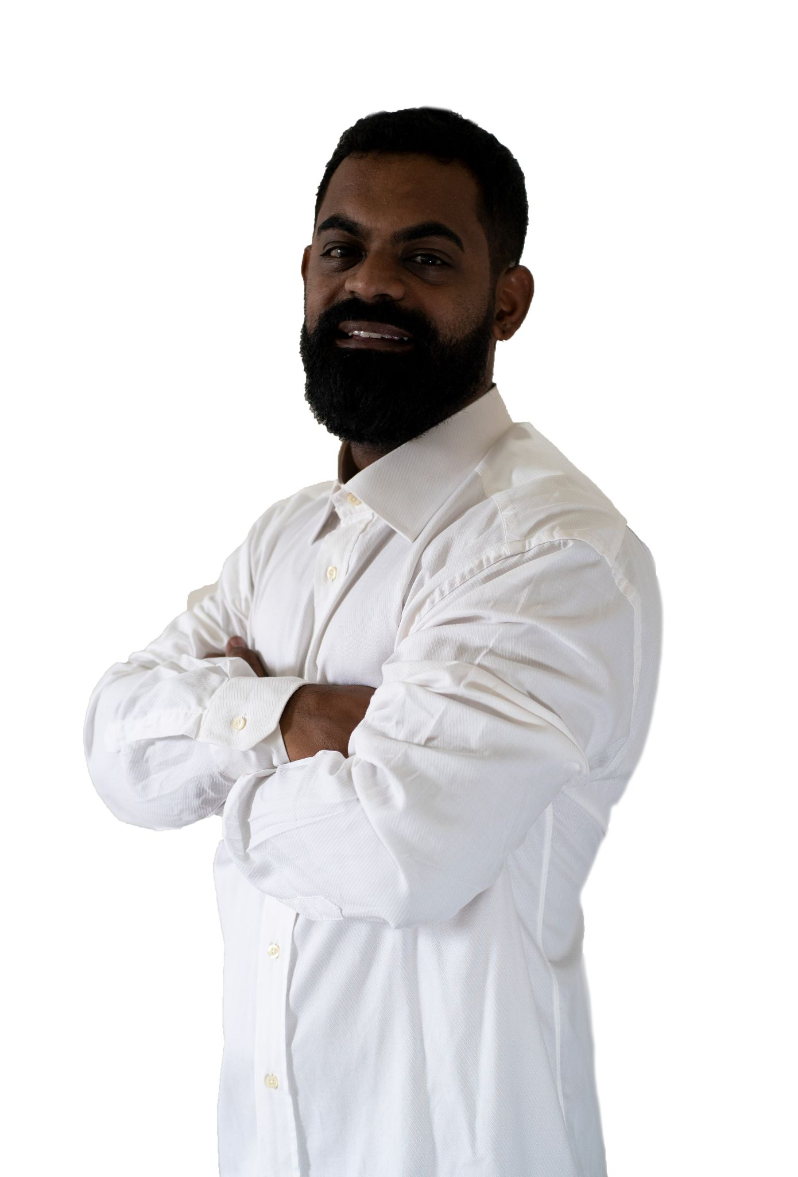 | Black Woman
Pardo Man | 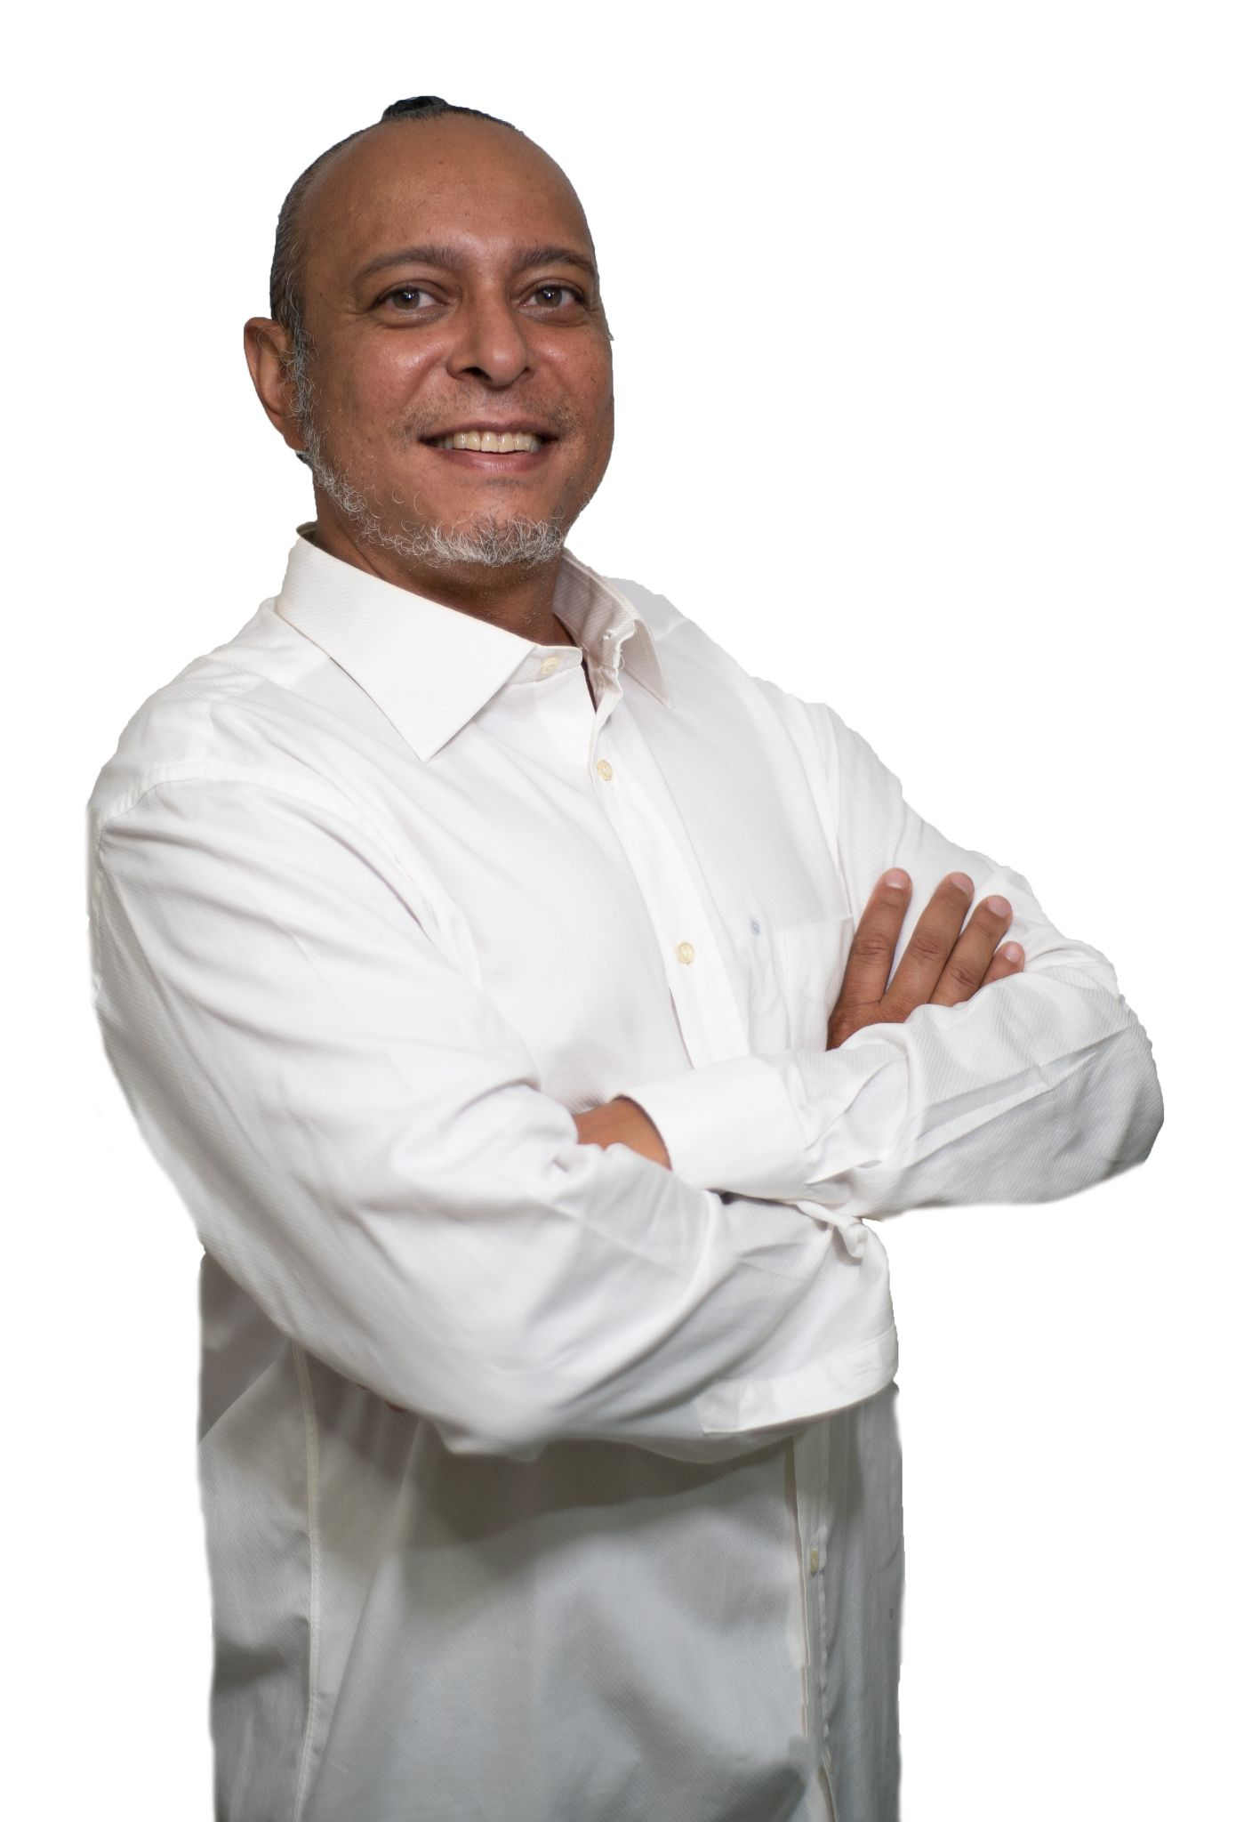 | Parda Woman | 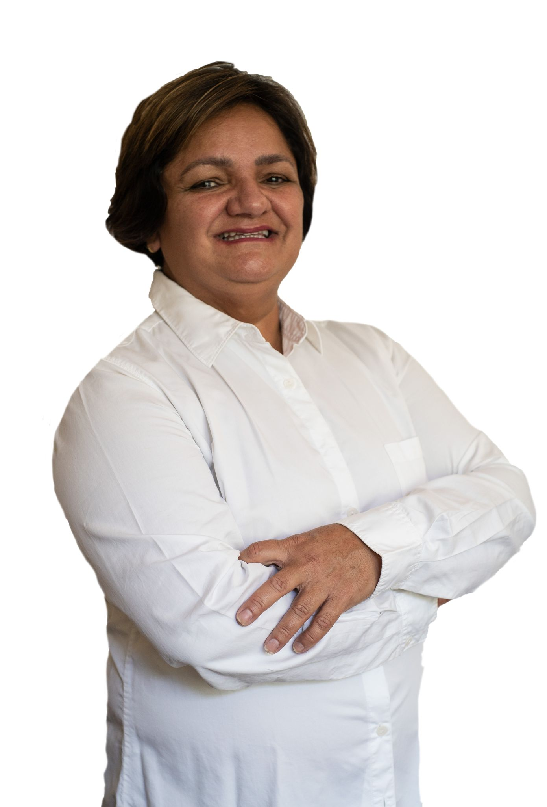
White Man | 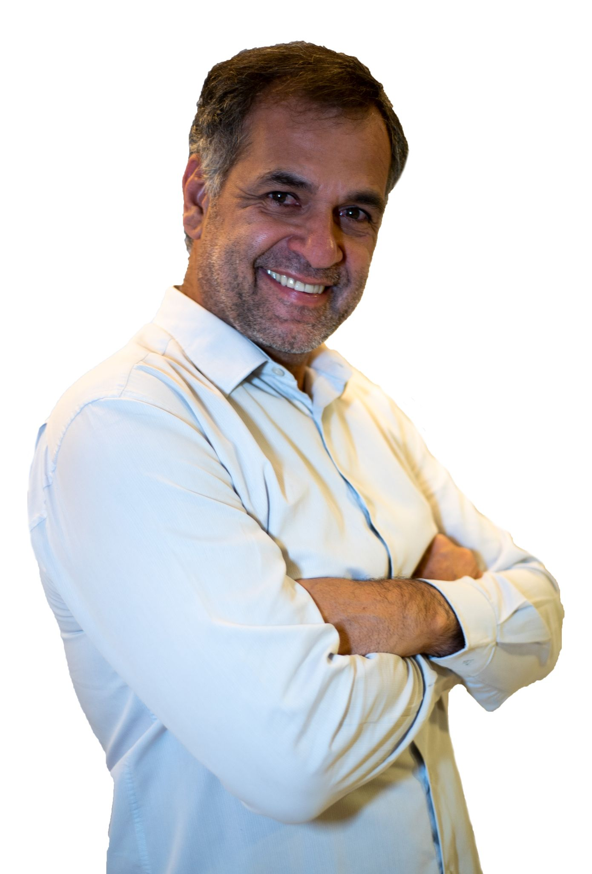 | White Woman

Appendix E: Costume Examples

 | Male | Female
Sheriff | 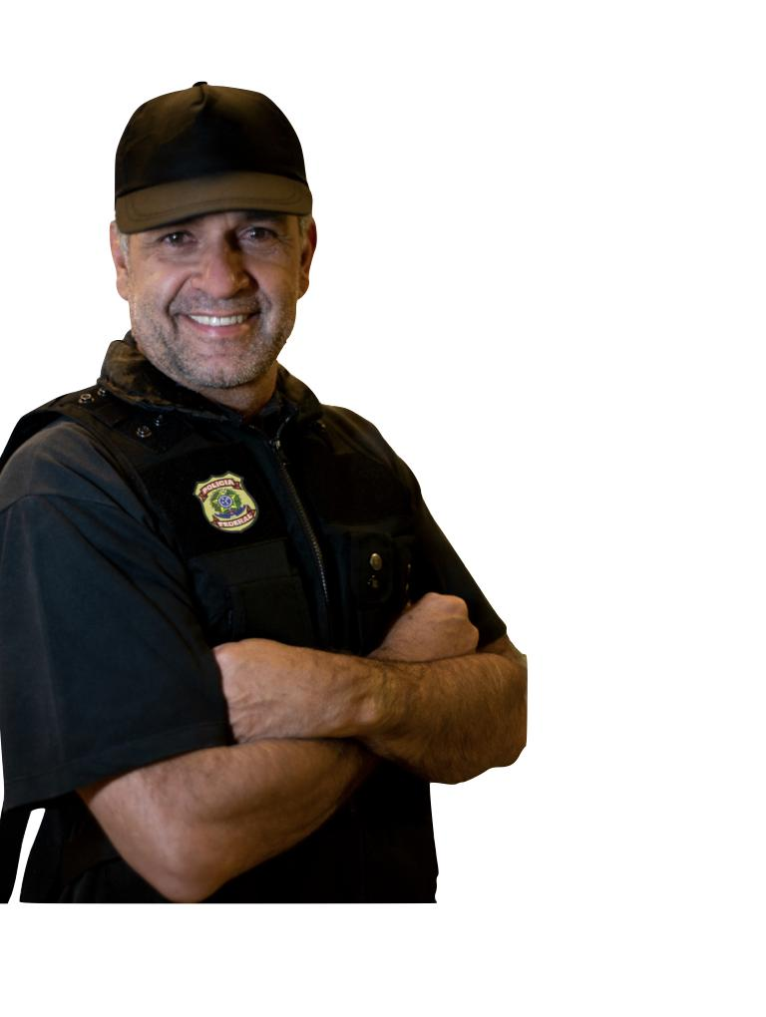 | 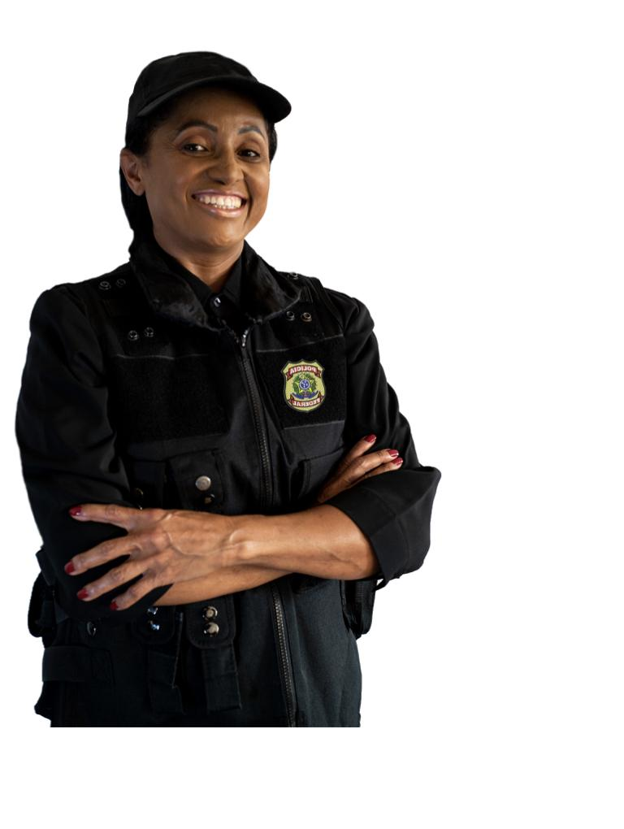
Soldier | 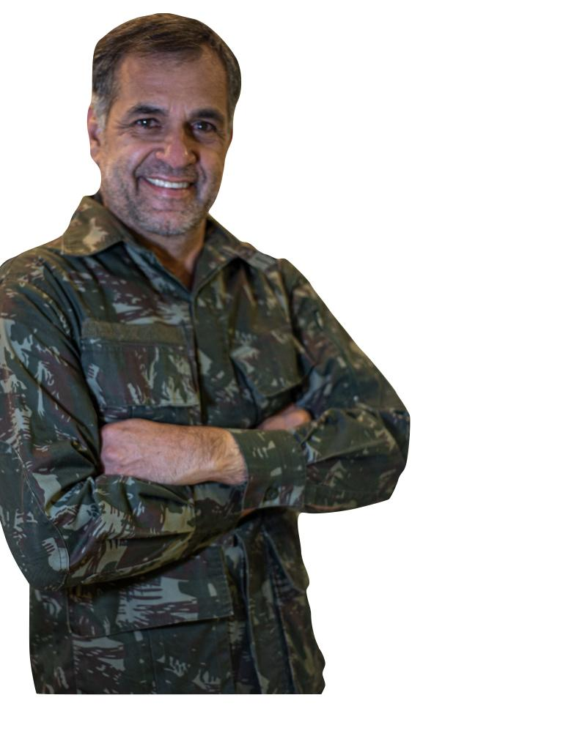
Pastor | 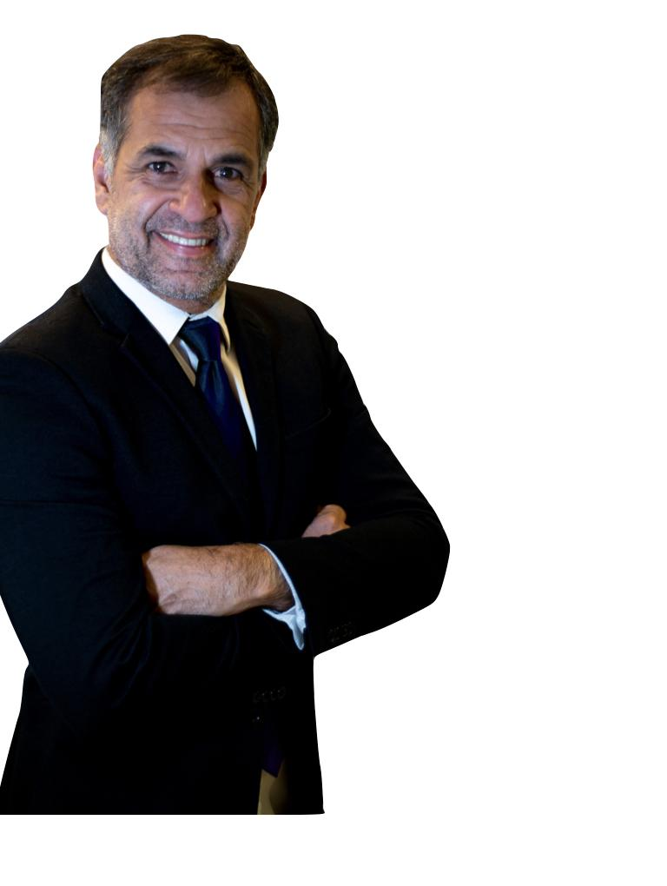
Doctor
Teacher | 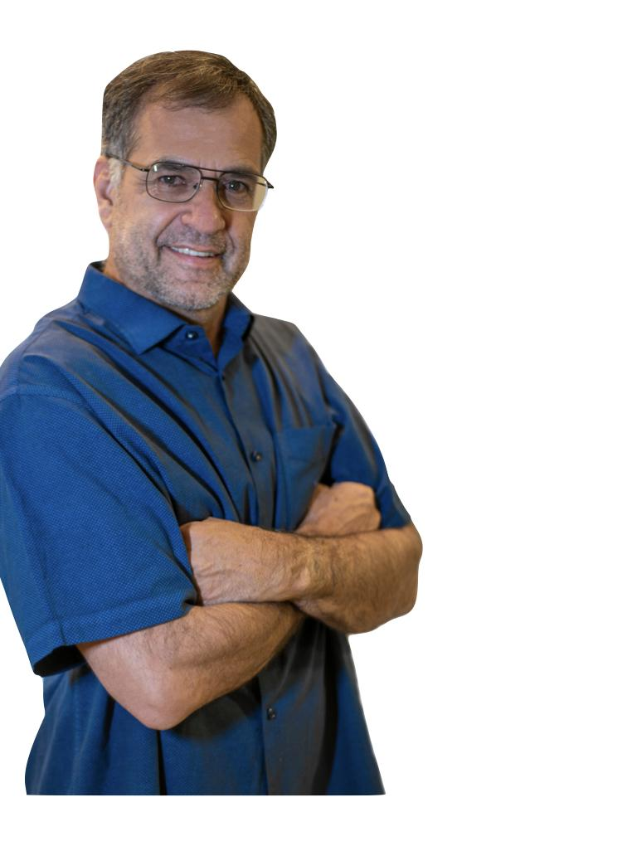 | 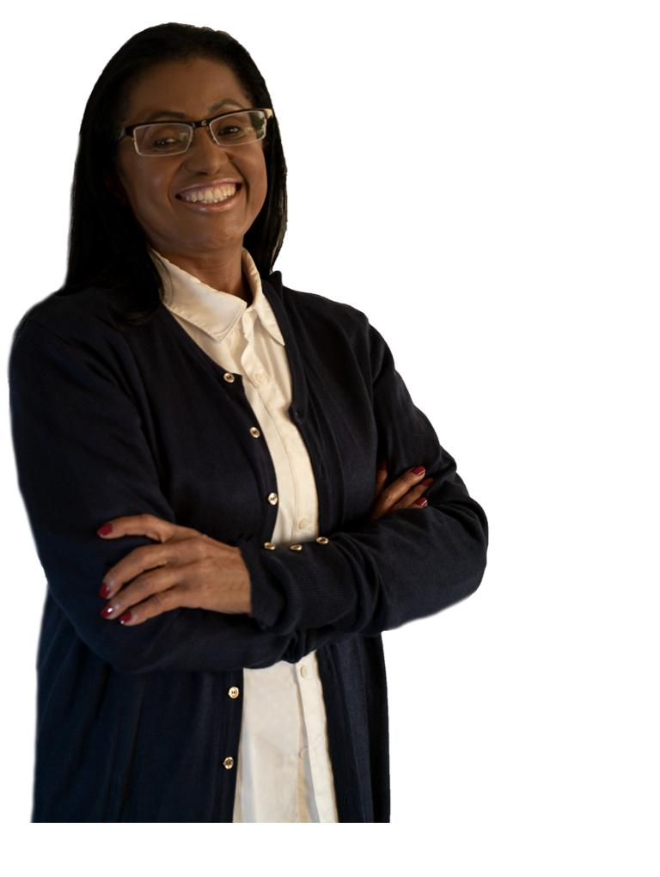
Not Stated (baseline) | 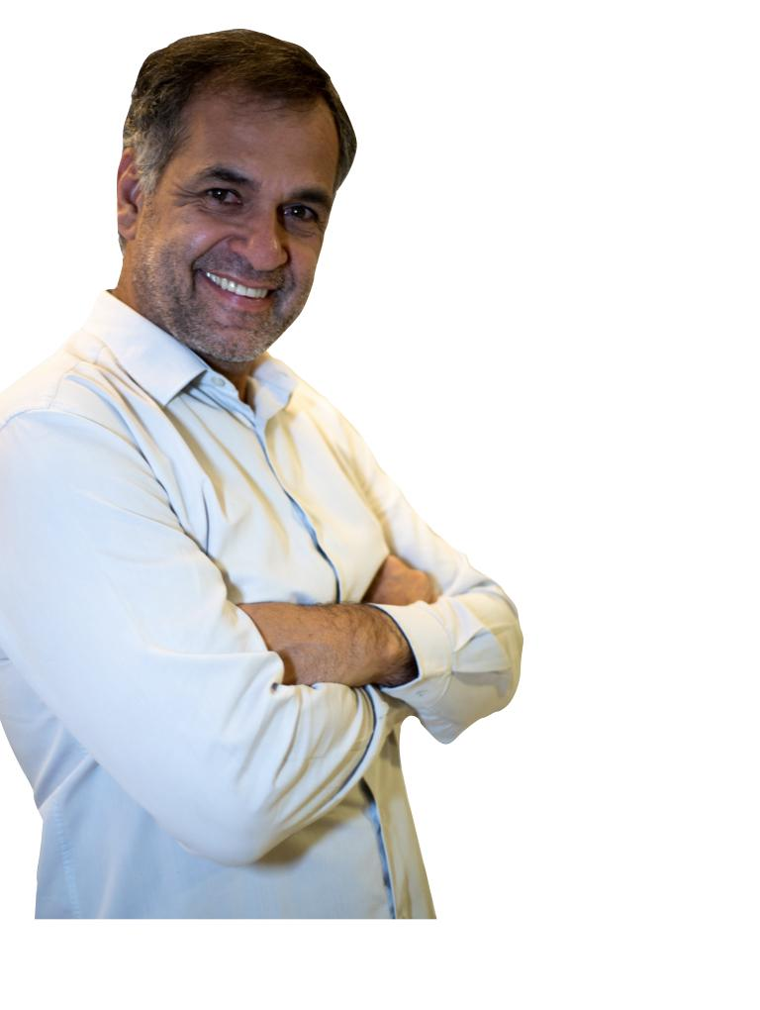

Appendix E: Descriptive Statistics of Sample

Gender
 | Vilaça-Turner | IBGE
Male | 50.6% | 48.8%
Female | 48.9% | 51.1%
Source: IBGE Pesquisa Nacional por Amostra de Domicílios Contínua (PNAD)

Race
 | Vilaça-Turner | IBGE
White | 49.6% | 47.5%
Black | 9.7% | 7.5%
Asian | 1.2% | 1.1%
Pardo | 36.2% | 43.4%
Indigenous | 1.0% | 0.4%
Source: IBGE Census 2010

Education (Highest Level Attended)
 | Vilaça-Turner | IBGE
None | 0.4% | 6.4%
Ensino Fundamental | 7.3% | 40.2%
Ensino Medio | 41.9% | 31.9%
Ensino Superior | 38.8% | 21.4%
Curso Técnico | 11.6% | NA
Source: IBGE Pesquisa Nacional por Amostra de Domicílios Contínua (PNAD)

Region
 | Vilaça-Turner | IBGE
North | 8.8% | 8.9%
Northeast | 24.5% | 26.7%
Southeast | 40.8% | 42.0%
Center-West | 11.5% | 7.9%
South | 14.5% | 14.8%
Source: IBGE Pesquisa Nacional por Amostra de Domicílios Contínua (PNAD)

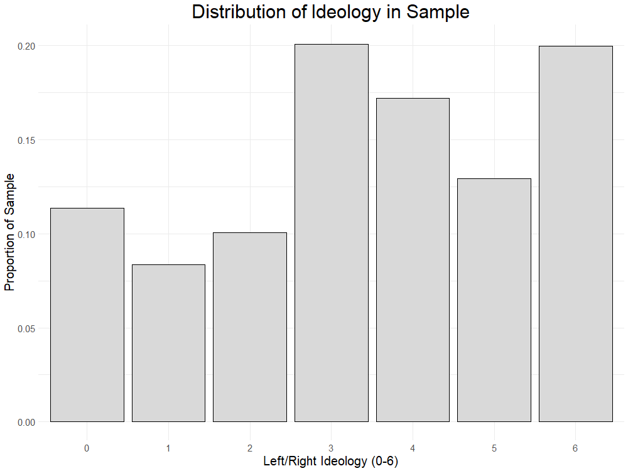
Appendix F: Observed Frequency of Certain Race/Gender/Professional Combinations

The rarity, absence, or even impossibility of certain combinations of conjoint feature levels does not by itself invalidate the design, nor should these combinations necessarily be excluded from the implementation of the experiment (???). However, to shed light on how realistic the experimental procedure is to respondents, we briefly examine how frequent different theoretically important candidate profiles are in real life.
The following figures present crosstabs of race, gender, and ideology for police officer candidates for all offices in 2022. Given the complexities of the Brazilian party system and the difficulties in classifying them, we took a rough approximation by presenting two sets of crosstabs: one for Workers’ Party (PT) candidates representing broadly “the left” and one for Liberal Party (PL) candidates representing broadly “the right”. These two parties represent the two most important electoral blocks of the 2022 electoral cycle, being the parties of Presidents Lula and Bolsonaro, respectively. While white, right-leaning men are the most common category, there are real cases of all race/gender/ideology combinations presented in the experiment. The only categories without cases are left-wing Asian candidates, and indigenous women. However, our experiment does not include these racial categories. Future research could incorporate a broader racial framework to explore these highly infrequent categories.

PT (Left-wing) Police Officer Candidate Frequencies
 | Female | Male
White | 5 | 40
Parda | 6 | 44
Black | 4 | 21
Asian | 0 | 0
Indigenous | 0 | 1

PL (Right-wing) Police Officer Candidate Frequencies
 | Female | Male
White | 28 | 233
Parda | 21 | 187
Black | 5 | 54
Asian | 0 | 3
Indigenous | 0 | 3

Appendix E: Summary Statistics for Police Legitimacy

Question  To what extent do you agree with the following statements (1-5 Likert) | Mean | 95% Confidence Interval
When the police deal with people, they always behave according to the law | 2.56 | [2.49, 2.64]
The police treat citizens with respect | 2.70 | [2.62, 2.77]
Crime levels in my neighborhood have changed for the better in the last year | 2.60 | [2.53 2.69]
I feel safe walking in my neighborhood at night | 2.50 | [2.39, 2.56]
The police make sure citizens receive the outcomes they deserve under the law | 2.50 | [2.38, 2.53]
Table ???: Police Legitimacy responses

Appendix E: Full Model Results

Within-respondent and random intercept models
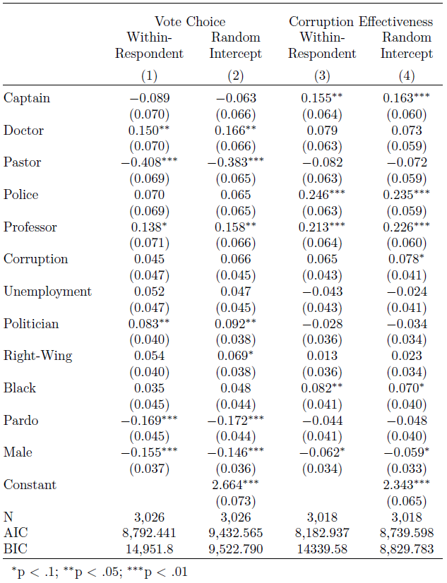

Full Model Results [cont.]

OLS with clustered standard errors

Dotplots: Vote Choice

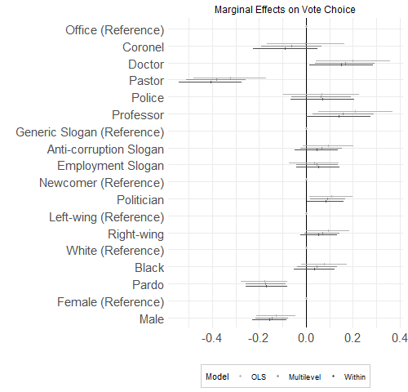

Dotplots: Anti-Corruption

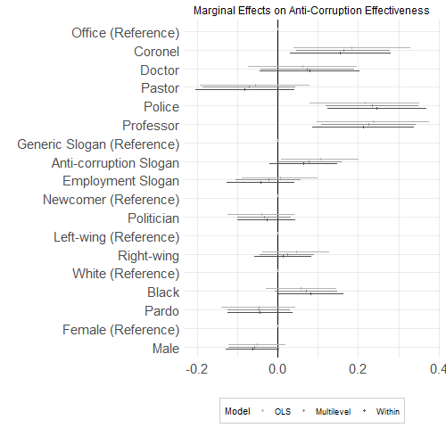

Appendix F: Pre-Analysis Plan
Corruption Scandals and the Emergence of Iron Fist Policies in Brazil
Pre Analysis Plan

Introduction and Overview
In the past decades, investigations against corruption in Latin America and beyond have been followed by shocking electoral outcomes. For example, both leftist and right-wing populist candidates were elected following corruption scandals in numerous countries, such as Mexico (Felbab-Brown 2019), Italy (Vannucci 2009), India (Vyas and Wu 2020), and Indonesia (Anggriani et al., 2014). In Brazil, revelations of widespread corruption in the government by a large-scale investigation called Car Wash (Lava Jato) were followed by a substantial increase in the number of religious (Damé 2018) and iron fist candidates (Carvalho 2018), that is, politicians who defend strict law and order policies. This raises critical questions about how exposure to corruption affects the choices of voters in subsequent elections.
Several scholars have examined how voters respond to information that candidates running for public office are involved in corruption (Choi 2010; Winter and Wetiz-Shapiro 2013; Breitenstein 2019 Fernandez-Vazquez et al 2015; Vera 2020). While we know a lot about the conditions under which voters punish politicians involved in corruption (Pavão 2018; Anduiza et al. 2013), it remains unclear how politicians' involvement in corruption affects voter choices beyond reelecting (or not) corrupt incumbents. Recent studies have found evidence that, when exposed to corruption in the government, voters are more likely to turn to outsiders (Petersen 2020), possibly because their trust in political institutions, such as established political parties, tend to decrease following allegations of widespread public corruption (Gonzalez-Ocantos and Pavão 2018). However, it is not clear whether other attributes of candidates beyond their outsider status matter in contexts where voters perceive the government to be corrupt.
We theorize that, when exposed to corruption, people experience a generalized feeling of disorder and a sense that that democracy is not functioning, such as was found in Garrido's (2020) ethnographic study in the Philippines. This, in turn, should lead people to vote for candidates who they believe they can trust and who they believe will do a competent job in restoring order. Following the literature on occupations as voting heuristics (Boas 2014; Carnes and Sadin 2015; Kirkland and Coppock 2018), we expect for candidates with a professional history of maintaining order such as former police and military officers, and religious leaders with a strong claim to moral authority will benefit in these situations.
We field two experiments to test for such a relationship and probe the plausibility of two causal mechanisms: the credibility and salience mechanisms. First, “Iron Fist” candidates such as police and military officers might simply be more credible when running an anti-corruption campaign. To test this explanation, we field an image-based factorial experiment that presents respondents with several randomly generated hypothetical campaign handbills, known as santinhos in Brazil. Respondents will be asked to rate each candidate along several different dimensions including likelihood of support and competence managing corruption, public security, and public health.
The second experiment will probe the salience mechanism, that when exposed to systemic corruption voters develop more punitive attitudes as a strategy to reestablish order in a corrupt society. Research on punitive attitudes has shown that such iron fist strategies remain popular despite a lack of evidence that they are effective at reducing crime (Brown and Socia 2017; Mummolo 2018). We hypothesize that punitive policies such as increased sentencing, declaring corruption a heinous crime, and limiting the rights of the accused will provide an intuitively appealing solution to a problem of social disorder.

Hypotheses

Credibility Hypotheses

The most traditional approaches to voter choice assume that voters select their candidates based on policy positions, minimizing the distance between their ideal point and the candidate’s proposed positions (Downs 1957). However, scholars have long recognized that there is simply too many candidates and too much information for voters to reasonably gather and process to make fully informed decisions, especially in relatively obscure local elections. As a result, they frequently rely on heuristics to choose from groups of relatively unknown candidates.
One such heuristic is occupation. Several recent studies suggest that the professional background of candidates may affect the choice of voters (Atkeson and Hamel 2020; Kirkland and Coppock 2018; McDermott 2005). We expect certain occupations to serve as anti-corruption heuristics to voters, meaning that voters will perceive candidates with those occupations to be less corrupt, and more credible when expressing an anti-corruption message. Despite the endemic corruption of law enforcement agencies in Latin America (Arias 2006; Ungar 2013), we expect candidates who campaign as police officers, military officers, and religious leaders to be perceived as less corrupt, or better able to combat corruption. This leads to our first hypothesis:

H1: Candidates with occupations in the police, military, or religious organizations will be perceived as better able to combat corruption.

We also expect these candidates to be more credible with anti-corruption messages. That is that the effect of running with an anti-corruption slogan will be enhanced when the candidate is from the police, military, or religious organization. These expectations imply two hypotheses: an additive effect and an interactive effect.

H2a: Candidates running with anti-corruption slogans will be rated more favorably and perceived as better able to combat corruption.

H2b: The effect of running with an anti-corruption slogan will be stronger for candidates with occupations in the police, military, or religious organizations.

Heterogeneous Credibility Hypotheses
We expect for different respondent groups defined by ideology, educational attainment, and trust in the police to respond systematically differently from others to the anti-corruption message and candidate affiliation with the police, military, or religious organization.

H3a: Respondents who are conservative, highly educated, and/or trusting of the police will rate candidates with professional connections to the police, military, or religious organizations as more favorable and better able to fight corruption

H3b: Candidates running with anti-corruption messages will be rated more favorably by respondents who are conservative, highly educated, and/or trusting of the police

Salience Hypotheses
A complementary causal pathway between corruption scandals and support for candidates with connections to the police, military, or religious organizations is what we term the salience explanation. We suggest that exposure to systemic corruption can lead to voters adjusting their policy preferences directly, favoring policies that take a hard, active line on corruption and criminality in general. This suggests that voters exposed to corruption scandals will have more punitive attitudes on questions of criminal justice. This would in turn lead them to support candidates that have punitive reputations such as police and military officers. The credibility and salience explanations are not mutually exclusive and could operate at the same time, but we propose two separate experiments to separate the independent effects of each. Our salience hypotheses are as follows:

H4: Voters exposed to public corruption scandals are more likely to express punitive attitudes on issues of criminal justice.

H5: Voters exposed to public corruption scandals are less likely to support state intervention in the economy.

H6: Voters exposed to public corruption scandals are less likely to express discontent with democracy.

Experimental Design
To test these hypotheses, we will field an online survey experiment on the Qualtrics platform to a representative sample of Brazilian voters. Embedded in this survey instrument will be two survey experiments that probe at the two hypothesized causal mechanisms suggested by our theory above.
The first experiment will evaluate the credibility mechanism that certain candidates with certain professional backgrounds including police and military officers and religious leaders will be perceived as more credibly anti-corruption than otherwise similar candidates. The experiment will follow the format of the factorial experiment (Auspurg 2015) where respondents are presented with several randomly generated profiles in sequence and asked to rate each one along several different dimensions including likelihood of supporting them in a hypothetical election.
The second experiment will test the salience mechanism. This experiment will present respondents with a short news story regarding the management of municipal resources during the Covid-19 pandemic in a fictional city. Half of the sample will read a story about a mayor mismanaging municipal funds, leading to a lack of respirators in local hospitals while the other half will read about a mayor who effectively and transparently managed the municipal budget and who received international recognition for his efforts. After a brief manipulation check, respondents will then be asked about their opinions of several political issues surrounding corruption, crime, and punishment. If the salience mechanism is at work, we expect for respondents exposed to systemic corruption to take harsher, more punitive positions on all issues.

Experiment 1: Image Based Factorial

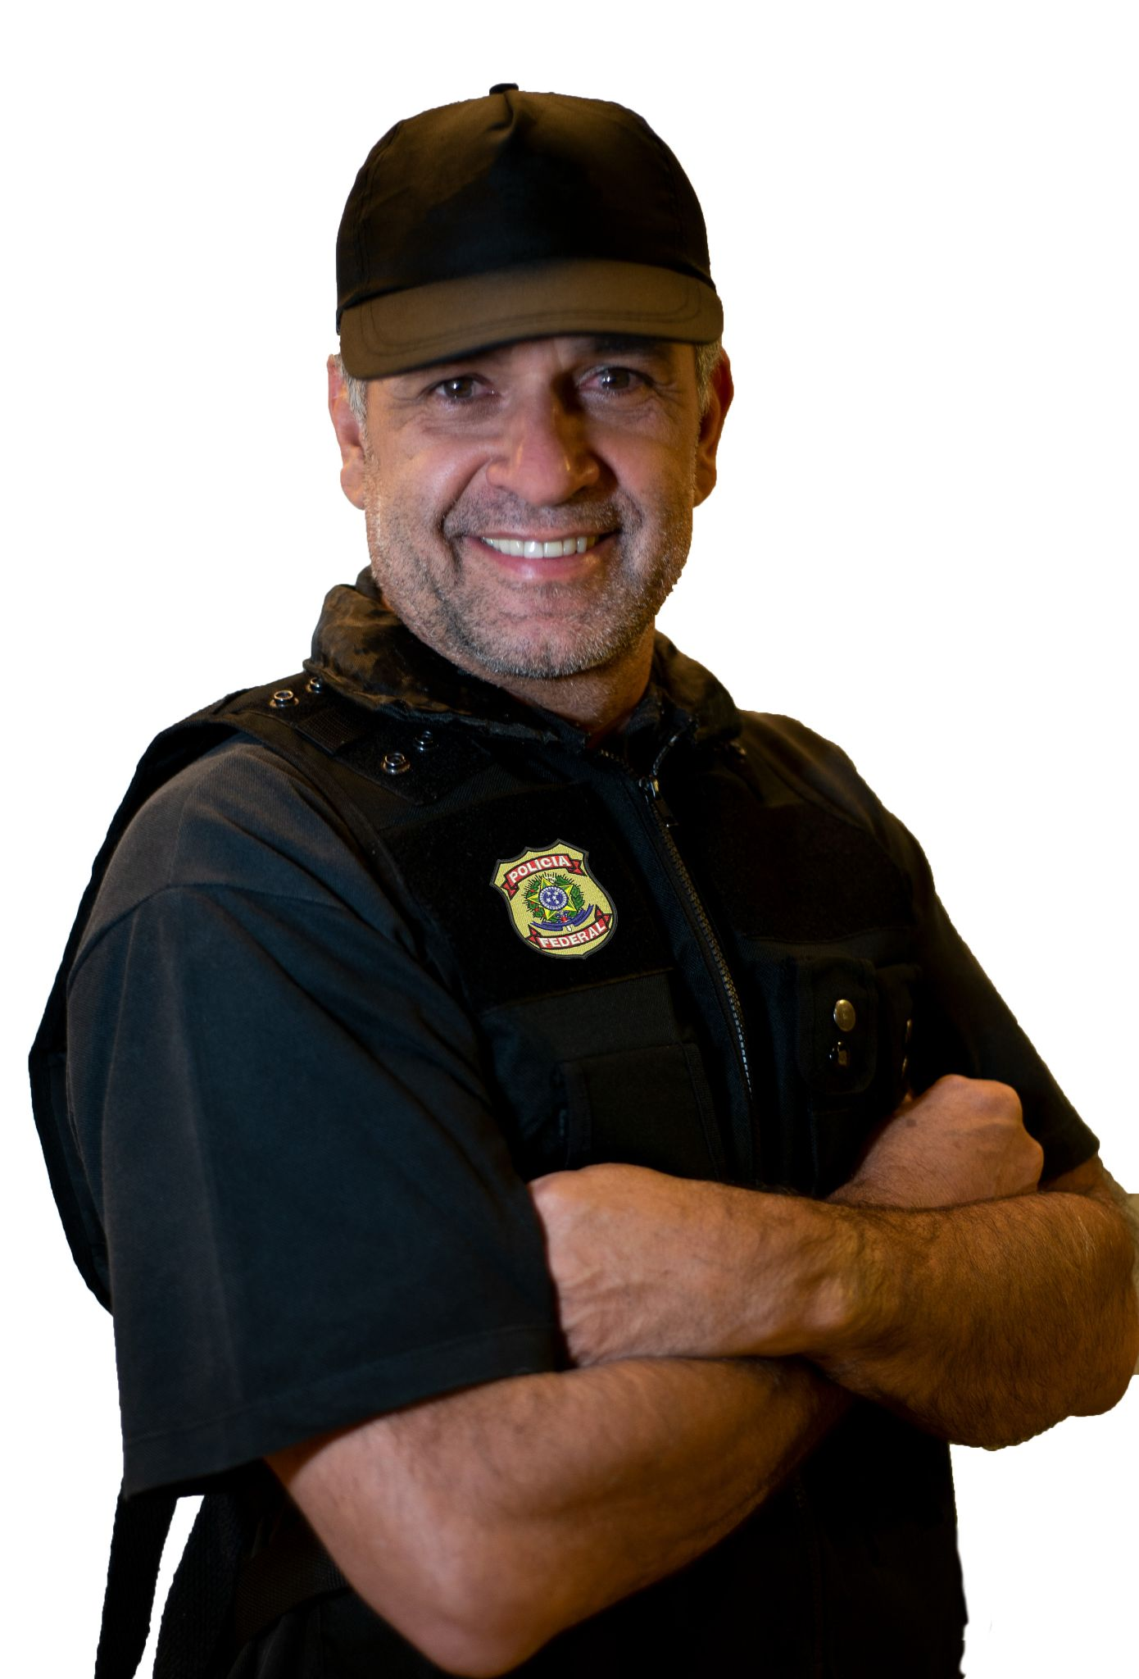
Figure 1: Sample images that might be seen by respondents demonstrating how occupation will be manipulated. In this case, the candidate on the left is a police officer and the candidate on the right is a doctor

The first experiment will investigate the credibility mechanism, that certain types of candidates are more believable and benefit more from anti-corruption campaign messages. In order to investigate the credibility of this mechanism, we will field an image-based factorial experiment. The factorial setup was chosen over the conjoint design (e.g. Hainmueller, Hopkins, and Yamamoto 2014) because we plan to ask respondents several questions about each profile. Presenting the profiles one at a time will reduce the cognitive burden on each respondent and allow for a simpler estimation procedure after data collection ends.
Respondents will view three candidate profiles in succession. Each candidate will be represented by a small flier to present the relevant information visually. These images will closely resemble leaflets, known as santinhos, that are commonly distributed by political campaigns in Brazil. This design is similar to Poertner 2020 who presents small images to voters in Bolivia to more closely approximate the real process by which voters select between candidates. An image-based experiment can also be found in Flores-Macias and Zarkin, 2021 who randomly present images of police officers with and without military gear. To make sure the information in the santinho gets across, each profile will have a small block of text underneath reemphasizing the important information.

Table 1: Candidate features and their possible labels
Feature | Levels
Campaign Slogan | Anti-corruption OR Reducing Unemployment OR Generic
Gender | Male OR Female
Race | Black OR Parda OR White
Occupation | Sheriff OR Captain OR Pastor OR Doctor OR Teacher OR Not Stated
Political Experience | State Legislator OR Political Novice
Economic Policy | Left Wing OR Right Wing

See Figure 1 for an example of two of these santinhos, demonstrating how profession might vary between candidates while holding some other features constant. See Table 1 for a summary of all features that the hypothetical candidates will have as well as the possible levels they can take. Respondents will be asked to evaluate each candidate on several attributes. First, they will answer the question “How likely would you be to support this candidate?” with options on a five-point scale ranging from Extremely Unlikely to Extremely Likely. Respondents will also evaluate how well they think each candidate would perform on the dimensions of healthcare, public security, corruption, and unemployment.
Based on the logic of the credibility mechanism, we expect for certain professional affiliations (the police, the military, and religious leaders) to be perceived as less corrupt than other candidates. We also expect to find interaction between profession and anti-corruption message. While all candidates should see some benefit on their corruption rating by taking an explicitly anti-corruption position in their top-line slogan, we expect for this benefit to be greater for police, military, and religious candidates.
In order to parse out the effect that these “iron fist” professions have, we construct credible control professions in two ways. First, we include a level that includes no occupational cues at all. Second, it is possible that the greater credibility of police officers, military officers, and pastors to promote anti-corruption slogans is driven by their positions of authority and respect within society. That is to say, voters might simply prefer a candidate with greater life experience (Atkeson and Hamel 2020). To parse out this effect, we also include “control” professions doctor and professor that imply similar levels of training and experience and carry similar levels of respect. If we estimate a similar interactive effect between all professional cues and anti-corruption messaging, then it is life experience and respect, not tough-on-crime reputation that is driving the credibility results.
To add further depth to our analysis, we include additional theoretically motivated features including the candidate’s previous political experience and cues regarding the candidate’s criminal justice and economic policies. Political experience will be manipulated using a small seal on the santinho indicating whether the candidate has “six years experience in the state legislature” or will “bring fresh ideas to politics”. Our design expands upon other studies highlighting the potential benefits to outsider candidates and parse out exactly what sort of outsider is likely to benefit most. We expect that the iron fist professions will have an effect independent of their outsider status, suggesting that outsider status is only part of the post-Lava Jato story.
One notable exclusion from our list of features is the candidate’s political party. Though parties tend to be comparatively more fluid and less institutionalized in Brazil (Mainwaring, Power, and Bizzarro 2018), party ID is still likely to overpower the other features and wash out the effects of features we are theoretically interested in, especially parties with recent high-profile national corruption scandals. Since we have no strong theoretical expectations about party affiliation, we omit party from our design. However, mayoral candidates in Brazil usually include the two-digit party identifier in their campaign materials, as this number functions as their ballot number too. To maintain realism while avoiding unwanted connections to known party brands, we will assign each santinho a two-digit number drawn from a list of numbers not associated with any party.
The final consideration for the construction of the santinhos is the candidate’s name. We will randomly assign each santinho a name drawn from a list of common Brazilian names, taking care that none of the last names are associated with well known and controversial figures in Brazilian politics and culture. While name and party number should therefore have no effect on the outcome variables, we will estimate models including name and party number indicator variables as a robustness check.
This experiment therefore has six features. The profile universe therefore has 3*2*3*6*2*2=432 possible profiles. In order to keep the profile universe a manageable size, we have kept the number of features to a minimum, including only the features that we expect to be theoretically important or necessary to maintain a degree of realism. We will field a full factorial design, meaning that all two and three-way interaction effects will be estimable (Auspurg and Hinz, 2015).

Estimation Procedure 1
The estimation of the quantities of interest in the factorial design can be achieved through linear regression. We are interested primarily in two outcome variables: vote intention, measured on a 1-5 scale as a response to How likely would you be to vote for this candidate and corruption competency, measured on a 1-5 scale as a response to How effective would the candidate be on the following issue: corruption. Our model therefore takes the form:

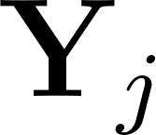 is the vector of outcomes for the th respondent. is the matrix of candidate characteristics for the candidates presented to the th respondent, including binary variables indicating whether each candidate profile belongs to each of our professions, and binary variables indicating whether each candidate profile was paired with an anti-corruption slogan. 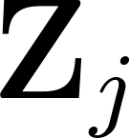 is a matrix of respondent-level characteristics. is the random intercept for the th respondent, and 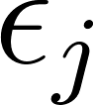 is a vector of errors for the th respondent distributed such that 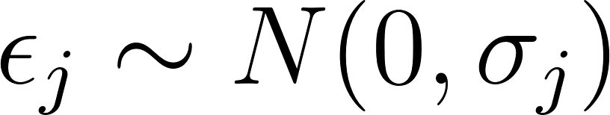. This model, estimated with maximum likelihood, accounts for the hierarchical nature of the data, as several candidate profiles will be evaluated by each respondent. Their evaluations of each candidate are likely not fully independent, necessitating the random intercept model to account for this at least partial dependence.
We are especially interested in the value of the coefficients for the indicator variables indicating police officer, military officer, and pastor, as well as on the variable indicating that the candidate is paired with an explicitly anti-corruption message. We expect for all of these coefficients to be positive, indicating that respondents perceive anti-corruption candidates and “iron fist” candidates as better willing and able to combat corruption. Additionally, we expect for the coefficient on the interaction between the candidate indicator variables and the anti-corruption variable to be positive, indicating that the effect of an anti-corruption message is enhanced when paired with a candidate from the security sector, or a religious leader. This would indicate that voters perceive candidates with these professions to be more credible in their anti-corruption positions.

Experiment 2: Vignette Experiment
The second experiment that we will embed in our survey instrument is a text-based experiment designed to test the hypothesized salience mechanism. That is, whether exposure to systemic corruption scandals increases policy preferences for punitive criminal justice policies directly. Since both the credibility and salience mechanisms are not mutually exclusive and have similar observable implications, it is important for us to tease out the two separate mechanisms through the two separate experiments.
We will present our respondents with a vignette describing the management of municipal finances in a fictional city, Rosa Branca. Respondents will read that Conselho de Controle de Atividades Financeiras (COAF) undertook a Brazil-wide investigation of municipal finances during the pandemic. A randomly selected half of our sample will read a story describing a situation in which the mayor of Rosa Branca misappropriated funds, resulting in a shortage of ventilators in public hospitals during the peak of the Covid-19 pandemic while the other half will read about how the investigation failed to uncover any misuse of funds and that, on the contrary, the mayor of Rosa Branca received recognition from Transparency International for his outstanding and transparent management. Both of these situations are based on real events. Below are examples of the vignette texts. See Appendix for the Portuguese.

Intro Text: Imagine that you live in a city similar to your own in Brazil called Rosa Branca. Last year, the Conselho de Controle de Atividades Financeiras (Coaf) analyzed the finances of municipalities across Brazil in order to identify which municipalities were spending their budgets to combat the Covid-19 pandemic effectively and which were inappropriately allocating funds.

[CONTROL: The COAF report did not find any irregularities in the finances of Rosa Branca. On the contrary, the mayor's office of Rosa Branca won an award from the international NGO Transparency International which recognized the municipalities that employed public resources in the most transparent and fair way to combat the Covid-19 pandemic. According to representatives from Transparency International, the mayor of Rosa Branca demonstrated great transparency in the procurement of ventilators and other medical equipment, guaranteeing quality healthcare to the population and avoiding unnecessary deaths due to Covid-19.]

[TREATMENT: The COAF report identified financial transfers to the bank accounts of the mayor of Rosa Branca and members of his administration that did not align with official accounting. The public prosecutor's office initiated an investigation and concluded that the mayor “led a criminal organization” that diverted funds from the purchase of ventilators “that could have contributed to the deaths of hundreds of people who contracted Covid-19 and did not have access to adequate healthcare,” according to the head prosecutor.]

As a manipulation check, we will ask respondents, immediately after reading the vignettes, the following multiple choice questions:

What did the COAF investigation find about the finances of Rosa Branca?
- The mayor had been stealing from the city budget
- The mayor had been managing the city budget honestly

In your opinion, how well have local governments managed the Covid-19 pandemic?

Respondents who answer the first question incorrectly will be asked to reread the vignette and answer the question again. Respondents who answer the question incorrectly a second time will be allowed to continue, but will be marked as non-compliant.
After the manipulation check, respondents will be asked to indicate the extent to which they agree with several statements regarding crime, corruption, and punishment. See Appendix for a full list of statements for respondents to evaluate. We expect for treated respondents to exhibit more punitive policy preferences, including greater support for police militarization, stricter sentences for offenders, and classifying corruption as a heinous crime.

Estimation Procedure 2
The quantities of interest will be the Average Treatment Effect (ATE) with responses to each of these questions as the outcome variables. That is, we will estimate for each policy question:

Where 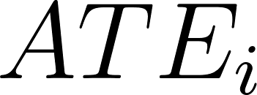 is the average treatment effect for question , 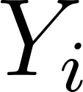 is the vector of responses to question , and is an indicator of treatment assignment. For this to be an unbiased estimate of the ATE, we assume random distribution of the treatment, that is that treatment assignment is independent of any respondent characteristics. This is a justifiable assumption in this case, because assignment to treatment will be performed for each respondent by a random number generator. However, balance tests will be performed after treatment assignment to demonstrate that assignment to treatment does not spuriously correlate with any respondent-level features.
In addition to this estimate, we will estimate the following linear regression model with OLS:

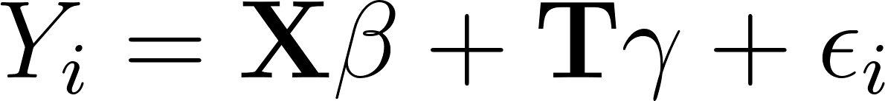

Where is the vector of responses to the th question, is a matrix of respondent characteristics, is the vector of treatment assignments, and 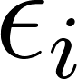 is the vector of error terms for responses to the th question such that 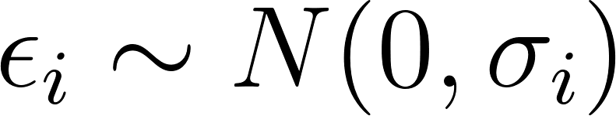. This model will allow us to investigate how certain respondent-level characteristics such as authoritarian personality and police legitimacy influence responses to each question, as well as how these respondent characteristics interact with treatment assignment.
We expect under both estimation strategies for the average treatment effect to be positive, indicating that exposure to corruption causes an increase in punitive attitudes. Specifically, we expect for conservative ideology, authoritarian personality, and notions of police legitimacy to interact with treatment assignment to further strengthen its effect.

Measuring Other Quantities of Interest
Our questionnaire will measure certain key concepts important to our theory with several batteries of pre-treatment questions. Since several of our theoretical expectations for both experiments imply interactive effects between treatment assignment and respondent-level characteristics, it is important to measure these respondent characteristics elsewhere in the survey. While the appendix contains the full survey instrument in English and Portuguese, we describe here several of the most critical respondent features that we will measure as well as a description of how we expect each feature to influence outcomes.
The first attitude that we will measure is police legitimacy, drawing from the battery of questions developed by Tankebe, Reisig, and Wang 2016. We expect for police legitimacy to explain some of the positive evaluations of police officer candidates. We also expect for individuals with stronger feelings of police legitimacy to respond more positively to the anti-corruption slogan from police officer mayoral candidates, implying a three-way interaction, and for such individuals to both have higher punitive attitudes on average and respond more strongly to the corruption treatment in Experiment 2.
The second attitude we will measure pre-treatment is authoritarian personality. It is likely that those exhibiting authoritarian personality traits are more likely to respond positively to electoral candidates from the security sector, especially in times of stress such as following a corruption scandal. To account for this alternate explanation, we include an authoritarian personality battery similar to the one originally developed by Feldman and Stenner, 1997 and recently updated by Englehardt, Feldmand and Hethrerington, 2021. This battery asks respondents about their preferences for child-rearing, asking whether respondents prefer for children to have more traditional characteristics such as “obedient” and “respectful of elders” as opposed to characteristics such as “self-reliance” and “independence”. We expect for respondents with more authoritarian personalities to support iron fist candidates more strongly, respond more positively to the anti-corruption messages, and respond more strongly to the corruption treatment in Experiment 2.
We also ask a battery of questions evaluating respondents’ political knowledge and ideology. Early approaches to political knowledge and “political sophistication” focused on asking factual questions (Luskin, 1987) have rightfully drawn critiques as being a poor indicator of what people know about politics (Graber, 2001) or simply being a proxy for formal educational attainment (Carpini, Keeter, and Kennamer 1994). However, a more nuanced approach to political knowledge with a better understanding of what knowledge questions actually measure has reemerged in recent years (Barabas et al. 2014; Leeper, Hobolt, and Tilley 2020), especially to understand so-called “knowledge gaps” that emerge between different social groups (Cordova and Rangel, 2017; Pedrazza and Ura, 2021).
For our purposes, we are less interested in measuring how much respondents know about “surveillance” and “policy-specific” facts (Barabas et al. 2014) but rather care about certain static-general facts such as the party of their current city and state, those politicians’ left-right ideology, and which government bodies are responsible for what policies. These questions are not meant to measure “sophistication” but instead serve specific purposes in evaluating mechanisms. For instance, a respondent’s ideological alignment with their actual mayor might influence how they interpret and react to our treatment, and a respondent who knows that the civil and military police answer to the governor (Ahnen 2007) might interpret an iron fist candidate for a municipal office differently.
Finally, we ask a battery of questions to evaluate the degree of contact that the respondent has with police officers, public health workers, crime, and corruption. Since when asked about their own habits and actions individuals can suffer from recall error (Krosnick, 2010), or may not wish to reveal certain behaviors (Katosh and Traugott, 1981), we ask about the behavior of the respondent and others in the respondent’s network during a relatively wide time frame. For example, instead of asking “in the previous 6 months how many times was something belonging to you stolen?” we will ask “in the previous 6 months, how many times was something belonging to you or someone in your household stolen?” to measure a respondent’s contact with crime.
Appendix G: Vignette Experiment Results

The second experiment examined whether exposure to corruption scandals in the public administration changes the policy preferences of voters. From this perspective, the rise of candidates from law enforcement backgrounds could be explained by a shift in voters' preferences towards policies that are more aligned with candidates from the police or the army, such as punitive criminal justice policies. The results, however, showed only very weak support for this hypothesis. Individual policy preferences were mostly unaffected by our experimental treatment, suggesting that punitive attitudes and attitudes toward criminal justice are relatively stable and difficult to change.
Exposure to corruption was associated, as one would expect, with stronger support for the creation of a task force to fight corruption. More specifically, the models showed that respondents who were exposed to corruption in the public administration were, on average, 27% more likely to support the creation of a task force to fight corruption when compared to those who were not exposed to corruption. This finding increases our confidence that the treatment group comprehended our text vignettes in the intended way, and that their perceptions of corruption in the fictional city were indeed manipulated. Since the treatment group did support stronger actions to address the problem of corruption, then if punitive policies were indeed linked to anti-corruption policies in their minds, we should have seen an effect.

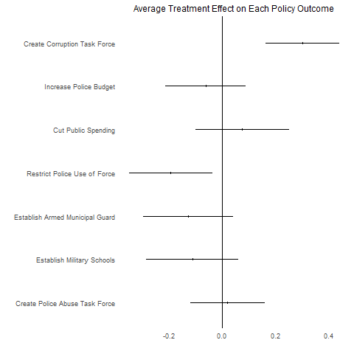
Figure 5: Estimated average treatment effects for corruption vignette on all outcomes. Point estimates and 95% confidence intervals plotted.

However, exposure to corruption, on average, did not produce many significant effects on support for iron fist policies, such as an increase in the budget of the police or the creation of a militarized police. While there is an estimated negative ATE for restricting police use of force, suggesting a punitive response, the significance of this effect disappears when respondent-level control variables are included. This means that the evidence is at best weak for the preference change mechanism. See Figure 5 for a plot describing the estimated ATE for the corruption vignette on support for each of the outcome policies.
One possible explanation for why we did not observe a stronger effect of exposure to corruption on policy preference change on the average voter is also related to the timing of the experiment. As investigators of Car Wash Operation (Operação Lava Jato) revealed a series of corrupt schemes under the adminstration of the Workers' Party, it is possible that the public momentarily switched their policy preferences towards iron fist support. However, as right-wing candidates consistently underperformed in several areas following their election after Car Wash, it may be that people either stopped supporting iron fist policies or feel unease to admit they support these policies, given that they are publicly associated with a government that lost legitimacy and public support.
Although we did not find significant results, on average, for policy preference change following exposure to corruption, we observed interesting heterogeneous effects for some of the iron fist policies. More specifically, the models revealed heterogeneous effects in relation to the support for the construction of military schools. For example, among respondents who self-identified as ideologically belonging to the far right, exposure to corruption increased support for the creation of military schools by 11%. By comparison, exposure to corruption decreased support for the construction of military schools among far-left respondents by 83%.
This suggests that while, on average, exposure to corruption does not have a large effect on people’s policy preferences in relation to law enforcement and discipline policies, it may be associated with important increases in support for these policies among those people who are already sympathetic to iron fist policies, such as people who are ideologically conservative.
Appendix H: Conditional Police Legitimacy Effects

Conditioning the effect of security sector professions instead on police legitimacy scores mirrors this finding. Just as with ideology, military candidates are more polarizing than police candidates, with a strong penalty on vote intention for those with weak feelings of police legitimacy and a strong benefit among those who view the police as highly legitimate. Police candidates, on the other hand, see a measurable benefit at the high levels, but no significant penalty at low levels. On the issue of corruption, the conditioning effect of police legitimacy is not as dramatic, as neither for military nor police candidates is there a measurable negative effect. Even respondents with a below average sense of police legitimacy expect for the iron fist candidates to be more effective at fighting corruption than the baseline candidate.

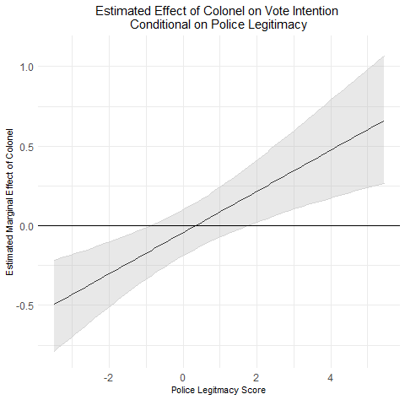 | 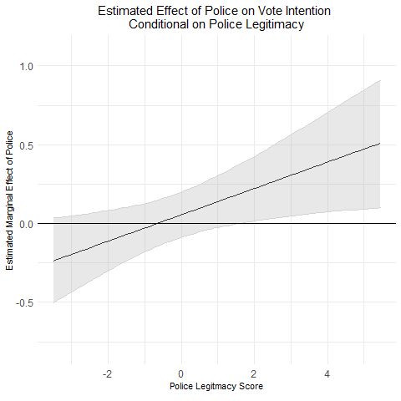
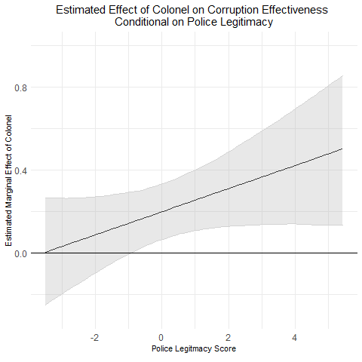 | 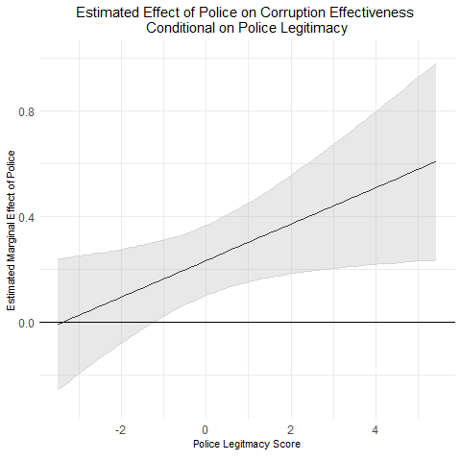
Figure 4: Estimated effects of iron fist professions conditional on police legitimacy

This finding suggests that while law enforcement institutions generally have low levels of trust among Brazilian voters, there is not necessarily a clear alternative for enforcing rules, either for violent crimes in the criminal justice system or for white-collar crimes. As a result, all but the most distrusting of police in our sample thought that the police and military candidates would do better than average fighting corruption in city hall, even when they report that they would not vote for the candidate.
Appendix References
Ahnen, Ronald E. 2007. “The Politics of Police Violence in Democratic Brazil.” Latin American Politics and Society 49(1): 141–64.
Anduiza, Eva, Aina Gallego, and Jordi Muñoz. 2013. “Turning a Blind Eye: Experimental Evidence of Partisan Bias in Attitudes Toward Corruption.” Comparative Political Studies 46(12):1664–92. doi: 10.1177/0010414013489081.
Anggriani, Novi. 2014. “A Bright Future for Indonesia.” The Mark News, July 28.
Arias, Enrique Desmond. 2006. Drugs & Democracy in Rio de Janeiro: Trafficking, Social Networks, & Public Security. Chapel Hill: University of North Carolina Press.
Atkeson, Lonna Rae, and Brian T. Hamel. 2020. “Fit for the Job: Candidate Qualifications and Vote Choice in Low Information Elections.” Political Behavior 42(1): 59–82.
Auspurg, Katrin. 2015. Factorial Survey Experiments. Los Angeles: SAGE. http://proxy.library.nd.edu/login?url=http://methods.sagepub.com/book/factorial-survey-experiments (March 20, 2021).
Barabas, Jason, Jennifer Jerit, William Pollock, and Carlislie Rainey. 2014. “The Question(s) of Political Knowledge.” The American Political Science Review; Washington 108(4): 840–55.
Boas, Taylor C. 2014. “Pastor Paulo vs. Doctor Carlos: Professional Titles as Voting Heuristics in Brazil.” Journal of Politics in Latin America 6(2): 39–72.
Breitenstein, Sofia. 2019. “Choosing the Crook: A Conjoint Experiment on Voting for Corrupt Politicians.” Research & Politics 6(1):205316801983223. doi: 10.1177/2053168019832230.
Brown, Elizabeth K., and Kelly M. Socia. 2017. “Twenty-First Century Punitiveness: Social Sources of Punitive American Views Reconsidered.” Journal of Quantitative Criminology 33(4): 935–59.
Carnes, Nicholas, and Meredith L. Sadin. 2015. “The ‘Mill Worker’s Son’ Heuristic: How Voters Perceive Politicians from Working-Class Families—and How They Really Behave in Office.” The Journal of Politics 77(1): 285–98.
Carpini, Michael X. Delli, Scott Keeter, and J. David Kennamer. 1994. “Effects of the News Media Environment on Citizen Knowledge of State Politics and Government.” Journalism & Mass Communication Quarterly 71(2): 443–56.
Carvalho, Ana Luiza. 2018. “Bancada Da Bala Deverá Ser Três Vezes Maior No Congresso a Partir de 2019.” Uol, November 16.
Choi, Eunjung, and Jongseok Woo. 2010. “Political Corruption, Economic Performance, and Electoral Outcomes: A Cross-National Analysis.” Contemporary Politics 16(3):249–62. doi: 10.1080/13569775.2010.501636.
Damé, Luiza. 2018. “Em Crescimento, Bancada Evangélica Terá 91 Parlamentares No Congresso.” Agência Brasil, October 18.
Downs, Anthony. 1957. An Economic Theory of Democracy. New York: Harper.
Fernández-Vázquez, Pablo, Pablo Barberá, and Gonzalo Rivero. 2016. “Rooting Out Corruption or Rooting for Corruption? The Heterogeneous Electoral Consequences of Scandals.” Political Science Research and Methods 4(2):379–97. doi: 10.1017/psrm.2015.8.
Garrido, Marco. 2020. “Democracy as Disorder: Institutionalized Sources of Democratic Ambivalence Among the Upper and Middle Class in Manila.” Social Forces soaa046. doi: 10.1093/sf/soaa046.
Gonzalez-Ocantos, Ezequiel, and Nara Pavão. 2018. The Public Opinion Effects of Anticorruption Judicial Crusades in Latin America: Emotions, Tolerance for Corruption, and Political Cynicism. Working Paper.
Hainmueller, Jens, Daniel J. Hopkins, and Teppei Yamamoto. 2014. “Causal Inference in Conjoint Analysis: Understanding Multidimensional Choices via Stated Preference Experiments.” Political Analysis 22(1): 1–30.
Kirkland, Patricia A., and Alexander Coppock. 2018. “Candidate Choice Without Party Labels:” Political Behavior 40(3): 571–91.
Leeper, Thomas J., Sara B. Hobolt, and James Tilley. 2020. “Measuring Subgroup Preferences in Conjoint Experiments.” Political Analysis 28(2): 207–21.
Mainwaring, Scott, Timothy Power, and Fernando Bizzarro. 2018. “The Uneven Institutionalization of a Party System: Brazil.” In Party Systems in Latin America: Institutionalization, Decay, and Collapse, Cambridge, Cambridge, United Kingdom ; New York, NY: Cambridge University Press. http://proxy.library.nd.edu/login?url=https://doi.org/10.1017/9781316798553 (January 14, 2020).
McDermott, Monika L. 2005. “Candidate Occupations and Voter Information Shortcuts.” The Journal of Politics 67(1): 201–19.
Mummolo, Jonathan. 2018. “Militarization Fails to Enhance Police Safety or Reduce Crime but May Harm Police Reputation.” Proceedings of the National Academy of Sciences of the United States of America 115(37): 9181–86.
Pavão, Nara. 2018. “Corruption as the Only Option: The Limits to Electoral Accountability.” The Journal of Politics 80(3):996–1010. doi: 10.1086/697954.
Petersen, German. 2020. “A Shocks and Punctuation Model of Anti-Corruption Reform: Evidence from Mexico.” Gestión y Política Pública 29(2):295–319.
Poertner, Mathias. 2020. “The Organizational Voter: Support for New Parties in Young Democracies.” American Journal of Political Science n/a(n/a). http://onlinelibrary.wiley.com/doi/abs/10.1111/ajps.12546 (July 20, 2021).
Tankebe, Justice, Michael D. Reisig, and Xia Wang. 2016. “A Multidimensional Model of Police Legitimacy: A Cross-Cultural Assessment.” Law and Human Behavior 40(1): 11–22.
Ungar, Mark. 2013. “The Rot Within: Security and Corruption in Latin America.” Social Research 80(4): 1187–1212.
Vannucci, Alberto. 2009. “The Controversial Legacy of ‘Mani Pulite’: A Critical Analysis of Italian Corruption and Anti-Corruption Policies.” Bulletin of Italian Politics 1(2):233–64.
Vera, Sofia B. 2020. “Accepting or Resisting? Citizen Responses to Corruption Across Varying Levels of Competence and Corruption Prevalence.” Political Studies 68(3):653–70. doi: 10.1177/0032321719868210.
Vyas, Lina, and Alfred M. Wu. 2020. “Anti-Corruption Policy: China’s Tiger Hunt and India’s Demonetization.” International Journal of Public Administration 43(11):1000–1011.
Winters, Matthew, and Rebecca Weitz-Shapiro. 2013. “Lacking Information or Condoning Corruption: When Do Voters Support Corrupt Politicians?” Comparative Politics 45(4):418–36.

The municipality of João Pessoa wins recognition from Transparency International for effective management during the Covid-19 pandemic: https://g1.globo.com/pb/paraiba/noticia/2020/06/29/joao-pessoa-e-capital-brasileira-com-melhor-transparencia-de-gastos-na-covid-19-indica-ong.ghtml; Mayor of Guarujá investigated for inappropriately diverting funds from the healthcare system: https://g1.globo.com/sp/santos-regiao/noticia/2021/09/17/prefeito-de-guaruja-e-suposto-lider-de-organizacao-que-desviou-dinheiro-da-saude-diz-investigacao.ghtml
Similar question wording can be found in the 2019 round of the National Crime Victimization Survey

