<Gelvez appendix>
Juan David Gelvez F. and Marcus Johnson, Los nadies y las nadies: The Effect of Peacebuilding on Political Behavior in Colombia. Latin American Politics and Society vol. 66, no. 3 (Fall 2024).

Appendix

Figure A1 Petro- Márquez vote share on the first (left) and second (right) round by deciles.
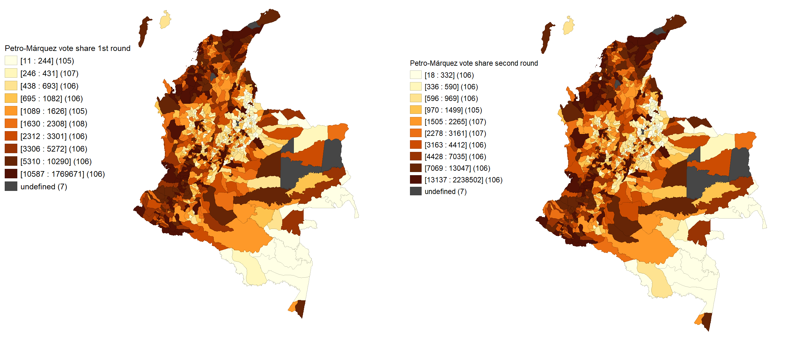

Table A1. Definitions and descriptives statistics of the main variables
Variable | Description | Descriptive Statistics
Acciones subversivas | Number of actions of a military nature that involves armed interaction between guerrilla groups Public Forces in the municipality from 2003 to 2019; this includes four different guerrillas (FARC, ELN, ERP, ERG and EPL). | Min = 0  Max = 107  Mean = 2.42
PDET | PDET 1 if the municipality is part of the PDET program, 0 otherwise | Min = 0  Max = 1  n = 170
Petro-Márquez Vote-Share (Round 1 and Round 2) | Percentage of votes for Gustavo Petro and Francia Márquez at the municipal level in the two presidential elections of 2022 (first and second round) | In the first round,  Min = 2.73%  Max = 95.18%  Mean = 34.74%.
Petro vote share 2018 | Percentage of votes for Gustavo Petro at the municipal level in 2018 | In the first round of 2018, Min = 1.07%  Max = 88.59%,  Mean = 24.35%.
Violence (VIPAA) | Indicates the violent presence (human rights violations) of armed actors at the municipality-year level. Five main categories of armed actors: Insurgents, paramilitaries, government forces, FARC dissidents between 1988 and 2019. | For the period 2003-2011, Min = 0  Max = 1245  Mean = 29.15
Social leaders | Number of social leaders killed in a municipality between 2005 and 2020. | Min = 0  Max = 34  Mean = 0.8192
Incumbent coalition | This dichotomous variable equals one if the mayor is part of one of the political parties that were part of President Duque's congress coalition. | Min = 0  Max = 1  Mean = 0.8
Local capacities | This variable measures the average performance of the management of territorial entities in 2005 and 2017, based on: the results obtained, the commitments made by these entities in development plans, the framework of the decentralization of competencies and resources process, and compliance with the legal framework that underpins it. | Min = 28.17  Max = 82.02  Mean = 62.69
NBI | Average of the index of unsatisfied basic needs at the municipality level between 1993, 1995, 2000, 2005 and 2018. | Min = 11.01  Max = 100  Mean = 46.73
Coca crops | The average number of hectares of coca crops in a given municipality between 1998-2018. | Min = 0  Max = 118676.4  Mean = 1598.26
Slave ratio | The ratio of the slave population in the middle of the XIX century collected by Ahmed., et al (2021). | Min = -0.32  Max = 9.77  Mean = 0
Distance to capital | Linear distance to the capital of the department in kilometers. | Min = 0  Max = 360.77  Mean = 80.38
Altitude | Height of the municipality - MSL (Meters Above Sea Level) | Min = 2  Max = 25221  Mean = 1110
Population | Log of the total population | Min = 6.82  Max = 14.57  Mean = 9.47
Covid death rate | Number of Covid-19 deaths as a proportion of the total population by December 2021. | Min = 0  Max = 0.765  Mean = 0.154

Figure A2 Predicted values and Actual Values of Petro- Márquez vote share on the first round.
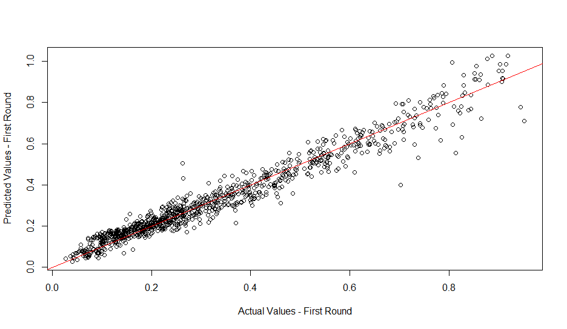
Figure A3 Predicted values and Actual Values of Petro- Márquez vote share on the second round.
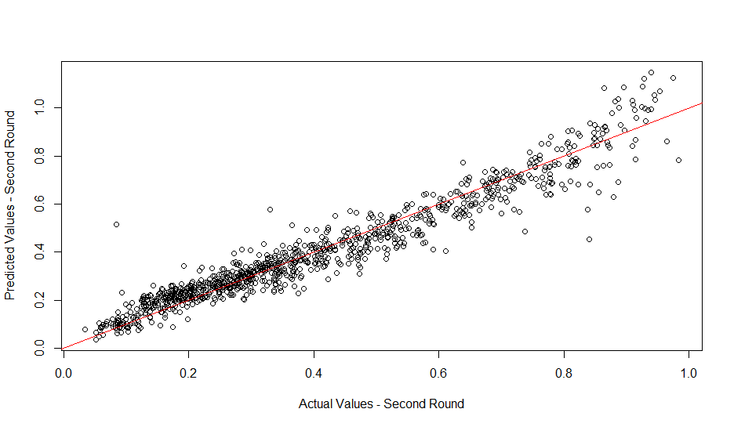

Table A2 First round determinants of Petro- Márquez vote share.
Variable | Model 1 | Model 2 | Model 3 | Model 4 | Model 5 | Model 6
(Intercept) | 0.308*** | 0.293*** | 0.080*** | 0.082*** | 0.081*** | 0.087***
 | [0.007] | [0.007] | [0.004] | [0.031] | [0.031] | [0.032]
PDET | 0.227*** | 0.177*** | 0.038*** | 0.012* | 0.018** | 0.014**
 | [0.017] | [0.019] | [0.012] | [0.006] | [0.008] | [0.007]
Log(Acciones subversivas+1) |  | 0.038*** | 0.012*** | -0.003 | -0.003 | -0.004
 |  | [0.008] | [0.004] | [0.003] | [0.003] | [0.003]
Acciones subversivas squared |  |  | -0.000 | -0.000 | 0.000 | -0.000
 |  |  | [0.000] | [0.000] | [0.000] | [0.000]
Log(Acciones subversivas + 1) * PDET |  |  | -0.029*** |  | -0.005
 |  |  | [0.007] |  | [0.005]
Acciones subversivas squared * PDET |  |  |  | -0.000
 |  |  |  | [0.000]
Social leaders |  |  |  | -0.001 | -0.001 | 0.001
 |  |  |  | [0.001] | [0.001] | [0.002]
Social leaders*PDET |  |  |  |  |  | -0.002
 |  |  |  |  |  | [0.002]
Petro vote share 2018 |  |  | 1.085*** | 0.890*** | 0.891*** | 0.888***
 |  |  | [0.014] | [0.015] | [0.015] | [0.015]
Incumbent coalition |  |  |  | -0.001 | -0.001 | -0.001
 |  |  |  | [0.004] | [0.005] | [0.005]
Local capacities |  |  |  | -0.000 | -0.000 | -0.001
 |  |  |  | [0.000] | [0.000] | [0.000]
Coca crops |  |  |  | 0.000* | 0.000* | 0.000*
 |  |  |  | [0.000] | [0.000] | [0.000]
NBI |  |  |  | -0.000 | -0.000 | -0.000
 |  |  |  | [0.000] | [0.000] | [0.000]
Slave ratio |  |  |  | 0.007*** | 0.007*** | 0.007***
 |  |  |  | [0.002] | [0.002] | [0.002]
Distance to capital |  |  |  | -0.000*** | -0.000*** | -0.000***
 |  |  |  | [0.000] | [0.000] | [0.000]
Altitute |  |  |  | -0.000*** | -0.000*** | -0.000***
 |  |  |  | [0.000] | [0.000] | [0.000]
log(Population) |  |  |  | 0.008*** | 0.008*** | 0.008***
 |  |  |  | [0.002] | [0.002] | [0.003]
Covid death rate |  |  |  | 6.672*** | 6.613*** | 6.576***
 |  |  |  | [2.365] | [2.368] | [2.367]
Turnout first round |  |  |  | 0.009 | 0.009 | 0.010
 |  |  |  | [0.018] | [0.018] | [0.018]
Department fixed effects | No | No | No | Yes | Yes | Yes
Observations | 1108 | 1108 | 1108 | 991 | 991 | 991
R squared | 0.146 | 0.164 | 0.865 | 0.950 | 0.950 | 0.950
Standard errors in square brackets
Note: *** p<0.001, ** p<0.01, * p<0.05

Table A3 Second round determinants of Petro- Márquez vote share.
Variable | Model 1 | Model 2 | Model 3 | Model 4 | Model 5 | Model 6
(Intercept) | 0.379*** | 0.364*** | 0.141*** | 0.000 | -0.000 | 0.003
 | [0.007] | [0.008] | [0.005] | [0.042] | [0.042] | [0.043]
PDET | 0.241*** | 0.191*** | 0.044*** | 0.020** | 0.023** | 0.022**
 | [0.018] | [0.021] | [0.015] | [0.008] | [0.011] | [0.009]
Log(Acciones subversivas+1) |  | 0.039*** | 0.011** | -0.002 | -0.002 | -0.002
 |  | [0.008] | [0.005] | [0.003] | [0.004] | [0.003]
Acciones subversivas squared |  |  | -0.000 | -0.000 | 0.000 | -0.000
 |  |  | [0.000] | [0.000] | [0.000] | [0.000]
Log(Acciones subversivas + 1) * PDET |  |  | -0.029*** |  | -0.002
 |  |  | [0.009] |  | [0.007]
Acciones subversivas squared * PDET |  |  |  |  | -0.000
 |  |  |  |  | [0.000]
Social leaders |  |  |  | -0.001 | -0.001 | -0.000
 |  |  |  | [0.001] | [0.001] | [0.002]
Social leaders*PDET |  |  |  |  |  | -0.001
 |  |  |  |  |  | [0.003]
Petro vote share 2018 |  |  | 1.134*** | 0.916*** | 0.917*** | 0.916***
 |  |  | [0.019] | [0.020] | [0.020] | [0.020]
Incumbent coalition |  |  |  | 0.006 | 0.006 | 0.006
 |  |  |  | [0.006] | [0.006] | [0.006]
Local capacities |  |  |  | -0.000 | -0.000 | -0.000
 |  |  |  | [0.000] | [0.000] | [0.000]
Coca crops |  |  |  | 0.000** | 0.000** | 0.000**
 |  |  |  | [0.000] | [0.000] | [0.000]
NBI |  |  |  | -0.000 | -0.000 | -0.000
 |  |  |  | [0.000] | [0.000] | [0.000]
Slave ratio |  |  |  | 0.007*** | 0.007*** | 0.007***
 |  |  |  | [0.002] | [0.002] | [0.002]
Distance to capital |  |  |  | -0.000*** | -0.000*** | -0.000**
 |  |  |  | [0.000] | [0.000] | [0.000]
Altitute |  |  |  | -0.000 | -0.000 | -0.000
 |  |  |  | [0.000] | [0.000] | [0.000]
log(Population) |  |  |  | 0.019*** | 0.019*** | 0.018***
 |  |  |  | [0.003] | [0.003] | [0.003]
Covid death rate |  |  |  | 6.052* | 6.007* | 6.020*
 |  |  |  | [3.138] | [3.143] | [3.141]
Turnout second round |  |  |  | 0.074*** | 0.074*** | 0.074***
 |  |  |  | [0.022] | [0.022] | [0.022]
Department fixed effects | No | No | No | Yes | Yes | Yes
Observations | 1108 | 1108 | 1108 | 991 | 991 | 991
R squared | 0.140 | 0.157 | 0.810 | 0.924 | 0.924 | 0.924
Standard errors in square brackets
Note: *** p<0.001, ** p<0.01, * p<0.05

Figure A4 Predicted values of Petro- Márquez vote share for PDET and non-PDET municipalities in the first round.

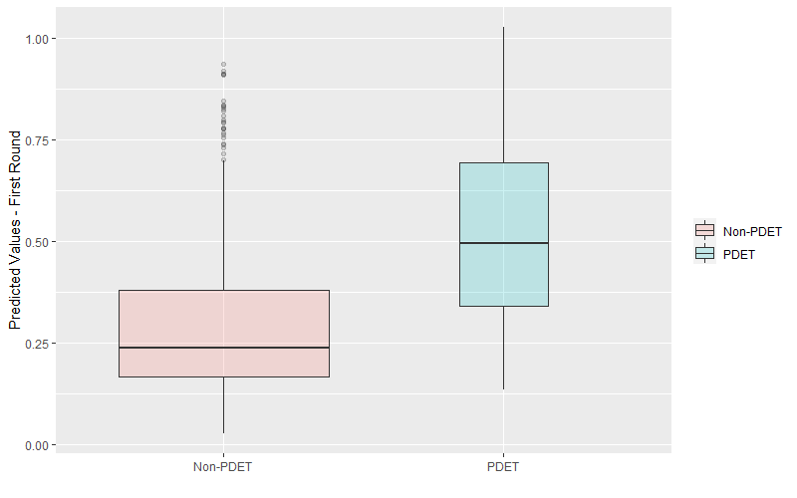
Figure A5 Predicted values of Petro- Márquez vote share for PDET and non-PDET municipalities in the second round.
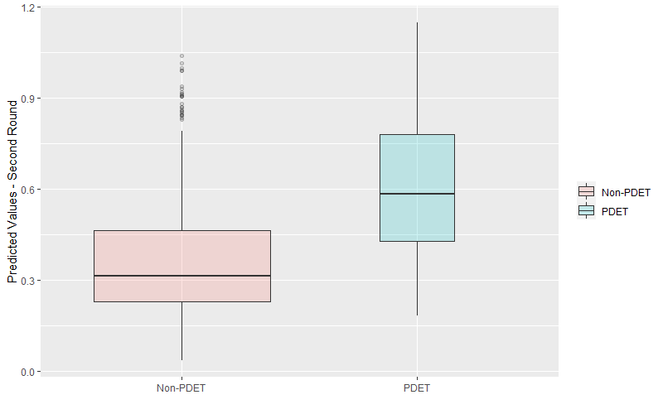

Table A4 Robustness check using VIPAA dataset. Petro- Márquez vote share as the dependent variable
Variable | First round | Second round
 | Model 1 | Model 2
Intercept | 0.90*** | 0.030
 | (0.032) | (0.043)
PDET | 0.016*** | 0.022**
 | (0.007) | (0.009)
Violence (1976-2002) | -0.002 | -0.003
 | (0.002) | (0.002)
Violence (1976-2002) | -0.000 | -0.000
 | (0.000) | (0.000)
Violence (2003-2011) | 0.000 | 0.003
 | (0.000) | (0.003)
Violence (2003-2011) | 0.000 | -0.000
 | (0.000) | (0.000)
Violence (2012-2016) | 0.001 | 0.003
 | (0.002) | (0.003)
Violence (2012-2016) | 0.000 | 0.000
 | (0.000) | (0.000)
Violence (2017-2019) | 0.002 | 0.004
 | (0.002) | (0.003)
Violence (2017-2019) | -0.000 | -0.000
 | (0.000) | (0.000)
Petro vote Share 201 | 0.884*** | 0.907***
 | (0.015) | (0.021)
Incumbent coalition | 0.000 | 0.008
 | (0.004) | (0.006)
Turn out | 0.001 | 0.070***
 | (0.018) | (0.022)
Local capacities | -0.001 | -0.000
 | (0.000) | (0.000)
Coca crops | -0.002** | -0.002
 | (0.001) | (0.001)
NBI | -0.000 | -0.000
 | (0.000) | (0.000)
Slave ratio | 0.007*** | 0.007***
 | (0.002) | (0.002)
Covid death rate | 6.621*** | 5.608*
 | -2.382 | -3.157
Social leaders | -0.001 | -0.001
 | (0.001) | (0.001)
Distance to capital | -0.000*** | -0.000***
 | (0.000) | (0.000)
Altitude | -0.000*** | -0.000
 | (0.000) | (0.000)
log(Population) | 0.008*** | 0.016***
 | (0.003) | (0.004)
Department fixed effects | Yes | Yes
Observations | 991 | 991
R squared | 0.950 | 0.924
Standard errors in square brackets
Note: *** p<0.001, ** p<0.01, * p<0.05

Table A5 Robustness check using VIPAA dataset disaggregating by paramilitaries. Petro- Márquez vote share as the dependent variable
Variable | First round | Second round
 | Model 1 | Model 2
Intercept | 0.074** | -0.008
 | [0.032] | [0.043]
Paramilitaries violence | -0.000 | -0.000
(VIPAA)
 | [0.000] | [0.000]
PDET | 0.015** | 0.022**
 | [0.007] | [0.009]
Paramilitaries violence (VIPAA)* PDET | 0.000 | 0.000
 | [0.000] | [0.000]
Paramilitaries violence (VIPAA) | 0.000 | 0.000
Squared
 | [0.000] | [0.000]
Petro vote share 2018 | 0.888*** | 0.912***
 | [0.015] | [0.020]
Incumbent coalition | -0.000 | 0.008
 | [0.004] | [0.006]
Local capacities | -0.001* | -0.000
 | [0.000] | [0.000]
Coca crops | -0.002** | -0.001
 | [0.001] | [0.001]
NBI | -0.000 | -0.000
 | [0.000] | [0.000]
Slave ratio | 0.008*** | 0.007***
 | [0.002] | [0.002]
Covid death rate | 6.634*** | 6.111*
 | [2.376] | [3.155]
Social leaders | -0.000 | 0.000
 | [0.001] | [0.001]
Turnout | 0.002 | 0.067***
 | [0.018] | [0.022]
Distance to capital | -0.000** | -0.000***
 | [0.000] | [0.000]
Altitute | -0.000*** | -0.000
 | [0.000] | [0.000]
log(Population) | 0.010*** | 0.020***
 | [0.003] | [0.004]
Department fixed effects | Yes | Yes
Observations | 991 | 991
R squared | 0.950 | 0.924
Standard errors in square brackets
Note: *** p<0.001, ** p<0.01, * p<0.05

Table A6 Covariants of the probability to be chosen as a PDET.
Variable | PSM
 | PDET (Yes=1)
Intercept | -1.798*
 | [1.044]
Acciones subversivas | 0.137***
 | [0.023]
Local capacities | -0.042***
 | [0.014]
Log(Coca crops) | 0.360***
 | [0.034]
NBI | 0.023***
 | [0.007]
Observations | 1108
Standard errors in parentheses
Note: *** p<0.001, ** p<0.01, * p<0.05

Figure A6 Estimated propensity scores by treatment status.
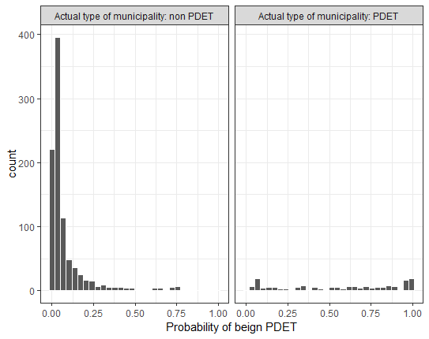

Figure A7 Distribution of matched and unmatched units
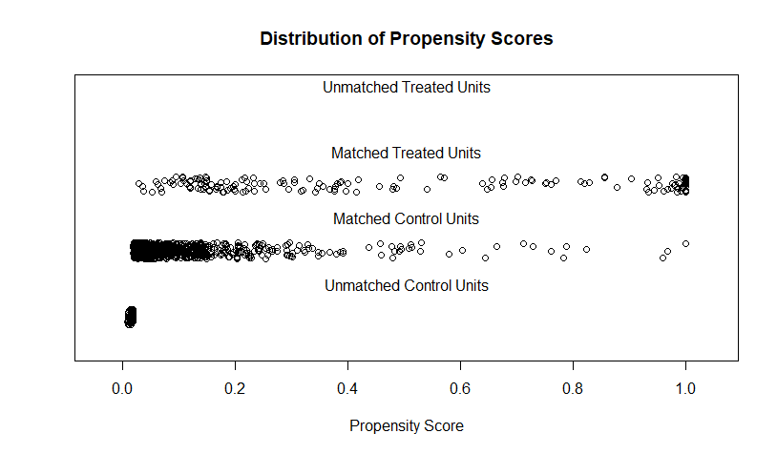

Table A7. Welch Two Sample t-test between treatment (PDET) and control group on covariants before the matching.
Covariant | t-value | df | P-value | 95% | Mean | Mean
 |  |  |  | Confidence interval | Control | Treatment
Acciones subversivas | -76.305 | 173.42 | 1.49e-12 | -11.389451 ; -6.708224 | 1.137.209 | 10.186.047
Local Capacities | 82.884 | 262.61 | 5,97E-12 | 4.438078 ; 7.203791 | 6.365.723 | 5.783.629
Coca crops | -65.754 | 172.22 | 5,15E-07 | -10935.382 ; -5894.769 | 1.816.868 | 85.967.623
NBI | -10.911 | 234.97 | 2.2e-16 | -20.44356 ; -14.19005 | 4.384.210 | 6.115.891

Table A8. Welch Two Sample t-test between treatment and control group on covariates after the matching.
Covariant | t-value | df | P-value | 95% | Mean | Mean
 |  |  |  | Confidence interval | Control | Treatment
Acciones subversivas | -76.305 | 173.42 | 1.49e-12 | -11.389451 ; -6.708224 | 1.137.209 | 10.186.047
Local Capacities | 82.884 | 262.61 | 5,97E-12 | 4.438078 ; 7.203791 | 6.365.723 | 5.783.629
Coca crops | -65.754 | 172.22 | 5,15E-07 | -10935.382 ; -5894.769 | 1.816.868 | 85.967.623
NBI | -10.911 | 234.97 | 2.2e-16 | -20.44356 ; -14.19005 | 4.384.210 | 6.115.891

Figure A8 Voter turnout in presidential elections.
