**ONLINE SUPPLEMENT**

**Uneven States, Unequal Societies, and Democracy's Unfulfilled Promises: Citizenship Rights in Chile and Contemporary Latin America.**

This appendix presents additional data analysis, which we refer to in our paper. In section A, we first offer a figure with a visual map of the operationalization strategy and describe the general formula for the construction of linear citizenship indexes. Then we present a figure with the parallel analysis that justifies the choice of three factors and the table of the factor analysis. Finally, we report the correlation between the indexes and the factors.

Section B provides more information on the construction of clusters from the citizenship factor scores. Figure 1B shows the distribution in the scoring of the three factors for each cluster. Figure 2B shows each cluster's percentages from the total sample. Figure B3 shows the distribution of each cluster over the different waves of the surveys. Finally, Figure B4 shows the distribution of the clusters according to the ethnic composition of the sample.

Section C provides more detail on the Multilevel post-stratification Regression (Mrp) that we used to construct the correlation graphs between municipalities in the Metropolitan Region of Chile. For this purpose, we described the additional database used (CASEN) for the weighting procedure. Table C1 presents the original AmericanBarometer sample size for each commune, the sample size for the CASEN base, and the weighted scores for the three citizenships.

Finally, section D shows additional data, which we did not refer to in the paper but anticipate might be of interest to the reader. Figure D1 shows boxplots for each type of citizenship, and the average of the three, for each country in the study from highest to lowest average score. Figure D2 shows boxplots for the case of Chile, showing the evolution of each citizenship, and the average of the three, for the three waves of the AmericanBarometer survey.

## A. Operationalization strategy, linear indicators, and factor analysis

**Figure A1. Operationalization and modeling strategy**

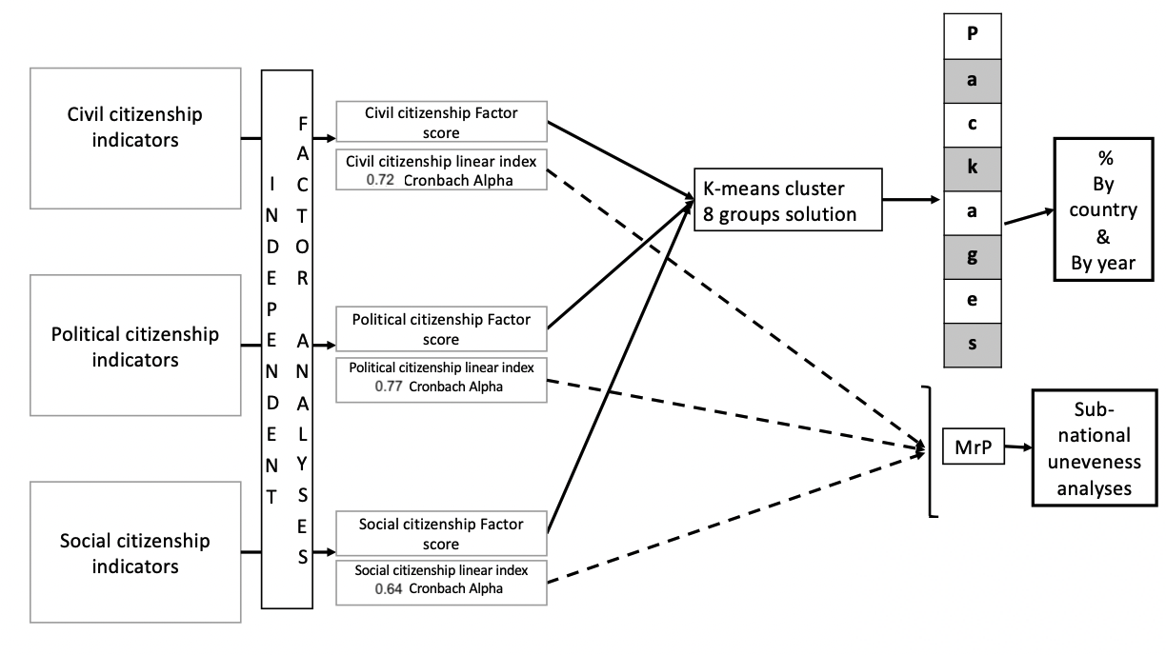

**Source: Authors’ construction.**

Since the variables used have diﬀerent units of measure, it is necessary to homologate this unit and the range of variation. For this purpose, we carried out a statistical procedure that seeks two objectives. First, sort all the variables from smallest to largest, for which we had to recode. Secondly, standardizing all scales to the same unit of measure, using a formula with a rule of three. The logic was to transform all indicators on a scale of 1 to 7 to make the measures comparable. **Table 1 in the main article**displays each of the variables we included in each linear index**.**

Therefore, to standardize the formula used is,

(Max(x) − Min(x)) ∗ (Obs.Value – Min Obs.V alue)

X = _______________________________________________ + Mín(x)

MaxObs.Value – Min Obs.Value

**Figure A2. Parallel analysis**



**Source: Authors’ construction on the basis of AmericasBarometer 2012-2014-2016-2018.**

**Table A1.** Exploratory factor analysis (varimax rotation)

|  |  |  |  |
| --- | --- | --- | --- |
|  | Political Citizenship  Chronbach alpha=0.77 | Civil Citizenship  Chronbach alpha=0.72 | Social Citizenship  Chronbach alpha =0.64 |
| Trust in political parties | **0.667** | 0.275 | 0.113 |
| Trust in the elections | **0.638** | 0.220 | 0.140 |
| Trust in congress | **0.624** | 0.389 | 0.143 |
| Trust in the executive | **0.667** | 0.275 | 0.113 |
| Health | 0.111 | 0.114 | **0.704** |
| Education | 0.141 | 0.151 | **0.707** |
| Judiciary will Punish the Guilty | 0.157 | **0.44** | 0.157 |
| Courts Guarantee Fair Trial | 0.283 | **0.649** | 0.104 |
| Trust in judicial system | 0.427 | **0.669** | 0.122 |
| Basic rights protected by the political system | 0.443 | **0.56** | 0.151 |
|  |  |  |  |
| Proportion of variance explained | 0.220 | 0.155 | 0.124 |
| Cumulative proportion | 0.220 | 0.374 | 0.5 |

Source: Authors’ elaboration based on American Barometer (2012-2018)

**Table A2. Correlation between factors and linear additive indexes**

|  |  |  |  |  |  |  |
| --- | --- | --- | --- | --- | --- | --- |
|  | Political citizenship linear index | Civil citizenship linear index | Social citizenship linear index | Political Citizenship  Factor scores | Social Citizenship  Factor scores | Civil Citizenship  Factor scores |
| Political citizenship linear index | **1** |  |  |  |  |  |
| Civil citizenship linear index | 0,58 | **1** |  |  |  |  |
| Social citizenship linear index | 0,25 | 0,26 | **1** |  |  |  |
| Political citizenship  Factor scores | **0,98** | 0,49 | 0,15 | **1** |  |  |
| Social citizenship  Factor scores | 0,08 | 0,11 | **0,97** | 0,00 | **1** |  |
| Civil citizenship  Factor scores | 0,47 | **0,95** | 0,18 | 0,37 | 0,00 | **1** |

**Source: Authors’ construction on the basis of AmericasBarometer 2012-2014-2016-2018.**

## B. Clusters solutions

**Figure B1. Clusters solution based on factor scores**



**Source: Authors’ construction on the basis of AmericasBarometer 2012-2014-2016-2018.**

**Figure B2. Clusters frequencies for Latin America**



**Source: Authors’ construction on the basis of AmericasBarometer 2012-2014-2016-2018.**

**Figure B3. Clusters solution thru waves for Latin America**



**Source: Authors’ construction on the basis of AmericasBarometer 2012-2014-2016-2018.**

**Figure B4. Clusters solution thru ethnic groups**



**Source: Authors’ construction on the basis of AmericasBarometer 2012-2014-2016-2018.**

## C- Multilevel post-stratification Regression (MrP)

To run the models with post stratiﬁcation, we apply the data of the CASEN 2015 (external prediction) to the multilevel model to do a post-stratification procedure. CASEN is a database based on a socioeconomic characterization survey, which is representative only in some years and only for a subset of communes identified in the specifications of the sample design of each version of the survey. According to the information published by the Ministry of Social Development and Family (MIDESO), the 2015 Casen Survey considered a sample design with representativeness for a subset of 139 of the 324 communes in which it had coverage (additional documentation at the following link: http://observatorio.ministeriodesarrollosocial.gob.cl/).

In sum, considering this background, we carried out the following actions:

-Selection of communes: we decided to use only the communes of the Metropolitan Region of Chile, which generally had the largest number of cases. In addition, we filtered out those that the survey declared as non-representative and did not have a sufficient number of cases, leaving 34 communes.

- Variables: to post stratify the communes of the Metropolitan Region of the AmericanBarometer, we post stratified using the external base of CASEN and selecting age and gender as stratification variables.

- Procedure: to perform the post-stratification, we followed the approach described in Kastellec, Lax, and Phillips 2010. In simple terms, the procedure consisted of running the multilevel models and making predictions for each type of citizenship using the linear indicators as dependent variables and the age and gender variables as explanatory variables. Then, using the estimates from the hierarchical model, we calculated the estimates in the subnational units by weighting the predictions with the data from the external database (further details in the reference section of Kastellec et al., 2010).

**Table C1. Multilevel post stratified databases**

|  |  |  |  |  |  |
| --- | --- | --- | --- | --- | --- |
| Municipality | N (CASEN) | Civil Citizenship | Social Citizenship | Political Citizenship | N (AmericanBarometer) |
| cerrillos | 300 | 3,584 | 3,197 | 3,697 | 49 |
| cerro navia | 817 | 3,311 | 3,686 | 3,696 | 48 |
| colina | 608 | 3,360 | 3,805 | 3,532 | 48 |
| conchalí | 3743 | 3,697 | 3,319 | 3,543 | 48 |
| el bosque | 2730 | 3,435 | 3,655 | 3,383 | 48 |
| el monte | 184 | 3,470 | 4,186 | 3,647 | 48 |
| huechuraba | 331 | 3,477 | 3,555 | 3,321 | 48 |
| independencia | 318 | 3,857 | 3,548 | 3,704 | 48 |
| la florida | 1386 | 3,105 | 3,226 | 3,422 | 145 |
| la granja | 650 | 3,154 | 3,576 | 3,565 | 48 |
| la pintana | 859 | 2,996 | 3,302 | 3,196 | 72 |
| la reina | 316 | 3,700 | 3,339 | 3,843 | 49 |
| las condes | 2698 | 3,548 | 3,868 | 3,648 | 120 |
| lo barnechea | 404 | 4,136 | 3,631 | 3,722 | 52 |
| lo espejo | 335 | 3,544 | 3,643 | 3,574 | 48 |
| maipú | 1621 | 3,982 | 3,359 | 3,821 | 289 |
| melipilla | 529 | 4,115 | 3,830 | 3,821 | 46 |
| Ñuñoa | 2802 | 3,585 | 3,729 | 3,552 | 47 |
| padre hurtado | 226 | 3,394 | 3,651 | 3,487 | 48 |
| peñalolén | 1058 | 3,711 | 3,855 | 3,799 | 48 |
| providencia | 2299 | 3,691 | 3,644 | 3,500 | 48 |
| pudahuel | 1247 | 3,919 | 3,584 | 3,739 | 99 |
| puente alto | 3966 | 3,434 | 3,193 | 3,453 | 249 |
| quilicura | 1260 | 3,570 | 3,735 | 3,804 | 72 |
| quinta normal | 813 | 2,942 | 3,054 | 3,356 | 48 |
| recoleta | 937 | 3,709 | 3,573 | 3,428 | 54 |
| renca | 770 | 3,460 | 3,540 | 3,357 | 48 |
| rengo | 738 | 3,146 | 3,587 | 3,340 | 49 |
| san bernardo | 1013 | 3,548 | 3,435 | 3,395 | 96 |
| san joaquín | 355 | 3,649 | 3,750 | 3,578 | 48 |
| san ramón | 367 | 3,263 | 3,627 | 3,438 | 48 |
| santiago | 1451 | 3,267 | 3,497 | 3,531 | 75 |
| talagante | 499 | 3,551 | 3,707 | 3,733 | 49 |

**Source: Authors’ construction on the basis of AmericasBarometer 2012-2014-2016-2018 and CASEN 2015.**

## D. Additional Figures

**Figure D1. Box plots for perceived access to citizenship rights in Latin America**



**Source: Authors’ construction on the basis of AmericasBarometer 2012-2014-2016-2018.**

**Figure D2. Box plots for perceived access to citizenship rights in Chile thru study waves**



**Source: Authors’ construction on the basis of AmericasBarometer 2012-2014-2016/2017.**