Germán Feierherd, Patricio Larroulet, Wei Long, and Nora Lustig, The Pink Tide and Inequality in Latin America. Latin American Politics and Society vol. 65, no. 2 (Summer 2023)

Appendix

A1. Alternative Data
Table A1. The Effect of Left on Inequality Using SWIID data
A2. Terms of trade and conditional effect of left governments
Figure A1. The Marginal Effect of Left on Inequality Over Terms of Trade
A3. Long-run Effects of Left
Table A2. Long-run Effects of Left on Inequality and Policy
A4. Extended results
Table A3. Extended results for the static model
Table A4. Extended results for the dynamic model
A5. Parallel Trend Tests
Figure A2. Parallel trend assumption: Results for all variables
A6. Data Availability
Table A5. Data availability
A7. Serial Correlation Test
Table A6. Serial correlation test for the residuals of the static model
A8. Computation of long-run effects
A9. Legislative control of left governments
Figure A3. The Marginal Effect of Left on Inequality Over the Legislature Control by the government
A10. Different definitions of left
Table A7. Robustness Checks: Left definition
A11. Coding of left definition
Table A8. Robustness check of the classification
A12. Descriptive statistics
Table A9. Descriptive Statistics for Outcome Variables
A13. Main results using exports as trade volume measure
Table A10. Main results using exports as control instead of exports plus imports
A14. V democracy indexes as control
Table A11. V-democracy indexes as control
A15. Description of data used from Latinobarometro
A16. Parallel trend for trade variables
Figure A4. Parallel trend test for terms of trade
A17. Main results without controls
Table A12. Main results without controls
A18. Descriptive statistics
Table A13. Descriptive statistics

A1. Alternative Data
Data on income inequality is often missing for some countries and years. We test the robustness of our results using the SWIID database. SWIID relies on the following data sources: OECD Income Distribution Database, the Socio-Economic Database for Latin America and the Caribbean generated by CEDLAS, the World Bank, Eurostat, the World Bank’s PovcalNet, the UN Economic Commission for Latin America and the Caribbean, national statistical offices around the world, and other sources. The Gini coefficients provided by SWIDD are imputed and its main objective is to reach the maximum comparability of inequality data across countries and years. We obtain strikingly similar results, showing that the Left lowers the Gini index in both the static and the dynamic models.
Dependent Variable | Ln(Gini)
Model | Static | Dynamic
Left¹ | -0.015** |  | -0.003**
 | [0.005] |  | [0.001]
Terms of Trade | -0.000 |  | 0.000
 | [0.000] |  | [0.000]
Trade/GDP | -0.000 |  | 0.000
 | [0.000] |  | [0.000]
High skilled/Low skilled | -0.061* |  | -0.002
 | [0.031] |  | [0.001]
Observations | 260 |  | 260
Country FE | YES |  | NO
Period FE | YES |  | YES
Clustered standard errors in brackets
*** p<0.01, ** p<0.05, * p<0.1
Note 1: Left is equal to missing after left-governed countries go back to being governed by a non-left government.
Note 2: Left is equal to 1 after the first year of a left government.
Table A1. The Effect of Left on Inequality Using SWIID data

A2. Terms of trade and conditional effect of left governments
Figure A1 shows the moderating effect of the Left across different levels of the Terms of trade variable. The histogram in the figure shows the distribution of “treated” (red) and “untreated” (grey) observations across different values of the terms of trade variable. For most of the range with sufficient data, the coefficient of Left is negative and significant.
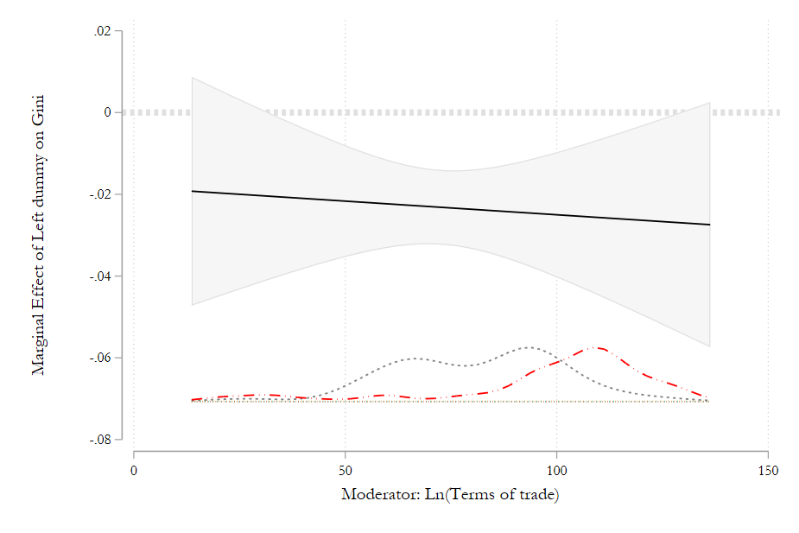
Notes: The black solid line represents the linear marginal effect of Left incumbency on the log of the Gini index at each point of the moderator variable, Ln(Terms of trade). The red line represent the distribution of Left governments and the grey line represent the non-Left governments across the moderator variable.

Figure A1. The Marginal Effect of Left on Inequality Over Terms of Trade

A3. Long-run Effects of Left
Table A2 shows results for the cumulative effect of being governed by the Left after one, four, and eight years.

Dependent Variable | Gini | Share of income top 10% | Income share middle deciles 4 to 7 | Share of income bottom 20% | Income share centile 90/Income share centile 10 | CCT's | UCT's | Social Pensions | Real minimum wage | Total tax revenues as % of the GDP | Total tax revenues on rents income profits and capital gains as % of the GDP
Left effect one year after | -0.00926** | -0.0249** | 0.0229** | 0.0393** | -0.0576** | 0.00346 | -0.0360 | 0.0522* | 0.0771** | 0.00636*** | 0.00238
 | (0.00446) | (0.0117) | (0.0102) | (0.0189) | (0.0246) | (0.0196) | (0.0286) | (0.0282) | (0.0332) | (0.00238) | (0.00181)
Left effect four years after | -0.0203** | -0.0532** | 0.0483** | 0.0822** | -0.118** | 0.00756 | -0.0759 | 0.124* | 0.183** | 0.0156*** | 0.00503
 | (0.00938) | (0.0240) | (0.0205) | (0.0378) | (0.0484) | (0.0425) | (0.0636) | (0.0649) | (0.0766) | (0.00584) | (0.00360)
Left effect eight after | -0.0310** | -0.0788** | 0.0704** | 0.119** | -0.167** | 0.0115 | -0.111 | 0.209** | 0.308** | 0.0272*** | 0.00736
 | (0.0137) | (0.0343) | (0.0287) | (0.0524) | (0.0663) | (0.0642) | (0.0991) | (0.105) | (0.127) | (0.0103) | (0.00499)
Left effect in the long-run | -0.0552** | -0.124** | 0.105** | 0.173** | -0.230** | 0.0199 | -0.167 | 0.785*** | 1.137 | 0.225 | 0.0112
 | (0.0223) | (0.0526) | (0.0413) | (0.0723) | (0.0924) | (0.109) | (0.185) | (0.272) | (1.032) | (0.157) | (0.00744)
Clustered standard errors in parentheses
* p<0.1 ** p<0.05 *** p<0.01
Table A2. Long-run Effects of Left on Inequality and Policy

A4. Extended results
In the following links, we present the results for all subsamples in Figure 2 of the main paper and for each one of our dependent variables, using both models (static and dynamic).

Table A3. Extended results for the static model
STATIC EXTENDED RESULTS

Table A4. Extended results for the dynamic model
DYNAMIC EXTENDED RESULTS
A5. Parallel Trend Tests
Below, we show plots for the parallel trend regression tests for all of our dependent variables. In all cases, each coefficient corresponds to the change in the natural logarithm of the dependent variable to the change one year before the leftist government begins, relative to the base period. The red dashed line represents the year where the Left government begins. The regression controls for the level of the terms of trade, the ratio between total trade and the GDP, and the ratio between high skilled and low-skilled workers.

Figure A2. Parallel trend assumption: Results for all variables
Panel 1. Income share centile 90 over income share centile 10
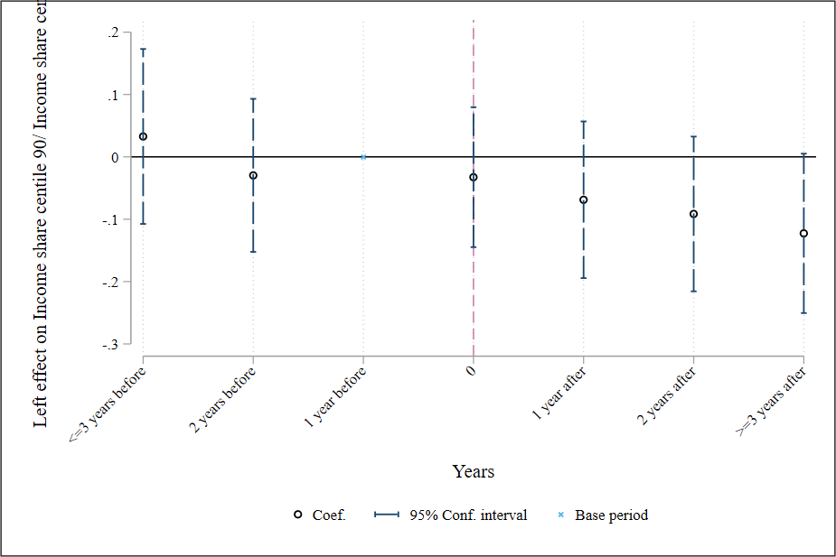
Panel 2. Income share bottom 20%
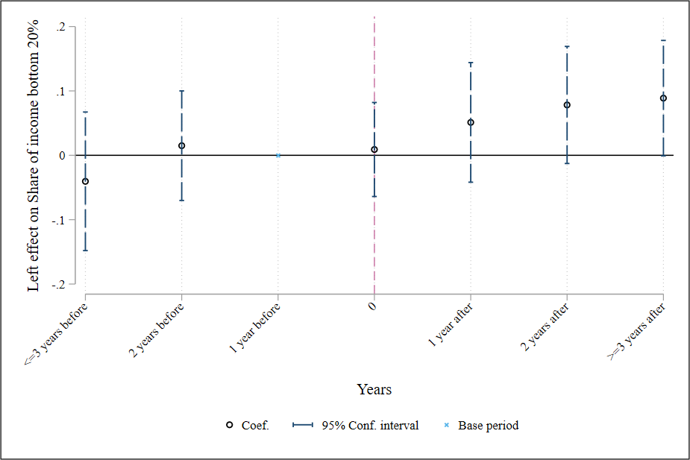
Panel 3. Income share middle deciles (4, 5, 6 & 7)
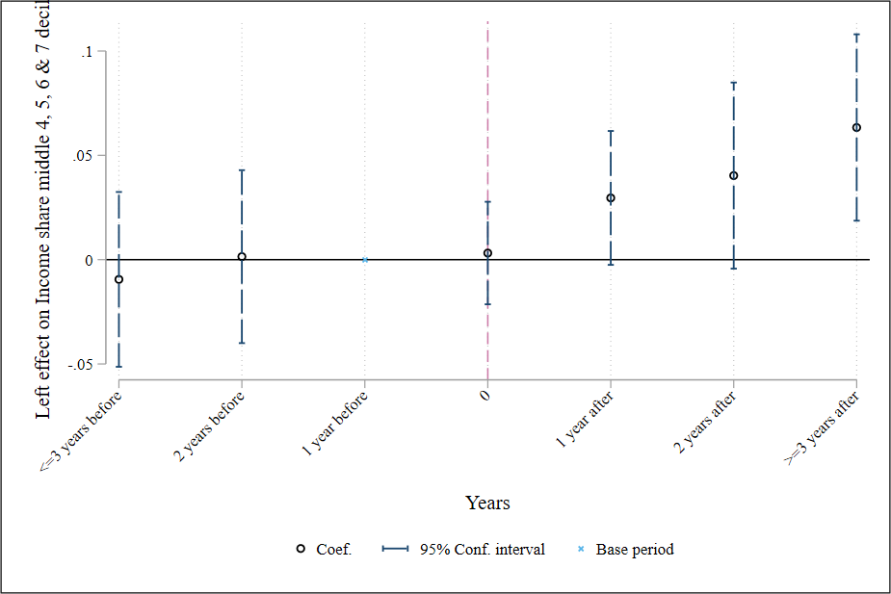
Panel 4. Income share top 10%
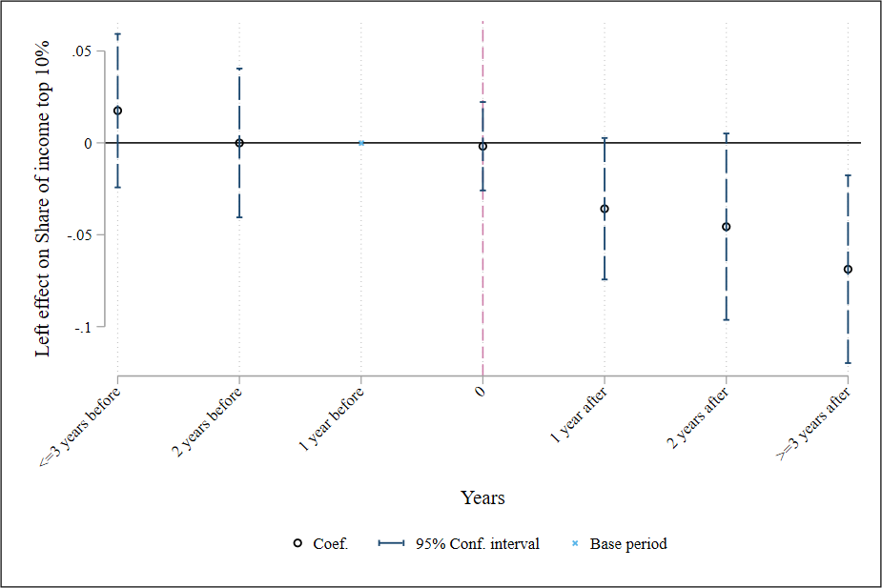
Panel 5. Terms of trade index as outcome variable
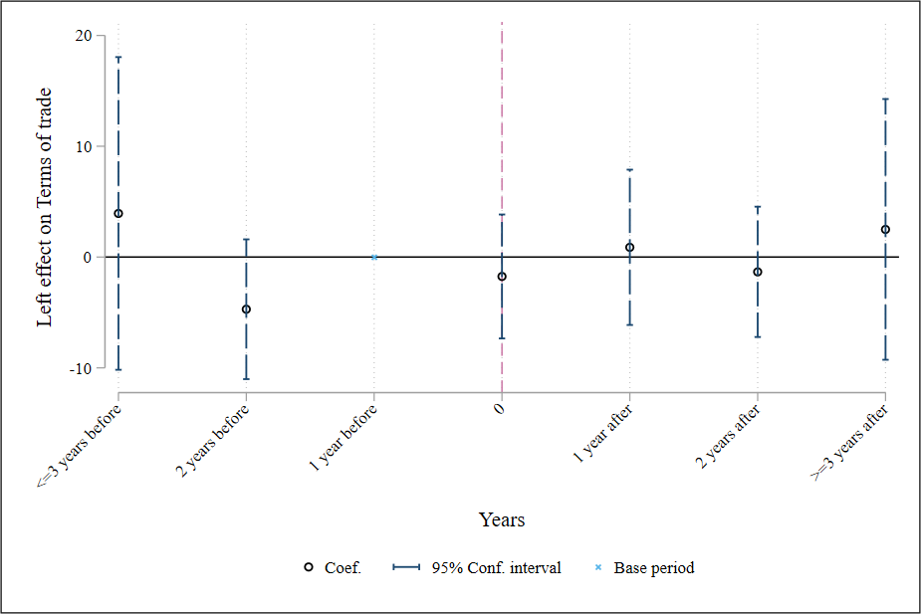

A6. Data Availability
In the table attached, we present the data availability for each dependent variable used in our paper.

Table A5. Data availability
DATA AVAILABILITY

A7. Serial Correlation Test
As discussed in the paper, there are reasons to believe there is serial correlation in our variables. In Table A6, we present the serial correlation test for the residuals of the static model for all variables used as outcome variables. As expected, we found one or higher order of serial correlation in all of our variables. In the static model, we account for this issue by using clustered standard errors. However, serial correlation may also introduce bias in our point estimates. To account for this possibility, we estimate a dynamic model (using the difference and system generalized method-of-moments estimator) where we explicitly account for the potential serial correlation in the dependent variable.

P-value of the Ljung-Box serial correlation test on the static models for one to six lags
Lags | Gini | Real ínimum wage | Income share centile 90/ Income share centile 10 | Income share middle 4, 5, 6 & 7 deciles | Share of income bottom 20% | Share of income top 10% | CCT’s | UCT’s | Social pensions | Total tax revenues | Taxes on income, rents, profits and capital gains
1 | 1.98E-15 | 1.68E-27 | 2.51E-16 | 2.2E-15 | 7.8E-16 | 2.97E-12 | 9.13E-10 | 1.01E-06 | 1.49E-05 | 1.11E-16 | 5.56E-06
2 | 1.54E-05 | 7.65E-19 | 1.61E-07 | 7.73E-06 | 2.8E-07 | 0.000573 | 0.041064 | 0.665003 | 0.781758 | 2.38E-10 | 0.00321
3 | 0.018809 | 1.61E-10 | 0.00664 | 0.003483 | 0.00791 | 0.078737 | 0.640467 | 0.015218 | 0.721504 | 0.000664 | 0.587566
4 | 0.252237 | 2.37E-05 | 0.202001 | 0.227743 | 0.239026 | 0.542216 | 0.664745 | 0.000875 | 0.079131 | 0.018243 | 0.930364
5 | 0.738051 | 0.132572 | 0.493371 | 0.81791 | 0.587314 | 0.738231 | 0.071501 | 0.000266 | 0.178724 | 0.422674 | 0.47719
6 | 0.547997 | 0.920787 | 0.671811 | 0.653269 | 0.548681 | 0.397779 | 0.069922 | 0.055614 | 0.278568 | 0.972717 | 0.123757
Notes: We test if the autocorrelation at each lag order is zero, but we allow for nonzero autocorrelations at lower lag orders. We run the test with the residuals of the static model.
Table A6. Serial correlation test for the residuals of the static model

A8. Computation of long-run effects
Our baseline dynamic model (excluding year fixed effects, w.l.o.g) is:
$$Y_{i,t}=β_{0}+ β_{1} L_{i,t}+ρ Y_{t-1}+ϵ_{i,t} (1)$$
Henceforth, we will assume a transition to a left government in the period $t$. As a result, $L_{i,j}=1 ∀ j>t$, hence $L_{i,t}=L_{i,t+s}=1 ∀ s≥0$.
Now, one year after $t$, equation (1) would transform into:
$$Y_{i,t+1}=β_{0}+ β_{1} L_{i,t+1}+ρ Y_{t}+ϵ_{i,t+1} (2)$$
Replacing equation (1) into equation (2):
$$Y_{i,t+1}=β_{0}+ β_{1} L_{i,t+1}+ρ (β_{0}+ β_{1} L_{i,t}+ρ Y_{t-1}+ϵ_{i,t})+ϵ_{i,t+1} (3)$$
Reordering equation (3) we get:
$$Y_{i,t+1}=β_{0}\left(1+ρ\right)+ β_{1} L_{i,t+1}+ β_{1}ρ L_{i,t}+ρ^{2}Y_{t-1}+ρϵ_{i,t}+ϵ_{i,t+1} (4)$$
Given the transition since period $t$, $L_{i,t+1}=L_{i,t}=1$, we can rewrite equation (4):
$$Y_{i,t+1}=β_{0}\left(1+ρ\right)+ β_{1} (1+ρ)L_{i,t}+ρ^{2}Y_{t-1}+ρϵ_{i,t}+ϵ_{i,t+1}$$
Now if we repeat the process to $Y_{t+2}$, it is easy to derive the following expression:
$$Y_{i,t+2}=β_{0}\left(1+ρ+ρ^{2}\right)+ β_{1} \left(1+ρ+ρ^{2}\right)L_{i,t}+ρ^{3}Y_{t-1}+ρ^{2}ϵ_{i,t}+ρϵ_{i,t+1}+ϵ_{i,t+2}$$
The coefficient $β_{1} \left(1+ρ+ρ^{2}\right)$ represents the cumulative effect of being governed by the Left 2 years after the beginning of the government. This example can be generalized for any time horizon. If we want to estimate the cumulative effect $T$ periods after the Left came into office, we can compute the following equation:
$$Y_{i,t+T}=β_{0}\sum_{j=0}^{T}{ρ^{j}}+ β_{1} \sum_{j=0}^{T}{ρ^{j}} L_{i,t}+ρ^{T+1}Y_{t-1}+\sum_{j=0}^{T}{ρ^{T-j}}ϵ_{i,t+j} (5)$$
It is easy to derive tur formula, in footnote 25, to calculate “long-run” effects from equation (5). As $j→∞$ the summation $\sum_{j=0}^{T}{ρ^{j}}$ converges to $\frac{1}{1-ρ}$, given it is a geometric summation. Also, given a finite value of $Y_{i,t-1}$ and, if the stability condition is satisfied $ρ$ within the unit circle ($|ρ|<1$), the term $ρ^{T+1}Y_{i,t-1}→0$. Similarly, $\sum_{j=0}^{T}{ρ^{T-j}}ϵ_{i,t+j}=ρ^{T} ϵ_{t} \left(1+ρ^{-1}L^{-1}+{\left(ρ^{-1}L^{-1}\right)}^{2}+…+{\left(ρ^{-1}L^{-1}\right)}^{T}\right)$, and when $T→∞$, $\left(1+ρ^{-1}L^{-1}+{\left(ρ^{-1}L^{-1}\right)}^{2}+…+{\left(ρ^{-1}L^{-1}\right)}^{T}\right)= \left(\frac{1}{1-ρ^{-1}L^{-1}}\right)$, and $ρ^{T}→0$. As a result, equation (5), when $j→∞,$ converges to:
$$Y_{i,t+∞}=\frac{β_{0}}{1-ρ}+ \frac{β_{1}}{1-ρ} L_{i,t} (6)$$
Now we can see that $\frac{β_{1}}{1-ρ}$ is the limiting value of an infinite iteration of equation 1 and represents the cumulative effect of the change from non-left to left.

A9. Legislative control of left governments
Figure A3 shows the moderating effect of the Left across levels of the control for congress. The histogram in the figure shows the distribution of “treated” (red) and “untreated” (grey) observations across different values of the moderator variable. For most of the range with sufficient data, the coefficient of Left is negative and significant.
Figure A3. The Marginal Effect of Left on Inequality Over the Legislature Control by the government
Panel 1. Moderator: Seat share of the leftist governments. Dependent variable: Gini coefficient.
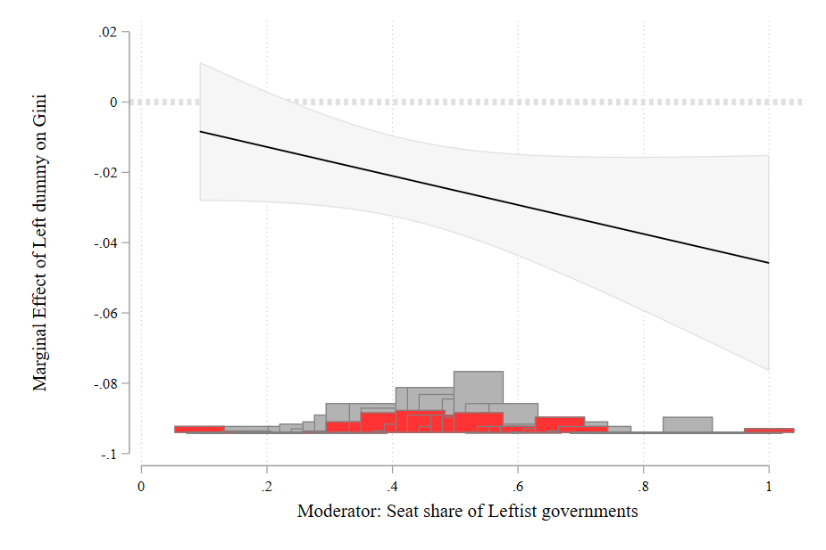
The coefficients of the regressions to create this plot are as follows: Coefficient associated with the Left variable: -0.005; Coefficient associated with the interaction between left dummy and seat share: -0.041. The sum of the previous two coefficients (which is the line displayed in Panel 1): -0.046***
Panel 2. Moderator: Seat share of the leftist governments. Dependent variable: Share of top 10%.
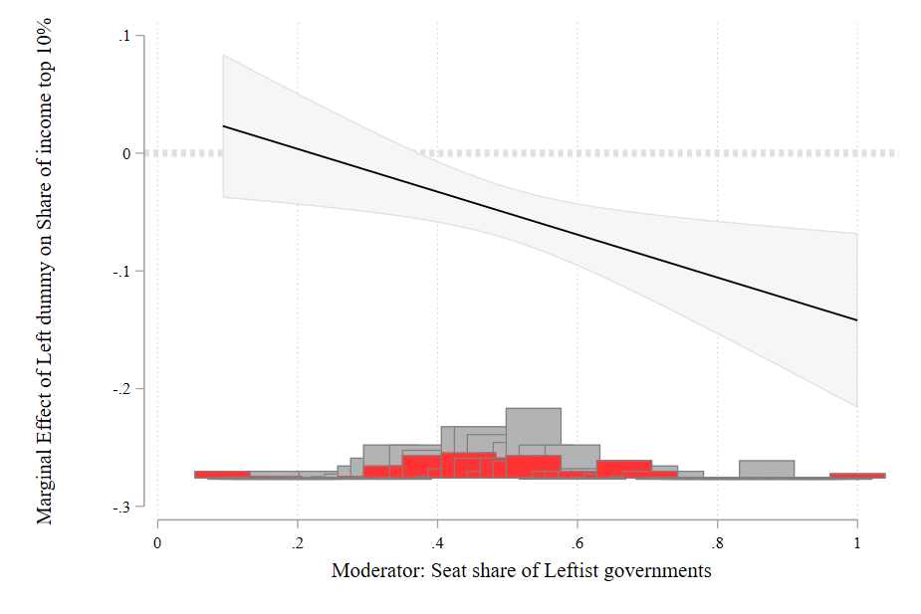
Panel 3. Moderator: Seat share of the leftist governments. Dependent variable: Share of deciles 4, 5, 6, & 7.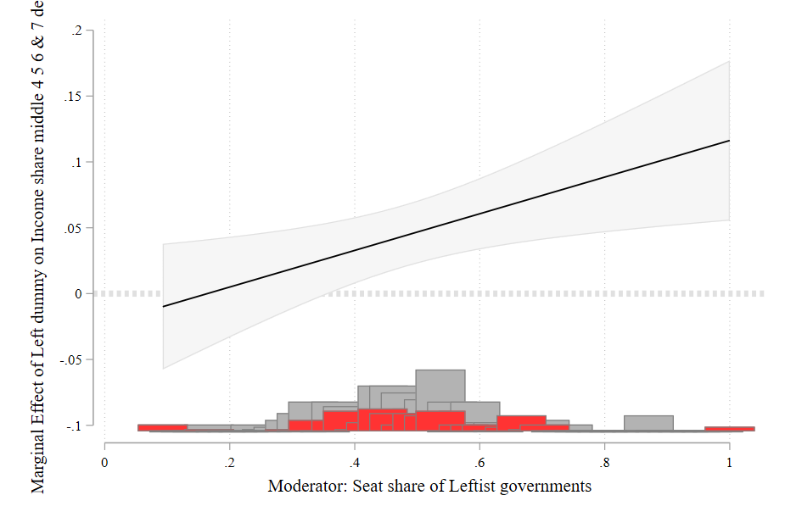.
Panel 4. Moderator: Seat share of the leftist governments. Dependent variable: Share bottom 20%.
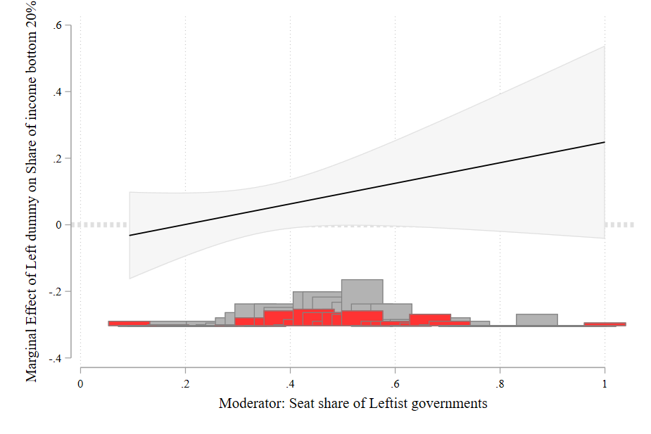
Panel 5. Moderator: Seat share of the leftist governments. Dependent variable: Extreme income ratio share centile 90/centile 10.
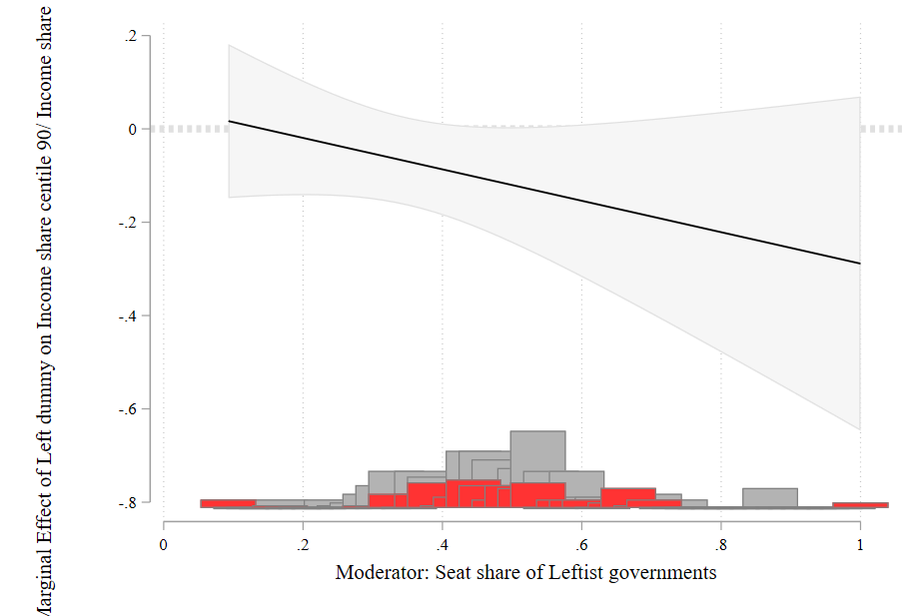
Notes: The seats share is calculated as total seats of the government divided by the total seats in the congress.

A10. Different definitions of left
In Table A7 we present the results for the static and the dynamic models using different definitions of left. In the main analysis, we dropped observations from “treated” countries after the Left is replaced by a non-leftist president. Then, in the two remaining definitions, we recode our main variable in two ways: we code all observations as treated after a country elects a left-wing government, regardless of what happens later, and we code observations according to which government is in office that year – i.e., we code Left-governed countries with a zero in the government ideology variable once the Left is voted out of office.

Dependent Variable |  | Gini | Share of income top 10% | Share of income 4,5,6 & 7 decile | Share bottom 20% | Share 90 cent/Share 10 cent | CCT/GDP | UCT/GDP | Social Pensions | Minimum Wage | Total Revenues / GDP | Taxes on rents capital gains income and Profits/GDP
Static
 | Left baseline 1¹ | -0.0242*** | -0.0499*** | 0.0452*** | 0.0881* | -0.114* | -0.0367 | 0.0274 | -0.0419 | 0.0556 | 1.127 | 0.148
 |  | (0.00582) | (0.0137) | (0.0132) | (0.0472) | (0.0607) | (0.0811) | (0.0336) | (0.0324) | (0.0950) | (0.795) | (0.309)
 | Left alternative 1² | -0.0293*** | -0.0631** | 0.0603** | 0.128** | -0.163** | -0.0359 | 0.0708*** | -0.0444 | 0.109 | 1.976** | -0.112
 |  | (0.00944) | (0.0216) | (0.0208) | (0.0594) | (0.0754) | (0.0568) | (0.0223) | (0.0488) | (0.117) | (0.848) | (0.433)
 | Left alternative 2³ | -0.0266*** | -0.0603*** | 0.0543*** | 0.116* | -0.148* | -0.0232 | 0.0736*** | -0.0454 | 0.154* | 1.893** | 0.00901
 |  | (0.00789) | (0.0167) | (0.0164) | (0.0591) | (0.0752) | (0.0484) | (0.0194) | (0.0384) | (0.0875) | (0.717) | (0.370)
Dynamic (System GMM)
 | Left baseline 1¹ | -0.00484** | -0.0131** | 0.0122** | 0.0209** | -0.0309** | 0.00181 | -0.0191 | 0.0266* | 0.0392** | 0.320*** | 0.126
 |  | (0.00237) | (0.00626) | (0.00552) | (0.0102) | (0.0135) | (0.0103) | (0.0149) | (0.0145) | (0.0171) | (0.120) | (0.0983)
 | Left alternative 1² | -0.00471** | -0.0129** | 0.0115** | 0.0187* | -0.0286** | 0.00688 | -0.0283* | 0.0313** | 0.0345* | 0.372*** | 0.116
 |  | (0.00224) | (0.00602) | (0.00530) | (0.00960) | (0.0132) | (0.00915) | (0.0166) | (0.0138) | (0.0207) | (0.113) | (0.0767)
 | Left alternative 2³ | -0.00530** | -0.0160** | 0.0133** | 0.0179* | -0.0261** | 0.00884 | -0.0275* | 0.0307** | 0.0447** | 0.410*** | 0.175**
 |  | (0.00235) | (0.00639) | (0.00526) | (0.00943) | (0.0122) | (0.00953) | (0.0165) | (0.0127) | (0.0215) | (0.124) | (0.0864)
All regressions include the controls of our specification in equation (1). The static model includes country and year fixed effects. The dynamic model includes year fixed effects.
*** p<0.01, ** p<0.05, * p<0.1
Note 1: Left is equal to missing after left-governed countries go back to being governed by a non-left government.
Note 2: Left is equal to 1 after the first year of a left government.
Note 3: Left is equal to 1 when a left government is in office and 0 when a non-left government is in office.
Table A7. Robustness Checks: Left definition

A11. Coding of left definition
Our main independent variable is a dummy variable that reflects the ideology of the government. We classify governments as Left and non-Left using the updated ideology score developed by Baker and Greene (2011). This score is based primarily on an expert survey conducted by Wiesehomeier and Benoit (2009) (W-B) that asked respondents to locate parties on a general left-right dimension. Baker and Greene complement this dataset with information from Pop-Eleches (2009) (PE), Coppedge (1998), and their assessments. As we explain in the main text, we code parties with the value they receive the first time they enter Baker and Greene’s sample and maintain that score throughout.
Pop-Eleches assigns each party one of the following categories: left (L), center-left (CL), center (C), center-right (CR), and right (R). To assign a score, Baker and Greene match each party in this classification with the W-B score and impute the W-B missing scores with the mean score for each category (L, CL, C, CR, R) for the matched parties. The resulting mean value for each category is the following: L=5.7; CL=7.9; C=11.6; CR=15.0; R=16.7. In the main text, we code parties as Left if they have a score equal to or less than nine. This threshold separates the Nicaraguan government of Daniel Ortega from the Frente Sandinista por la Liberacion Nacional (2007-present), a party with clearly leftist roots (with a W-B score of 8.55), from the Fernando De la Rua administration (1999-2001), and from the centrist Alianza between UCR and FREPASO in Argentina (9.05). To test the sensitivity of this classification, we present results using different thresholds for the classification below using the mean score values from the match between Pop-Eleches and W-B classifications for L and CL, respectively.

Definition | (1) |  | (2) |  | (3) |  | (4) |  | (5)
 | Gini |  | Share of income top 10% |  | Income share middle deciles 4 to 7 |  | Share of income bottom 20% |  | Income share centile 90/Income share centile 10
Left Alternative (B&G score <5.7) static | -0.0273*** |  | -0.0590*** |  | 0.0413*** |  | 0.138* |  | -0.167*
 | (0.00740) |  | (0.0142) |  | (0.0136) |  | (0.0658) |  | (0.0847)
Left Alternative (B&G score <5.7) dynamic | -0.00717*** |  | -0.0186*** |  | 0.0165*** |  | 0.0299*** |  | -0.0413***
 | (0.00169) |  | (0.00419) |  | (0.00423) |  | (0.00909) |  | (0.0123)
Left Alternative (B&G score <7.9) static | -0.0195** |  | -0.0376*** |  | 0.0323*** |  | 0.103* |  | -0.128
 | (0.00676) |  | (0.0127) |  | (0.0102) |  | (0.0582) |  | (0.0740)
Left Alternative (B&G score <7.9) dynamic | -0.00536*** |  | -0.0137*** |  | 0.0123*** |  | 0.0257*** |  | -0.0343***
 | (0.00143) |  | (0.00382) |  | (0.00423) |  | (0.00728) |  | (0.0101)
All regressions include the controls of our specification in equation (1). The static model includes country and year fixed effects. The dynamic model includes year fixed effects
Clustered standard errors at country level in brackets.
*** p<0.01, ** p<0.05, * p<0.1
Table A8. Robustness check of the classification

A12. Descriptive statistics
Below we present the descriptive statistics for all variables used in our paper.
Variable | Full sample
 | Non-left  Mean¹ | Left Mean |  | Difference
Gini coefficien² | 0.530 | 0.491 |  | -0.0398***
 | [0.003] | [0.003] |  | [0.0047]
Income share of the bottom 20% ² | 3.27 | 4.01 |  | 0.74***
 | [0.078] | [0.064] |  | [0.1003]
Income share of the middle deciles 4, 5, 6 & 7 ² | 24.82 | 26.84 |  | 2.02***
 | [0.155] | [0.178] |  | [0.2356]
Income share of the top 10% ² | 41.12 | 37.65 |  | -3.47***
 | [0.266] | [0.319] |  | [0.4149]
Income ratio 90/10² | 12.99 | 10.62 |  | -2.37***
 | [0.403] | [0.318] |  | [0.5125]
Spending in Conditional cash transfers as % GDP⁵ | 0.22 | 0.30 |  | 0.08**
 | [0.021] | [0.020] |  | [0.0291]
Spending in Unconditional cash transfers as % GDP⁵ | 0.18 | 0.14 |  | -0.035
 | [0.027] | [0.015] |  | [0.0313]
Total tax revenues as % of GDP³ | 15.85 | 18.94 |  | 3.09***
 | [0.295] | [0.355] |  | [0.4614]
Total tax revenues on rents, income, profits and capital gains as % of GDP³ | 4.47 | 4.15 |  | -0.32**
 | [0.111] | [0.110] |  | [0.1559]
Real minimum Wage index^{4,6} | 117.26 | 123.81 |  | 6.55
 | [3.509] | [2.670] |  | [4.4032]
Spending in Social pensions as % GDP⁴ | 0.10 | 0.46 |  | 0.36***
 | [0.016] | [0.031] |  | [0.0349]
Significance levels: * < 10% ** < 5% *** < 1%.
Clustered standard errors at country level in brackets.
1 Left countries are those with a Left government as defined in Table 1. Non-Left are those countries that never were governed by the Left between 1992 and 2017.
2 Source: SEDLAC (CEDLAS and The World Bank). Version : May 2018. Consulted July 25, 2020. The Gini coefficient and all the income shares were calculated using per capita income.
3 Source: OECD et al. (2021), Estadísticas tributarias en América Latina y el Caribe 2021, OECD Publishing, Paris, https://doi.org/10.1787/96ce5287-en-es.
4 Source: CEPALSTATS. Consulted: October 31,2020.
5 Source: World Bank’s Atlas of Social Protection Indicators of Resilience and Equity (ASPIRE). Consulted
6 The real wage index is calculated using the value of 2000.
Table A9. Descriptive Statistics for Outcome Variables

A13. Main results using exports as trade volume measure
Table A10 shows the main results in Table 2 but uses exports as % of the GDP instead of the sum of the exports and imports as % of the GDP in the regression. For all variables, and in both estimation methods, the size of the coefficients are similar, and the statistical significance does not change.

Model |  | Gini | Share of income top 10% |  | Income shares middle deciles 4 to 7 |  | Share of income bottom 20% | Income share centile 90/Income share centile 10 | CCT's | UCT's | Social Pensions | Real minimum wage | Total tax revenues |  | Revenues on income, rents, profits and capital gains
 |  | OLS
Baseline |  | -0.0242*** | -0.0499*** |  | 0.0452*** |  | 0.0881* | -0.114* | -0.0367 | 0.0274 | -0.0419 | 0.0556 | 1.127 |  | 0.148
 |  | (0.00582) | (0.0137) |  | (0.0132) |  | (0.0472) | (0.0607) | (0.0811) | (0.0336) | (0.0324) | (0.0950) | (0.795) |  | (0.309)
Exports as % of the GDP as control |  | -0.0231*** | -0.0438** |  | 0.0377** |  | 0.0790* | -0.102* | -0.0154 | 0.0175 | -0.0109 | 0.0542 | 1.054 |  | 0.148
 |  | (0.00567) | (0.0158) |  | (0.0133) |  | (0.0376) | (0.0484) | (0.0739) | (0.0356) | (0.0268) | (0.0989) | (0.819) |  | (0.309)
 |  | GMM
Baseline |  | -0.00484** | -0.0131** |  | 0.0122** |  | 0.0209** | -0.0309** | 0.00884 | -0.0275* | 0.0307** | 0.0447** | 0.410*** |  | 0.175**
 |  | (0.00237) | (0.00626) |  | (0.00552) |  | (0.0102) | (0.0135) | (0.00953) | (0.0165) | (0.0127) | (0.0215) | (0.124) |  | (0.0864)
Exports as % of the GDP as control |  | -0.00573** | -0.0145*** |  | 0.0133*** |  | 0.0247** | -0.0360** | 0.00606 | -0.0297* | 0.0281** | 0.0513** | 0.294** |  | 0.180**
 |  | (0.00232) | (0.00564) |  | (0.00496) |  | (0.0114) | (0.0151) | (0.00826) | (0.0157) | (0.0125) | (0.0227) | (0.136) |  | (0.0854)
 | Clustered standard errors at country-level in brackets.
 | *** p<0.01, ** p<0.05, * p<0.1
 | Note 1: Baseline refer to the model including the terms of trade, the high skilled to low skilled workers ratio and the sum of exports and imports as % of the GDP.
 | Note 2: Exports as % of the GDP as control includes the exports as % of the GDP instead of the sum of the exports and imports as % of the GDP.
Table A10. Main results using exports as control instead of exports plus imports
A14. V democracy indexes as control
We use five democracy indexes created in the V-dem (varieties of democracy) project: electoral democracy, liberal democracy, participatory democracy, deliberative democracy, and egalitarian democracy. Each of them include many variables in the aggregation process. To see the full detail of the variables, please see pages 379-390 in the Codebook document of the V-dem dataset in the following link: https://www.v-dem.net/static/website/img/refs/codebookv12.pdf.
Table A11 shows the main results in Table 2 but adds different measures of democracy using the V-democracy indexes. For all variables, and in both estimation methods, the size of the coefficients are similar using the five indexes, and all the coefficients remain statistically significant.

Model | Gini | Share of income top 10% | Income share middle deciles 4 to 7 | Share of income bottom 20% | Income share centile 90/Income share centile 10
OLS Estimation
Baseline OLS | -0.0242*** | -0.0499*** | 0.0452*** | 0.0881* | -0.114*
 | (0.00582) | (0.0137) | (0.0132) | (0.0472) | (0.0607)
Electoral democracy as control | -0.0243*** | -0.0500*** | 0.0453*** | 0.0891* | -0.115*
 | (0.00572) | (0.0139) | (0.0134) | (0.0458) | (0.0587)
Liberal democracy as control | -0.0241*** | -0.0499*** | 0.0453*** | 0.0879* | -0.114*
 | (0.00570) | (0.0139) | (0.0134) | (0.0457) | (0.0587)
Participatory democracy as control | -0.0242*** | -0.0497*** | 0.0450*** | 0.0858* | -0.111*
 | (0.00578) | (0.0136) | (0.0131) | (0.0447) | (0.0573)
Deliberative democracy as control | -0.0246*** | -0.0501*** | 0.0458*** | 0.0915* | -0.118*
 | (0.00568) | (0.0139) | (0.0135) | (0.0440) | (0.0566)
Egalitarian democracy as control | -0.0242*** | -0.0500*** | 0.0453*** | 0.0883* | -0.114*
 | (0.00560) | (0.0138) | (0.0131) | (0.0460) | (0.0591)
GMM Estimation
Baseline GMM | -0.00484** | -0.0131** | 0.0122** | 0.0209** | -0.0309**
 | (0.00237) | (0.00626) | (0.00552) | (0.0102) | (0.0135)
Electoral democracy as control | -0.00399** | -0.0136** | 0.0127** | 0.0219** | -0.0325***
 | (0.00187) | (0.00624) | (0.00542) | (0.00931) | (0.0123)
Liberal democracy as control | -0.00354* | -0.0126** | 0.0119** | 0.0200** | -0.0299**
 | (0.00188) | (0.00628) | (0.00542) | (0.0100) | (0.0131)
Participatory democracy as control | -0.00421** | -0.0139** | 0.0130** | 0.0228** | -0.0337***
 | (0.00190) | (0.00633) | (0.00548) | (0.00960) | (0.0127)
Deliberative democracy as control | -0.00380** | -0.0129** | 0.0122** | 0.0206** | -0.0308**
 | (0.00182) | (0.00622) | (0.00542) | (0.00931) | (0.0124)
Egalitarian democracy as control | -0.00404** | -0.0135** | 0.0128** | 0.0219** | -0.0325***
 | (0.00183) | (0.00623) | (0.00536) | (0.00957) | (0.0125)
Clustered standard errors at country-level in brackets.
*** p<0.01, ** p<0.05, * p<0.1
Table A11. V-democracy indexes as control
A15. Description of data used from Latinobarometro
Latinobarometro is an annual public opinion survey that involves some 20,000 interviews in 18 Latin American countries, representing more than 600 million inhabitants. This survey covers all Latin American countries between 1995 and 2017. In the political positioning section, the survey asks respondents to determine, on a 10-point scale, their location on the ideological spectrum. Values closer to 10 indicate more rightist positions. We calculate the average value of this question for all observations in each country. This is the average ideological positioning of each country and we use it as a proxy of the median voter's ideological positioning in each country.
A16. Parallel trends in trade variables
Figure A4 shows the results of the parallel trend test using the terms of trade as the outcome variable. As shown in the figure, before and after the start of the left, the terms of trade were not statistically different between those countries with a left government and those with a non-left government.
Figure A4. Parallel trends for trade variables
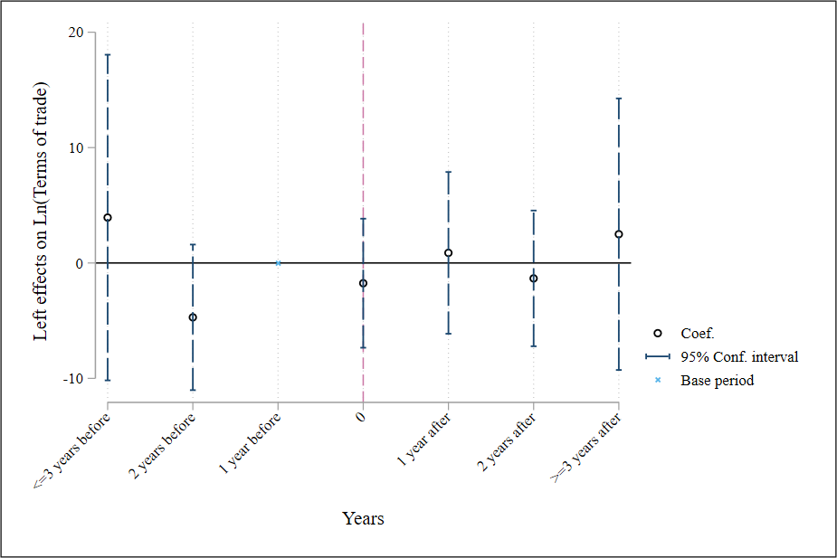
A17. Main results without controls
Table A12 shows our main results but without controlling by terms trade, trade to GDP and high to skilled workers ration. As shown in Table A12, the results remain unchanged.
Left dummy | Gini | Share of income top 10% | Income share middle deciles 4 to 7 | Share of income bottom 20% | Income share centile 90/Income share centile 10
OLS estimates | -0.0224** | -0.0474** | 0.0417** | 0.0761 | -0.104
 | (0.00834) | (0.0197) | (0.0187) | (0.0591) | (0.0748)
GMM estimation | -0.00543** | -0.0134* | 0.0113* | 0.0231** | -0.0337**
 | (0.00253) | (0.00711) | (0.00584) | (0.0111) | (0.0141)
Note: Standard errors are clustered at country level. The regression only includes country and years fixed effects.

Table A12. Main results without controls

A18. Descriptive statistics
Table A13 shows the mean, and standard deviation of our main outcome variables for treated and control groups.
Variable | Full sample
 | Non-Left  Mean¹ | Left  Mean
Gini coefficient⁴ | 0.530 | 0.491
 | [0.003] | [0.003]
Income share of the bottom 20% ⁴ | 3.269 | 4.007
 | [0.078] | [0.064]
Income share of the middle deciles 4, 5, 6 & 7 ⁴ | 24.816 | 26.835
 | [0.155] | [0.178]
Income share of the top 10% ⁴ | 41.121 | 37.652
 | [0.266] | [0.319]
Extreme income ratio 90/10 | 12.986 | 10.619
 | [0.403] | [0.318]
Total tax revenues as % of GDP | 15.845 | 18.936
 | [0.295] | [0.355]
Total tax revenues on rents, income, profits and capital gains as % of GDP | 4.465 | 4.146
 | [0.111] | [0.110]
Real minimum Wage | 117.261 | 123.809
 | [3.509] | [2.670]
Spending in Conditional cash transfers as % GDP | 0.220 | 0.295
 | [0.021] | [0.020]
Spending in Unconditional cash transfers as % GDP | 0.177 | 0.142
 | [0.027] | [0.015]
Spending in Social pensions as % GDP | 0.104 | 0.455
 | [0.016] | [0.031]
Significance levels: * < 10% ** < 5% *** < 1%.
Robust standard errors in brackets.
1 Left is defined as all countries eventually governed by the left
2 Non-Left governments are those countries who never were governed by the left between 1992 and 2017
3 Venezuela in 1999 is the first country with a left government. See Appendix Table XX.
4 The Gini coefficient and all the income shares were calculated using the per-capita income.
3 We calculate the mean for the period 1992-1998 for countries eventually governed by the left and for those countries who never were governed by the left.
Table A13. Descriptive statistics

