Mary Fran T. Malone, Fearing the “Nicas”: Perceptions of Immigrants and Policy Choices in Costa Rica. Latin American Politics and Society vol. 61, no. 1, Spring 2019.

Appendix

Figure A1: Total Population and Immigrant Population by Year

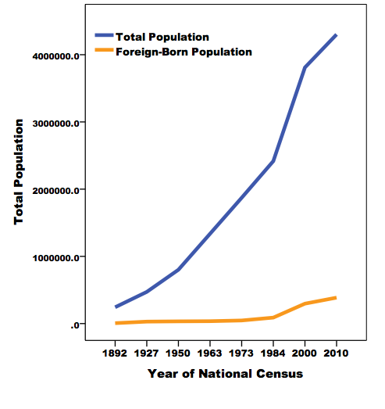

Figure A2: Trends in Central American Homicide Rates, 2000-2015

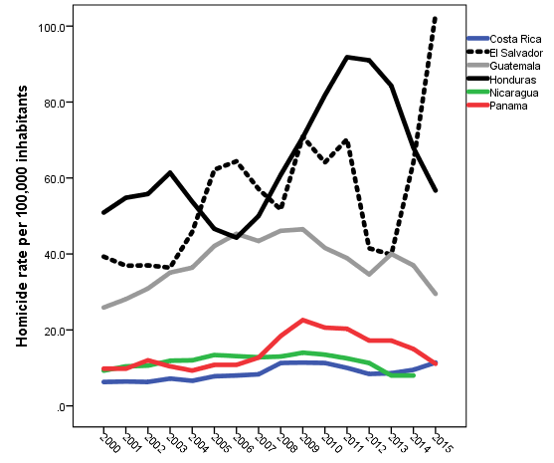

Table A1:
Pearson Correlation Coefficients among Measures of Perceptions of Immigrants

 | Immigrants Take Costa Rican Jobs | Immigrants Increase Crime | Immigrants Threaten Culture
Immigrants Take Costa Rican Jobs |  | .156** | .156**
Immigrants Increase Crime | .156** |  | .480**
Immigrants Threaten Culture | .156** | .480**
*significant at the .001 level for a two-tailed test

Table A2: Measuring the Independent Variables

 | Independent Variables | Recoded Measure  (if different from survey)
Crime | Victimization  VIC1EXT. Now, changing the subject, have you been a victim of any type of crime in the past 12 months? That is, have you been a victim of robbery, burglary, assault, fraud, blackmail, extortion, violent threats or any other type of crime in the past 12 months?  (1) Yes (2) No | (1) victim, (0) not victim
Fear of Crime
AOJ11. Speaking of the neighborhood where you live and thinking of the possibility of being assaulted or robbed, do you feel very safe, somewhat safe, somewhat unsafe or very unsafe? (1) Very safe (2) Somewhat safe (3) Somewhat unsafe (4) Very unsafe
 | Gang Activity in Neighborhood  AOJ17. To what extent do you think your neighborhood is affected by gangs? Would you say a lot, somewhat, a little or none?  (1) A lot (2) Somewhat (3) Little (4) None | (1) not at all – (4) a lot
Institutional Trust | Trust the Justice System Will Punish Guilty Party  AOJ12. If you were a victim of a robbery or assault how much faith do you have that the judicial system would punish the guilty?  (1) A lot (2) Some (3) Little (4) None | (1) not at all – (4) a great deal
Trust in Police
B18. To what extent do you trust the National Police?
(1) not at all – (7) a great deal
Media Exposure | Attention to News  GI0. About how often do you pay attention to the news, whether on TV, the radio, newspapers or the internet? [Read alternatives]: (1) Daily (2) A few times a week (3) A few times a month (4) Rarely (5) Never | (1) never – (5) daily
Ideology | Ideology  L1. Now, to change the subject.... On this card there is a 1-10 scale that goes from left to right. The number one means left and 10 means right. Nowadays, when we speak of political leanings, we talk of those on the left and those on the right. In other words, some people sympathize more with the left and others with the right. According to the meaning that the terms "left" and "right" have for you, and thinking of your own political leanings, where would you place yourself on this scale? Tell me the number.
Socioeconomic Indicators | Education  ED. How many years of schooling have you completed?
 | Income  To conclude, could you tell me if you have the following in your house: refrigerator; telephone; cell phone; car, motorcycle, computer; microwave oven; washing machine; drinking water; sewage system, internet service, TV, flat screen TV. Responses were coded as (1) yes and (0) no. I created an index of personal income using a means formula that included a case if there were valid responses to at least twelve of the fourteen items. | Number of consumer goods owned by respondents. The Cronbach’s alpha for this scale is .685.
 | Sex Q1. [Record but do not ask]: (1) Male (2) Female | Women = 0 Men = 1
 | Municipality Size  TAMANO. Size of place: (1) National Capital (Metropolitan area) (2) Large City (3) Medium City  (4) Small City (5) Rural Area | (1) rural, (2) small city, (3) medium city, (4) large city (5) capital
 | Age  Q2Y. In what year were you born?________ year | Age measured in cohorts: (1) 18-25, (2) 26-35, (3) 36-45, (4) 46-55 (5) 56-65 (6) 66 and over
 | Race and Ethnicity  ETID. Do you consider yourself white, mestizo, indigenous, black, mulatto, or of another race? [If respondent says Afro-country, mark (4) Black]  (1) White (2) Mestizo (3) Indigenous (4) Black  (5) Mulatto | Mestiza (1= mestiza; 0 = not mestiza)  Mulata  (1= mulata; 0 = not mulata)  Other  (1= black or indigenous; 0 = not black or indigenous)
Economic Perceptions | Pocketbook Evaluations  IDIO2. Do you think that your economic situation is better than, the same as, or worse than it  was 12 months ago?  (1) Better (2) Same (3) Worse | (1) worse, (2) same, (3) better
 | Sociotropic Evaluations  SOCT2. Do you think that the country’s current economic situation is better than, the same  as or worse than it was 12 months ago?  (1) Better (2) Same (3) Worse | (1) worse, (2) same, (3) better
Evaluations of Government | Government Effectiveness Index  N9. To what extent would you say the current administration combats (fights) government corruption?  N11. To what extent would you say the current administration improves citizen safety?  N15. To what extent would you say that the current administration is managing the economy well?  (1) not at all – (7) a lot | I created an index by adding respondents’ answers on these items together.  The Cronbach’s alpha for this scale is .786.
Personal Benefit from Government Program | Receive Government Assistance  WF1. Do you or someone in your household receive regular assistance in the form of money,  food, or products from the government, not including pensions/social security?  (1) Yes (2) No | (0) no, (1) yes
Ideology | Ideology  Now, to change the subject.... On this card there is a 1-10 scale that goes from left to right. The number  one means left and 10 means right. Nowadays, when we speak of political leanings, we talk of those on  the left and those on the right. In other words, some people sympathize more with the left and others with the right. According to the meaning that the terms "left" and "right" have for you, and thinking of your own political leanings, where would you place yourself on this scale? Tell me the number.

Table A3:
Correlations among Perceptions of Immigrants and Other Attitudes (LAPOP 2014)

 | Income | Salary Covers Household Expenditures | Quality of Life Better than Parents | People Are Trustworthy | Tolerance of Gay Individuals | Crime Victimization | Fear of Crime in Neighborhood | Crime in Neighborhood Better than Other Neighborhoods | Crime in Neighborhood Better Now than a Year Ago
Immigrants take Jobs from Costa Ricans | -.093** | -.088** | -.069** | -.062* | -.106** | -.007 | .047 | -.040 | -.015
Immigrants Increase Crime | .019 | -.009 | -.031 | -.020 | -.035 | .001 | .027 | .002 | -.037
Immigrants Threaten Culture | -.024 | -.035 | .048 | -.032 | -.060* | .011 | .107** | -.031 | -.038

*p<.05; **p<.01

Data from 2000-2013 are from the World Bank’s World Development Indicators. For 2014 and 2015, I relied upon data reported by Insight Crime (see Gagne 2016), and verified these data through official government agencies and independent think tanks.

