Jorge Mangonnet, Maria Victoria Murillo, and Julia Maria Rubio, Local Economic Voting and the Agricultural Boom in Argentina, 2007–2015. Latin American Politics and Society vol. 60, no. 3 (Fall 2018)

Supplementary Materials

Table of Contents
A. Additional Figures and Tables 2
Figure A1: Scatterplots of vote shares against soybean harvests, 2007-2015 2
Figure A2: Spatial distribution of the vote, 2007-2015 3
Figure A3: Moran’s I permutation tests 4
Figure A4: Moran scatterplot (dependent variables) 5
Figure A5: Moran scatterplot (residuals) 6
Table A1: Descriptive statistics (departmental level) 7
Table A2: Descriptive statistics (provincial level) 8
B. Robustness Checks: Alternative Measures 9
B1. Planted hectares 9
B2. Produced kilograms 12
B3. Yield per harvested hectare 15
C. Sensitivity Analysis 18
C1. Spatial lag 18
C2. Random intercepts 22
C3. Spatial fixed effects 26
D. Criteria for Classifying Appointees 30

Additional Figures and Tables

Figure A1: Scatterplots of vote shares against soybean harvests, 2007-2015
 | Panel A: Legislative vote
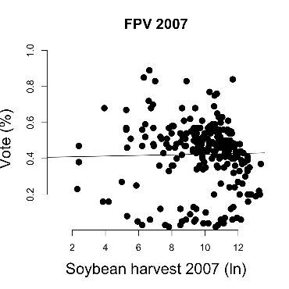 | 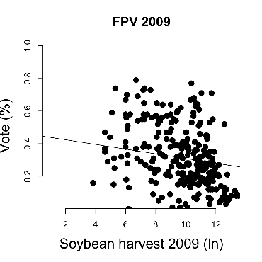 | 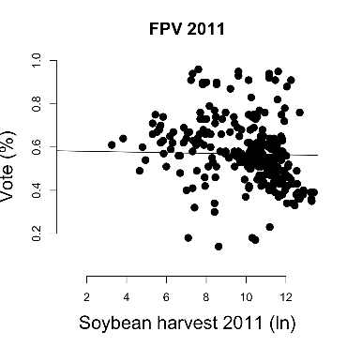
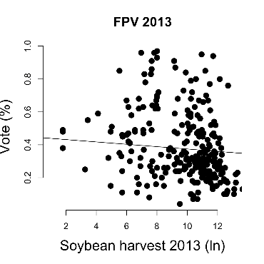 | 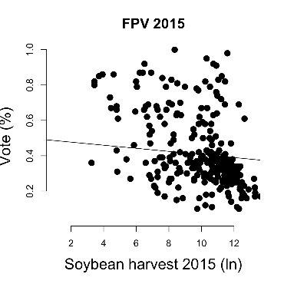
 | Panel B: Presidential vote
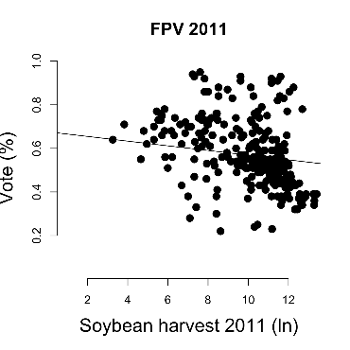 | 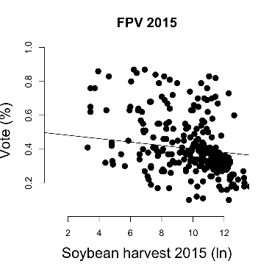 | 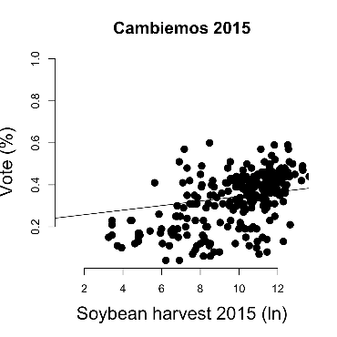

Figure A2: Spatial distribution of the vote, 2007-2015
 | Panel A: Legislative vote
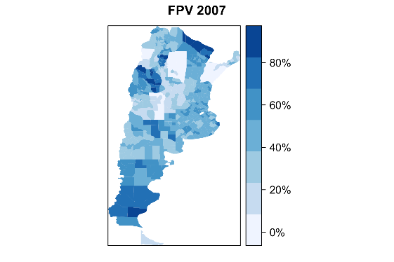 | 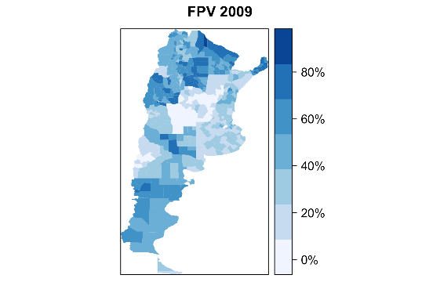 | 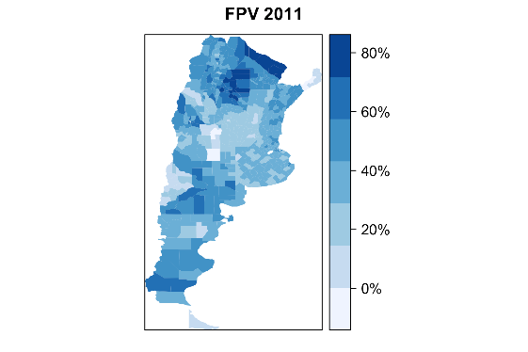
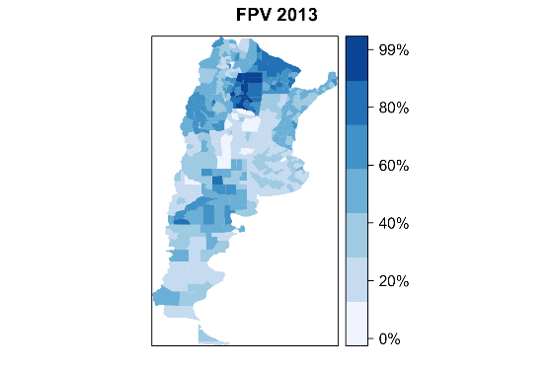 | 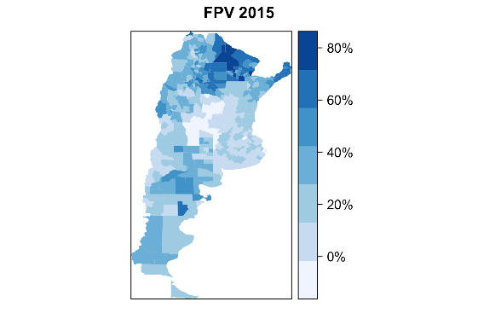
 | Panel B: Presidential vote
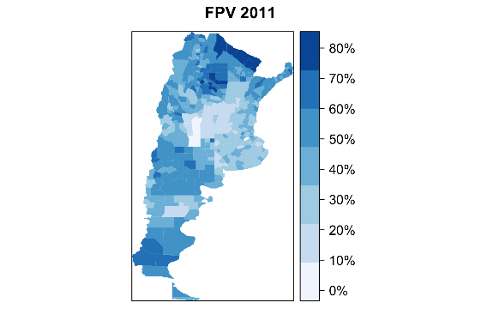 | 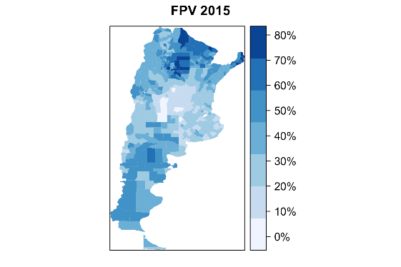

Figure A3: Moran’s I permutation tests
 | Panel A: Legislative vote
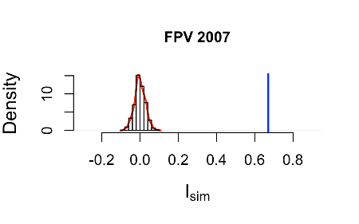 | 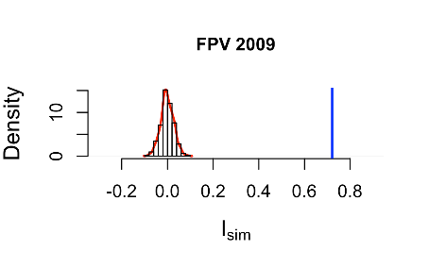 | 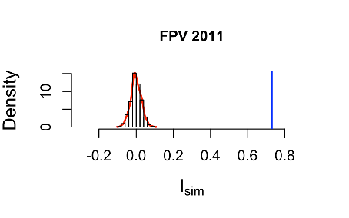
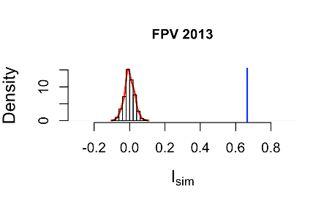 | 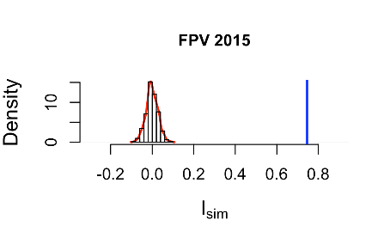
 | Panel B: Presidential vote
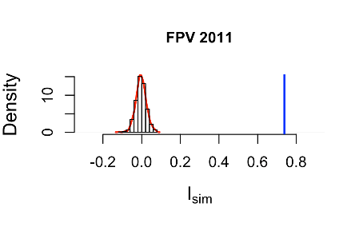 | 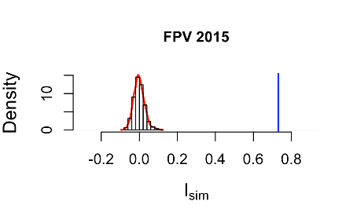 | 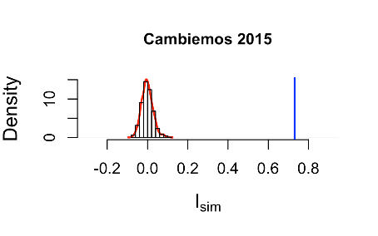
This figure displays the estimated permutation distribution of Moran’s I for the vote shares of the FPV and Cambiemos for each election. Given the spatial weighting scheme, this test considers all possible ways of reassigning the values to the spatial locations. The null hypothesis is that the data (i.e., vote shares) were assigned to their spatial locations (i.e., departments) at random. The alternative hypothesis is that assignment to each particular location depended on the assignment of that location’s neighbors. The histogram to the left shows the simulated I statistics for each of the 999 permutations. The blue vertical line indicates the actual value of the I statistic for the data as observed within the permutation distribution. The tests reject the null hypothesis of no spatial autocorrelation in the data (p < .001).

Figure A4: Moran scatterplot (dependent variables)
 | Panel A: Legislative vote
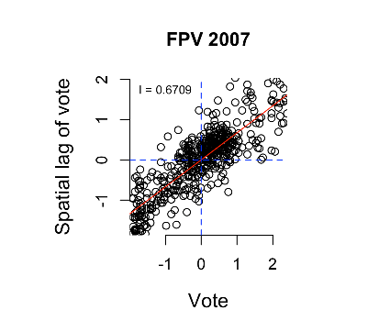 | 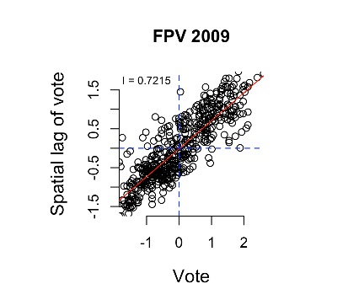 | 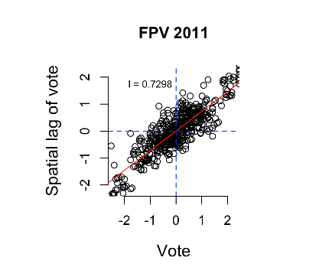
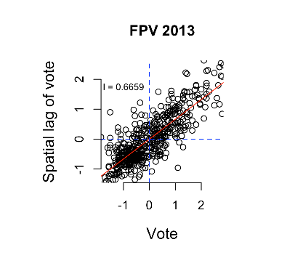 | 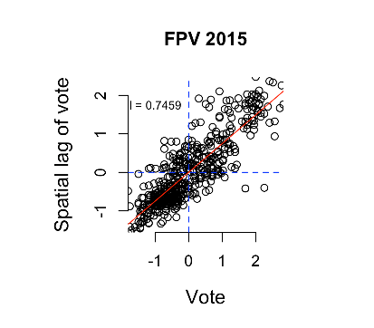
 | Panel B: Presidential vote
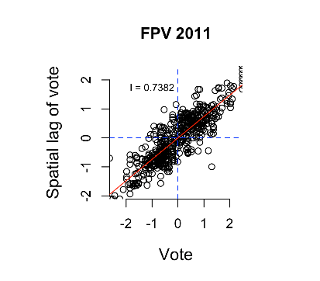 | 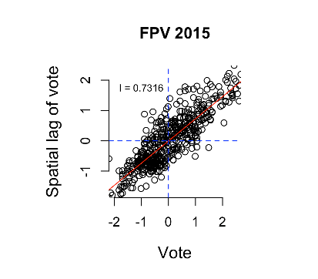 | 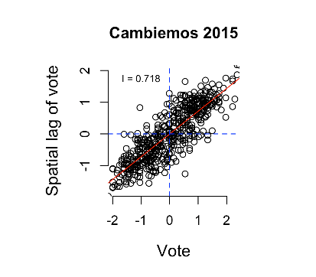
This figure shows Moran scaterplots between (a) the standardized values (z-scores) of vote shares for the FPV and Cambiemos in each election and (b) the standardized values of the spatially weighted, neighboring vote shares around the spatial unit (i.e. department) of interest. Positive slopes indicate positive spatial autocorrelation of the dependent variable. Spatial clustering of observations in the bottom-left and top-right corners of each plot indicate low-low and high-high autocorrelation.

Figure A5: Moran scatterplot (residuals)
 | Panel A: Legislative vote
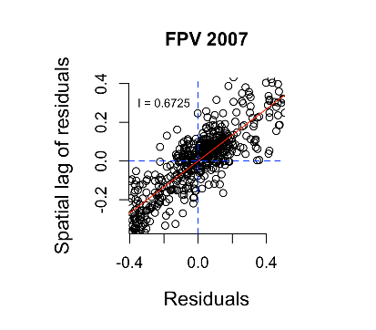 | 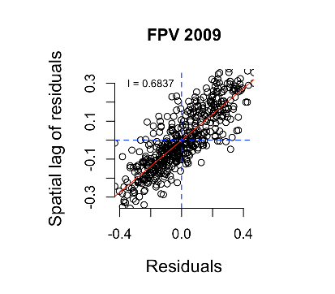 | 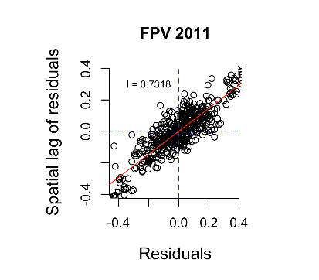
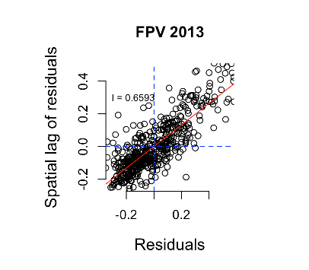 | 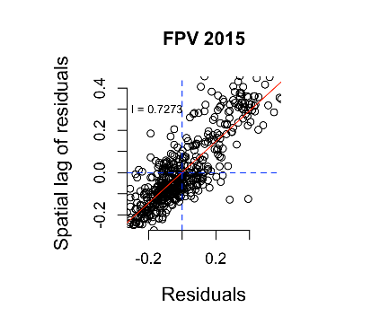
 | Panel B: Presidential vote
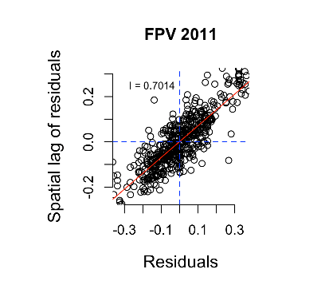 | 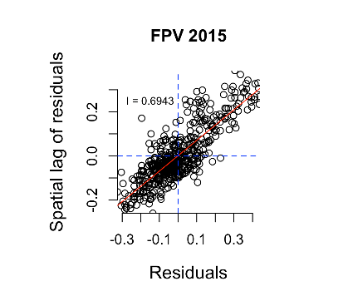 | 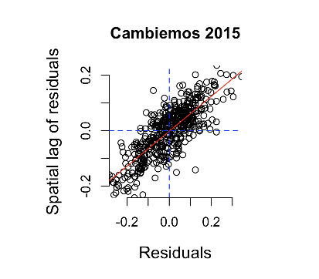
This figure shows Moran scaterplots between (a) the residuals of vote shares regressed on soybean harvests for the FPV and Cambiemos in each election and (b) the spatially weighted, neighboring residuals around the spatial unit (i.e. department) of interest. Positive slopes indicate positive spatial autocorrelation of the residuals. Spatial clustering of observations in the bottom-left and top-right corners of each plot indicate low-low and high-high autocorrelation.

Table A1: Descriptive statistics (departmental level)
Variable | N | Mean | St. Dev. | Min | Max
FPV legislative vote 2005 | 499 | 0.423 | 0.184 | 0.000 | 0.930
FPV legislative vote 2007 | 499 | 0.413 | 0.207 | 0.000 | 0.910
FPV legislative vote 2009 | 499 | 0.381 | 0.207 | 0.000 | 0.920
FPV legislative vote 2011 | 499 | 0.575 | 0.173 | 0.120 | 1.000
FPV legislative vote 2013 | 499 | 0.411 | 0.199 | 0.040 | 0.980
FPV legislative vote 2015 | 499 | 0.451 | 0.194 | 0.100 | 1.000
FPV presidential vote 2011 | 499 | 0.622 | 0.152 | 0.220 | 1.000
FPV presidential vote 2015 | 499 | 0.452 | 0.160 | 0.100 | 0.880
Cambiemos presidential vote 2015 | 499 | 0.292 | 0.126 | 0.020 | 0.600
Soybean harvest 2007 (ln) | 499 | 4.839 | 5.134 | 0.000 | 13.363
Soybean harvest 2009 (ln) | 499 | 4.991 | 5.071 | 0.000 | 13.508
Soybean harvest 2011 (ln) | 499 | 5.206 | 5.176 | 0.000 | 13.405
Soybean harvest 2013 (ln) | 499 | 5.096 | 5.183 | 0.000 | 13.642
Soybean harvest 2015 (ln) | 499 | 5.138 | 5.173 | 0.000 | 13.629
Soybean planted 2007 (ln) | 499 | 4.847 | 5.140 | 0.000 | 13.388
Soybean planted 2009 (ln) | 499 | 5.080 | 5.134 | 0.000 | 13.508
Soybean planted 2011 (ln) | 499 | 5.213 | 5.181 | 0.000 | 13.405
Soybean planted 2013 (ln) | 499 | 5.154 | 5.197 | 0.000 | 13.642
Soybean planted 2015 (ln) | 499 | 5.153 | 5.186 | 0.000 | 13.629
Soybean product 2007 (ln) | 499 | 5.290 | 5.597 | 0.000 | 14.638
Soybean product 2009 (ln) | 499 | 5.115 | 5.225 | 0.000 | 14.473
Soybean product 2011 (ln) | 499 | 5.640 | 5.592 | 0.000 | 14.637
Soybean product 2013 (ln) | 499 | 5.447 | 5.541 | 0.000 | 14.619
Soybean product 2015 (ln) | 499 | 5.653 | 5.663 | 0.000 | 14.751
Soybean yield 2007 (ln) | 499 | 3.857 | 3.921 | 0.000 | 8.243
Soybean yield 2009 (ln) | 499 | 3.677 | 3.607 | 0.000 | 8.460
Soybean yield 2011 (ln) | 499 | 4.062 | 3.874 | 0.000 | 8.330
Soybean yield 2013 (ln) | 499 | 3.938 | 3.809 | 0.000 | 8.339
Soybean yield 2015 (ln) | 499 | 4.129 | 3.953 | 0.000 | 8.469
Lockouts 2008 (ln) | 499 | 0.258 | 0.560 | 0.000 | 2.079
Agricultural capital | 499 | 0.212 | 0.244 | 0.000 | 1.000
Smallholding farms | 499 | 0.054 | 0.160 | 0.000 | 1.000
Education 2001 | 499 | 0.177 | 0.083 | 0.013 | 0.485
Education 2010 | 499 | 0.169 | 0.079 | 0.024 | 0.587
Poverty 2001 | 499 | 0.232 | 0.126 | 0.043 | 0.846
Poverty 2010 | 499 | 0.129 | 0.090 | 0.011 | 0.955
Farms (ln) | 499 | 5.999 | 1.255 | 0.000 | 8.843
Rural population 2001 | 499 | 0.350 | 0.298 | 0.000 | 1.000
Rural population 2010 | 499 | 0.313 | 0.288 | 0.000 | 1.000
Population density 2001 | 499 | 1.843 | 2.277 | -3.545 | 8.987
Population density 2010 | 499 | 2.203 | 9.217 | -3.126 | 9.217

Table A2: Descriptive statistics (provincial level)
Variable | N | Mean | St. Dev. | Min | Max
Provincial fiscal balance 2007 | 499 | 1.859 | 2.902 | -2.816 | 6.820
Provincial fiscal balance 2009 | 499 | 0.438 | 1.723 | -1.803 | 3.194
Provincial fiscal balance 2011 | 499 | 0.774 | 2.032 | -2.280 | 4.162
Provincial fiscal balance 2013 | 499 | 0.513 | 2.741 | -1.916 | 12.011
Provincial fiscal balance 2015 | 499 | -1.787 | 2.668 | -6.083 | 1.526
Aligned governor 2007 | 499 | 0.060 | 0.238 | 0 | 1
Aligned governor 2009 | 499 | 0.172 | 0.378 | 0 | 1

Robustness Checks: Alternative Measures

B1. Planted hectares
Table B1.1: Legislative vote and local wealth in Argentina, 2007-2009
 | FPV 2007 |  | FPV 2009
 | (1) | (2) | (3) | (4)
Soybean planted (ln) | 0.007*** | 0.005*** | -0.007*** | -0.007***
 | (0.002) | (0.002) | (0.002) | (0.002)
Lockouts 2008 (ln) |  |  |  | 0.005
 |  |  |  | (0.012)
Agricultural capital |  | 0.060 |  | -0.027
 |  | (0.039) |  | (0.036)
Smallholding farms |  | -0.028 |  | 0.063**
 |  | (0.032) |  | (0.030)
Lagged vote share | 0.479*** | 0.482*** | 0.349*** | 0.354***
 | (0.038) | (0.038) | (0.036) | (0.036)
Education | -0.388*** | -0.360** | -0.528*** | -0.552***
 | (0.143) | (0.144) | (0.134) | (0.135)
Poverty | -0.133 | -0.109 | 0.119 | 0.111
 | (0.096) | (0.097) | (0.089) | (0.091)
Farms (ln) | -0.013** | -0.013** | -0.004 | -0.005
 | (0.005) | (0.005) | (0.005) | (0.005)
Rural population | -0.023 | -0.024 | 0.031 | 0.027
 | (0.024) | (0.025) | (0.023) | (0.023)
Population density (ln) | -0.004 | -0.005 | 0.009* | 0.009*
 | (0.006) | (0.006) | (0.005) | (0.005)
Constant | 0.384*** | 0.372*** | 0.342*** | 0.350***
 | (0.063) | (0.063) | (0.059) | (0.059)
Observations | 499 | 499 | 499 | 499
Log Likelihood | 392.242 | 393.810 | 429.117 | 431.640
sigma² | 0.010 | 0.010 | 0.009 | 0.009
Akaike Inf. Crit. | -764.483 | -763.620 | -838.233 | -837.281
Wald Test (df = 1) | 1,288.167*** | 1,313.578*** | 968.029*** | 985.147***
LR Test (df = 1) | 451.217*** | 452.404*** | 338.932*** | 338.353***
Note: *p<0.10**p<0.05***p<0.01

Table B1.2: Legislative vote and local wealth in Argentina, 2011-2015
 | FPV 2011 |  | FPV 2013 |  | FPV 2015
 | (1) | (2) | (3) | (4) | (5) | (6)
Soybean planted (ln) | -0.002 | -0.0005 | -0.003 | -0.003 | -0.002 | -0.001
 | (0.001) | (0.002) | (0.002) | (0.002) | (0.001) | (0.002)
Lockouts 2008 (ln) |  | -0.009 |  | -0.022 |  | 0.010
 |  | (0.025) |  | (0.031) |  | (0.026)
Agricultural capital |  | -0.002 |  | -0.007 |  | -0.008
 |  | (0.010) |  | (0.012) |  | (0.010)
Smallholding farms |  | -0.077** |  | 0.020 |  | -0.012
 |  | (0.030) |  | (0.037) |  | (0.031)
Lagged FPV vote share | 0.356*** | 0.357*** | 0.596*** | 0.599*** | 0.497*** | 0.496***
 | (0.034) | (0.034) | (0.048) | (0.048) | (0.032) | (0.032)
Education | -0.218** | -0.225** | -0.411*** | -0.402*** | -0.398*** | -0.402***
 | (0.088) | (0.088) | (0.108) | (0.109) | (0.091) | (0.091)
Poverty | 0.121** | 0.116* | 0.078 | 0.079 | 0.142** | 0.135**
 | (0.060) | (0.060) | (0.075) | (0.075) | (0.062) | (0.062)
Farms (ln) | 0.010** | 0.011*** | -0.007 | -0.007 | 0.002 | 0.002
 | (0.004) | (0.004) | (0.005) | (0.005) | (0.004) | (0.004)
Rural population | -0.013 | -0.011 | 0.034 | 0.037 | 0.017 | 0.015
 | (0.018) | (0.018) | (0.022) | (0.023) | (0.019) | (0.019)
Population density (ln) | 0.002 | 0.003 | -0.002 | -0.002 | 0.004 | 0.004
 | (0.004) | (0.004) | (0.005) | (0.005) | (0.004) | (0.004)
Constant | 0.406*** | 0.406*** | 0.183*** | 0.177*** | 0.280*** | 0.283***
 | (0.045) | (0.045) | (0.053) | (0.054) | (0.041) | (0.041)
Observations | 499 | 499 | 499 | 499 | 499 | 499
Log Likelihood | 513.326 | 516.685 | 424.278 | 424.803 | 521.330 | 521.818
sigma² | 0.006 | 0.006 | 0.009 | 0.009 | 0.006 | 0.006
Akaike Inf. Crit. | -1,006.652 | -1,007.370 | -828.556 | -823.606 | -1,022.660 | -1,017.637
Wald Test (df = 1) | 1,452.519*** | 1,391.536*** | 528.565*** | 518.473*** | 343.786*** | 344.543***
LR Test (df = 1) | 506.721*** | 451.560*** | 246.909*** | 234.612*** | 210.025*** | 193.566***
Note: *p<0.10**p<0.05***p<0.01

Table B1.3: Presidential vote and local wealth in Argentina, 2011-2015
 | FPV 2011 |  | FPV 2015 |  | Cambiemos 2015
 | (1) | (2) | (3) | (4) | (5) |  | (6)
Soybean planted (ln) | -0.003*** | -0.001 | -0.001 | -0.001 | 0.005*** |  | 0.004***
 | (0.001) | (0.001) | (0.001) | (0.001) | (0.001) |  | (0.001)
Lockouts 2008 (ln) |  | -0.005 |  | -0.006 |  |  | 0.014*
 |  | (0.008) |  | (0.007) |  |  | (0.008)
Agricultural capital |  | -0.061*** |  | 0.023 |  |  | 0.077***
 |  | (0.022) |  | (0.021) |  |  | (0.025)
Smallholding farms |  | 0.018 |  | 0.008 |  |  | 0.023
 |  | (0.019) |  | (0.017) |  |  | (0.021)
Lagged FPV vote share | 0.453*** | 0.447*** | 0.657*** | 0.662***
 | (0.029) | (0.029) | (0.032) | (0.033)
Education | -0.220*** | -0.235*** | -0.331*** | -0.330*** | 0.329*** |  | 0.336***
 | (0.068) | (0.068) | (0.061) | (0.061) | (0.071) | (0.071)
Poverty | 0.153*** | 0.143*** | 0.064 | 0.063 | -0.207*** | -0.200***
 | (0.046) | (0.046) | (0.042) | (0.042) | (0.050) | (0.049)
Farms (ln) | -0.001 | -0.0001 | -0.003 | -0.003 | -0.003 | -0.005
 | (0.003) | (0.003) | (0.003) | (0.003) | (0.004) | (0.004)
Rural population | 0.011 | 0.010 | 0.050*** | 0.049*** | -0.018 | -0.020
 | (0.014) | (0.014) | (0.013) | (0.013) | (0.015) | (0.015)
Population density (ln) | 0.002 | 0.002 | -0.0001 | -0.001 | -0.002 | -0.003
 | (0.003) | (0.003) | (0.003) | (0.003) | (0.003) | (0.003)
Constant | 0.398*** | 0.405*** | 0.101*** | 0.097*** | 0.270*** | 0.268***
 | (0.034) | (0.034) | (0.033) | (0.033) | (0.030) | (0.030)
Observations | 499 | 499 | 499 | 499 | 499 | 499
Log Likelihood | 662.001 | 666.548 | 721.932 | 722.958 | 622.744 | 629.418
sigma² | 0.004 | 0.003 | 0.003 | 0.003 | 0.004 | 0.004
Akaike Inf. Crit. | -1,304.003 | -1,307.095 | -1,423.865 | -1,419.916 | -1,227.488 | -1,234.837
Wald Test (df = 1) | 531.192*** | 541.705*** | 383.833*** | 362.332*** | 563.415*** | 480.034***
LR Test (df = 1) | 271.720*** | 274.477*** | 225.345*** | 203.187*** | 236.718*** | 221.858***
Note: *p<0.10**p<0.05***p<0.01

B2. Produced kilograms

Table B2.1: Legislative vote and local wealth in Argentina, 2007-2009
 | FPV 2007 |  | FPV 2009
 | (1) | (2) | (3) | (4)
Soybean production (ln) | 0.006*** | 0.005*** | -0.007*** | -0.006***
 | (0.002) | (0.002) | (0.002) | (0.002)
Lockouts 2008 (ln) |  |  |  | 0.004
 |  |  |  | (0.012)
Agricultural capital |  | 0.060 |  | -0.034
 |  | (0.039) |  | (0.036)
Smallholding farms |  | -0.027 |  | 0.062**
 |  | (0.032) |  | (0.030)
Lagged vote share | 0.478*** | 0.482*** | 0.352*** | 0.357***
 | (0.038) | (0.038) | (0.036) | (0.036)
Education | -0.388*** | -0.360** | -0.513*** | -0.541***
 | (0.143) | (0.144) | (0.135) | (0.135)
Poverty | -0.132 | -0.109 | 0.122 | 0.112
 | (0.096) | (0.097) | (0.089) | (0.091)
Farms (ln) | -0.013** | -0.013** | -0.005 | -0.006
 | (0.005) | (0.005) | (0.005) | (0.005)
Rural population | -0.023 | -0.024 | 0.034 | 0.030
 | (0.024) | (0.025) | (0.023) | (0.023)
Population density (ln) | -0.004 | -0.005 | 0.009* | 0.009*
 | (0.006) | (0.006) | (0.005) | (0.005)
Constant | 0.384*** | 0.371*** | 0.335*** | 0.344***
 | (0.063) | (0.063) | (0.059) | (0.059)
Observations | 499 | 499 | 499 | 499
Log Likelihood | 392.372 | 393.967 | 428.559 | 431.189
sigma² | 0.010 | 0.010 | 0.009 | 0.009
Akaike Inf. Crit. | -764.744 | -763.934 | -837.117 | -836.377
Wald Test (df = 1) | 1,290.569*** | 1,315.558*** | 966.315*** | 982.813***
LR Test (df = 1) | 451.554*** | 452.746*** | 337.400*** | 336.969***
Note: *p<0.10**p<0.05***p<0.01

Table B2.2: Legislative vote and local wealth in Argentina, 2011-2015
 | FPV 2011 |  | FPV 2013 |  | FPV 2015
 | (1) | (2) | (3) | (4) | (5) | (6)
Soybean production (ln) | -0.002 | -0.0003 | -0.004** | -0.005*** | -0.002 | -0.001
 | (0.001) | (0.001) | (0.002) | (0.002) | (0.001) | (0.002)
Lockouts 2008 (ln) |  | -0.009 |  | -0.025 |  | 0.010
 |  | (0.025) |  | (0.031) |  | (0.026)
Agricultural capital |  | -0.002 |  | -0.006 |  | -0.008
 |  | (0.010) |  | (0.012) |  | (0.010)
Smallholding farms |  | -0.078** |  | 0.034 |  | -0.013
 |  | (0.030) |  | (0.037) |  | (0.031)
Lagged FPV vote share | 0.357*** | 0.358*** | 0.589*** | 0.594*** | 0.497*** | 0.496***
 | (0.034) | (0.034) | (0.048) | (0.048) | (0.032) | (0.032)
Education | -0.217** | -0.225** | -0.417*** | -0.403*** | -0.397*** | -0.402***
 | (0.088) | (0.088) | (0.108) | (0.108) | (0.091) | (0.091)
Poverty | 0.121** | 0.116* | 0.078 | 0.081 | 0.141** | 0.134**
 | (0.061) | (0.060) | (0.074) | (0.075) | (0.062) | (0.062)
Farms (ln) | 0.010** | 0.011*** | -0.006 | -0.006 | 0.001 | 0.002
 | (0.004) | (0.004) | (0.005) | (0.005) | (0.004) | (0.004)
Rural population | -0.013 | -0.011 | 0.034 | 0.037 | 0.017 | 0.016
 | (0.018) | (0.018) | (0.022) | (0.023) | (0.019) | (0.019)
Population density (ln) | 0.002 | 0.003 | -0.002 | -0.002 | 0.004 | 0.004
 | (0.004) | (0.004) | (0.005) | (0.005) | (0.004) | (0.004)
Constant | 0.406*** | 0.405*** | 0.189*** | 0.180*** | 0.280*** | 0.283***
 | (0.045) | (0.045) | (0.053) | (0.054) | (0.041) | (0.041)
Observations | 499 | 499 | 499 | 499 | 499 | 499
Log Likelihood | 513.241 | 516.669 | 426.009 | 426.854 | 521.229 | 521.753
sigma² | 0.006 | 0.006 | 0.009 | 0.009 | 0.006 | 0.006
Akaike Inf. Crit. | -1,006.482 | -1,007.338 | -832.017 | -827.707 | -1,022.457 | -1,017.506
Wald Test (df = 1) | 1,449.814*** | 1,388.830*** | 526.905*** | 517.393*** | 344.902*** | 345.905***
LR Test (df = 1) | 506.216*** | 452.566*** | 247.157*** | 234.767*** | 210.461*** | 194.761***
Note: *p<0.10**p<0.05***p<0.01

Table B2.3: Presidential vote and local wealth in Argentina, 2011-2015
 | FPV 2011 |  | FPV 2015 |  | Cambiemos 2015
 | (1) | (2) | (3) | (4) | (5) |  | (6)
Soybean production (ln) | -0.002*** | -0.001 | -0.001 | -0.001 | 0.005*** |  | 0.003***
 | (0.001) | (0.001) | (0.001) | (0.001) | (0.001) |  | (0.001)
Lockouts 2008 (ln) |  | -0.005 |  | -0.006 |  |  | 0.014*
 |  | (0.008) |  | (0.007) |  |  | (0.008)
Agricultural capital |  | -0.061*** |  | 0.023 |  |  | 0.079***
 |  | (0.022) |  | (0.021) |  |  | (0.025)
Smallholding farms |  | 0.018 |  | 0.008 |  |  | 0.022
 |  | (0.019) |  | (0.017) |  |  | (0.021)
Lagged FPV vote share | 0.454*** | 0.448*** | 0.657*** | 0.663***
 | (0.029) | (0.029) | (0.032) | (0.033)
Education | -0.219*** | -0.234*** | -0.330*** | -0.329*** | 0.326*** |  | 0.335***
 | (0.068) | (0.068) | (0.061) | (0.061) | (0.071) | (0.071)
Poverty | 0.154*** | 0.143*** | 0.063 | 0.062 | -0.206*** | -0.199***
 | (0.046) | (0.046) | (0.042) | (0.042) | (0.050) | (0.049)
Farms (ln) | -0.001 | -0.0001 | -0.003 | -0.003 | -0.003 | -0.005
 | (0.003) | (0.003) | (0.003) | (0.003) | (0.004) | (0.004)
Rural population (ln) | 0.011 | 0.010 | 0.051*** | 0.050*** | -0.019 | -0.020
 | (0.014) | (0.014) | (0.013) | (0.013) | (0.015) | (0.015)
Population density (ln) | 0.002 | 0.002 | -0.00005 | -0.0005 | -0.002 | -0.004
 | (0.003) | (0.003) | (0.003) | (0.003) | (0.003) | (0.003)
Constant | 0.397*** | 0.405*** | 0.101*** | 0.097*** | 0.270*** | 0.268***
 | (0.034) | (0.034) | (0.033) | (0.033) | (0.031) | (0.030)
Observations | 499 | 499 | 499 | 499 | 499 | 499
Log Likelihood | 661.837 | 666.477 | 721.855 | 722.863 | 621.656 | 628.754
sigma² | 0.004 | 0.003 | 0.003 | 0.003 | 0.004 | 0.004
Akaike Inf. Crit. | -1,303.673 | -1,306.954 | -1,423.711 | -1,419.725 | -1,225.312 | -1,233.507
Wald Test (df = 1) | 530.200*** | 541.011*** | 383.067*** | 361.671*** | 571.488*** | 483.633***
LR Test (df = 1) | 270.967*** | 273.812*** | 225.168*** | 202.984*** | 237.827*** | 222.285***
Note: *p<0.10**p<0.05***p<0.01

Table B3.1: Legislative vote and local wealth in Argentina, 2007-2009
 | FPV 2007 |  | FPV 2009
 | (1) | (2) | (3) | (4)
Soybean yield (ln) | 0.008*** | 0.007*** | -0.006*** | -0.005**
 | (0.002) | (0.002) | (0.002) | (0.002)
Lockouts 2008 (ln) |  |  |  | 0.004
 |  |  |  | (0.012)
Agricultural capital |  | 0.059 |  | -0.055
 |  | (0.039) |  | (0.035)
Smallholding farms |  | -0.028 |  | 0.064**
 |  | (0.032) |  | (0.030)
Lagged FPV vote share | 0.482*** | 0.485*** | 0.346*** | 0.353***
 | (0.038) | (0.038) | (0.036) | (0.036)
Education | -0.383*** | -0.355** | -0.508*** | -0.546***
 | (0.143) | (0.143) | (0.136) | (0.136)
Poverty | -0.136 | -0.113 | 0.124 | 0.104
 | (0.096) | (0.097) | (0.090) | (0.092)
Farms (ln) | -0.012** | -0.013** | -0.007 | -0.007
 | (0.005) | (0.005) | (0.005) | (0.005)
Rural population | -0.024 | -0.024 | 0.038* | 0.035
 | (0.024) | (0.025) | (0.023) | (0.023)
Population density (ln) | -0.004 | -0.005 | 0.009* | 0.010*
 | (0.006) | (0.006) | (0.005) | (0.005)
Constant | 0.380*** | 0.368*** | 0.337*** | 0.348***
 | (0.062) | (0.063) | (0.060) | (0.060)
Observations | 499 | 499 | 499 | 499
Log Likelihood | 393.398 | 395.041 | 424.072 | 427.616
sigma² | 0.010 | 0.010 | 0.009 | 0.009
Akaike Inf. Crit. | -766.796 | -766.083 | -828.144 | -829.232
Wald Test (df = 1) | 1,261.872*** | 1,290.283*** | 1,017.579*** | 1,014.563***
LR Test (df = 1) | 444.495*** | 445.492*** | 341.302*** | 340.864***
Note: *p<0.10**p<0.05***p<0.01

B3. Yield per harvested hectare
Table B3.2: Legislative vote and local wealth in Argentina, 2011-2015
 | FPV 2011 |  | FPV 2013 |  | FPV 2015
 | (1) | (2) | (3) | (4) | (5) | (6)
Soybean yield (ln) | -0.002 | -0.001 | -0.005** | -0.005** | -0.001 | -0.0003
 | (0.002) | (0.002) | (0.002) | (0.002) | (0.002) | (0.002)
Lockouts 2008 (ln) |  | -0.009 |  | -0.024 |  | 0.011
 |  | (0.025) |  | (0.031) |  | (0.026)
Agricultural capital |  | -0.002 |  | -0.007 |  | -0.009
 |  | (0.010) |  | (0.012) |  | (0.010)
Smallholding farms |  | -0.077*** |  | 0.030 |  | -0.021
 |  | (0.029) |  | (0.036) |  | (0.030)
Lagged FPV vote share | 0.358*** | 0.357*** | 0.591*** | 0.596*** | 0.499*** | 0.498***
 | (0.034) | (0.034) | (0.048) | (0.048) | (0.032) | (0.032)
Education | -0.217** | -0.226** | -0.415*** | -0.402*** | -0.392*** | -0.399***
 | (0.088) | (0.088) | (0.108) | (0.108) | (0.091) | (0.091)
Poverty | 0.121** | 0.116* | 0.079 | 0.082 | 0.141** | 0.132**
 | (0.061) | (0.060) | (0.074) | (0.075) | (0.062) | (0.062)
Farms (ln) | 0.009** | 0.011*** | -0.007 | -0.006 | 0.001 | 0.001
 | (0.004) | (0.004) | (0.005) | (0.005) | (0.004) | (0.004)
Rural population | -0.013 | -0.012 | 0.035 | 0.038* | 0.018 | 0.016
 | (0.018) | (0.018) | (0.022) | (0.023) | (0.019) | (0.019)
Population density (ln) | 0.002 | 0.003 | -0.002 | -0.002 | 0.004 | 0.004
 | (0.004) | (0.004) | (0.005) | (0.005) | (0.004) | (0.004)
Constant | 0.407*** | 0.406*** | 0.187*** | 0.179*** | 0.278*** | 0.282***
 | (0.045) | (0.045) | (0.053) | (0.054) | (0.041) | (0.041)
Observations | 499 | 499 | 499 | 499 | 499 | 499
Log Likelihood | 513.326 | 516.685 | 424.278 | 424.803 | 521.330 | 521.818
sigma² | 0.006 | 0.006 | 0.009 | 0.009 | 0.006 | 0.006
Akaike Inf. Crit. | -1,006.652 | -1,007.370 | -828.556 | -823.606 | -1,022.660 | -1,017.637
Wald Test (df = 1) | 1,452.519*** | 1,391.536*** | 528.565*** | 518.473*** | 343.786*** | 344.543***
LR Test (df = 1) | 506.721*** | 451.560*** | 246.909*** | 234.612*** | 210.025*** | 193.566***
Note: *p<0.10**p<0.05***p<0.01

Table B3.3: Presidential vote and local wealth in Argentina, 2011-2015
 | FPV 2011 |  | FPV 2015 |  | Cambiemos 2015
 | (1) | (2) | (3) | (4) | (5) |  | (6)
Soybean yield (ln) | -0.003*** | -0.002 | -0.001 | -0.001 | 0.004*** |  | 0.001
 | (0.001) | (0.001) | (0.001) | (0.001) | (0.001) |  | (0.001)
Lockouts 2008 (ln) |  | -0.005 |  | -0.007 |  |  | 0.016*
 |  | (0.008) |  | (0.007) |  |  | (0.008)
Agricultural capital |  | -0.061*** |  | 0.016 |  |  | 0.098***
 |  | (0.022) |  | (0.020) |  |  | (0.024)
Smallholding farms |  | 0.017 |  | 0.009 |  |  | 0.019
 |  | (0.019) |  | (0.017) |  |  | (0.021)
Lagged FPV vote share | 0.456*** | 0.447*** | 0.663*** | 0.667***
 | (0.029) | (0.029) | (0.032) | (0.033)
Education | -0.219*** | -0.236*** | -0.327*** | -0.327*** | 0.316*** |  | 0.333***
 | (0.068) | (0.068) | (0.061) | (0.061) | (0.072) | (0.071)
Poverty | 0.154*** | 0.145*** | 0.063 | 0.061 | -0.200*** | -0.193***
 | (0.046) | (0.046) | (0.042) | (0.042) | (0.050) | (0.050)
Farms (ln) | -0.002 | -0.0003 | -0.004 | -0.004 | -0.001 | -0.003
 | (0.003) | (0.003) | (0.003) | (0.003) | (0.004) | (0.004)
Rural population | 0.011 | 0.009 | 0.051*** | 0.050*** | -0.023 | -0.022
 | (0.014) | (0.014) | (0.013) | (0.013) | (0.015) | (0.015)
Population density (ln) | 0.002 | 0.003 | 0.00003 | -0.0003 | -0.003 | -0.004
 | (0.003) | (0.003) | (0.003) | (0.003) | (0.003) | (0.003)
Constant | 0.399*** | 0.407*** | 0.096*** | 0.094*** | 0.274*** | 0.269***
 | (0.034) | (0.034) | (0.033) | (0.033) | (0.031) | (0.030)
Observations | 499 | 499 | 499 | 499 | 499 | 499
Log Likelihood | 662.120 | 666.951 | 721.322 | 722.164 | 616.082 | 626.042
sigma² | 0.004 | 0.003 | 0.003 | 0.003 | 0.004 | 0.004
Akaike Inf. Crit. | -1,304.240 | -1,307.903 | -1,422.644 | -1,418.327 | -1,214.163 | -1,228.085
Wald Test (df = 1) | 545.130*** | 545.862*** | 381.610*** | 362.842*** | 672.692*** | 525.856***
LR Test (df = 1) | 274.599*** | 276.041*** | 224.456*** | 203.780*** | 259.355*** | 231.038***
Note: *p<0.10**p<0.05***p<0.01

Sensitivity Analysis

C1. Spatial lag

A spatial lag model incorporates spatial effects by including a spatially lagged dependent variable as a predictor. As in the manuscript’s empirics, we estimate the following equation:

$$y_{i}=α+y_{i}W_{i}ρ+{Harvest}_{i}β+{Lockouts}_{i}γ+X_{i}δ+ε_{i},$$

where $y_{i, }$ is the vote share for the FPV or Cambiemos in a given department $i$; ${Harvest}_{i}$ is the log of the number of soybean harvested hectares; ${Lockouts}_{i}$ is the logged number of departmental lockouts occurring in 2008; $X_{i}$ denotes a matrix of agricultural-related variables (capital intensity and smallholding farms) and controls, which includes lagged vote shares and sociodemographic covariates; and $ε_{i}$ is the error term.
In this specification, ${y_{i}W}_{i}$ is the vector of the dependent variable $y_{i }$ weighted by $W_{i}$, which is a matrix of spatial weights specifying the degree of interdependence among observations.

Table C1.1: Legislative vote and local wealth in Argentina, 2007-2009
 | FPV 2007 |  | FPV 2009
 | (1) | (2) | (3) | (4)
Soybean harvest (ln) | 0.004*** | 0.004*** | -0.003*** | -0.003**
 | (0.001) | (0.001) | (0.001) | (0.001)
Lockouts 2008 (ln) |  |  |  | 0.001
 |  |  |  | (0.010)
Agricultural capital |  | 0.020 |  | 0.007
 |  | (0.030) |  | (0.026)
Smallholding farms |  | 0.004 |  | 0.061**
 |  | (0.034) |  | (0.031)
Lagged FPV vote share | 0.301*** | 0.303*** | 0.209*** | 0.209***
 | (0.031) | (0.031) | (0.024) | (0.024)
Education | -0.412*** | -0.396*** | -0.500*** | -0.491***
 | (0.124) | (0.126) | (0.112) | (0.116)
Poverty | -0.183*** | -0.167** | 0.078 | 0.096
 | (0.065) | (0.069) | (0.060) | (0.069)
Farms (ln) | -0.014*** | -0.014*** | -0.002 | -0.002
 | (0.005) | (0.005) | (0.004) | (0.004)
Rural population | 0.014 | 0.014 | 0.053** | 0.046**
 | (0.025) | (0.025) | (0.023) | (0.023)
Population density (ln) | 0.002 | 0.001 | 0.009*** | 0.007**
 | (0.003) | (0.003) | (0.003) | (0.003)
Constant | 0.134*** | 0.128** | 0.087* | 0.082*
 | (0.049) | (0.050) | (0.046) | (0.048)
Observations | 499 | 499 | 499 | 499
Log Likelihood | 364.250 | 364.478 | 421.684 | 423.610
sigma² | 0.012 | 0.012 | 0.010 | 0.009
Akaike Inf. Crit. | -708.499 | -704.955 | -823.368 | -821.221
Wald Test (df = 1) | 813.838*** | 813.948*** | 526.639*** | 522.443***
LR Test (df = 1) | 395.257*** | 393.759*** | 322.967*** | 321.278***
Note: *p<0.10**p<0.05***p<0.01

Table C1.2: Legislative vote and local wealth in Argentina, 2011-2015
 | FPV 2011 |  | FPV 2013 |  | FPV 2015
 | (1) | (2) | (3) | (4) | (5) | (6)
Soybean harvest (ln) | 0.001 | 0.003*** | -0.002** | -0.004*** | -0.001 | -0.003**
 | (0.001) | (0.001) | (0.001) | (0.001) | (0.001) | (0.001)
Lockouts 2008 (ln) |  | -0.006 |  | 0.019 |  | 0.008
 |  | (0.028) |  | (0.033) |  | (0.026)
Agricultural capital |  | 0.017** |  | -0.008 |  | 0.001
 |  | (0.008) |  | (0.010) |  | (0.008)
Smallholding farms |  | -0.084*** |  | 0.081*** |  | 0.063***
 |  | (0.023) |  | (0.028) |  | (0.022)
Lagged FPV vote share | 0.157*** | 0.167*** | 0.319*** | 0.347*** | 0.383*** | 0.392***
 | (0.026) | (0.026) | (0.036) | (0.036) | (0.029) | (0.029)
Education | -0.159* | -0.169** | -0.522*** | -0.496*** | -0.290*** | -0.274***
 | (0.085) | (0.085) | (0.100) | (0.100) | (0.084) | (0.084)
Poverty | 0.059 | 0.054 | 0.001 | 0.015 | 0.111** | 0.145***
 | (0.057) | (0.059) | (0.067) | (0.069) | (0.055) | (0.056)
Farms (ln) | -0.003 | -0.001 | -0.0003 | -0.002 | -0.002 | -0.003
 | (0.004) | (0.004) | (0.004) | (0.004) | (0.004) | (0.004)
Rural population | -0.007 | -0.010 | 0.035 | 0.040* | 0.022 | 0.027
 | (0.020) | (0.020) | (0.024) | (0.024) | (0.019) | (0.019)
Population density (ln) | -0.001 | 0.0003 | 0.004 | 0.003 | 0.004* | 0.003
 | (0.002) | (0.003) | (0.003) | (0.003) | (0.002) | (0.002)
Constant | 0.110*** | 0.115*** | 0.069 | 0.052 | 0.101*** | 0.095**
 | (0.039) | (0.040) | (0.047) | (0.048) | (0.037) | (0.037)
Observations | 499 | 499 | 499 | 499 | 499 | 499
Log Likelihood | 463.969 | 471.265 | 400.701 | 404.892 | 515.937 | 520.224
sigma² | 0.008 | 0.008 | 0.011 | 0.011 | 0.007 | 0.007
Akaike Inf. Crit. | -907.939 | -916.531 | -781.403 | -783.783 | -1,011.874 | -1,014.448
Wald Test (df = 1) | 720.431*** | 601.730*** | 266.410*** | 259.250*** | 224.007*** | 213.619***
LR Test (df = 1) | 407.987*** | 360.748*** | 197.501*** | 191.943*** | 199.215*** | 190.353***
Note: *p<0.10**p<0.05***p<0.01

Table C1.3: Presidential vote and local wealth in Argentina, 2011-2015
 | FPV 2011 |  | FPV 2015 |  | Cambiemos 2015
 | (1) | (2) | (3) | (4) | (5) |  | (6)
Soybean harvest (ln) | -0.001* | -0.001* | 0.001 | -0.0004 | 0.003*** |  | 0.002*
 | (0.001) | (0.001) | (0.001) | (0.001) | (0.001) |  | (0.001)
Lockouts 2008 (ln) |  | 0.008 |  | -0.006 |  |  | 0.005
 |  | (0.006) |  | (0.006) |  |  | (0.006)
Agricultural capital |  | -0.018 |  | 0.060*** |  |  | 0.040**
 |  | (0.018) |  | (0.016) |  |  | (0.017)
Smallholding farms |  | -0.017 |  | 0.029 |  |  | 0.009
 |  | (0.021) |  | (0.019) |  |  | (0.021)
Lagged FPV vote share | 0.292*** | 0.290*** | 0.509*** | 0.532***
 | (0.026) | (0.026) | (0.031) | (0.031)
Education | -0.241*** | -0.244*** | -0.375*** | -0.357*** | 0.244*** |  | 0.257***
 | (0.065) | (0.065) | (0.059) | (0.058) | (0.061) | (0.061)
Poverty | 0.137*** | 0.144*** | -0.029 | -0.017 | -0.196*** | -0.177***
 | (0.046) | (0.047) | (0.041) | (0.042) | (0.043) | (0.044)
Farms (ln) | -0.005* | -0.005 | -0.004 | -0.005** | 0.003 | 0.002
 | (0.003) | (0.003) | (0.003) | (0.003) | (0.003) | (0.003)
Rural population | -0.012 | -0.011 | 0.058*** | 0.059*** | -0.019 | -0.015
 | (0.016) | (0.016) | (0.014) | (0.014) | (0.015) | (0.015)
Population density (ln) | -0.001 | -0.0004 | 0.003** | 0.002 | -0.0002 | -0.0005
 | (0.002) | (0.002) | (0.002) | (0.002) | (0.002) | (0.002)
Constant | 0.208*** | 0.206*** | 0.011 | -0.001 | 0.060** | 0.058**
 | (0.033) | (0.034) | (0.030) | (0.030) | (0.028) | (0.028)
Observations | 499 | 499 | 499 | 499 | 499 | 499
Log Likelihood | 619.744 | 621.175 | 684.249 | 692.507 | 627.310 | 630.599
sigma² | 0.005 | 0.005 | 0.004 | 0.004 | 0.004 | 0.004
Akaike Inf. Crit. | -1,219.488 | -1,216.350 | -1,348.497 | -1,359.014 | -1,236.621 | -1,237.197
Wald Test (df = 1) | 216.298*** | 210.637*** | 161.462*** | 153.300*** | 363.376*** | 317.964***
LR Test (df = 1) | 187.239*** | 183.750*** | 149.953*** | 142.210*** | 246.036*** | 224.354***
Note: *p<0.10**p<0.05***p<0.01

C2. Random intercepts

Political and economic factors at the provincial level could also be driving voters’ decisions to either support or punish national incumbents in Argentina. Variations in patterns of electoral support at particular levels of departmental soybean wealth could be the result of differences between provinces. We fit hierarchical regressions in which departments are nested into provinces. We estimate varying-intercept models that allow intercepts to vary by province in order to capture group-level differences.
We also include two variables that allow us to explore the influence of the provincial context on local electoral behavior: (i) whether the governor is not a member or an ally of the FPV; and (ii) the fiscal balance of the provincial treasury. Voters supporting governors who oppose the president in office might as well vote against the national government (see Calvo and Escolar 2005). Moreover, as the scholarship on fiscal federalism suggests (e.g. Wibbels 2005), voters judge national incumbents for the province’s fiscal situation. In fiscally centralized polities such as Argentina, worsening balances may encourage citizens to cast a vote against the president in office.
We estimate the following equation:

$$y_{ij}=α_{j}+{Harvest}_{ij}β+{Lockouts}_{i}γ+X_{ij}δ+{Fiscal}_{j}+{Align}_{j}+ε_{ij},$$

where $α_{j}$ is the random intercept for a department $i$ in province $j$; ${Fiscal}_{j}$ is the annual percent change in a province’s fiscal balance; and ${Align}_{j}$ is a dummy variable indicating whether the governor is aligned with the president. Moreover, $α_{ij}$ is modeled as:

$$α_{ij}=α+{Fiscal}_{j}+{Align}_{j}+η_{j},$$

with $η_{j}$ being the error term for province $j$.

Table C2.1: Legislative vote and local wealth in Argentina, 2007-2009
 | FPV 2007 |  | FPV 2009
 | (1) | (2) | (3) | (4)
Soybean harvest (ln) | 0.002* | 0.002* | -0.002** | -0.002**
 | (0.001) | (0.001) | (0.001) | (0.001)
Lockouts 2008 (ln) |  |  | -0.012 | -0.013
 |  |  | (0.009) | (0.009)
Agricultural capital | -0.021 | -0.021 | -0.030 | -0.031
 | (0.024) | (0.024) | (0.023) | (0.023)
Smallholding farms | -0.048** | -0.048** | 0.054** | 0.053**
 | (0.023) | (0.023) | (0.023) | (0.023)
Provincial fiscal balance |  | 0.003 |  | -0.035
 |  | (0.028) |  | (0.028)
Aligned governor |  | -0.166 |  | -0.192***
 |  | (0.129) |  | (0.072)
Lagged FPV vote share | 0.329*** | 0.327*** | 0.401*** | 0.382***
 | (0.037) | (0.037) | (0.041) | (0.041)
Education | -0.287*** | -0.282*** | -0.301*** | -0.302***
 | (0.101) | (0.101) | (0.101) | (0.101)
Poverty | 0.035 | 0.037 | 0.175*** | 0.178***
 | (0.065) | (0.065) | (0.065) | (0.065)
Farms (ln) | -0.004 | -0.004 | -0.001 | -0.001
 | (0.004) | (0.004) | (0.004) | (0.004)
Rural population | 0.006 | 0.006 | 0.028 | 0.030
 | (0.019) | (0.019) | (0.019) | (0.019)
Population density (ln) | 0.002 | 0.002 | 0.007** | 0.007**
 | (0.003) | (0.003) | (0.003) | (0.003)
Constant | 0.320*** | 0.340*** | 0.247*** | 0.287***
 | (0.060) | (0.064) | (0.055) | (0.056)
Observations | 499 | 499 | 499 | 499
Log Likelihood | 529.564 | 526.693 | 535.405 | 534.451
Akaike Inf. Crit. | -1,035.129 | -1,025.386 | -1,044.810 | -1,038.903
Bayesian Inf. Crit. | -984.577 | -966.409 | -990.046 | -975.713
Note: *p<0.10**p<0.05***p<0.01

Table C2.2: Legislative vote and local wealth in Argentina, 2011-2015
 | FPV 2011 |  | FPV 2013 |  | FPV 2015
 | (1) | (2) | (3) | (4) | (5) | (6)
Soybean harvest (ln) | 0.0003 | 0.0002 | -0.002 | -0.002 | 0.003** | 0.003**
 | (0.001) | (0.001) | (0.001) | (0.001) | (0.001) | (0.001)
Lockouts 2008 (ln) | -0.005 | -0.005 | -0.004 | -0.005 | -0.008 | -0.007
 | (0.009) | (0.009) | (0.010) | (0.010) | (0.010) | (0.010)
Agricultural capital | -0.090*** | -0.090*** | 0.025 | 0.025 | -0.065*** | -0.065***
 | (0.021) | (0.021) | (0.024) | (0.024) | (0.024) | (0.024)
Smallholding farms | -0.015 | -0.015 | -0.005 | -0.005 | 0.005 | 0.005
 | (0.021) | (0.021) | (0.024) | (0.024) | (0.024) | (0.024)
Provincial fiscal balance |  | 0.008 |  | 0.001 |  | 0.023*
 |  | (0.031) |  | (0.008) |  | (0.013)
Aligned governor |  | 0.044 |  | -0.151** |  | -0.074
 |  | (0.090) |  | (0.062) |  | (0.054)
Lagged FPV vote share | 0.416*** | 0.418*** | 0.490*** | 0.486*** | 0.529*** | 0.516***
 | (0.038) | (0.038) | (0.045) | (0.045) | (0.041) | (0.041)
Education | -0.229*** | -0.229*** | -0.267*** | -0.261*** | -0.344*** | -0.350***
 | (0.076) | (0.076) | (0.085) | (0.085) | (0.087) | (0.087)
Poverty | 0.156*** | 0.156*** | 0.005 | 0.005 | 0.179*** | 0.175***
 | (0.050) | (0.050) | (0.057) | (0.057) | (0.057) | (0.057)
Farms (ln) | 0.009*** | 0.009*** | -0.005 | -0.005 | -0.004 | -0.004
 | (0.003) | (0.003) | (0.004) | (0.004) | (0.004) | (0.004)
Rural population | -0.034** | -0.034** | 0.054*** | 0.054*** | 0.005 | 0.006
 | (0.017) | (0.017) | (0.018) | (0.018) | (0.019) | (0.019)
Population density (ln) | 0.004 | 0.004 | -0.001 | -0.001 | 0.004 | 0.004
 | (0.003) | (0.003) | (0.003) | (0.003) | (0.003) | (0.003)
Constant | 0.380*** | 0.373*** | 0.213*** | 0.244*** | 0.301*** | 0.335***
 | (0.048) | (0.053) | (0.051) | (0.052) | (0.046) | (0.049)
Observations | 499 | 499 | 499 | 499 | 499 | 499
Log Likelihood | 574.127 | 570.138 | 521.046 | 518.153 | 517.317 | 513.813
Akaike Inf. Crit. | -1,122.253 | -1,110.276 | -1,016.091 | -1,006.307 | -1,008.633 | -997.626
Bayesian Inf. Crit. | -1,067.489 | -1,047.087 | -961.327 | -943.118 | -953.869 | -934.436
Note: *p<0.10**p<0.05***p<0.01

Table C2.3: Presidential vote and local wealth in Argentina, 2011-2015
 | FPV 2011 |  | FPV 2015 |  | Cambiemos 2015
 | (1) | (2) | (3) | (4) | (5) |  | (6)
Soybean harvest (ln) | -0.002 | -0.001 | 0.0003 | 0.0003 | 0.003*** |  | 0.003***
 | (0.001) | (0.001) | (0.001) | (0.001) | (0.001) |  | (0.001)
Lockouts 2008 (ln) | -0.004 | -0.004 | -0.006 | -0.006 | 0.022*** |  | 0.021***
 | (0.007) | (0.007) | (0.007) | (0.007) | (0.008) |  | (0.008)
Agricultural capital | -0.069*** | -0.070*** | 0.006 | 0.005 | 0.093*** |  | 0.093***
 | (0.018) | (0.018) | (0.017) | (0.017) | (0.019) |  | (0.019)
Smallholding farms | -0.005 | 0.005 | 0.016 | 0.016 | 0.020 |  | 0.020
 | (0.018) | (0.018) | (0.017) | (0.017) | (0.020) |  | (0.020)
Provincial fiscal balance |  | -0.015 |  | 0.013 |  |  | -0.024**
 |  | (0.016) |  | (0.008) |  |  | (0.009)
Aligned governor |  | -0.033 |  | -0.039 |  |  | 0.060
 |  | (0.047) |  | (0.033) |  |  | (0.038)
Lagged FPV vote share | 0.486*** | 0.481*** | 0.624*** | 0.615***
 | (0.033) | (0.033) | (0.035) | (0.035)
Education | -0.229*** | -0.233*** | -0.352*** | -0.356*** | 0.425*** |  | 0.422***
 | (0.066) | (0.066) | (0.061) | (0.062) | (0.069) | (0.069)
Poverty | 0.169*** | 0.167*** | 0.080* | 0.078* | -0.234*** | -0.229***
 | (0.043) | (0.043) | (0.041) | (0.041) | (0.046) | (0.046)
Farms (ln) | 0.003 | 0.003 | -0.005 | -0.005 | -0.007** | -0.007**
 | (0.003) | (0.003) | (0.003) | (0.003) | (0.003) | (0.003)
Rural population | 0.0003 | 0.001 | 0.053*** | 0.053*** | -0.024 | -0.024
 | (0.014) | (0.014) | (0.013) | (0.013) | (0.015) | (0.015)
Population density (ln) | 0.005** | 0.005** | 0.001 | 0.001 | -0.009*** | -0.009***
 | (0.002) | (0.002) | (0.002) | (0.002) | (0.002) | (0.002)
Constant | 0.366*** | 0.373*** | 0.126*** | 0.147*** | 0.254*** | 0.228***
 | (0.038) | (0.040) | (0.036) | (0.038) | (0.033) | (0.034)
Observations | 499 | 499 | 499 | 499 | 499 | 499
Log Likelihood | 656.259 | 651.390 | 692.814 | 687.934 | 621.336 | 618.590
Akaike Inf. Crit. | -1,286.519 | -1,272.781 | -1,359.627 | -1,345.868 | -1,218.673 | -1,209.179
Bayesian Inf. Crit. | -1,231.755 | -1,209.592 | -1,304.864 | -1,282.679 | -1,168.122 | -1,150.203
Note: *p<0.10**p<0.05***p<0.01

C3. Spatial fixed effects

We fit a regression model with spatial fixed effects—at the group level, or province—and Huber-White robust standard errors to correct for heteroscedasticity. We estimate the following equation:

$$y_{i}=α+{Harvest}_{i}β+{Lockouts}_{i}γ+X_{i}δ+θ_{j}+ε_{i},$$

where $θ_{j}$ are spatial dummies for each province $j$.

Table C3.1: Legislative vote and local wealth in Argentina, 2007-2009
 | FPV 2007 |  | FPV 2009
 | (1) | (2) | (3) | (4)
Soybean harvest (ln) | 0.002* | 0.002* | -0.003*** | -0.002*
 | (0.001) | (0.001) | (0.001) | (0.001)
Lockouts 2008 (ln) |  |  |  | -0.013
 |  |  |  | (0.010)
Agricultural capital |  | -0.021 |  | -0.032
 |  | (0.024) |  | (0.023)
Smallholding farms |  | -0.049** |  | 0.052**
 |  | (0.023) |  | (0.023)
Lagged FPV vote share | 0.321*** | 0.316*** | 0.395*** | 0.395***
 | (0.037) | (0.037) | (0.043) | (0.043)
Education | -0.280*** | -0.288*** | -0.291*** | -0.291***
 | (0.101) | (0.101) | (0.101) | (0.102)
Poverty | 0.057 | 0.039 | 0.200*** | 0.168**
 | (0.064) | (0.066) | (0.063) | (0.065)
Farms (ln) | -0.003 | -0.003 | -0.004 | -0.001
 | (0.004) | (0.004) | (0.004) | (0.004)
Rural population | -0.0004 | 0.006 | 0.033* | 0.030
 | (0.018) | (0.019) | (0.018) | (0.019)
Population density (ln) | 0.001 | 0.002 | 0.009*** | 0.007**
 | (0.003) | (0.003) | (0.003) | (0.003)
Constant | 0.408*** | 0.415*** | 0.133*** | 0.139***
 | (0.041) | (0.042) | (0.044) | (0.045)
Fixed Effects | YES | YES | YES | YES
Observations | 499 | 499 | 499 | 499
R² | 0.889 | 0.890 | 0.890 | 0.892
Adjusted R² | 0.882 | 0.883 | 0.883 | 0.885
Residual Std. Error | 0.071  (df = 469) | 0.071  (df = 467) | 0.071  (df = 469) | 0.070  (df = 466)
Note: *p<0.10**p<0.05***p<0.01

Table C3.2: Legislative vote and local wealth in Argentina, 2011-2015
 | FPV 2011 |  | FPV 2013 |  | FPV 2015
 | (1) | (2) | (3) | (4) | (5) | (6)
Soybean harvest (ln) | -0.002** | 0.0001 | -0.001 | -0.002 | 0.002 | 0.004***
 | (0.001) | (0.001) | (0.001) | (0.001) | (0.001) | (0.001)
Lockouts 2008 (ln) |  | -0.015 |  | -0.006 |  | 0.005
 |  | (0.021) |  | (0.024) |  | (0.024)
Agricultural capital |  | -0.005 |  | -0.004 |  | -0.008
 |  | (0.009) |  | (0.010) |  | (0.010)
Smallholding farms |  | -0.087*** |  | 0.022 |  | -0.074***
 |  | (0.021) |  | (0.024) |  | (0.024)
Lagged FPV vote share | 0.434*** | 0.415*** | 0.476*** | 0.483*** | 0.519*** | 0.510***
 | (0.038) | (0.038) | (0.046) | (0.047) | (0.043) | (0.043)
Education | -0.240*** | -0.229*** | -0.246*** | -0.240*** | -0.355*** | -0.346***
 | (0.077) | (0.076) | (0.086) | (0.086) | (0.088) | (0.088)
Poverty | 0.176*** | 0.156*** | -0.003 | -0.0003 | 0.188*** | 0.166***
 | (0.051) | (0.050) | (0.057) | (0.057) | (0.057) | (0.057)
Farms (ln) | 0.007* | 0.010*** | -0.005 | -0.005 | -0.007* | -0.004
 | (0.003) | (0.003) | (0.004) | (0.004) | (0.004) | (0.004)
Rural population | -0.036** | -0.034** | 0.054*** | 0.056*** | 0.012 | 0.008
 | (0.017) | (0.017) | (0.018) | (0.018) | (0.019) | (0.019)
Population density (ln) | 0.003 | 0.004 | -0.002 | -0.002 | 0.004 | 0.004
 | (0.002) | (0.003) | (0.003) | (0.003) | (0.003) | (0.003)
Constant | 0.438*** | 0.443*** | 0.124*** | 0.121*** | 0.238*** | 0.242***
 | (0.032) | (0.032) | (0.042) | (0.043) | (0.037) | (0.037)
Fixed Effects | YES | YES | YES | YES | YES | YES
Observations | 499 | 499 | 499 | 499 | 499 | 499
R² | 0.865 | 0.870 | 0.874 | 0.875 | 0.860 | 0.863
Adjusted R² | 0.857 | 0.861 | 0.867 | 0.866 | 0.851 | 0.854
Residual Std. Error | 0.065  (df = 469) | 0.064  (df = 466) | 0.073  (df = 469) | 0.073  (df = 466) | 0.075  (df = 469) | 0.074  (df = 466)
Note: *p<0.10**p<0.05***p<0.01

Table C3.3: Presidential vote and local wealth in Argentina, 2011-2015
 | FPV 2011 |  | FPV 2015 |  | Cambiemos 2015
 | (1) | (2) | (3) | (4) | (5) |  | (6)
Soybean harvest (ln) | -0.003*** | -0.001 | 0.0002 | 0.0005 | 0.006*** |  | 0.003**
 | (0.001) | (0.001) | (0.001) | (0.001) | (0.001) |  | (0.001)
Lockouts 2008 (ln) |  | -0.005 |  | -0.006 |  |  | 0.022***
 |  | (0.007) |  | (0.007) |  |  | (0.008)
Agricultural capital |  | -0.071*** |  | -0.002 |  |  | 0.094***
 |  | (0.018) |  | (0.017) |  |  | (0.020)
Smallholding farms |  | 0.007 |  | 0.015 |  |  | 0.020
 |  | (0.018) |  | (0.017) |  |  | (0.020)
Lagged FPV vote share | 0.499*** | 0.477*** | 0.603*** | 0.600***
 | (0.034) | (0.035) | (0.035) | (0.037)
Education | -0.243*** | -0.240*** | -0.355*** | -0.352*** | 0.474*** |  | 0.445***
 | (0.068) | (0.067) | (0.063) | (0.063) | (0.072) | (0.070)
Poverty | 0.175*** | 0.160*** | 0.083** | 0.082** | -0.252*** | -0.221***
 | (0.044) | (0.043) | (0.041) | (0.041) | (0.047) | (0.046)
Farms (ln) | 0.001 | 0.004 | -0.005* | -0.005 | -0.003 | -0.007**
 | (0.003) | (0.003) | (0.003) | (0.003) | (0.003) | (0.003)
Rural population | 0.004 | 0.003 | 0.057*** | 0.055*** | -0.028* | -0.026*
 | (0.014) | (0.014) | (0.013) | (0.013) | (0.015) | (0.015)
Population density (ln) | 0.005** | 0.005** | 0.002 | 0.001 | -0.010*** | -0.010***
 | (0.002) | (0.002) | (0.002) | (0.002) | (0.002) | (0.002)
Constant | 0.336*** | 0.346*** | 0.110*** | 0.113*** | 0.315*** | 0.312***
 | (0.032) | (0.032) | (0.032) | (0.032) | (0.028) | (0.027)
Fixed Effects | YES | YES | YES | YES | YES | YES
Observations | 499 | 499 | 499 | 499 | 499 | 499
R² | 0.870 | 0.875 | 0.900 | 0.900 | 0.770 | 0.785
Adjusted R² | 0.862 | 0.866 | 0.894 | 0.893 | 0.756 | 0.771
Residual Std. Error | 0.056  (df = 469) | 0.056  (df = 466) | 0.052  (df = 469) | 0.052  (df = 466) | 0.062  (df = 470) | 0.060  (df = 467)
Note: *p<0.10**p<0.05***p<0.01

Criteria for Classifying Appointees
We classified all high-rank appointments to the ministries of Agriculture and Agroindustry between 2009 and 2017 as follows. We first gathered all the names included in the executive orders in which the president appoints an official—also dubbed “designaciones”—to know who they are. Next, using these names, we conducted several searches on multiple online sources (e.g., media outlets, personal webpages, social networking services for employment) to identify their career backgrounds and classify them according to one of the six categories outlined in the table below.
When an appointee meets the criteria for more than one category, we make our classification decision based on the following criteria. First, we always prioritize whether the appointee comes from a rural organization, regardless of his/her other past experience. If s/he held an important position in an organization representing agricultural interests, we automatically code him/her as “Agricultural organizations.” Second, if more than one category other than “Agricultural organizations” applies, we prioritize the seniority of prior positions—that is, we classify the appointee in accordance with the activity in which s/he has worked for the longest period of time. For instance, an appointee who was a chief scientist in a government biotechnological institute and a CEO in an important food company could be classified as “Government technical (agriculture)” or “Business and private sector” at the same time. However, if s/he spent more years working as the former than as the latter, then that appointee will be classified as “Government technical (agriculture).”

Table D.1: Categories for appointees in the ministries of Agriculture and Agroindustry
Agricultural organizations | The appointee has held a top position—e.g., president, vice-president, secretary, treasurer, board member—at one of the four main organizations representing the agricultural sector (SRA, CRA, FAA, and CONINAGRO) or an association specializing in agricultural technology (AACREA). For example, Ricardo Etchevehere, president of the SRA, appointed as Minister of Agroindustry on November 22, 2017 (Executive Order 947/2017).
Business and private sector | The appointee has held a top position—e.g., CEO, CFO, manager—in a private firm or association representing the industrial, service, or financial sector. For example, Santiago Moreno Hueyo, corporate manager of Pluspetrol, appointed as Undersecretary of Communications on December 13, 2017 (Executive Order 1031/2017).
Political career (unrelated) | The appointee has held a political position as an elected or unelected official requiring no technical or policy expertise. S/he could also be an outsider with no experience in government whatsoever. One example is Raúl A. Mircovich, former mayor of General Madariaga, Buenos Aires, appointed as Undersecretary of Institutional Coordination on February 17, 2012 (Executive Order 232/2012). A second example is Julián F. Mandriotti, songwriter, appointed as Secretary of Institutional Communications on February 17, 2012 (Executive Order 233/2012).
Government technical (agriculture) | The appointee has held a government position requiring technical or policy knowledge related to agricultural activity. These are mostly government institutes that conduct research in agricultural technology, such as the National Institute of Agricultural Research (INTA) or the National Food Safety and Quality Service (SENASA). For example, Carlos D. Casamiquela, Director of the Patagonia Regional Center at INTA, appointed as Minister of Agriculture on October 13, 2009 (Executive Order 1462/2009).
Government technical (non-agriculture) | The appointee has held a government position requiring technical or policy knowledge but unrelated to agricultural activity. For example, Juan M. Pomar, coordinator of a program to improve access to drinking water in the Province of Corrientes, appointed as Undersecretary of Family Farming on June 8, 2017 (Executive Order 400/2017).
Technocratic | The appointee is an expert professional with no linkages to government, such as an engineer, lawyer, university professor, or external consultant working for an NGO/non-profit organization or independently. For example, Lorenzo R. Basso, Agronomist, Dean of the School of Agronomy at the University of Buenos Aires and external consultant for multiple R&D projects, appointed as Secretary of Agriculture on October 2, 2009 (Executive Order 1369/2009).
N/A | No background information about the appointee was found.

Supplementary References

Calvo, Ernesto and Escolar, Marcelo. 2005. La nueva política de partidos en la Argentina: Crisis política, realinamientos partidarios y reforma electoral. Prometeo.

Cherny, Nicolás, Freytes, Carlos, Niedzwiecki, Sara, and Scherlis, Gerardo. 2015. Base de datos de alienación política subnacional, Argentina 2003-2015. Instituto de Investigaciones Gino Germani, Universidad de Buenos Aires.

Wibbels, Erik. 2005. Federalism and the market: Intergovernmental conflict and economic reform in the developing world. Cambridge University Press.

Governor-president alignments were obtained at the Argentine political alignments data base by Cherny et al. (2015).
Data come from the National Directorate of Provincial Fiscal Coordination (DNCFP), http://www2.mecon.gov.ar/hacienda/dncfp/provincial.html. A more common measure of economic performance would be provincial GDP per capita. However, most Argentine provinces failed to collect and report data on income and economic output systematically through the studied period. Refer to “Poco acceso a los datos de PBG por Provincia,” Chequeado, January 22, 2015 (accessed December 13, 2017).

