Thomas Mustillo, The Multiple Dimensions of Electoral Volatility: A Qualified Account of Instability During Party System Transformation. *Latin American Politics and Society* vol. 60, no. 3 (Fall 2018).

**Supplemental Information**

**Appendix 1: Pedersen’s Index of Electoral Volatility**

|  |  |  |  |  |  |  |
| --- | --- | --- | --- | --- | --- | --- |
|  | Bolivia | | Ecuador | | Venezuela | |
|  |  |  | 1984 | 44.5 |  |  |
|  |  |  | 1986 | 16.7 |  |  |
|  |  |  | 1988 | 19.9 | 1963 | 32.4 |
|  |  |  | 1990 | 22.0 | 1968 | 34.1 |
|  |  |  | 1992 | 20.7 | 1973 | 34.4 |
|  |  |  | 1994 | 15.6 | 1978 | 18.0 |
|  | 1989 | 34.1 | 1996 | 23.3 | 1983 | 17.4 |
|  | 1993 | 34.9 | 1998 | 28.0 | 1988 | 15.4 |
|  | 1997 | 26.4 | 2002 | 39.3 | 1993 | 37.7 |
| Average: |  | 31.8 |  | 25.5 |  | 27.0 |
| NEW LEFT PARTY ENTRY | | | | | | |
|  | 2002 | 56.2 | 2006 | 38.0 | 1998 | 46.8 |
|  | 2005 | 69.8 | 2009 | 58.6 | 2000 | 37.5 |
|  | 2009 | 40.5 | 2013 | 39.7 | 2005 | 48.9 |
|  | 2014 | 32.9 |  |  | 2010 | 42.4 |
| Average: |  | 49.9 |  | 45.4 |  | 43.9 |
| % change in the Average |  | +57% |  | +78% |  | +62% |

**Appendix 2: Data Modifications**

These data have been downloaded from official websites, gathered at headquarters during field research, transmitted informally by agency officials, and transcribed from bound publications.

I modify the source data in several ways. First, I omit very small parties from the analysis. Electoral reforms in Ecuador and Venezuela in the late 1990s yielded many hundreds of tiny new parties and movements. In order to be included in this analysis, a party had to earn 2% of the national vote at least one time. This yields 22 parties with 495 district-level observations in Bolivia, 36 parties with 3895 observations in Ecuador, and 20 parties with 2719 observations in Venezuela. Second, a party level analysis requires a method for decomposing electoral alliances. In Bolivia, when an electoral alliance includes a clear leading partner, I allocate all votes to the lead partner; otherwise, I divide the vote evenly between partners. In practice, I only divide the vote of one alliance—the 1993 Acuerdo Patriótico which united MIR and ADN. In Ecuador, I always divide the vote evenly between alliance partners; with one exception, these alliances always form at the district level. Third, I am interested in analyzing parties that exist continuously over time; thus, I adopt a set of the decision rules from Mustillo (2009) to deal with party discontinuity (mergers, etc.). Finally, if a party doesn’t compete in a district, I add an observation with a vote percentage of zero because a party with missing district-level observations will appear artificially nationalized. In all cases, I use a party’s most recent name if it has changed.

**Appendix 3:   
Conceptualizing High System Stability with Low Individual Stability**

Cell II in Figure A2 (below) and Figure 1 in the main paper, which represents the combination of system stability and individual-level instability, may seem to be a peculiar and under-theoreized outcome in the literature, and so a description is instructive. This scenario will arise when a relatively constant set of parties competing with relatively steady levels of national electoral support coexists with large numbers of unattached voters. It may arise in party systems that are dominated by party elites operating primarily with an eye towards legislative and executive functions, but without building representative functions in society. These party elites may strongly control the system level features that govern new party entry—that is, they may be able to block new rivals through restrictive electoral and party laws—and be able to preserve the relative balance of power between the main competitors. At the same time, members to these bargains may compete with each other strongly in the electorate, but with mere electoral vehicles or by competing for support from local notables. This dynamic could generate highly fluid party-voter allegiances as national parties shop around for local support at each new election. For example, Ecuador’s main social democratic party, Izquirda Democratica, spent the first two post-transition decades (from 1979-1996) as a fairly entrenched national level party, but with a great deal of flexibility in some local and provincial constituencies. This tendency was most pronounced in the low-magnitude districts of the Amazon, where it rather nimbly moved in and out of districts with each cycle. In Pastaza province (district), it won a seat with more than 30% of the vote in three elections: 1979, 1988, and 1994. However, in the two intervening elections of 1984 and 1986, it did not even field a candidate, and in 1990 and 1992 it won only 15% and 6% of the vote, respectively. When combined with the inverse of this pattern in other provinces, the party was able to manage a relatively stable national level trajectory of performance in terms of votes and seats.

**Figure A3: Two Dimensions of Instability**

|  |  |  |  |
| --- | --- | --- | --- |
|  |  | Individual-level | |
|  |  | Stability | Instability |
| System-level | Stability | I  Flat secular trends  Low cyclical variability | II  Flat secular trends  High cyclical variability |
| Instability | III  Sloped secular trends  Low cyclical variability | IV  Sloped secular trends  High cyclical variability |

**Appendix 4: Developing an Intuition of the Estimates**

In order to facilitate the intuition behind the parameter estimates in the model, Supplementary Appendix 3 presents six of them in graphical form. To simplify the presentation, $β_{3}$ and $β_{4}$ are both held to zero (no curvature). I approach the Figure’s fixed effects first, and then work down the levels through party, district, and occasion.

The solid line represents the mean trajectory of all parties, in all districts, over three elections held at times 0, 4, and 8 (the transitional democratic election, plus two subsequent elections held every four years). It can be fully described with the intercept, $β_{1}$, and the slope, $β_{2}$. This trajectory is not substantively interesting, but it serves as a baseline mean around which other trajectories vary. The dashed line represents the mean trajectory of party k in all districts, over all elections. For this particular party, and relative to the solid country mean trajectory, the intercept is estimated to be $π_{1k}$ higher, and the slope is estimated to be $π_{2k}$ steeper. The dotted line represents the mean trajectory of party k in district j. For this particular party in this particular district, and relative to the dashed party mean trajectory, the intercept is estimated to be $ζ_{1jk}$ higher, and its slope is estimated to be $ζ_{2jk}$ shallower. Of course, after accounting for these components of the variance, party k’s observed performance in district j for elections 0, 4 and 8 may not lie on the dotted line; this residual variance, $ϵ_{ijk}$, is represented for these three occasions as $ϵ_{0jk}$, $ϵ_{4jk}$ and $ϵ_{8jk}$, respectively. To compute residual instability, I aggregate these values as a mean squared error over all observations, in all districts, for all parties in the subset of interest.

**Figure A4: Parameter Estimates of Party Performance Trajectories**

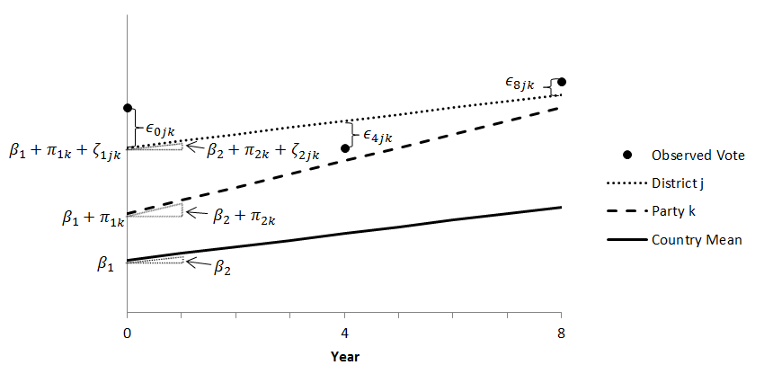

**Appendix 5: Unconditional 3-Level Growth Curve Model of Vote Percentage**

|  |  |  |  |  |  |  |  |
| --- | --- | --- | --- | --- | --- | --- | --- |
|  | | Bolivia | | Ecuador | | Venezuela | |
| Fixed Effects | |  | |  | |  | |
| $$β_{1}$$ | Intercept | 9.301 | * | 9.881 | *** | 13.896 | ** |
| $$β_{2}$$ | Linear | -0.961 |  | -1.305 | * | -2.065 |  |
| $$β_{3}$$ | Quadratic | 0.130 |  | 0.087 | ** | 0.082 |  |
| $$β_{4}$$ | Cubic | -0.0041 |  | -0.0017 | ** | -0.0009 |  |
| Random Effects | |  | |  | |  |  |
| Party (Level 3) | |  |  |  |  |  |  |
| $$π_{1k}$$ | Var(Intercept) | 386.17 |  | 135.45 |  | 239.11 |  |
| $$π_{2k}$$ | Var(Linear) | 8.23 |  | 9.65 |  | 54.40 |  |
| $$π_{3k}$$ | Var(Quadratic) | 0.148 |  | 0.038 |  | 0.102 |  |
| $$π_{4k}$$ | Var(Cubic) | 0.0001 |  | 0.00001 |  | .00001 |  |
| $$σ_{12}$$ | Cov(Intercept, Linear) | 31.52 |  | -29.43 |  | -20.77 |  |
| $$σ_{13}$$ | Cov(Intercept, Quadratic) | -4.55 |  | 1.59 |  | 0.67 |  |
| $$σ_{14}$$ | Cov(Intercept, Cubic) | 0.083 |  | -0.025 |  | -0.007 |  |
| $$σ_{23}$$ | Cov(Linear, Quadratic) | -1.10 |  | -0.59 |  | -2.35 |  |
| $$σ_{24}$$ | Cov(Linear, Cubic) | 0.030 |  | 0.010 |  | 0.025 |  |
| $$σ_{34}$$ | Cov(Quadratic, Cubic) | -0.004 |  | -0.0006 |  | -0.0011 |  |
| District (Level 2) | |  | |  | |  |  |
| $ζ_{1jk}$ | Var(Intercept) | 8.44 |  | 30.09 |  | 29.82 |  |
| $$ζ_{2jk}$$ | Var(Linear) | 0.03 |  | 0.36 |  | 0.01 |  |
| $$ζ_{3jk}$$ | Var(Quadratic) | - |  | 0.0002 |  | - |  |
| $$σ_{12}$$ | Cov(Intercept, Linear) | 0.42 |  | -2.03 |  | -0.52 |  |
| $$σ_{13}$$ | Cov(Intercept, Quadratic) | - |  | 0.028 |  | - |  |
| $$σ_{23}$$ | Cov(Linear, Quadratic) | - |  | -0.0081 |  | - |  |
| Election (Level 1) | |  |  |  |  |  |  |
| $ϵ_{ijk}$ | Residual Variance | 33.02 |  | 27.03 |  | 35.44 |  |
| N | | 495 |  | 3895 |  | 2719 |  |
| Fit statistics | |  |  |  |  |  |  |
| BIC | | 3495 |  | 25434 |  | 18255 |  |
| AIC | | 3512 |  | 25408 |  | 18232 |  |
| Log likelihood | | -1743.57 |  | -12700.26 |  | -9111.92 |  |
| Wald χ2(df) v. linear regression | | 651.2 (13) | *** | 2829.0 (16) | *** | 4164.1 (13) | *** |

Significance of fixed effects tested with t-test; *p<.05; **p<.01; ***p<.001; Significance of random effects tested with fit statistics comparing nested models

**Appendix 6: Mean Fitted Party Trajectories  
(To reduce clutter, parties that never exceed 10% nationally are omitted)**Panel A: Bolivia  
  
Panel B: Ecuador  
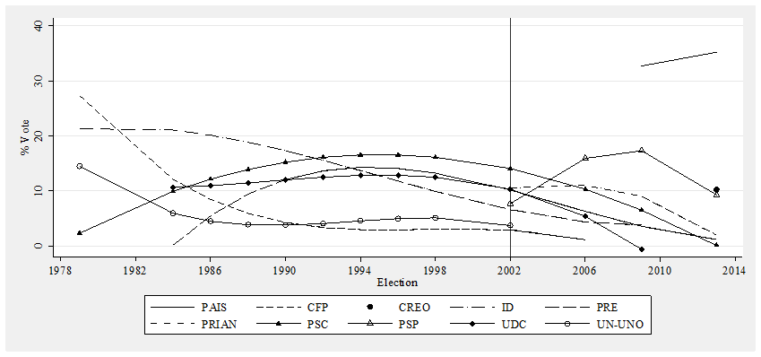  
Panel C: Venezuela  
