Matthew L. Layton, Maureen M. Donaghy, and Lúcio R. Rennó, Does Welfare Provision Promote Democratic State Legitimacy? Evidence from Brazil’s Bolsa Família Program. Latin American Politics and Society vol. 59, no. 4 (Winter 2017).

Appendix: Supplemental Material and Analyses

Table A1. Covariate Balance Statistics for Matched and Unmatched Samples, 2007-2014
Year | Variable | Matched (M) or Unmatched (U) Sample | Mean  (CCT Beneficiary) | Mean  (Non-beneficiary) | Student’s  t-score  (CCT-Non)
2014 | Child in School (0=no; 1=yes) | U | 0.56 | 0.37 | 6.66
 |  | M | 0.54 | 0.51 | 0.73
 | Household Size (# of people) | U | 4.74 | 3.53 | 12.08
 |  | M | 4.38 | 4.31 | 0.53
 | Female (0=male; 1=female) | U | 0.55 | 0.49 | 2.28
 |  | M | 0.55 | 0.58 | -0.65
 | Age (years) | U | 35.62 | 40.99 | -5.57
 |  | M | 36.19 | 35.16 | 0.90
 | Quintile of Wealth (1-5) | U | 2.20 | 3.26 | -13.17
 |  | M | 2.35 | 2.41 | -0.64
 | Level of Education (0-3) | U | 1.34 | 1.66 | -7.36
 |  | M | 1.39 | 1.39 | 0.00
 | Working (0=no; 1=yes) | U | 0.49 | 0.56 | -2.26
 |  | M | 0.52 | 0.49 | 0.72
 | Urban (0=rural; 1=urban) | U | 0.77 | 0.90 | -6.30
 |  | M | 0.82 | 0.84 | -0.54
 | North (0=no; 1=North) | U | 0.19 | 0.13 | 3.16
 |  | M | 0.20 | 0.20 | 0.00
 | Northeast (0=no; 1=Northeast) | U | 0.38 | 0.18 | 8.12
 |  | M | 0.34 | 0.31 | 0.95
 | Center-West (0=no; 1=CW) | U | 0.15 | 0.14 | 0.68
 |  | M | 0.15 | 0.17 | -0.77
 | Southeast (0=no; 1=Southeast) | U | 0.21 | 0.35 | -5.07
 |  | M | 0.24 | 0.25 | -0.37
 | South (0=no; 1=South) | U | 0.06 | 0.20 | -6.31
 |  | M | 0.08 | 0.08 | 0.00
2012 | Child in School (0=no; 1=yes) | U | 0.67 | 0.39 | 8.99
 |  | M | 0.64 | 0.60 | 1.01
 | Household Size (# of people) | U | 4.57 | 3.51 | 9.90
 |  | M | 4.39 | 4.42 | -0.23
 | Female (0=male; 1=female) | U | 0.56 | 0.49 | 2.26
 |  | M | 0.55 | 0.51 | 0.98
 | Age (years) | U | 36.57 | 38.12 | -1.64
 |  | M | 36.84 | 35.93 | 0.78
 | Quintile of Wealth (1-5) | U | 2.14 | 3.14 | -10.89
 |  | M | 2.22 | 2.26 | -0.35
 | Level of Education (0-3) | U | 1.38 | 1.80 | -8.97
 |  | M | 1.42 | 1.43 | -0.22
 | Working (0=no; 1=yes) | U | 0.37 | 0.53 | -4.70
 |  | M | 0.39 | 0.40 | -0.18
 | Urban (0=rural; 1=urban) | U | 0.77 | 0.90 | -5.93
 |  | M | 0.79 | 0.80 | -0.22
 | North (0=no; 1=North) | U | 0.19 | 0.13 | 2.54
 |  | M | 0.20 | 0.21 | -0.44
 | Northeast (0=no; 1=Northeast) | U | 0.41 | 0.18 | 8.59
 |  | M | 0.39 | 0.38 | 0.18
 | Center-West (0=no; 1=CW) | U | 0.08 | 0.16 | -3.38
 |  | M | 0.09 | 0.06 | 1.17
 | Southeast (0=no; 1=Southeast) | U | 0.21 | 0.35 | -4.67
 |  | M | 0.22 | 0.24 | -0.63
 | South (0=no; 1=South) | U | 0.11 | 0.18 | -2.85
 |  | M | 0.10 | 0.10 | 0.15
2010 | Child in School (0=no; 1=yes) | U | 0.64 | 0.50 | 6.08
 |  | M | 0.60 | 0.57 | 0.99
 | Household Size (# of people) | U | 3.24 | 2.56 | 9.77
 |  | M | 3.06 | 2.97 | 0.89
 | Female (0=male; 1=female) | U | 0.58 | 0.51 | 2.80
 |  | M | 0.56 | 0.57 | -0.20
 | Age (years) | U | 36.61 | 40.25 | -4.81
 |  | M | 36.70 | 36.65 | 0.06
 | Quintile of Wealth (1-5) | U | 2.17 | 3.29 | -17.18
 |  | M | 2.28 | 2.30 | -0.16
 | Level of Education (0-3) | U | 1.29 | 1.66 | -10.76
 |  | M | 1.33 | 1.34 | -0.15
 | Working (0=no; 1=yes) | U | 0.33 | 0.41 | -3.43
 |  | M | 0.35 | 0.32 | 0.96
 | Urban (0=rural; 1=urban) | U | 0.75 | 0.90 | -9.16
 |  | M | 0.79 | 0.81 | -0.82
 | North (0=no; 1=North) | U | 0.20 | 0.13 | 3.87
 |  | M | 0.20 | 0.19 | 0.57
 | Northeast (0=no; 1=Northeast) | U | 0.43 | 0.16 | 13.92
 |  | M | 0.37 | 0.34 | 0.95
 | Center-West (0=no; 1=CW) | U | 0.10 | 0.18 | -4.92
 |  | M | 0.11 | 0.11 | -0.21
 | Southeast (0=no; 1=Southeast) | U | 0.19 | 0.33 | -6.52
 |  | M | 0.21 | 0.23 | -0.70
 | South (0=no; 1=South) | U | 0.09 | 0.20 | -6.01
 |  | M | 0.10 | 0.12 | -1.03
2008 | Child in School (0=no; 1=yes) | U | 0.70 | 0.42 | 7.85
 |  | M | 0.68 | 0.68 | 0.00
 | Household Size (# of people) | U | 4.06 | 2.60 | 12.96
 |  | M | 3.82 | 3.59 | 1.29
 | Female (0=male; 1=female) | U | 0.64 | 0.52 | 3.21
 |  | M | 0.62 | 0.62 | 0.10
 | Age (years) | U | 39.13 | 41.78 | -2.16
 |  | M | 38.95 | 38.52 | 0.31
 | Quintile of Wealth (1-5) | U | 2.00 | 3.15 | -11.58
 |  | M | 2.08 | 2.02 | 0.53
 | Level of Education (0-3) | U | 1.14 | 1.52 | -7.09
 |  | M | 1.16 | 1.15 | 0.09
 | Working (0=no; 1=yes) | U | 0.21 | 0.33 | -3.78
 |  | M | 0.20 | 0.26 | -1.32
 | Urban (0=rural; 1=urban) | U | 0.59 | 0.85 | -9.47
 |  | M | 0.61 | 0.64 | -0.63
 | North (0=no; 1=North) | U | 0.07 | 0.05 | 1.11
 |  | M | 0.08 | 0.09 | -0.36
 | Northeast (0=no; 1=Northeast) | U | 0.61 | 0.21 | 12.87
 |  | M | 0.57 | 0.55 | 0.41
 | Center-West (0=no; 1=CW) | U | 0.03 | 0.09 | -3.12
 |  | M | 0.03 | 0.02 | 1.01
 | Southeast (0=no; 1=Southeast) | U | 0.21 | 0.49 | -7.79
 |  | M | 0.23 | 0.26 | -0.70
 | South (0=no; 1=South) | U | 0.09 | 0.16 | -2.95
 |  | M | 0.09 | 0.09 | 0.18
2007 | Child in School (0=no; 1=yes) | U | 0.68 | 0.36 | 7.21
 |  | M | 0.67 | 0.63 | 0.66
 | Household Size (# of people) | U | 4.37 | 3.63 | 4.54
 |  | M | 4.30 | 4.32 | -0.06
 | Female (0=male; 1=female) | U | 0.63 | 0.49 | 3.16
 |  | M | 0.62 | 0.59 | 0.51
 | Age (years) | U | 38.54 | 39.89 | -0.89
 |  | M | 38.49 | 40.65 | -1.12
 | Quintile of Wealth (1-5) | U | 1.94 | 2.98 | -7.86
 |  | M | 1.98 | 2.04 | -0.42
 | Level of Education (0-3) | U | 1.15 | 1.55 | -5.97
 |  | M | 1.17 | 1.13 | 0.65
 | Working (0=no; 1=yes) | U | 0.39 | 0.58 | -4.24
 |  | M | 0.40 | 0.34 | 0.91
 | Urban (0=rural; 1=urban) | U | 0.69 | 0.84 | -4.30
 |  | M | 0.70 | 0.66 | 0.67
 | North (0=no; 1=North) | U | 0.05 | 0.06 | -0.24
 |  | M | 0.06 | 0.04 | 0.59
 | Northeast (0=no; 1=Northeast) | U | 0.47 | 0.25 | 5.53
 |  | M | 0.45 | 0.48 | -0.38
 | Center-West (0=no; 1=CW) | U | 0.05 | 0.08 | -1.17
 |  | M | 0.06 | 0.04 | 0.59
 | Southeast (0=no; 1=Southeast) | U | 0.31 | 0.45 | -3.26
 |  | M | 0.32 | 0.33 | -0.27
 | South (0=no; 1=South) | U | 0.11 | 0.16 | -1.25
 |  | M | 0.12 | 0.11 | 0.20
Note: Covariate balance test results reported from pstest command. Bold indicates statistically significant difference at p < 0.05.

Table A2. Predictors of Bolsa Família Beneficiary Status, 2007-2014
 | 2014 | 2012 | 2010 | 2008 | 2007
Child in School (0=no; 1=yes) | 0.84 | 0.98 | 0.44 | 0.82 | 1.31
 | (0.14) | (0.17) | (0.15) | (0.22) | (0.25)
Household Size (# of people) | 0.34 | 0.30 | 0.33 | 0.37 | 0.15
 | (0.05) | (0.05) | (0.05) | (0.07) | (0.05)
Female (0=male; 1=female) | 0.23 | 0.24 | 0.13 | 0.38 | 0.29
 | (0.14) | (0.15) | (0.14) | (0.20) | (0.26)
Age (years) | -0.04 | -0.01 | -0.04 | -0.03 | -0.02
 | (0.01) | (0.01) | (0.00) | (0.01) | (0.01)
Quintile of Wealth (1-5) | -0.50 | -0.42 | -0.49 | -0.48 | -0.37
 | (0.08) | (0.07) | (0.05) | (0.08) | (0.09)
Level of Education (0-3) | -0.57 | -0.65 | -0.47 | -0.50 | -0.79
 | (0.13) | (0.14) | (0.13) | (0.18) | (0.22)
Working (0=no; 1=yes) | 0.04 | -0.03 | -0.13 | -0.27 | -0.71
 | (0.15) | (0.17) | (0.15) | (0.22) | (0.24)
Urban (0=rural; 1=urban) | -0.78 | -0.73 | -0.90 | -0.89 | -0.37
 | (0.21) | (0.30) | (0.28) | (0.28) | (0.31)
Northeast (0=no; 1=NE) | 0.56 | 0.83 | 0.47 | 1.21 | 0.90
 | (0.25) | (0.34) | (0.25) | (1.01) | (0.85)
Center-West (0=no; 1=CW) | 0.12 | -0.51 | -0.73 | -0.27 | 0.25
 | (0.28) | (0.35) | (0.27) | (1.00) | (0.97)
Southeast (0=no; 1=SE) | -0.10 | -0.12 | -0.35 | 0.08 | 0.37
 | (0.29) | (0.37) | (0.30) | (0.96) | (0.84)
South (0=no; 1=S) | -0.49 | 0.27 | -0.54 | 0.29 | 0.70
 | (0.40) | (0.40) | (0.32) | (0.99) | (0.89)
Constant | 1.17 | -0.22 | 2.05 | -0.45 | -0.90
 | (0.49) | (0.66) | (0.56) | (1.14) | (1.08)
Number of observations | 1466 | 1482 | 2219 | 1428 | 1207
Wald Test (F-score) | 18.94 | 17.24 | 31.14 | 14.33 | 7.77
Note: Survey design effects-corrected logit regression coefficients reported. Standard errors in parentheses. Estimates used to calculate propensity scores for use in matching procedure.

Figures A1-A5. Comparison of Propensity Scores, Pre- and Post-Matching, 2007-2014 Waves of the AmericasBarometer in Brazil

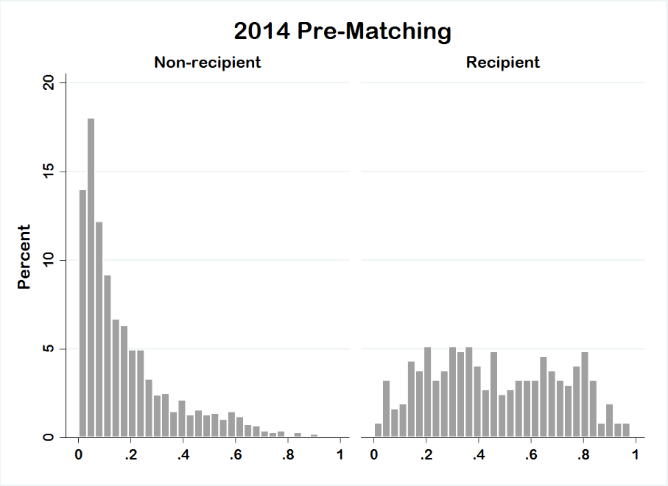
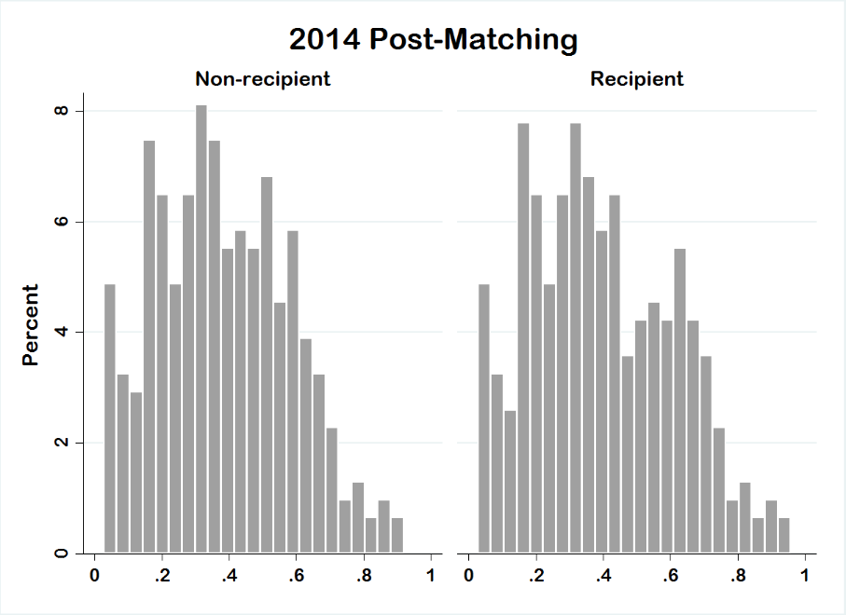
Figure A1. Comparison of Propensity Scores, Pre- and Post-Matching, 2014 AmericasBarometer
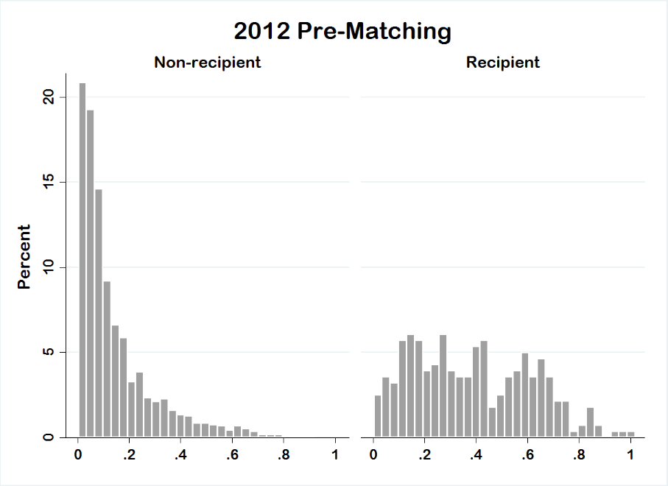

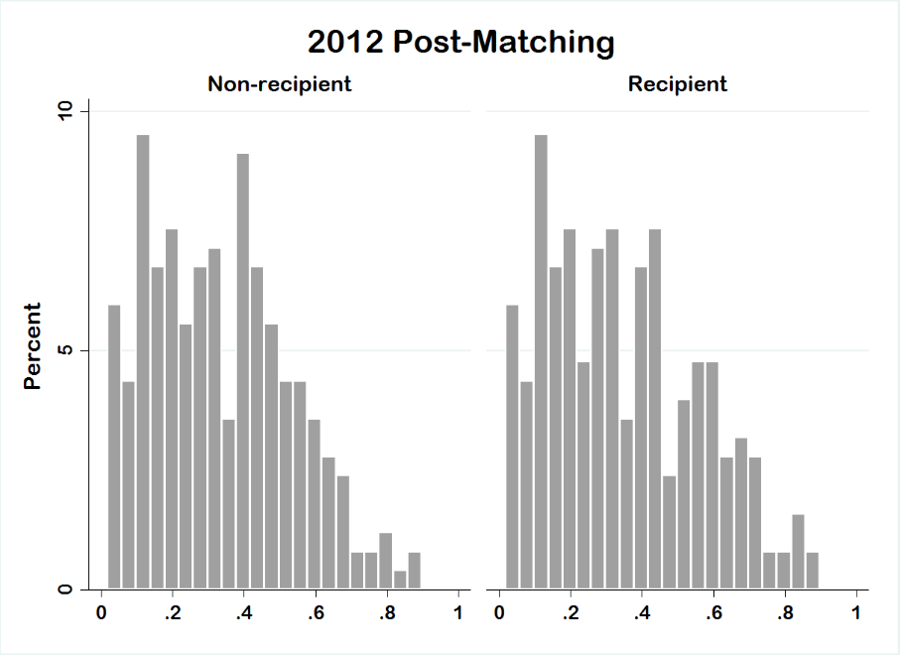
Figure A2. Comparison of Propensity Scores, Pre- and Post-Matching, 2012 AmericasBarometer
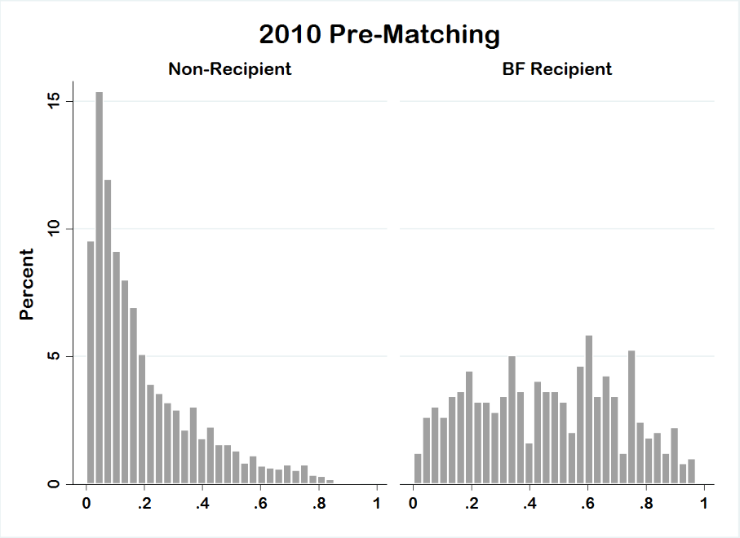
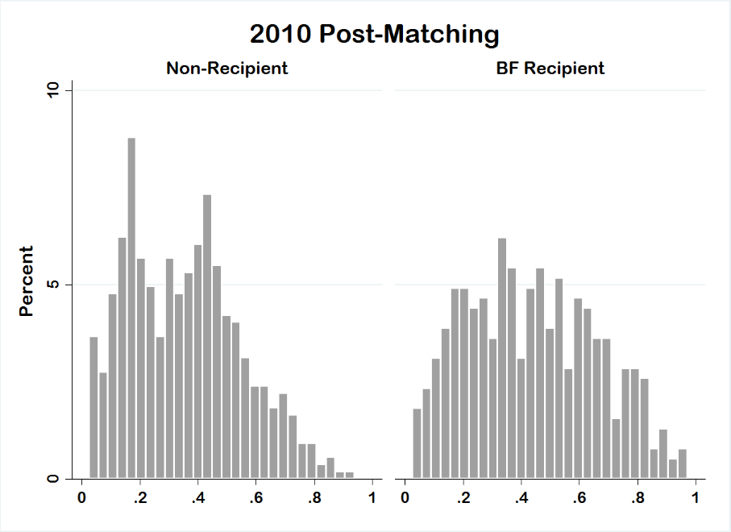
Figure A3. Comparison of Propensity Scores, Pre- and Post-Matching, 2010 AmericasBarometer

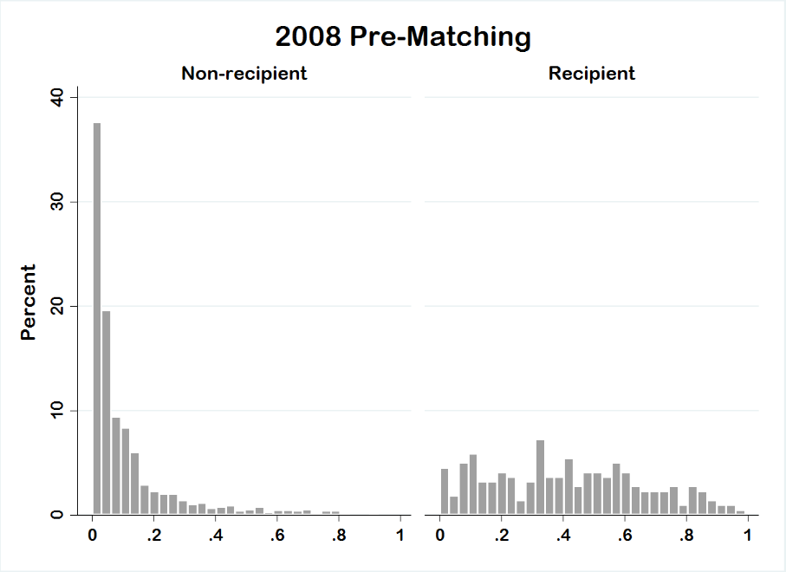
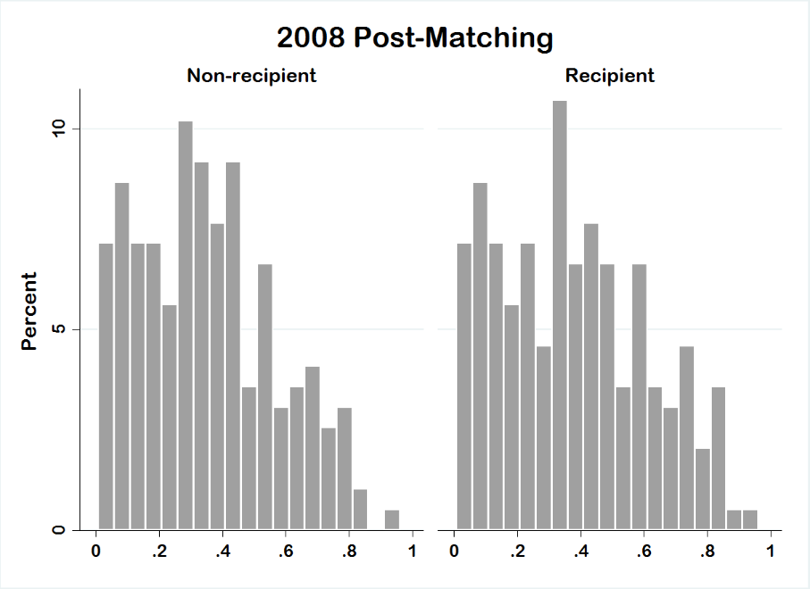
Figure A4. Comparison of Propensity Scores, Pre- and Post-Matching, 2008 AmericasBarometer
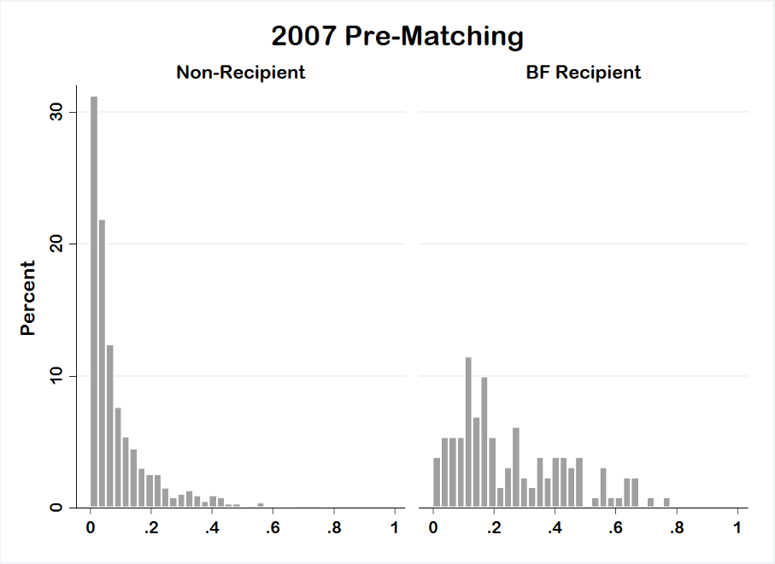
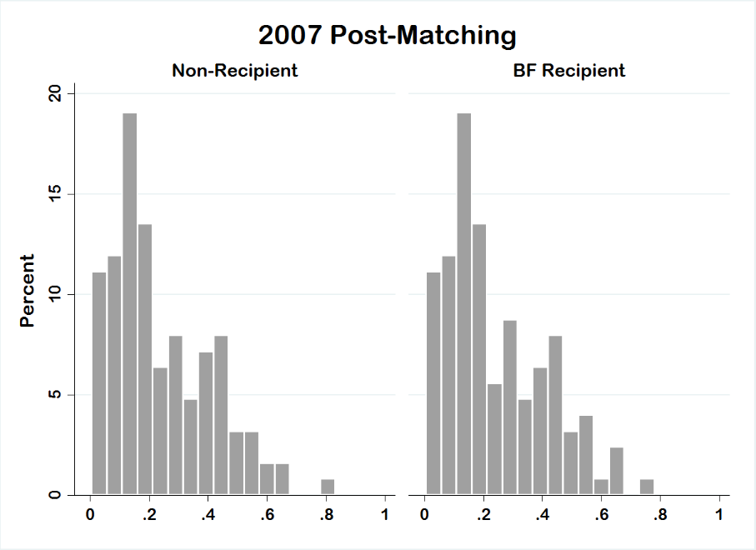
Figure A5. Comparison of Propensity Scores, Pre- and Post-Matching, 2007 AmericasBarometer
Dependent Variables

Discussion of the AmericasBarometer (AB) items used, their Portuguese wording, and the differences in the items used by Booth and Seligson (2009) in their measurement model.

Support for Incumbent Actors (Issue Performance), AB items N9, N11, N15

In Portuguese, these items read: “N9. Até que ponto diria que o atual governo federal combate a corrupção no governo? N11. Até que ponto o(a) sr./sra. diria que o atual governo federal melhora a segurança do cidadão? N15. Até que ponto o(a) sr./sra. diria que o atual governo federal está gerenciando bem a economia?” Responses are given on a 1 to 7 scale where ‘1’ means “Not at all” and ‘7’ means “A lot.” We add responses across the three items and rescale the resulting value from 0 to 1. The Chronbach alpha score for these items is 0.833 for the pooled matched sample. Booth and Seligson (2009) use evaluations of combating poverty, combating government corruption, and promoting democratic principles.

Support for Local Government, AB item B32

In Portuguese, this item reads: “Até que ponto o(a) sr./sra. tem confiança no governo municipal?” Booth and Seligson (2009) also include a question that prompts respondents to evaluate the services provided by the municipal government.

Support for Regime Institutions, AB items B1, B2, B3, B4, B6, B10A, B13, B21

In Portuguese, these items read: “B1. Até que ponto o(a) sr./sra. acredita que os tribunais de justiça do Brasil garantem um julgamento justo? B2. Até que ponto o(a) sr./sra. tem respeito pelas instituições políticas do Brasil? B3. Até que ponto o(a) sr./sra. acredita que os direitos básicos do cidadão estão bem protegidos pelo sistema político brasileiro? B4. Até que ponto o(a) sr./sra. se sente orgulhoso(a) de viver no sistema político brasileiro? B6. Até que ponto o(a) sr./sra. acha que se deve apoiar o sistema político brasileiro? B10A. Até que ponto o(a) sr./sra. tem confiança na justiça? B13. Até que ponto o(a) sr./sra. tem confiança no Congresso Nacional? B21. Até que ponto o(a) sr./sra. tem confiança nos partidos políticos?” Responses are given on a 1 to 7 scale where ‘1’ means “not at all” and ‘7’ means “a lot.” We add responses across the eight items and rescale the resulting value from 0 to 1. The Chronbach alpha score for these items is 0.868 for the pooled matched sample. Booth and Seligson (2009) use the same first five items, and include the following specific institutions: national election bureau, national legislature, political parties, and supreme court.

Economic Performance, AB item SOCT2

In Portuguese, this item reads: “O(A) sr./sra. considera que a situação econômica atual do país está melhor, igual, ou pior que há doze meses?” Booth and Seligson (2009) use two different items: a question that taps current evaluations of the economy, without the retrospective prompt, and a question that asks about perceptions of where the economy will be in 12 months.

Regime Principles, AB items E5, E8, E11

In Portuguese, these items read: “Quero que me diga o quanto o(a) sr./sra. aprovaria ou desaprovaria as seguintes ações: E5. A participação de pessoas em manifestações permitidas por lei; E8. A participação de pessoas em uma organização ou grupo para resolver os problemas das comunidades; E11. O trabalho de pessoas em campanhas eleitorais para um partido político ou candidato.” Responses are given on a 1 to 10 scale where ‘1’ means “Strongly disapprove” and ‘10’ means “Strongly approve.” We add responses across the three items and rescale the resulting value from 0 to 1. The Chronbach alpha score for these items is 0.697 for the pooled matched sample.

Sense of Political Community, AB item B43

In Portuguese the question reads, “Até que ponto o(a) sr./sra. tem orgulho de ser brasileiro(a)?” Responses are given on a 1 to 7 scale where ‘1’ means “Not at all” and ‘7’ means “A lot.” We rescale those responses from 0 to 1. Booth and Seligson (2009) include an additional item measuring respondents’ sense of national unity that is only available in the 2007 and 2008 data we use.

Table A3. Predictors of Political Legitimacy, Brazil (2007-2014) (Cross-Temporal Interactions, Matched Sample Results)
 | (1) | (2) | (3) | (4) | (5) | (6)
 | Political Communityª | Support for Regime Principles | Regime Economic Performance^{b} | Support for Core Institutions | Trust in Local Government | Support for Political Actors^{c}
BFP Recipient | 0.048 | 0.033 | 0.346 | 0.089** | 0.047 | 0.033
 | (0.039) | (0.025) | (0.275) | (0.032) | (0.047) | (0.019)
Survey Year 2008 | 0.096** | 0.018 | 0.568 | 0.011 | -0.065 | --
 | (0.031) | (0.035) | (0.341) | (0.033) | (0.047) | --
Survey Year 2010 | 0.091** | 0.060 | 0.584* | 0.090** | 0.014 | --
 | (0.029) | (0.031) | (0.254) | (0.028) | (0.042) | --
Survey Year 2012 | 0.021 | 0.011 | 0.664* | 0.046 | -0.078 | -0.065*
 | (0.033) | (0.028) | (0.274) | (0.031) | (0.043) | (0.028)
Survey Year 2014 | -- | -0.025 | -0.271 | -0.058* | -0.158*** | -0.169***
 | -- | (0.026) | (0.234) | (0.029) | (0.042) | (0.026)
BFP*2008 | -0.088 | -0.035 | 0.032 | -0.015 | 0.047 | --
 | (0.046) | (0.040) | (0.444) | (0.043) | (0.059) | --
BFP*2010 | -0.052 | -0.057 | -0.217 | -0.089* | -0.097 | --
 | (0.041) | (0.030) | (0.313) | (0.035) | (0.053) | --
BFP*2012 | 0.003 | -0.024 | -0.422 | -0.063 | -0.023 | 0.044
 | (0.044) | (0.034) | (0.360) | (0.038) | (0.054) | (0.033)
BFP*2014 | -- | -0.035 | -0.438 | -0.035 | 0.010 | 0.037
 | -- | (0.031) | (0.330) | (0.036) | (0.053) | (0.029)
Constant | 0.825*** | 0.659*** | 0.658*** | 0.390*** | 0.496*** | 0.489***
 | (0.027) | (0.021) | (0.197) | (0.025) | (0.037) | (0.020)
Number of Observations | 2073 | 2617 | 2644 | 2326 | 2663 | 1970
Wald Test (F-statistic) | 3.324** | 1.934* | 7.851*** | 9.351*** | 6.874*** | 18.228***
Source: AmericasBarometer by LAPOP
Notes: The reference category for survey year is 2007 except in model 6 where the baseline survey year is 2010. All estimates are survey design-effects based and are calculated from a propensity-score matching pre-processed sample. All estimates are based on OLS regression with the exception of model 3, which is based on logistic regression. Standard errors in parentheses.
*p<0.05; **p<0.01; ***p<0.001
ªNo data for 2014
^{b}Estimates based on logit regression
^{c}No data for 2007, 2008

Figures A6-A11. Average Marginal Effect of Bolsa Família on Six Political Legitimacy Dimensions, 2007-2014, AmericasBarometer in Brazil
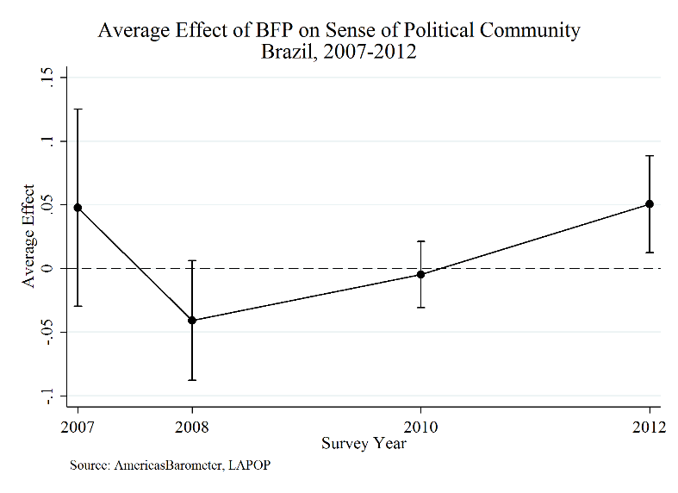
Figure A6. Average Effect of BFP on Sense of Political Community, Brazil (2007-2012)
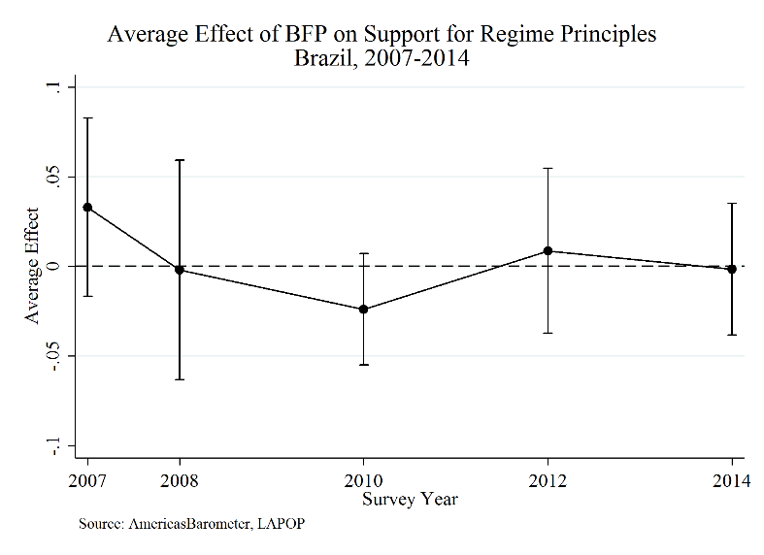
Figure A7. Average Effect of BFP on Support for Regime Principles, Brazil (2007-2014)
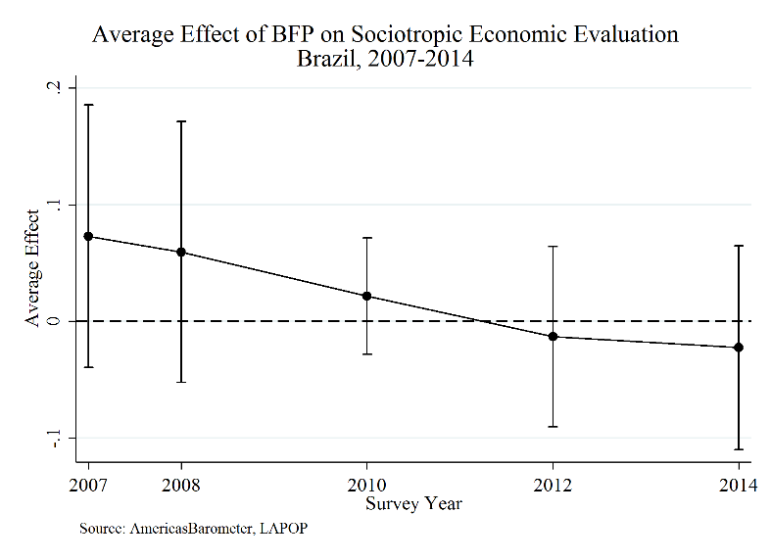
Figure A8. Average Effect of BFP on Sociotropic Economic Evaluation, Brazil (2007-2014)

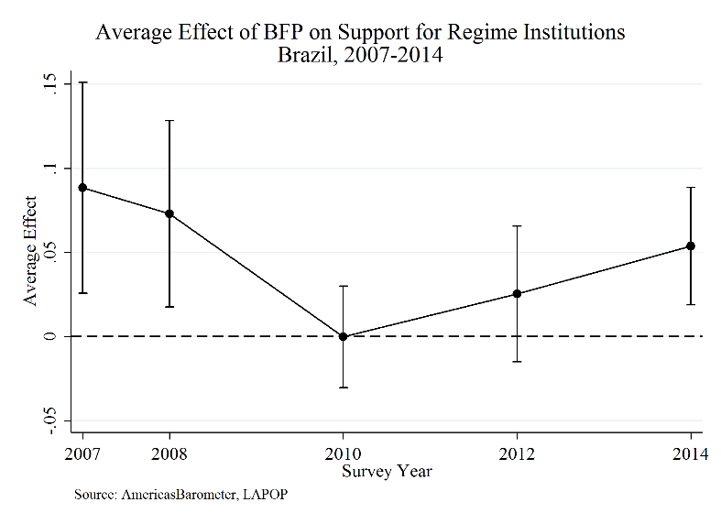
Figure A9. Average Effect of BFP on Support for Regime Institutions, Brazil (2007-2014)
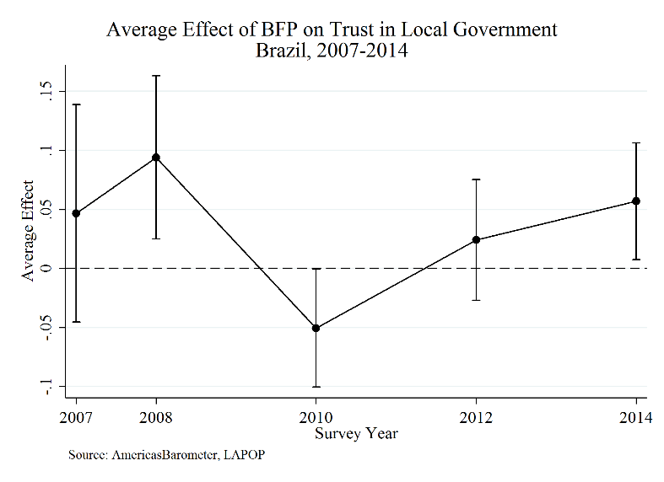
Figure A10. Average Effect of BFP on Trust in Local Government, Brazil (2007-2014)
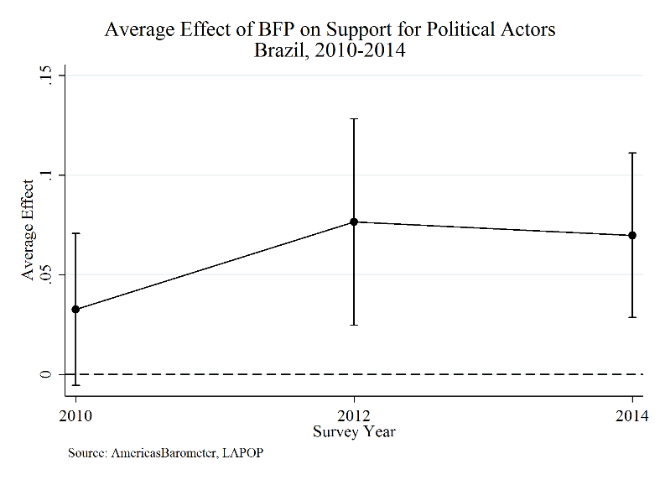
Figure A11. Average Effect of BFP on Support for Political Actors, Brazil (2010-2014)

Alternative Dependent Variable Models

Alternative dependent variables:
- Diffuse support for democratic regime - AB variable ING4 – Democracy is Best (Model 1)
  - Question wording: “Changing the subject again, democracy may have problems, but it is better than any other form of government. To what extent do you agree or disagree with this statement?” Answers given on 1-7 scale where ‘1’ means strongly disagree and ‘7’ means strongly agree.
  - Question coding: 0 to 1 with same endpoint interpretations, modeled using OLS
- Specific support for president – AB variable M1 – Presidential Job Approval (Model 2)
  - Question wording: “Speaking in general of the current administration, how would you rate the job performance of President [Lula (for 2007, 2008, and 2010) or Dilma (for 2012 or 2014)]? (1) Very good (2) Good (3) Neither good nor bad (fair) (4) Bad (5) Very bad”
  - Question coding: 0 to 1, inverted endpoint interpretations, modeled using OLS
- Diffuse support for democratic regime – AB variable DEM2 – Democratic Preference (Model 3)
  - Question wording: “Now changing the subject, which of the following statements do you agree with the most: (1) For people like me it doesn’t matter whether a government is democratic or nondemocratic, or (2) Democracy is preferable to any other form of government, or (3) Under some circumstances an authoritarian government may be preferable to a democratic one.”
  - Question coding: Original 3-point scale maintained, modeled using multinomial logit

Table A4. Predictors of Alternate Measures of Political Legitimacy, Brazil (2007-2014) Matched Samples
 | (1) | (2)
 | Democracy is Best | Presidential Job Approval
BFP Recipient | -0.007 | 0.050***
 | (0.013) | (0.011)
Survey Year 2008 | -0.050 | 0.071**
 | (0.030) | (0.022)
Survey Year 2010 | -0.026 | 0.133***
 | (0.030) | (0.021)
Survey Year 2012 | -0.038 | 0.075***
 | (0.027) | (0.018)
Survey Year 2014 | -0.080** | -0.052**
 | (0.027) | (0.019)
Constant | 0.746*** | 0.576***
 | (0.021) | (0.016)
Number of Observations | 2479 | 2691
Wald-Test (F-statistic) | 2.052 | 29.694***
Source: AmericasBarometer by LAPOP
Notes: The reference category for survey year is 2007. All estimates are survey design-effects based and are calculated from a propensity-score matching pre-processed sample. All estimates are based on OLS regression. Standard errors in parentheses.
*p<0.05; **p<0.01; ***p<0.001

Table A5. Predictors of Alternate Measure of Democratic Political Legitimacy, Brazil (2007-2014) Matched Samples
 | (3)
 | Democratic Preference
 | Option 1 (Indifference) | Option 3 (Authoritarian)
BFP Recipient | 0.338* | 0.012
 | (0.140) | (0.127)
Survey Year 2008 | 0.790* | -0.168
 | (0.338) | (0.286)
Survey Year 2010 | 0.474 | 0.091
 | (0.315) | (0.257)
Survey Year 2012 | 1.151*** | 0.412
 | (0.307) | (0.252)
Survey Year 2014 | 0.969** | 0.358
 | (0.295) | (0.251)
Constant | -2.427*** | -1.561***
 | (0.279) | (0.223)
Number of Observations | 2382
Wald Test (F-statistic) | 2.846**
Source: AmericasBarometer by LAPOP
Notes: The reference category for the dependent variable is Option 2 (Democratic Preference). The reference category for survey year is 2007. All estimates are survey design-effects based and are calculated from a propensity-score matching pre-processed sample. All estimates are based on multinomial logit regression. Standard errors in parentheses.
*p<0.05; **p<0.01; ***p<0.001

Sensitivity Analysis

Simultaneous sensitivity analysis conducted for selected values of Δ and Γ with user-written pairsimsens Stata file (see Lempert 2015). Reporting p-values indicating maximum probability that the null hypothesis would hold given selected characteristics of a potential unobserved confounder.

Table A6. Simultaneous Sensitivity Analysis for Selected Values of Δ and Γ. Support for Core Institutions
Γ | Δ = 1 | Δ = 1.1 | Δ = 1.2 | Δ = 1.5 | Δ = 2 | Δ = 2.5 | Δ = 3 | Δ = ∞
1 | 0.0002 | 0.0002 | 0.0002 | 0.0002 | 0.0002 | 0.0002 | 0.0002 | 0.0002
1.1 | 0.0002 | 0.0002 | 0.0003 | 0.0006 | 0.0013 | 0.0020 | 0.0026 | 0.0116
1.2 | 0.0002 | 0.0003 | 0.0005 | 0.0018 | 0.0059 | 0.0119 | 0.0187 | 0.1380
1.5 | 0.0002 | 0.0006 | 0.0018 | 0.0161 | 0.1035 | 0.2457 | 0.3854 | 0.9735
2 | 0.0002 | 0.0014 | 0.0067 | 0.1172 | 0.6139 | 0.8972 | 0.9743 | 1
2.5 | 0.0002 | 0.0024 | 0.0155 | 0.3066 | 0.9218 | 0.9966 | 0.9998 | 1
3 | 0.0002 | 0.0034 | 0.0272 | 0.5040 | 0.9887 | 0.9999 | 1 | 1
∞ | 0.0002 | 0.0329 | 0.3934 | 0.9999 | 1 | 1 | 1 | 1

Table A7. Simultaneous Sensitivity Analysis for Selected Values of Δ and Γ. Trust in Local Government
Γ | Δ = 1 | Δ = 1.1 | Δ = 1.2 | Δ = 1.5 | Δ = 2 | Δ = 2.5 | Δ = 3 | Δ = ∞
1 | 0.0932 | 0.0932 | 0.0932 | 0.0932 | 0.0932 | 0.0932 | 0.0932 | 0.0932
1.1 | 0.0932 | 0.1085 | 0.1238 | 0.1676 | 0.2285 | 0.2740 | 0.3078 | 0.5182
1.2 | 0.0932 | 0.1239 | 0.1571 | 0.2614 | 0.4134 | 0.5218 | 0.5961 | 0.9021
1.5 | 0.0932 | 0.1691 | 0.2646 | 0.5715 | 0.8664 | 0.9571 | 0.9838 | 1
2 | 0.0932 | 0.2372 | 0.4334 | 0.8823 | 0.9971 | 0.9999 | 1 | 1
2.5 | 0.0932 | 0.2938 | 0.5645 | 0.9720 | 1 | 1 | 1 | 1
3 | 0.0932 | 0.3400 | 0.6593 | 0.9930 | 1 | 1 | 1 | 1
∞ | 0.0932 | 0.6908 | 0.9847 | 1 | 1 | 1 | 1 | 1

Table A8. Simultaneous Sensitivity Analysis for Selected Values of Δ and Γ. Support for Political Actors
Γ | Δ = 1 | Δ = 1.1 | Δ = 1.2 | Δ = 1.5 | Δ = 2 | Δ = 2.5 | Δ = 3 | Δ = ∞
1 | 0.0000 | 0.0000 | 0.0000 | 0.0000 | 0.0000 | 0.0000 | 0.0000 | 0.0000
1.1 | 0.0000 | 0.0000 | 0.0001 | 0.0001 | 0.0002 | 0.0004 | 0.0005 | 0.0027
1.2 | 0.0000 | 0.0001 | 0.0001 | 0.0003 | 0.0013 | 0.0028 | 0.0046 | 0.0473
1.5 | 0.0000 | 0.0001 | 0.0004 | 0.0039 | 0.0333 | 0.0973 | 0.1773 | 0.8770
2 | 0.0000 | 0.0003 | 0.0015 | 0.0386 | 0.3511 | 0.7022 | 0.8786 | 1
2.5 | 0.0000 | 0.0005 | 0.0037 | 0.1300 | 0.7493 | 0.9695 | 0.9968 | 1
3 | 0.0000 | 0.0007 | 0.0070 | 0.2599 | 0.9303 | 0.9982 | 1 | 1
∞ | 0.0000 | 0.0087 | 0.1824 | 0.9979 | 1 | 1 | 1 | 1

Table A9. Simultaneous Sensitivity Analysis for Selected Values of Δ and Γ. Presidential Job Approval (Table A4, Model 2)
Γ | Δ = 1 | Δ = 1.1 | Δ = 1.2 | Δ = 1.5 | Δ = 2 | Δ = 2.5 | Δ = 3 | Δ = ∞
1 | 0.0000 | 0.0000 | 0.0000 | 0.0000 | 0.0000 | 0.0000 | 0.0000 | 0.0000
1.1 | 0.0000 | 0.0000 | 0.0000 | 0.0000 | 0.0000 | 0.0000 | 0.0000 | 0.0000
1.2 | 0.0000 | 0.0000 | 0.0000 | 0.0000 | 0.0000 | 0.0000 | 0.0001 | 0.0029
1.5 | 0.0000 | 0.0000 | 0.0000 | 0.0000 | 0.0009 | 0.0048 | 0.0132 | 0.5784
2 | 0.0000 | 0.0000 | 0.0000 | 0.0011 | 0.0428 | 0.2031 | 0.4196 | 1
2.5 | 0.0000 | 0.0000 | 0.0000 | 0.0073 | 0.2387 | 0.6752 | 0.9006 | 1
3 | 0.0000 | 0.0000 | 0.0001 | 0.0238 | 0.5230 | 0.9256 | 0.9927 | 1
∞ | 0.0000 | 0.0001 | 0.0127 | 0.9115 | 1 | 1 | 1 | 1

REFERENCES:

Booth, John A., & Seligson, Mitchell A. (2009). The Legitimacy Puzzle in Latin America: Political Support and Democracy in Eight Nations (1st ed.). Cambridge University Press.
Lempert, Daniel. (2015). Simultaneous Sensitivity Analysis in Stata: arsimsens and pairsimsens. Observational Studies, 1: 74-90.

