Yann P. Kerevel, The Costs and Benefits of Party Switching in Mexico. Latin American Politics and Society vol. 59, no. 1 (Spring 2017)

Online Appendix

In this appendix, I explain in more detail the decisions used to match party loyalists and party switchers using coarsened exact matching (CEM) (Iacus, King and Porro 2012). In addition, I present additional empirical results where I match deputies on additional characteristics which more drastically reduce the number of matched deputies.
The treatment is whether or not a deputy switched parties during or after the legislative term (loyalist=0, party switcher=1). Deputies are matched on 10 different characteristics that are correlated with the propensity to switch parties and a deputy’s political ambition.
- Deputies were matched on whether or not they had a co-partisan governor at the end of the deputy’s legislative term (opposition governor=0, co-partisan governor=1).
- Deputies were matched based on whether or not they had prior legislative experience (0=no prior legislative experience, 1=previous experience as a state or federal deputy, or as a senator). For the purposes of matching, I used a dichotomous version of the legislative experience variable, since 56% of deputies had no prior experience, while an additional 30% of deputies had only served one prior term in legislative office. In the post-matching multivariate models in the manuscript, I include the full range on the legislative experience variable (range: 0-7 terms) as a control.
- Deputies were matched based on whether or not they had prior executive experience (0=no prior executive experience, 1=experience as a mayor, governor, state or federal cabinet member, or state or federal party leader). For the purposes of matching, I used a dichotomous version of the executive experience variable, since 62% of deputies had no prior executive experience, while an additional 30% of deputies had only one prior term of executive experience. In the post-matching multivariate models in the manuscript, I include the full range on the executive experience variable (range: 0-6 terms) as a control.
- Deputies were matched based on leadership experience within the Chamber of Deputies. Deputies who have served as caucus leader (coordinador parlamentario), a member of the Chamber’s Governing Board (mesa directiva) or committee chair are coded 1, while backbenchers are coded 0.
- Deputies were matched on level of education. Deputies with a college degree (licenciatura) or higher were coded 1, otherwise 0. 59% of deputies have a college degree, and an additional 23% have engaged on post-graduate studies. For purposes of matching, I use a dichotomous version of education, but in the post-matching multivariate models, I include as a control an 8-point scale of the level of education which ranges from primary education to doctoral studies.
- Deputies were matched on age, using three categories: 21-39, 40-59, 60-77. In the post-matching empirical models, I include age (in years) as a control rather than these categories.
- Deputies were matched on gender (male=0, female=1).
- Deputies were matched on their mode of election (elected in a single-member district=0, elected by proportional representation=1).
- Deputies were matched on the legislative term in which they served: 57th Legislature (1997-2000), 58th Legislative (2000-2003), 59th Legislature (2003-2006), or 60th Legislature (2006-2009).
- Deputies were matched on whether or not they had switched parties at some point before entering office in the Chamber of Deputies. 7% of deputies switched parties prior to entering office. Data on prior switches come from official biographies and most involve switches from the PRI to another party. I did not count as a prior switch PRD deputies who used to be members of a variety of minor left parties that existed prior to the founding of the PRD. I also did not consider small changes in a party’s name over time as a prior switch. For more on prior switches, see Kerevel (2014).
Coarsened exact matching was implemented using the CEM package in Stata. For more details on how to use the CEM package, see Blackwell, Iacus, King and Porro (2009).
In this appendix I replicate the analysis presented in the manuscript but also match deputies on their original party identification at the time they entered the Chamber of Deputies. Additionally matching on party ID substantially reduces the number of observations, but does not drastically alter the main findings presented in the manuscript. Party ID was coded in four categories for purposes matching: PRI, PAN, PRD, and minor parties (PVEM, PT, Convergencia, PANAL, PASC, PAS, PSN).
Appendix Table 1 replicates Table 1 from the manuscript while also matching on party identification. I continue to find party switchers are more likely to obtain ballot access, but less likely to win elected office compared to party loyalists.

Appendix Table 1. Electoral Success and Party Switching Among Federal Deputies
 | Balanced: CEM
 | Party Loyalists | Party Switchers
No ballot access | 61.4% | 26.8%
Ballot Access
State deputy/city councilor | 7.8% | 9.9%
Federal deputy/Senator | 9.3% | 19.7%
Mayor | 20.5% | 38.0%
Governor/President | 1.1% | 5.6%
Total N | 220 | 71
Won office | 39.3% | 13.5%
Lost office | 60.7% | 86.5%
Total N | 85 | 52
The treatment variable (party switcher) was matched on co-partisan governor, mode of election, legislative experience, executive experience, age, education, gender, congressional leadership experience, legislative term, party ID and prior party switchers.

Appendix Table 2 attempts to replicate the multinomial logistic regression model predicting ballot access from Table 2 of the manuscript, although most of the control variables had to be dropped due to lack of variation within several of the categories of the dependent variable. Model 1 presents bivariate results without any additional controls while Model 2 includes prior elected office, age and education as controls. In both models, I find party switchers are more likely to obtain ballot access for federal legislative office, mayoral office and gubernatorial office compared to party loyalists. In Table 2 of the manuscript, there were 1863 observations used in the model without matching, and 526 in the post-matching model. The models presented here in the Appendix further reduce the number of observations to 279, although the findings are largely consistent across all model specifications. Appendix Figure 1 also replicates Figure 1 from the manuscript and the substantive effects of party switching on ballot access are largely similar.

Appendix Table 2. Who gets ballot access? Chamber of Deputies, 1997-2009
 | Model 1
Dependent Variable | State Deputy/ City Councilor v. No Ballot Access |  | Federal Deputy/ Senator v. No Ballot Access |  | Mayor vs. No Ballot Access | Governor/ President v. No Ballot Access
 | b | s.e. | b | s.e. | b | s.e. | b | s.e.
Party switcher | 0.49 | 0.61 | 1.57** | 0.43 | 1.58** | 0.36 | 2.2** | 0.91
Constant | -1.99** | 0.26 | -1.82** | 0.24 | -1.18** | 0.18 | -3.99** | 0.66
LR χ2 | 28.71**
N | 281
Matched treated | 66
Matched control | 215
 | Model 2
Party switcher | 0.44 | 0.62 | 1.66** | 0.44 | 1.45** | 0.37 | 2.42** | 0.94
Prior elected office | 0.12 | 0.54 | -0.82 | 0.52 | 0.66* | 0.34 | -0.52 | 1.16
Age | -0.07** | 0.03 | 0.00 | 0.02 | -0.05** | 0.02 | -0.01 | 0.06
Education | -0.29 | 0.28 | 0.27 | 0.28 | -0.22 | 0.19 | 0.93 | 0.65
Constant | 2.88 | 2.25 | -3.21 | 2.10 | 2.39 | 1.54 | -9.33* | 5.20
LR χ2 | 54.11**
N | 279
Matched treated | 65
Matched control | 214
L1 imbalance (pre-matching) | 0.88
L1 imbalance (post-matching) | 1.299E-15
Note: Multinomial logistic regression, **p<.05, *p<.10, two-tailed test. Alternates excluded. Models weighted using coarsened exact matching.

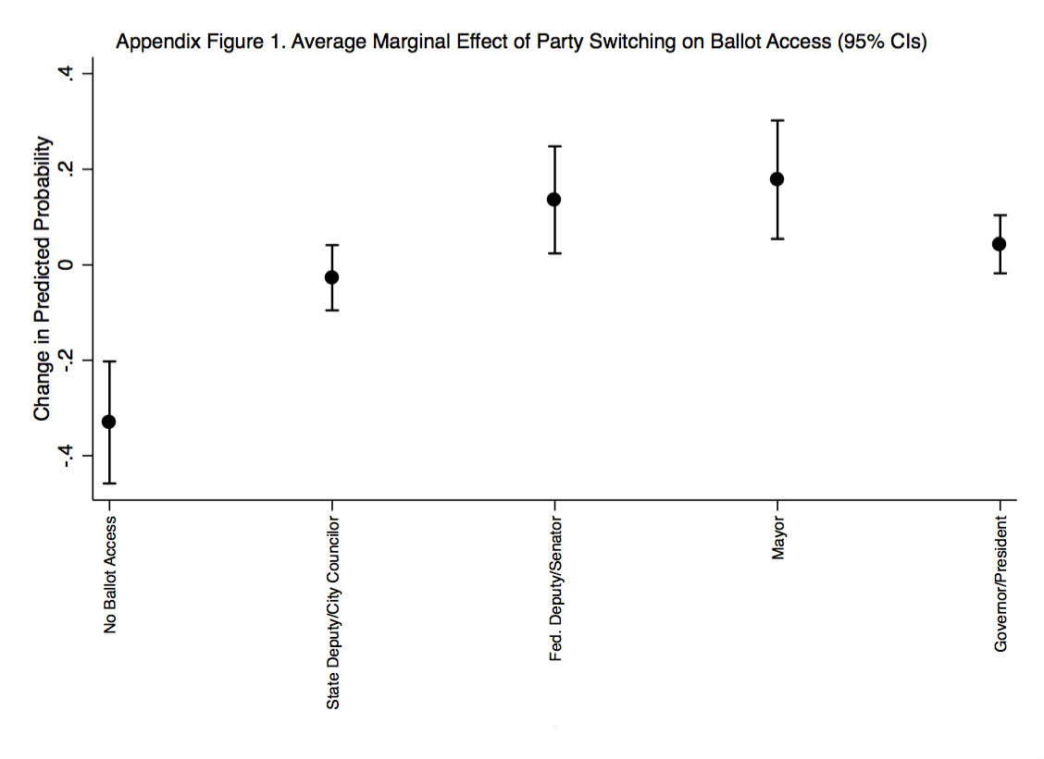

Appendix Table 3 replicates Table 3 from the manuscript examining the effect of party switching on electoral success. However, in this model deputies who obtained ballot access for gubernatorial or presidential office were dropped from the analysis since nearly all of these deputies were dropped from the sample after the matching procedure. I continue to find party switchers are less likely to win office compared to party loyalists. The unbalanced sample used all 667 observations, while the matching procedure used in the manuscript reduced the sample to 233 observations. The model presented here in the Appendix further reduced the sample to 125 observations, although the results are largely consistent across all models. Appendix Figure 2 also replicates Figure 2 from the manuscript. The substantive effects of party switching on winning are largely similar.

Appendix Table 3. Who wins elections? Chamber of Deputies, 1997-2009
Dependent Variable | Won Election
 | b | s.e.
Party switcher | -1.39** | 0.54
PR ballot access | -0.10 | 0.79
Co-partisan governor | 0.08 | 0.64
Mode of election (PR=1) | 1.09 | 0.76
Congressional leader | 0.00 | 1.14
Prior elected office | 0.32 | 0.60
Female | -1.00 | 0.90
Age | 0.05 | 0.04
Education | 0.65* | 0.36
Prior party switch | 2.15* | 1.16
PAN | -0.01 | 0.68
PRD | -0.24 | 0.78
Minor Parties | -1.91 | 1.45
Executive experience | 0.63 | 0.49
Legislative experience | -0.42 | 0.44
Federal deputy/Senator ballot access | -2.02** | 0.85
Mayor ballot access | -1.66** | 0.72
Constant | -5.70** | 2.85
LR χ2 | 38.64**
N | 125
Matched treated | 47
Matched control | 78
L1 imbalance (pre-matching) | 0.88
L1 imbalance (post-matching) | 1.299E-15
Note: Logistic regression, **p<.05, *p<.10, two-tailed test. Alternates excluded and model restricted to deputies who obtained ballot access. Model is weighted using coarsened exact matching.

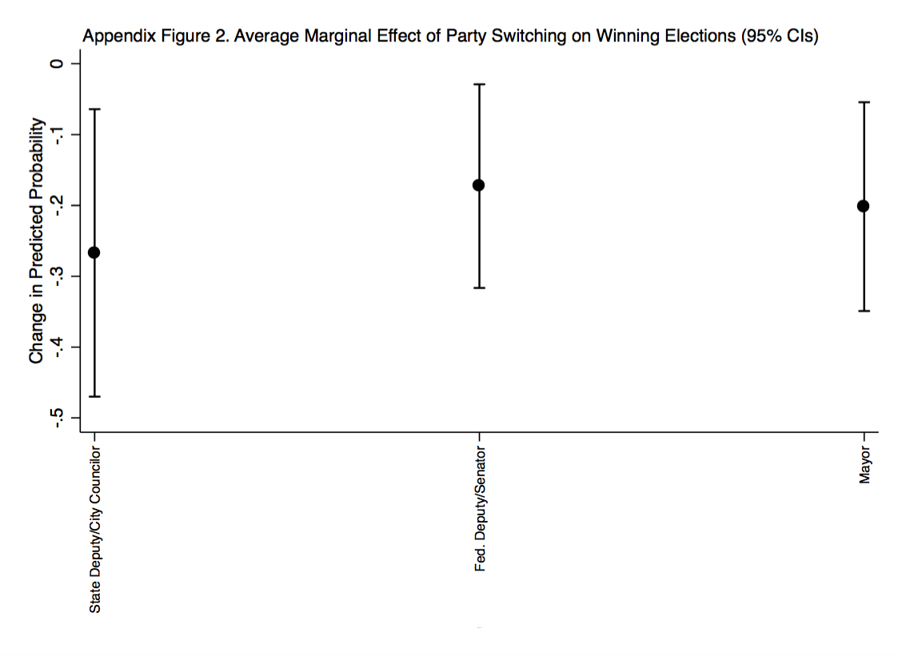

References
Blackwell, Matthew, Stefano Iacus, Gary King, and Giuseppe Porro. 2009. “cem: Coarsened Exact Matching in Stata.” The Stata Journal 9(4): 524-546.
Iacus, Stefano M., Gary King, and Giuseppe Porro. 2012. “Causal Inference without Balance Checking: Coarsened Exact Matching.” Political Analysis 20(1): 1-24.
Kerevel, Yann P. 2014. “Party Loyalty and Disloyalty in the Mexican Party System.” Latin American Politics and Society 56(3): 93-117.

