Appendix Figure 1. Distribution of C-reactive protein values.
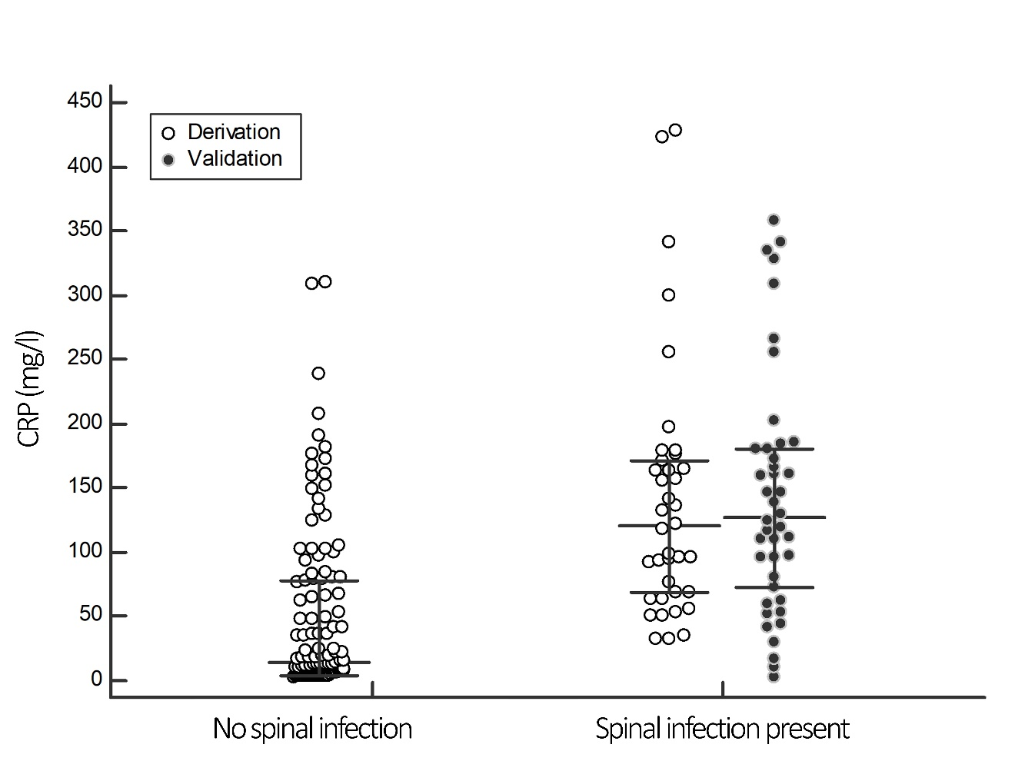
* Long horizontal bars represent medians for each group and vertical lines represent the interquartile range.

Appendix Figure 2. Sensitivity of C-reactive protein cut-off values from 0 to 100 mg/l.

