Appendix Figure 1. Sequential ECGs demonstrating tachydysrhythmias.
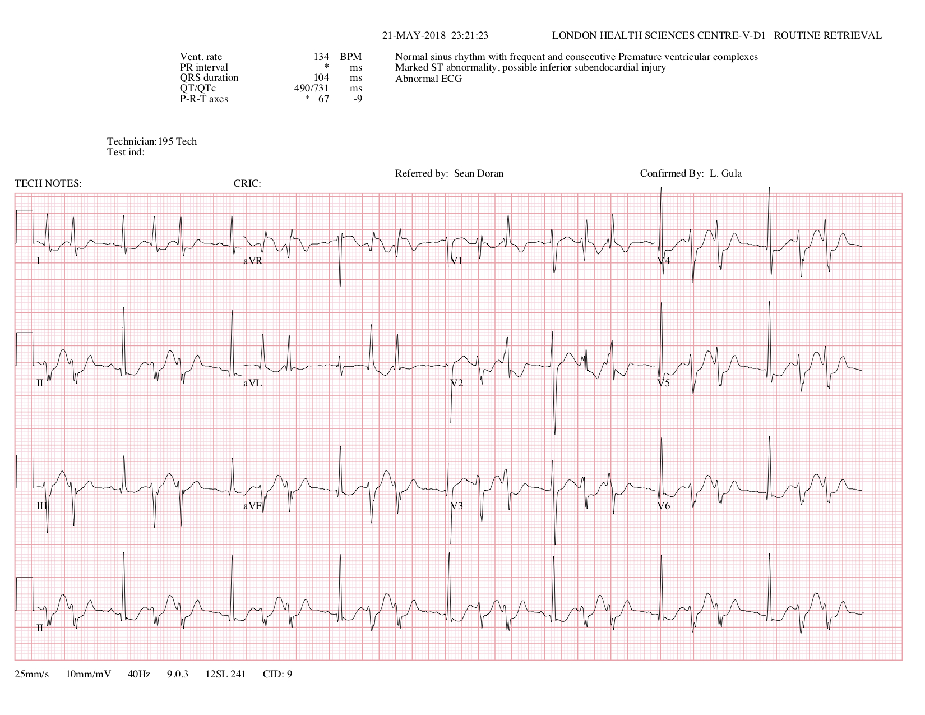
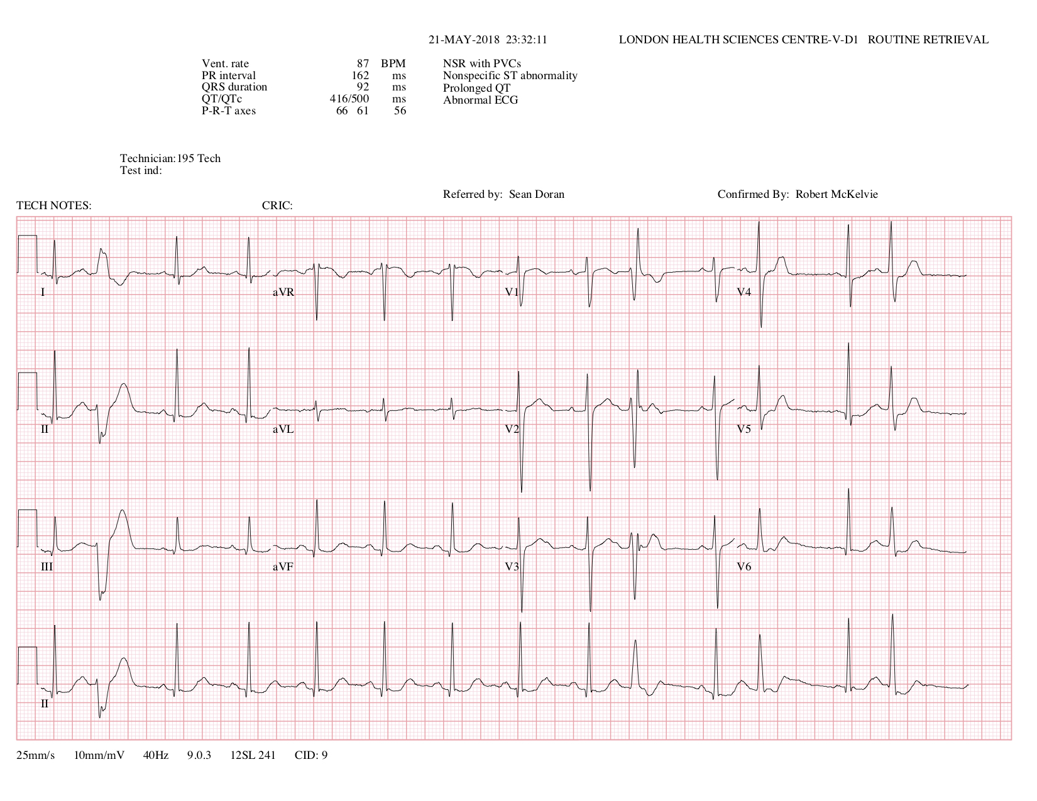
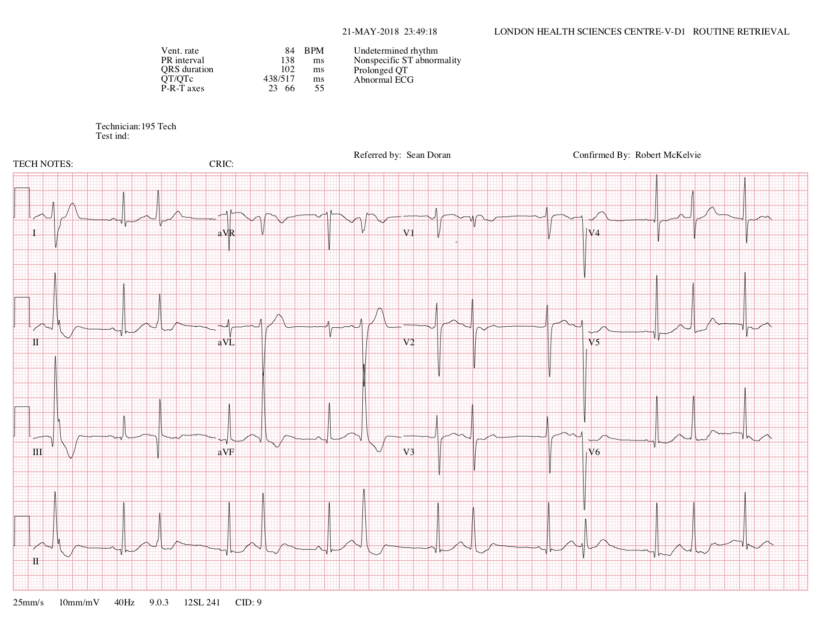
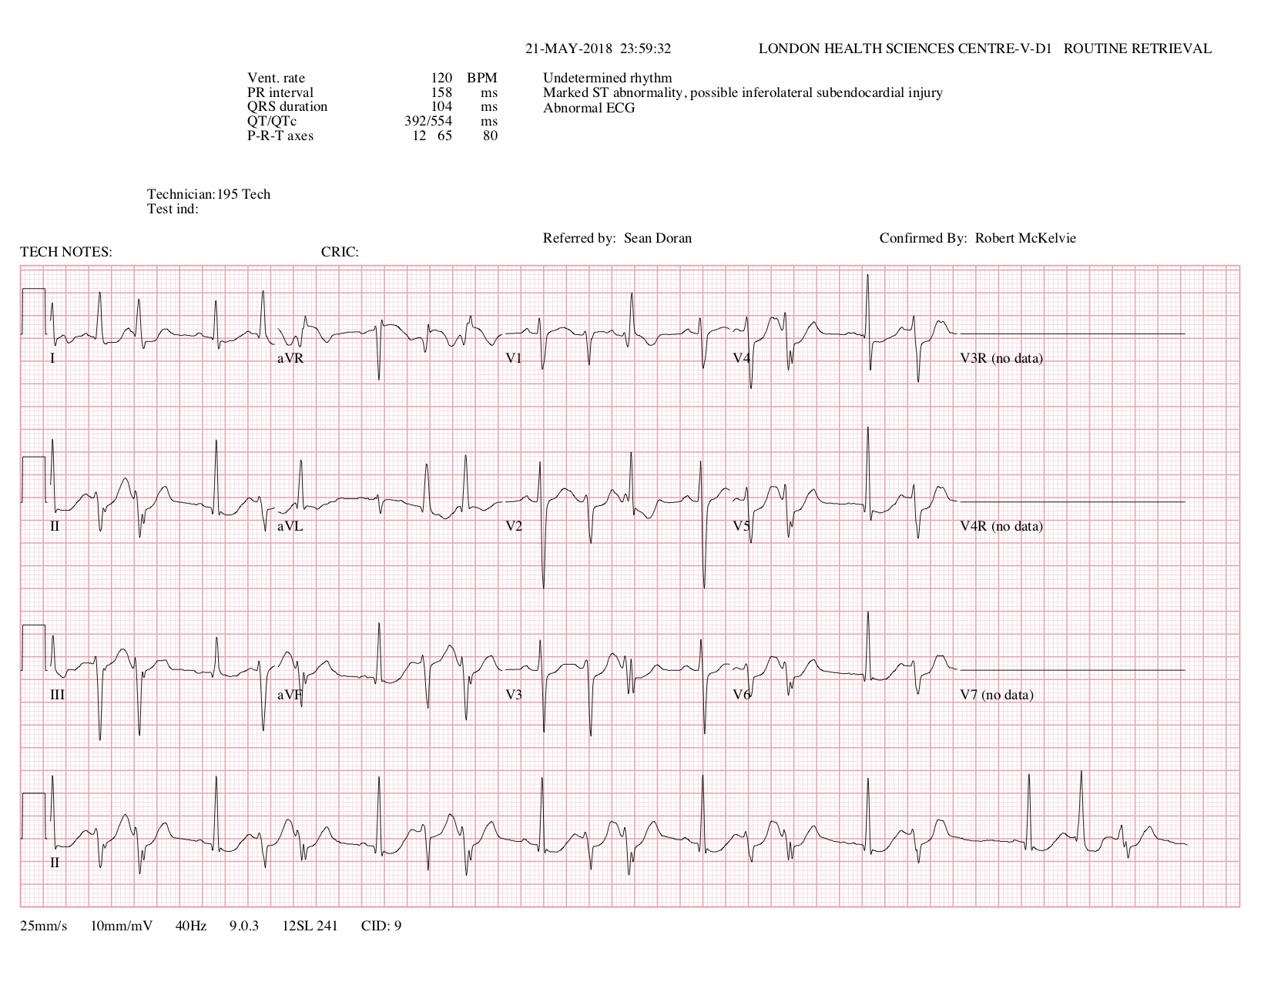
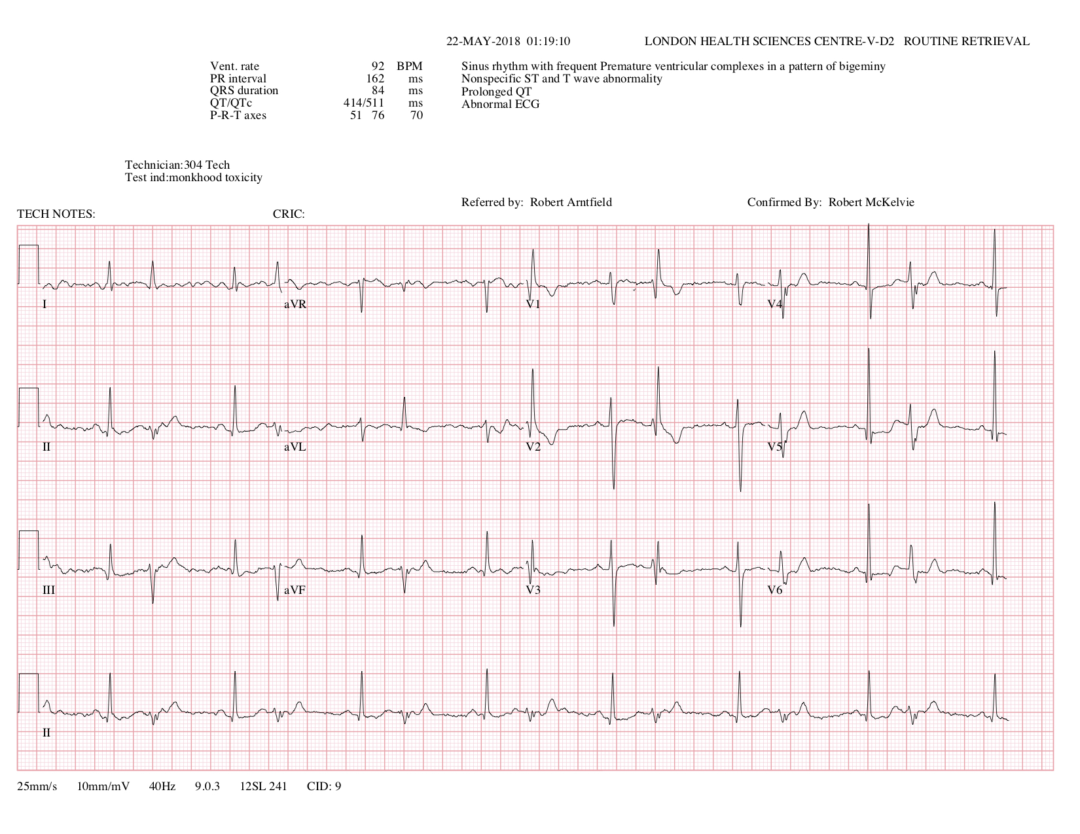

Appendix Table 1. PictureThis Plant Identifier Application Details.
Developer: | Glority LLC
Release Date: | July 20, 2017
Size: | 111.4 Mb
Category: | Education
Price: | Free with in-app upgrades
Rating: | 4.7/5
Reviews: | 63,600
Catalogue | 10,000+ plant species
Accuracy: | 98% within top 3 answers
Verification method: | AI engine performance is measured by user real identification requests while learning from experts and specialists.

Appendix Table 2. Initial laboratory investigations.
VBG | 23:15 | 00:15
pH | 7.47 | 7.37
PCO₂ | 36 mm Hg | 41 mm Hg
HCO₃ | 27.3 mmol/L | 25 mmol/L
Lactate | 2.0 mmol/L | 1.6 mmol/L
CBC
Hb | 150 g/L
WBC | 7.9 x10⁹/L
Platelets | 275 x10⁹/L
Electrolytes
Sodium | 144 mmol/L
Potassium | 3.5 mmol/L
Chloride | 104 mmol/L
Bicarbonate | 24 mmol/L
Calcium | 2.37 mmol/L
Magnesium | 0.92 mmol/L
Albumin | 44 g/L
Renal Function
Urea | 4.7 mmol/L
Creatinine | 82 µmol/L
Toxicology
Salicylates | <0.1 mmol/L
Acetaminophen | < 33 µmol/L
Ethanol | <2.2 mmol/L
Serum Osmolality | 300 mOsm/kg
Urine Drug Screen
Opiates | Negative
Cannabinoids | Negative
Cocaine | Negative
Amphetamines | Negative
Barbiturates | Negative
Benzodiazepines | Negative

