Appendix 1: QUICk FAST assessment tool

Hepatorenal Space
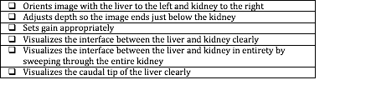
Splenorenal Space
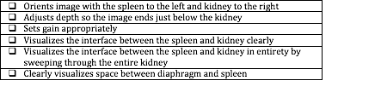
Pelvis
