Appendices

Table S1. Detailed Patient Characteristics of Lung POCUS and Control Groups
 |  | Lung POCUS group |  | No lung POCUS group
Characteristics |  | n = 81 |  | n = 243 |  | P value
Past history, n (%)
Hypertension |  | 61 | (75.3) | 174 | (71.6) | 0.57
Diabetes |  | 35 | (43.2) | 92 | (37.9) | 0.43
Smoking |  | 31 | (38.3) | 108 | (44.4) | 0.37
MI/Angina |  | 30 | (37.0) | 121 | (49.8) | 0.054
Atrial fibrillation |  | 26 | (32.1) | 104 | (42.8) | 0.12
Chronic kidney disease |  | 21 | (25.9) | 68 | (28.0) | 0.78
Pacemaker |  | 16 | (19.8) | 13 | (5.4) | 0.0004
Stroke/TIA |  | 14 | (17.3) | 32 | (13.2) | 0.36
Asthma |  | 4 | (4.9) | 17 | (7.0) | 0.61
Home oxygen, n (%) |  | 5 | (6.2) | 26 | (10.7) | 0.28
Current cardiac medication, n (%)
Diuretics |  | 50 | (61.7) | 148 | (60.9) | 1.00
Beta blockers |  | 49 | (60.5) | 134 | (55.1) | 0.44
Statins |  | 44 | (54.3) | 144 | (59.3) | 0.44
ACEIs/ARBs |  | 39 | (48.2) | 122 | (50.2) | 0.80
Ca blockers |  | 32 | (39.5) | 72 | (29.6) | 0.10
Nitrates |  | 17 | (21.0) | 57 | (23.5) | 0.76
Antiarrhythmics |  | 8 | (9.9) | 15 | (6.2) | 0.32
Current respiratory medication, n (%)
Inhaled beta agonists |  | 33 | (40.7) | 106 | (43.6) | 0.70
Inhaled steroids |  | 22 | (27.2) | 61 | (25.1) | 0.77
Inhaled anticholinergics |  | 18 | (22.2) | 62 | (25.5) | 0.66
Oral steroids |  | 8 | (9.9) | 28 | (11.5) | 0.84
Symptoms, n (%)  Cough  Sputum production  Orthopnea  Palpitation | 48  34  34  1 |  | (59.3)  (42.0)  (42.0)  (1.2) | 163  94  87  14 | (67.1)  (38.7)  (35.8)  (5.8) | 0.23  0.60  0.35  0.13
Physical examination, n (%)  Peripheral edema  Bilateral crackles  Bilateral wheezes | 52  51  23 |  | (64.2)  (63.0)  (28.4) | 141  144  83 | (58.0)  (59.3)  (34.2) | 0.36  0.60  0.41
POCUS=point-of-care ultrasonography; MI=myocardial infarction; TIA=transient ischemic attack, ACEI=angiotensin-converting enzyme inhibitor; ARB=angiotensin II receptor antagonist, SD=standard deviation; BP=blood pressure

Table S2. Characteristics of Lung POCUS
 | Lung POCUS group
Characteristics | n = 81
Physician initial assessment time to POCUS time (minutes), median, Q1-Q3 | 71.0 | 34-153
POCUS time to patient left ED time (minutes), median, Q1-Q3 | 374.0 | 221-848
Timing of POCUS performed, n (%)  Before disease-specific treatment administration  After disease-specific treatment administration | 45  29 | (55.6)  (35.8)
POCUS findings, n (%)
B-lines  Positive  Negative  Indeterminate | 64  17  0 | (79.0)  (21.0)  (0)
*Non-physician sonographers refer to trained medical students or trained ultrasound technicians
POCUS=point-of-care ultrasonography

Table S3. Incidence of Adverse Events for POCUS Group Versus No POCUS Group
 | Lung POCUS group |  |  | No lung POCUS group
Adverse events | n = 81 |  |  | n = 243
Potentially unnecessary treatment*, n (%)  Beta agonists  Anticholinergics  Steroids  Diuretics  Vasodilators | 8  5  3  1  2  1 | (9.9)  (6.2)  (3.7)  (1.2)  (2.5)  (1.2) | 30  23  18  6  4  2 |  | (12.4)  (9.5)  (7.4)  (2.5)  (1.6)  (0.8)
Return within 7 days, n (%) | 3 | (3.7) | 12 |  | (4.9)
Inaccurate ED diagnosis, n (%) | 0 | (0) | 10 |  | (4.1)
*Potentially unnecessary treatment is defined as administration of disease-specific treatment for inaccurate diagnosis based on the final diagnosis
POCUS=point-of-care ultrasonography

Table S4. Unadjusted and Adjusted Odds Ratios Comparing Incidence of Adverse Events for POCUS Group Versus No POCUS Group
 | Unadjusted |  |  | Adjusted
Adverse events | OR | 95% CI | P value* | OR | 95% CI | P value
Potentially unnecessary treatment* | 0.78 | 0.30 to 1.84 | 0.71 | 0.62 | 0.22 to 1.54 | 0.37
Return within 7 days | 0.74 | 0.13 to 2.85 | 0.92 | 0.80 | 0.14 to 3.15 | 1.00
Inaccurate ED diagnosis | 0.21 | 0 to 1.03 | 0.054 | 0.25 | 0 to 1.24 | 0.08
*Potentially unnecessary treatment is defined as administration of disease-specific treatment for inaccurate diagnosis based on the final diagnosis
POCUS=point-of-care ultrasonography; ED=emergency department; OR=odds ratio; CI=confidence interval

Figure S1. Schema of Timeline and Time Intervals in the ED
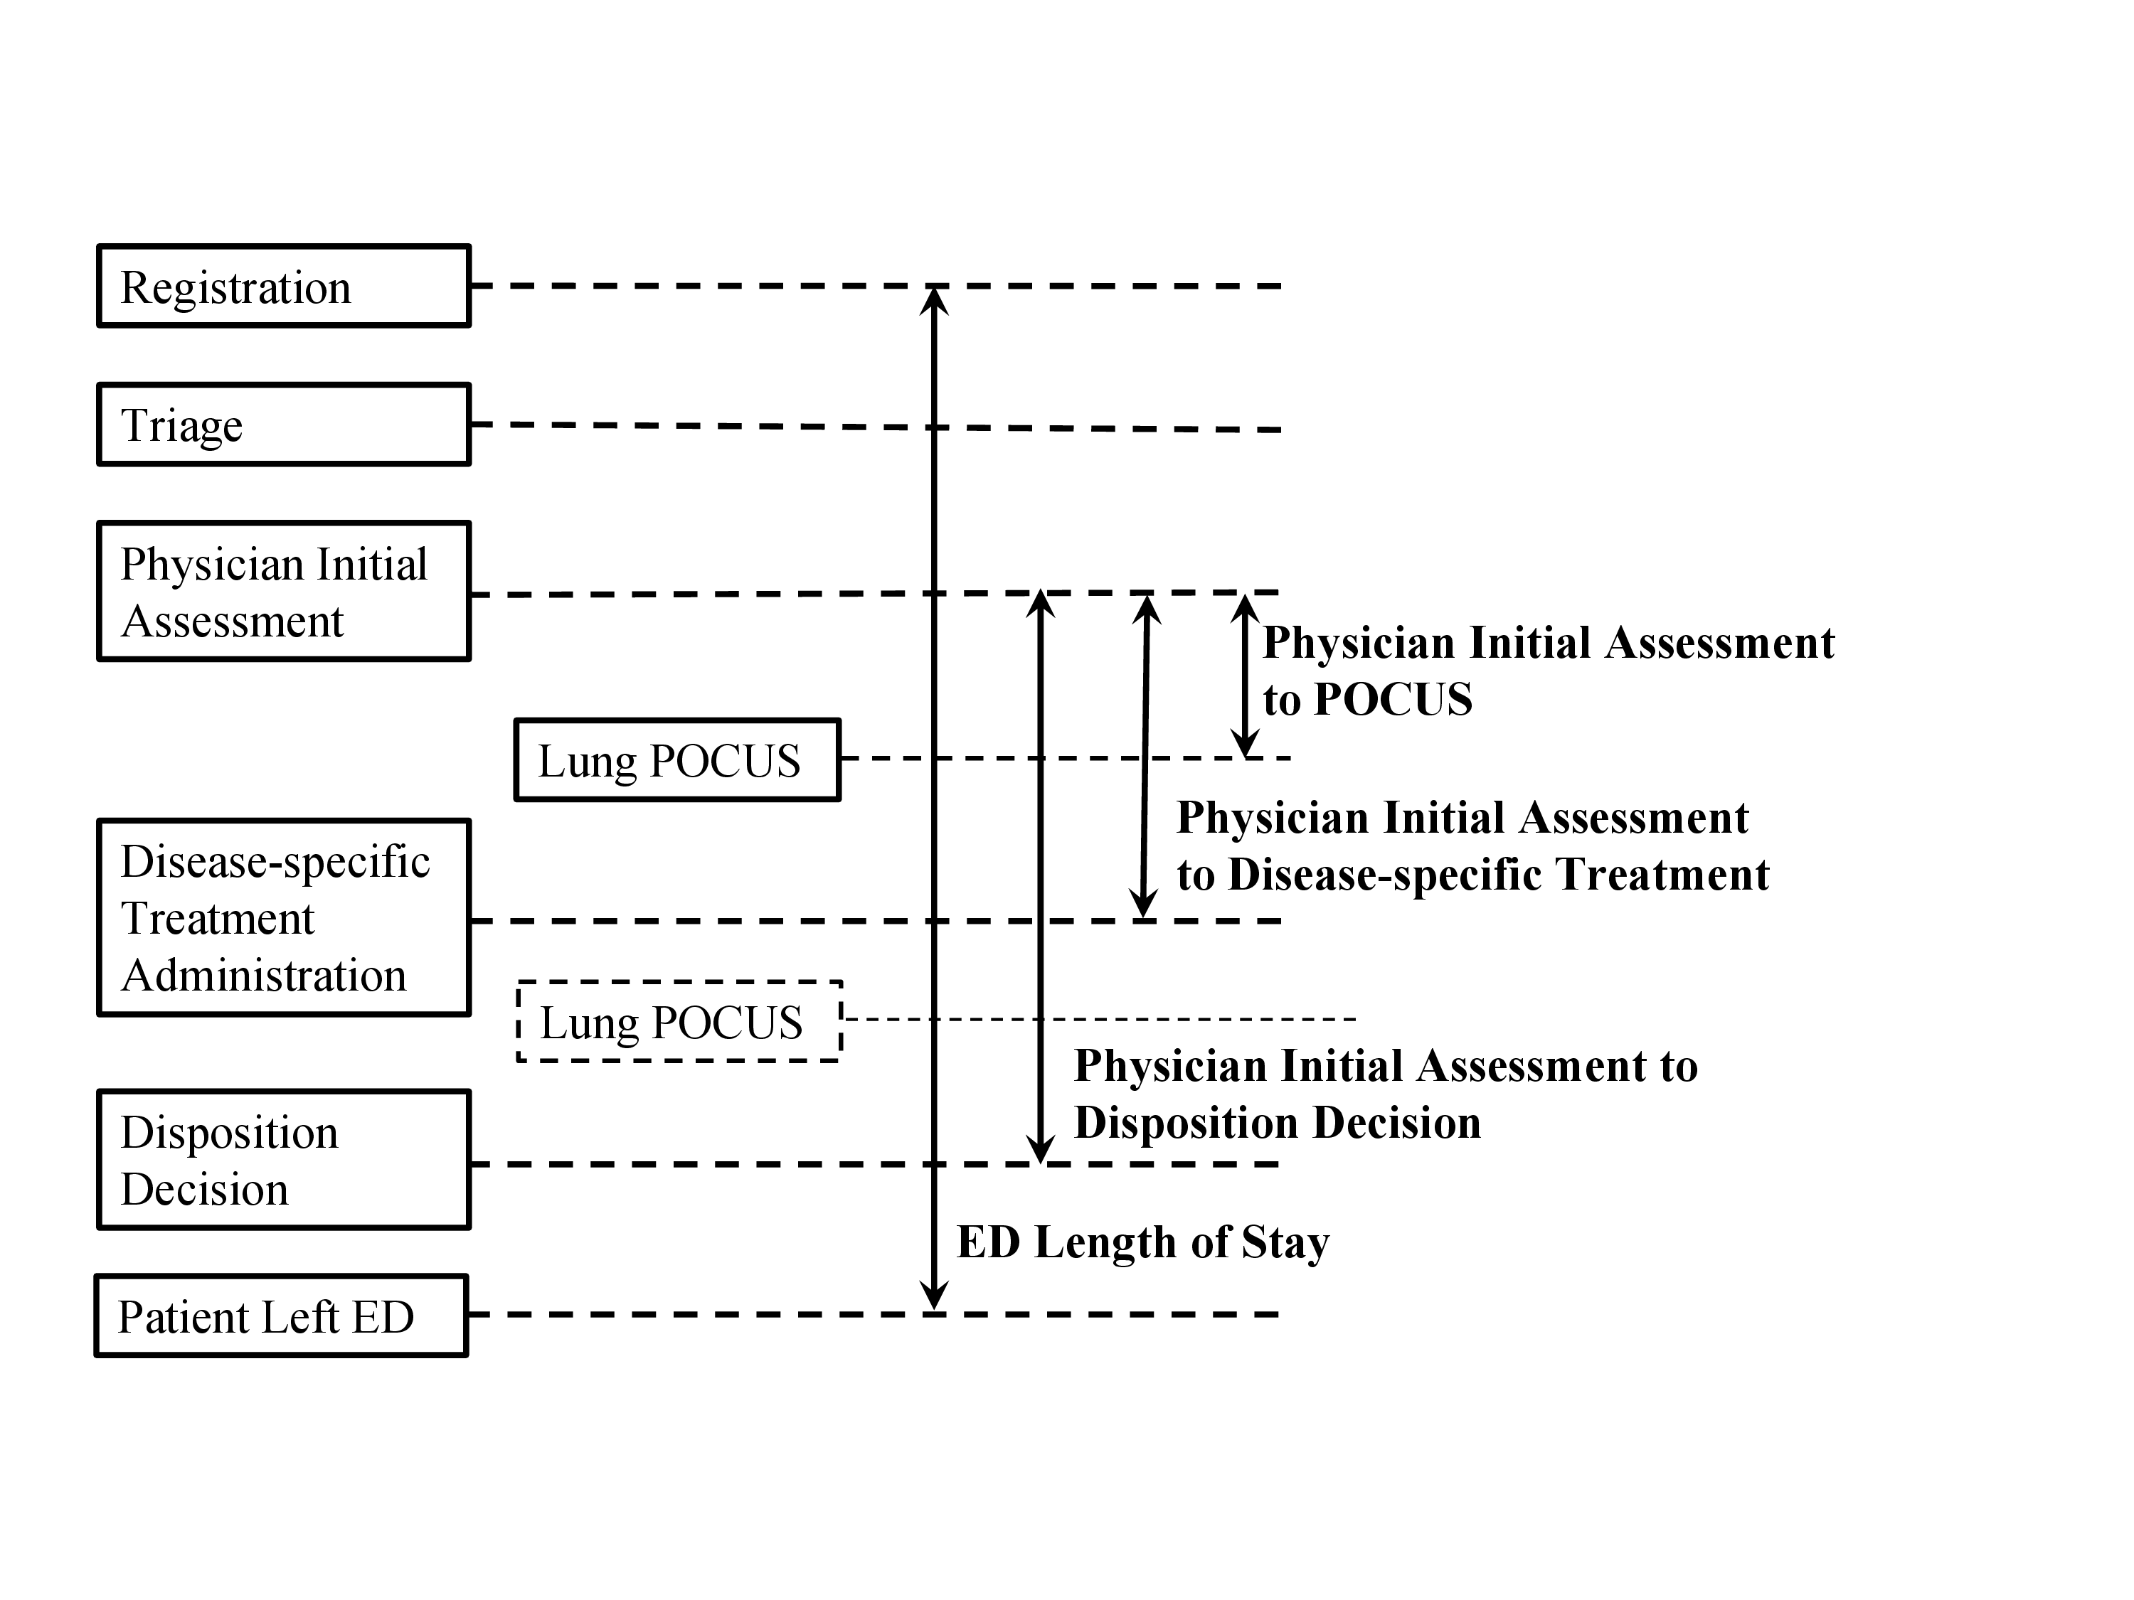

POCUS may be done anytime after Physician Initial Assessment
ED=emergency department; POCUS=point-of-care ultrasonography

Figure S2. Kaplan-Meier Curves for Time to Disease-Specific Treatment for Patients with and without Lung POCUS, Accounting for POCUS as a Time-Dependent Variable
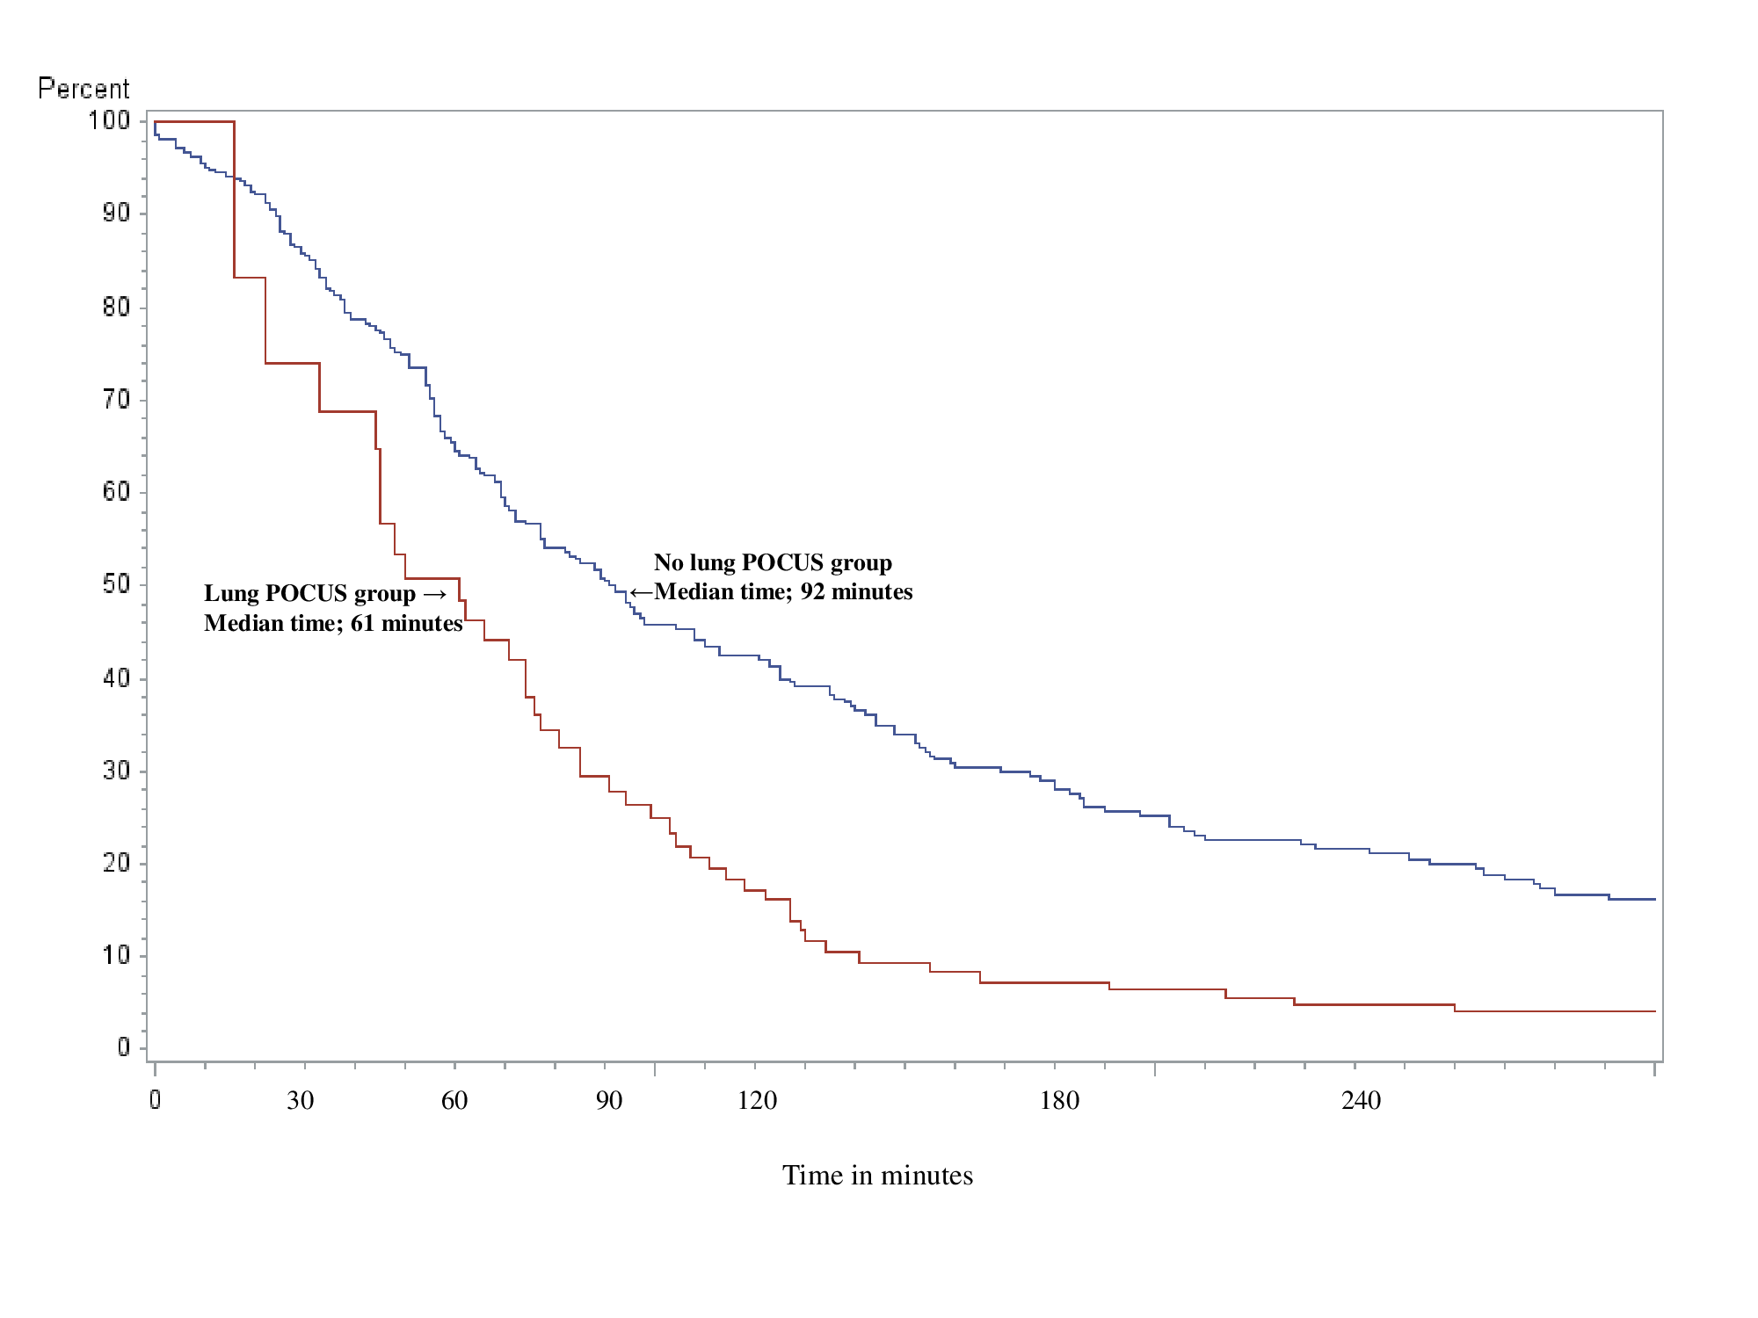

POCUS=point-of-care ultrasonography

