**Appendix 1. Image of model with plastic dressing in place**

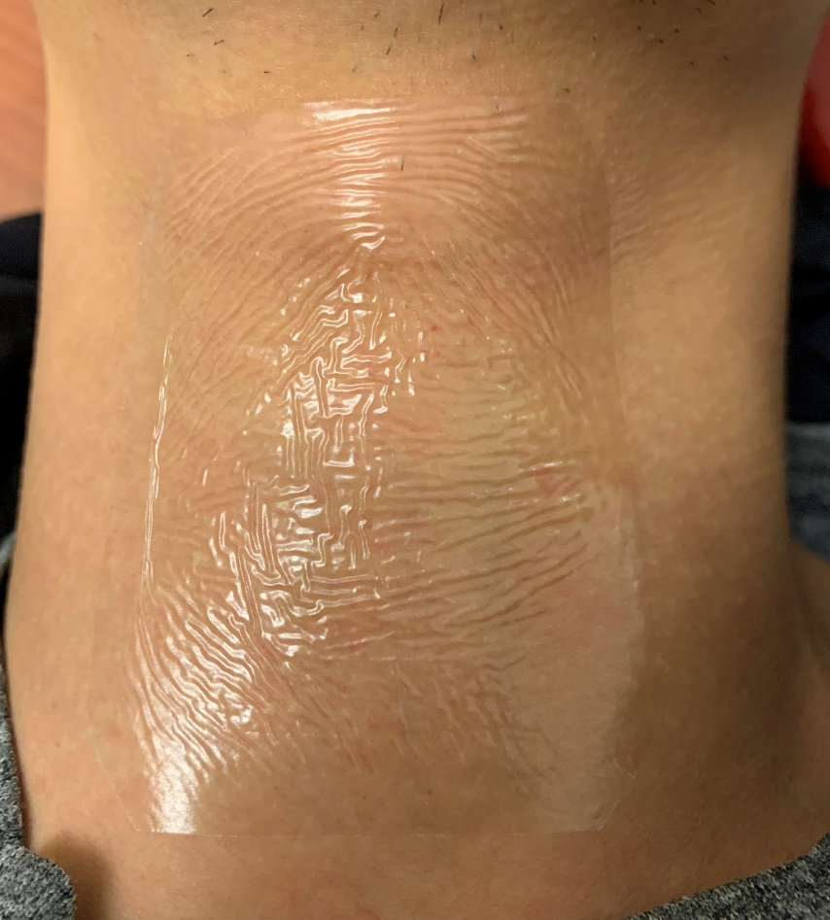

**Appendix 2.**

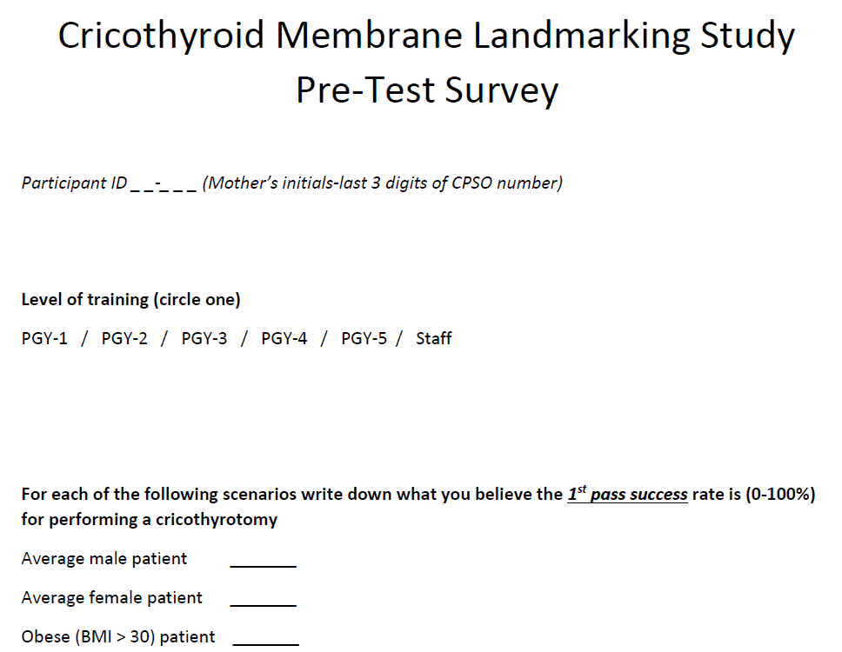

**Appendix 3.**

